

CAPSTONE PROJECT REPORT
Report 3 – Software Requirement Specification

– Can Tho, September 2026 –
Table of Contents
I. Record of Changes 4
II. Software Requirement Specification 5
1. Product Overview 5
2. User Requirements 6
2.1 Actors 6
2.2 Use Cases 7
2.3 Authentication & Account Management 52
2.4 eKYC & Identity Verification Flow 76
2.5 Role-Based Access Control (RBAC) 114
2.6 Event Discover 117
2.7 Virtual Queue & Fair Admission 132
2.8 Interactive Seating Chart & Ticket Selection 151
2.9 Dynamic QR Code & Ticket Wallet 168
2.10 Ticket Return & Re-Issue Workflow 190
2.11 Event Creation & Lifecycle Management 197
2.12 Seating Chart Builder & Ticket Class Configuration 216
2.13 Revenue Analytics & Sales Dashboard 230
2.14 Real-time Check-in Monitoring 236
2.15 QR Code Scanner & Check-in Interface 247
2.16 Incident Reporting & On-site Support 261
2.17 User Management, Event Approval, Review, Wishlist & Dispute Resolution 267
2.18 AI Risk Scoring & Fraud Alert Dashboard 302
2.19 System Activity Log & Audit Trail 337
2.20 Real-time Notification Management 342
2.21 Payment Gateway Integration, Voucher & Checkout 349
2.22 Governance, Policy Versioning & Compliance 389
3. Functional Requirements 403
3.1 System Functional Overview 403
3.2 Feature 1: Authentication & Account Management 530
3.3 Feature 2: eKYC & Identity Verification Flow 560
3.4 Feature 3: Role-Based Access Control (RBAC) 590
3.5 Feature 4: Event Discovery & Search 593
3.6 Feature 5:Virtual Queue & Waiting Room 634
3.7 Feature 6: Interactive Seating Chart & Ticket Selection 676
3.8 Feature 7: Dynamic QR Code & Ticket Wallet 699
3.9 Feature 8: Ticket Return & Re-Issue Workflow 719
3.10 Feature 9: Event Creation & Lifecycle Management 733
3.11 Feature 10: Seating Chart Builder & Ticket Class Configuration 777
3.12 Revenue Analytics & Sales Dashboard 810
3.13 Real-time Check-in Monitoring 818
3.14 QR Code Scanner & Check-in Interface 826
3.15 Incident Reporting & On-site Support 835
3.16 User Management, Event Approval, Review, Wishlist & Dispute Resolution 845
3.17 Risk-Based Anti-Fraud 887
3.18 System Activity Log & Audit Trail 928
3.19 Real-time Notification Management 931
3.20 Payment Gateway Integration, Voucher & Checkout 937
3.21 Governance, Policy, Versioning & Compliance 970
4. Non-Functional Requirements 985
4.1 External Interfaces 985
4.2 Quality Attributes 988
5. Requirement Appendix 990
5.1 Business Rules 990
5.2 Common Requirements 1012
5.3 Application Messages List 1012
5.4 Other Requirements… 1014

I. Record of Changes
Date | A*  M, D | In charge | Change Description
15/9/2026 | A | TaiNH | Add Guest UC diagram, Customer UC diagram, Event Organizer  & Admin UC digram
15/9/2026 | M | TaiNH | Add 2.2.2 Descriptions
15/9/2026 | A | TanMN | Add UC description: UC 01- 01.1, UC 05, UC 05.1, UC 06, UC 07, UC 07.1,  UC 08.2, UC 09, UC 10, UC 10.1, UC 10.2
16/9/2026 | A | TanMN | Add UC description: UC 11, UC 69-69.2, UC 70, UC 71, UC 72, UC 73,  UC 75, UC 76, UC 77, UC 78, UC 79, UC 101, UC 101.1
20/09/2026 | A | MinhTH | Add UC description: UC: 31-31.2, 52-52.3,22-22.2
21/9/2026 | A | TanMN | Add ERD and Entities Description
22/09/2026 | A | MinhTH | Add 5.1, 5.2, 5.3, 4.2.1, 4.2.2, 4.2.3, 4.2.4, 4.2.5, 4.2.6, 4.2.7
22/9/2026 | A | KhiemNPG | Add UC description: UC 6.1 - 6.4, 7.1 - 7.4, 8.1 - 8.5, 17.10 - 17.12
29/09/2026 | M | MinhTH | 5.1
30/9/2026 | M | TanMN | Modify ERD and Entities Description
30/9/2026 | A | KhiemNPG | Add UC description: UC: 7.12 - 7.14, 8.6, 8.9, 8.11
*A - Added M - Modified D - Deleted

II. Software Requirement Specification

1. Product Overview

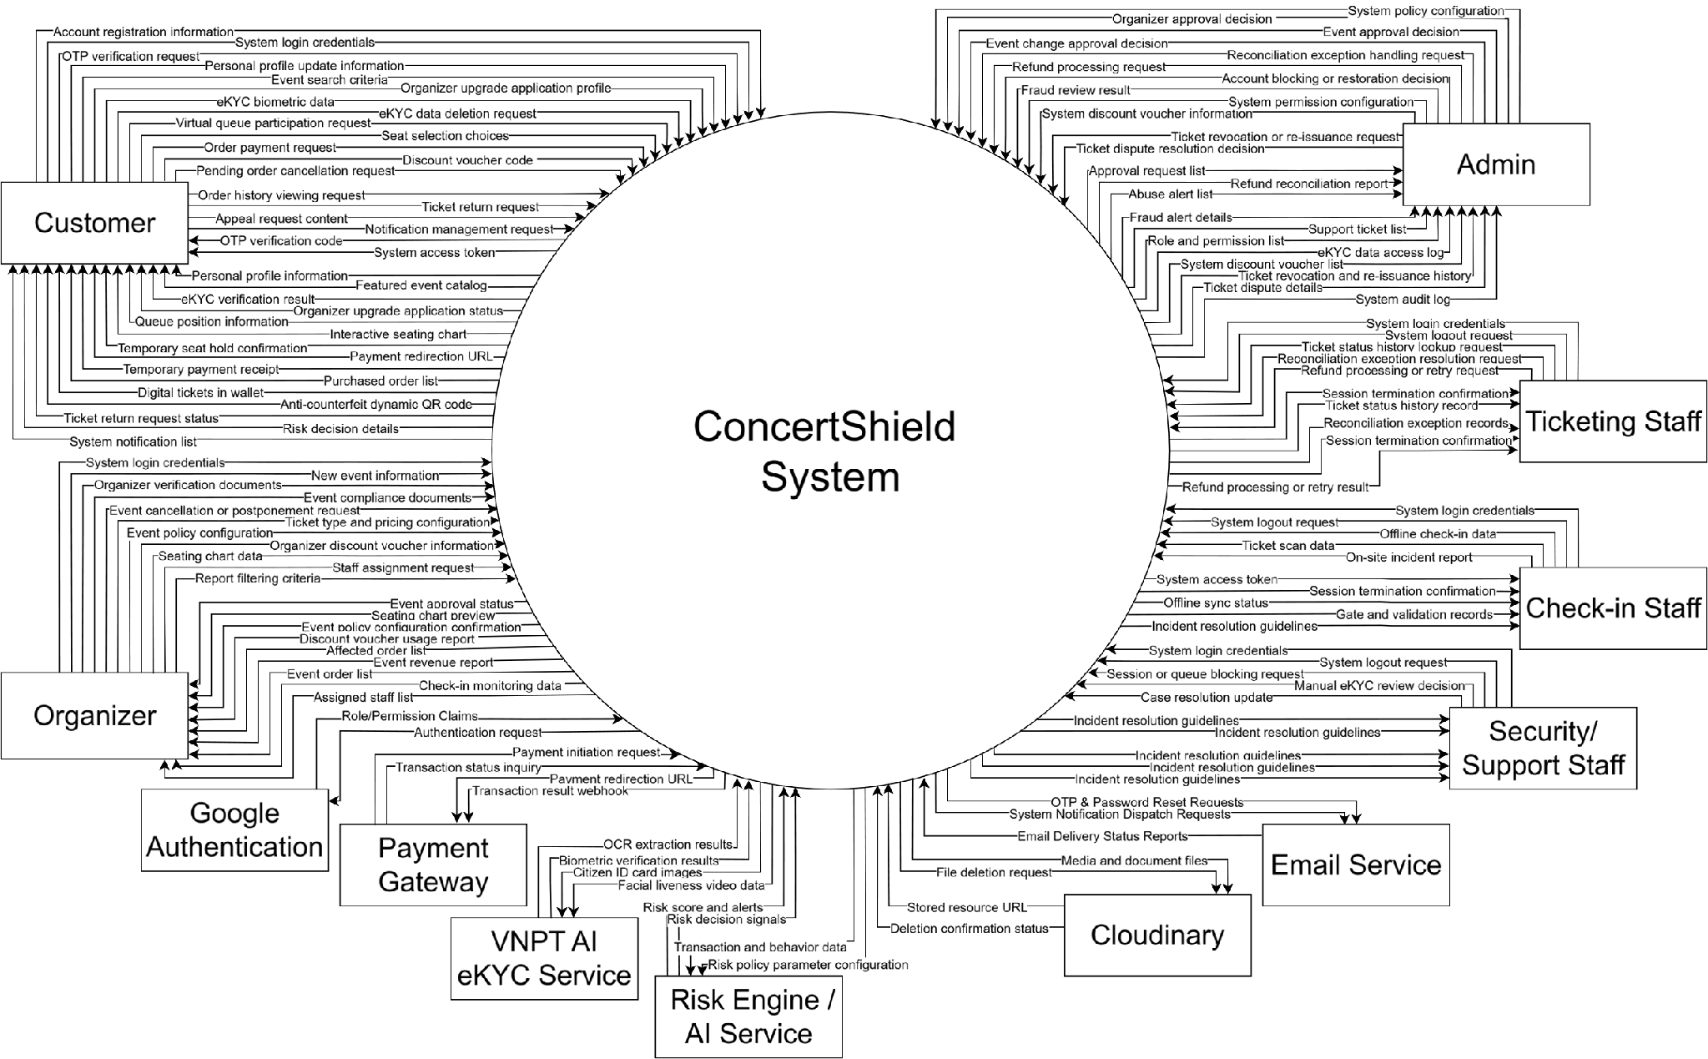
Figure 1. Context Digram

2. User Requirements

2.1 Actors

# | Actor | Description
1 | Guest | An unauthenticated visitor who can access public ConcertShield functions such as viewing the homepage, browsing/searching music concerts, viewing concert details, and accessing registration/login.
2 | Customer | A registered ticket buyer who can manage their account, complete eKYC when required, browse concerts, join pre-queue/virtual queue, select seats or tickets, place and pay for orders, use the ticket wallet, request returns, receive notifications, and contact support.
3 | Event Organizer | The concert organizer/owner. This actor manages concert creation and lifecycle, compliance documents, seating/inventory configuration, ticket types, pricing/refund policies, sale controls, vouchers, revenue, and organizer-side operations.
4 | Ticketing/Operations Staff | Operational staff responsible for ticket/order operations, voucher-related operations, ticket status handling, reconciliation support, and other assigned ticketing tasks.
5 | Check-in Staff | Gate staff responsible for gate assignments, scanning Dynamic QR tickets, manual check-in, ticket lookup, check-in history, and offline check-in operations when enabled.
6 | Security/Support Staff | Support/security staff responsible for incidents, disputes/support cases, suspicious-session or abuse handling, fraud-related operational follow-up, and escalation according to assigned permissions.
7 | Platform Administrator | The platform administrator responsible for user/role administration, organizer and concert approval, system policies, eKYC governance, disputes/refunds, fraud/risk oversight, vouchers, audit logs, and system parameters.
8 | Email/Notification Service | External messaging service used for OTPs, password recovery, approval results, event/ticket updates, and other system-generated notifications.
9 | Google OAuth Service | External authentication provider used for Customer registration/sign-in through Google OAuth 2.0.
10 | Cloudinary | External media storage service used for avatars, concert media, organizer/compliance documents, and incident evidence.
11 | Payment Gateway (VNPay) | External payment service used to process customer payments, callbacks/webhooks, refunds, and payment reconciliation data.
12 | VNPT AI eKYC Service | External third-party service integrated via API for citizen ID OCR, facial liveness detection, face matching, and eKYC verification.
 | Risk Engine / AI Service | Risk evaluation service used to generate risk decisions/signals for anti-fraud controls; it supports risk-based actions rather than acting as the sole automatic fraud verdict.

2.2 Use Cases

2.2.1 Diagram(s)
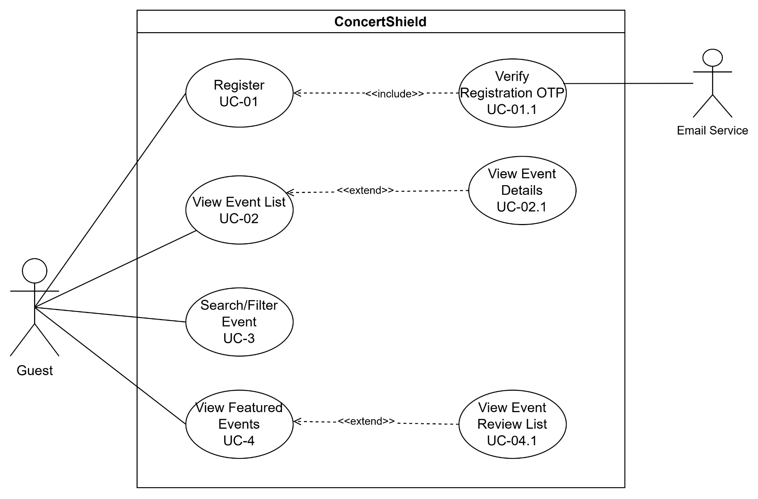
Figure 2. Guest UC diagram
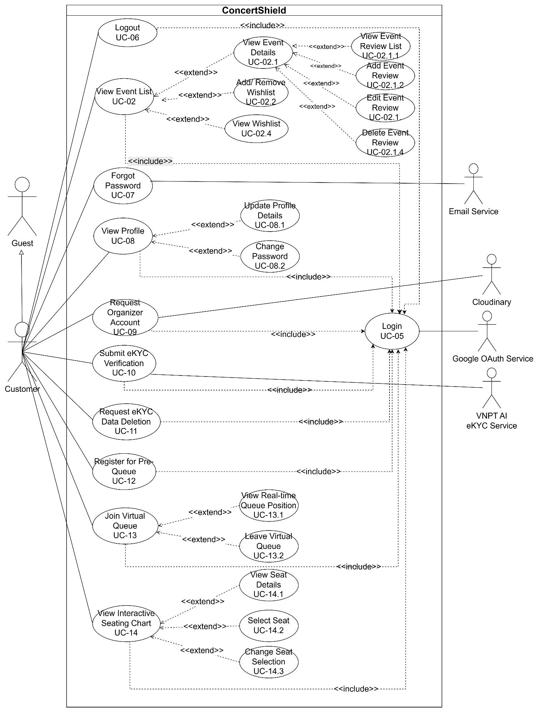
Figure 3. Customer UC diagram
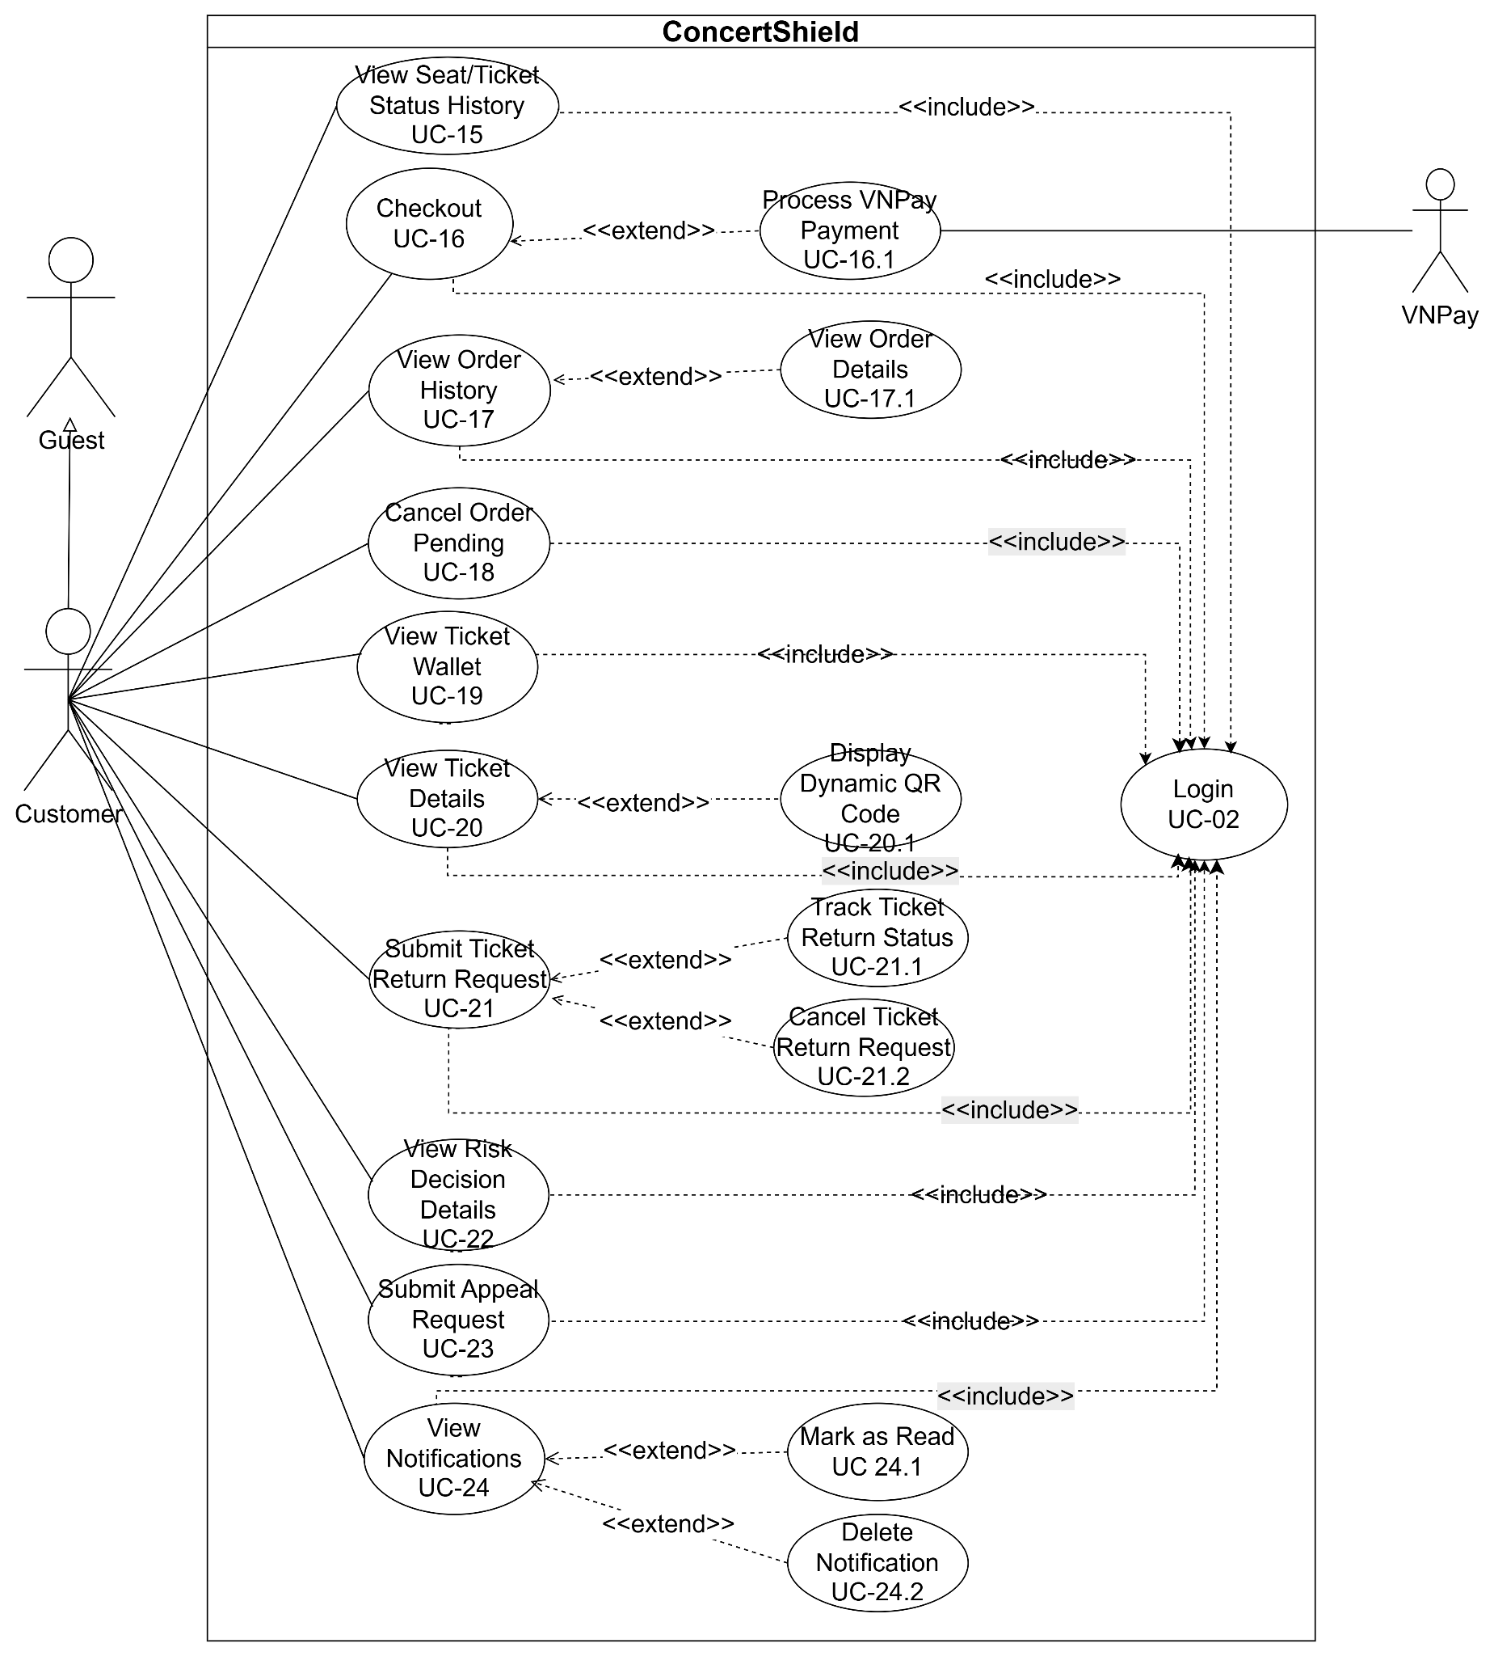
Figure 4. Customer UC diagram
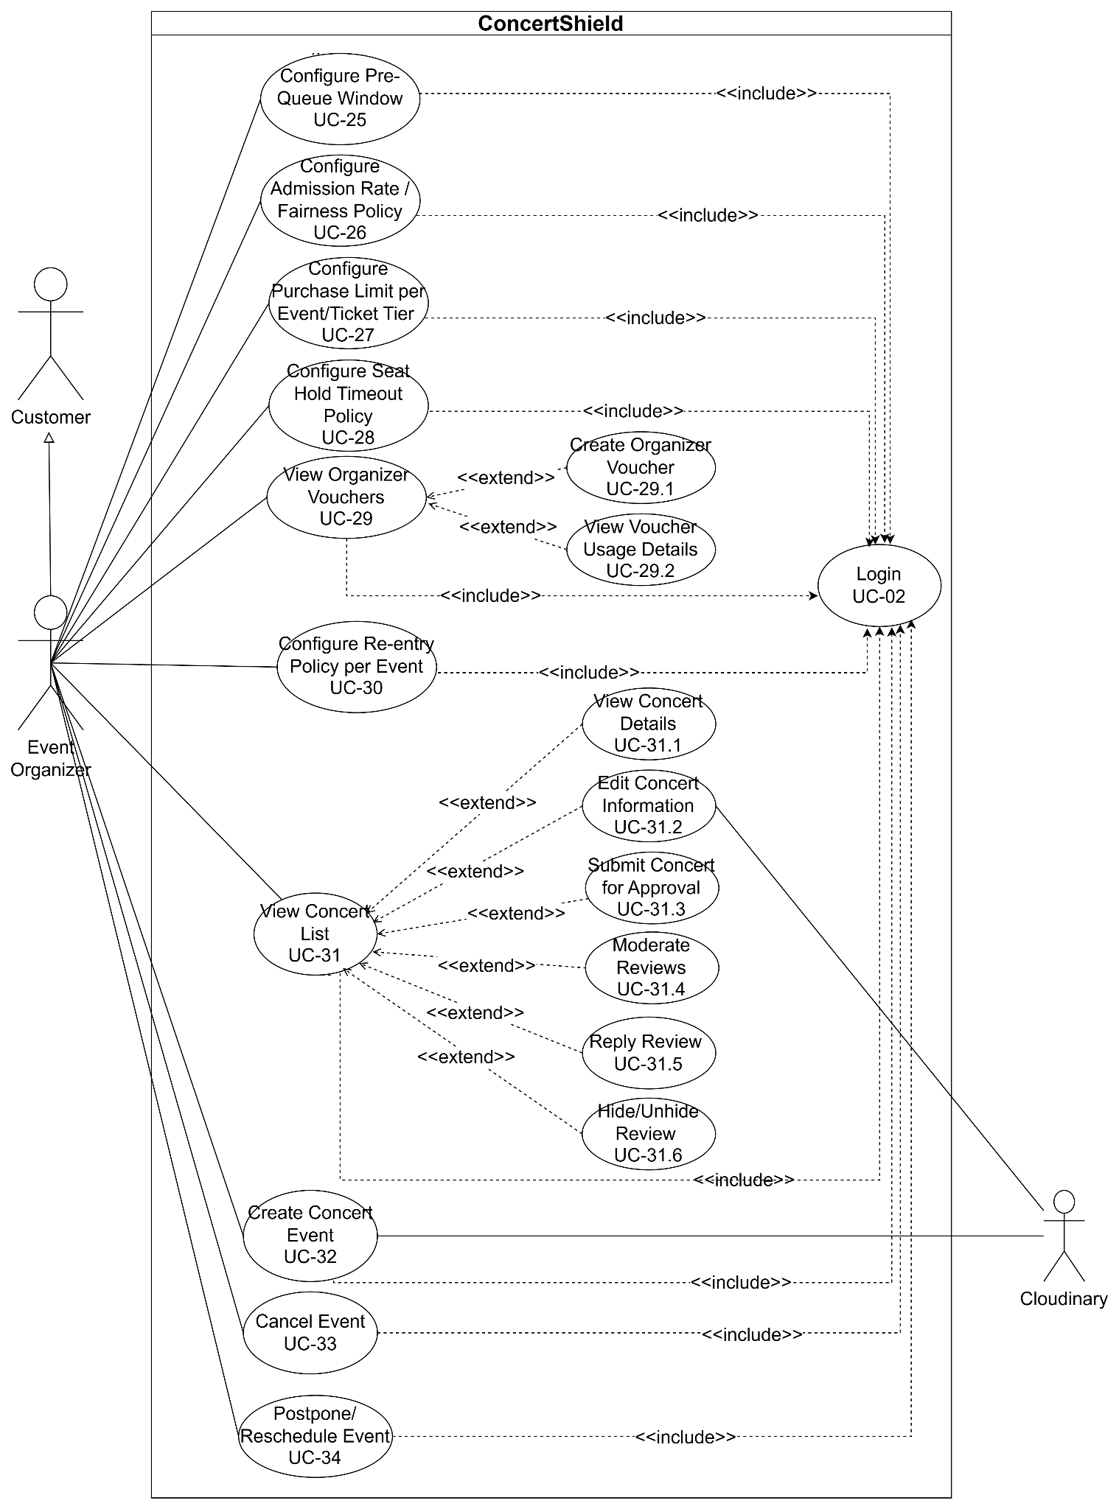
Figure 5. Organizer UC diagram
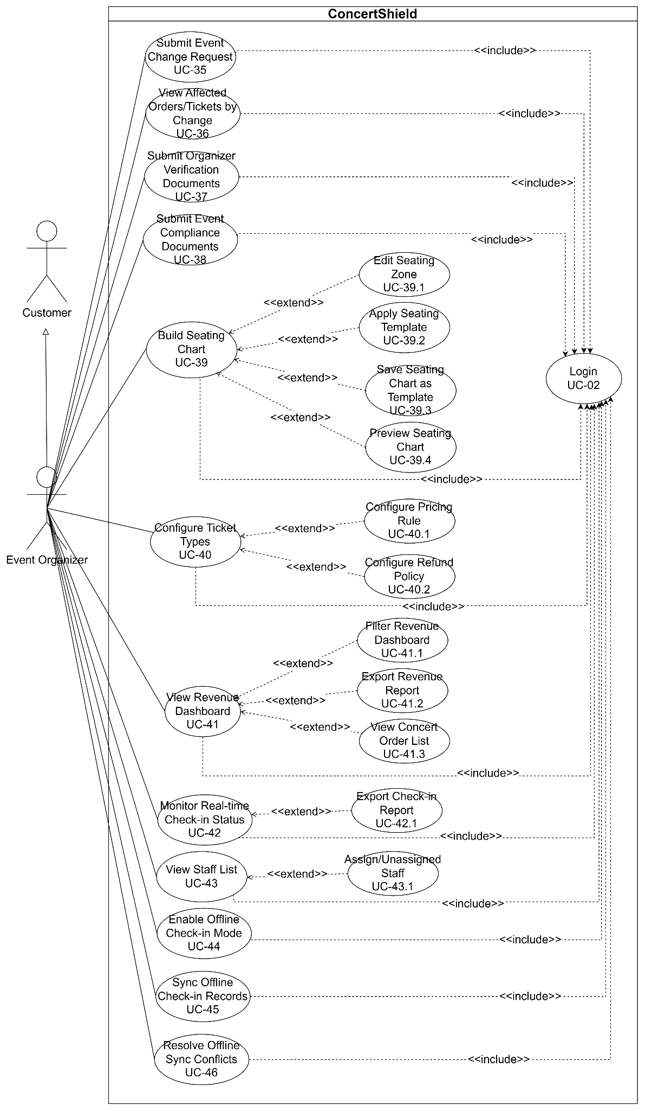
Figure 6. Organizer UC diagram
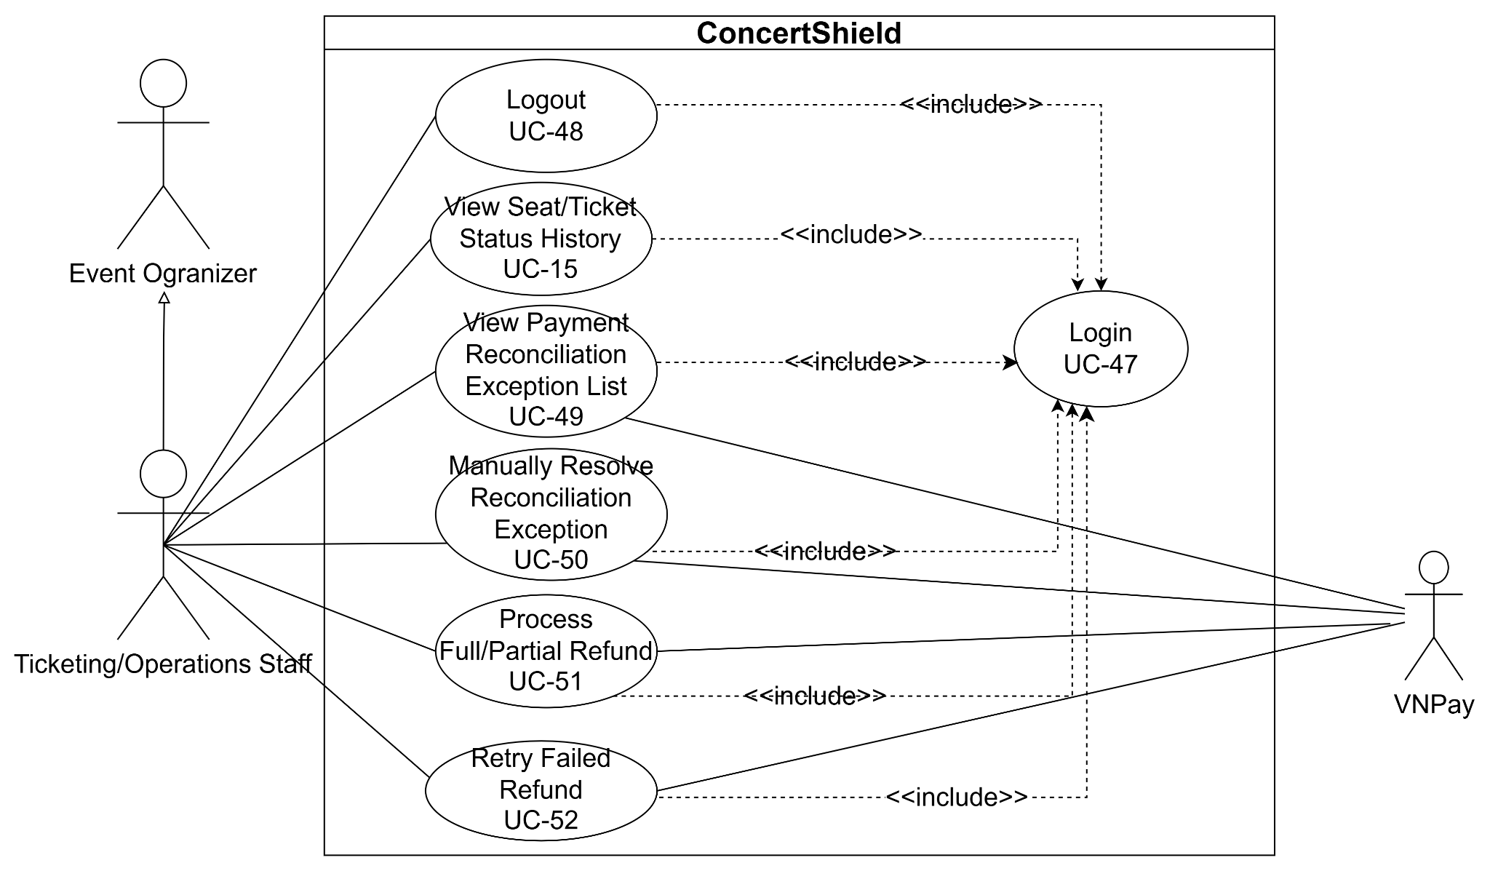
Figure 7. Ticketing/Operations Staff UC diagram

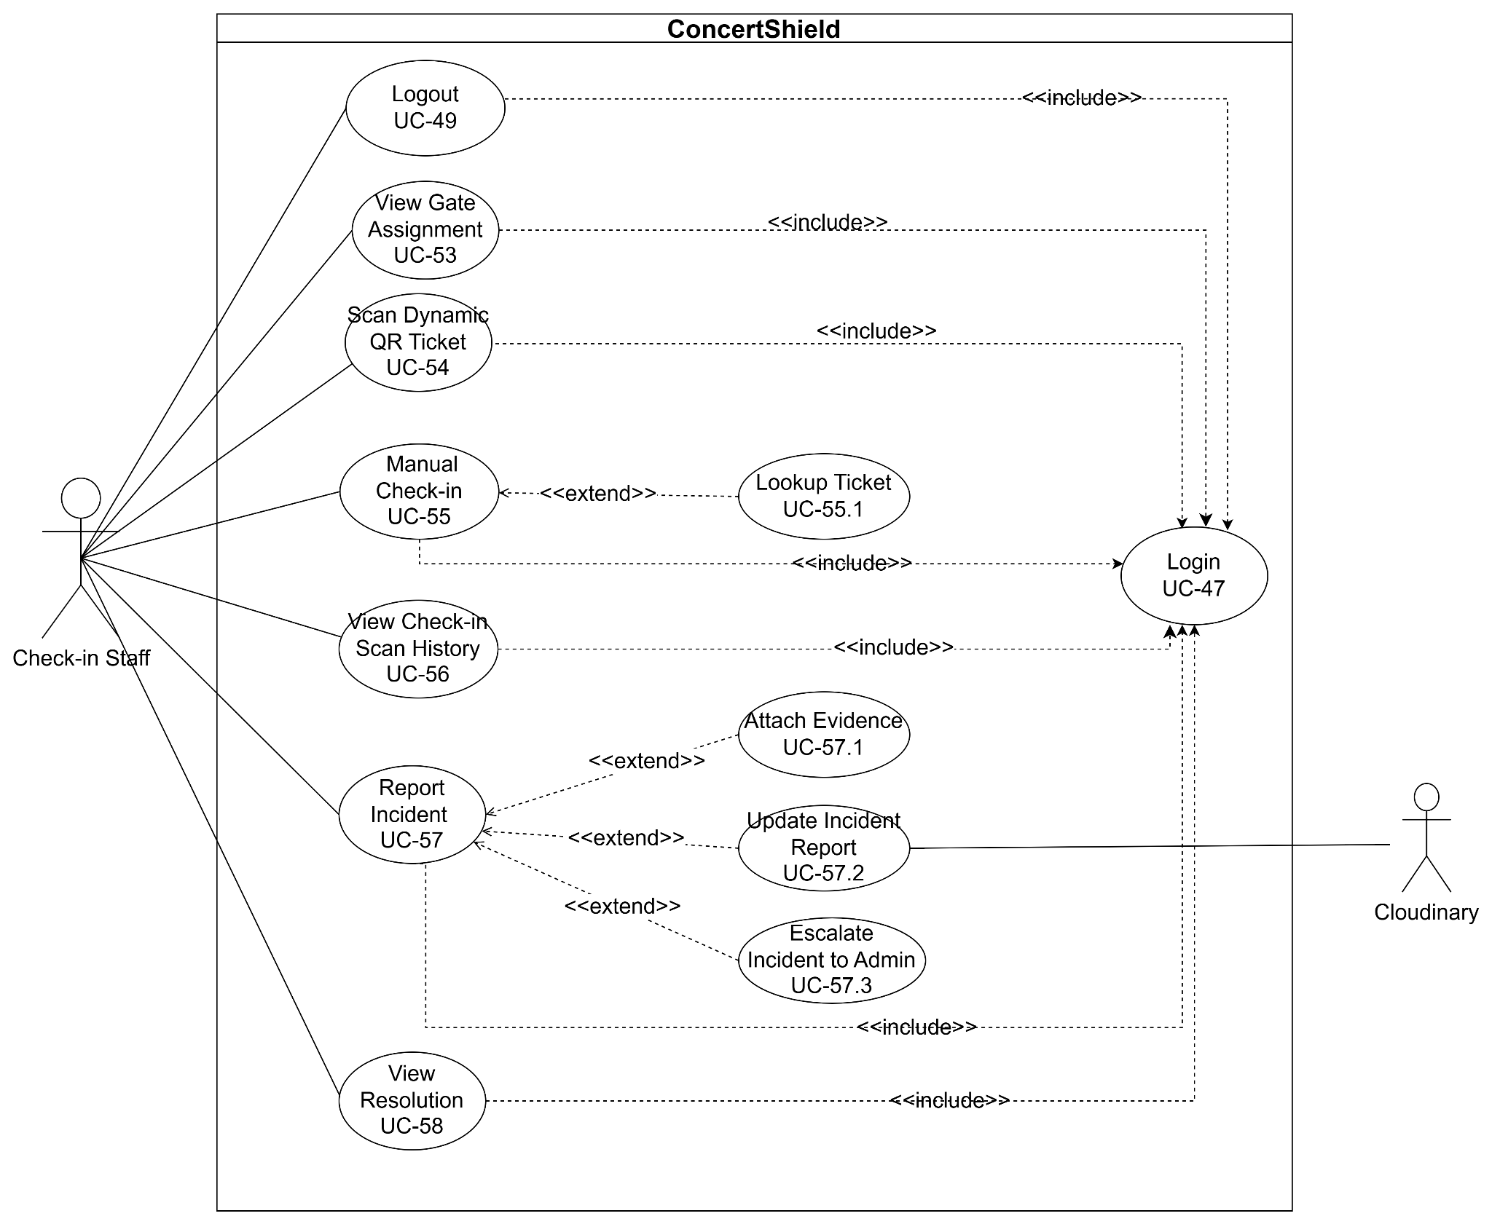
Figure 8. Check-in Staff UC diagram

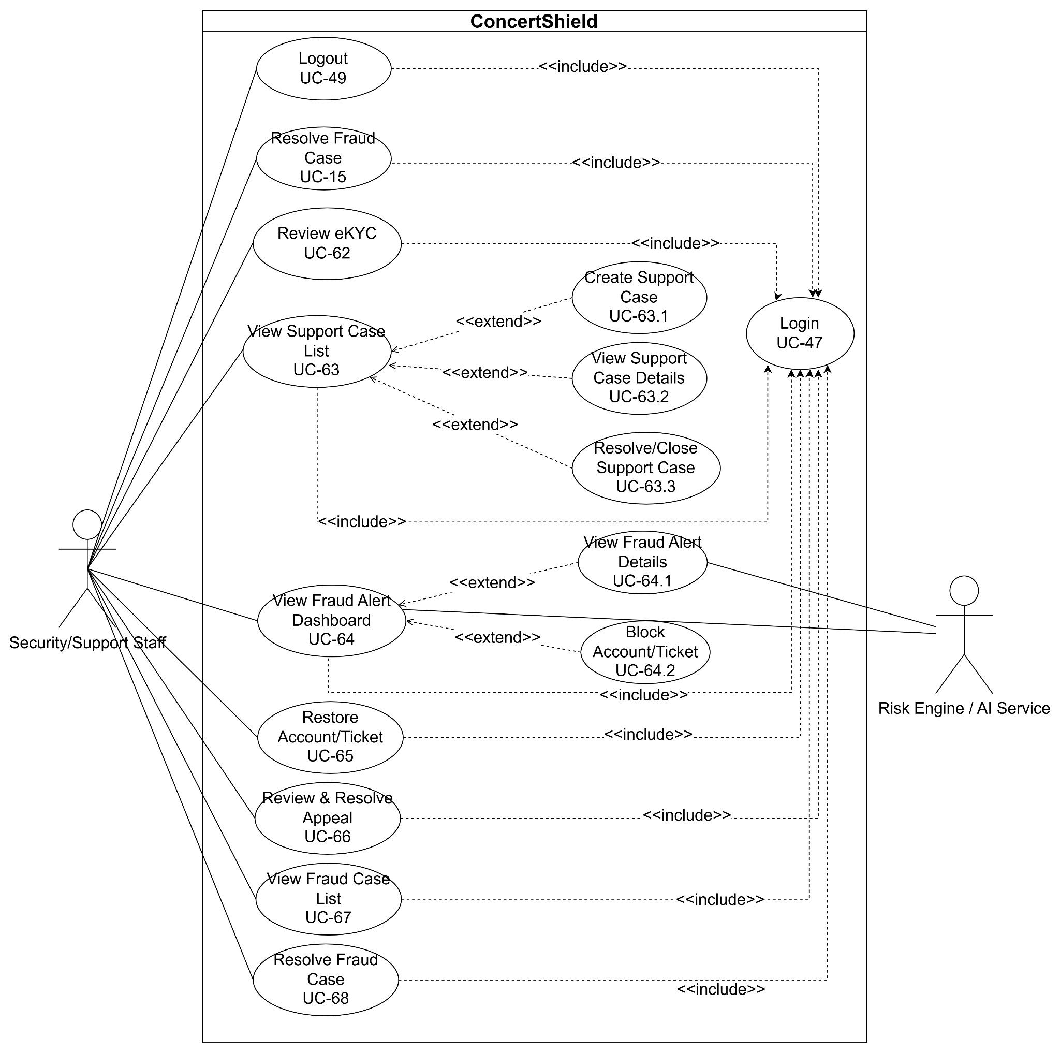
Figure 9. Security/Support Staff UC diagram

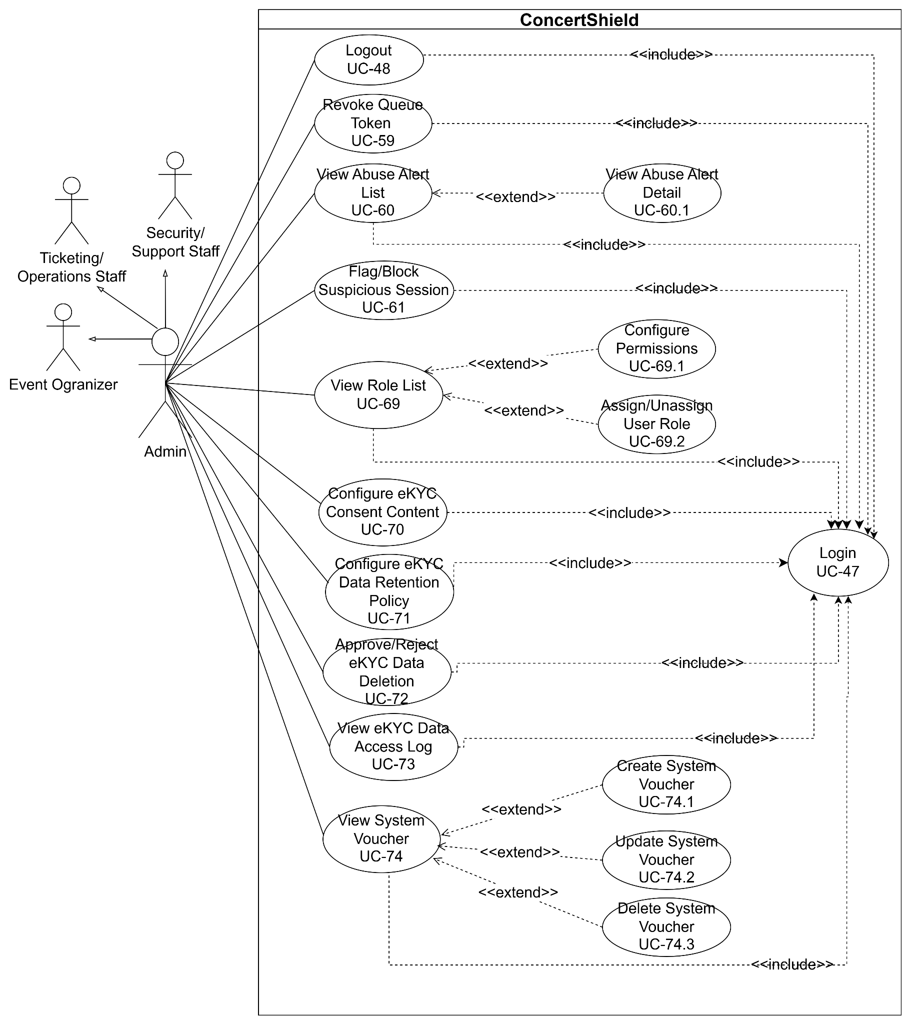
Figure 10. Admin UC diagram

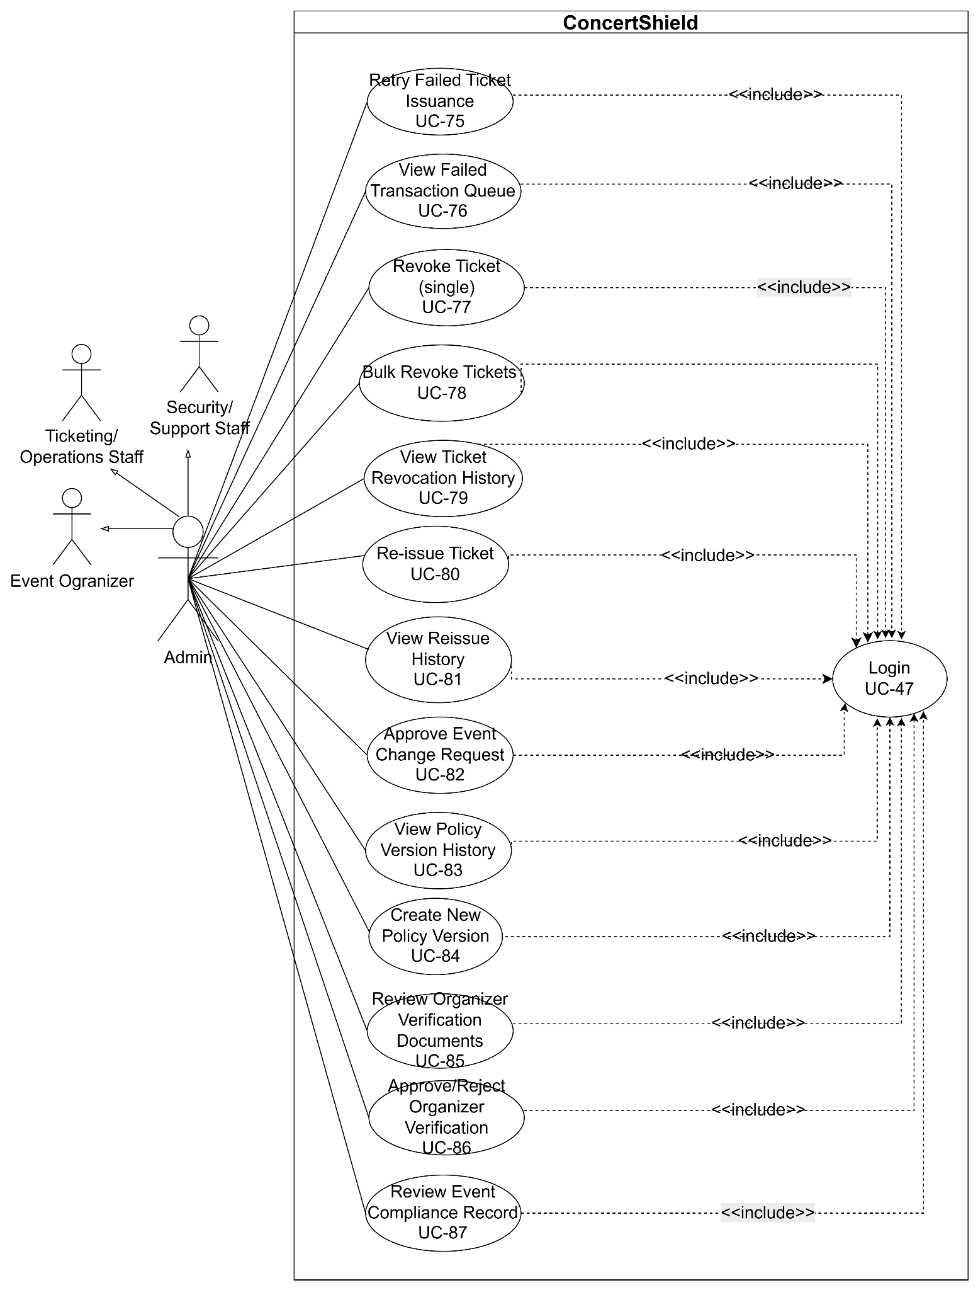
Figure 11. Admin UC diagram

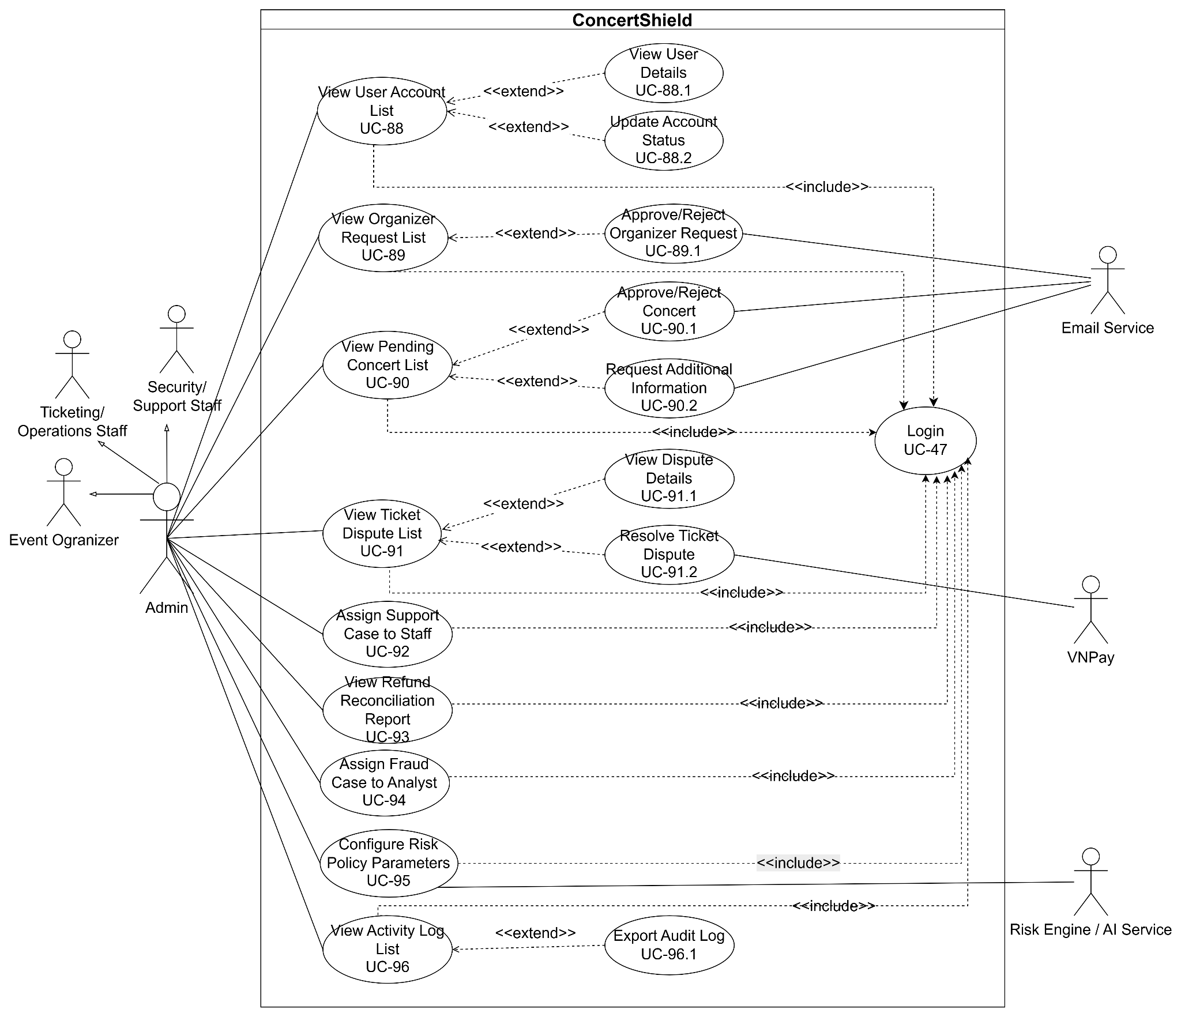
Figure 12. Admin UC diagram

2.2.2 Descriptions
This part describes the use cases for the ConcertShield System (CSS), following the standard table format as below:
ID | Use Case | Primary Actors | Secondary Actors | Use Case Description
UC-01 | Register | Guest | Email Service | Allows guests to create a new customer account using their email address, password, and personal details. The system sends an OTP verification code via email to confirm account ownership.
UC-01.1 | Verify Registration OTP | Guest | Email Service | Allows guests to enter the 6-digit one-time password (OTP) sent to their registered email to activate their account upon successful verification.
UC-02 | View Event List | Guest, Customer |  | Allows guests and customers to browse the catalog of music concerts, festivals, and live shows with pagination, displaying poster, title, date, venue, starting price, and sales status.
UC-02.1 | View Event Details | Guest, Customer |  | Allows guests and customers to view comprehensive event details, including event overview, performing artists, venue location, schedule, ticket tiers, seating chart preview, and return/refund policy.
UC-02.1.1 | View Event Review List | Guest, Customer |  | Allows guests and customers to view the visible reviews and ratings submitted for a specific event, including reviewer information, rating, comment, and review date.
UC-02.1.2 | Add Event Review | Customer |  | Allows a customer who has attended and successfully checked in to an event to submit one rating and comment for that event.
UC-02.1.3 | Edit Event Review | Customer |  | Allows customers to modify the rating or comment of a review they previously submitted. Only the original author may edit the review.
UC-02.1.4 | Delete Event Review | Customer |  | Allows customers to delete a review they previously submitted for an event. Only the original author may delete the review.
UC-02.2 | Add/Remove Wishlist | Customer |  | Allows customers to add a published event to their personal wishlist for later reference or remove a previously saved event. The same event cannot be added to the same customer's wishlist more than once.
UC-02.3 | View Wishlist | Customer |  | Allows customers to view the list of events they have previously saved to their personal wishlist.
UC-03 | Search Event | Guest, Customer |  | Allows guests and customers to search for concerts by keyword, artist name, music genre, event date range, city location, and ticket price range.
UC-04 | View Featured Events | Guest, Customer |  | Allows guests and customers to view spotlight banners and trending concerts highlighted by organizers and platform administrators on the homepage.
UC-05 | Login (Customer, Organizer) | Customer, Event Organizer |  | Allows registered customers and organizers to log in to the portal using their registered email and password credentials. The system issues stateless JWT tokens upon successful verification.
UC-05.1 | Login with Google (Customer) | Customer | Google OAuth Service | Allows customers to quickly sign in or register into the platform using their verified Google account credentials via Google OAuth 2.0 service.
UC-06 | Logout (Customer, Organizer) | Customer, Event Organizer |  | Allows logged-in customers and organizers to terminate their active web session securely, invalidating their refresh token in the database.
UC-07 | Forgot Password | Customer, Event Organizer | Email Service | Allows users who forgot their password to request a password reset by providing their registered email address. The system sends a verification OTP to the registered email address.
UC-08 | View Profile | Customer, Event Organizer |  | Allows authenticated users to view their account profile details, including full name, email, phone number, avatar, eKYC verification status, and role assignment.
UC-08.1 | Update Profile Details | Customer, Event Organizer | Cloudinary | Allows users to modify their personal contact details and upload an updated avatar image stored on Cloudinary.
UC-08.2 | Change Password | Customer, Event Organizer |  | Allows users to update their current password by providing the existing password and confirming a new password conforming to security complexity rules.
UC-09 | Request Organizer Account | Customer | Cloudinary | Allows customers to submit an application to upgrade their account to an Event Organizer, providing company information, organizer experience, website, and supporting business license documents.
UC-10 | Submit eKYC Verification | Customer | Third-party eKYC API | Allows customers to perform electronic Know-Your-Customer (eKYC) identity verification to authenticate their identity before purchasing high-demand concert tickets, mitigating scalper bot risks.
UC-11 | Request eKYC Data Deletion | Customer |  | Allows customers to request deletion of their stored eKYC data (identity images, extracted data, and biometric artifacts). The system processes the request according to the retention policy and notifies the customer of the outcome.
UC-12 | Register for Pre-Queue | Customer |  | Allows customers to register for an event's pre-queue during the configured window, so that admission order at sale start is determined fairly rather than by who connects first.
UC-13 | Join Virtual Queue | Customer |  | Allows customers to enter the First-In-First-Out (FIFO) virtual waiting room during high-demand concert ticket flash sales, throttling server traffic and preventing scalper bot raids.
UC-13.1 | View Real-time Queue Position | Customer |  | Allows customers in the virtual queue to view their live numeric position in line, total people ahead, and estimated wait time until admission.
UC-13.2 | Leave Virtual Queue | Customer |  | Allows customers to voluntarily exit the waiting room, releasing their assigned queue slot.
UC-14 | View Interactive Seating Chart | Customer |  | Allows customers admitted from the queue or accessing open sales to view the interactive 2D venue seating map with real-time seat availability statuses (Available, Held, Sold).
UC-14.1 | View Seat Details | Customer |  | Allows customers to inspect specific seat information upon hovering or clicking, including zone name, row label, seat number, ticket class, and unit price.
UC-14.2 | Select Seats | Customer |  | Allows customers to choose seats. The system executes a concurrency-safe temporary hold (10 minutes) on the selected seats to prevent double-booking.
UC-14.3 | Change Seat Selection | Customer |  | Allows customers to deselect held seats and pick alternate available seats before the hold countdown expires.
UC-15 | View Seat/Ticket Status History | Customer, Ticketing/Operations Staff, Platform Administrator |  | Allows customers (for their own tickets), Ticketing/Operations Staff, and platform administrators to view the chronological state changes of a seat or ticket (e.g., available, held, sold, released, returned, revoked, reissued, checked-in).
UC-16 | Checkout | Customer | Payment Gateway (VNPay) | Allows customers holding seats to proceed to the checkout screen, review ticket order summary, input attendee identification details, apply discount vouchers, and initialize payment.
UC-16.1 | Process VNPay Payment | Customer | Payment Gateway (VNPay) | Allows customers to complete payment through the VNPay gateway. The system validates the webhook callback and issues confirmed digital tickets.
UC-17 | Cancel Pending Order | Customer |  | Allows customers to cancel an order that is awaiting payment. The system releases the seat hold immediately and closes the order so that no pending order is left open.
UC-18 | View Order History | Customer |  | Allows customers to review their past ticket purchasing transactions, including order IDs, transaction dates, payment statuses, and total amounts paid, and to open specific order details.
UC-18.1 | View Order Details | Customer |  | Allows a logged-in Customer to view comprehensive details of a specific order, including event information, ticket statuses, payment summary, and buyer details, and to access the dynamic QR code for valid tickets.
UC-19 | View Ticket Wallet | Customer |  | Allows customers to access their digital ticket wallet displaying all active and past concert admission tickets with status indicators (Unused, Checked-in, Returned, Cancelled).
UC-20 | View Ticket Details | Customer |  | Allows customers to inspect full admission information of an individual ticket, including event schedule, venue gate, zone, seat designation, and attendee identity name.
UC-20.1 | Display Dynamic QR Code | Customer |  | Allows customers to display the anti-counterfeit dynamic QR code on screen. The system automatically refreshes the short-lived encrypted security token to prevent screenshot forwarding.
UC-21 | Submit Ticket Return Request | Customer |  | Allows customers to request returning an eligible ticket in compliance with the organizer's refund policy, releasing the ticket for controlled system re-issuance at original face value.
UC-21.1 | Track Ticket Return Status | Customer |  | Allows customers to track the progress of their return request (Pending Review, Re-issued to New Buyer, Refunded, or Rejected).
UC-21.2 | Cancel Ticket Return Request | Customer |  | Allows customers to withdraw a pending ticket return request prior to organizer or admin approval, restoring the ticket to active status.
UC-22 | View Risk Decision Details | Platform Administrator, Security/Support Staff, Customer (limited view) |  | Allows platform administrators and Security/Support Staff to view the risk level assigned to a session, account, or order and the reasons behind the resulting action. Customers can view a limited explanation of decisions affecting them.
UC-23 | Submit Appeal Request | Customer |  | Allows customers whose account or ticket was challenged or blocked to submit an appeal with supporting information.
UC-24 | View Notifications | Customer, Event Organizer |  | Allows users across all roles to view real-time in-app notifications (queue admission alerts, payment receipts, event schedule reminders, approval updates).
UC-24.1 | Mark Notification as Read | Customer, Event Organizer |  | Allows users to mark single or all received notification items as read.
UC-24.2 | Delete Notification | Customer, Event Organizer |  | Allows users to dismiss or remove notification entries from their notification tray.
UC-25 | Configure Pre-Queue Window | Platform Administrator |  | Allows platform administrators to define the pre-queue registration window for a high-demand event, including its opening and closing times before the sale starts.
UC-26 | Configure Admission Rate / Fairness Policy | Platform Administrator |  | Allows platform administrators to set the rate at which queued customers are admitted to the purchase step and the fairness rules applied when granting queue tokens.
UC-27 | Configure Purchase Limit per Event/Ticket Tier | Event Organizer |  | Allows event organizers to limit the number of tickets a single account may buy per event and per ticket tier in order to deter scalping.
UC-28 | Configure Seat Hold Timeout Policy | Event Organizer, Platform Administrator |  | Allows event organizers and platform administrators to configure how long selected seats remain held during checkout before being automatically released.
UC-29 | View Organizer Vouchers | Event Organizer |  | Allows organizers to view all discount promotional vouchers created for their concerts.
UC-29.1 | Create Organizer Voucher | Event Organizer |  | Allows organizers to issue event-specific discount codes, specifying discount percentage/amount, minimum order value, total usage cap, and validity duration.
UC-29.2 | View Voucher Usage Details | Event Organizer |  | Allows organizers to inspect detailed redemptions of a voucher code, tracking orders where discounts were applied.
UC-30 | Configure Re-entry Policy per Event | Event Organizer, Platform Administrator |  | Allows event organizers and platform administrators to define, per event, whether attendees may leave and re-enter the venue and under which conditions.
UC-31 | View Concert List | Event Organizer |  | Allows organizers to view all concert events created under their organization account, accompanied by lifecycle status badges (Draft, Pending, Published, Rejected, Cancelled).
UC-31.1 | View Concert Details | Event Organizer |  | Allows organizers to view detailed administrative specifications of a selected concert, including ticket sales metrics, seating layout overview, and assigned staff roster.
UC-31.2 | Edit Concert Information | Event Organizer | Cloudinary | Allows organizers to update concert title, description, category, schedule, venue address, and promotional banner images stored on Cloudinary for unapproved or draft events.
UC-31.3 | Submit Concert for Approval | Event Organizer |  | Allows organizers to submit a completed concert setup to the platform administration team for policy compliance review and sales authorization.
UC-31.4 | Delete Draft Concert | Event Organizer |  | Allows organizers to delete draft concert records that have not been submitted for approval and have no registered tickets.
UC-31.5 | Moderate Reviews | Event Organizer |  | Allows Event Organizers to review and moderate customer reviews submitted for concerts they own according to platform moderation rules.
UC-31.6 | Reply Review | Event Organizer |  | Allows Event Organizers to reply to customer reviews submitted for concerts they own.
UC-31.7 | Hide/Unhide Review | Event Organizer |  | Allows Event Organizers to hide or unhide customer reviews for concerts they own, subject to platform moderation rules.
UC-32 | Create Concert Event | Event Organizer | Cloudinary | Allows organizers to create a new concert event profile by defining general information, venue metadata, event dates, terms of admission, and media assets.
UC-33 | Cancel Event | Event Organizer, Platform Administrator |  | Allows event organizers and platform administrators to cancel a published concert, freezing ticket sales, notifying attendees automatically, and triggering ticket refund processing.
UC-34 | Postpone/  Reschedule Event | Event Organizer, Platform Administrator |  | Allows event organizers and platform administrators to postpone or reschedule a published event. The system freezes ticket sales, notifies affected customers, and triggers the refund/reissue process.
UC-35 | Submit Event Change Request | Event Organizer |  | Allows event organizers to submit a change request for an approved event (e.g., date, venue, lineup) with justification for administrator review.
UC-36 | View Affected Orders/Tickets by Change | Event Organizer, Platform Administrator |  | Allows event organizers and platform administrators to view the orders and tickets impacted by a postponement, cancellation, or other event change, so that refund and reissue progress can be tracked.
UC-37 | Submit Organizer Verification Documents | Event Organizer | Cloudinary | Allows event organizers to upload legal and business verification documents (stored on Cloudinary) to be verified by the platform before they can sell tickets.
UC-38 | Submit Event Compliance Documents | Event Organizer | Cloudinary | Allows event organizers to upload event permits and safety/compliance documents (stored on Cloudinary) for a specific event.
UC-39 | Build Seating Chart | Event Organizer |  | Allows organizers to construct an interactive venue seating chart using a visual builder, establishing stage placement, grandstands, rows, and individual seat coordinates.
UC-39.1 | Edit Seating Zone | Event Organizer |  | Allows organizers to configure zone boundaries, designate standing/seated areas, set row capacities, and link zones to specific ticket tiers.
UC-39.2 | Apply Seating Template | Event Organizer |  | Allows organizers to load and apply a standard pre-configured venue layout template (e.g., Stadium, Indoor Arena, Theater) to expedite seating setup.
UC-39.3 | Save Seating Chart as Template | Event Organizer |  | Allows organizers to save a customized seating layout into their reusable template library for future concerts.
UC-39.4 | Preview Seating Chart | Event Organizer |  | Allows organizers to preview the finalized seating layout in interactive buyer mode to inspect rendering and seat label accuracy.
UC-40 | Configure Ticket Types | Event Organizer |  | Allows organizers to establish ticket tiers (VIP, Early Bird, General Admission), quota limits, individual base prices, and purchase limits per account.
UC-40.1 | Configure Pricing Rule | Event Organizer |  | Allows organizers to define algorithmic pricing rules based on time triggers or inventory thresholds (e.g., automated price escalations as seats sell out).
UC-40.2 | Configure Refund Policy | Event Organizer |  | Allows organizers to specify return criteria, cutoff deadlines before showtime, refund percentages, and approval requirements for ticket returns.
UC-41 | View Revenue Dashboard | Event Organizer |  | Allows organizers to view real-time commercial analytics, including gross ticket sales, net revenue, ticket inventory velocity, and sales conversion rates.
UC-41.1 | Filter Revenue Dashboard | Event Organizer |  | Allows organizers to refine financial charts by custom date intervals, ticket tiers, payment channels, or individual showtimes.
UC-41.2 | Export Revenue Report | Event Organizer |  | Allows organizers to download sales ledger reports and financial settlement summaries in Excel (.xlsx) or CSV format.
UC-41.3 | View Concert Order List | Event Organizer |  | Allows organizers to view, search, and monitor all customer purchase orders placed for their concert, displaying buyer names, seat numbers, amounts paid, and payment statuses.
UC-42 | Monitor Real-time Check-in Status | Event Organizer |  | Allows organizers to supervise attendee admission flows in real time, displaying scan rates, total attendees checked in versus tickets sold, and hourly gate throughput.
UC-42.1 | Export Check-in Report | Event Organizer |  | Allows organizers to download audit logs of admissions and gate reconciliation reports.
UC-43 | View Staff List | Event Organizer |  | Allows organizers to view all on-site gate staff members assigned to their concert event along with their operational roles and gate assignments.
UC-43.1 | Assign/Unassigned Staff | Event Organizer |  | Allows organizers to allocate an authorized staff account to a designated admission gate and grant validation credentials for the event.
UC-44 | Enable Offline Check-in Mode | Event Organizer, Platform Administrator, Check-in Staff |  | Allows event organizers, platform administrators, and Check-in Staff to enable offline check-in for an event or gate, so that scanning continues locally when the venue network is unavailable.
UC-45 | Sync Offline Check-in Records | Event Organizer, Platform Administrator, Check-in Staff |  | Allows event organizers, platform administrators, and Check-in Staff to upload check-in records captured offline once connectivity is restored, so that each ticket is counted exactly once.
UC-46 | Resolve Offline Sync Conflicts | Event Organizer, Platform Administrator, Check-in Staff |  | Allows event organizers, platform administrators, and Check-in Staff to resolve conflicts detected during offline synchronization, such as the same ticket being checked in on multiple devices.
UC-47 | Login (Staff, Admin) | Event Manager, Ticketing/Operations Staff, Check-in Staff, Security/Support Staff, Platform Administrator |  | Allows internal users (Event Manager, Ticketing/Operations Staff, Check-in Staff, Security/Support Staff and Platform Administrator) to log in to the operations portal or using their assigned credentials. The system issues role-scoped access tokens upon successful verification.
UC-48 | Logout (Staff, Admin) | Event Manager, Ticketing/Operations Staff, Check-in Staff, Security/Support Staff, Platform Administrator |  | Allows internal users to log out of the operations portal securely upon completing their shift or administrative session, revoking their session tokens.
UC-49 | View Payment Reconciliation Exception List | Platform Administrator, Ticketing/Operations Staff | Payment Gateway (VNPay) | Allows platform administrators and Ticketing/Operations Staff to review payments whose ConcertShield order status does not match the payment gateway (VNPay) records, such as paid-without-ticket, duplicate, or late callbacks.
UC-50 | Manually Resolve Reconciliation Exception | Platform Administrator, Ticketing/Operations Staff | Payment Gateway (VNPay) | Allows platform administrators and Ticketing/Operations Staff to resolve a reconciliation exception by confirming, correcting, or refunding the transaction. The resolution and its reason are recorded.
UC-51 | Process Full/Partial Refund | Platform Administrator, Ticketing/Operations Staff | Payment Gateway (VNPay) | Allows platform administrators and Ticketing/Operations Staff to process a full or partial refund for an order or ticket through the payment gateway (VNPay), according to the refund policy version applicable at purchase time.
UC-52 | Retry Failed Refund | Platform Administrator, Ticketing/Operations Staff | Payment Gateway (VNPay) | Allows platform administrators and Ticketing/Operations Staff to retry a refund that failed at the payment gateway (VNPay) without creating a duplicate refund.
UC-53 | View Gate Assignment | Check-in Staff |  | Allows check-in staff to view their assigned concert event, gate identifier, validator role permissions, and active operational hours.
UC-54 | Scan Dynamic QR Ticket | Check-in Staff |  | Allows staff to scan attendee dynamic QR codes via device camera or optical scanner. The system performs instantaneous cryptographic validation and records admission.
UC-55 | Manual Check-in | Check-in Staff |  | Allows staff to process ticket validation manually when an attendee's screen is damaged or unreadable.
UC-55.1 | Lookup Ticket | Check-in Staff |  | Allows staff to search for valid tickets using the attendee's phone number or verified eKYC CCCD identity number.
UC-56 | View Check-in Scan History | Check-in Staff |  | Allows staff to inspect the real-time chronological log of tickets scanned at their gate station (Approved, Already Used, Wrong Gate, Invalid).
UC-57 | Report On-site Incident | Check-in Staff | Cloudinary | Allows staff to file an immediate incident log at the gate (e.g., duplicate ticket presentation, lost ticket claims, fraudulent scalper activity).
UC-57.1 | Attach Evidence | Check-in Staff | Cloudinary | Allows staff to upload photographic evidence or scanned documents to Cloudinary as part of an incident report.
UC-57.2 | Update Incident Report | Check-in Staff |  | Allows staff to append progress notes or on-site resolution outcomes to an open incident report.
UC-57.3 | Escalate Incident to Admin | Check-in Staff |  | Allows staff to escalate complex disputes or detected counterfeiting syndicates to platform administrators for urgent resolution.
UC-58 | View Resolution | Check-in Staff |  | Allows staff to check directives and resolution instructions returned by organizers or admins for open incident tickets.
UC-59 | Revoke Queue Token | Platform Administrator |  | Allows platform administrators to manually revoke a queue token issued to an account or session found to be abusing admission, removing it from the purchase flow.
UC-60 | View Abuse Alert List | Platform Administrator |  | Allows platform administrators and Security/Support Staff to browse alerts generated by suspicious queue and purchase behavior, filtered by event, severity, and status.
UC-60.1 | View Abuse Alert Details | Platform Administrator |  | Allows platform administrators to inspect a single abuse alert, including the involved accounts, sessions, IP/device signals, and the timeline of actions.
UC-61 | Flag/Block Suspicious Session | Platform Administrator |  | Allows platform administrators to flag a suspicious session for monitoring or block it from queueing and purchasing. The action is recorded in the audit log.
UC-62 | Review eKYC | Platform Administrator, Security/Support Staff |  | Allows platform administrators and Security/Support Staff to manually review flagged or ambiguous eKYC submissions where the automated match result falls within borderline thresholds.
UC-63 | View Support Case List | Security/Support Staff, Platform Administrator |  | Allows Security/Support Staff and platform administrators to browse and filter support cases by status, priority, and assignee.
UC-63.1 | Create Support Case | Security/Support Staff, Platform Administrator |  | Allows Security/Support Staff and platform administrators to open a support case for a customer issue, linked to the related order, ticket, and payment.
UC-63.2 | View Support Case Details | Security/Support Staff, Platform Administrator |  | Allows Security/Support Staff and platform administrators to view a support case in full, including the linked order/ticket/payment, message history, and handling notes.
UC-63.3 | Resolve/Close Support Case | Security/Support Staff |  | Allows Security/Support Staff to record the resolution of an assigned support case and close it, notifying the customer of the outcome.
UC-64 | View Fraud Alert Dashboard | Platform Administrator, Security/Support Staff | Risk Engine | Allows platform administrators and Security/Support Staff to monitor real-time fraud indicators, risk score distributions, and bot/scalper detection feeds produced by the Risk Engine.
UC-64.1 | View Fraud Alert Details | Platform Administrator, Security/Support Staff | Risk Engine | Allows platform administrators and Security/Support Staff to examine a specific fraud alert, including IP velocity, device fingerprints, risk score, and affected account or ticket IDs.
UC-64.2 | Block Account/Ticket | Platform Administrator, Security/Support Staff |  | Allows platform administrators and Security/Support Staff to block an account or ticket flagged as fraudulent. The action is recorded in the audit log.
UC-65 | Restore Account/Ticket | Platform Administrator, Security/Support Staff |  | Allows platform administrators and Security/Support Staff to restore a previously blocked account or ticket after review or a successful appeal.
UC-66 | Review & Resolve Appeal | Platform Administrator, Security/Support Staff |  | Allows platform administrators and Security/Support Staff to review an appeal and resolve it by upholding or reversing the original decision, notifying the customer of the result.
UC-67 | View Fraud Case List | Platform Administrator, Security/Support Staff |  | Allows platform administrators and Security/Support Staff to browse fraud cases with filtering by status, severity, and assignee.
UC-68 | Resolve Fraud Case | Platform Administrator, Security/Support Staff |  | Allows platform administrators and Security/Support Staff to record the investigation outcome of a fraud case and close it.
UC-69 | View Role List | Platform Administrator |  | Allows platform administrators to inspect the system roles (Customer, Event Organizer, Event Manager, Ticketing/Operations Staff, Check-in Staff, Security/Support Staff, Platform Administrator) and their functional privilege scopes.
UC-69.1 | Configure Permissions | Platform Administrator |  | Allows administrators to fine-tune granular access control permissions assigned to each system role across platform endpoints and screens.
UC-69.2 | Assign/Unassign User Role | Platform Administrator |  | Allows administrators to assign or remove authorized roles for user accounts according to platform access policies.
UC-70 | Configure eKYC Consent Content | Platform Administrator |  | Allows administrators to create and update the consent clause content presented to customers before they submit eKYC data. Each published version is retained so that consent can be traced to the wording the customer accepted.
UC-71 | Configure eKYC Data Retention Policy | Platform Administrator |  | Allows administrators to define how long eKYC images, extracted identity data, and AI artifacts are retained before they must be purged.
UC-72 | Approve/Reject eKYC Data Deletion | Platform Administrator |  | Allows Platform Administrators to review an eKYC data deletion request submitted by a user and approve or reject the request. The system records the decision and processes the deletion according to the applicable eKYC data retention policy when approved.
UC-73 | View eKYC Data Access Log | Platform Administrator |  | Allows administrators to review the log of who accessed eKYC data, when, and for what purpose, supporting privacy compliance and audit.
UC-74 | View System Voucher | Platform Administrator |  | Allows administrators to browse platform-sponsored promotional discount campaigns and voucher codes.
UC-74.1 | Create System Voucher | Platform Administrator |  | Allows administrators to configure new platform-wide vouchers, setting global budgets, discount caps, and event eligibility.
UC-74.2 | Update System Voucher | Platform Administrator |  | Allows administrators to pause, activate, or terminate promotional voucher campaigns early.
UC-74.3 | Delete System Voucher | Platform Administrator |  | Allows administrators to remove a platform-wide voucher campaign from active circulation. The system performs a soft delete (marking the voucher as deleted and recording who and when), preserving historical usage records for orders that already applied the voucher.
UC-75 | Retry Failed Ticket Issuance | Platform Administrator |  | Allows platform administrators to re-run ticket issuance for paid orders whose issuance failed, ensuring that no duplicate tickets are created.
UC-76 | View Failed Transaction Queue | Platform Administrator |  | Allows platform administrators to view transactions that failed at ticket issuance or processing and are waiting for retry or manual handling.
UC-77 | Revoke Ticket (single) | Platform Administrator |  | Allows platform administrators to immediately invalidate a single ticket (e.g., due to fraud, return, or reissue) so that its QR code can no longer be used for check-in.
UC-78 | Bulk Revoke Tickets (event change) | Platform Administrator |  | Allows platform administrators to invalidate all tickets affected by an event-level change, such as cancellation or postponement, in one controlled operation with a reconciliation record.
UC-79 | View Ticket Revocation History | Platform Administrator |  | Allows platform administrators to review the history of revoked tickets, including who revoked them, when, and why.
UC-80 | Re-issue Ticket | Platform Administrator |  | Allows platform administrators to issue a replacement ticket for an existing order or returned ticket. The old ticket is revoked immediately and a new QR identity is generated.
UC-81 | View Reissue History | Platform Administrator |  | Allows platform administrators to view the history of reissued tickets, linking each old ticket to its replacement together with the reason and the acting user.
UC-82 | Approve Event Change Request | Platform Administrator |  | Allows platform administrators to review and approve or reject an event change request. On approval the change is applied and affected customers are notified.
UC-83 | View Policy Version History (Price/Refund/Queue/Risk) | Platform Administrator |  | Allows platform administrators to view all versions of the price, refund, queue, and risk policies with effective dates and authors, so that any transaction can be traced to the policy version that applied to it.
UC-84 | Create New Policy Version | Platform Administrator |  | Allows platform administrators to publish a new version of a policy without affecting transactions made under earlier versions.
UC-85 | Review Organizer Verification Documents | Platform Administrator |  | Allows platform administrators to inspect the verification documents submitted by an organizer and record review notes.
UC-86 | Approve/Reject Organizer Verification | Platform Administrator | Email Service | Allows platform administrators to approve or reject an organizer's verification. The result is sent to the organizer by email.
UC-87 | Review Event Compliance Record | Platform Administrator |  | Allows platform administrators to review an event's compliance documents and record the compliance status required before sales can open.
UC-88 | View User Account List | Platform Administrator |  | Allows administrators to browse and search all user accounts registered across the platform with filtering by role, status, and verification level.
UC-88.1 | View User Account Details | Platform Administrator |  | Allows administrators to inspect comprehensive user profiles, eKYC submission records, order transaction history, and associated risk flags.
UC-88.2 | Update Account Status | Platform Administrator |  | Allows platform administrators to ban, suspend, or activate user accounts that violate platform terms of service.
UC-89 | View Organizer Request List | Platform Administrator |  | Allows administrators to review pending applications submitted by customers seeking upgrade to organizer accounts.
UC-89.1 | Approve/Reject Organizer Request | Platform Administrator | Email Service | Allows administrators to approve verified applications, automatically upgrading the account role to Organizer and emailing notification credentials.
UC-90 | View Pending Concert List | Platform Administrator |  | Allows administrators to inspect concerts submitted by organizers awaiting official platform approval before going on sale.
UC-90.1 | Approve/Reject Concert | Platform Administrator | Email Service | Allows administrators to approve a compliant concert, transitioning its lifecycle status to Approved and permitting ticket sales.
UC–90.2 | Request Additional Information | Platform Administrator | Email Service
UC-91 | View Ticket Dispute List | Platform Administrator |  | Allows administrators to monitor formal disputes arising from ticket returns, failed check-ins, or unauthorized resale reports.
UC-91.1 | View Dispute Details | Platform Administrator |  | Allows administrators to review evidence, payment records, eKYC credentials, and statements from all involved parties.
UC-91.2 | Resolve Ticket Dispute | Platform Administrator | Payment Gateway (VNPay) | Allows administrators to execute a binding dispute judgment, authorizing full/partial refund via VNPay or reissuing valid admission tickets.
UC-92 | Assign Support Case to Staff | Platform Administrator |  | Allows platform administrators to assign a support case to a Security/Support Staff member for handling.
UC-93 | View Refund Reconciliation Report | Platform Administrator |  | Allows platform administrators to view the refund reconciliation report comparing refunds requested in ConcertShield against those confirmed by the payment gateway, highlighting mismatches.
UC-94 | Assign Fraud Case to Analyst | Platform Administrator |  | Allows platform administrators to assign a fraud case to an analyst for investigation.
UC-95 | Configure Risk Policy Parameters | Platform Administrator | Risk Engine | Allows platform administrators to adjust risk scoring weights, thresholds, and rate limits that determine risk levels and trigger step-up actions such as mandatory eKYC or challenge.
UC-96 | View Activity Log List | Platform Administrator |  | Allows administrators to view immutable system audit trail logs capturing administrative actions, critical data alterations, and security events.
UC-96.1 | Export Audit Log | Platform Administrator |  | Allows administrators to export filtered audit trail records to encrypted file archives for compliance inspection.

2.3 Authentication & Account Management

1. Register function

UC ID and Name: | UC-01 Register
Created By: | TanMN | Date Created: | 15/9/2026
Primary Actor: | Customer, Staff, Event Organizer, Admin | Secondary Actors: | Email Service
Trigger: | The user clicks the "Register" link/button.
Description: | This use case describes how a new user registers a local account on the ConcertShield platform using full name, email, phone number, and password. On success, the system does not create the account immediately; instead it temporarily caches the registration data and sends an OTP code to the user's email for verification
Preconditions: | PRE-1: The user does not yet have an account with the given email.
Post-conditions: | POST-1: On success, the system caches the pending registration data (with password hashed) for 5 minutes, sends an OTP to the user's email, and returns a success message. No user account is created yet.  POST-2: On failure (duplicate email), no data is cached, no email is sent, and the system logs a warning.  POST-3: If the OTP is not verified within 5 minutes, the pending registration expires and the user must register again.
Normal Flow: | A. Successful registration request  - The user goes to the registration page.  - The user enters full name, email, phone number, and password.  - The system checks whether an account already exists with that email.  - The system generates an OTP code.  - The system hashes the password (BCrypt).  - The system stores the pending registration (full name, email, phone, password hash, OTP, expiry = now + 5 minutes) in cache, keyed by email.  - The system sends the OTP code to the user's email.  - The system returns success: "Registration successful. Please check your email for the verification OTP code."  - The user proceeds to UC-02 Verify OTP to complete account creation.
Alternative Flows: | A.3 – Email already registered  - Occurs at step A.3 (checking for existing account).  - The system logs a warning ("Registration failed: email already exists").  - The system returns 400 Bad Request: "Email already exists."  - The user may return to step A.2 with a different email, or use "Forgot Password" if the account is theirs.
Exceptions: | EX01: Unexpected system error  - Can occur at any step (e.g. cache failure, email service failure).  - The system logs the error, including the attempted email.  - The system returns 500 Internal Server Error: "An unexpected error occurred while processing your registration. Please try again later."  - No pending registration is left in an inconsistent state.
Priority: | High (Medium, Low)
Frequency of Use: | Daily – All internal users must log in to access system functions.
Business Rules: | BR-18, BR-19, BR-24, BR-25
Other Information: | N/A
Assumptions: | N/A

2. Verify Registration OTP function

UC ID and Name: | UC-1.1 Verify Registration OTP
Created By: | TanMN | Date Created: | 15/9/2026
Primary Actor: | Customer, Staff, Event Organizer, Admin | Secondary Actors: | N/A
Trigger: | The user enters the OTP code received by email and submits the verification form, immediately after completing UC-01 Register.
Description: | This use case describes how a user verifies the OTP code sent to their email to complete account creation on the ConcertShield platform. On success, the system creates the permanent user account from the cached pending registration data, assigns the default role, activates the account, and clears the pending registration.
Preconditions: | PRE-1: A pending registration exists in cache for the given email
Post-conditions: | POST-1: On success, the system creates a new User record (IsVerified = true, IsActive = true, AuthProvider = "local", HasPassword = true), assigns the default role, removes the pending registration from cache, and logs the account creation.  POST-2: On failure (no pending registration, wrong OTP, expired OTP, missing default role), no user account is created; the system logs a warning or error and the pending registration is left unchanged, except that an expired OTP also removes the pending registration from cache.
Normal Flow: | A. Successful email verification  - The user enters their email and the OTP code on the verification page.  - The system looks up the pending registration in cache by email.  - The system checks the submitted OTP against the cached OTP.  - The system checks that the cached pending registration has not expired.  - The system retrieves the default role from the database.  - The system creates a new User record from the pending registration data (full name, email, phone, password hash), marked as verified and active.  - The system saves the new user to the database.  - The system assigns the default role to the new user (UserRole record).  - The system removes the pending registration from cache.  - The system returns success: "Email verified successfully. Your account has been activated."
Alternative Flows: | A.2 – No pending registration found  - Occurs at step A.2 (cache lookup).  - The system logs a warning ("no pending registration for {Email}").  - The system returns 404 Not Found: "No pending registration found for this email. Please register again."  - The user must restart from UC-01 Register.  A.3 – Invalid OTP  - Occurs at step A.3 (OTP comparison).  - The system increments the wrong-attempt counter for that pending registration by 1.  - If the wrong-attempt count is less than 5:  - The system logs a warning ("invalid OTP for {Email}, attempt {n}/5").  - The system returns 400 Bad Request: "Invalid OTP. You have {5-n} attempt(s) remaining."  - The pending registration remains in cache; the user may retry step A.1 until it expires or the attempt limit is reached.  - If the wrong-attempt count reaches 5 (the 5th wrong entry):  - The system removes the pending registration from cache.  - The system logs a warning ("registration cancelled after 5 failed OTP attempts for {Email}").  - The system returns 400 Bad Request: "Too many incorrect attempts. Your registration has been cancelled. Please register again."  - The user must restart from UC-01 Register.  A.4 – OTP expired  - Occurs at step A.4 (expiry check).  - The system removes the pending registration from cache.  - The system logs a warning ("OTP expired for {Email}").  - The system returns 400 Bad Request: "OTP has expired. Please register again."  - The user must restart from UC-01 Register.  A.5 – Default role not seeded  - Occurs at step A.5 (role lookup).  - The system returns 400 Bad Request with a configuration error message (default role missing in database).  - No user account is created; this indicates a system setup issue, not a user error.  A.6 – A new registration request replaces the pending one during verification  - Can occur at any point before the user completes verification, if the user (or someone using the same email) submits UC-01 Register again for the same email.  - Per BR-21, the old pending registration (including its old OTP and wrong-attempt count) is fully replaced by the new pending registration (new OTP, wrong-attempt count reset to 0, new 5-minute expiry).  - If the user then submits the old OTP for verification, the system treats it as an invalid OTP and follows the A.3 flow.
Exceptions: | EX01: Unexpected system error  - Can occur at any step (e.g. database failure while saving user or role).  - The system logs the error, including the attempted email.  - The system returns 500 Internal Server Error: "An unexpected error occurred while verifying your email. Please try again later."  - No partial user account is left in the database (user creation and role assignment should be treated as a single unit of work).
Priority: | High
Frequency of Use: | Medium — once per new user, immediately following UC-01 Register
Business Rules: | BR-19, BR-20, BR-21, BR-22, BR-23,BR-24
Other Information: | - The account is only created at this step, not during UC-01 Register; UC-01 only stages the data in cache.  - OTP and pending registration share the same 5-minute expiry set during UC-01.
Assumptions: | A default role (e.g. "Customer") must already be seeded in the database for account creation to succeed.

3. Login function

UC ID and Name: | UC-05 Login
Created By: | TanMN | Date Created: | 13/9/2026
Primary Actor: | Customer, Staff, Event Organizer, Admin | Secondary Actors: | N/A
Trigger: | 1. The user clicks the "Login" link/button.  2. The user attempts to access a feature that requires authentication (e.g. booking, event management, check-in scanning) while not logged in, and the system redirects to the login page.
Description: | This use case describes how a user (Customer, Staff, Event Organizer, Admin) authenticates their identity with the ConcertShield platform using an email/password (local account). On success, the system issues an Access Token and Refresh Token and redirects the user to the home page appropriate to their role.
Preconditions: | PRE-1: The user already has an account in the system (registered via email).  PRE-2: The account has been verified (IsVerified = true).  PRE-3: The account has not been locked/banned (IsActive = true).
Post-conditions: | POST-1: On success, the system generates an Access Token and Refresh Token, stores the Refresh Token, logs the session, and redirects the user to the role-appropriate home page.  POST-2: On failure (wrong password / non-existent email), no session is created; the system logs a warning and the account status is unchanged.  POST-3: If the account is locked, or flagged by AI Risk Scoring as suspicious, the system rejects the login and, where applicable, notifies the Admin dashboard.
Normal Flow: | A. Successful login with a system account  - The user goes to the login page.  - The user enters their email and password.  - The system validates the input data (email format, password not empty).  - The AI System screens the login attempt for bot/automated behavior (rate, device, pattern).  - The system looks up the account by email and checks that it is verified, not locked, and has a local password set.  - The system compares the entered password against the stored hashed password.  - If login succeeds, the system generates an Access Token and Refresh Token and redirects to the home page appropriate to the user's role (Customer, Staff, Event Organizer, Admin).  B. Login with Google  - The user clicks "Sign in with Google".  - The system redirects to Google's authentication page.  - The user authenticates and grants access on Google.  - The system receives the authenticated identity (token/email) from Google.  - If the email does not exist, the system creates a new account (AuthProvider = "Google", HasPassword = false); otherwise it uses the existing account.  - The system generates tokens and redirects to the home page (rejoins step A.7).
Alternative Flows: | A.3 Invalid data  - The system displays an error message (invalid email format or missing required field).  - Return to step A.2.  A.4 Account does not exist  - Occurs during step A.5.  - System returns 401 Unauthorized: "Invalid email or password." (does not reveal whether the account exists).  A.5 Local-password login attempted on a Google-registered account  - The system displays: "This account was created with Google Sign-In. Please log in with Google, or use 'Forgot Password' to set a password."  - Return to step A.2, or switch to flow B.  B.3 User denies permission or cancels Google authentication  - Occurs during step B.3.  - The user clicks "Cancel/Deny" or closes the Google authentication window.  - The system returns to the login page and displays: "Google sign-in was cancelled. Please try again or log in with your email and password."  - Return to step A.2, or the user selects "Sign in with Google" again (step B.1).  B.4 Google authentication fails or token is invalid  - Occurs during step B.4.  - The system receives no token/identity from Google, or the token is invalid (bad signature, expired, wrong Client ID/audience, wrong issuer), or the Google service returns an error or times out.  - The system returns 401 Unauthorized (or 502/503 if the failure is on Google's side) and displays: "Unable to sign in with Google. Please try again later."  - The system logs the error for monitoring.  - Return to step B.1, or switch to flow A.
Exceptions: | EX01: Unexpected system error  - Can occur at any step.  - System logs the error .  - System returns 500 Internal Server Error: "An unexpected error occurred while logging in. Please try again later." No partial state is persisted.
Priority: | High (Medium, Low)
Frequency of Use: | Daily – All internal users must log in to access system functions.
Business Rules: | BR-26, BR-27,BR-29,BR-30, BR-31, BR-32.
Other Information: | N/A
Assumptions: | N/A

4. Logout function

UC ID and Name: | UC-06 Logout
Created By: | TanMN | Date Created: | 15/9/2026
Primary Actor: | Customer, Staff, Event Organizer, Admin | Secondary Actors: | N/A
Trigger: | - The user clicks the "Logout" link/button.  - The Access Token and Refresh Token both expire or are revoked, and the system forces the session to end on the next authenticated request.
Description: | This use case describes how an authenticated user ends their session on the ConcertShield platform. On success, the system invalidates the current Refresh Token, clears the session, and redirects the user to the home page
Preconditions: | PRE-1: The user is currently logged in with a valid Access Token and Refresh Token.
Post-conditions: | POST-1: On success, the system revokes/invalidates the Refresh Token, ends the session, logs the logout event, and redirects the user to the login page.  POST-2: On failure, the system logs a warning; the client-side session is cleared regardless to avoid a stuck logged-in state.
Normal Flow: | A. Successful logout  - The user clicks "Logout".  - The system identifies the current session from the Access Token/Refresh Token.  - The system revokes the Refresh Token (removes it or marks it invalid in storage).  - The system clears session data on the server side (e.g. active session record).  - The system instructs the client to discard the Access Token and Refresh Token  - The system logs the logout event (user, timestamp, device/IP).  - The system redirects the user to the login page.
Alternative Flows: | A.3 Refresh Token already invalid or not found  - Occurs at step A.3 (revoking the Refresh Token).  - The system treats the session as already ended; no error is shown to the user.  - Proceed to step A.5.  A.2 Access Token expired at logout time  - Occurs at step A.2 (identifying the session).  - The system uses the Refresh Token alone to identify and revoke the session, since the Access Token is no longer valid.  - Proceed to step A.3
Exceptions: | EX01: Unexpected system error  - Can occur at any step.  - The system logs the error.  - The system still clears the client-side session/tokens to prevent the user from appearing logged in.  - The system returns 500 Internal Server Error: "An unexpected error occurred while logging out. Please try again later."
Priority: | High
Frequency of Use: | Daily – Every logged-in user ends sessions this way.
Business Rules: | None
Other Information: | N/A
Assumptions: | N/A

5. Forgot Password function

ID and Name: | UC-07 Forgot Password
Created By: | TanMN | Date Created: | 15/09/2026
Primary Actor: | Customer, Staff, Event Organizer | Secondary Actors: | Email Service
Trigger: | The user clicks "Forgot Password" on the login page.
Description: | This use case describes how a user who cannot remember their password resets it. The user requests an OTP code via email, verifies the OTP to obtain a Reset Token, and then submits a new password. To avoid revealing whether an email is registered, the system always returns the same generic message when the OTP is requested, regardless of whether the account exists. On success, the account's password hash is updated and the account is marked as having a local password, regardless of how it was originally created (including Google-registered accounts).
Preconditions: | PRE-1: User has a registered account with a valid email.  PRE-2: System email service is operational.
Post-conditions: | POST-1: If the email belongs to a verified account, the system generates an OTP, stores its hash and expiry (5 minutes) on the user record, and sends the OTP to the user's email.  POST-2: If the email does not exist or the account is not verified, no OTP is generated and no email is sent, but the same generic success message is returned (to prevent account enumeration).  POST-3: On successful OTP verification, the system issues a Reset Token (stored as a hash in cache) that the user must use to set a new password before it expires.  POST-4: On successful reset, the system updates the password hash, sets HasPassword = true, removes the Reset Token from cache, and logs the event.  POST-5: On failure (account not found, OTP/token missing, expired or mismatched), the password is not changed and the system logs a warning.
Normal Flow: | A. Successful password reset  - The user goes to the "Forgot Password" page.  - The user enters their email.  - The system looks up the account by email.  - The system checks that the account exists and is verified.  - The system generates an OTP code.  - The system hashes the OTP and stores it on the user record along with an expiry of now + 5 minutes.  - The system saves the changes to the database.  - The system sends the OTP code to the user's email.  - The system returns a generic success message: "If this email is registered, you will receive an OTP code to reset your password."  - The user enters their email and the OTP received.  - The system compares the hash of the submitted OTP against the stored hash and checks that it has not expired.  - The system generates a Reset Token, stores its hash in cache by email, and returns the Reset Token to the user.  - The user enters a new password together with the Reset Token.  - The system looks up the account by email and the stored Reset Token hash in cache.  - The system compares the hash of the submitted Reset Token against the stored hash.  - The system hashes the new password (BCrypt) and updates the user's PasswordHash.  - The system sets HasPassword = true on the account.  - The system saves the changes to the database.  - The system removes the Reset Token from cache.  - The system logs the successful password reset.  - The system returns a success message confirming the password has been reset, and the user can log in with the new password.
Alternative Flows: | A.4 Account does not exist or is not verified  - Occurs at step A.4 (account/verification check).  - The system logs an informational entry ("Forgot-password request for a non-existent/unverified email").  - The system takes no further action (no OTP generated, no email sent).  - The system still returns the same generic success message as step A.9, so as not to reveal account existence to an attacker.
Exceptions: | A.4 Account does not exist or is not verified  - Occurs at step A.4 (account/verification check).  - The system logs an informational entry ("Forgot-password request for a non-existent/unverified email").  - The system takes no further action (no OTP generated, no email sent).  - The system still returns the same generic success message as step A.9, so as not to reveal account existence to an attacker.  A.11 Account not found or OTP mismatch  - Occurs at step A.11 (account lookup / OTP comparison).  - The system logs a warning ("Password reset OTP verification failed for {Email}").  - The system returns 401 Unauthorized with a generic message: "Invalid or expired OTP." (does not distinguish between a wrong OTP and a non-existent account).  - Return to step A.10, or the user restarts from step A.1.  A.11a OTP expired  Occurs at step A.11 (expiry check).  The system logs a warning ("Password reset OTP expired for {Email}").  The system returns 401 Unauthorized with the same generic message: "Invalid or expired OTP."  The user must restart from step A.1.  A.15 Reset Token missing, expired, or mismatched  - Occurs at step A.15 (Reset Token check).  - The system logs a warning ("Password reset token validation failed for {Email}").  - The system returns 401 Unauthorized with a generic message: "Invalid or expired reset token."  - The password is not changed. The user must restart from step A.1.
Priority: | Medium
Frequency of Use: | Low – Used only when a user cannot remember their password
Business Rules: | BR-18, BR-20, BR-21, BR-29, BR-34, BR-35
Other Information: | - The response message in step A.9 is intentionally identical for existing and non-existing emails. This is a security measure (prevents account enumeration) and should be called out to reviewers/testers so it isn't mistaken for a bug.  - The OTP is stored as a hash (OtpHash), not plaintext, on the user record, unlike Register, where the pending record lives in cache. The Reset Token is stored as a hash in cache.  - This use case also converts a Google-only account (HasPassword = false) into one that supports local login as well.  - Currently, existing sessions (Access/Refresh Tokens issued before the reset) are not automatically revoked. There is a TODO in the code for RevokeAllRefreshTokensAsync. This is a security gap: after a password reset, old sessions should ideally be invalidated so a compromised device is logged out.
Assumptions: | A separate "Reset Password" use case

6. Change Password function

ID and Name: | UC-08.2 Change Password
Created By: | TanMN | Date Created: | 15/09/2026
Primary Actor: | Customer, Staff, Event Organizer | Secondary Actors: | N/A
Description: | An authenticated user changes the password of their own account by providing the current password and a new password. On success, the account's password hash is updated and all other active sessions are invalidated.
Trigger: | The user opens the Change Password screen Profile , fills in the form and submits it while logged in.
Preconditions: | PRE-1: The user is authenticated and holds a valid, unexpired Access Token.  PRE-2: The account exists and has a local password (HasPassword = true).
Post-conditions: | POST-1: On success, the system updates the user's password hash to the new password, revokes the user's other refresh tokens, and logs the event.  POST-2: On failure (validation error, account not found, no local password, wrong current password, new password same as current), the password is not changed and the system logs a warning.
Normal Flow: | A. Successful password change  - The user enters the current password, the new password and the confirmation of the new password.  - The client submits the request with the Access Token in the Authorization header.  - The system validates the request (all fields present, new password matches confirmation, new password satisfies the password policy).  - The system identifies the user from the Access Token claims and looks up the account.  - The system checks that the account has a local password (HasPassword = true).  - The system verifies the submitted current password against the stored PasswordHash (BCrypt).  - The system checks that the new password is different from the current password.  - The system hashes the new password (BCrypt) and updates the user's PasswordHash.  - The system saves the changes to the database.  - The system revokes all other refresh tokens of the user (RevokeAllRefreshTokensAsync), keeping the current session active.  - The system logs the successful password change.  - The system returns a success message confirming the password has been changed.
Alternative Flows: | A.3 Validation failed  - Occurs at step A.3 (missing field, confirmation mismatch, or new password violates the password policy).  - The system returns 400 Bad Request with the validation error details.  - The password is not changed.  A.5 Account has no local password  - Occurs at step A.5 (Google-only account, HasPassword = false).  - The system logs a warning ("Change password rejected: no local password for {Email}").  - The system returns 400 Bad Request: "This account does not have a password yet. Please use Forgot Password to set one."  A.6 Current password incorrect  - Occurs at step A.6 (BCrypt verification fails).  - The system logs a warning ("Change password failed: incorrect current password for {Email}").  - The system returns 400 Bad Request: "Current password is incorrect." The password is not changed.  A.7 New password same as current password  1. Occurs at step A.7.  2. The system returns 400 Bad Request: "New password must be different from the current password."
Exceptions: | EX01: Unexpected system error  - Can occur at any step (e.g. database save failure).  - The system logs the error.  - The system returns 500 Internal Server Error: "An unexpected error occurred while processing your request. Please try again later."  EX02: Missing, invalid or expired Access Token  - Detected before the use case starts (JWT middleware / GatewayAPI).  - The system returns 401 Unauthorized. The client should refresh the token or redirect the user to the login screen.
Priority: | Medium
Frequency of Use: | Low – Used only when a logged-in user wants to change their password voluntarily.
Business Rules: | BR-36 , BR-37, BR-38,BR-39
Other Information: | - Unlike UC Reset Password (where the user is not authenticated), this use case requires a valid Access Token and the current password, so the caller is identified from the token rather than from an email in the request body.  - Security note: refresh tokens issued before the change should be revoked (step A.10) so that a compromised device is logged out. If RevokeAllRefreshTokensAsync is not yet implemented, this is the same gap as in Reset Password and should be completed.  - Google-only accounts (HasPassword = false) cannot use this use case; they obtain a local password through Forgot Password / Reset Password, which sets HasPassword = true.  - Failed attempts with a wrong current password should be covered by the rate limiting configured on the GatewayAPI.
Assumptions: | - The user is identified by a user-id claim in the Access Token.  - The password policy (minimum length and complexity) is the one already applied at registration.  - The client shows the "confirm new password" field and checks it; the server re-validates it.

7. View Profile function

UC ID and Name: | UC-08 View Profile
Created By: | VinhNT | Date Created: | 19/9/2026
Primary Actor: | Customer | Secondary Actors: | None
Trigger: | The user clicks the "Profile" icon/menu.
Description: | This use case describes how a logged-in user views their own account information, including personal details, contact information, and eKYC verification status.
Preconditions: | PRE-1: The user has successfully logged in.
Post-conditions : | POST-1: The user's profile information is displayed on screen.  POST-2: No data in the system is modified.
Normal Flow: | A. Successful profile view  1. The user clicks on "My Profile" from the navigation menu.  2. The system retrieves the user's account record from the database using the authenticated user ID.  3. The system displays the full name, avatar, email, phone number, account status, and eKYC verification status (if applicable).  4. The user reviews the displayed information.
Alternative Flows : | A.2 – Profile record not found  1. Occurs at step A.2 when no account record matches the authenticated user ID.  2. The system logs a warning ("Profile lookup failed for user ID").  3. The system returns 404 Not Found and forces the user to log out.
Exceptions: | EX01: Unexpected system error  1. Can occur at step A.2 (e.g., database timeout).  2. The system logs the error.  3. The system returns 500 Internal Server Error: "Unable to load your profile. Please try again later."
Priority: | Medium
Frequency of Use: | Very high — viewed in almost every session (estimated 5,000+ times/day).
Business Rules: | BR-117.
Other Information : | Response time should be under 1 second under normal load. Related to FE-01 (User Authentication & Account Management).
Assumptions: | It is assumed the user's session token is valid at the time of the request.

8. Update Profile Details function

UC ID and Name: | UC-08.1 Update Profile Details
Created By: | VinhNT | Date Created: | 19/9/2026
Primary Actor: | Customer | Secondary Actors: | Image Storage Service
Trigger: | The user clicks "Edit Profile" and submits the update form.
Description: | This use case describes how a logged-in user updates personal information such as full name, avatar, and phone number.
Preconditions: | PRE-1: The user has successfully logged in.  PRE-2: The user is on the "My Profile" screen.
Post-conditions: | POST-1: On success, the user's profile record is updated with the new information and a success message is returned.  POST-2: On failure, no data is changed and an error message is returned.
Normal Flow: | A. Successful profile update  1. The user clicks "Edit Profile".  2. The system displays the current profile information in an editable form.  3. The user modifies full name, phone number, and/or avatar, then clicks "Save".  4. The system validates the input (e.g., phone number format).  5. If an avatar was changed, the system uploads the new image to the Image Storage Service.  6. The system updates the user's profile record in the database.  7. The system returns success: "Profile updated successfully."
Alternative Flows: | A.4 – Invalid phone number format  1. Occurs at step A.4 when the phone number does not match the required format.  2. The system returns 400 Bad Request: "Please enter a valid phone number."  3. The user may correct the phone number and resubmit.
Exceptions: | EX01: Unexpected system error  1. Can occur at step A.5 or A.6 (e.g., image upload failure, database write failure).  2. The system logs the error, including the attempted change.  3. The system returns 500 Internal Server Error: "An unexpected error occurred while updating your profile. Please try again later."  4. No partial update is left in an inconsistent state (the transaction is rolled back).
Priority: | Medium
Frequency of Use: | Low — estimated a few times per user per month.
Business Rules: | BR-118.
Other Information: | Avatar file size is limited to 5MB and must be an image format (JPEG/PNG). Related to FE-01.
Assumptions: | It is assumed the Image Storage Service is available; if it is not, the text fields can still be updated without changing the avatar.

9. Request Organizer Account function

ID and Name: | UC-09 Request Organizer Account
Created By: | TanMN | Date Created: | 15/09/2026
Primary Actor: | Customer | Secondary Actors: | N/A
Description: | An authenticated Customer submits a request to be upgraded to an Event Organizer account by providing a reason and optional supporting information. The request is stored with a Pending status for an Admin to review in a separate use case.
Trigger: | The user opens the "Request Organizer Account" screen from the Account/Profile page, fills in the form, and submits it while logged in.
Preconditions: | PRE-1: The user is authenticated and holds a valid, unexpired Access Token.  PRE-2: The account does not currently hold the Event Organizer role and has no existing request with status Pending.
Post-conditions: | POST-1: On success, the system creates an OrganizerRequest record with status Pending, linked to the user, and logs the event.  POST-2: On failure (validation error, already an Organizer, already has a Pending request), no record is created and the system logs a warning.
Normal Flow: | A. Successful request submission  - The user enters the Reason (required) and the optional fields: Company name, Website, Phone number, Experience.  - The client submits the request with the Access Token in the Authorization header.  - The system validates the request: Reason is present and at most 1000 characters; Company name at most 200 characters; Website is a valid URL and at most 255 characters; Phone number at most 20 characters; Experience at most 2000 characters.  - The system identifies the user from the Access Token claims.  - The system checks that the user does not already hold the Event Organizer role and has no request currently Pending.  - The system creates an OrganizerRequest record with status Pending, storing the Reason, Company name, Website, Phone number, Experience, submission timestamp, and the submitting user's Id.  - The system saves the changes to the database.  - The system logs the successful submission.  - The system returns a success message: "Your request has been submitted and is pending review."
Alternative Flows: | A.3 Validation failed  - Occurs at step A.3 (missing Reason, a field exceeding its length limit, or an invalid Website URL format).  - The system returns 400 Bad Request with the validation error details.  - No request is created.  A.5 User is already an Event Organizer  - Occurs at step A.5.  - The system logs a warning ("Organizer request rejected: user {UserId} already has Organizer role").  - The system returns 409 Conflict: "You are already an Event Organizer."  A.5.1 User already has a Pending request  - Occurs at step A.5.  - The system logs a warning ("Organizer request rejected: user {UserId} already has a pending request").  - The system returns 409 Conflict: "You already have a pending organizer request."
Exceptions: | EX01: Unexpected system error  - Can occur at any step (e.g. database save failure).  - The system logs the error.  - The system returns 500 Internal Server Error: "An unexpected error occurred while processing your request. Please try again later."  EX02: Missing, invalid or expired Access Token  - Detected before the use case starts (JWT middleware / GatewayAPI).  - The system returns 401 Unauthorized. The client should refresh the token or redirect the user to the login screen.
Priority: | Medium
Frequency of Use: | Low – Used only when a logged-in user wants to change their password voluntarily.
Business Rules: | BR-25 ,BR-31
Other Information: | This use case covers only the submission of the request; the Admin reviewing, approving, or rejecting the request is a separate use case (e.g. UC Review Organizer Request). The user's role is only updated to Event Organizer once the request is approved.
Assumptions: | N/A

2.4 eKYC & Identity Verification Flow

1. Submit eKYC Verification function

ID and Name: | UC-10 Submit eKYC Verification
Created By: | TanMN | Date Created: | 15-09-2026
Primary Actor: | Customer, | Secondary Actors: | VNPT AI eKYC Service
Trigger: | The user opens the eKYC Verification screen (Profile / Account Verification) while logged in and starts the identity verification.
Description: | An authenticated user verifies their identity in three stages: (1) scan the front and back of their citizen ID card, which the system reads through VNPT AI and returns the extracted information for review; (2) capture a selfie, which the system checks for liveness and compares with the portrait on the ID card; (3) submit the verification request. On success, a verification request with status Pending is created and the account's verification status is set to Pending until it is reviewed. Reviewing, approving or rejecting the request is described in a separate use case.
Preconditions: | PRE-1: The user is authenticated and holds a valid, unexpired Access Token.  PRE-2: The account exists and is not yet verified  PRE-3: The user has no verification request currently in Pending status.  PRE-4: The VNPT AI service credentials are configured on the server.
Post-conditions: | POST-1: After the ID card scan, the system returns the extracted information to the client and does not keep the images.  POST-2: After a successful face check, the system saves the liveness and face matching result with an expiry time.  POST-3: On final success, the system stores the submitted images, creates a new verification request with status Pending, sets the account's verification status to Pending, and logs the event.  POST-4: On failure at any stage (validation error, invalid file, account already verified, pending request exists, VNPT AI unavailable, card unreadable or expired, liveness failed, face not matched, ID number already used, storage error), no verification request is created, any uploaded files are removed, and the system logs a warning or error.
Normal Flow: | A. Successful eKYC submission  - The user reads the data-sharing notice and gives consent to send their data to a third-party service.  - The user captures or selects the ID card front image and the ID card back image.  - The client submits the images with the Access Token in the Authorization header.  - The system validates the request (both images present, each file has an allowed type and size).  - The system identifies the user from the Access Token claims and looks up the account.  - The system checks that the account is not already verified.  - The system checks that the user has no request currently in Pending status.  - The system sends the ID card images to the VNPT AI eKYC API for OCR and card validation.  - VNPT AI returns the extracted information (full name, ID number, date of birth, gender, place of origin, place of residence, issue date, expiry date) and the validation result.  - The system checks the result (recognition succeeded, the image is a valid ID card, front and back belong to the same card, required fields were extracted).  - The system checks that the card is not expired.  - The system returns the extracted information to the client for the user to review (images are processed in memory and not stored).  - The user captures a selfie following the on-screen instructions (face centered, good lighting, no mask or sunglasses).  - The client submits the selfie together with the ID card front image (or the scan reference) with the Access Token.  - The system validates the request (both images present, each file has an allowed type and size).  - The system identifies the user from the Access Token claims, looks up the account, and checks that it is not already verified.  - The system sends the selfie to the VNPT AI liveness API.  - VNPT AI returns the liveness result and liveness score.  - The system checks that the selfie contains exactly one clear face.  - The system sends the selfie and the ID card front image to the VNPT AI face comparison API.  - VNPT AI returns the face match score (similarity).  - The system saves the liveness score and the face match score with an expiry time.  - The system returns a response to the client confirming that the selfie was received, without disclosing the scores or the approval outcome.  - The user confirms the extracted information and submits the verification request (ID card front, ID card back and selfie, or the scan reference).  - The system identifies the user from the Access Token, looks up the account, and re-checks that the account is not verified and has no Pending request.  - The system checks that a valid, unexpired face check result (liveness score and face match score) exists for the user.  - The system checks that the extracted ID number is not already used by another verified account.  - The system uploads the images to secure storage.  - The system evaluates the scores: if the liveness score ≥ 70 and the face match score ≥ 70, the decision is Auto-Approved; otherwise the decision is Manual Review.  - The system creates a new verification request linked to the user, the extracted information, the stored image references and both scores, with status Approved (Auto-Approved) or Pending (Manual Review).  - The system sets the account's verification status to Verified (Auto-Approved) or Pending (Manual Review).  - The system saves the changes to the database.  - The system logs the submission, including the decision type and scores (without logging the ID number, extracted data, facial data or image content).  - The system returns a message based on the decision:  - Auto-Approved: "Your account has been verified."  - Manual Review: "Your request has been submitted and is waiting for review."
Alternative Flows: | A.4 ID card images validation failed  - Occurs at step A.4 (missing image, file type not allowed, or file exceeds the maximum size).  - The system returns 400 Bad Request: "Invalid image file. Please upload the front and back of your ID card as JPG or PNG within the allowed size."  No data is saved. Return to step A.2.  A.5 Account not found  - Occurs at step A.5 (also A.16 and A.25) when the account referenced by the token no longer exists.  - The system logs a warning ("Submit eKYC failed: account not found for user {UserId}").  - The system returns 401 Unauthorized: "Unauthorized."  A.6 Account already verified  - Occurs at step A.6 (also A.16 and A.25).  - The system logs a warning ("Submit eKYC rejected: account already verified for {UserId}").  - The system returns 409 Conflict: "This account has already been verified."  A.7 Pending request exists  - Occurs at step A.7 (also A.25).  - The system logs a warning ("Submit eKYC rejected: pending request exists for {UserId}").  - The system returns 409 Conflict: "You already have a verification request that is waiting for review."  A.8 VNPT AI service unavailable  - Occurs at step A.8 (also A.17 and A.20) due to timeout, network error, or error response from VNPT AI.  - The system logs the error.  - The system returns 503 Service Unavailable: "The verification service is temporarily unavailable. Please try again later."  - No request is created. The user can retry the failed stage later.  A.10 ID card cannot be read or is invalid  - Occurs at step A.10 (blurry or glare image, not an ID card, front/back mismatch, missing required fields, or VNPT AI flags the card as invalid).  - The system logs a warning ("Submit eKYC failed: ID card not recognized for {UserId}").  - The system returns 400 Bad Request: "Unable to read your ID card. Please retake clear photos of both sides and try again."  - Return to step A.2.  A.11 ID card expired  - Occurs at step A.11.  - The system logs a warning ("Submit eKYC rejected: ID card expired for {UserId}").  - The system returns 400 Bad Request: "Your ID card has expired. Please use a valid ID card."  A.15 Selfie validation failed  - Occurs at step A.15 (missing image, file type not allowed, or file exceeds the maximum size).  - The system returns 400 Bad Request: "Invalid image file. Please capture your face again using your camera."  - Return to step A.13.  A.19 Selfie cannot be processed  - Occurs at step A.19 (no face detected, more than one face, or image too dark, blurry or partially covered).  - The system logs a warning ("Face verification failed: selfie not usable for {UserId}").  - The system returns 400 Bad Request: "We could not detect a clear face. Please retake your selfie in good lighting and try again."  - Return to step A.13.  A.26 Face check result missing or expired  - Occurs at step A.26 (no face check result exists, or it has expired).  - The system logs a warning ("Submit eKYC rejected: face verification missing or expired for {UserId}").  - The system returns 400 Bad Request: "Face verification is missing or has expired. Please verify your face again."  - Return to step A.13.  A.27 ID number already used  - Occurs at step A.27.  - The system logs a warning ("Submit eKYC rejected: ID number already used, requested by {UserId}").  - The system returns 409 Conflict: "This ID card has already been used to verify another account."  A.28 Image upload failed  - Occurs at step A.28 (storage unavailable or upload error).  - The system logs the error and removes any files already uploaded for this request.  - The system returns 500 Internal Server Error: "Unable to upload the documents. Please try again later."  A.29 Liveness score or face match score below 70 (manual review)  - Occurs at step A.29 (the liveness score < 70 or the face match score < 70).  - The system does not reject the request. It creates the verification request with status Pending (Manual Review) and sets the account's verification status to Pending.  - The system logs an informational entry ("Submit eKYC routed to manual review: score below threshold for {UserId}").  - The system returns: "Your request has been submitted and is waiting for review." (the message does not reveal the scores or the reason).  - Continue at step A.32.
Exceptions: | EX01: Unexpected system error  - Can occur at any step (e.g. database save failure).  - The system logs the error and removes any files already uploaded for this request.  - The system returns 500 Internal Server Error: "An unexpected error occurred while processing your request. Please try again later."  EX02: Missing, invalid or expired Access Token  Detected before the use case starts (JWT middleware / GatewayAPI).  The system returns 401 Unauthorized. The client should refresh the token or redirect the user to the login screen.
Priority: | High
Frequency of Use: | Medium – Used once per account to become verified, repeated when photos are unclear or a previous request was rejected.
Business Rules: | BR-01, BR-02, BR-03, BR-40, BR-41, BR-42, BR-43, BR-44, BR-45, BR-46, BR-47, BR-48, BR-49, BR-50, BR-51, BR-52, BR-53, BR-54, BR-55, BR-109, BR-146
Other Information: | - This use case only covers submitting the request and extracting the information. Reviewing and approving or rejecting it is described in a separate use case.  - The system depends on an external service (VNPT AI). A timeout and a clear error response (A.7) are required so that the user is not blocked when the service is slow or down.  - Because personal data is sent to a third party, the client should show a notice and obtain the user's consent before submission.  - Security note: the ID number should be stored encrypted or masked in responses (e.g. show only the last 4 digits), and uploaded images should be served only through short-lived, authorized links.  - Consider limiting the number of submissions per user within a time window (rate limiting on the GatewayAPI), since each submission triggers a call to a paid external API.
Assumptions: | - The user is identified by a user-id claim in the Access Token.  - Images are sent as multipart/form-data and stored in file/object storage; the database keeps only the references.  - The extracted information comes from VNPT AI and is not editable by the user.  - After submission the request is reviewed (status flow: Pending → Approved / Rejected).

2. Configure eKYC Consent Content

ID and Name: | UC-75 Configure eKYC Consent
Created By: | TanMN | Date Created: | 16-09-2026
Primary Actor: | Admin | Secondary Actors: | N/A
Trigger: | The admin opens the eKYC Settings screen (Administration / eKYC Consent), add new the consent content and saves it while logged in.
Description: | An authenticated admin configures the consent notice shown to customers before they submit an eKYC request. The notice explains which personal data is collected (ID card images, selfie, extracted information), the purpose, the third-party processing (VNPT AI), the retention period and the user's rights. Each save creates a new version of the consent content. Once published, the new version becomes the active version and is displayed to customers. Older versions are kept for audit.
Preconditions: | PRE-1: The admin is authenticated and holds a valid, unexpired Access Token.  PRE-2: The admin account has the permission to manage eKYC settings (Admin role).
Post-conditions: | POST-1: On success, the system creates a new consent version with the submitted content, marks it as Active, marks the previous active version as Inactive, and logs the event (who changed it, when, and the new version number).  POST-2: On failure (validation error, no permission, concurrent update, storage error), no new version is created, the current active version is unchanged, and the system logs a warning or error.
Normal Flow: | A. Successful consent configuration  - The admin opens the eKYC Consent settings screen.  - The system loads and displays the current active consent content (title, body, language, version, effective date).  - The admin edits the title and body of the consent content (and optionally the version note).  - The admin previews the content as it will appear to customers.  - The admin submits the changes with the Access Token in the Authorization header.  - The system validates the request (title and body present, length within limits, content contains no disallowed markup/script).  - The system identifies the admin from the Access Token claims and checks that the admin has permission to manage eKYC settings.  - The system checks that the content differs from the current active version and that the admin edited the latest version (no concurrent update).  - The system sanitizes the content and creates a new consent version (version number increased by 1, status Active, effective date, created by the admin).  - The system sets the previous active version to Inactive.  - The system saves the changes to the database.  - The system logs the successful update (version number and admin id only; the full content is not logged).  - The system returns a success message confirming that the consent content has been updated and shows the new version number.
Alternative Flows: | A.6 Validation failed  - Occurs at step A.6 (title or body missing, content exceeds the maximum length, or content contains disallowed markup).  - The system returns 400 Bad Request: "Invalid consent content. Please provide a title and body within the allowed length." No version is created.  A.7a Account not found  - Occurs at step A.7 (the account referenced by the token no longer exists).  - The system logs a warning ("Configure eKYC consent failed: account not found for user {UserId}").  - The system returns 401 Unauthorized with a generic message: "Unauthorized."  A.7b No permission  - Occurs at step A.7.  - The system logs a warning ("Configure eKYC consent rejected: insufficient permission for {UserId}").  - The system returns 403 Forbidden: "You do not have permission to perform this action."  A.8a No changes detected  - Occurs at step A.8 (the submitted content is identical to the active version).  - The system returns 400 Bad Request: "No changes detected. The consent content is the same as the current version." No version is created.  A.8b Concurrent update  - Occurs at step A.8 (another admin published a newer version after this admin loaded the screen).  - The system logs a warning ("Configure eKYC consent rejected: version conflict for {UserId}").  - The system returns 409 Conflict: "The consent content has been updated by someone else. Please reload and try again."
Exceptions: | EX01: Unexpected system error  - Can occur at any step (e.g. database save failure).  - The system logs the error, rolls back any partial changes and keeps the current active version.  - The system returns 500 Internal Server Error: "An unexpected error occurred while processing your request. Please try again later."  EX02: Missing, invalid or expired Access Token  - Detected before the use case starts (JWT middleware / GatewayAPI).  - The system returns 401 Unauthorized. The client should refresh the token or redirect the user to the login screen.
Priority: | Medium
Frequency of Use: | Low –Used only when legal or policy text changes, or when the third-party provider or data retention rules change.
Business Rules: | BR-213, BR-214, BR-215, BR-216, BR-52
Other Information: | - Recommended change to UC-06: when a customer submits eKYC, store the consent version id and the timestamp of agreement with the verification request, so there is evidence of which text the customer accepted. The submission should be rejected if the consent flag is missing.  - Old versions must never be edited or deleted, because they are legal evidence of what customers agreed to.  - The consent body should be plain text or a restricted rich-text subset, sanitized on the server to prevent XSS.  - Consider supporting multiple languages (e.g. vi / en), with the customer's language selecting the version shown. If so, all languages should be published together as one version.  - Consider a Get Active Consent endpoint for the client (public to authenticated customers, read-only, cacheable).
Assumptions: | - The admin is identified by a user-id claim and a role claim in the Access Token.  - Consent versions are stored in the database (text content only, no files).  - Only one consent version per language is Active at any time.  - Changes take effect immediately after publishing; customers who already submitted a request are not asked to re-consent.

3. Configure eKYC Data Retention Policy

ID and Name: | UC-76 Configure eKYC Data Retention Policy
Created By: | TanMN | Date Created: | 16-09-2026
Primary Actor: | Admin | Secondary Actors: | N/A
Trigger: | The admin opens the eKYC Settings screen (Administration / Data Retention), changes the retention periods and saves the policy while logged in.
Description: | An authenticated admin configures how long eKYC data is kept after a verification request reaches a final status. The policy defines separate retention periods for Approved requests and Rejected requests, and separately for the stored images (ID card front, ID card back, selfie) and the extracted information. When the retention period ends, a scheduled cleanup job deletes the images and anonymizes the extracted information. Each save creates a new policy version, and previous versions are kept for audit.
Preconditions: | PRE-1: The admin is authenticated and holds a valid, unexpired Access Token.  PRE-2: The admin account has the permission to manage eKYC settings (Admin role).  PRE-3: A current active policy exists (a default policy is seeded when the system is installed).
Post-conditions: | POST-1: On success, the system creates a new policy version with the submitted retention periods, marks it as Active, marks the previous active version as Inactive, and logs the event (who changed it, when, old and new values, new version number).  POST-2: On failure (validation error, no permission, below legal minimum, confirmation missing, concurrent update, storage error), no new version is created, the current active policy is unchanged, and the system logs a warning or error.
Normal Flow: | A. Successful retention policy configuration  - The admin opens the Data Retention settings screen.  - The system loads and displays the current active policy (retention period for Approved images, Approved extracted data, Rejected images, Rejected extracted data, the cleanup schedule, version, effective date, last modified by).  - The admin edits one or more retention periods (in days, months or years) and optionally adds a change note.  - The system shows an impact summary (number of existing records that would become eligible for cleanup under the new values).  - The admin submits the changes with the Access Token in the Authorization header. If any period is shortened, the admin must also confirm that data will be permanently deleted.  - The system validates the request (values are positive numbers within the allowed range, units are valid, the rejected retention period is not longer than the approved one, the change note is within the length limit).  - The system identifies the admin from the Access Token claims and checks that the admin has permission to manage eKYC settings.  - The system checks that the approved-request retention period is not below the legal minimum configured for the system.  - The system checks that the policy differs from the current active version and that the admin edited the latest version (no concurrent update).  - The system creates a new policy version (version number increased by 1, status Active, effective date, created by the admin) and sets the previous active version to Inactive.  - The system saves the changes to the database.  - The system logs the successful update (version number, admin id, old and new retention values; no personal data is logged).  - The system returns a success message confirming that the retention policy has been updated, shows the new version number and states that the cleanup job will apply it at its next scheduled run.
Alternative Flows: | A.6 Validation failed  - Occurs at step A.6 (value missing, not a positive number, outside the allowed range, invalid unit, or rejected retention longer than approved retention).  - The system returns 400 Bad Request: "Invalid retention policy. Please provide valid retention periods within the allowed range." No version is created.  A.7a Account not found  - Occurs at step A.7 (the account referenced by the token no longer exists).  - The system logs a warning ("Configure eKYC retention failed: account not found for user {UserId}")  - The system returns 401 Unauthorized with a generic message: "Unauthorized."  A.7b No permission  - Occurs at step A.7.  - The system logs a warning ("Configure eKYC retention rejected: insufficient permission for {UserId}").  - The system returns 403 Forbidden: "You do not have permission to perform this action."  A.5 Deletion not confirmed  - Occurs at step A.5 (a retention period is shortened but the confirmation flag is missing or false).  - The system returns 400 Bad Request: "Shortening a retention period will permanently delete data. Please confirm to continue." No version is created.  A.8 Below legal minimum  - Occurs at step A.8.  - The system logs a warning ("Configure eKYC retention rejected: below legal minimum, requested by {UserId}").  - The system returns 422 Unprocessable Entity: "The retention period is shorter than the minimum required by regulations ({MinimumPeriod})."  A.9a No changes detected  - Occurs at step A.9 (the submitted values are identical to the active policy).  - The system returns 400 Bad Request: "No changes detected. The retention policy is the same as the current version." No version is created.  A.9b Concurrent update  - Occurs at step A.9 (another admin published a newer version after this admin loaded the screen).  - The system logs a warning ("Configure eKYC retention rejected: version conflict for {UserId}").  - The system returns 409 Conflict: "The retention policy has been updated by someone else. Please reload and try again."
Exceptions: | EX01: Unexpected system error  - Can occur at any step (e.g. database save failure).  - The system logs the error, rolls back any partial changes and keeps the current active policy.  - The system returns 500 Internal Server Error: "An unexpected error occurred while processing your request. Please try again later."  EX02: Missing, invalid or expired Access Token  - Detected before the use case starts (JWT middleware / GatewayAPI).  - The system returns 401 Unauthorized. The client should refresh the token or redirect the user to the login screen..
Priority: | Medium
Frequency of Use: | Low –Used only when legal or compliance requirements change, or when the organization revises its data protection policy.
Business Rules: | BR-217, BR-218, BR-219, BR-220, BR-54
Other Information: | - This use case only covers configuring the policy. The cleanup itself (a scheduled background job that deletes images and anonymizes extracted data) should be described in a separate use case, e.g. "Purge Expired eKYC Data (System)", with the system as the primary actor.  - The retention clock should start from the final decision date (approved or rejected), not from the submission date. Requests in Pending status must never be purged.  - On cleanup, the system should delete the stored images and remove or mask the personal fields. It is recommended to keep a one-way hash of the ID number so that the rule "ID number not already used by another verified account.  - The legal minimum retention period must be confirmed with the legal or compliance team (for example under anti-money-laundering and personal data protection regulations), because it depends on the business domain. It should be a system-level setting that the admin cannot lower.  - Shortening a retention period is irreversible once the job runs, so the impact summary (step 4) and the explicit confirmation (step 5) are recommended safeguards. Consider a grace period or a dry-run report before the first deletion under a new policy.  - Consider a legal hold flag on individual requests (for disputes or investigations) that excludes them from cleanup regardless of the policy. This can be added as a separate use case.  - The policy changes and every purge run should be recorded in the audit log, and old policy versions must never be edited or deleted.  - Consider notifying the compliance officer by email when the policy is changed.
Assumptions: | - The admin is identified by a user-id claim and a role claim in the Access Token.  - Policy versions are stored in the database (settings only, no personal data).  - Only one policy version is Active at any time, and it applies to all existing and future requests at the next cleanup run.  - The cleanup job runs on a fixed schedule (e.g. daily) and is not configurable in this use case, unless the system decides otherwise.  - Retention periods are configured per request status (Approved / Rejected) and per data type (images / extracted information).

4. Purge Expired eKYC Data

ID and Name: | UC-06 Purge Expired eKYC Data
Created By: | TanMN | Date Created: | 16-09-2026
Primary Actor: | System | Secondary Actors: | N/A
Trigger: | The scheduler starts the cleanup job at the configured interval (e.g. every 6 hours, and once shortly after the application starts). No user action is required.
Description: | The system automatically removes eKYC data whose retention period has ended, according to the active retention policy (UC-08). For each eligible verification request (in a final status, not yet purged, and past its retention period), the system deletes the stored images (ID card front, ID card back, selfie), clears the raw extracted data and biometric data, and marks the request as purged. Depending on the policy, the one-way hash of the ID number is kept so that the rule "ID number already used by another verified account" (UC-06, A.10) still works. Non-personal audit information (request id, status, score, decision date, purge date) is kept. Each purged request is recorded in the access/audit log, and the run result is stored for viewing in UC-09.
Preconditions: | PRE-1: The application and the scheduler are running.  PRE-2: An active retention policy exists (a default policy is seeded when the system is installed).  PRE-3: The retention period in the active policy is enabled (greater than 0). If it is 0 or disabled, the job does nothing.  PRE-4: No other instance of the job is currently running (single execution at a time).
Post-conditions: | POST-1: On success, for every processed request the stored images are deleted, the raw extracted data and biometric data are cleared, the purge timestamp is set, and an audit log entry is written. The run summary (start time, end time, number of records purged, number of failures) is saved.  POST-2: Requests in Pending or ManualReview status, requests already purged, requests on legal hold, and requests still within the retention period are never changed.  POST-3: On partial failure (storage or database error for some records), the failed records remain unpurged and are retried at the next run. Records that were purged successfully are not rolled back.
Normal Flow: | A. Successful cleanup run  - The scheduler starts the job and the system acquires the run lock so that only one instance runs at a time.  - The system loads the active retention policy (retention periods, keep-ID-hash setting, legal minimum).  - The system checks that the retention period is enabled and not below the legal minimum.  - The system calculates the cutoff date for each rule (based on the final decision date of each request, not the submission date).  - The system loads a batch of eligible requests (final status, not purged, no legal hold, decision date earlier than the cutoff), ordered by id, up to the batch size (e.g. 500).  - For each request, the system deletes the stored images (ID card front, ID card back, selfie) from object storage.  - The system clears the image references, the raw extracted data and the biometric data of the request.  - If the policy does not keep the ID number hash, the system also clears the ID number hash and the encrypted ID number; otherwise it keeps them.  - The system sets the purge timestamp of the request and saves the changes to the database.  - The system writes an audit log entry for the request (action "retention purge", actor type System, retention value used; no personal data).  - The system repeats steps A.5 to A.10 for the next batch until no eligible request remains or a stop condition is reached.  - The system saves the run summary (start time, end time, records purged, records failed, policy version used) and releases the run lock.  - The system logs the result of the run (number of records purged and the retention period used, without personal data).
Alternative Flows: | A.1 Another run in progress  - Occurs at step A.1 (the run lock is held by another instance).  - The system logs an information message ("Purge skipped: another run is in progress") and ends this run without changes.  A.2 Active policy not found  - Occurs at step A.2.  - The system logs an error ("Purge aborted: no active retention policy found") and ends the run without changes.  A.3a Retention disabled  - Occurs at step A.3 (retention period is 0 or disabled).  - The system ends the run without changes. The run summary shows 0 records purged.  A.3b Policy below legal minimum  - Occurs at step A.3 (the configured period is shorter than the legal minimum, e.g. after a configuration error).  - The system logs an error ("Purge aborted: retention period below legal minimum") and ends the run without deleting anything.  A.5 No eligible records  - Occurs at step A.5 (no request matches the conditions).  - The system skips to step A.12 and records a run with 0 records purged.  A.6 Image deletion failed  - Occurs at step A.6 (storage unavailable or delete error). If the image is already missing in storage, this is treated as success.  - The system logs the error with the request id, does not mark the request as purged, keeps its data unchanged, and continues with the next request. The request is retried at the next run.  A.9 Database save failed  - Occurs at step A.9.  - The system logs the error with the request id, continues with the next request, and the request is retried at the next run. Because the images may already be deleted, the retry must treat missing files as success.  A.11 Stop condition reached  - Occurs at step A.11 (all requests in the last batch failed, the maximum run duration is exceeded, or the application is shutting down).  - The system stops after finishing the current record, saves the run summary as partial, releases the lock, and leaves the remaining records for the next run.
Exceptions: | EX01: Unexpected system error  - Can occur at any step (e.g. database connection lost).  - The system logs the error, saves the run summary with the failed status if possible, releases the run lock, and lets the scheduler start again at the next interval. The job must not crash the application.  EX02: Application shutdown during a run  - The system stops after the current record (cancellation token), saves what was done, and continues the remaining records at the next run after restart.
Priority: | High
Frequency of Use: | High – Runs automatically on a fixed schedule (e.g. every 6 hours or daily). Most runs purge few or no records.
Business Rules: | BR-221, BR-222, BR-223, BR-224, BR-220, BR-217, BR-218
Other Information: | - This use case is executed by the system only. The policy is configured in UC-08 and viewed in UC-09.  - The job runs at a fixed interval defined in code (currently every 6 hours, not configurable by the admin) and once about 1 minute after the application starts. The interval only affects the delay before expired data is removed; which records are purged depends only on the retention days in the policy.  - Purging is irreversible and must be idempotent: running it again on an already purged request changes nothing, and a file that is already missing in storage is treated as success.  - Per request, delete the files first, then clear the database fields and set the purge timestamp. If file deletion fails, the request is left unchanged and retried at the next run.  - Process in batches (e.g. 500). Stop early if a whole batch fails, to avoid looping on the same records.  - Keep after purge: request id, user id, status, score, decision date and purge date, plus the ID number hash if the policy says to keep it. Remove: images, raw OCR data, face vector, and the encrypted ID number when the hash is not kept.  - If the system runs on more than one instance, a lock is needed so that two instances do not purge at the same time.  - Suggested improvements (optional): store a run summary for UC-09, a dry-run mode, a grace period after shortening the retention days, and an alert when runs fail repeatedly
Assumptions: | - The job runs inside the application as a background service with access to the database and object storage.  - The retention days and the keep-ID-hash setting come from the eKYC settings table (configured in UC-08). A value of 0 means auto-delete is disabled.  - The run interval and batch size are system constants, not configurable by the admin.  - The retention clock starts from the verification (decision) date, or the creation date if there is no decision date.  - Each request has a purge timestamp that is empty until the data is purged.  - Object storage can delete a file by its key.

5. Request eKYC Data Deletion function

ID and Name: | UC-11 Request eKYC Data Deletion
Created By: | TanMN | Date Created: | 16-09-2026
Primary Actor: | Customer | Secondary Actors: | N/A
Trigger: | The user opens the eKYC Verification screen (Profile / Account Verification / My eKYC Data), selects "Request deletion of my eKYC data" and confirms while logged in.
Description: | An authenticated user asks the system to delete the eKYC data that was collected about them (ID card images, selfie, raw extracted data and, depending on the policy, the ID number hash). On success, a deletion request with status Pending is created and waits for an admin to approve or reject it. The data is not deleted at this point. The user can also view the history and status of their own deletion requests.
Preconditions: | PRE-1: The user is authenticated and holds a valid, unexpired Access Token.  PRE-2: The user has no deletion request currently in Pending status.  PRE-3: The user has eKYC data that can still be deleted (at least one verification record that has not been purged, or one that still holds an ID number hash or encrypted ID number which the current policy does not allow to keep).
Post-conditions: | POST-1: On success, the system creates a deletion request with status Pending linked to the user, records the request time, and writes an access log entry (action "deletion requested", actor type User, request id, IP address). No eKYC data is deleted yet.  POST-2: On failure (pending request exists, no data to delete, concurrent request, storage or database error), no deletion request is created and the system logs a warning or error.
Normal Flow: | A. Successful deletion request  - The user opens the eKYC data screen and selects "Request deletion of my eKYC data".  - The client shows a notice explaining that the request will be reviewed by an admin, which data will be deleted, that the deletion cannot be undone, and that some information may be kept as required by the policy. The user confirms.  - The client submits the request with the Access Token in the Authorization header.  - The system identifies the user from the Access Token claims.  - The system checks that the user has no deletion request in Pending status.  - The system loads the current retention setting (keep-ID-hash option) and checks that the user has eKYC data that can be deleted.  - The system creates a new deletion request with status Pending, linked to the user, with the request time.  - The system saves the changes to the database.  - The system writes an access log entry for the request (request id and IP address; no personal data).  - The system returns a success message confirming that the request has been submitted and is waiting for review, together with the request id, status and request time.
Alternative Flows: | A.5 Pending request exists  - Occurs at step A.5.  - The system logs a warning ("Request eKYC deletion rejected: pending request exists for {UserId}").  - The system returns 409 Conflict: "You already have a pending deletion request."  A.6 No eKYC data to delete  - Occurs at step A.6 (the user never submitted eKYC, or all data has already been purged).  - The system returns 400 Bad Request: "You have no eKYC data to delete." No request is created.  A.8 Concurrent request  - Occurs at step A.8 (two requests from the same user arrive at the same time and the database unique rule "one Pending request per user" blocks the second one).  - The system returns 409 Conflict: "You already have a pending deletion request." Only one request is created.
Exceptions: | EX01: Unexpected system error  - Can occur at any step (e.g. database save failure).  - The system logs the error and no request is created.  - The system returns 500 Internal Server Error: "An unexpected error occurred while processing your request. Please try again later."  EX02: Missing, invalid or expired Access Token  - Detected before the use case starts (JWT middleware / GatewayAPI).  - The system returns 401 Unauthorized. The client should refresh the token or redirect the user to the login screen.
Priority: | Medium
Frequency of Use: | Low – Used only when a user wants their eKYC data removed before the automatic retention period ends.
Business Rules: | BR-56, BR-225, BR-226, BR-227, BR-231
Other Information: | - This use case only covers submitting the request and viewing the user's own requests. Listing, approving and rejecting requests are for the admin and should be described in separate use cases (e.g. "Review eKYC Data Deletion Request"). Approving performs the same purge as UC-10, but triggered by the admin instead of the scheduler.  - What is deleted on approval follows the current retention setting: images, raw extracted data and face data are always removed; the ID number hash and encrypted ID number are removed only if the policy does not keep them.  - The current design does not check the state of the user's eKYC submissions when the request is created. A submission under ManualReview is only checked when the admin approves (the approval is refused until it is resolved). If you prefer to fail early, add a check at step A.6 and return 409 Conflict.  - After the data is deleted, the account verification status is not described here. Decide whether the account stays verified or must be re-verified, and document it in the approval use case.  - Because the request cannot be undone after approval, the client should show a clear confirmation (step A.2). The API itself does not need a confirmation flag, but you may add one if the API can be called by other clients.  - The user should be able to see the result (Completed / Rejected and the admin's reason) in the history (flow B). Consider sending a notification (in-app or email) when the request is processed.  - Consider limiting how often a user can submit requests (e.g. after a Rejected result) to avoid spam.
Assumptions: | - The user is identified by a user-id claim in the Access Token.  - Deletion requests are stored in the database with status Pending, Completed or Rejected, and the database enforces at most one Pending request per user.  - The request itself does not delete data; deletion happens only after admin approval.  - The IP address of the requester is captured by the API and stored in the access log.  - The keep-ID-hash option comes from the eKYC settings table (UC-08).

6. Approve/Reject eKYC Data Deletion function

ID and Name: | UC-06 Request eKYC Data Deletion
Created By: | TanMN | Date Created: | 16-09-2026
Primary Actor: | Admin | Secondary Actors: | N/A
Trigger: | The admin opens the eKYC Data Deletion Requests screen, selects a request in Pending status and chooses "Approve" or "Reject" while logged in.
Description: | An authenticated admin reviews a deletion request that a user submitted in UC-06. The admin can view the list and the details of the requests, then approve or reject a Pending request. On approval, the system deletes the user's eKYC data according to the current retention setting and marks the request Completed. On rejection, the admin gives a reason, the request is marked Rejected and no data is deleted. The user can see the result and the reason in the history of their own requests.
Preconditions: | PRE-1: The admin is authenticated and holds a valid, unexpired Access Token.  PRE-2: The admin has the Admin role.  PRE-3: The deletion request exists and is in Pending status.
Post-conditions: | POST-1: On approval, the eKYC data of the user is deleted according to the retention setting (images, raw extracted data and face data are always removed; the ID number hash and encrypted ID number are removed only if the policy does not keep them). The request is Completed with the processing time, the admin and the note recorded, and an access log entry is written.  POST-2: On rejection, the request is Rejected with the processing time, the admin and the reason recorded, and an access log entry is written. No eKYC data is deleted.  POST-3: On failure (request not found or already processed, unresolved ManualReview submission, missing reason, concurrent processing, storage or database error), the request status does not change and the system logs a warning or error. If the failure happens during the purge, the request stays Pending so the admin can try again.
Normal Flow: | A. Successful approval  - The admin opens the eKYC Data Deletion Requests screen (Admin / eKYC / Deletion Requests). The list is filtered by status Pending by default.The system returns the list of requests (request id, user, request time, status), newest first.  - The admin selects a request to view its details (user, request time, status and a summary of the eKYC data the user holds, without showing the images, the ID number or the face data).  - The admin selects "Approve". The client shows a notice explaining which data will be deleted and that the deletion cannot be undone. The admin may enter an optional note and confirms.  - The client submits the approval with the Access Token in the Authorization header.  - The system identifies the admin from the Access Token claims and checks that the admin has the Admin role.  - The system loads the deletion request and checks that it exists and is in Pending status.  - The system loads the current retention setting (keep-ID-hash option) and checks that none of the user's eKYC submissions is in ManualReview.  - The system deletes the stored files of the user's eKYC records (ID card front and back images, selfie) from object storage, using the same purge procedure as UC-10.  - The system clears the raw extracted data and the face data of each verification record, clears the ID number hash and the encrypted ID number only if the retention setting does not keep them, and sets the purge time (data_purged_at) on each record.  - The system updates the request: status Completed, processing time, the admin who processed it, and the note (if any).  - The system saves all changes to the database.  - The system writes an access log entry (action "deletion approved", actor type Admin, subject user, request id, IP address; no personal data).  - The system returns a success message with the request id, status Completed and processing time.  B. Successful rejection  - The admin opens the eKYC Data Deletion Requests screen (Admin / eKYC / Deletion Requests). The list is filtered by status Pending by default.The system returns the list of requests (request id, user, request time, status), newest first.  - The admin selects a request to view its details (user, request time, status and a summary of the eKYC data the user holds, without showing the images, the ID number or the face data).  - The admin selects "Reject". The client shows a notice explaining which data will be deleted and that the deletion cannot be undone.  - The admin may enter an optional note and confirms.  - The admin selects "Reject". The client asks the admin to enter a rejection reason (required) and confirm.  - The client submits the rejection with the reason and the Access Token.  - The system identifies the admin from the Access Token claims and checks that the admin has the Admin role.  - The system loads the deletion request and checks that it exists and is in Pending status.  - The system validates that the rejection reason is not empty.  - The system updates the request: status Rejected, processing time, the admin who processed it, and the reason stored in the note. No eKYC data is deleted.  - The system saves the changes to the database.  - The system writes an access log entry (action "deletion rejected", actor type Admin, subject user, request id, IP address).  - The system returns a success message with the request id, status Rejected and processing time.
Alternative Flows: | A.7 / B.7 Request not found  Occurs at step A.7 or B.7.  - The system logs a warning.  - The system returns 404 Not Found: "Deletion request not found."  A.7 / B.7 Request already processed  Occurs at step A.7 or B.7 (the request is already Completed or Rejected).  - The system logs a warning.  - The system returns 409 Conflict: "This deletion request has already been processed." No data is changed.  A.8 Submission under manual review  Occurs at step A.8 (one of the user's eKYC submissions is in ManualReview).  - The system returns 409 Conflict: "The user has an eKYC submission under manual review. Resolve it before approving." The request stays Pending.  B.8 Missing rejection reason  Occurs at step B.8.  - The system returns 400 Bad Request: "A rejection reason is required." The request stays Pending.  A.12 / B.10 Concurrent processing  Occurs at step A.12 or B.10 (two admins process the same request at the same time).  - The system only accepts the update if the request is still Pending, so only the first one succeeds.  - The system returns 409 Conflict to the second admin: "This deletion request has already been processed."
Exceptions: | EX01: Unexpected system error  - Can occur at any step (e.g. database save failure).  - The system logs the error and no request is created.  - The system returns 500 Internal Server Error: "An unexpected error occurred while processing your request. Please try again later."  EX02: Missing, invalid or expired Access Token  - Detected before the use case starts (JWT middleware / GatewayAPI).  - The system returns 401 Unauthorized. The client should refresh the token or redirect the user to the login screen.  EX03: Not an admin  - The system logs a warning and returns 403 Forbidden. No data is changed.
Priority: | Medium
Frequency of Use: | Low – Used only when users submit eKYC data deletion requests
Business Rules: | BR-56, BR-227, BR-228, BR-229, BR-230, BR-231, BR-220
Other Information: | - Approval performs the same purge as UC-10, but triggered by the admin instead of the scheduler. What is deleted follows the current retention setting from UC-08.  - Approval cannot be undone, so the client must show a clear confirmation (step A.4). The purge should be safe to run again, so that a request left Pending after a storage error can be approved again.  - The admin screen should not show the ID card images, the ID number or the face data. The admin only needs to know whether data exists.  - After the data is deleted, the account verification status (users.ekyc_status) is not described here. Decide whether the account stays verified or must be re-verified, and document it in this use case.  - Consider sending a notification (in-app or email) to the user when the request is processed, and showing the result (Completed / Rejected and the admin's reason) in the user's history in UC-06.  - Consider requiring a minimum length for the rejection reason.
Assumptions: | - The admin is identified by a user-id claim in the Access Token, and the Admin role is checked from the token claims.  - Deletion requests are stored with status Pending, Completed or Rejected, together with the processing time, the admin who processed them and a note; the note holds the optional approval note or the rejection reason.  - Only requests in Pending status can be approved or rejected.  - The IP address of the admin is captured by the API and stored in the access log.  - The keep-ID-hash option comes from the eKYC settings table (UC-08).

7 View eKYC Data Access Log

ID and Name: | UC-79 View eKYC Data Access Log
Created By: | TanMN | Date Created: | 16-09-2026
Primary Actor: | Admin | Secondary Actors: | N/A
Trigger: | The admin opens the eKYC Data Access Log screen (Admin / eKYC / Access Log) while logged in.
Description: | An authenticated admin reviews the access log of eKYC data. Every action on eKYC data (submission, viewing, deletion request, deletion approved or rejected, purge by the scheduler, setting change) writes one log entry. The admin can view the list, filter it by date range, action, actor type and user, and open one entry to see its details. The log is read-only and contains no personal data.
Preconditions: | PRE-1: The admin is authenticated and holds a valid, unexpired Access Token.  PRE-2: The admin has the Admin role.
Post-conditions: | POST-1: On success, the system returns the requested page of log entries (or one entry's details). No log entry is created, changed or deleted.  POST-2: On failure (invalid filter, entry not found, access denied, system error), no data is changed and the system logs a warning or error.
Normal Flow: | A. View and filter the access log  - The admin opens the eKYC Data Access Log screen (Admin / eKYC / Access Log). The list uses the default filter: the last 7 days, all actions, all actor types.  - The client sends the request with the filters and paging parameters, and the Access Token in the Authorization header.  - The system identifies the admin from the Access Token claims and checks that the admin has the Admin role.  - The system validates the filters (date range valid, action and actor type among the allowed values, page number and page size valid).  - The system loads the matching log entries, newest first, with paging.  - The system returns the list (log id, time, action, actor type, subject user, request id, IP address) and the total count.  - The admin may change the filters (date range, action, actor type, subject user) or the page. The client repeats steps 2–6.
Alternative Flows: | A.4 Invalid filter  Occurs at step A.4 (e.g. start date later than end date, unknown action value, invalid page size).  - The system returns 400 Bad Request with a message naming the invalid filter, e.g. "The start date must not be later than the end date."  - The list stays unchanged.  A.5 No matching entries  Occurs at step A.5.  - The system returns an empty list with total count 0.  - The client shows "No log entries found.
Exceptions: | EX01: Unexpected system error  Can occur at any step (e.g. database read failure).  - The system logs the error.  - The system returns 500 Internal Server Error: "An unexpected error occurred while processing your request. Please try again later."  EX02: Missing, invalid or expired Access Token  Detected before the use case starts (JWT middleware / GatewayAPI).  - The system returns 401 Unauthorized.  - The client should refresh the token or redirect the user to the login screen.  EX03: Not an admin  Occurs at step A.3 or B.3.  - The system logs a warning.  - The system returns 403 Forbidden. No data is returned.
Priority: | Medium
Frequency of Use: | Low – Used for audits and when checking who accessed or deleted a user's eKYC data
Business Rules: | BR-232, BR-233, BR-234, BR-235, BR-238
Other Information: | - The log is read-only. This use case has no edit, delete or export function.  - The list must be paged (e.g. 20 entries per page, maximum 100) and sorted newest first. The default 7-day filter prevents loading the whole table.  - Decide whether viewing the log is itself logged. This document assumes it is not, to avoid the log growing on every view.  - Consider exporting the filtered log to CSV for audits (not in this version).
Assumptions: | - The admin is identified by a user-id claim in the Access Token, and the Admin role is checked from the token claims.  - Each log entry stores the time, action, actor type (User, Admin, System), actor id, subject user, related request id, IP address and result.  - Log entries are written by the system when the action happens, never by the admin through this screen.

2.5 Role-Based Access Control (RBAC)

1. View Role List function

UC ID and Name: | UC-74 View Role List
Created By: | VinhNT | Date Created: | 19/9/2026
Primary Actor: | Admin | Secondary Actors: | None
Trigger: | The Admin clicks "Roles" from the admin navigation menu.
Description: | This use case describes how an Admin views the list of system roles that can be created, edited, or deleted, as part of Role-Based Access Control management.
Preconditions: | PRE-1: The Admin has successfully logged in.
Post-conditions: | POST-1: The list of roles is displayed.  POST-2: No data is changed.
Normal Flow: | A. Successful role list view  1. The Admin navigates to "Roles".  2. The system retrieves all role records from the database.  3. The system displays each role's name, description, and number of assigned users.
Alternative Flows:
Exceptions: | EX01: Unexpected system error  1. Can occur at step A.2 (e.g., database timeout).  2. The system logs the error.  3. The system returns 500 Internal Server Error: "Unable to load roles. Please try again later."
Priority: | High
Frequency of Use: | Low — configuration is done infrequently, mostly during initial setup.
Business Rules: | None.
Other Information: | Related to FE-03 (Role-Based Access Control).
Assumptions: | It is assumed the default system roles (Customer, Organizer, Staff, Admin) cannot be deleted, only custom roles can.

2. Configure Permissions function

UC ID and Name: | UC-74.1 Configure Permissions
Created By: | VinhNT | Date Created: | 19/9/2026
Primary Actor: | None | Secondary Actors: | None
Trigger: | The system initializes its authorization configuration during application startup.
Description: | This requirement describes how the system configures permission-based authorization for protected modules and operations using ASP.NET Core Authorization Policies.
Preconditions: | PRE-1: The application is starting or running.  PRE-2: Authorization policies and permission definitions are configured in the application.
Post-conditions: | POST-1: Authorization policies are registered and available to the application.  POST-2: Protected operations can be restricted according to their required permissions.  POST-3: Requests without the required permission are denied access.
Normal Flow: | A. Successful permission configuration  1. The application starts.  2. The system registers authorization policies through AddAuthorization().  3. Each policy is associated with its required permission.  4. Protected API endpoints reference the corresponding authorization policy.  5. The authorization middleware evaluates the user's permissions when a protected operation is requested.  6. The system allows the request when the required permission is satisfied.
Alternative Flows: | A.6 - Required permission is not satisfied  1. The authorization middleware determines that the authenticated user does not have the required permission.  2. The system denies access to the protected operation.  3. The system returns 403 Forbidden.
Exceptions: | EX01: Authorization configuration error  1. Can occur during application startup when an authorization policy is incorrectly configured.  2. The system logs the configuration error.  3. The affected authorization configuration is not available until the configuration is corrected.  EX02: Unauthorized request  1. Can occur when a request is made without valid authentication credentials.  2. The system rejects the request.  3. The system returns 401 Unauthorized.
Priority: | High
Frequency of Use: | Continuous - authorization policies are applied whenever protected operations are requested.
Business Rules: | BR-128.
Other Information: | This is a security-related Non-Functional Requirement. Permission configuration is implemented in code using ASP.NET Core AddAuthorization() and authorization policies. Protected endpoints use [Authorize(Policy = "...")].
Assumptions: | It is assumed that authorization policies are defined and registered during application configuration and that already-issued JWT access tokens remain valid until expiration or refresh according to the system's authentication mechanism.

2.6 Event Discover

1. View Event List

ID and Name: | UC_09 View Event List
Created By: | TaiNH | Date Created: | 15-09-2026
Primary Actor: | Guest, Customer | Secondary Actors: | N/A
Description: | Allows Guest and Customer users to browse Published concerts exposed by the public EventAPI. The current UI presents public event cards and can also use filter/featured endpoints.
Trigger: | The user accesses the homepage/event list.
Preconditions: | PRE-01: ConcertShield is available.  PRE-02: The event list can be accessed without authentication.
Post-conditions: | POST-01: Available public events are displayed on the homepage.  POST-02: Events are displayed in their appropriate homepage sections.  POST-03: No event or user data is modified.  POST-04: The user may select an event to proceed to UC_09.1 View Event Details.
Normal Flow: | A. Successful View Event List  1. The user opens the homepage/event list.  2. The system retrieves events available for public display.  3. The system displays event cards with poster, title, date, venue, starting price, and sales status.  4. The system displays pagination/available event sections when applicable.  5. The user browses the events.  6. The user selects an event.  7. System opens UC_09.1 View Event Details.
Alternative Flows: | A.2 No Event: If no event is available, the system displays an empty state.  A.4 No Event in a Section: The empty section may be hidden or shown as empty according to the UI.
Exceptions: | EX-01: Loss of Connection  1. The system cannot retrieve event information from the server.  2. Display the message “Cannot connect to server.”  3. The use case ends.  EX-02: Event Data Loading Error  1. An unexpected error occurs while retrieving event data.  2. The system logs the error.  3. Display the message “Error loading events. Please try again later.”  4. The use case ends.  EX-03: Event Image Loading Error  1. The system cannot load an event poster.  2. The system displays a default placeholder image.  3. The remaining event information continues to be displayed.
Priority: | High
Frequency of Use: | High
Business Rules: | BR-57, BR-58
Other Information: | Search and filtering are handled separately by UC_10 Search/Filter Event. Complete information for a selected event is handled by UC_09.1 View Event Details.
Assumptions: | N/A

2. View Event Details

ID and Name: | UC_09.1 View Event Details
Created By: | TaiNH | Date Created: | 15-09-2026
Primary Actor: | Guest, Customer | Secondary Actors: | N/A
Description: | Allows Guest and Customer users to view the public details currently returned for a Published concert, including event information, ticket types and refund policies. A seating preview API exists, but the current EventDetailPage does not yet render that preview. Performing-artist data is not implemented in the inspected Event model/UI.
Trigger: | The user selects an event.
Preconditions: | PRE-01: The ConcertShield website is available.  PRE-02: The selected event is available for public viewing.
Post-conditions: | POST-01: The selected event details are displayed.  POST-02: No event data is modified.
Normal Flow: | A. Successful View Event Details  1. The user selects a public event.  2. System requests the event by id/slug.  3. EventAPI verifies that the event is publicly visible.  4. The system returns the event details.  5. UI displays title, status, date/time, venue/address/city and descriptions when available.  6. UI displays ticket types, prices, availability and sale information when available.  7. UI displays active refund policies when available.  8. UI displays ticket availability and the Buy Tickets action when buying is allowed.  9. The user reviews the event details.
Alternative Flows: | A.4 No Artist Information: Continue with remaining details.  A.7 No Seating Chart: Omit seating preview and continue.
Exceptions: | EX-01: Connection Error  1. The system cannot reach the server.  2. The system displays an error message.  3. No partial update is committed.  EX-02: Server/Data Error  1. The requested data cannot be loaded or saved.  2. The system displays an appropriate error message.  3. The user may retry the operation.
Priority: | High
Frequency of Use: | High
Business Rules: | BR-57, BR-58
Other Information: | The user accesses this use case by selecting an event from UC_09 View Event List.
Assumptions: | N/A

3. View Featured Events

ID and Name: | UC-04 View Featured Events
Created By: | TaiNH | Date Created: | 02/10/2026
Primary Actor: | Guest, Customer | Secondary  Actors: | N/A
Description: | Allows guests and customers to view spotlight banners and trending concerts highlighted by organizers and platform administrators on the homepage.
Trigger: | The user opens the ConcertShield homepage.
Preconditions: | PRE-01: The homepage is available.
Postconditions: | POST-01: Eligible featured events are displayed on the homepage when available.  POST-02: No event data is modified by viewing featured events.
Normal Flow: | A. Featured events viewed successfully  1. The user opens the homepage.  2. The client requests featured events.  3. The system validates the request parameters.  4. The system retrieves events marked as featured that are available for public display.  5. The system sorts and limits the featured-event result according to the configured display rule.  6. The system returns the event information required for featured cards.  7. The client displays the Featured Events section.  8. The user may select a featured event to view its details.
Alternative Flows: | A.1 No featured events  1. The system finds no eligible featured event.  2. The system returns an empty list.  3. The client hides the Featured Events section.  A.2 Poster unavailable  1. A featured event poster cannot be loaded.  2. The client displays the default placeholder image for that event card.
Exceptions: | EX-01: Invalid request parameters - The system rejects the request.  EX-02: Event no longer available - The system does not open the unavailable event and refreshes the featured list.
Priority: | Medium
Frequency of Use: | High
Business Rules: | BR-57, BR-58, BR-311
Other Information: | N/A
Assumptions: | N/A

4. Search Event
ID and Name: | UC-03 Search Event
Created By: | TaiNH | Date Created: | 02/10/2026
Primary Actor: | Guest, Customer | Secondary  Actors: | N/A
Description: | Allows guests and customers to search for concerts by keyword, artist name, music genre, event date range, city location, and ticket price range.
Trigger: | The user enters search criteria or applies event filters on the event discovery page.
Preconditions: | PRE-01: The event discovery page is available.  PRE-02: Search/filter parameters, if provided, are in supported formats.
Postconditions: | POST-01: Matching available events are displayed according to the submitted criteria.  POST-02: No event data is modified by the search operation.
Normal Flow: | A. Events searched successfully  1. The user opens the event discovery page.  2. The user enters a keyword and/or selects one or more supported filters.  3. The user submits the search request.  4. The system validates the search/filter parameters.  5. The system retrieves available events matching the criteria.  6. The system returns the matching events with paging information.  7. The client displays the result list.  8. The user may open an event to view its details.
Alternative Flows: | A.1 No matching events  1. No available event matches the submitted criteria.  2. The system returns an empty result set.  3. The client displays a no-results message and keeps the selected criteria.  A.2 Clear search/filter  1. The user clears the current criteria.  2. The system reloads the default available-event list.
Exceptions: | EX-01: Invalid search/filter parameters - The system rejects the request and displays an appropriate validation message.  EX-02: Server/Data Error - The system cannot retrieve events and displays an error message.
Priority: | Medium
Frequency of Use: | High
Business Rules: | BR-57, BR-58
Other Information: | N/A
Assumptions: | N/A

5. View Event Review List function

UC ID and Name: | UC-02.1.1 View Event Review List
Created By: | VinhNT | Date Created: | 19/9/2026
Primary Actor: | Guest, Customer | Secondary Actors: | None
Trigger: | The user opens/scrolls to the "Reviews" tab on the Event Details screen.
Description: | This use case describes how the system displays the list of customer reviews and ratings for a specific event.
Preconditions: | PRE-1: The event exists in the system.
Post-conditions: | POST-1: The list of visible (non-hidden) reviews for the event is displayed.  POST-2: No data is changed.
Normal Flow: | A. Successful review list view  1. The user opens the "Reviews" tab on the Event Details screen.  2. The system retrieves all reviews for the event that are not hidden.  3. The system displays each review's rating, comment, reviewer name, and date, sorted by most recent.
Alternative Flows: | A.2 – No reviews yet  1. Occurs at step A.2 when no review records exist for the event.  2. The system displays a message: "No reviews yet for this event."
Exceptions: | EX01: Unexpected system error  1. Can occur at step A.2 (e.g., database timeout).  2. The system logs the error.  3. The system returns 500 Internal Server Error: "Unable to load reviews. Please try again later."
Priority: | Medium
Frequency of Use: | Very high — loaded every time an Event Details page is viewed.
Business Rules: | BR-120.
Other Information: | Should support pagination for events with a large number of reviews. Related to FE-04.
Assumptions: | It is assumed review data may lag by a few seconds after a new review is submitted (eventual consistency).

6. Add Event Review function

UC ID and Name: | UC-02.1.2 Add Event Review
Created By: | VinhNT | Date Created: | 19/9/2026
Primary Actor: | Customer | Secondary Actors: | None
Trigger: | The user clicks "Write a Review" on the Event Details screen.
Description: | This use case describes how a customer who has attended and successfully checked in to an event submits a rating and comment for that event.
Preconditions: | PRE-1: The user has successfully logged in.  PRE-2: The user holds at least one ticket for the event with a "checked-in" status.  PRE-3: The user has not already submitted a review for this event.
Post-conditions: | POST-1: On success, a new review record is created and displayed publicly on the Event Details screen.  POST-2: On failure, no review is created.
Normal Flow: | A. Successful review submission  1. The user clicks "Write a Review" on the Event Details screen.  2. The system verifies that the user has at least one checked-in ticket for the event.  3. The system displays a star rating and comment input form.  4. The user selects a star rating and enters a comment, then clicks "Submit".  5. The system validates the input (rating required, comment within length limit).  6. The system creates a new review record linked to the user and the event.  7. The system returns success: "Thank you for your review." and displays the new review in the Event Review List.
Alternative Flows: | A.2 – User has not checked in to the event  1. Occurs at step A.2 when the user has no ticket with a "checked-in" status for the event.  2. The system disables the "Write a Review" button and displays a message: "You can review this event after you have checked in."  A.3 – User has already reviewed this event  1. Occurs at step A.3 when a review already exists for this user and event.  2. The system opens the existing review in edit mode instead of a blank form (see UC_09.1.3 Edit Event Review).
Exceptions: | EX01: Unexpected system error  1. Can occur at step A.6 (e.g., database write failure).  2. The system logs the error, including the attempted review content.  3. The system returns 500 Internal Server Error: "An unexpected error occurred while submitting your review. Please try again later."  4. No partial review is left in an inconsistent state.
Priority: | Medium
Frequency of Use: | Medium — estimated a few hundred times/day, concentrated after events end.
Business Rules: | BR-121.
Other Information: | Comment length is limited to 1,000 characters. Related to FE-04.
Assumptions: | It is assumed the ticket's check-in status is updated in real time by the QR Code Scanner & Check-in module (FE-13) before the customer attempts to review.

7. Edit Event Review function

UC ID and Name: | UC-02.1.3 Edit Event Review
Created By: | VinhNT | Date Created: | 19/9/2026
Primary Actor: | Customer | Secondary Actors: | None
Trigger: | The user clicks "Edit" on their own previously submitted review.
Description: | This use case describes how a customer modifies the rating or comment of a review they previously submitted.
Preconditions: | PRE-1: The user has successfully logged in.  PRE-2: A review authored by this user exists for the event.
Post-conditions: | POST-1: On success, the review record is updated with the new rating/comment.  POST-2: On failure, the review remains unchanged.
Normal Flow: | A. Successful review edit  1. The user clicks "Edit" on their existing review.  2. The system displays the current rating and comment in an editable form.  3. The user modifies the rating and/or comment, then clicks "Save".  4. The system validates the input.  5. The system updates the review record.  6. The system returns success: "Your review has been updated." and displays the updated review.
Alternative Flows: | A.1 – User attempts to edit another user's review  1. Occurs at step A.1 when the requesting user is not the author of the review.  2. The system returns 403 Forbidden and does not display the edit form.
Exceptions: | EX01: Unexpected system error  1. Can occur at step A.5 (e.g., database write failure).  2. The system logs the error.  3. The system returns 500 Internal Server Error: "Unable to update your review. Please try again later."
Priority: | Low
Frequency of Use: | Low — only a small fraction of reviews are edited after submission.
Business Rules: | BR-122
Other Information: | Related to FE-04.
Assumptions: | It is assumed the review has not been hidden by an Organizer or Admin at the time of editing.

8. Delete Event Review function

UC ID and Name: | UC-02.1.4 Delete Event Review
Created By: | VinhNT | Date Created: | 19/9/2026
Primary Actor: | Customer | Secondary Actors: | None
Trigger: | The user clicks "Delete" on their own review and confirms.
Description: | This use case describes how a customer permanently removes a review they previously submitted for an event.
Preconditions: | PRE-1: The user has successfully logged in.  PRE-2: A review authored by this user exists for the event.
Post-conditions: | POST-1: On success, the review record is deleted and no longer appears in the Event Review List.  POST-2: On cancellation, the review remains unchanged.
Normal Flow: | A. Successful review deletion  1. The user clicks "Delete" on their existing review.  2. The system displays a "Delete Review Confirmation" popup.  3. The user confirms the deletion.  4. The system deletes the review record.  5. The system returns success and removes the review from the Event Review List.
Alternative Flows: | A.1 – User attempts to delete another user's review  1. Occurs at step A.1 when the requesting user is not the author of the review.  2. The system returns 403 Forbidden and does not display the confirmation popup.  A.3 – User cancels deletion  1. Occurs at step A.3 when the user clicks "Cancel".  2. The system closes the popup without deleting any data.
Exceptions: | EX01: Unexpected system error  1. Can occur at step A.4 (e.g., database failure).  2. The system logs the error.  3. The system returns 500 Internal Server Error: "Unable to delete your review. Please try again later."
Priority: | Low
Frequency of Use: | Low — only a small fraction of reviews are deleted.
Business Rules: | BR-123.
Other Information: | Deleting a review also removes any Organizer reply associated with it. Related to FE-04.
Assumptions: | It is assumed the deletion is permanent and cannot be undone by the customer.

9. Add Wishlist function

UC ID and Name: | UC-02.2 Add Wishlist
Created By: | VinhNT | Date Created: | 19/9/2026
Primary Actor: | Customer | Secondary Actors: | None
Trigger: | The user clicks the "Add to Wishlist" icon on the Event Details screen.
Description: | This use case describes how a customer saves an event to their personal wishlist for later reference.
Preconditions: | PRE-1: The user has successfully logged in.  PRE-2: The event exists and is not already in the user's wishlist.
Post-conditions: | POST-1: On success, the event is added to the user's wishlist and a confirmation is shown.  POST-2: On failure, the wishlist is unchanged.
Normal Flow: | A. Successful add to wishlist  1. The user views an event on the Event Details screen.  2. The user clicks the "Add to Wishlist" icon.  3. The system checks whether the event is already in the user's wishlist.  4. The system creates a new wishlist record linking the user and the event.  5. The system updates the icon state to "saved" and returns success: "Event added to your wishlist."
Alternative Flows: | A.3 – Event already in wishlist  1. Occurs at step A.3 when a wishlist record already exists for this user and event.  2. The system does not create a duplicate record.  3. The system displays the icon as already "saved" with no error shown to the user.
Exceptions: | EX01: Unexpected system error  1. Can occur at step A.4 (e.g., database write failure).  2. The system logs the error.  3. The system returns 500 Internal Server Error: "Unable to add this event to your wishlist. Please try again later."
Priority: | Low
Frequency of Use: | High — estimated 1,000+ times/day, spiking during new event launches.
Business Rules: | BR-119.
Other Information: | None.
Assumptions: | It is assumed the event is currently published and visible to customers.

10. Remove Wishlist function

UC ID and Name: | UC-02.3 Remove Wishlist
Created By: | VinhNT | Date Created: | 19/9/2026
Primary Actor: | Customer | Secondary Actors: | None
Trigger: | The user clicks the "Remove from Wishlist" icon/button, then confirms.
Description: | This use case describes how a customer removes a previously saved event from their wishlist.
Preconditions: | PRE-1: The user has successfully logged in.  PRE-2: The event currently exists in the user's wishlist.
Post-conditions: | POST-1: On success, the wishlist record is deleted.  POST-2: On cancellation, the wishlist is unchanged.
Normal Flow: | A. Successful wishlist removal  - The user clicks the "Remove from Wishlist" icon on the Wishlist screen or Event Details screen.  - The system displays a "Remove Wishlist Confirmation" popup.  - The user confirms the removal.  - The system deletes the wishlist record linking the user and the event.  - The system returns success and removes the event from the displayed wishlist.
Alternative Flows: | A.3 – User cancels removal  1. Occurs at step A.3 when the user clicks "Cancel" on the confirmation popup.  2. The system closes the popup without deleting any data.
Exceptions: | EX01: Unexpected system error  1. Can occur at step A.4 (e.g., database failure).  2. The system logs the error.  3. The system returns 500 Internal Server Error: "Unable to remove this event from your wishlist. Please try again later."
Priority: | Low
Frequency of Use: | Medium — estimated a few hundred times/day.
Business Rules: | None.
Other Information: | Related to FE-04 (Event Discovery & Search).
Assumptions: | It is assumed the wishlist record still exists at the time of removal (i.e., it was not already removed in another session).

11. View Wishlist function

UC ID and Name: | UC-02.4 View Wishlist
Created By: | VinhNT | Date Created: | 19/9/2026
Primary Actor: | Customer | Secondary Actors: | None
Trigger: | The user clicks "My Wishlist" from the navigation menu.
Description: | This use case describes how a customer views the list of events they have previously saved to their wishlist.
Preconditions: | PRE-1: The user has successfully logged in.
Post-conditions: | POST-1: The list of events in the user's wishlist is displayed.  POST-2: No data is changed.
Normal Flow: | A. Successful wishlist view  1. The user clicks "My Wishlist".  2. The system retrieves all wishlist records for the authenticated user.  3. The system displays each saved event's name, banner image, date, and ticket availability status.
Alternative Flows: | A.2 – Wishlist is empty  1. Occurs at step A.2 when no wishlist records exist for the user.  2. The system displays a message: "Your wishlist is empty. Start exploring events!"
Exceptions: | EX01: Unexpected system error  1. Can occur at step A.2 (e.g., database timeout).  2. The system logs the error.  3. The system returns 500 Internal Server Error: "Unable to load your wishlist. Please try again later."
Priority: | Low
Frequency of Use: | Medium — estimated a few hundred times/day.
Business Rules: | None.
Other Information: | Related to FE-04.
Assumptions: | It is assumed events that are no longer on sale remain visible in the wishlist with a "no longer available" indicator rather than being silently removed.

2.7 Virtual Queue & Fair Admission

1. Configure Pre-Queue Window

ID and Name: | UC-26 Configure Pre-Queue Window
Created By: | VinhNT | Date Created: | 09/21/2026
Primary Actor: | Customer | Secondary Actors: | Admin
Description: | Allows an Admin to define the time window during which Customers may register for the Pre-Queue of an event.
Trigger: | The Admin opens Queue Management, selects an event and saves the Pre-Queue time settings.
Preconditions: | PRE-1: The Admin is logged in with an authorized role (Admin).  PRE-2: The event exists.  PRE-3: The Admin has entered a Pre-Queue start time and end time.
Postconditions: | POST-1: The Queue Configuration of the event is created or updated in PostgreSQL (one configuration per event).  POST-2: The Pre-Queue window (start/end) is stored in Vietnam time.  POST-3: The Admin sees the saved configuration
Normal Flow: | A. Successful configuration  - The Admin opens the Queue Management page and selects an event.  - The Admin enters the Pre-Queue start time and end time.  - The Admin clicks "Save".  - The system verifies the Admin's authentication and role.  - The system converts the input times to Vietnam time.  - The system validates that start time is earlier than end time.  - The system looks up the Queue Configuration of the event.  - The system creates a new configuration (or updates the existing one) and saves it to PostgreSQL.  - The system returns and displays the saved configuration.
Alternative Flows: | A.8 – Configuration already exists  - The system finds an existing configuration for the event.  - The system updates the Pre-Queue start/end time of that configuration instead of creating a new one.  A.5 – Time sent in UTC  - The input time is marked as UTC.  - The system converts it to Vietnam time before validating and saving.
Exceptions: | EX01: Start time is not earlier than end time – the system rejects the request and no change is saved.  EX02: The user is not authenticated or lacks the required role – the system returns UNAUTHORIZED (401).  EX03: Persistence fails – no partial configuration is saved and an error message is shown.
Priority: | High
Frequency of Use: | Low — normally configured once for each ticket-selling session, with occasional administrative changes before registration starts
Business Rules: | BR-157, BR-168, BR-169.
Other Information: | The Pre-Queue Window determines when the "Register for Pre-Queue" function is available to customers. The configuration should be managed centrally by Admin to ensure consistent queue behavior across the system.
Assumptions: | The Event Organizer has already configured the event's ticket-selling information, while Admin controls the system-level queue schedule.

2. Register for Pre-Queue

ID and Name: | UC-12 Register for Pre-Queue
Created By: | VinhNT | Date Created: | 09/21/2026
Primary Actor: | Customer | Secondary Actors: | System
Description: | Allows a Customer to register for an upcoming ticket-selling session before the Virtual Queue opens.
Trigger: | The Customer clicks "Register for Pre-Queue" for an eligible event.
Preconditions: | PRE-1: The Customer is logged in (valid JWT).  PRE-2: The event has a Queue Configuration and the queue is enabled.  PRE-3: The current time (Vietnam time) is within the configured Pre-Queue window.  PRE-4: The Customer has no active registration for the event.
Postconditions: | POST-1: A Queue Session (status REGISTERED) is created in PostgreSQL and Redis.  POST-2: A unique queue token is issued to the Customer.  POST-3: The Customer is eligible to join the Virtual Queue.
Normal Flow: | A. Successful register for Pre-Queue.  - The Customer opens the Event Details screen.  - The system displays "Register for Pre-Queue".  - The Customer clicks the button.  - The system identifies the Customer from the JWT (UserId).  - The system reads the Queue Configuration and checks the current Vietnam time against the Pre-Queue window.  - The system generates a unique queue token.  - The system creates the Queue Session in PostgreSQL.  - The system stores the session/token in Redis.  - The system returns status REGISTERED and displays "Pre-Queue registration successful."  - The frontend stores the token as queue-token:{eventId}.
Alternative Flows: | A.5 - Already registered  - The system detects an existing active session for (EventId, UserId).  - The system returns ALREADY_REGISTERED and displays the existing registration status; no new record is created.  A.5 - Re-registration after leaving  - The existing session status is LEFT or EXPIRED.  - The system allows the Customer to register again and issues a new token.  A.5 - Pre-Queue not yet open  - The current time is before the start time.  - The system returns PREQUEUE_NOT_OPEN and the UI disables registration.  A.5 - Pre-Queue closed  - The current time is after the end time.  - The system returns PREQUEUE_CLOSED and the UI disables registration.
Exceptions: | EX01: No Queue Configuration / queue disabled - QUEUE_NOT_AVAILABLE (409).  EX02: Event not found - EVENT_NOT_FOUND (404).  EX03: Not authenticated - UNAUTHORIZED (401).  EX04: Redis registration fails - the system rolls back the PostgreSQL record; no duplicate or partial registration remains.
Priority: | High
Frequency of Use: | High - potentially thousands of customers before a popular concert sale.
Business Rules: | BR-157, BR-168, BR-171, BR-172, BR-174.
Other Information: | Pre-Queue registration is different from actually joining the Virtual Queue.
Assumptions: | The Queue System can identify the Customer using the authenticated account/session.

3. Configure Admission Rate / Fairness Policy

ID and Name: | UC-27 Configure Admission Rate / Fairness Policy
Created By: | VinhNT | Date Created: | 09/30/2026
Primary Actor: | Customer | Secondary Actors: | System
Description: | Allows an Admin to set how many Customers are admitted per admission window and which fairness policy orders the queue.
Trigger: | The Admin edits the admission rate / fairness policy on the Queue Management page and saves.
Preconditions: | PRE-1: The Admin is logged in with an authorized role.  PRE-2: The event exists.  PRE-3: The Admin enters an admission rate and fairness policy.
Postconditions: | POST-1: AdmissionRate, FairnessPolicy and QueueEnabled are stored in the event's Queue Configuration.  POST-2: The Admission Worker uses the new rate in its next admission cycle.
Normal Flow: | A. Configure admission rate and fairness policy successfully.  - The Admin opens the Queue Management page and selects an event.  - The Admin enters the admission rate (users per minute), selects the fairness policy (e.g. RANDOMIZED) and sets Queue Enabled.  - The Admin clicks "Save".  - The system verifies authentication and role.  - The system validates that the admission rate is greater than 0.  - The system creates or updates the Queue Configuration in PostgreSQL.  - The system returns the saved configuration and the UI shows a success message.
Alternative Flows: | A.6 - Disable the queue  - The Admin sets Queue Enabled = false and saves.  - The system stores the flag; new registrations return QUEUE_NOT_AVAILABLE.  A.6 - Change during an active sale  - The configuration is updated while admission is running.  - The next worker cycle (about every 5 seconds) uses the new rate.
Exceptions: | EX01: Admission rate is 0 or negative - the request is rejected and nothing is saved.  EX02: Not authenticated or unauthorized - UNAUTHORIZED (401).  EX03: Persistence fails - no partial configuration is saved.
Priority: | High
Frequency of Use: | Low – before the sale, occasionally tuned during it.
Business Rules: | BR-172, BR-134. BR-135,BR-136,BR-137.
Other Information: | Current limitation: the random score is generated when the user joins the queue, not in a single randomization at Pre-Queue close.
Assumptions: | Redis is running and the Admission Worker is active.

4. Join Virtual Queue

ID and Name: | UC-13 Join Virtual Queue
Created By: | VinhNT | Date Created: | 09/30/2026
Primary Actor: | Customer | Secondary Actors: | System
Description: | Allows a registered Customer to enter the Virtual Queue and receive a randomized queue position.
Trigger: | The Customer opens the queue page (/events/eventId/queue) and clicks "Join Queue".
Preconditions: | PRE-1: The Customer is logged in.  PRE-2: The Customer has registered for the Pre-Queue and holds a valid queue token.  PRE-3: The queue token still exists in Redis (not left, revoked or expired).  PRE-4: The Customer's session is not BLOCKED.
Postconditions: | POST-1: The Customer is added to the Redis waiting set and order set with a random score.  POST-2: The session status is WAITING in PostgreSQL.  POST-3: The Customer receives a queue position.
Normal Flow: | A. Join the queue successfully.  - The Customer opens the queue page.  - The Customer clicks "Join Queue"; the frontend sends the request with the X-Queue-Token header.  - The system finds the Queue Session in PostgreSQL.  - The system verifies that the current user owns the session.  - The system verifies the queue token in Redis.  - The system generates a random score.  - The system adds the Customer to the Redis waiting set and order set.  - The system calculates the position.  - The system updates the session status to WAITING in PostgreSQL.  - The system returns the queue status and the UI displays the position and waiting state.
Alternative Flows: | A.5 - Already admitted  - The system finds an active admission key for the Customer.  - The system returns status ADMITTED (with expiry time) and does not re-add the Customer.  A.6 - Already in queue  - The Customer is already in the order set.  - The system keeps the existing random score and position; position is never regenerated.
Exceptions: | EX01: Token missing or not found in Redis - TOKEN_INVALID (401).  EX02: The session does not belong to the current user - UNAUTHORIZED (401).  EX03: Session is REVOKED or BLOCKED - the UI shows the revoked/blocked state and joining is denied.  EX04: Queue not available - QUEUE_NOT_AVAILABLE (409).  EX05: Redis unavailable - SERVER_ERROR (500); the Customer remains REGISTERED.
Priority: | High
Frequency of Use: | High - a burst of requests when the sale starts (load test: 50 concurrent joins, 50 unique positions).
Business Rules: | BR-04, BR-157, BR-171, BR-172, BR-174.
Other Information: | API: POST /api/queue/{eventId}/join.  Redis keys: queue:event:{eventId}:waiting, :order.
Assumptions: | The token is stored on the client.

5. View Real-time Queue Position

ID and Name: | UC-13.1 View Real-time Queue Position
Created By: | VinhNT | Date Created: | 09/30/2026
Primary Actor: | Customer | Secondary Actors: | System
Description: | Allows a Customer to see the current queue status, position, total waiting and estimated wait time, and the purchase window countdown once admitted. .
Trigger: | The Customer opens the queue page; the page then polls the status every few seconds.
Preconditions: | PRE-1: The Customer is logged in.  PRE-2: The Customer holds a queue token for the event.
Postconditions: | POST-1: The Customer sees the latest status (REGISTERED, WAITING, ADMITTED, LEFT, EXPIRED, REVOKED or BLOCKED).  POST-2: No queue data is modified, except syncing the database status when an expiry is detected.
Normal Flow: | A. View position while waiting.  - The Customer opens /events/:eventId/queue.  - The frontend calls the status API with X-Queue-Token.  - The system validates the token and reads the runtime state from Redis.  - The system determines the status and, if WAITING, the position and total waiting.  - The system calculates the estimated wait time.  - The system returns the status response (status, position, totalWaiting, estimatedWaitTimeMinutes, admissionExpiresAt, lastUpdated).  - The UI displays the information and refreshes it by polling every few seconds.
Alternative Flows: | A.4 - Registered but not joined  - The token is valid but the Customer is not in the order set.  - The system returns REGISTERED and the UI offers "Join Queue".  A.4 - Admitted  - The admission key exists in Redis with the remaining TTL.  - The system returns ADMITTED with admissionExpiresAt; the UI shows the purchase-window countdown and a link to /events/:eventId/tickets.  A.4 - Purchase window expired  - The admission key has expired.  - The system returns EXPIRED, syncs the database status and the UI shows the expired state.
Exceptions: | EX01: Token no longer in Redis (left/revoked/expired) – TOKEN_INVALID (401).  EX02: Session REVOKED or BLOCKED - the UI shows the revoked/blocked state.  EX03: Network/server error - SERVER_ERROR; the UI shows a friendly message and keeps polling.
Priority: | High
Frequency of Use: | Very high - continuous polling by every waiting Customer.
Business Rules: | BR-158.
Other Information: | GET /api/queue/{eventId}/status (alias GET /api/queue/{eventId}/position). Current limitation: database status after TTL expiry is only synced when the user calls status or by a separate job.
Assumptions: | The Admission Worker is running so that positions decrease over time.

6. Leave Virtual Queue

ID and Name: | UC-13.2 Leave Virtual Queue
Created By: | VinhNT | Date Created: | 09/30/2026
Primary Actor: | Customer | Secondary Actors: | System
Description: | Allows a Customer to voluntarily leave the Virtual Queue and give up their position.
Trigger: | The Customer clicks "Leave Queue" and confirms.
Preconditions: | PRE-1: The Customer is logged in.  PRE-2: The Customer has a valid queue token and an active session (REGISTERED, WAITING or ADMITTED)
Postconditions: | POST-1: All Redis state (waiting, order, admission, session, token) is deleted.  POST-2: The session status in PostgreSQL is LEFT.  POST-3: The old token cannot be used again.
Normal Flow: | A. Leave the queue successfully.  - The Customer clicks "Leave Queue" on the queue page.  - The system displays a leave confirmation.  - The Customer confirms.  - The frontend sends the leave request with X-Queue-Token.  - The system validates the token and ownership.  - The system removes the Customer from the Redis waiting, order, admission, session and token keys.  - The system updates the session status to LEFT in PostgreSQL.  - The UI shows "You have left the queue".
Alternative Flows: | A.3 - Customer cancels the confirmation  - The Customer dismisses the dialog.  - The system does nothing and the Customer stays in the queue.  A.8 - Register again  - After leaving, the Customer may register again if the Pre-Queue window is still open and receives a new token.
Exceptions: | EX01: Token invalid or already removed - TOKEN_INVALID (401).  EX02: Session not owned by the current user - UNAUTHORIZED (401).  EX03: Redis or database update fails - SERVER_ERROR; the UI shows an error and the Customer can retry.
Priority: | Medium
Frequency of Use: | Medium
Business Rules: | BR-159, BR-173, BR-175.
Other Information: | API: DELETE /api/queue/{eventId}/leave.
Assumptions: | The Customer is aware that leaving is not reversible.

7. Revoke Queue Token

ID and Name: | UC-60 Revoke Queue Token
Created By: | VinhNT | Date Created: | 09/30/2026
Primary Actor: | Admin | Secondary Actors: | System
Description: | Allows an Admin to invalidate a Customer's queue token/session, for example when abuse is suspected.
Trigger: | The Admin selects a session in Queue Management and clicks "Revoke".
Preconditions: | PRE-1: The Admin is logged in with an authorized role (Admin).  PRE-2: The Queue Session or token exists.
Postconditions: | POST-1: The Redis state of the session is deleted.  POST-2: The session status is REVOKED in PostgreSQL.  POST-3: The token cannot be used again.
Normal Flow: | A. Revoke a session successfully.  - The Admin opens /admin/queue and views the list of sessions (optionally filtered by event).  - The Admin selects a session and clicks "Revoke".  - The system asks for confirmation.  - The Admin confirms.  - The system verifies the Admin's authentication and role.  - The system deletes the Redis state (waiting, order, admission, session, token).  - The system updates the session status to REVOKED in PostgreSQL.  - The system displays "Token revoked".
Alternative Flows: | A.2 - Revoke by token  - The Admin provides the queue token instead of selecting a session.  - The system revokes the session that owns the token.  A.5 - Session already revoked  - The session is already REVOKED.  - The system returns the current state without changing anything.
Exceptions: | EX01: Session/token not found - the system returns a not-found error and nothing changes.  EX02: Not authenticated or lacks the role - UNAUTHORIZED (401).  EX03: Redis or database update fails - the system shows an error; the Admin can retry.
Priority: | Medium
Frequency of Use: | Low - only when abuse or a problem is detected.
Business Rules: | BR-170, BR-173, BR-176, BR-178
Other Information: | APIs: POST /api/queue/admin/tokens/{token}/revoke and POST /api/queue/admin/sessions/{sessionId}/revoke.  Related admin actions: flag, block, unblock, and viewing abuse alerts.
Assumptions: | The Admin has reviewed the session before revoking it.

8. View Abuse Alert List

ID and Name: | UC-61 View Abuse Alert List
Created By: | VinhNT | Date Created: | 09/30/2026
Primary Actor: | Admin | Secondary Actors: | System
Description: | Allows an Admin to view the list of abuse alerts generated by security/admin actions on queue sessions.
Trigger: | The Admin opens the "Abuse Alerts" page from Queue Management (/admin/queue/abuse-alerts).
Preconditions: | PRE-1: The Admin is logged in with an authorized role (Admin).
Postconditions: | POST-1: The list of abuse alerts is displayed.  POST-2: No data is modified.
Normal Flow: | A. View the abuse alert list successfully.  - The Admin opens Queue Management and clicks the link to Abuse Alerts.  - The system verifies the Admin's authentication and role.  - The system retrieves the abuse alerts from PostgreSQL.  - The system returns the list (alert type, severity, related session/event, created time).  - The UI displays the list, newest first.
Alternative Flows: | A.3 - No alerts  - The system finds no abuse alert.  - The UI displays an empty-state message.  A.5 - Open an alert  - The Admin selects an alert from the list.  - The system navigates to the alert details.
Exceptions: | EX01: Not authenticated or lacks the required role - UNAUTHORIZED (401).  EX02: Database error - SERVER_ERROR (500); the UI shows a friendly error message.
Priority: | Medium
Frequency of Use: | Medium - checked regularly during and after a sale.
Business Rules: | BR-170, BR-180, BR-181.
Other Information: | API: GET /api/queue/admin/abuse-alerts.
Assumptions: | Alerts are created by flag/block actions

9. View Abuse Alert Details

ID and Name: | UC-62 View Abuse Alert Details
Created By: | VinhNT | Date Created: | 09/30/2026
Primary Actor: | Admin | Secondary Actors: | System
Description: | Allows an Admin to view the full information of one abuse alert to decide on follow-up actions.
Trigger: | The Admin selects an alert in the list (/admin/queue/abuse-alerts/:alertId).
Preconditions: | PRE-1: The Admin is logged in with an authorized role (Admin).  PRE-2: The abuse alert exists.
Postconditions: | POST-1: The alert details are displayed.  POST-2: No data is modified.
Normal Flow: | A. View alert details successfully.  - The Admin clicks an alert in the Abuse Alert List.  - The system verifies authentication and role.  - The system retrieves the alert by ID from PostgreSQL.  - The system returns the alert type, severity, related session/event and created time.  - The UI displays the alert details and the actions available for the related session.
Alternative Flows: | A.5 - Go back to the list  - The Admin clicks "Back".  - The system returns to the Abuse Alert List.
Exceptions: | EX01: Alert not found - the system returns a not-found error and the UI shows "Alert not found".  EX02: Not authenticated or lacks the required role - UNAUTHORIZED (401).
Priority: | Medium.
Frequency of Use: | Medium.
Business Rules: | BR-170, BR-180, BR-181.
Other Information: | API: GET /api/queue/admin/abuse-alerts/{id}
Assumptions: | The Admin reached the page from the alert list or a valid link.

10. Flag/Block Suspicious Session

ID and Name: | UC-63 Flag/Block Suspicious Session
Created By: | VinhNT | Date Created: | 09/30/2026
Primary Actor: | Admin | Secondary Actors: | System
Description: | Allows an Admin to flag a suspicious queue session for review or block it to stop abuse.
Trigger: | The Admin selects a session in Queue Management and clicks "Flag" or "Block".
Preconditions: | PRE-1: The Admin is logged in with an authorized role (Admin).  PRE-2: The Queue Session exists.
Postconditions: | POST-1 (Flag): An abuse alert of type MANUAL_FLAG is created.  POST-2 (Block): The Redis state of the session is deleted, the session status is BLOCKED and an abuse alert of type SESSION_BLOCKED is created.  POST-3: The action is visible in the Abuse Alert List.
Normal Flow: | A. Flag a suspicious session.  - The Admin opens /admin/queue and views the sessions (optionally filtered by event).  - The Admin selects a session and clicks "Flag".  - The Admin enters the reason and severity (LOW, MEDIUM, HIGH or CRITICAL).  - The system verifies authentication and role.  - The system creates a MANUAL_FLAG abuse alert in PostgreSQL.  - The UI shows "Session flagged".  B. Block a suspicious session.  - The Admin selects a session and clicks "Block".  - The system asks for confirmation.  - The Admin confirms.  - The system verifies authentication and role.  - The system deletes the Redis state of the session.  - The system sets the session status to BLOCKED in PostgreSQL.  - The system creates a SESSION_BLOCKED abuse alert.  - The UI shows "Session blocked".
Alternative Flows: | B.2 – Admin cancels the confirmation  - The Admin dismisses the dialog; nothing changes.  C – Unblock a session  - The Admin selects a BLOCKED session and clicks "Unblock".  - The system verifies authentication and role and removes the BLOCKED status of the session.  - The UI shows "Session unblocked".  B.4 – Session already blocked  - The session is already BLOCKED.  - The system returns the current state without creating a duplicate action.
Exceptions: | EX01: Session not found - the system returns a not-found error and nothing changes.  EX02: Not authenticated or lacks the required role - UNAUTHORIZED (401).  EX03: Redis or database update fails - the system shows an error; no partial block is left (alert created without state change or vice versa must be avoided or retried).
Priority: | High.
Frequency of Use: | Low - only when suspicious behavior is detected.
Business Rules: | BR-170, BR-176, BR-177, BR-178, BR-179.
Other Information: | APIs: POST /api/queue/admin/sessions/{sessionId}/flag, /block, /unblock. After unblocking, whether the Customer must register again depends on the token state, which was deleted at block time.
Assumptions: | The Admin has reviewed the suspicious behavior before acting.

2.8 Interactive Seating Chart & Ticket Selection

1. View Interactive Seating Chart

ID and Name: | UC-14 View Interactive Seating Chart
Created By: | KhiemNPG | Date Created: | 09/21/2026
Primary Actor: | Customer | Secondary Actors: | N/A
Description: | Allows customers admitted from the queue or accessing open sales to view the interactive 2D venue seating map with real-time seat availability statuses (Available, Held, Sold).
Trigger: | 1. User clicks the "Seating Chart" tab on the Event Details page of an event that has a seating chart.  2. Customer arrives at the seat selection page after clicking "Get Tickets" (and after the virtual queue, if applicable).
Preconditions: | PRE-1: The event exists, is published, and is not deleted.  PRE-2: The event has a configured seating chart.
Postconditions: | POST-1: The interactive seating chart is displayed with real-time seat statuses and a legend.  POST-2: No seats are reserved or held by simply viewing the chart.
Normal Flow: | A. Interactive seating chart viewed successfully  1. The User opens the Event Details page or the seat selection page.  2. The client requests the seating chart data, sending the Access Token in the 3. Authorization header if the user is logged in.  4. The system validates the event slug, checks that it is published, not deleted, and has a seating chart.  5. The system retrieves the chart layout (stage, rows, seats) and calculates the status of every seat (Available, Sold, Held). Expired holds are treated as  Available. If logged in, seats held by the current user are marked as Selected.  6. The system returns the chart data.  7. The client displays the seating chart, including the stage, rows, seats with their statuses, and a legend explaining the statuses.  8. The User moves the pointer over or taps a seat.  9. The client displays the seat details: row, seat number, ticket tier, price, and status.  10. While the chart is open, the client periodically requests the latest seat statuses.  11. The system returns the current status of all seats.  12. The client updates the seats whose status has changed without reloading the page.  13. The User clicks an available seat.  14. The system initiates the seat selection process for that seat.
Alternative Flows: | A.6 - All seats unavailable  1. Occurs at step 6 (Every seat of the event is sold or held).  2. The client displays the chart with all seats marked accordingly.  3. The client displays the message "All seats are taken right now." (or "All seats are sold out." if every seat is permanently sold).  A.12 - Seat becomes unavailable while viewing/clicking  1. Occurs at step 11 or 12 (A seat becomes sold or held by another customer right before the User clicks it).  2. The client updates the seat in the chart and cancels the click if it has not been sent.  3. The client displays the message "This seat is no longer available."
Exceptions: | EX01: Event not found or not available  1. Occurs at step 3 (The slug does not match any event, or the event is not published/deleted).  2. The system returns 404 Not Found.  3. The client displays the message "This event is no longer available." and returns the User to the event list.  EX02: Event has no seating chart  1. Occurs at step 3 (The event exists but does not have a seating chart configured).  2. The system returns 404 Not Found.  3. The client hides the "Seating Chart" tab and shows the ticket tiers of the event instead.  EX03: Seat status cannot be refreshed (Connection lost)  1. Occurs at step 9 or 10 (The connection is lost, or the refresh request fails).  2. The client keeps the last known statuses and displays the notice "Seat  availability may be out of date. Reconnecting…".  3. The client tries again automatically and removes the notice when the statuses are successfully refreshed.
Priority: | High
Frequency of Use: | High - Accessed by almost every user attempting to buy tickets for a seated event.
Business Rules: | BR-57, BR-68, BR-69, BR-70, BR-71, BR-75, BR-301, BR-302, BR-303, BR-304, BR-305
Other Information: | 1. Viewing the chart does not require login and does not reserve any seat.  2. The legend must explain every status shown in the chart.
Assumptions: | 1. The seating chart layout and seat data are pre-configured in the system.  2. Client polling interval for seat status is optimized for real-time updates without overloading the server.

2. View Seat Details
ID and Name: | UC-14.1 View Seat Details
Created By: | KhiemNPG | Date Created: | 09/21/2026
Primary Actor: | Customer | Secondary Actors: | N/A
Description: | Allows customers to inspect specific seat information upon hovering or clicking, including zone name, row label, seat number, ticket class, and unit price.
Trigger: | User moves the pointer over a seat in the seating chart.
Preconditions: | PRE-1: The seating chart of the event is successfully loaded and displayed on the client.  PRE-2: The target seat belongs to the displayed seating chart.
Postconditions: | POST-1: On success, the seat details card is displayed with accurate information (row, number, tier, price, status).  POST-2: On failure or unavailability, the card displays an appropriate error/unavailable message, and the seat cannot be selected.
Normal Flow: | Seat details viewed successfully  1. The User interacts with a seat (hovers, taps, focuses, or clicks) on the open seating chart.  2. The client retrieves the seat data (row, number, ticket tier, price, and status) from the locally loaded chart data.  3. The client validates that the seat has all the required data (price and tier).  4. The client displays the details card next to the seat, showing the row and seat number (e.g., "Row C · Seat 8"), status, ticket tier, price (e.g., "350,000₫"), and a status-specific hint.  5. While the card is open, the chart refreshes in the background. If the seat status changes, the client updates the status label and hint in the open card.
Alternative Flows: | A.3 - Seat data incomplete  1. Occurs at step 3 (the seat has no price or no ticket tier).  2. The client displays the card with the available data and shows "Price not available" or "Tier not available" for the missing item.  3. The client prevents the seat from being chosen and logs the data issue.  A.6 - Customer tries to choose an unavailable seat  1. Occurs at step 6 (the Customer clicks a seat that is Sold or Held by another customer).  2. The client does not start the seat selection process.  3. The client keeps the details card open and displays the message "This seat is no longer available." (if Sold) or "This seat is being kept for another buyer." (if Held).
Exceptions: | EX01: Unexpected system error  1. Can occur at any step (e.g., chart data is corrupted or missing).  2. The client displays a generic error message if the user attempts to interact further.
Priority: | High
Frequency of Use: | High - Executed frequently by users evaluating seats before making a selection.
Business Rules: | BR-68, BR-69, BR-70, BR-76, BR-77
Other Information: | 1. The details card must stay inside the visible screen area and auto-adjust if the seat is near the edge.  2. Only one seat's details can be shown at a time; opening a new card closes the previous one.
Assumptions: | The client handles real-time status updates seamlessly without requiring a full page reload.

3. Select Seats

ID and Name: | UC-14.2 Select Seat
Created By: | KhiemNPG | Date Created: | 09/21/2026
Primary Actor: | Customer | Secondary Actors: | N/A
Description: | Allows customers to select available seats, hold them for a limited time, remove selections, and proceed to checkout.
Trigger: | Customer clicks an available seat in the seating chart.
Preconditions: | PRE-1: The customer is authenticated and holds a valid, unexpired Access Token.  PRE-2: The event is valid, published, has a seating chart, and has tickets available.  PRE-3: If the event requires a virtual queue, the customer has valid, unexpired queue access.
Postconditions: | POST-1: On success (select), the seat is held, marked as "Selected", and the hold timer starts/updates.  POST-2: On success (remove), the seat is released and marked as "Available".  POST-3: On success (continue), the system initiates the checkout process with the held seats.  POST-4: On timeout, all held seats are released and marked as "Available".
Normal Flow: | A. Seats selected successfully  1. The logged-in Customer opens the seating chart (with valid queue access if required).  2. The Customer clicks an available seat.  3. The client checks that the number of selected seats is below the maximum and sends the request with the seat ID and Access Token.  4. The system validates the Access Token, user account, event details, and queue access.  5. The system validates the seat ID, checks it is Available, and ensures the maximum seat limit will not be exceeded.  6. The system holds the seat for the customer, sets/aligns the expiration time, saves the hold, and logs the selection.  7. The system returns the updated list of held seats, total price, and hold expiration time.  8. The client displays the seat as "Selected", updates the "Your seats" summary with the total price and countdown timer, and enables the "Continue" button if the minimum seat requirement is met.  9. The Customer clicks the "Continue" button.  10. The system initiates the checkout process with the selected seats and the remaining hold time.
Alternative Flows: | A.5 - Maximum number of seats reached  1. Occurs at step 5 (the customer already holds the maximum number of seats).  2. The client (or system returning 409 Conflict) prevents the seat from being held.  3. The client displays the message "You can select up to {max} seats for this event."  A.8 - Customer removes a selected seat  1. Occurs at step 2 or after step 8 (Customer clicks a selected seat or the remove button).  2. The client sends the remove request with the seat ID and Access Token.  3. The system validates the token, event, and seat ID, and checks the seat is held by this customer.  4. The system releases the hold, making the seat Available.  5. The client updates the UI to show the seat as Available, updates "Your seats", and hides the timer if no seats are left.
Exceptions: | EX01: Guest clicks a seat  1. Occurs at step 2.  2. The client does not send the request, displays "Please log in to select seats", and redirects to the Login page.  EX02: Access Token missing, invalid or expired  1. Occurs at step 3 or 4 (or during A.8).  2. The system rejects the request (401 Unauthorized). The client attempts to refresh the token. If it fails, it redirects to Login. (Already held seats stay held until their time ends).  EX03: Account not found or not active  1. Occurs at step 4 (or during A.8).  2. The system logs a warning, releases any seats held by the user, and returns 401 Unauthorized. The client redirects to Login.  EX04: Event not found or not available  1. Occurs at step 4 (invalid slug, unpublished, deleted, or no seating chart).  2. The system returns 404 Not Found. The client displays "This event is no longer available" and returns to the event list.  EX05: Seat not found or cannot be chosen  1. Occurs at step 5 (invalid seat ID, not in chart, or no price).  2. The system returns 400 Bad Request. The client displays "This seat cannot be selected" and reloads the chart.  EX06: Hold time expired (Timeout)  1. Occurs at step 9 or anytime during the hold.  2. The system automatically releases all seats held by the customer.  3.The client clears "Your seats", resets the UI, and displays the message "Your seats were released because the time ended. Please select your seats again."
Priority: | High
Frequency of Use: | High - Core action during the ticket purchasing process.
Business Rules: | BR-06, BR-07, BR-137, BR-142, BR-160, BR-161
Other Information: | Two customers must never hold the same seat simultaneously.
Assumptions: | The system handles concurrent seat selection requests atomically to prevent double-booking.

4. Change Seat Selection

ID and Name: | UC-14.3 Change Seat Selection
Created By: | KhiemNPG | Date Created: | 09/21/2026
Primary Actor: | Customer | Secondary Actors: | N/A
Description: | Allows customers who already hold seats to replace them with other seats before paying, without losing the current seats if the new seats are taken by someone else.
Trigger: | Customer clicks the "Change seats" button in the order summary at checkout while holding seats.
Preconditions: | PRE-1: The customer is authenticated and holds a valid, unexpired Access Token.  PRE-2: The customer currently holds at least one seat for the event, and the hold time has not ended.  PRE-3: The event is valid, published, has a seating chart, and has tickets available.  PRE-4: If the event requires a virtual queue, the customer has valid, unexpired queue access.
Postconditions: | POST-1: On success, the new seats are held, the current seats not in the new selection are released, and the customer returns to checkout with updated seats and price.  POST-2: On cancellation (keep current seats), no changes are made, and the customer returns to checkout with original seats.  POST-3: On failure (any new seat unavailable, validation error), no changes are made, and the customer keeps all current seats.  POST-4: On timeout, all held seats are released.
Normal Flow: | A. Seat selection changed successfully  1, The logged-in Customer is at checkout and holds seats. The Customer clicks "Change seats".  2. The client checks that the hold time has not ended and that the Customer holds at least one seat.  3. The client displays the seating chart in change mode. Current seats are shown as "Current seat", the counter shows "0 / {n} selected", "Confirm change" is disabled, and the time left is displayed.  4. The Customer clicks an available seat to select it as a replacement.  5. The client checks that the number of new seats is below {n} (the number of current seats).  6. The client shows the seat as a new selection, adds it to "New seats" with its price, updates the counter, new total, and price difference.  7. The client enables "Confirm change" when the number of new seats equals and the selection differs from current seats.  8. The Customer clicks "Confirm change".  9. The client validates that the number of new seats is {n} and the selection differs from current seats, then sends the request with the list of new seat IDs and Access Token.  10. The system validates the Access Token, user account, event details, and queue access.  11. The system verifies the customer holds seats and the hold time has not ended.  12. The system validates each new seat ID, checks each is Available or already held by the same customer.  13. The system verifies the number of new seats equals the number of current seats and is within min/max limits.  14. In one atomic operation, the system holds the new seats until the same expiration time as the current hold, and releases the current seats not in the new selection.  15. The client shows the new seats as "Selected", shows released seats as "Available", displays "Your seats have been changed.", and returns the Customer to checkout with the new total price.
Alternative Flows: | A.3 - Customer keeps current seats  1. Occurs at step 1 or anytime during the flow (Customer clicks "Keep current seats" or "Back to checkout").  2. The client discards the new selection and sends no request.  3. The client returns the Customer to checkout. The current seats remain unchanged.  A.7 - Too many new seats selected  1. Occurs at step 5 (Customer has already chosen {n} new seats and clicks another available seat).  2. The client does not add the seat.  3. The client displays "You can choose {n} seats to replace your current seats."  A.7b - New seat becomes unavailable while choosing  1. Occurs during step 4-7 (a background chart refresh shows a new seat becoming Sold or Held by another customer).  2. The client removes the seat from "New seats", shows it with its new status, and updates the counter, totals, and price difference.  3. The client displays "This seat has just been taken." and disables "Confirm change".  4. The Customer chooses another seat.
Exceptions: | EX01: Access Token missing, invalid or expired  1. Occurs at step 9 or 10.  2. The system rejects the request (401 Unauthorized). The client attempts to refresh the token. If it fails, it redirects to Login. (Already held seats stay held until their time ends).  EX02: Account not found or not active  1. Occurs at step 10.  2. The system logs a warning, releases any seats held by the user, and returns 401 Unauthorized. The client redirects to Login.  EX03: Event not found or not available  1. Occurs at step 10 (invalid slug, unpublished, deleted, or no seating chart).  2. The system returns 404 Not Found. The client displays "This event is no longer available" and returns to the event list.  EX04: No seat held or hold time expired  1. Occurs at step 2 or 11 (customer holds no seat or hold time ended).  2. The client does not open change mode (or the system returns 409 Conflict).  3. The client displays "Your seats were released because the time ended. Please select your seats again." and returns to the seating chart.  EX05: Seat not found or cannot be chosen  1. Occurs at step 12 (invalid seat ID, duplicate, not in chart, or no price).  2. The system returns 400 Bad Request. The client displays "This seat cannot be selected." and reloads the chart. The current seats stay held.  EX06: Hold time expired (Timeout)  1. Occurs anytime during the flow.  2. The system automatically releases all seats held by the customer.  3. The client discards the new selection, displays "Your seats were released because the time ended.", and returns the Customer to the seating chart.
Priority: | Medium
Frequency of Use: | Medium - Used when customers want to change their seat selection before completing payment.
Business Rules: | BR-06, BR-07, BR-137, BR-142, BR-161
Other Information: | New seats are held and current seats are released in one operation, or nothing changes.
Assumptions: | The system handles concurrent seat changes atomically to prevent double-booking.

5. Configure Seat Hold Timeout Policy

ID and Name: | UC-15 Configure Seat Hold Timeout Policy
Created By: | KhiemNPG | Date Created: | 09/30/2026
Primary Actor: | Organizer, Admin | Secondary Actors: | N/A
Description: | Allows event organizers and platform administrators to configure how long selected seats remain held during checkout before being automatically released.
Trigger: | Organizer or Admin navigates to the Event Settings (for Organizers) and clicks "Configure Seat Hold Timeout".
Preconditions: | PRE-1: The customer is authenticated and holds a valid, unexpired Access Token.  PRE-2: The customer currently holds at least one seat for the event, and the hold time has not ended.  PRE-3: The event is valid, published, has a seating chart, and has tickets available.  PRE-4: If the event requires a virtual queue, the customer has valid, unexpired queue access.
Postconditions: | POST-1: On success, the new timeout policy is saved. Future seat holds will use the new duration. If applied to active holds, currently held seats are updated with the new expiration logic.  POST-2: On cancellation, no changes are made, and the user returns to the settings dashboard with the previous configuration intact.  POST-3: On failure (validation error, database error), no changes are saved, the previous policy remains active, and an error message is displayed.
Normal Flow: | A. Seat selection changed successfully  1. A. Seat hold timeout policy configured successfully  2. The Organizer/Admin navigates to the Event Settings or System Settings and selects "Seat Hold Timeout Policy".  3. The system displays the current timeout configuration, including the duration (in minutes) and the scope of application (e.g., "New holds only" or "New and active holds").  4. The Organizer/Admin modifies the timeout duration (e.g., changes from 10 minutes to 5 minutes).  5. The Organizer/Admin selects the scope of the change (defaults to "New holds only").  6. The Organizer/Admin clicks "Save".  7. The client validates the input (duration is within allowed limits, scope is valid).  8. The system validates the user's permissions, event details (if applicable), and the input data.  9. The system updates the timeout policy in the database in a single transaction.  I10. f "New and active holds" was selected, the system recalculates and updates the expiration time for all currently active seat holds based on the new policy.  The system returns a success response. The client displays "Timeout policy updated successfully" and shows the new configuration.
Alternative Flows: | A.4 - User selects to apply to active holds  1. Occurs at step 4 (User changes scope to "New and active holds").  2. The client displays a warning modal: "Applying this to active holds will affect {X} currently held seats. They may expire sooner than originally expected. Continue?"  3. The Organizer/Admin clicks "Confirm".  A.5 - User cancels the configuration  Occurs at any step before 5 (User clicks "Cancel" or navigates away).  The client discards any unsaved changes.  The client returns the user to the previous settings screen. The current policy remains unchanged.
Exceptions: | EX01: Unauthorized access  1. Occurs at step 1 or 7.  2. The system rejects the request (401 Unauthorized or 403 Forbidden). The client displays "You do not have permission to configure this setting."  EX02: Invalid timeout duration  1. Occurs at step 6 (duration is <= 0, not a number, or exceeds the system maximum limit).  2. The client prevents submission and displays "Timeout duration must be between {min} and {max} minutes."  EX03: Event not found or not accessible (Organizer context)  1. Occurs at step 1 or 7.  2. The system returns 404 Not Found or 403 Forbidden. The client displays "Event not found or you do not have access to this event."  EX04: Database update failure  1. Occurs at step 8 or 9.  2. The system rolls back the transaction to ensure data consistency. Returns 500 Internal Server Error.  3. The client displays "Failed to save configuration. Please try again." The previous policy remains active.  EX05: Active holds recalculation failure  1. Occurs at step 9 (if "New and active holds" was selected, but updating active holds fails partially or fully).  2. The system rolls back the entire transaction (including the policy update from step 8).  3. The client displays "Failed to update active holds. No changes were saved."
Priority: | High
Frequency of Use: | Medium - Configured once per event creation or globally. Rarely changed during an active,
Business Rules: | BR-06, BR-181, BR-182, BR-183
Other Information: | All changes to the timeout policy must be logged in the system audit trail, including the user ID, previous value, new value, and timestamp.
Assumptions: | The system supports real-time updates to the hold expiration logic and can efficiently recalculate expiration times for active holds without causing performance degradation or system locks.

6. View Seat/Ticket Status History

ID and Name: | UC-15. View Seat/Ticket Status History
Created By: | KhiemNPG | Date Created: | 09/30/2026
Primary Actor: | KhiemNPG | Secondary Actors: | N/A
Description: | Allows customers (for their own tickets), Ticketing/Operations Staff, and platform administrators to view the chronological state changes of a seat or ticket (e.g., available, held, sold, released, returned, revoked, reissued, checked-in).
Trigger: | The user navigates to the Ticket or Seat details page and clicks the "View History" button or selects the "History" tab.
Preconditions: | PRE-1: The user is authenticated and holds a valid, unexpired Access Token.  PRE-2: The target seat or ticket exists in the system.  PRE-3: The user has the appropriate data scope to view the specific ticket/seat:  Customer: Can only view the history of tickets/seats they own.  Staff: Can only view the history of tickets/seats for events they manage or customers they are assigned to support.  Admin: Has unrestricted access to view the history of any ticket/seat in the system.
Postconditions: | POST-1: On success, the system displays the chronological list of status changes for the selected seat/ticket.  POST-2: On failure (unauthorized, not found, or system error), an appropriate error message is displayed, and no history is shown.
Normal Flow: | A. Seat/Ticket status history viewed successfully  1. The authenticated User navigates to the Ticket or Seat details page.  2. The system verifies the User's permissions and data scope (Customer, Staff, or Admin) for the requested ticket/seat.  3. The User clicks the "View History" button or navigates to the "History" tab.  4. The client sends a request to the system with the ticket/seat ID and the User's Access Token.  5. The system validates the Access Token and re-verifies the user's data scope for this specific item.  6. The system retrieves the status history records for the specified ticket/seat from the audit database, ordered by timestamp (newest first).  7. The system formats the data (Current Status, Previous Status, Timestamp, Triggered By/Source, and Notes/Reason).  8. The client displays the history timeline/list to the User.
Alternative Flows: | A.2 - User lacks permission for this specific ticket/seat (Scope violation)  1. Occurs at step 2 (e.g., Customer tries to view another Customer's ticket, or Staff tries to view an event they don't manage).  2. The system returns 403 Forbidden.  3. The client displays "You do not have permission to view this history." and hides the "View History" option or redirects the User.  A.6 - No history found  1. Occurs at step 6 (the system finds no history records, e.g., for a newly initialized item before any state change).  2. The client displays "No status history available for this item."  A.8 - User filters or paginates the history  1. Occurs at step 8 (The User applies a filter like 'Refunds only' or navigates to page 2 of the history).  2. The client sends a new request with filter/pagination parameters.  3. The system retrieves and returns the filtered/paginated data.  4. The client updates the display accordingly.
Exceptions: | EX01: Access Token missing, invalid, or expired  1. Occurs at step 4 or 5.  2. The system rejects the request (401 Unauthorized). The client attempts to refresh the token. If it fails, it redirects to Login.  EX02: Ticket/Seat not found  1. Occurs at step 2 or 5 (invalid ID, deleted ticket/seat).  2. The system returns 404 Not Found. The client displays "This ticket or seat could not be found."  EX03: Database retrieval failure  1. Occurs at step 6.  2. The system returns 500 Internal Server Error. The client displays "Failed to load history. Please try again later."
Priority: | Medium
Frequency of Use: | Medium - Customers check occasionally for their own records; Staff and Admin check frequently for customer support, auditing, and troubleshooting.
Business Rules: | BR-115, BR-184, BR-185, BR-186, BR-187, BR-188
Other Information: | The history log is strictly append-only (immutable). Once a status change is recorded, it cannot be altered or deleted, ensuring a reliable audit trail.
Assumptions: | The system maintains a dedicated, indexed audit log table for all ticket/seat status transitions to ensure fast retrieval without impacting the performance of the main transactional tables.

2.9 Dynamic QR Code & Ticket Wallet

1. View Order History

ID and Name: | UC-19 View History Order
Created By: | KhiemNP | Date Created: | 09/22/2026
Primary Actor: | Customer | Secondary Actors: | Payroll System
Description: | Allows customers to review their past ticket purchasing transactions, including order IDs, transaction dates, payment statuses, and total amounts paid, and to open specific order details.
Trigger: | Customer opens the "Order history" page.
Preconditions: | PRE-1: The customer is authenticated and holds a valid, unexpired Access Token.  PRE-2: The account referenced by the token exists and is active.
Postconditions: | POST-1: The order history list is displayed with correct pagination, filters, and search results.  POST-2: No order data is modified by viewing the history.
Normal Flow: | A. Order history viewed successfully  1. The logged-in Customer opens the Order history page.  2. The client sends the initial request with the Access Token in the Authorization header.  3. The system validates the Access Token, identifies the user, and checks that the account is active.  4. The system retrieves the customer's matching orders, sorted by creation date descending (then by order code descending), calculates the total matching count, and returns the page data.  5. The client displays the orders, the result counter and the pagination controls.  6. The Customer applies a status filter, enters a search keyword, or changes the page.  7. The client validates the input, resets page to 1 if the filter/search changes, aborts any previous pending requests, and sends the new request.  8. The system retrieves and returns the updated page data based on the new parameters.  9. The client updates the order list, counter, and pagination controls.
Alternative Flows: | A.5 - No orders found (Empty states)  Occurs at step 5 (the system returns an empty list).  If no filters/search are applied, the client hides pagination and displays "You have not purchased any tickets yet." with a link to the event list.  If a filter or search is applied, the client hides pagination and displays "No orders found."
Exceptions: | EX01: Guest opens the page  1. Occurs at step 1.  2. The client does not send the request, displays "Please log in to view your orders.", and redirects the user to the Login page.  EX02: Access Token missing, invalid or expired  1. Occurs at step 2 or 3.  2. The system rejects the request and returns 401 Unauthorized.  3. The client attempts to refresh the token. If it fails, it deletes stored tokens, displays "Your session has expired. Please log in again.", and redirects to Login.  EX03: Account not found or not active  1. Occurs at step 3.  2. The system logs a warning, returns no orders, and returns 401 Unauthorized.  3. The client redirects the user to the Login page with a "Your account is not available. Please contact support." message.
Priority: | Medium
Frequency of Use: | Medium - Accessed when customers want to review their past purchases or check order status.
Business Rules: | BR-164
Other Information: | Total price format: Vietnamese dong with thousands separator
Assumptions: | Search is case-insensitive and matches partial text for both event name and order code.

2. View Order Details

ID and Name: | UC-19.1 View Order Details
Created By: | KhiemNPG | Date Created: | 09/22/2026
Primary Actor: | Customer | Secondary Actors: | N/A
Description: | Allows a logged-in Customer to view comprehensive details of a specific order, including event information, ticket statuses, payment summary, and buyer details, and to access the dynamic QR code for valid tickets.
Trigger: | Customer clicks the "View details" button of an order in the Order history page.
Preconditions: | PRE-1: The customer is authenticated and holds a valid, unexpired Access Token.  PRE-2: The customer's account exists and is active.  PRE-3: The order code is valid and belongs to the authenticated customer.
Postconditions: | POST-1: The complete order details are displayed accurately to the customer.  POST-2: No order data is modified by viewing the details.
Normal Flow: | A. Order details viewed successfully  1. The logged-in Customer clicks "View details" for a specific order in the Order history page.  2. The client sends the request with the order code and the Access Token in the Authorization header.  3. The system validates the Access Token, identifies the user, and checks that the account is active.  4. The system validates the order code format and verifies that the order belongs to the authenticated customer.  5. The system retrieves the order details: order code, creation date/time, status, event info, tickets, payment info, and buyer info.  6. The system groups tickets by type, calculates the quantity and amount for each type, and verifies the total price.  7. The system returns the complete order details to the client.  8. The client displays the order details, including the event, tickets (sorted by code), payment summary, payment method/time, and buyer info. "View QR" buttons are displayed only for Valid tickets in Paid orders.
Alternative Flows: | A.5 - Order is not in Paid status (Pending, Cancelled, or Refunded)  1. Occurs at step 5 (the order status is not "Paid").  2. The system returns the tickets and available payment data.  3. The client adjusts the UI accordingly: shows "Not paid yet" if unpaid, shows "Refunded on" if refunded, and hides the "View QR" button for all non-Valid tickets.
Exceptions: | EX01: Guest opens the page  1. Occurs at step 1.  2. The client does not send the request, displays "Please log in to view this order.", and redirects the user to the Login page.  EX02: Access Token missing, invalid or expired  1. Occurs at step 2 or 3.  2. The system rejects the request and returns 401 Unauthorized.  3. The client attempts to refresh the token. If it fails, it deletes stored tokens, displays "Your session has expired. Please log in again.", and redirects to Login.  EX03: Account not found or not active  1. Occurs at step 3.  2. The system logs a warning, returns no data, and returns 401 Unauthorized.  3. The client redirects the user to the Login page with an account error message.  EX04: Order not found or access denied  1. Occurs at step 4 (invalid code, order does not exist, or belongs to another customer).  2. The system returns 400 Bad Request (invalid code) or 404 Not Found (not found/wrong owner).  3. The client displays "This order was not found." with a link to the Order history and redirects the Customer there.
Priority: | Medium
Frequency of Use: | Medium - Accessed when customers need to review specific order details or retrieve their tickets.
Business Rules: | BR-133, BR-141, BR-164
Other Information: | Prices are formatted in VND with thousands separators. Dates use specific formats (Vietnam time for order/payment, event timezone for event).
Assumptions: | The client handles the sorting of tickets by ticket code (lowest to highest) and the formatting of dates/prices as specified.

3. View Ticket Wallet

ID and Name: | UC-20 View Ticket Wallet
Created By: | KhiemNPG | Date Created: | 09/22/2026
Primary Actor: | Customer | Secondary Actors: | N/A
Description: | Allows customers to access their digital ticket wallet displaying all active and past concert admission tickets with status indicators (Still valid, Has used, Has expired), and to open a specific ticket to view its dynamic QR code.
Trigger: | Customer opens the "My tickets" page.
Preconditions: | PRE-1: The customer is authenticated and holds a valid, unexpired Access Token.  PRE-2: The account referenced by the token exists and is active.
Postconditions: | POST-1: The ticket wallet is displayed with correct pagination, sorting, and status indicators.  POST-2: No ticket data is modified by viewing the wallet.
Normal Flow: | A. Ticket wallet viewed successfully  1. The logged-in Customer opens the "My tickets" page.  2. The client sends the initial request with the Access Token in the Authorization header.  3. The system validates the Access Token, identifies the user, and checks that the account is active.  4. The system retrieves the customer's tickets belonging to "Paid" orders. It calculates the status of each ticket ("Still valid", "Has used", or "Has expired") based on scan records and event end time.  5. The system sorts the tickets: "Still valid" first (by event date, nearest first), then "Has used" (most recent first), then "Has expired" (most recent first).  6. The system retrieves the display data (poster, event name, event date, seat or ticket type, status) for the requested page and returns it along with the total count.  7. The client displays one card for each ticket, showing the status label.  8. The Customer scrolls to the end of the list.  9. The client requests the next page, appends the new tickets to the existing list, and repeats this until all pages are loaded.  10. The Customer clicks a ticket card.  11. The system initiates the View Dynamic QR Code function for that ticket.
Alternative Flows: | A.7 - Customer has no tickets  1. Occurs at step 7 (the system returns an empty list because the customer has no tickets in paid orders).  2. Displays the message "You have no tickets yet." with a link to the event list.  A.5 - Event data missing  1. Occurs at step 7 (the event of a ticket has been deleted, unpublished, or its poster is missing).  2. The system returns the ticket using the event data saved at the time of purchase.  3. The client displays the saved event name and date, and uses a default placeholder image for the poster. The ticket remains clickable.
Exceptions: | EX01: Guest opens the page  1. Occurs at step 1.  2. The client does not send the request, displays "Please log in to view your tickets.", and redirects the user to the Login page.  EX02: Access Token missing, invalid or expired  1. Occurs at step 2 or 3 (or during step 10).  2. The system rejects the request and returns 401 Unauthorized.  3. The client attempts to refresh the token. If it fails, it deletes stored tokens, displays "Your session has expired. Please log in again.", and redirects to Login.  EX03: Account not found or not active  1. Occurs at step 3.  2. The system logs a warning, returns no tickets, and returns 401 Unauthorized.  3. The client redirects the user to the Login page with an account error message.
Priority: | Medium
Frequency of Use: | Medium - Accessed when customers need to retrieve their tickets for event entry or review past attendance.
Business Rules: | BR-164
Other Information: | Status logic: "Has used" (scanned at entrance), "Has expired" (not scanned and event ended), "Still valid" (all other cases).
Assumptions: | N/A

4. View Ticket Details

ID and Name: | UC-21 View Ticket Details
Created By: | KhiemNPG | Date Created: | 09/22/2026
Primary Actor: | KhiemNPG | Secondary Actors: | N/A
Description: | Allows customers to inspect full admission information of an individual ticket, including event schedule, venue gate, zone, seat designation, and attendee identity name.
Trigger: | Customer clicks on a specific ticket card in the Ticket Wallet.
Preconditions: | PRE-1: The customer is authenticated and holds a valid, unexpired Access Token.  PRE-2: The account referenced by the token exists and is active.  PRE-3: The ticket code is valid, belongs to the customer, and its order status is "Paid".
Postconditions: | POST-1: On success, the full admission information of the ticket is displayed accurately to the customer.  POST-2: No ticket data is modified by viewing the details.
Normal Flow: | A. Ticket details viewed successfully  1. The Customer clicks on a ticket card in the Ticket Wallet.  2. The client sends the request with the ticket code and the Access Token in the Authorization header.  3. The system validates the Access Token, identifies the user, and checks that the account is active.  4. The system validates the ticket code, checks ownership, and verifies that the ticket belongs to a "Paid" order.  5. The system retrieves the full admission details: event schedule (date, time), venue information (gate, zone), seat designation (or ticket type), attendee identity name, and current ticket status.  6. The system returns the ticket details to the client.  7. The client displays the full admission information page. (If the ticket status is "Available" or "Return Requested", the dynamic QR code section is also rendered).
Alternative Flows: | A.7 - Ticket status is "Return Requested"  1. Occurs at step 7.  2. The system returns the ticket details along with the return request status.  3. The client displays the admission information but shows a warning banner.
Exceptions: | EX01: Access Token missing, invalid or expired  1. Occurs at step 2 or 3.  2. The system rejects the request and returns 401 Unauthorized.  3. The client attempts to refresh the token. If it fails, it redirects the user to the Login page.  EX02: Account not found or not active  1. Occurs at step 3.  2. The system logs a warning and returns 401 Unauthorized.  3. The client redirects the user to the Login page.  EX03: Ticket not found, not owned, or order not Paid  1. Occurs at step 4 (Invalid code, belongs to another user, or order is not Paid).  2. The system returns 404 Not Found or 403 Forbidden.  3. The client displays "This ticket is not available." and returns the Customer to the Ticket Wallet.  EX04: Ticket no longer available  1. Occurs at step 4 (The order was cancelled or refunded after the wallet was loaded).  2. The system returns 404 Not Found.  3. The client displays "This ticket is no longer available." and reloads the Ticket Wallet.
Priority: | Medium
Frequency of Use: | High - Accessed frequently when customers prepare to enter the event venue.
Business Rules: | BR-141
Other Information: | The UI must clearly distinguish between different ticket statuses (e.g., Available, Used, Expired, Return Requested).
Assumptions: | Definition and ticket information is retrieved from the database in real time.

5. Display Dynamic QR Code

ID and Name: | UC-21.1 Display Dynamic QR Code
Created By: | KhiemNPG | Date Created: | 09/22/2026
Primary Actor: | Customer | Secondary Actors: | N/A
Description: | Allows customers to display the anti-counterfeit dynamic QR code on screen. The system automatically refreshes the short-lived encrypted security token to prevent screenshot forwarding.
Trigger: | The ticket details page of an available ticket has been loaded.
Preconditions: | PRE-1: The customer is authenticated and holds a valid, unexpired Access Token.  PRE-2: The customer's account exists and is active.  PRE-3: The ticket code is valid, exists, belongs to the authenticated customer, and its order is Paid.
Postconditions: | POST-1: A secure, short-lived signed QR code is generated and displayed accurately.  POST-2: No ticket status or core data is modified by displaying or refreshing the code.
Normal Flow: | A. Dynamic QR code displayed successfully  1. The ticket details page has been loaded with an "Available" ticket, or the countdown reaches 00:00, or the Customer clicks "Refresh code" (ensuring at least 5 seconds have passed since the last new code).  2. The client sends the request for a code, with the ticket code and the Access Token in the Authorization header.  3. The system validates the Access Token, identifies the user from its claims, looks up the account, and checks that it is active.  4. The system validates the ticket code, and checks that the ticket belongs to the customer and that its order is Paid.  5. The system checks that the status of the ticket is "Available".  6. The system checks that no code was created for this ticket less than 5 seconds ago.  7. The system creates a signed code, makes the previous code of the ticket invalid, and saves its validity while logging its creation without the code text.  8. The system returns the code text and the remaining time.  9. The client draws the QR code, displays the text "Will auto-refresh after {mm:ss}" and the "Refresh code" button, restarts/starts the countdown with the remaining time, and handles any 5-second button disable logic if manually requested.
Alternative Flows: | A.1 - User clicks "Refresh code" before cooldown expires  1. Occurs at step 1 (Customer clicks "Refresh code" but less than 5 seconds have passed since the last code generation).  2. The client does not send the request to the server.  3. The client keeps the "Refresh code" button disabled and displays the remaining cooldown time (or a visual indicator) until the 5-second window is over.
Exceptions: | EX02: Account not found or not active  1. Occurs at Normal Flow, Step 3.  2. The system logs a warning, creates no code, and returns 401 Unauthorized.  4. The client deletes stored tokens, displays "Your account is not available. Please contact support.", and redirects to Login.  EX03: Ticket not found  1. Occurs at Normal Flow, Step 4.  2. The system returns 400 Bad Request (invalid code) or 404 Not Found (other cases) and creates no code.  3. The client displays "This ticket was not found." with a link to "My tickets".  EX04: Ticket no longer available  1. Occurs at Normal Flow, Step 4.  2. The system returns 404 Not Found and creates no code.  3. The client displays "This ticket is no longer available." and returns the Customer to "My tickets".  EX08: The code cannot be loaded  1. Occurs at Normal Flow, Step 2 to 8.  2. The system logs the error and creates no code.  3. The client keeps ticket details, replaces the QR code with "Unable to load the QR code. Please try again.", and displays the "Refresh code" button for retry.
Priority: | High
Frequency of Use: | High - Accessed frequently by customers entering the event venue.
Business Rules: | BR-08, BR-141
Other Information: | The QR code is displayed with dark squares on a white background with a white margin. Code text is never logged or stored persistently on the device.
Assumptions: | The client accurately handles countdown timers, local background state checks, and UI rendering based on the system's returned remaining time.

6. Revoke Ticket

ID and Name: | UC-82 Revoke Ticket
Created By: | KhiemNPG | Date Created: | 09/30/2026
Primary Actor: | Customer | Secondary Actors: | N/A
Description: | Allows platform administrators to invalidate all active tickets associated with a specific event due to an event-level change (e.g., cancellation, postponement) in a single, controlled operation, ensuring a comprehensive reconciliation record is generated.
Trigger: | Platform Administrator changes an event's status to "Cancelled" or "Postponed", or explicitly clicks the "Revoke All Active Tickets" button in the Event Management dashboard.
Preconditions: | PRE-1: The user is authenticated and holds a valid, unexpired Access Token.  PRE-2: The user has the Platform Administrator role.  PRE-3: The target event exists and is in a state that warrants revocation (e.g., transitioning to Cancelled/Postponed).  PRE-4: There is at least one active/issued ticket associated with the event (or the system gracefully handles zero tickets).
Postconditions: | POST-1: On success, all active tickets for the event are marked as "Revoked" (invalidated), a bulk reconciliation/audit record is created, and downstream processes (e.g., refund queue, customer notification) are triggered.  POST-2: On cancellation, no tickets are revoked, the event status remains unchanged, and the user returns to the dashboard.  POST-3: On failure (system error, database lock), the operation is entirely rolled back (atomic). No tickets are partially revoked, and an error is logged.
Normal Flow: | A. Event-level tickets revoked successfully  1. The authenticated Platform Administrator navigates to the Event Management dashboard and selects the target event.  2. The Administrator initiates the event status change to "Cancelled" or "Postponed" (or clicks "Revoke All Active Tickets").  3. The system displays a high-severity confirmation modal showing the Event Name, total number of active tickets to be revoked, and a warning that this action is irreversible.  4. The Administrator enters a mandatory "Revocation Reason" (e.g., "Event cancelled due to severe weather") and clicks "Confirm Revocation".  5. The client sends a request to the system with the Event ID, Revocation Reason, and Access Token.  6. The system validates the Access Token and verifies the user has Platform Administrator privileges.  7. The system verifies the event exists and retrieves the count of active/issued tickets associated with it.  8. The system initiates a single, atomic database transaction to update the status of all active tickets for this Event ID to "Revoked".  9. The system immediately invalidates these tickets in the central validation cache (e.g., marking QR codes as invalid for gate scanners).  10. The system creates an immutable bulk reconciliation/audit record containing: Event ID, Administrator ID, Revocation Reason, Total Tickets Revoked, and Timestamp.  11. The system triggers asynchronous downstream workflows (e.g., adding affected orders to the automated refund queue or notification service).  12. The client displays "All tickets for the event have been successfully revoked. Reconciliation record created." and updates the event status.
Alternative Flows: | A.3 – Administrator cancels the operation  1. Occurs at step 3 or 4 (Administrator clicks "Cancel" or closes the modal).  2. The client discards the action. No request is sent, and the event status remains unchanged.  A.4 – Missing or invalid revocation reason  1. Occurs at step 4 (Administrator leaves the reason field blank or it is below the minimum character limit).  2. The client prevents submission and displays "A detailed revocation reason is mandatory for audit purposes."  A.7 – Event has no active tickets  1. Occurs at step 7 (The event has no issued or active tickets).  2. The system skips the bulk update (step 8), creates a reconciliation record noting "0 tickets revoked", and completes the flow successfully.  3. The client displays "Event status updated. No active tickets were found to revoke."
Exceptions: | EX01: Access Token missing, invalid, or expired  1. Occurs at step 5 or 6.  2. The system rejects the request (401 Unauthorized). The client attempts to refresh the token. If it fails, it redirects to Login.  EX02: Insufficient permissions  1. Occurs at step 6 (User is not a Platform Administrator, e.g., an Event Organizer).  2. The system returns 403 Forbidden. The client displays "You do not have permission to perform bulk ticket revocation."  EX03: Event not found  1. Occurs at step 7.  2. The system returns 404 Not Found. The client displays "The specified event could not be found."  EX04: Database transaction failure during bulk update  1. Occurs at step 8 (e.g., database timeout, deadlock, or constraint violation).  2. The system rolls back the entire transaction to ensure zero partial revocations.  3. The system returns 500 Internal Server Error. The client displays "Failed to revoke tickets due to a system error. Please check the logs and try again."
Priority: | High
Frequency of Use: | Low - Only executed when an event is officially cancelled or significantly postponed.
Business Rules: | BR-201, BR-202, BR-203, BR-204
Other Information: | This Use Case focuses strictly on the invalidation and reconciliation recording. The actual processing of refunds or sending apology emails to customers is handled by separate, downstream Use Cases triggered by the completion of this UC.
Assumptions: | The system's database and caching layers are optimized to handle bulk status updates efficiently without causing prolonged table locks that would disrupt other platform operations.

7. Re-issue Ticket

ID and Name: | UC-85 Re-issue Ticket
Created By: | KhiemNPG | Date Created: | 09/30/2026
Primary Actor: | Customer | Secondary Actors: | N/A
Description: | Platform Administrator navigates to the Order or Ticket Details page and clicks the "Re-issue Ticket" or "Generate Replacement" button.
Trigger: | Platform Administrator changes an event's status to "Cancelled" or "Postponed", or explicitly clicks the "Revoke All Active Tickets" button in the Event Management dashboard.
Preconditions: | PRE-1: The user is authenticated and holds a valid, unexpired Access Token.  PRE-2: The user has the Platform Administrator role (or highly privileged Support Staff role, if configured).  PRE-3: The target order/ticket exists and is in an eligible state for re-issuance (e.g., currently "Active/Issued", or "Returned" but eligible for restoration).  PRE-4: The associated event is valid and has not been permanently cancelled in a way that forbids any ticket validity.
Postconditions: | POST-1: On success, the old ticket is immediately marked as "Revoked" (Reason: Replaced), a new ticket with a new unique QR identity is generated and linked to the original order, and an immutable audit record is created.  POST-2: On cancellation, no changes are made, and the original ticket remains in its previous state.  POST-3: On failure (validation error, system error), the transaction is rolled back. The old ticket remains unchanged, no new ticket is created, and an error is displayed.
Normal Flow: | A. Ticket re-issued successfully  1. The authenticated Platform Administrator navigates to the specific Order or Ticket Details page.  2. The Administrator clicks the "Re-issue Ticket" button.  3. The system displays a high-severity confirmation modal showing the current ticket details (Ticket ID, QR Code snippet, Seat) and a warning: "The current QR code will be permanently invalidated immediately."  4. The Administrator enters a mandatory "Re-issue Reason" (e.g., "Customer lost phone", "Corrupted QR code", "Accidental return") and clicks "Confirm".  5. The client sends a request to the system with the Ticket/Order ID, Re-issue Reason, and Access Token.  6. The system validates the Access Token and verifies the user has the required administrative privileges.  7. The system verifies the ticket exists and is in an eligible state for re-issuance.  8. Atomic Operation: The system initiates a single database transaction to:  a. Update the old ticket status to "Revoked" (Sub-reason: Replaced).  b. Immediately invalidate the old QR code/UUID in the central gate validation cache.  c. Generate a new ticket record with a new, cryptographically secure QR identity/UUID.  d. Link the new ticket to the original order, retaining original metadata (event, seat, price).  9. The system creates an immutable audit log entry containing: Administrator ID, Old Ticket ID, New Ticket ID, Timestamp, and Re-issue Reason.  10. The system triggers the notification service to email/SMS the new ticket details to the customer.  11. The client displays "Ticket re-issued successfully. The old QR code is now invalid." and refreshes the UI to show the new ticket details.
Alternative Flows: | A.3 – Administrator cancels the operation  1. Occurs at step 3 or 4 (Administrator clicks "Cancel" or closes the modal).  2. The client discards the action. No request is sent, and the ticket remains unchanged.  A.4 – Missing or invalid re-issue reason  1. Occurs at step 4 (Administrator leaves the reason field blank).  2. The client prevents submission and displays "A re-issue reason is mandatory for audit purposes."  A.7 – Ticket is already revoked or invalid  1. Occurs at step 7 (The ticket was already revoked, refunded, or used).  2. The system returns 400 Bad Request.  3. The client displays "This ticket cannot be re-issued because it is no longer in an eligible state."  A.10 – Customer notification fails  1. Occurs at step 10 (The email/SMS service fails to deliver the new ticket).  2. The system still completes the ticket re-issuance (steps 8-9 are not rolled back) but logs a warning.  3. The client displays a warning: "Ticket re-issued successfully, but notification delivery failed. Please manually provide the new ticket to the customer."
Exceptions: | EX01: Access Token missing, invalid, or expired  1. Occurs at step 5 or 6.  2. The system rejects the request (401 Unauthorized). The client attempts to refresh the token. If it fails, it redirects to Login.  EX02: Insufficient permissions  1. Occurs at step 6 (User lacks Administrator privileges).  2. The system returns 403 Forbidden. The client displays "You do not have permission to re-issue tickets."  EX03: Ticket or Order not found  1. Occurs at step 7.  2. The system returns 404 Not Found. The client displays "The specified ticket or order could not be found."  EX04: Database or QR generation failure  1. Occurs at step 8 (e.g., database deadlock, QR generation service timeout).  2. The system rolls back the entire transaction to ensure the old ticket is not left in a "Revoked" state without a replacement.  - The system returns 500 Internal Server Error. The client displays "Failed to re-issue ticket due to a system error. Please try again."
Priority: | High
Frequency of Use: | Medium - Used when customers report lost devices, corrupted QR codes, or accidental returns.
Business Rules: | BR-147, BR-150, BR-197, BR-205, BR-206, BR-207, BR-208
Other Information: | The re-issued ticket retains all original purchase metadata (event, section, seat, price paid) but will have a new issuance timestamp and a new QR code. This Use Case is distinct from "Refund and Re-purchase".
Assumptions: | The central gate validation cache (e.g., Redis) supports near real-time invalidation updates, ensuring that if a customer attempts to scan the old QR code immediately after re-issuance, it will be rejected.

8. Configure Re-entry Policy per Event

ID and Name: | UC-31 Configure Re-entry Policy per Event
Created By: | KhiemNPG | Date Created: | 09/30/2026
Primary Actor: | Organizer, Admin | Secondary Actors: | N/A
Description: | Allows Event Organizers and Platform Administrators to define, update, or disable the re-entry policy for a specific event, specifying the conditions under which attendees are permitted to leave and re-enter the venue (e.g., No Re-entry, Unlimited Re-entry, or Time-limited Re-entry).
Trigger: | Organizer or Admin navigates to the Event Settings (or Global Event Templates for Admins) and clicks "Configure Re-entry Policy".
Preconditions: | PRE-1: The user is authenticated and holds a valid, unexpired Access Token.  PRE-2: The user has the appropriate role and data scope:  Event Organizer: Can only configure policies for events they own or manage.  Platform Administrator: Can configure policies for any event or set global default policies.  PRE-3: The target event exists in the system.
Postconditions: | POST-1: On success, the new re-entry policy is saved and immediately propagated to the gate validation system to enforce the new rules for future scans.  POST-2: On cancellation, no changes are made, and the user returns to the settings dashboard with the previous configuration intact.  POST-3: On failure (validation error, system error), no changes are saved, the previous policy remains active, and an error message is displayed.
Normal Flow: | A. Re-entry policy configured successfully  1. The authenticated Organizer/Admin navigates to the target Event's Settings page.  2. The system displays the current re-entry policy configuration (e.g., "No Re-entry", "Unlimited", or "Time-limited: 30 minutes") and any associated conditions (e.g., "Requires hand stamp", "Requires QR re-scan").  3. The user selects a new policy type from the available options.  4. If "Time-limited" is selected, the user inputs a specific duration (in minutes) and selects the validation method (e.g., QR re-scan mandatory).  5. The user clicks "Save Policy".  6. The client validates the input (e.g., duration is a positive number, policy type is valid).  7. The system validates the user's permissions and verifies the event exists.  8. The system updates the re-entry policy for the event in the database.  9. The system asynchronously pushes the policy update to the gate validation cache/service to ensure real-time enforcement by venue scanners.  10. The system logs the configuration change in the audit trail.  11. The client displays "Re-entry policy updated successfully" and refreshes the settings view.
Alternative Flows: | A.3 - Changing policy while the event is "Active" (In Progress)  1. Occurs at step 3 (The system detects the event status is currently "Active" or "Ongoing").  2. The system displays a high-severity warning modal: "Changing the re-entry policy while the event is in progress will immediately affect attendees currently inside the venue. Are you sure you want to proceed?"  3. The user clicks "Confirm" to proceed.  A.5 - User cancels the configuration  1. Occurs at any step before 5 (User clicks "Cancel" or navigates away).  2. The client discards any unsaved changes.  3. The client returns the user to the previous settings screen. The current policy remains unchanged.
Exceptions: | EX01: Access Token missing, invalid, or expired  1. Occurs at step 5 or 7.  2. The system rejects the request (401 Unauthorized). The client attempts to refresh the token. If it fails, it redirects to Login.  EX02: Insufficient permissions  1. Occurs at step 7 (e.g., an Organizer attempts to modify an event they do not manage).  2. The system returns 403 Forbidden. The client displays "You do not have permission to configure settings for this event."  EX03: Event not found  1. Occurs at step 7.  2. The system returns 404 Not Found. The client displays "The specified event could not be found."  EX04: Gate validation cache update failure  1. Occurs at step 9 (The database saves successfully, but the push to the gate scanner cache fails or times out).  2. The system logs a critical warning for operations staff.  3. The client displays a warning: "Policy saved, but gate scanners may not reflect the change immediately. Please manually sync scanners or contact support."
Priority: | Medium
Frequency of Use: | Low - Typically configured once during event setup and rarely changed, unless operational issues arise during the event.
Business Rules: | BR-209, BR-210, BR-211, BR-212
Other Information: | This policy is actively consumed by the "Gate Validation" Use Case. When a ticket is scanned for exit or re-entry, the gate system checks this specific event policy to determine whether to grant access, deny access, or start a re-entry timer.
Assumptions: | The gate validation infrastructure (e.g., mobile scanner apps or turnstile APIs) is designed to fetch or receive real-time cache updates for event policies, ensuring that venue staff do not need to manually restart or reconfigure their devices when a policy changes.

2.10 Ticket Return & Re-Issue Workflow

1. Submit Ticket Return Request

ID and Name: | UC-22 Submit Ticket Return Request
Created By: | KhiemNPG | Date Created: | 09/22/2026
Primary Actor: | Customer | Secondary Actors: | N/A
Description: | Allows customers to request returning an eligible ticket in compliance with the organizer's refund policy, releasing the ticket for controlled system re-issuance at original face value.
Trigger: | Customer clicks the "Return ticket" button on the ticket details page.
Preconditions: | PRE-1: The customer is authenticated and holds a valid, unexpired Access Token.  PRE-2: The account referenced by the token exists and is active.  PRE-3: The ticket code is valid, belongs to the customer, and its order status is "Paid".  PRE-4: The ticket status is "Available".  PRE-5: The return deadline for the ticket has not passed.  PRE-6: No return request with status "Pending" or "Approved" currently exists for this ticket.
Postconditions: | POST-1: On success, a return request is created with status "Pending", the ticket status changes to "Return Requested", and the dynamic QR code generation is disabled.  POST-2: On failure (validation error, ticket ineligible, deadline passed), no request is created, the ticket status remains unchanged, and an appropriate error message is displayed.
Normal Flow: | A. Ticket return request submitted successfully  1. The Customer is on the ticket details page for an "Available" ticket and clicks "Return ticket".  2. The client opens the Refund request screen and displays the ticket summary (event image, name, date, and seat).  3. The client displays the reason options (defaulting to "Cannot attend"), an empty notes box, and the "Send request" button.  4. The Customer selects a reason, optionally writes a note, and clicks "Send request".  5. The client performs client-side validation (reason selected, notes <= 500 characters, notes mandatory if reason is "Others reason"). If valid, it disables the button to prevent double submission and sends the request with the ticket code, reason, notes, and Access Token.  6. The system validates the Access Token, user account, reason, and notes.  7. The system validates the ticket code, ownership, Paid order status, "Available" status, return deadline, and absence of existing active requests.  8. The system creates the return request with status "Pending" and changes the ticket status to "Return Requested" in a single atomic transaction.  9. The client displays the success message ("Your refund request has been sent. We will review it within 1–2 business days.") and returns the Customer to the ticket details page, which now shows the "Return Requested" status and hides the QR code.
Alternative Flows: | A.4 - Customer cancels the request  1. Occurs at step 1 or 4 (Customer closes the Refund request screen or navigates back before submitting).  2. The client closes the screen without sending any request.  3. The Customer remains on the ticket details page, and the ticket status remains "Available".
Exceptions: | EX01: Access Token missing, invalid or expired  1. Occurs at step 5 or 6.  2. The system rejects the request and returns 401 Unauthorized.  3. The client attempts to refresh the token. If it fails, it redirects the user to the Login page.  EX02: Account not found or not active  1. Occurs at step 6.  2. The system logs a warning and returns 401 Unauthorized.  3. The client redirects the user to the Login page.  EX03: Invalid reason or notes (Server-side)  1. Occurs at step 6 (No reason selected, invalid value, notes > 500 chars, or missing notes for "Others reason").  2. The system returns 400 Bad Request.  3. The client re-enables the "Send request" button and displays the specific error message under the related field, keeping the typed data.  EX04: Ticket not found or access denied  1. Occurs at step 7 (Invalid code, belongs to another user, or order is not Paid).  2. The system returns 400 Bad Request or 404 Not Found.  3. The client displays "This ticket was not found." with a link to "My tickets".  EX05: Ticket already used  1. Occurs at step 7 (Ticket was scanned at the entrance while the screen was open).  2. The system returns 409 Conflict.  3. The client displays "This ticket has already been used.", updates the status to "Used", and hides the "Send request" button.  EX06: Return deadline passed  1. Occurs at step 7 (Deadline passed while the screen was open).  2. The system returns 409 Conflict.  3. The client displays "This ticket can no longer be returned." and returns to the ticket details page, hiding the "Return ticket" button.  EX7: Return request already exists  1. Occurs at step 7 or 8 (A Pending or Approved request already exists, e.g., from another device or double-click).  2. The system returns 409 Conflict.  3. The client displays "You have already sent a refund request for this ticket." and returns to the ticket details page showing "Return Requested".
Priority: | Medium
Frequency of Use: | Low - Executed only when a customer needs to request a refund for a purchased ticket.
Business Rules: | BR-12, BR-13, BR-165
Other Information: | The "Send request" button must be disabled immediately upon clicking to prevent double submission.
Assumptions: | The return deadline is a configurable time before the event start (e.g., 24 hours).

2. Track Ticket Return Status

ID and Name: | UC-22.1 Track Ticket Return Status
Created By: | KhiemNPG | Date Created: | 09/22/2026
Primary Actor: | Customer | Secondary Actors: | N/A
Description: | Allows customers to track the progress of their return request (Pending Review, Re-issued to New Buyer, Refunded, or Rejected) and to cancel the request while it is not yet reviewed, so that the Customer can keep and use the ticket.
Trigger: | Customer clicks the "View request status" link on the ticket details page of a ticket with the status "Return Requested".
Preconditions: | PRE-1: The customer is authenticated and holds a valid, unexpired Access Token.  PRE-2: The ticket has an associated return request.
Postconditions: | POST-1: On success (view), the current progress of the return request is displayed accurately.  POST-2: On success (cancel), the request status changes to "Cancelled", the ticket status reverts to "Available", and the QR code generation is re-enabled.  POST-3: On failure, no state changes occur, and an appropriate error message is displayed.
Normal Flow: | A. Ticket return status tracked successfully  1. The Customer clicks "View request status" on the ticket details page.  2. The client sends the request with the ticket code and the Access Token in the Authorization header.  3. The system validates the Access Token, identifies the user, and checks that the account is active.  4. The system validates the ticket code, checks ownership, and retrieves the latest return request and ticket summary.  5. The system returns the request details (status, timestamps) and ticket information.  6. The client displays the ticket summary and the progress tracker (e.g., Request submitted -> Pending review -> Refunded/Rejected/Cancelled), highlighting the current step.  7. If the request status is "Pending", the client displays the message "Your request is being reviewed by the organizing team." and shows the active "Cancel Request" button. (If the status is Approved, Rejected, or Cancelled, the button is hidden).
Alternative Flows: | A.7 - Customer cancels the return request  1. Occurs at step 7 (Customer clicks "Cancel Request" while the status is "Pending").  2. The client displays a confirmation popup asking if the Customer wants to cancel the request and keep the ticket.  3. The Customer confirms the cancellation.  4. The client disables the button and sends the cancel request with the Access Token.  5. The system validates the token, account, and verifies the request is still in "Pending" status.  6. The system changes the request status to "Cancelled" and reverts the ticket status back to "Available" in a single atomic transaction.  7. The system logs the cancellation and returns a success result.  8. The client displays a success message, updates the progress tracker to show "Cancelled", and re-enables the ticket's QR code and usage options.
Exceptions: | EX01: Access Token missing, invalid or expired  1. Occurs at step 2, 3.  2. The system rejects the request and returns 401 Unauthorized.  3. The client attempts to refresh the token. If it fails, it redirects the user to the Login page.  EX02: Account not found or not active  1. Occurs at step 3.  2. The system logs a warning and returns 401 Unauthorized.  3. The client redirects the user to the Login page.  EX03: Ticket or Request not found  1. Occurs at step 4 (The ticket code is invalid, belongs to another user, or the request was deleted).  2. The system returns 404 Not Found.  3. The client displays "This request was not found." and returns the Customer to "My tickets".
Priority: | Medium
Frequency of Use: | Low - Executed only by customers who have submitted a return request and wish to check its status or cancel it.
Business Rules: | BR-166
Other Information: | The progress tracker UI dynamically adapts its final step based on the actual outcome (Refunded, Re-issued, Rejected, or Cancelled).
Assumptions: | The system handles the atomic update of both the request status and the ticket status to prevent data inconsistency.

3. Cancel Ticket Return Request

ID and Name: | UC-22.2 Cancel Ticket Return Request
Created By: | KhiemNPG | Date Created: | 09/22/2026
Primary Actor: | Customer | Secondary Actors: | N/A
Description: | Allows customers to withdraw a pending ticket return request prior to organizer or admin approval, restoring the ticket to active status.
Trigger: | Customer clicks the "Cancel Request" button on the Refund request status screen and confirms the action.
Preconditions: | PRE-1: The customer is authenticated and holds a valid, unexpired Access Token.  PRE-2: The account referenced by the token exists and is active.  PRE-3: The ticket has an associated return request with the status "Pending" (not yet approved or rejected by the organizer/admin).
Postconditions: | POST-1: On success, the return request status is updated to "Cancelled", the ticket status is reverted to "Available", and the dynamic QR code generation is re-enabled.  POST-2: On failure (validation error, request already processed), no state changes occur, and an appropriate error message is displayed.
Normal Flow: | A. Ticket return request canceled successfully  1. The Customer clicks the "Cancel Request" button on the Refund request status screen.  2. The client displays a confirmation popup asking if the Customer wants to cancel the request and keep the ticket.  3. The Customer confirms the cancellation.  4. The client disables the button and sends the cancel request with the ticket code and the Access Token in the Authorization header.  5. The system validates the Access Token, identifies the user, and checks that the account is active.  6. The system validates the ticket code, checks ownership, and verifies that the return request is still in "Pending" status.  7. The system changes the return request status to "Cancelled" and reverts the ticket status back to "Available" in a single atomic transaction.  8. The system logs the cancellation and returns a success result.  9. The client displays a success message, updates the progress tracker to show "Cancelled", and re-enables the ticket's QR code and usage options.
Alternative Flows: | A.3 - Customer cancels the action  1. Occurs at step 3 (Customer clicks "No" or closes the confirmation popup).  2. The client closes the popup without sending any request.  3. The request and ticket statuses remain unchanged.
Exceptions: | EX01: Access Token missing, invalid or expired  1. Occurs at step 4 or 5.  2. The system rejects the request and returns 401 Unauthorized.  3. The client attempts to refresh the token. If it fails, it redirects the user to the Login page.  EX02: Account not found or not active  1. Occurs at step 5.  2. The system logs a warning and returns 401 Unauthorized.  3. The client redirects the user to the Login page.  EX03: Ticket or Request not found  1. Occurs at step 6 (The ticket code is invalid, belongs to another user, or the request was deleted).  2. The system returns 404 Not Found.  3. The client displays "This request was not found." and returns the Customer to "My tickets".
Priority: | Medium
Frequency of Use: | Low - Executed only when a customer changes their mind about returning a ticket before it is processed.
Business Rules: | BR-167
Other Information: | Reverting the ticket to "Available" automatically re-enables the dynamic QR code generation for event entry.
Assumptions: | The system handles the atomic update of both the request status and the ticket status to prevent data inconsistency.

2.11 Event Creation & Lifecycle Management

1. View Concert List

ID and Name: | UC_32 – View Concert List
Created By: | TaiNH | Date Created: | 20/09/2026
Primary Actor: | Organizer | Secondary Actors: | N/A
Description: | Allows the Organizer to view concerts under their management and their current lifecycle status.
Trigger: | The Organizer opens the concert management page.
Preconditions: | PRE-01: The Organizer is logged in.
Postconditions: | POST-01: The Organizer's concert list is displayed.  POST-02: No concert data is modified.
Normal Flow: | A. Successful View Concert List  1. The Organizer accesses the concert management page.  2. The system retrieves concerts created by the Organizer.  3. The system displays the concert list.  4. The system displays the current status of each concert.  5. The Organizer browses the concert list.  6. The Organizer may select a concert to view its details.  7. The system opens UC_24.1 – View Concert Details.
Alternative Flows: | A.2 No Concert FounD  1. The Organizer has no concert events.  2. The system displays an appropriate empty-state message.  3. The use case ends.
Exceptions: | EX-01: Loss of Connection  1. The system cannot connect to the server.  2. The system displays “Cannot connect to server.”  3. The use case ends.  EX-02: Concert Data Loading Error  1. The concert list cannot be retrieved.  2. The system displays an appropriate error message.  3. The use case ends.
Priority: | High
Frequency of Use: | High
Business Rules: | BR-59
Other Information: | Concert details are handled by UC_24.1 – View Concert Details.
Assumptions: | The Organizer has access to the Organizer Dashboard.

2. View Concert Details

ID and Name: | UC_32.1 View Concert Details
Created By: | TaiNH | Date Created: | 20/09/2026
Primary Actor: | Organizer | Secondary Actors: | N/A
Description: | Allows the Organizer to view management details of a selected concert.
Trigger: | When the Organizer selects a concert from the concert list.
Preconditions: | PRE-01: The Organizer is logged in.  PRE-02: The selected concert belongs to the Organizer.
Postconditions: | POST-01: The selected concert details are displayed.  POST-02: No concert data is modified
Normal Flow: | A. Successful View Concert Details  1. Select a concert.  2. Verify management access.  3. Load general information, media, venue and schedule.  4. Display lifecycle status.  5. Display ticket/pricing information when configured.  6. Display seating overview when configured.  7. Display refund policy when configured.  8. Display supported management actions according to status.
Alternative Flows: | A.4 No Seating Layout Available  1. No seating layout has been configured.  2. The system does not display seating layout information.  3. The remaining concert information continues to be displayed.
Exceptions: | EX-01: Concert Not Found  1. The selected concert cannot be found.  2. The system displays an appropriate message.  3. The use case ends.  EX-02: Data Loading Error  1. Concert details cannot be retrieved.  2. The system displays an error message.  3. The use case ends.
Priority: | High
Frequency of Use: | High
Business Rules: | BR-59
Other Information: | N/A
Assumptions: | The selected concert exists in the system.

3. Edit Concert Information

ID and Name: | UC_32.2 – Edit Concert Information
Created By: | TaiNH | Date Created: | 20/09/2026
Primary Actor: | Organizer | Secondary Actors: | Cloudinary
Description: | Allows the Organizer to update the information of a concert that can still be edited.
Trigger: | When the Organizer selects the option to edit a concert.
Preconditions: | PRE-01: The Organizer is logged in.  PRE-02: The selected concert belongs to the Organizer.  PRE-03: The concert is in a status that allows editing
Postconditions: | POST-01: Valid changes are saved.  POST-02: Updated concert information is displayed.
Normal Flow: | A. Successful Edit Concert Information  1. The Organizer selects Edit for an editable Draft or Rejected concert.  2. The system verifies the Organizer's management permission and the concert's current status.  3. The system loads the current concert information into the edit interface.  4. The Organizer modifies the supported general information, venue, schedule, admission settings, or other editable event fields.  5. The Organizer may update event media through the corresponding image management step.  6. The Organizer selects Save or continues to the next configuration step.  7. The system validates the modified values, including required fields and date/time consistency.  8. The system submits the valid changes to the server.  9. The server updates the concert while preserving its applicable lifecycle state.  10. The system reloads the updated concert information.  11. The system confirms that the changes were saved successfully.
Alternative Flows: | A.6 Cancel Editing  1. The Organizer cancels the edit operation.  2. The system does not save the changes.  3. The use case ends.  A.7 Invalid Concert Information  1. The system detects one or more invalid or missing values.  2. The system displays field-level validation messages.  3. The changes are not submitted.  4. Return to step A.4.
Exceptions: | EX-01: Update Error  1. The system cannot save the changes.  2. The system displays an error message.  3. The use case ends.  EX-02: Media Upload Error  1. Updated media cannot be uploaded to Cloudinary.  2. The system displays an appropriate error message.
Priority: | High
Frequency of Use: | Medium
Business Rules: | BR-59, BR-60, BR-65
Other Information: | Rejected concerts remain unapproved until resubmitted.
Assumptions: | N/A

4. Submit Concert for Approval
ID and Name: | UC_32.3 – Submit Concert for Approval
Created By: | TaiNH | Date Created: | 20/09/2026
Primary Actor: | Organizer | Secondary Actors: | N/A
Description: | Allows the Organizer to submit a completed concert configuration for Admin review.
Trigger: | When the Organizer selects Submit for Approval for an eligible concert.
Preconditions: | PRE-01: The Organizer is logged in.  PRE-02: The concert belongs to the Organizer.  PRE-03: The concert is Draft or Rejected and eligible for submission.
Postconditions: | POST-01: The concert is submitted for Admin review.  POST-02: Status becomes Pending.  POST-03: Submission time is recorded.
Normal Flow: | A. Successful Submit Concert for Approval  1. The Organizer opens a Draft or Rejected concert.  2. The Organizer selects Review & Submit.  3. The system loads the latest concert configuration.  4. The system validates required general information.  5. The system validates schedule and venue information.  6. The system validates required media.  7. The system validates ticket types and quantities.  8. If seating is used, the system validates zones, seats, mappings, and capacity consistency.  9. The system validates applicable pricing configuration.  10. The system validates refund-policy configuration.  11. The system presents the validation result.  12. The Organizer selects Submit for Approval.  13. The system displays a confirmation prompt.  14. The Organizer confirms submission.  15. The server revalidates the concert.  16. The server changes status to Pending.  17. The server records submission time.  18. The system displays Pending Review and disables editing while Pending.
Alternative Flows: | A.4-A.10 Incomplete or Invalid Configuration  1. The system identifies the affected section.  2. The concert status is not changed.  3. The Organizer returns to that section and corrects it.  A.13 Cancel Submission  1. The Organizer cancels the confirmation.  2. The concert remains Draft or Rejected.
Exceptions: | EX-01: Connection Error  1. The system cannot reach the server.  2. The system displays an appropriate error message.  3. No invalid partial update is committed.  EX-02: Server/Data Error  1. The requested data cannot be loaded or saved.  2. The system displays an appropriate error message.  3. The last valid state is preserved.
Priority: | High
Frequency of Use: | Medium
Business Rules: | BR-59, BR-61, BR-62, BR-67, BR-91, BR-92, BR-301
Other Information: | Admin review is handled by UC_47 and UC_47.1.
Assumptions: | N/A

5. Delete Draft Concert

ID and Name: | UC_32.5 - Delete Draft Concert
Created By: | TaiNH | Date Created: | 20/09/2026
Primary Actor: | Organizer | Secondary Actors: | N/A
Description: | Allows the Organizer to soft-delete an owned concert while its status is Draft or Rejected.
Trigger: | When the Organizer selects Delete for a draft concert.
Preconditions: | PRE-01: Organizer owns the concert.  PRE-02: Current status is Draft or Rejected.  PRE-03: The concert has not been soft-deleted already.
Postconditions: | POST-01: The draft is deleted.
Normal Flow: | A. Successful Delete Draft Concert  1. The Organizer selects Delete for a concert that is eligible for deletion.  2. The system displays a destructive-action confirmation prompt.  3. The Organizer confirms the deletion.  4. The system verifies the Organizer's permission and rechecks the concert's current status.  5. The server deletes the eligible concert and its dependent configuration according to the current data rules.  6. The system returns a successful deletion result.  7. The interface removes the concert from My Concerts.  8. The system displays a deletion confirmation. .
Alternative Flows: | A.3 Cancel Deletion  1. Organizer cancels.  2. No concert data is deleted.  3. The use case ends.
Exceptions: | EX-01: Connection Error  1. The system cannot reach the server.  2. The system displays an error message.  3. No partial update is committed.  A.4 Concert No Longer Eligible for Deletion  1. The server detects that the concert cannot be deleted under the current status/rules.  2. The system rejects the deletion and displays an appropriate message.
Priority: | High
Frequency of Use: | Medium
Business Rules: | BR-59, BR-64
Other Information: | N/A
Assumptions: | The Organizer no longer needs the draft concert.

6.Create Concert Event

ID and Name: | UC_33 – Create Concert Event
Created By: | TaiNH | Date Created: | 20/09/2026
Primary Actor: | Organizer | Secondary Actors: | Cloudinary
Description: | Allows an approved Organizer to create a Music concert through the implemented four-step wizard: Info to Images to Tickets & Seating to Review & Submit. The first successful save in Step 1 creates a Draft; later steps update/configure that same event.
Trigger: | When the Organizer selects Create Concert.
Preconditions: | PRE-01: User is authenticated.  PRE-02: User satisfies the RequireOrganizer policy used by the create endpoint.  PRE-03: Create Concert page is accessible.
Postconditions: | POST-01: After the first successful Step 1 save, a Draft event exists.  POST-02: The wizard switches to edit mode for that eventId.  POST-03: Images/tickets/seating/refund/pricing configured later are attached to the same Draft.  POST-04: If final submission succeeds, status changes from Draft/Rejected to Pending.
Normal Flow: | A. Successful Create Concert Event  1. The Organizer selects Create Concert from the Organizer interface.  2. The system opens the creation wizard at Step 1 - Info.  3. The system indicates that the concert belongs to the Music category used by ConcertShield.  4. The Organizer enters the concert title, descriptions, venue/location information, start and end date/time, timezone, ticket-per-account limits, and other supported event settings.  5. The system performs client-side validation for the entered information.  6. The Organizer selects Save & Continue.  7. The system sends the valid event information to the server.  8. The server validates the request, generates or validates the event slug, and creates the concert with Draft status.  9. The system receives the created event identifier and reloads the Draft in edit mode.  10. The wizard moves to Step 2 - Images.  11. The Organizer uploads or configures the poster, banner, and supported event images.  12. The system validates the selected media and uploads valid files through the configured media service.  13. The system stores the returned media references for the Draft concert.  14. The Organizer selects Save & Continue.  15. The wizard moves to Step 3 - Tickets & Seating.  16. The Organizer creates one or more ticket types by entering the ticket name, price, quantity, and supported sales information.  17. The system validates and saves each ticket type.  18. The Organizer configures the seating chart when the concert requires seating, or keeps the event without a seating chart when appropriate.  19. For a seating chart, the Organizer creates or applies zones and associates them with ticket types.  20. The system calculates zone capacity from the seating configuration and keeps ticket quantity consistent with the chart rules implemented by the project.  21. The Organizer may configure dynamic pricing rules and the event refund policy.  22. The system saves the valid ticket, seating, pricing, and refund configuration.  23. The Organizer selects Continue to Review.  24. The wizard moves to Step 4 - Review & Submit and displays the consolidated Draft information.  25. The system runs submission validation across the required concert sections.  26. The Organizer reviews the concert and resolves any reported validation issues.  27. When the Draft is valid, the Organizer selects Submit for Approval.  28. The system requests confirmation and the Organizer confirms.  29. The server changes the concert status from Draft to Pending and records the submission time.  30. The system displays the Pending Review state. The Organizer can no longer edit the concert until the workflow permits editing again.
Alternative Flows: | A.5 Invalid Info Data  1. The system detects missing or invalid values in Step 1.  2. Field-level validation messages are displayed.  3. The Draft is not created or updated with invalid data.  4. Return to step A.4.  A.8 Slug Conflict  1. The server detects that the generated/provided slug is not available.  2. The system returns a validation error and does not create the Draft.  3. The Organizer corrects the relevant information and retries.  A.12 Invalid Image  1. The selected file violates the supported image requirements or upload fails validation.  2. The system rejects that file and displays an error.  3. The Organizer may select another file.  A.17 Invalid Ticket Type  1. A ticket type contains invalid price, quantity, or required information.  2. The system does not save the invalid ticket type and displays validation feedback.  3. Return to step A.16.  A.20 Seating Capacity Mismatch  1. The system detects that the seating configuration is inconsistent with ticket capacity rules.  2. The system prevents the invalid seating configuration from being finalized.  3. The Organizer corrects the affected zone/ticket mapping.  A.25 Submission Validation Failed  1. The system reports one or more incomplete required sections.  2. The concert remains Draft or Rejected.  3. The Organizer returns to the indicated step and corrects the configuration.  A.28 Cancel Submit  1. The Organizer cancels the submission confirmation.  2. The concert remains in its current editable status.
Exceptions: | EX-01: Connection Error  1. The system cannot reach the server.  2. The system displays an error message.  3. No partial update is committed.  EX-02: Server/Data Error  1. The requested data cannot be loaded or saved.  2. The system displays an appropriate error message.  3. The user may retry the operation.
Priority: | High
Frequency of Use: | Medium
Business Rules: | BR-59, BR-65, BR-66, BR-67
Other Information: | Seating is handled by UC_26–UC_26.4. Ticket types, pricing, and refund policy are handled by UC_27–UC_27.2.
Assumptions: | N/A

7. Cancel Concert
ID and Name: | UC_32.4 – Cancel Event
Created By: | TaiNH | Date Created: | 20/09/2026
Primary Actor: | Event Organizer | Secondary Actors: | N/A
Description: | Allows the Organizer to cancel an owned Published concert when cancellation is permitted, while preserving the cancellation record and initiating the required customer notification and refund-processing workflow.
Trigger: | When the Organizer selects Cancel Event for an eligible Published concert.
Preconditions: | PRE-01: The Organizer is logged in.  PRE-02: The concert belongs to the Organizer.  PRE-03: The concert status is Published.  PRE-04: The concert has not already been cancelled.
Postconditions: | POST-01: The concert status becomes Cancelled.  POST-02: The cancellation reason and time are recorded.  POST-03: Affected customers are notified.  POST-04: Refund processing is initiated for eligible paid orders according to the system's cancellation/refund workflow.
Normal Flow: | A. Successful Cancel Concert  1. The Organizer opens a Published concert.  2. The Organizer selects Cancel Concert.  3. The system displays a cancellation warning and requests a reason.  4. The Organizer enters the cancellation reason.  5. The Organizer confirms the cancellation.  6. The system verifies ownership and rechecks the current concert status.  7. The system validates that cancellation is permitted.  8. The server changes the concert status to Cancelled.  9. The system records the cancellation reason and timestamp.  10. The system prevents further ticket sales for the cancelled concert.  11. The system notifies affected customers.  12. The system initiates the applicable refund-processing workflow for paid orders.  13. The Organizer sees the updated Cancelled status.
Alternative Flows: | A.5 Cancel Confirmation  1. The Organizer closes or rejects the confirmation.  2. The concert remains Published.  3. No cancellation or refund workflow is initiated.  A.7 Concert No Longer Eligible  1. The system detects that the concert is no longer eligible for cancellation.  2. The system rejects the request and displays an appropriate message.
Exceptions: | EX-01: Connection Error  1. The system cannot reach the server.  2. The system displays an appropriate error message.  3. No partial cancellation is committed.  EX-02: Server/Data Error  1. The cancellation cannot be completed.  2. The system records/logs the failure as applicable.  3. The concert remains in its last valid state.
Priority: | High
Frequency of Use: | Low
Business Rules: | BR-59, BR-63
Other Information: | UC_27.2 configures the event refund policy. This use case cancels the concert itself; payment/refund execution is handled by the corresponding refund/payment workflow rather than by UC_27.2.
Assumptions: | The Organizer has authority to cancel the selected concert.

8. Postpone/Reschedule Event
ID and Name: | UC-35 Postpone/Reschedule Event
Created By: | TaiNH | Date Created: | 20/09/2026
Primary Actor: | Event Organizer, Platform Administrator | Secondary Actors: | N/A
Description: | Allows authorized actors to postpone or reschedule a Published event while preserving the event-change record and initiating handling for affected customers, orders, and tickets.
Trigger: | An authorized actor selects Postpone/Reschedule for a Published event.
Preconditions: | PRE-1: The actor is authenticated and authorized for the selected concert.  PRE-2: The concert exists and is Published.  PRE-3: The requested new schedule is valid.  PRE-4: If approval is required, the corresponding event change request has been approved.
Postconditions: | POST-1: The approved schedule change is applied and recorded.  POST-2: Ticket sales are frozen or updated as required by the change.  POST-3: Affected orders/tickets are identified for refund/reissue handling.  POST-4: Affected customers are notified.
Normal Flow: | A. Event postponed/rescheduled successfully  1. The actor opens the Published concert.  2. The actor selects Postpone/Reschedule.  3. The system displays the current schedule and change form.  4. The actor enters the new schedule and reason.  5. The system validates authorization, lifecycle status, and the requested schedule.  6. The actor confirms the change.  7. The system applies the approved schedule change.  8. The system records the previous and new schedule, actor, reason, and time.  9. The system updates/freeze ticket sales as applicable.  10. The system identifies affected orders and tickets.  11. The system triggers required notification and refund/reissue handling.  12. The system displays the updated event status/schedule.
Alternative Flows: | A.5 Approval required  1. The system determines that Organizer approval is required before changing the Published concert.  2. The Organizer is directed to Submit Event Change Request (UC-36).  3. The current Published concert data remains unchanged.  A.6 Cancel change  1. The actor cancels before confirmation.  2. No event data is changed.
Exceptions: | EX-1: Invalid schedule  1. The requested schedule violates date/time rules.  2. The system rejects the change and displays validation errors.  EX-2: Server/Data Error  1. The change cannot be saved.  2. The previous valid event state is preserved.
Priority: | High
Frequency of Use: | Low
Business Rules: | BR-59
Other Information: | Refund/payment execution is handled by the corresponding refund/payment workflow. Affected records can be reviewed through UC-37.
Assumptions: | The actor has authority to perform or apply the approved event change.

9. Submit Event Change Request
ID and Name: | UC-36 Submit Event Change Request
Created By: | TaiNH | Date Created: | 20/09/2026
Primary Actor: | Event Organizer | Secondary Actors: | N/A
Description: | Allows an Event Organizer to request changes to an approved/Published event, such as date, venue, or lineup, with justification for Platform Administrator review.
Trigger: | The Event Organizer selects Submit Event Change Request for an approved/Published concert.
Preconditions: | PRE-1: The Event Organizer is authenticated.  PRE-2: The concert is within the Organizer's authorized scope.  PRE-3: The concert is in a state that requires approval for the requested change.  PRE-4: No conflicting Pending change request exists for the same concert.
Postconditions: | POST-1: A Pending event change request is created.  POST-2: The request stores the requested changes, justification, requester, and submission time.  POST-3: The currently approved concert data remains unchanged until approval.
Normal Flow: | A. Event change request submitted successfully  1. The Organizer opens the approved/Published concert.  2. The Organizer selects Request Change.  3. The system displays the current event information and editable requested-change fields.  4. The Organizer selects the change type and enters the requested value(s).  5. The Organizer enters a justification.  6. The system validates the request and checks for an existing Pending request.  7. The Organizer selects Submit.  8. The system creates a Pending event change request.  9. The system records current values, requested values, justification, requester, and submission time.  10. The system makes the request available for Platform Administrator review.  11. The system confirms successful submission.
Alternative Flows: | A.4 Modify request before submission  1. The Organizer changes the requested values before selecting Submit.  2. The flow continues from Step 6.  A.7 Cancel submission  1. The Organizer cancels.  2. No request is created.
Exceptions: | EX-1: Pending request already exists  1. The system rejects the new request.  2. The Organizer is informed that the existing Pending request must be resolved first.  EX-2: Server/Data Error  1. The request cannot be saved.  2. No partial request is created.
Priority: | High
Frequency of Use: | Low
Business Rules: | BR-59
Other Information: | The request is reviewed through UC-87. Submission alone does not modify the approved event.
Assumptions: | The Organizer provides a meaningful justification for the requested change.

10. Approve Event Change Request
ID and Name: | UC-87 Approve Event Change Request
Created By: | TaiNH | Date Created: | 20/09/2026
Primary Actor: | Platform Administrator | Secondary Actors: | Event Organizer
Description: | Allows a Platform Administrator to review and approve or reject an event change request. On approval, the reviewed change is applied and affected customers are notified.
Trigger: | The Platform Administrator opens a Pending event change request and selects a review action.
Preconditions: | PRE-1: The Platform Administrator is authenticated and authorized.  PRE-2: The event change request exists and is Pending.  PRE-3: The related concert exists.
Postconditions: | POST-1: The request is marked Approved or Rejected.  POST-2: If approved, only the reviewed requested changes are applied.  POST-3: If rejected, the approved concert data remains unchanged and a rejection reason is stored.  POST-4: Affected orders/tickets and customers are handled when the approved change impacts sold tickets.
Normal Flow: | A. Event change request approved successfully  1. The Administrator opens the Pending change request.  2. The system displays the concert, current values, requested values, justification, and requester.  3. The Administrator reviews the request.  4. The Administrator selects Approve.  5. The system revalidates the request and related concert.  6. The Administrator confirms approval.  7. The system marks the request Approved and records reviewer and decision time.  8. The system applies only the approved requested changes to the concert.  9. If the change affects schedule/sales, the system updates or freezes ticket sales as applicable.  10. The system identifies affected orders/tickets.  11. The system triggers required customer notification and refund/reissue handling.  12. The system confirms the decision.
Alternative Flows: | A.4 Reject request  1. The Administrator selects Reject.  2. The system requires a non-empty rejection reason.  3. The Administrator confirms rejection.  4. The system marks the request Rejected and records reviewer, reason, and decision time.  5. The concert remains unchanged.  6. The Organizer is notified.  A.6 Cancel review  1. The Administrator cancels before confirmation.  2. The request remains Pending.
Exceptions: | EX-1: Request no longer Pending  1. The system detects that the request was already resolved.  2. The decision is not applied again.  EX-2: Server/Data Error  1. The decision cannot be completed.  2. The last valid request/concert state is preserved.
Priority: | High
Frequency of Use: | Low
Business Rules: | BR-87
Other Information: | Affected orders/tickets can be reviewed through UC-37.
Assumptions: | The Administrator reviews the submitted justification and requested values before deciding.

11. View Affected Orders/Tickets by Change
ID and Name: | UC-37 View Affected Orders/Tickets by Change
Created By: | TaiNH | Date Created: | 20/09/2026
Primary Actor: | Event Organizer, Platform Administrator | Secondary Actors: | N/A
Description: | Allows authorized actors to view orders and tickets impacted by a cancellation, postponement, reschedule, or other approved event change and track refund/reissue handling.
Trigger: | An authorized actor opens the affected orders/tickets view for an event change.
Preconditions: | PRE-1: The actor is authenticated and authorized for the concert.  PRE-2: The concert has a recorded change that may affect sold orders/tickets.
Postconditions: | POST-1: The affected order/ticket list and processing statuses are displayed.  POST-2: Viewing the list does not modify order, ticket, refund, or reissue status.
Normal Flow: | A. Affected orders/tickets viewed successfully  1. The actor opens the changed concert.  2. The actor selects Affected Orders/Tickets.  3. The system validates access to the concert.  4. The system retrieves the relevant event-change record.  5. The system identifies linked affected orders and tickets.  6. The system displays customer/order/ticket references and current refund/reissue status.  7. The actor may filter the list by processing status.  8. The system displays the matching records.
Alternative Flows: | A.5 No affected records  1. No sold order/ticket is affected by the change.  2. The system displays an empty-state message.  A.7 Apply filter  1. The actor selects a supported status filter.  2. The system refreshes the list without modifying data.
Exceptions: | EX-1: Access denied  1. The actor is not authorized for the concert.  2. The system denies access.  EX-2: Data retrieval error  1. The affected records cannot be loaded.  2. The system displays an error and preserves the last valid state.
Priority: | High
Frequency of Use: | Low
Business Rules: | BR-59
Other Information: | This is a monitoring use case; refund/reissue execution is handled by the corresponding operational workflow.
Assumptions: | Affected order/ticket relationships are recorded when the approved event change is applied.

2.12 Seating Chart Builder & Ticket Class Configuration

1. Build Seating Chart

ID and Name: | UC_40 Build Seating Chart
Created By: | TaiNH | Date Created: | 20/09/2026
Primary Actor: | Organizer, Admin | Secondary Actors: | N/A
Description: | Allows the Organizer/Admin to build and save the seating layout for a seating-enabled concert.
Trigger: | When the Organizer selects Create Concert.
Preconditions: | PRE-01: Organizer is logged in.  PRE-02: Concert is editable.  PRE-03: Required ticket types are available.
Postconditions: | POST-01: Valid chart, zones, and mappings are stored.
Normal Flow: | A. Successful Build Seating Chart  1. Open Tickets & Seating.  2. The system displays the seating canvas.  3. Choose manual configuration.  4. Select Add Zone.  5. Enter zone name.  6. Select Seated or Standing.  7. Position and size the zone.  8. Map the zone to a ticket type.  9. For Seated, configure rows and seats per row.  10. The system represents the seats.  11. For Standing, enter capacity.  12. Confirm the zone.  13. The system validates the zone.  14. The system adds it to the chart.  15. Repeat steps 4-14 for additional zones.  16. Review the complete chart.  17. Select Save Seating Chart.  18. The system validates mappings and capacity.  19. The system stores the chart.  20. The system confirms success.
Alternative Flows: | A.6 Standing Zone  1. Individual seats are not required.  2. Enter capacity and continue at A.12.  A.8 Ticket Type Not Available  1. Create/select a valid ticket type.  2. Return to A.8.  A.13 Invalid Zone  1. Correct validation errors.  2. Return to A.12.  A.18 Capacity Mismatch  1. Adjust zone/seats/ticket quantity.  2. Return to A.16.
Exceptions: | EX-01: Connection Error  1. The system cannot reach the server.  2. The system displays an error message.  3. No partial update is committed.  EX-02: Server/Data Error  1. The requested data cannot be loaded or saved.  2. The system displays an appropriate error message.  3. The user may retry the operation.
Priority: | High
Frequency of Use: | Medium
Business Rules: | BR-59, BR-68, BR-69, BR-70, BR-71, BR-72, BR-301, BR-302, BR-304
Other Information: | Organizer may alternatively apply a template under UC_26.2.
Assumptions: | N/A

2. Edit Seating Zone

ID and Name: | UC_40.1 – Edit Seating Zone
Created By: | TaiNH | Date Created: | 20/09/2026
Primary Actor: | Organizer | Secondary Actors: | N/A
Description: | Allows the Organizer to modify an existing seating zone.
Trigger: | When the Organizer selects an existing zone to edit.
Preconditions: | PRE-01: Organizer is logged in.  PRE-02: Concert/chart is editable.  PRE-03: Zone exists.
Postconditions: | POST-01: Valid zone changes are stored.
Normal Flow: | A. Successful Edit Seating Zone  1. Open the seating chart.  2. Select an existing zone.  3. The system displays current configuration.  4. Modify permitted zone information.  5. Adjust name, position, dimensions, capacity, or ticket mapping as applicable.  6. For Seated, adjust supported row/seat configuration.  7. For Standing, adjust capacity.  8. Select Save.  9. The system validates the zone.  10. The system validates mapping and capacity.  11. The system stores the updated zone.  12. The system refreshes the chart.  13. The system confirms success.
Alternative Flows: | A.9 Invalid Zone  1. The system displays validation errors.  2. Correct the zone and return to A.8.  A.10 Capacity/Mapping Conflict  1. Correct the affected values.  2. Return to A.8.
Exceptions: | EX-01: Connection Error  1. The system cannot reach the server.  2. The system displays an appropriate error message.  3. No invalid partial update is committed.  EX-02: Server/Data Error  1. The requested data cannot be loaded or saved.  2. The system displays an appropriate error message.  3. The last valid state is preserved.
Priority: | High
Frequency of Use: | Medium
Business Rules: | BR-59, BR-68, BR-69, BR-70, BR-71, BR-72, BR-301, BR-302, BR-303, BR-304
Other Information: | N/A
Assumptions: | N/A

3. Apply Seating Template

ID and Name: | UC_40.2 – Apply Seating Template
Created By: | TaiNH | Date Created: | 20/09/2026
Primary Actor: | Organizer | Secondary Actors: | Admin
Description: | Allows the Organizer to apply a public System Template or the Organizer’s own Private Template to a concert.
Trigger: | When the Organizer selects Apply Template.
Preconditions: | PRE-01: Organizer is logged in.  PRE-02: Concert is editable.  PRE-03: An accessible template exists.
Postconditions: | POST-01: An event-specific copy is applied.  POST-02: Source template remains unchanged.
Normal Flow: | A. Successful Apply Seating Template  1. Open seating configuration.  2. Select Apply Template.  3. The system retrieves System and Private Templates visible to the Organizer.  4. The system displays the template library.  5. Select a template.  6. Review the displayed layout.  7. Confirm the selection.  8. The system creates an event-specific copy.  9. The system displays copied zones on the event canvas.  10. Adjust zones where necessary.  11. Map zones to event ticket types.  12. Adjust event-specific capacity/seating details.  13. Select Save Seating Chart.  14. The system validates mappings and capacity.  15. The system stores the event chart.  16. The system confirms success.
Alternative Flows: | A.3 No Template Available  1. The system displays an empty state.  2. Organizer may build manually under UC_26.  A.7 Cancel Application  1. No template is copied.  A.14 Invalid Resulting Configuration  1. Correct the copied chart.  2. Return to A.10.
Exceptions: | EX-01: Connection Error  1. The system cannot reach the server.  2. The system displays an appropriate error message.  3. No invalid partial update is committed.  EX-02: Server/Data Error  1. The requested data cannot be loaded or saved.  2. The system displays an appropriate error message.  3. The last valid state is preserved.
Priority: | High
Frequency of Use: | Medium
Business Rules: | BR-59, BR-68, BR-69, BR-70, BR-71, BR-72, BR-73, BR-74, BR-301, BR-302, BR-304, BR-305
Other Information: | Applying a template never modifies the source template
Assumptions: | N/A

4. Save Seating Chart as Private Template

ID and Name: | UC_40.3 – Save Seating Chart as Private Template
Created By: | TaiNH | Date Created: | 20/09/2026
Primary Actor: | Organizer | Secondary Actors: | N/A
Description: | Allows the Organizer to save the current event seating chart as a reusable Private Organizer Template.
Trigger: | When the Organizer selects Save as Template.
Preconditions: | PRE-01: Organizer is logged in.  PRE-02: A valid event seating chart exists.
Postconditions: | POST-01: A Private Organizer Template is created.  POST-02: Source chart remains unchanged.
Normal Flow: | A. Successful Save Seating Chart as Private Template  1. Open an existing event seating chart.  2. Select Save as Template.  3. The system displays the template form.  4. Enter a template name.  5. Optionally enter a description.  6. Confirm the operation.  7. The system validates the source chart and template information.  8. The system snapshots the reusable layout and zones.  9. The system associates the template with the Organizer.  10. The system stores it as private/non-public.  11. The system confirms success.  12. The template becomes available in the Organizer's template picker.
Alternative Flows: | A.6 Cancel Saving  1. No template is created.  A.7 Invalid Source/Information  1. The system displays validation errors.  2. Correct the information and return to A.4.
Exceptions: | EX-01: Connection Error  1. The system cannot reach the server.  2. The system displays an appropriate error message.  3. No invalid partial update is committed.  EX-02: Server/Data Error  1. The requested data cannot be loaded or saved.  2. The system displays an appropriate error message.  3. The last valid state is preserved.
Priority: | High
Frequency of Use: | Medium
Business Rules: | BR-59, BR-68, BR-71, BR-75
Other Information: | This UC does not create a public System Template.
Assumptions: | N/A

5.Preview Seating Chart

ID and Name: | UC_40.4 – Preview Seating Chart
Created By: | TaiNH | Date Created: | 20/09/2026
Primary Actor: | Organizer | Secondary Actors: | N/A
Description: | Allows the Organizer to view the seating layout in read-only mode.
Trigger: | When the Organizer selects Preview.
Preconditions: | PRE-01: Organizer is logged in.  PRE-02: A seating chart exists.
Postconditions: | POST-01: The chart is displayed without modification.
Normal Flow: | A. Successful Preview Seating Chart  1. Open seating configuration.  2. Select Preview.  3. The system loads the chart in read-only mode.  4. The system displays zones and layout.  5. The system distinguishes Seated and Standing zones.  6. The system displays applicable zone/ticket information.  7. Review the chart.  8. Close Preview.  9. The system returns without changing data.
Alternative Flows: | A.3 Incomplete Chart  1. The system displays the configured portion.  2. Incomplete configuration is indicated where applicable.
Exceptions: | EX-01: Connection Error  1. The system cannot reach the server.  2. The system displays an appropriate error message.  3. No invalid partial update is committed.  EX-02: Server/Data Error  1. The requested data cannot be loaded or saved.  2. The system displays an appropriate error message.  3. The last valid state is preserved.
Priority: | High
Frequency of Use: | Medium
Business Rules: | BR-59, BR-68
Other Information: | N/A
Assumptions: | N/A

6.Configure Ticket Types
ID and Name: | UC_41 – Configure Ticket Types
Created By: | TaiNH | Date Created: | 20/09/2026
Primary Actor: | Organizer | Secondary Actors: | N/A
Description: | Allows the Organizer to create and maintain ticket types for a concert.
Trigger: | When the Organizer opens Ticket Types.
Preconditions: | PRE-01: Organizer is logged in.  PRE-02: Concert is editable.
Postconditions: | POST-01: Valid ticket types are stored.
Normal Flow: | A. Successful Configure Ticket Type  1. Open Ticket Types.  2. The system displays existing types.  3. Select Add Ticket Type.  4. Enter ticket name.  5. Enter price.  6. Enter quantity.  7. Configure purchase limits where applicable.  8. Configure sales start time.  9. Configure sales end time.  10. Select Save.  11. The system validates required information.  12. The system validates purchase limits.  13. The system validates sales period against the concert schedule.  14. The system stores the ticket type.  15. The system refreshes the list.  16. The system confirms success.
Alternative Flows: | A.11 Invalid Ticket Information  1. Correct highlighted fields.  2. Return to A.4.  A.13 Invalid Sales Period  1. Correct the sales period.  2. Return to A.8.
Exceptions: | EX-01: Connection Error  1. The system cannot reach the server.  2. The system displays an appropriate error message.  3. No invalid partial update is committed.  EX-02: Server/Data Error  1. The requested data cannot be loaded or saved.  2. The system displays an appropriate error message.  3. The last valid state is preserved.
Priority: | High
Frequency of Use: | Medium
Business Rules: | BR-59, BR-66, BR-69, BR-72, BR-76, BR-77, BR-78, BR-91, BR-92
Other Information: | N/A
Assumptions: | N/A

7. Configure Pricing Rule
ID and Name: | UC_41.1 – Configure Pricing Rule
Created By: | TaiNH | Date Created: | 20/09/2026
Primary Actor: | Organizer | Secondary Actors: | N/A
Description: | Allows the Organizer to configure a supported dynamic pricing rule for a ticket type.
Trigger: | When the Organizer selects Add Pricing Rule.
Preconditions: | PRE-01: Organizer is logged in.  PRE-02: Concert is editable.  PRE-03: A ticket type exists.
Postconditions: | POST-01: A valid pricing rule is stored.
Normal Flow: | A. Successful Configure Pricing Rule  1. Open Dynamic Pricing.  2. The system displays existing rules.  3. Select Add Pricing Rule.  4. Select a ticket type.  5. Enter rule name.  6. Select a supported rule type.  7. The system displays fields required for that rule type.  8. Enter the rule condition.  9. Configure adjusted price or discount percentage as supported.  10. Configure priority/active state where applicable.  11. Select Save.  12. The system validates the rule.  13. The system stores the rule.  14. The system refreshes the list.  15. The system confirms success.
Alternative Flows: | A.7 Quantity-Based Rule  1. Enter the quantity threshold.  2. Continue at A.9.  A.7 Time-Based Rule  1. Enter the applicable trigger time/range.  2. Continue at A.9.  A.12 Invalid Rule  1. Correct validation errors.  2. Return to A.6.
Exceptions: | EX-01: Connection Error  1. The system cannot reach the server.  2. The system displays an appropriate error message.  3. No invalid partial update is committed.  EX-02: Server/Data Error  1. The requested data cannot be loaded or saved.  2. The system displays an appropriate error message.  3. The last valid state is preserved.
Priority: | High
Frequency of Use: | Medium
Business Rules: | BR-59, BR-79, BR-80, BR-93
Other Information: | N/A
Assumptions: | N/A

8.Configure Refund Policy
ID and Name: | UC_41.2 – Configure Refund Policy
Created By: | TaiNH | Date Created: | 20/09/2026
Primary Actor: | Organizer | Secondary Actors: | N/A
Description: | Allows the Organizer to define refund-policy conditions for a concert.
Trigger: | When the Organizer opens Refund Policy Management.
Preconditions: | PRE-01: Organizer is logged in.  PRE-02: Concert is editable.
Postconditions: | POST-01: Valid refund-policy configuration is stored.
Normal Flow: | A. Successful Configure Refund Policy  1. Open Refund Policy Management.  2. The system displays existing policies.  3. Select Add Policy.  4. Enter policy name.  5. Optionally enter description.  6. Enter deadline before the event.  7. Enter refund percentage.  8. Specify whether Organizer approval is required where supported.  9. Configure active state where applicable.  10. Select Save.  11. The system validates deadline.  12. The system validates refund percentage and required fields.  13. The system stores the policy.  14. The system refreshes the list.  15. The system confirms success.
Alternative Flows: | A.11 Invalid Deadline  1. Correct the deadline.  2. Return to A.6.  A.12 Invalid Refund Percentage  1. Enter a permitted value.  2. Return to A.7.
Exceptions: | EX-01: Connection Error  1. The system cannot reach the server.  2. The system displays an appropriate error message.  3. No invalid partial update is committed.  EX-02: Server/Data Error  1. The requested data cannot be loaded or saved.  2. The system displays an appropriate error message.  3. The last valid state is preserved.
Priority: | High
Frequency of Use: | Medium
Business Rules: | BR-12, BR-59, BR-81, BR-82
Other Information: | N/A
Assumptions: | N/A

9. Configure Purchase Limit per Event/Ticket Tier
ID and Name: | UC-28 Configure Purchase Limit per Event/Ticket Tier
Created By: | TaiNH | Date Created: | 02/10/2026
Primary Actor: | Event Organizer | Secondary  Actors: | N/A
Description: | Allows event organizers to limit the number of tickets a single account may buy per event and per ticket tier in order to deter scalping.
Trigger: | The Event Organizer selects the purchase-limit configuration for an owned concert.
Preconditions: | PRE-01: The Event Organizer is authenticated.  PRE-02: The concert belongs to the Event Organizer.  PRE-03: The target ticket tier exists for the concert.
Postconditions: | POST-01: Valid purchase-limit settings are saved for the event and/or ticket tier.  POST-02: The configured limits are available to the purchase-validation flow.
Normal Flow: | A. Purchase limit configured successfully  1. The Event Organizer opens the concert configuration.  2. The Event Organizer selects Purchase Limit settings.  3. The system displays the current event-level and ticket-tier limits.  4. The Event Organizer enters or updates the permitted quantity per account.  5. The system validates the entered limits.  6. The Event Organizer confirms the changes.  7. The system saves the valid limits.  8. The system displays a success message.
Alternative Flows: | A.1 Keep existing limit  1. The Event Organizer cancels the edit.  2. The system keeps the existing purchase-limit configuration unchanged.
Exceptions: | EX-01: Invalid limit - The system rejects zero, negative, or otherwise invalid values and requests correction.  EX-02: Unauthorized concert - The system rejects changes outside the Organizer's authorized concert scope.
Priority: | High
Frequency of Use: | Medium
Business Rules: | BR-59, BR-66, BR-76
Other Information: | The configured limit is enforced during ticket purchase and does not itself reserve inventory.
Assumptions: | N/A

2.13 Revenue Analytics & Sales Dashboard

1. View Revenue Dashboard
ID and Name: | UC_42 – View Revenue Dashboard
Created By: | TaiNH | Date Created: | 20/09/2026
Primary Actor: | Organizer | Secondary Actors: | N/A
Description: | Allows the Organizer to view the ticket-sales and gross-revenue summary currently supported by the system.
Trigger: | When the Organizer opens the Revenue Dashboard.
Preconditions: | PRE-01: Organizer is logged in.
Postconditions: | POST-01: Revenue and ticket-sales information is displayed.  POST-02: No business data is modified.
Normal Flow: | A. Successful View Revenue Dashboard  1. Open the Revenue Dashboard.  2. The system identifies the current Organizer.  3. The system retrieves the Organizer's concerts.  4. The system retrieves available ticket-sales information.  5. The system calculates supported summary values.  6. The system displays event counts.  7. The system displays published/on-sale counts where applicable.  8. The system displays tickets sold.  9. The system displays gross revenue.  10. The system displays available per-event summaries.  11. The Organizer reviews the dashboard.
Alternative Flows: | A.4 No Sales Data  1. The system displays zero values or an empty state.  2. Event information remains available.
Exceptions: | EX-01: Connection Error  1. The system cannot reach the server.  2. The system displays an appropriate error message.  3. No invalid partial update is committed.  EX-02: Server/Data Error  1. The requested data cannot be loaded or saved.  2. The system displays an appropriate error message.  3. The last valid state is preserved.
Priority: | High
Frequency of Use: | Medium
Business Rules: | BR-59, BR-83, BR-84
Other Information: | UC_28.1 and UC_28.2 should be removed from the code-aligned set until implemented.
Assumptions: | N/A

2. Filter Revenue Dashboard
ID and Name: | UC_42.1 – Filter Revenue Dashboard
Created By: | TaiNH | Date Created: | 20/09/2026
Primary Actor: | Organizer | Secondary Actors: | N/A
Description: | Allows the Organizer to refine revenue analytics by supported filters such as date range, concert/event, ticket type, payment channel, or showtime.
Trigger: | When the Organizer applies filters on the Revenue Dashboard.
Preconditions: | PRE-01: Organizer is logged in.  PRE-02: Revenue Dashboard is accessible.
Postconditions: | POST-01: Revenue information is refreshed according to the selected filters.  POST-02: No business data is modified.
Normal Flow: | A. Successful Filter Revenue Dashboard  1. The Organizer opens the Revenue Dashboard.  2. The system displays the current revenue summary.  3. The Organizer opens the filter controls.  4. The Organizer selects one or more supported filters.  5. The Organizer selects Apply.  6. The system validates the filter values.  7. The system retrieves revenue data matching the selected criteria.  8. The system recalculates the supported summary values.  9. The system refreshes the dashboard charts/summary.  10. The system displays the active filter criteria.
Alternative Flows: | A.4 No Filter Selected  1. The system uses the default dashboard scope.  2. The Organizer continues viewing the dashboard.  A.7 No Matching Data  1. The system displays zero values or an empty state for the selected criteria.  2. The selected filters remain visible.
Exceptions: | EX-01: Connection Error  1. The system cannot reach the server.  2. The system displays an appropriate error message.  3. No invalid partial update is committed.  EX-02: Server/Data Error  1. The requested data cannot be loaded or saved.  2. The system displays an appropriate error message.  3. The last valid state is preserved.
Priority: | High
Frequency of Use: | Medium
Business Rules: | BR-59, BR-83, BR-84, BR-85
Other Information: | This specification follows UC_28.1 in the Use Case Description. Availability of individual filter dimensions depends on the implemented dashboard.
Assumptions: | N/A

3. Export Revenue Report
ID and Name: | UC_42.2 – Export Revenue Report
Created By: | TaiNH | Date Created: | 20/09/2026
Primary Actor: | Organizer | Secondary Actors: | N/A
Description: | Allows the Organizer to export revenue and sales information for owned concerts in a supported report format.
Trigger: | When the Organizer selects Export Revenue Report.
Preconditions: | PRE-01: Organizer is logged in.  PRE-02: Revenue data for at least one owned concert is accessible.
Postconditions: | POST-01: A revenue report is generated for the selected scope.  POST-02: No sales or payment data is modified.
Normal Flow: | A. Successful Export Revenue Report  1. The Organizer opens the Revenue Dashboard.  2. The Organizer selects Export Revenue Report.  3. The system displays the supported export options.  4. The Organizer selects the report scope/filter criteria.  5. The Organizer selects a supported export format.  6. The Organizer confirms Export.  7. The system validates the Organizer's access to the selected concert data.  8. The system retrieves the matching revenue and sales records.  9. The system generates the report.  10. The system provides the generated file to the Organizer.
Alternative Flows: | A.8 No Data  1. The system informs the Organizer that no data matches the selected scope.  2. No empty report is generated unless supported by the implementation.  A.6 Cancel Export  1. The Organizer cancels the export.  2. No report is generated.
Exceptions: | EX-01: Connection Error  1. The system cannot reach the server.  2. The system displays an appropriate error message.  3. No invalid partial update is committed.  EX-02: Server/Data Error  1. The requested data cannot be loaded or saved.  2. The system displays an appropriate error message.  3. The last valid state is preserved.
Priority: | Medium
Frequency of Use: | Low
Business Rules: | BR-59, BR-83, BR-84, BR-85, BR-86
Other Information: | The Use Case Description specifies Excel (.xlsx) or CSV output. The UI inventory also contains an Export Revenue Report Form.
Assumptions: | N/A

4. View Concert Order List
ID and Name: | UC_42.3 – View Concert Order List
Created By: | TaiNH | Date Created: | 20/09/2026
Primary Actor: | Organizer | Secondary Actors: | N/A
Description: | Allows the Organizer to view, search, and monitor customer purchase orders placed for concerts owned by the Organizer.
Trigger: | When the Organizer opens the order list from the Revenue/Sales area or a concert dashboard.
Preconditions: | PRE-01: Organizer is logged in.  PRE-02: The selected concert belongs to the Organizer.
Postconditions: | POST-01: The matching concert orders are displayed.  POST-02: No order data is modified.
Normal Flow: | A. Successful View Concert Order List  1. The Organizer opens the Concert Order List.  2. The system identifies the current Organizer.  3. The Organizer selects an owned concert where applicable.  4. The system validates ownership of the selected concert.  5. The system retrieves orders associated with that concert.  6. The system displays available order information, including buyer, ticket/seat information, amount, and payment status where available.  7. The Organizer may search or filter the displayed orders.  8. The system refreshes the list according to the selected criteria.  9. The Organizer reviews the order information.
Alternative Flows: | A.5 No Orders  1. The system displays an empty order-list state.  2. The Organizer may select another concert.  A.4 Unauthorized Concert  1. The system denies access to orders for a concert not owned by the Organizer.
Exceptions: | EX-01: Connection Error  1. The system cannot reach the server.  2. The system displays an appropriate error message.  3. No invalid partial update is committed.  EX-02: Server/Data Error  1. The requested data cannot be loaded or saved.  2. The system displays an appropriate error message.  3. The last valid state is preserved.
Priority: | High
Frequency of Use: | Medium
Business Rules: | BR-59
Other Information: | Order Details (Organizer) exists in the UI inventory; this UC covers the order list defined as UC_28.3.
Assumptions: | N/A

2.14 Real-time Check-in Monitoring

1. Monitor Real-time Check-in Status
ID and Name: | UC_43 – Monitor Real-time Check-in Status
Created By: | TaiNH | Date Created: | 20/09/2026
Primary Actor: | Event Organizer | Secondary Actors: | N/A
Description: | Allows the Organizer to supervise attendee admission flow in real time, including scan rates, checked-in totals, tickets sold, and gate throughput where available.
Trigger: | When the Organizer opens the real-time Check-in Dashboard for an owned concert.
Preconditions: | PRE-01: Organizer is logged in.  PRE-02: The selected concert belongs to the Organizer.
Postconditions: | POST-01: Current check-in information is displayed.  POST-02: No ticket check-in state is changed by viewing the dashboard.
Normal Flow: | A. Successful Monitor Real-time Check-in Status  1. The Organizer opens the Check-in Dashboard.  2. The system identifies the selected concert.  3. The system validates that the concert belongs to the Organizer.  4. The system retrieves current check-in/scan information.  5. The system calculates the available check-in summary.  6. The system displays total tickets sold where available.  7. The system displays total attendees checked in.  8. The system displays current scan/check-in rates and gate information where available.  9. The dashboard refreshes the displayed information as new check-in records become available.  10. The Organizer monitors the admission status.
Alternative Flows: | A.4 No Check-in Data  1. The system displays zero values or an empty state.  2. The dashboard remains available.  A.3 Unauthorized Concert  1. The system denies access to check-in data for concerts not owned by the Organizer.
Exceptions: | EX-01: Connection Error  1. The system cannot reach the server.  2. The system displays an appropriate error message.  3. No invalid partial update is committed.  EX-02: Server/Data Error  1. The requested data cannot be loaded or saved.  2. The system displays an appropriate error message.  3. The last valid state is preserved.
Priority: | High
Frequency of Use: | High
Business Rules: | BR-59
Other Information: | The UI inventory identifies a Real-time Check-in Dashboard under Real-time Check-in Monitoring.
Assumptions: | N/A

2. Export Check-in Report
ID and Name: | UC_43.1 – Export Check-in Report
Created By: | TaiNH | Date Created: | 20/09/2026
Primary Actor: | Event Organizer | Secondary Actors: | N/A
Description: | Allows the Organizer to export admission audit logs and gate reconciliation information for an owned concert.
Trigger: | When the Organizer selects Export Check-in Report.
Preconditions: | PRE-01: Organizer is logged in.  PRE-02: The selected concert belongs to the Organizer.  PRE-03: Check-in data is accessible.
Postconditions: | POST-01: A check-in report is generated for the selected concert/scope.  POST-02: Check-in records are not modified.
Normal Flow: | A. Successful Export Check-in Report  1. The Organizer opens the Check-in Dashboard.  2. The Organizer selects Export Check-in Report.  3. The system displays the supported report options.  4. The Organizer selects the report scope/date range where supported.  5. The Organizer confirms Export.  6. The system validates concert ownership.  7. The system retrieves matching admission/check-in records.  8. The system generates the check-in report.  9. The system provides the generated report to the Organizer.
Alternative Flows: | A.7 No Check-in Records  1. The system informs the Organizer that no records match the selected scope.  2. No report is generated unless empty-report export is supported.  A.5 Cancel Export  1. The Organizer cancels the operation.  2. No report is generated.
Exceptions: | EX-01: Connection Error  1. The system cannot reach the server.  2. The system displays an appropriate error message.  3. No invalid partial update is committed.  EX-02: Server/Data Error  1. The requested data cannot be loaded or saved.  2. The system displays an appropriate error message.  3. The last valid state is preserved.
Priority: | Medium
Frequency of Use: | Low
Business Rules: | BR-59
Other Information: | The UI inventory contains an Export Check-in Report Form.
Assumptions: | N/A

3. View Staff List
ID and Name: | UC_44 – View Staff List
Created By: | TaiNH | Date Created: | 20/09/2026
Primary Actor: | Event Organizer | Secondary Actors: | N/A
Description: | Allows the Organizer to view on-site Staff members assigned to an owned concert together with their operational roles and gate assignments.
Trigger: | When the Organizer opens Staff Management for a concert.
Preconditions: | PRE-01: Organizer is logged in.  PRE-02: The selected concert belongs to the Organizer.
Postconditions: | POST-01: The current Staff assignments for the concert are displayed.  POST-02: No Staff assignment is modified.
Normal Flow: | A. Successful View Staff List  1. The Organizer opens Staff Management.  2. The system identifies the selected concert.  3. The system validates concert ownership.  4. The system retrieves Staff assignments for the concert.  5. The system displays the assigned Staff list.  6. The system displays available operational role/gate assignment information.  7. The Organizer reviews the current assignments.
Alternative Flows: | A.4 No Staff Assigned  1. The system displays an empty Staff list.  2. The system provides the Assign Staff action where available.  A.3 Unauthorized Concert  1. The system denies access to Staff assignments for concerts not owned by the Organizer.
Exceptions: | EX-01: Connection Error  1. The system cannot reach the server.  2. The system displays an appropriate error message.  3. No invalid partial update is committed.  EX-02: Server/Data Error  1. The requested data cannot be loaded or saved.  2. The system displays an appropriate error message.  3. The last valid state is preserved.
Priority: | High
Frequency of Use: | Medium
Business Rules: | BR-59
Other Information: | The UI inventory identifies Staff List under Real-time Check-in Monitoring.
Assumptions: | N/A

4. Assign/Unassign Staff
ID and Name: | UC_44.1 – Assign/Unassign Staff
Created By: | TaiNH | Date Created: | 20/09/2026
Primary Actor: | Organizer | Secondary Actors: | N/A
Description: | Allows the Organizer to assign an authorized Staff account to a designated admission gate/area for an owned concert or remove an existing assignment.
Trigger: | When the Organizer selects Assign Staff or Unassign for a Staff assignment.
Preconditions: | PRE-01: Organizer is logged in.  PRE-02: The selected concert belongs to the Organizer.  PRE-03: The target Staff account is eligible for assignment.
Postconditions: | POST-01: On Assign, the Staff assignment is stored for the selected concert/gate.  POST-02: On Unassign, the selected Staff assignment is removed/deactivated according to the current data rules.
Normal Flow: | A. Successful Assign Staff  1. The Organizer opens Staff Management.  2. The Organizer selects Assign Staff.  3. The system displays eligible Staff and assignment fields.  4. The Organizer selects a Staff member.  5. The Organizer selects the designated gate/area and supported operational role information.  6. The Organizer confirms the assignment.  7. The system validates concert ownership and Staff eligibility.  8. The system checks for conflicting/duplicate assignment where applicable.  9. The system stores the assignment.  10. The system refreshes the Staff list and confirms success.  B. Successful Unassign Staff  1. The Organizer selects Unassign for an existing assignment.  2. The system displays a confirmation prompt.  3. The Organizer confirms.  4. The system validates that the assignment belongs to the Organizer's concert.  5. The system removes/deactivates the assignment according to current data rules.  6. The system refreshes the Staff list and confirms success.
Alternative Flows: | A.8 Conflicting or Duplicate Assignment  1. The system rejects the invalid assignment.  2. The Organizer corrects the selected Staff/gate configuration.  B.3 Cancel Unassign  1. The Organizer cancels the confirmation.  2. The existing assignment remains unchanged.
Exceptions: | EX-01: Connection Error  1. The system cannot reach the server.  2. The system displays an appropriate error message.  3. No invalid partial update is committed.  EX-02: Server/Data Error  1. The requested data cannot be loaded or saved.  2. The system displays an appropriate error message.  3. The last valid state is preserved.
Priority: | High
Frequency of Use: | Medium
Business Rules: | BR-59
Other Information: | The UI inventory contains both Assign Staff Form and Unassign Staff Confirmation.
Assumptions: | N/A

5. Enable Offline Check-in Mode
ID and Name: | UC-45 Enable Offline Check-in Mode
Created By: | TaiNH | Date Created: | 20/09/2026
Primary Actor: | Event Organizer, Platform Administrator, Check-in Staff | Secondary Actors: | N/A
Description: | Allows event organizers, platform administrators, and Check-in Staff to enable offline check-in for an event or gate so scanning can continue locally when the venue network is unavailable.
Trigger: | An authorized actor selects Enable Offline Mode for an event/gate when connectivity is unavailable or unreliable.
Preconditions: | PRE-1: The actor is authenticated/authorized for the event or gate.  PRE-2: The event/gate is valid for check-in.  PRE-3: Required offline validation data is available locally.
Postconditions: | POST-1: Offline Check-in Mode is enabled for the selected event/gate.  POST-2: Subsequent eligible check-ins can be recorded locally for later synchronization.
Normal Flow: | A. Offline Check-in Mode enabled successfully  1. The actor opens the assigned event/gate check-in screen.  2. The system detects unavailable/unreliable connectivity or the actor selects Offline Mode.  3. The system displays the offline-mode confirmation.  4. The system verifies authorization and local offline validation data.  5. The actor confirms Enable Offline Mode.  6. The system switches the event/gate session to Offline Mode.  7. The system indicates that check-ins will be stored locally until synchronization.  8. Check-in operations continue using available local validation data.
Alternative Flows: | A.5 Cancel enabling offline mode  1. The actor cancels.  2. The session remains in its previous mode.  A.4 Offline data not ready  1. Required local validation data is unavailable.  2. The system does not enable Offline Mode and displays the reason.
Exceptions: | EX-1: Local storage unavailable  1. The system cannot safely persist offline records.  2. Offline Mode is not enabled.  EX-2: Authorization error  1. The actor is not authorized for the selected event/gate.  2. Access is denied.
Priority: | High
Frequency of Use: | Medium
Business Rules: | N/A
Other Information: | Records captured in Offline Mode are synchronized through UC-46 when connectivity is restored.
Assumptions: | The check-in device supports local storage and has the required event/gate validation data.

7. Sync Offline Check-in Records
ID and Name: | UC-46 Sync Offline Check-in Records
Created By: | TaiNH | Date Created: | 20/09/2026
Primary Actor: | Event Organizer, Platform Administrator, Check-in Staff | Secondary Actors: | N/A
Description: | Allows authorized actors to upload check-in records captured offline once connectivity is restored so that each ticket is counted exactly once.
Trigger: | Connectivity is restored and an authorized actor/system initiates synchronization of pending offline check-in records.
Preconditions: | PRE-1: The actor/session is authorized for the event/gate.  PRE-2: One or more unsynchronized offline check-in records exist.  PRE-3: Network connectivity is available.
Postconditions: | POST-1: Non-conflicting offline records are synchronized to the server.  POST-2: The same offline record is not counted more than once.  POST-3: Conflicting records are marked for resolution through UC-47.  POST-4: Synchronization status is recorded.
Normal Flow: | A. Offline records synchronized successfully  1. Connectivity is restored.  2. The actor opens Offline Check-in or selects Sync.  3. The system identifies pending local offline records.  4. The client sends the records with their unique local identifiers and event/gate context.  5. The server validates authorization and record integrity.  6. The server checks whether each record was already synchronized or whether the ticket already has an authoritative check-in.  7. Non-duplicate, non-conflicting records are committed to the authoritative check-in history.  8. Successfully synchronized local records are marked Synced.  9. Any conflicting records are marked Conflict.  10. The system displays the synchronization summary.
Alternative Flows: | A.3 No pending records  1. The system finds no unsynchronized records.  2. The system displays that synchronization is already complete.  A.7 Partial synchronization  1. Some records synchronize successfully while others conflict/fail.  2. Successful records remain Synced.  3. Remaining records retain Pending/Conflict status for retry or resolution.
Exceptions: | EX-1: Connection lost during sync  1. Synchronization stops safely.  2. Already confirmed records remain Synced.  3. Unconfirmed records remain Pending for retry.  EX-2: Server/Data Error  1. The affected record is not marked Synced without server confirmation.  2. The system displays an error.
Priority: | High
Frequency of Use: | Medium
Business Rules: | N/A
Other Information: | Conflicts are resolved through UC-47. The catalog requirement is that each ticket is counted exactly once.
Assumptions: | Offline records retain stable local identifiers across synchronization retries.

8. Resolve Offline Sync Conflicts
ID and Name: | UC-47 Resolve Offline Sync Conflicts
Created By: | TaiNH | Date Created: | 20/09/2026
Primary Actor: | Event Organizer, Platform Administrator, Check-in Staff | Secondary Actors: | N/A
Description: | Allows authorized actors to review and resolve conflicts produced when offline check-in records cannot be synchronized automatically, such as a ticket already checked in on another device.
Trigger: | The synchronization process identifies one or more conflicting offline check-in records.
Preconditions: | PRE-1: The actor is authenticated and authorized for the event/gate.  PRE-2: At least one offline synchronization record is in Conflict status.  PRE-3: The authoritative server check-in record is available for comparison.
Postconditions: | POST-1: The conflict has a recorded authoritative resolution.  POST-2: No second valid admission is created for a ticket already authoritatively checked in.  POST-3: Resolver, resolution time, and reason/result are recorded for audit.
Normal Flow: | A. Offline synchronization conflict resolved successfully  1. The actor opens the Offline Sync Conflict list.  2. The system displays the conflicting local record and authoritative server record.  3. The actor reviews ticket, event/gate, device, and check-in timestamps.  4. The actor selects the appropriate resolution.  5. The system validates that the conflict is still unresolved.  6. The actor confirms the resolution.  7. The system preserves one authoritative admission result for the ticket.  8. The system marks the conflict Resolved.  9. The system records the resolver, resolution time, selected result, and reason when required.  10. The system refreshes the conflict list.
Alternative Flows: | A.4 Keep server record  1. The actor selects the existing server check-in as authoritative.  2. The offline record is retained as a resolved conflict and is not counted as another admission.  A.4 Accept offline record when valid  1. The actor selects the offline record according to permitted resolution rules.  2. The system updates the authoritative result without creating duplicate admission.  A.6 Cancel resolution  1. The actor cancels.  2. The conflict remains unresolved.
Exceptions: | EX-1: Conflict already resolved  1. Another authorized actor resolved the conflict first.  2. The system prevents a second resolution and refreshes the record.  EX-2: Server/Data Error  1. The resolution cannot be saved.  2. The conflict remains unresolved.
Priority: | High
Frequency of Use: | Low
Business Rules: | N/A
Other Information: | Conflict resolution must preserve auditability and exactly-once admission semantics.
Assumptions: | Authorized staff can determine the correct authoritative result from the available conflict information.

2.15 QR Code Scanner & Check-in Interface

1. View Gate Assignment

ID and Name: | UC-54 View Gate Assignment
Created By: | KhiemNPG | Date Created: | 09/22/2026
Primary Actor: | Staff | Secondary Actors: | N/
Description: | Allows check-in staff to view their assigned concert event, gate identifier, validator role permissions, and active operational hours before starting their shift.
Trigger: | The staff member checks in and opens the Gate Allocation screen.
Preconditions: | PRE-1: The staff member is authenticated and holds a valid, unexpired Access Token.  PRE-2: The account is active and has the "Check-in Staff" or "Validator" role.  PRE-3: The staff member has an active gate assignment for the current shift/event.
Postconditions: | POST-1: The staff member successfully views their event, gate, role, operational hours, and terminal device status.  POST-2: No assignment data is modified by viewing the screen.
Normal Flow: | A. Gate assignment viewed successfully  1. The Check-in Staff opens the Gate Assignment screen in the Check-in App.  2. The client sends the request with the Access Token in the Authorization header.  3. The system validates the Access Token, identifies the staff member, and verifies they have the required Check-in/Validator role.  4. The system retrieves the staff member's current active assignment, including: event details (name, date/time, status), assigned gate (name, zone, location), role permissions, operational hours (shift duration, break time), and the linked terminal device status.  5. The system returns the assignment details.  6. The client displays the Gate Assignment screen with all the retrieved information (e.g., Event Active, Gate A - Main Entrance, Gate Manage role, Terminal TRM-8842 Connected & Ready).
Alternative Flows: | A.6 - Staff proceeds to Check-in  1. Occurs at step 6 (Staff clicks the "Open Check-in Terminal" button).  2. The client navigates the staff member to the Ticket Check-in screen to begin scanning tickets.
Exceptions: | EX01: Access Token missing, invalid or expired  1. Occurs at step 2 or 3.  2. The system rejects the request and returns 401 Unauthorized.  3. The client redirects the staff member to the Login screen.  EX02: Account not active or insufficient role  1. Occurs at step 3 (The user does not have the Check-in/Validator role).  2. The system returns 403 Forbidden.  3. The client displays an "Access Denied" message and logs the user out.  EX03: No active gate assignment  1. Occurs at step 4 (The staff member is not assigned to any gate for the current time/event).  2. The system returns 404 Not Found.  3. The client displays "No active assignment found. Please contact the event administrator."
Priority: | High
Frequency of Use: | Medium Executed once per shift when staff logs in to start working.
Business Rules: | BR-288
Other Information: | The screen must clearly indicate if the event is currently "Active" or "Inactive".
Assumptions: | Staff assignments and terminal device pairings are pre-configured by the Event Organizer/Admin before the event starts.

2. Scan Dynamic QR Ticket

ID and Name: | UC-55 Scan Dynamic QR Ticket
Created By: | KhiemNPG | Date Created: | 09/22/2026
Primary Actor: | Staff | Secondary Actors: | N/A
Description: | Allows staff to scan attendee dynamic QR codes via device camera or optical scanner. The system performs instantaneous cryptographic validation and records admission.
Trigger: | Check-in Staff points the active device camera or optical scanner at an attendee's dynamic QR code.
Preconditions: | PRE-1: The Check-in Staff is authenticated and has an active gate assignment.  PRE-2: The Check-in Terminal is connected.  PRE-3: The attendee presents a valid dynamic QR code for the current event.
Postconditions: | POST-1: On success, the ticket status is updated to "Used" (Checked-in), the admission is recorded with a timestamp, and the Real-time Scan Feed is updated with a "Success" status.  POST-2: On failure (already used, invalid QR, wrong gate), the ticket status remains unchanged, and the Real-time Scan Feed is updated with the corresponding error status ("Already Used" or "Invalid QR").
Normal Flow: | A. Dynamic QR ticket scanned successfully  1. The Check-in Staff opens the Check-in Terminal screen, where the Camera Viewfinder is active.  2. The Staff points the camera/scanner at the attendee's dynamic QR code.  3. The client captures the QR code data and sends an instantaneous validation request to the system.  4. The system performs cryptographic validation on the QR payload, verifies the ticket belongs to the current event and assigned gate, and checks that the ticket status is "Available".  5. The system updates the ticket status to "Used" (Checked-in) and records the exact admission time.  6. The system returns a success result along with the attendee's details (Name, Ticket Type, Order ID).  7. The client plays a success cue (sound/visual) and adds a new row to the "Real-time Scan Feed" showing the Time, Attendee Name, Ticket Type, Order ID, and a green "Success" status.
Alternative Flows: | A.4 - Ticket already used (Checked-in previously)  1. Occurs at step 4 (The ticket status is already "Used").  2. The system rejects the admission and returns an "Already Used" status with the original check-in time.  3. The client adds a row to the "Real-time Scan Feed" with a yellow/warning "Already Used" status.  A.4b - Invalid QR or Wrong Gate  1. Occurs at step 4 (The cryptographic signature is invalid, the ticket is expired, or it belongs to a different gate/event).  2. The system rejects the admission and returns an "Invalid" status with the specific reason.  3. The client adds a row to the "Real-time Scan Feed" with a red/error "Invalid QR" (or specific error) status.
Exceptions: | EX01: Camera/Scanner hardware error  1. Occurs at step 2 or 3.  2. The client displays a "Camera/Scanner not available" error and prompts the staff to check device permissions or hardware connection.  EX02: Network connection lost  1. Occurs at step 3 or 4 (System cannot be reached for validation).  2. The client displays a "Network disconnected" warning. (If offline mode is supported, the client queues the scan locally; otherwise, it prompts the staff to reconnect).
Priority: | High
Frequency of Use: | High - Executed continuously for every attendee entering the event.
Business Rules: | BR-08, BR-10, BR-152, BR-153, BR-289
Other Information: | The Real-time Scan Feed must display the most recent scans at the top.
Assumptions: | The Check-in Terminal has a stable network connection to the central system for real-time validation.

3. Manual Check-in

ID and Name: | UC-56 Manual Check-in
Created By: | KhiemNPG | Date Created: | 9/22/2026
Primary Actor: | Staff | Secondary Actors: | N/A
Description: | Allows staff to manually verify tickets when attendees' screens are broken or unreadable, by directly entering the Ticket Code or using a hardware scanner.
Trigger: | Check-in Staff enters a Ticket ID into the input field and clicks "Validate Ticket".
Preconditions: | PRE-1: The Check-in Staff is authenticated and has an active gate assignment.  PRE-2: The Check-in Terminal is active and on the Manual / Hardware Scanner Input screen.  PRE-3: The attendee provides their Ticket ID (verbally, via physical printout, or through a connected hardware scanner).
Postconditions: | POST-1: On success, the ticket status is updated to "Used" (Checked-in), the admission is recorded, and the Real-time Scan Feed is updated.  POST-2: On failure, the ticket status remains unchanged, and an error status is displayed.
Normal Flow: | A. Manual check-in completed successfully  1. The Check-in Staff navigates to the Manual / Hardware Scanner Input screen.  2. The Staff enters the Ticket ID manually into the text field, or uses a connected hardware barcode scanner (acting as keyboard input) to scan the physical ticket.  3. The Staff clicks the "Validate Ticket" button (or presses Enter).  4. The client validates the input format and sends the Ticket ID with the Access Token in the Authorization header.  5. The system validates the Access Token, staff role, and gate assignment.  6. The system validates the Ticket ID, verifies it belongs to the current event and assigned gate, and checks that the ticket status is "Available".  7. The system updates the ticket status to "Used" and records the exact admission time.  8. The system returns a success result along with the attendee's details.  The client clears the input field, provides success feedback, and adds a new row to the "Real-time Scan Feed" with a "Success" status.
Alternative Flows: | A.6 - Ticket already used (Checked-in previously)  1. Occurs at step 6 (The ticket status is already "Used").  2. The system rejects the admission and returns an "Already Used" status.  3. The client displays a warning message and adds a row to the "Real-time Scan Feed" with a yellow "Already Used" status.  A.6b - Invalid Ticket or Wrong Gate  1. Occurs at step 6 (The Ticket ID is invalid, expired, or belongs to a different gate/event).  2. The system rejects the admission and returns an "Invalid" status with the specific reason.  3. The client displays an error message and adds a row to the "Real-time Scan Feed" with a red "Invalid Ticket" status.
Exceptions: | EX01: Invalid Input Format  1. Occurs at step 4 (The entered Ticket ID does not match the expected format, e.g., "TKT-nnnn-nnn").  2. The client prevents the request from being sent and displays "Invalid Ticket ID format. Please check and try again."  EX02: Access Token missing, invalid or expired  1. Occurs at step 4 or 5.  2. The system rejects the request and returns 401 Unauthorized.  3. The client redirects the staff member to the Login screen.
Priority: | Medium
Frequency of Use: | Medium - Used as a fallback when dynamic QR codes cannot be scanned.
Business Rules: | BR-153, BR-290, BR-291, BR-292, BR-293
Other Information: | Hardware barcode scanners connected via USB/Bluetooth typically operate in HID (Human Interface Device) mode, meaning they input text directly into the focused text field just like a keyboard.
Assumptions: | The system accepts both manual typing and hardware scanner input through the same text field.

4. Lookup Ticket

ID and Name: | UC-56.1 Lookup Ticket
Created By: | KhiemNPG | Date Created: | 09/22/2026
Primary Actor: | Staff | Secondary Actors: | N/A
Description: | Allows staff to search for valid tickets using the attendee's phone number or verified eKYC CCCD identity number.
Trigger: | Check-in Staff enters a Phone Number or CCCD into the search field and clicks the "Search" button.
Preconditions: | PRE-1: The Check-in Staff is authenticated and has an active gate assignment.  PRE-2: The Check-in Terminal is active and on the Manual Ticket Lookup screen.  PRE-3: The attendee provides their Phone Number or CCCD for verification.
Postconditions: | POST-1: On success (search), the attendee's profile and associated tickets for the event are displayed with their current statuses.  POST-2: On success (check-in), the selected ticket status is updated to "Used" and the admission is recorded.  POST-3: On failure (not found, invalid input), no data is modified, and an appropriate message is displayed.
Normal Flow: | 5.0 Register for Payroll Deduction  1. The Check-in Staff opens the Manual Ticket Lookup screen.  2. The Staff selects the search criteria (Phone Number or CCCD) and enters the value.  3. The Staff clicks the "Search" button.  4. The client validates the input format and sends the request with the Access 5. Token in the Authorization header.  6. The system validates the Access Token, staff role, and gate assignment.  7. The system searches for the attendee using the provided Phone Number or CCCD.  8. The system retrieves the attendee's details (Name, Phone, CCCD, Email) and their associated tickets for the current event.  9. The system returns the results.  10. The client displays the attendee's profile and the list of associated tickets, showing the Order ID, Zone/Seat, and current status.  11. For an "Unused" ticket, the Staff clicks the "Check-in Now" button.  12. The system validates the ticket, updates its status to "Used", records the admission time, and returns a success result.  13. The client updates the ticket status in the UI to "Checked-in at Already Used" and adds the entry to the Real-time Scan Feed.
Alternative Flows: | A.2 - Staff switches search criteria  1. Occurs at step 2 (Staff toggles between "Phone Number" and "CCCD").  2. The client clears the input field and updates the placeholder text to match the selected criteria.  A.9 - Ticket already used  1. Occurs at step 9 or 10 (The retrieved ticket status is already "Used").  2. The client displays the ticket with the status "Already Used".
Exceptions: | EX01: No attendee found  1. Occurs at step 6 (No account matches the provided Phone Number or CCCD).  2. The system returns an empty result.  3. The client displays the message "No attendee found with this information." and clears the results area.  EX02: Invalid input format  1. Occurs at step 4 (The entered Phone Number or CCCD does not match the expected format).  2. The client prevents the request from being sent and displays "Invalid format. Please check the Phone Number or CCCD."  EX03: Access Token missing, invalid or expired  1. Occurs at step 4 or 5.  2The system rejects the request and returns 401 Unauthorized.  3. The client redirects the staff member to the Login screen.
Priority: | Medium
Frequency of Use: | Medium - Used as a fallback when attendees cannot present a scannable QR code or physical ticket ID.
Business Rules: | BR-154, BR-155, BR-156, BR-291
Other Information: | The search must strictly match verified eKYC CCCD numbers to ensure identity accuracy.
Assumptions: | Attendees have previously provided and verified their Phone Number and CCCD via the eKYC process during account creation or checkout.

5. View Check-in Scan History

ID and Name: | UC-57 View Check-in Scan History
Created By: | KhiemNPG | Date Created: | 09/22/2026
Primary Actor: | Staff | Secondary Actors: | N/A
Description: | Allows staff to inspect the real-time chronological log of tickets scanned at their gate station, including summary statistics and status filters (Approved, Already Used, Wrong Gate, Invalid).
Trigger: | Staff opens the "Scan History" screen.
Preconditions: | PRE-1: The Check-in Staff is authenticated and holds a valid, unexpired Access Token.  PRE-2: The staff member has an active gate assignment for the current shift.
Postconditions: | POST-1: The scan history log and summary statistics are displayed accurately based on the applied filters.  POST-2: No scan records are modified by viewing the history.
Normal Flow: | A. Check-in scan history viewed successfully  1. The Check-in Staff opens the Scan History screen.  2. The client sends a request for the current gate's scan logs and summary statistics, along with the Access Token.  3. The system validates the Access Token, staff role, and gate assignment.  4. The system retrieves the chronological scan log for the assigned gate and calculates the summary statistics (Total Scans, Approved, Already Used, Warn/Invalid).  5. The system returns the data.  6. The client displays the summary statistics and the chronological list of scanned tickets.
Alternative Flows: | A.6 - Staff filters by status  1. Occurs at step 6 (Staff clicks a status filter tab: All, Approved, Already Used, Invalid).  2. The client filters the displayed list to show only records matching the selected status.
Exceptions: | EX01: Access Token missing, invalid or expired  1. Occurs at step 2 or 3.  2. The system rejects the request and returns 401 Unauthorized.  3. The client redirects the staff member to the Login screen.  EX02: No active gate assignment  1. Occurs at step 3.  2. The system returns 403 Forbidden or 404 Not Found.  3. The client displays "No active gate assignment found."
Priority: | Medium
Frequency of Use: | Medium - Checked periodically by staff or supervisors to monitor gate throughput.
Business Rules: | BR-295
Other Information: | The success rate is calculated as (Approved / Total Scans) * 100.
Assumptions: | The system can push real-time updates to the Scan History screen via WebSocket or frequent polling.

7. View Pending Concert List
ID and Name: | UC_95 - View Pending Concert List
Created By: | TaiNH | Date Created: | 20/09/2026
Primary Actor: | Admin | Secondary Actors: | N/A
Description: | Allows Admin to view concerts submitted by Organizers and awaiting review.
Trigger: | When Admin opens Concert Approval.
Preconditions: | PRE-01: Admin is logged in and authorized.
Postconditions: | POST-01: Pending concerts are displayed.  POST-02: No status is changed.
Normal Flow: | A. Successful View Pending Concert List  1. Admin opens Concert Approval.  2. The system verifies Admin authorization.  3. The system retrieves Pending concerts.  4. The system displays the Pending list.  5. The system displays summary information for each concert.  6. Admin reviews the list.  7. Admin selects a Pending concert.  8. The system retrieves the latest concert information.  9. The system opens it for review.
Alternative Flows: | A.3 No Pending Concert  1. The system displays an empty state.  2. The use case ends.
Exceptions: | EX-01: Connection Error  1. The system cannot reach the server.  2. The system displays an appropriate error message.  3. No invalid partial update is committed.  EX-02: Server/Data Error  1. The requested data cannot be loaded or saved.  2. The system displays an appropriate error message.  3. The last valid state is preserved.
Priority: | High
Frequency of Use: | Medium
Business Rules: | BR-87, BR-88
Other Information: | N/A
Assumptions: | N/A

8. Approve/Reject Concert
ID and Name: | UC_95.1 - Approve/Reject Concert
Created By: | TaiNH | Date Created: | 20/09/2026
Primary Actor: | Admin | Secondary Actors: | Organizer
Description: | Allows Admin to review a Pending concert and approve it for publication or reject it with a reason.
Trigger: | When Admin makes an approval decision for a Pending concert.
Preconditions: | PRE-01: Admin is authorized.  PRE-02: Concert exists and is Pending.
Postconditions: | POST-01: Approved concert becomes Published.  POST-02: Rejected concert becomes Rejected and reason is recorded.
Normal Flow: | A. Successful Approve Concert  1. Admin opens a Pending concert.  2. The system verifies it is still Pending.  3. The system displays general concert information.  4. The system displays schedule, venue, and media.  5. The system displays ticket and pricing configuration.  6. The system displays refund-policy information.  7. If seating is used, the system displays a read-only seating preview.  8. Admin reviews the submitted configuration.  9. Admin selects Approve.  10. The system displays confirmation.  11. Admin confirms approval.  12. The server verifies permission and Pending status again.  13. The system validates publication requirements.  14. The system changes Pending to Published.  15. The system records approval information.  16. The system reloads the concert state.  17. The system confirms success.
Alternative Flows: | A.9 Reject Concert  1. Admin selects Reject.  2. The system displays the rejection form.  3. Admin enters a rejection reason.  4. Admin confirms rejection.  5. The system validates the reason.  6. The server verifies Pending status.  7. The system changes Pending to Rejected.  8. The system records the reason/review information.  9. The system confirms rejection.  A.11 Cancel Approval  1. The concert remains Pending.  A.13 Publication Validation Failed  1. The concert remains Pending.  2. The system displays the failed requirement.
Exceptions: | EX-01: Connection Error  1. The system cannot reach the server.  2. The system displays an appropriate error message.  3. No invalid partial update is committed.  EX-02: Server/Data Error  1. The requested data cannot be loaded or saved.  2. The system displays an appropriate error message.  3. The last valid state is preserved.
Priority: | High
Frequency of Use: | Medium
Business Rules: | BR-17, BR-87, BR-88, BR-94, BR-95, BR-312
Other Information: | Admin seating review is read-only.
Assumptions: | N/A

2.16 Incident Reporting & On-site Support

1. Report On-site Incident
ID and Name: | UC-58 Report On-site Incident
Created By: | TaiNH | Date Created: | 20/09/2026
Primary Actor: | Check-in Staff | Secondary  Actors: | Cloudinary
Description: | Allows staff to file an immediate incident log at the gate, such as duplicate ticket presentation, lost ticket claims, or suspected fraudulent/scalper activity.
Trigger: | The Check-in Staff selects Report Incident while handling an on-site issue.
Preconditions: | PRE-01: The Check-in Staff is authenticated.  PRE-02: The staff member is operating within an assigned concert/gate context.
Postconditions: | POST-01: A new incident report is recorded and linked to the concert.  POST-02: The report contains its reporter, creation time, status, and incident information.
Normal Flow: | A. Incident reported successfully  1. The Check-in Staff opens the Incident Report form.  2. The system identifies the current concert/gate and staff member.  3. The staff member enters the incident type, description, and relevant ticket/customer information when available.  4. The staff member optionally attaches evidence.  5. The system validates the required incident information.  6. The staff member submits the report.  7. The system creates the incident with an initial open status and timestamp.  8. The system displays the created incident details.
Alternative Flows: | A.1 Submit without evidence  1. No evidence is available at report time.  2. The staff member submits the required incident information.  3. Evidence may be attached later through UC-58.1.
Exceptions: | EX-01: Missing required information - The system requests the missing incident data.  EX-02: Server/Data Error - The incident is not created and an error is displayed.
Priority: | High
Frequency of Use: | Low
Business Rules: | BR-306
Other Information: | N/A
Assumptions: | N/A

2. Attach Evidence
ID and Name: | UC-58.1 Attach Evidence
Created By: | TaiNH | Date Created: | 20/09/2026
Primary Actor: | Check-in Staff | Secondary  Actors: | Cloudinary
Description: | Allows staff to upload photographic evidence or scanned documents to Cloudinary as part of an incident report.
Trigger: | The Check-in Staff selects Attach Evidence for an incident report.
Preconditions: | PRE-01: The Check-in Staff is authenticated.  PRE-02: The incident report exists and is accessible to the staff member.
Postconditions: | POST-01: Valid evidence is stored on Cloudinary.  POST-02: The returned evidence reference is linked to the incident report.
Normal Flow: | A. Evidence attached successfully  1. The staff member opens an incident report.  2. The staff member selects Attach Evidence.  3. The staff member selects an image or supported document.  4. The system validates the selected file.  5. The system uploads the file to Cloudinary.  6. Cloudinary returns the stored media reference.  7. The system links the evidence reference to the incident report.  8. The system displays the attached evidence.
Alternative Flows: | A.1 Replace selected file  1. Before upload, the staff member removes the selected file.  2. The staff member selects another supported file and continues the upload.
Exceptions: | EX-01: Invalid file - The system rejects the unsupported file.  EX-02: Cloudinary upload failure - The evidence is not recorded as successfully attached.
Priority: | High
Frequency of Use: | Low
Business Rules: | BR-306, BR-313
Other Information: | N/A
Assumptions: | N/A

3. Update Incident Report
ID and Name: | UC-58.2 Update Incident Report
Created By: | TaiNH | Date Created: | 20/09/2026
Primary Actor: | Check-in Staff | Secondary  Actors: | N/A
Description: | Allows staff to append progress notes or on-site resolution outcomes to an open incident report.
Trigger: | The Check-in Staff selects Update on an open incident report.
Preconditions: | PRE-01: The Check-in Staff is authenticated.  PRE-02: The incident report exists and is still open.
Postconditions: | POST-01: The new progress note or on-site outcome is appended to the incident history.  POST-02: Previous incident history remains preserved.
Normal Flow: | A. Incident report updated successfully  1. The staff member opens an open incident report.  2. The system displays the current incident details and history.  3. The staff member selects Update Incident.  4. The staff member enters a progress note or on-site outcome.  5. The system validates the update.  6. The staff member confirms the update.  7. The system appends the update with author and timestamp.  8. The system displays the refreshed incident history.
Alternative Flows: | A.1 Cancel update  1. The staff member cancels before confirmation.  2. No new incident update is recorded.
Exceptions: | EX-01: Incident no longer open - The system rejects the update and refreshes the incident status.  EX-02: Server/Data Error - The update is not saved.
Priority: | High
Frequency of Use: | Low
Business Rules: | BR-306
Other Information: | N/A
Assumptions: | N/A

4. Escalate Incident to Admin
ID and Name: | UC-58.3 Escalate Incident to Admin
Created By: | TaiNH | Date Created: | 20/09/2026
Primary Actor: | Check-in Staff | Secondary  Actors: | N/A
Description: | Allows staff to escalate complex disputes or detected counterfeiting activity to platform administrators for urgent resolution.
Trigger: | The Check-in Staff selects Escalate to Admin for an open incident.
Preconditions: | PRE-01: The Check-in Staff is authenticated.  PRE-02: The incident exists and is open.  PRE-03: The incident has not already been escalated with the same active escalation.
Postconditions: | POST-01: The incident is marked/escalated for administrator attention.  POST-02: The escalation action is added to the incident history.
Normal Flow: | A. Incident escalated successfully  1. The staff member opens the incident.  2. The staff member selects Escalate to Admin.  3. The system displays an escalation confirmation.  4. The staff member provides an escalation reason when required.  5. The staff member confirms.  6. The system records the escalation status, reason, actor, and time.  7. The system makes the escalated incident available for administrator handling.  8. The system displays the updated incident status.
Alternative Flows: | A.1 Cancel escalation  1. The staff member cancels the confirmation.  2. The incident remains unchanged.
Exceptions: | EX-01: Incident already resolved - The system prevents escalation of the resolved incident.  EX-02: Server/Data Error - The escalation is not recorded.
Priority: | High
Frequency of Use: | Low
Business Rules: | BR-306
Other Information: | N/A
Assumptions: | N/A

5. View Resolution
ID and Name: | UC-59 View Resolution
Created By: | TaiNH | Date Created: | 20/09/2026
Primary Actor: | Check-in Staff | Secondary  Actors: | N/A
Description: | Allows staff to check directives and resolution instructions returned by organizers or administrators for open or resolved incident tickets.
Trigger: | The Check-in Staff opens the resolution information for an incident.
Preconditions: | PRE-01: The Check-in Staff is authenticated.  PRE-02: The incident exists and is accessible to the staff member.
Postconditions: | POST-01: The latest resolution/directive information is displayed.  POST-02: Viewing the resolution does not modify the incident.
Normal Flow: | A. Resolution viewed successfully  1. The staff member opens the incident/resolution list.  2. The staff member selects an incident.  3. The system retrieves the incident resolution/directive information.  4. The system displays the resolution status, instructions, notes, and relevant timestamps.  5. The staff member reviews the instructions.
Alternative Flows: | A.1 Resolution not yet available  1. The incident has no final resolution/directive yet.  2. The system displays the current processing status.
Exceptions: | EX-01: Incident not found or inaccessible - The system denies access or displays not found.  EX-02: Server/Data Error - The resolution cannot be loaded.
Priority: | Medium
Frequency of Use: | Low
Business Rules: | BR-306
Other Information: | N/A
Assumptions: | N/A

2.17 User Management, Event Approval, Review, Wishlist & Dispute Resolution

1. View User Account List function

UC ID and Name: | UC-93 View User Account List
Created By: | VinhNT | Date Created: | 19/9/2026
Primary Actor: | Admin | Secondary Actors: | None
Trigger: | The Admin clicks "User Accounts" from the admin navigation menu.
Description: | This use case describes how an Admin views the list of all user accounts in the system, with filtering and search options, for administrative management.
Preconditions: | PRE-1: The Admin has successfully logged in.
Post-conditions: | POST-1: The list of user accounts is displayed.  POST-2: No data is changed.
Normal Flow: | A. Successful account list view  1. The Admin navigates to "User Accounts".  2. The system retrieves all user accounts from the database, paginated.  3. The system displays each account's name, email, role, status (active/blocked), and eKYC level.
Alternative Flows: | A.2 – Admin applies search/filter  1. The Admin enters a search keyword or selects a filter (by role, status).  2. The system retrieves accounts matching the criteria and displays the filtered list.
Exceptions: | EX01: Unexpected system error  1. Can occur at step A.2 (e.g., database timeout).  2. The system logs the error.  3. The system returns 500 Internal Server Error: "Unable to load user accounts. Please try again later."
Priority: | High
Frequency of Use: | High — used frequently by Admin for daily operations.
Business Rules: | None.
Other Information: | Must support pagination and search for a large number of accounts. Related to FE-03 (RBAC) and FE-15/FE-18 (Admin Management).
Assumptions: | It is assumed the Admin's own account appears in the list but cannot be blocked by the Admin themselves (see UC-44.2).

2. View User Account Detail function

UC ID and Name: | UC-93.1 View User Account Detail
Created By: | VinhNT | Date Created: | 19/9/2026
Primary Actor: | Admin | Secondary Actors: | None
Trigger: | The Admin clicks on a user account row in the User Account List.
Description: | This use case describes how an Admin views detailed information about a specific user account, including profile data, role, and eKYC status.
Preconditions: | PRE-1: The Admin has successfully logged in.  PRE-2: The selected user account exists.
Post-conditions: | POST-1: The account's detailed information is displayed in a popup.  POST-2: No data is changed.
Normal Flow: | A. Successful account detail view  1. The Admin clicks on a user account in the list.  2. The system retrieves the full account record, including role, eKYC status, orders transaction history and account status.  3. The system displays the details in a popup
Alternative Flows: | None
Exceptions: | EX01: Unexpected system error  1. Can occur at step A.2 (e.g., database timeout, or the account no longer exists).  2. The system logs the error.  3. The system returns 500 Internal Server Error (or 404 Not Found): "Unable to load account details."
Priority: | Medium
Frequency of Use: | Medium.
Business Rules: | None.
Other Information: | Related to FE-03.
Assumptions: | It is assumed the eKYC data shown here is a summary; full biometric documents remain restricted to the eKYC Review workflow.

3. Update Account Status function

UC ID and Name: | UC-93.2 Update Account Status
Created By: | VinhNT | Date Created: | 19/9/2026
Primary Actor: | Admin | Secondary Actors: | None
Trigger: | The Admin clicks "Block" or "Unblock" on a user account, then confirms.
Description: | This use case describes how an Admin blocks or unblocks a user account, restricting or restoring the user's ability to log in and use the system.
Preconditions: | PRE-1: The Admin has successfully logged in.  PRE-2: The selected user account exists and is not the Admin's own account.
Post-conditions: | POST-1: On success, the account's status is updated (blocked or active) and the action is logged.  POST-2: On cancellation, the status is unchanged.
Normal Flow: | A. Successful account blocking  1. The Admin clicks "Block" on a user account.  2. The system displays a "Block/Unblock Account Confirmation" popup.  3. The Admin confirms the action.  4. The system updates the account's status to "blocked" and immediately revokes all active sessions/tokens for that account.  5. The system logs the action to the Audit Trail.  6. The system returns success: "Account has been blocked."
Alternative Flows: | A.1 – Unblock action  1. The Admin clicks "Unblock" on a blocked account.  2. The system displays a confirmation popup; upon confirmation, the system updates the account's status to "active" and logs the action.  A.3 – Admin cancels the action  1. Occurs at step A.3 when the Admin clicks "Cancel".  2. The system closes the popup without changing the account status.
Exceptions: | EX01: Unexpected system error  1. Can occur at step A.4 (e.g., database write failure).  2. The system logs the error.  3. The system returns 500 Internal Server Error: "Unable to update the account status. Please try again later."
Priority: | High
Frequency of Use: | Low — an exceptional administrative action.
Business Rules: | BR-111, BR-112, BR-127.
Other Information: | This is a security-sensitive operation and must be recorded in the Audit Trail (FE-18). Related to FE-03 and FE-16.
Assumptions: | It is assumed blocked users are notified of the reason via email or in-app notification.

4. Assign/Unassign User Role function

UC ID and Name: | UC-74.2 Assign/Unassign User Role
Created By: | VinhNT | Date Created: | 19/9/2026
Primary Actor: | Admin | Secondary Actors: | None
Trigger: | The Admin selects a user account and assigns or removes a role.
Description: | This use case describes how an Admin assigns a specific role to a user account, or removes a role from it, changing the user's access rights within the system.
Preconditions: | PRE-1: The Admin has successfully logged in.  PRE-2: The selected user account and role exist.
Post-conditions: | POST-1: On success, the user's role assignment is updated and takes effect on the user's next request.  POST-2: On failure, the assignment is unchanged.
Normal Flow: | A. Successful role assignment  1. The Admin opens a user account's detail and clicks "Assign Role".  2. The system displays the list of available roles.  3. The Admin selects a role and clicks "Save".  4. The system updates the user's role assignment in the database.  5. The system logs the action to the Audit Trail.  6. The system returns success: "Role assigned successfully."
Alternative Flows: | A.3 – Unassign a role  1. The Admin selects "Remove" next to an existing role assignment.  2. The system removes the role assignment and logs the action.
Exceptions: | EX01: Unexpected system error  1. Can occur at step A.4 (e.g., database write failure).  2. The system logs the error.  3. The system returns 500 Internal Server Error: "Unable to update the user's role. Please try again later."
Priority: | High
Frequency of Use: | Low.
Business Rules: | BR-129, BR-249.
Other Information: | Related to FE-03. Must be recorded in the Audit Trail (FE-18).
Assumptions: | It is assumed the role change takes effect on the user's next authenticated request or token refresh.

5. View Organizer Request List function

UC ID and Name: | UC-94 View Organizer Request List
Created By: | VinhNT | Date Created: | 19/9/2026
Primary Actor: | Admin | Secondary Actors: | None
Trigger: | The Admin clicks "Organizer Requests" from the admin navigation menu.
Description: | This use case describes how an Admin views the list of pending requests submitted by Customers to upgrade their account to an Organizer account.
Preconditions: | PRE-1: The Admin has successfully logged in.
Post-conditions: | POST-1: The list of organizer requests is displayed.  POST-2: No data is changed.
Normal Flow: | A. Successful request list view  1. The Admin navigates to "Organizer Account Requests".  2. The system retrieves all organizer upgrade requests with status "Pending, Approved, Rejected".  3. The system displays each request's applicant name,company, experience, submission date, and status.
Alternative Flows: | A.2 – No pending requests  1. Occurs at step A.2 when no data are in "Pending, Approved, Rejected" status.  2. The system displays a message: "No pending organizer requests."
Exceptions: | EX01: Unexpected system error  1. Can occur at step A.2 (e.g., database timeout).  2. The system logs the error.  3. The system returns 500 Internal Server Error: "Unable to load organizer requests. Please try again later."
Priority: | Medium
Frequency of Use: | Low — dependent on the rate of new Organizer applications.
Business Rules: | BR-130.
Other Information: | Related to FE-01 (Organizer Request) and FE-15 (Event Approval & Dispute Resolution).
Assumptions: | It is assumed each Customer may only have one pending Organizer request at a time.

6. Approve/Reject Organizer Request function

UC ID and Name: | UC-94.1 Approve/Reject Organizer Request
Created By: | VinhNT | Date Created: | 19/9/2026
Primary Actor: | Admin | Secondary Actors: | None
Trigger: | The Admin clicks "Approve" or "Reject" on a pending organizer request.
Description: | This use case describes how an Admin reviews a Customer's supporting documents and either approves the request (upgrading the account to Organizer) or rejects it with a reason.
Preconditions: | PRE-1: The Admin has successfully logged in.  PRE-2: The selected request is in "Pending" status.
Post-conditions: | POST-1: On approval, the requesting user's account role is upgraded to "Organizer" and a notification is sent.  POST-2: On rejection, the request status is updated to "Rejected" with a reason, and a notification is sent.  POST-3: On failure, the request status is unchanged.
Normal Flow: | A. Successful request approval  1. The Admin opens a pending organizer.  2. The Admin clicks "Approve".  3. The system displays an "Approve Organizer Request Confirmation" popup.  4. The Admin confirms.  5. The system updates the request status to "Approved" and upgrades the user's account role to "Organizer".  6. The system sends a notification/email to the user informing them of the approval.  7. The system logs the action to the Audit Trail.
Alternative Flows: | A.2 – Reject the request  1. The Admin clicks "Reject" and enters a rejection reason in the "Reject Organizer Request Form".  2. The system updates the request status to "Rejected" with the given reason.  3. The system sends a notification/email to the user informing them of the rejection and reason.  A.4 – Admin cancels approval  1. Occurs at step A.4 when the Admin clicks "Cancel" on the confirmation popup.  2. The system closes the popup without changing the request status.
Exceptions: | EX01: Unexpected system error  1. Can occur at step A.5 (e.g., database write failure or email service failure).  2. The system logs the error.  3. The system returns 500 Internal Server Error: "Unable to process this request. Please try again later."  4. If the role upgrade partially completed before the failure, the system rolls back the role change to keep the account consistent with the request status.
Priority: | High
Frequency of Use: | Low.
Business Rules: | BR-130, BR-249.
Other Information: | Related to FE-15. If the Email Service fails after the role has already been upgraded, the use case is still considered successful and a separate warning is logged for the failed notification.
Assumptions: | It is assumed the applicant's uploaded documents remain accessible for audit purposes even after the request is resolved.

7. View Pending Concert List

ID and Name: | UC_95 - View Pending Concert List
Created By: | TaiNH | Date Created: | 20/09/2026
Primary Actor: | Admin | Secondary Actors: | N/A
Description: | Allows Admin to view concerts submitted by Organizers and awaiting review.
Trigger: | When Admin opens Concert Approval.
Preconditions: | PRE-01: Admin is logged in and authorized.
Postconditions: | POST-01: Pending concerts are displayed.  POST-02: No status is changed.
Normal Flow: | A. Successful View Pending Concert List  1. Admin opens Concert Approval.  2. The system verifies Admin authorization.  3. The system retrieves Pending concerts.  4. The system displays the Pending list.  5. The system displays summary information for each concert.  6. Admin reviews the list.  7. Admin selects a Pending concert.  8. The system retrieves the latest concert information.  9. The system opens it for review.
Alternative Flows: | A.3 No Pending Concert  1. The system displays an empty state.  2. The use case ends.
Exceptions: | EX-01: Connection Error  1. The system cannot reach the server.  2. The system displays an appropriate error message.  3. No invalid partial update is committed.  EX-02: Server/Data Error  1. The requested data cannot be loaded or saved.  2. The system displays an appropriate error message.  3. The last valid state is preserved.
Priority: | High
Frequency of Use: | Medium
Business Rules: | BR-96, BR-97
Other Information: | N/A
Assumptions: | N/A

8. Approve/Reject Concert
ID and Name: | UC_95.1 - Approve/Reject Concert
Created By: | TaiNH | Date Created: | 20/09/2026
Primary Actor: | Admin | Secondary Actors: | Organizer
Description: | Allows Admin to review a Pending concert and approve it for publication or reject it with a reason.
Trigger: | When Admin makes an approval decision for a Pending concert.
Preconditions: | PRE-01: Admin is authorized.  PRE-02: Concert exists and is Pending.
Postconditions: | POST-01: Approved concert becomes Published.  POST-02: Rejected concert becomes Rejected and reason is recorded.
Normal Flow: | A. Successful Approve Concert  1. Admin opens a Pending concert.  2. The system verifies it is still Pending.  3. The system displays general concert information.  4. The system displays schedule, venue, and media.  5. The system displays ticket and pricing configuration.  6. The system displays refund-policy information.  7. If seating is used, the system displays a read-only seating preview.  8. Admin reviews the submitted configuration.  9. Admin selects Approve.  10. The system displays confirmation.  11. Admin confirms approval.  12. The server verifies permission and Pending status again.  13. The system validates publication requirements.  14. The system changes Pending to Published.  15. The system records approval information.  16. The system reloads the concert state.  17. The system confirms success.
Alternative Flows: | A.9 Reject Concert  1. Admin selects Reject.  2. The system displays the rejection form.  3. Admin enters a rejection reason.  4. Admin confirms rejection.  5. The system validates the reason.  6. The server verifies Pending status.  7. The system changes Pending to Rejected.  8. The system records the reason/review information.  9. The system confirms rejection.  A.11 Cancel Approval  1. The concert remains Pending.  A.13 Publication Validation Failed  1. The concert remains Pending.  2. The system displays the failed requirement.
Exceptions: | EX-01: Connection Error  1. The system cannot reach the server.  2. The system displays an appropriate error message.  3. No invalid partial update is committed.  EX-02: Server/Data Error  1. The requested data cannot be loaded or saved.  2. The system displays an appropriate error message.  3. The last valid state is preserved.
Priority: | High
Frequency of Use: | Medium
Business Rules: | BR-17, BR-87, BR-88, BR-94, BR-95, BR-312
Other Information: | Admin seating review is read-only.
Assumptions: | N/A

10. View Ticket Dispute List

ID and Name: | UC-96 View Ticket Dispute List
Created By: | KhiemNPG | Date Created: | 09/22/2026
Primary Actor: | Admin | Secondary Actors: | N/A
Description: | Allows administrators to monitor formal disputes arising from ticket returns, failed check-ins, or unauthorized resale reports.
Trigger: | Administrator opens the "Ticket Dispute Management" page.
Preconditions: | PRE-1: The Administrator is authenticated and holds a valid, unexpired Access Token.  PRE-2: The account has the "Administrator".
Postconditions: | POST-1: The dispute summary statistics and the chronological list of disputes are displayed accurately.  POST-2: No dispute records are modified by viewing the list.
Normal Flow: | A. Ticket dispute list viewed successfully  1. The Administrator opens the Ticket Dispute Management page.  2. The client sends a request for the dispute summary statistics and the dispute list, along with the Access Token.  3. The system validates the Access Token and verifies the Administrator role.  4. The system retrieves the dispute records (sorted by Opened Date, newest first) and calculates the summary statistics (Total Disputes, Pending Review, Resolved).  5. The system returns the data.  6. The client displays the summary statistics cards and the dispute list table (showing Dispute ID, Customer & Order, Event, Dispute Type, Status, Opened Date, and Actions).
Alternative Flows: | A.6 - Administrator filters the list  1. Occurs at step 6 (Administrator selects a specific Status or Dispute Type from the dropdowns).  2. The client sends a new request with the selected filter parameters.  3. The system returns the filtered list and updated summary statistics.  4. The client updates the table and the summary cards.
Exceptions: | EX01: Access Token missing, invalid or expired  1. Occurs at step 2 or 3.  2. The system rejects the request and returns 401 Unauthorized.  3. The client redirects the Administrator to the Login page.  EX02: Insufficient permissions  1. Occurs at step 3 (The user does not have the Administrator/Support Manager role).  2. The system returns 403 Forbidden.  3. The client displays an "Access Denied" message.  EX03: No disputes found  1. Occurs at step 4 (The system returns an empty list based on filters/search).  2. The system returns an empty list and zero counts.  3. The client displays "No disputes found." in the table area.
Priority: | Medium
Frequency of Use: | Medium - Checked regularly by support staff or administrators to manage customer issues.
Business Rules: | BR-143, BR-144
Other Information: | Dispute Types include: Refund / Not Received, Failed Check-in, etc.
Assumptions: | The Administrator can view sensitive customer and order information within the dispute details.

11. View Dispute Details

ID and Name: | UC-96.1 View Dispute Details
Created By: | KhiemNPG | Date Created: | 09/22/2026
Primary Actor: | Admin | Secondary Actors: | N/A
Description: | Allows administrators to review evidence, payment records, eKYC credentials, and statements from all involved parties for a specific ticket dispute.
Trigger: | Administrator clicks the "View" button on a dispute in the Ticket Dispute List.
Preconditions: | PRE-1: The Administrator is authenticated and holds a valid, unexpired Access Token.  PRE-2: The account has the "Administrator".  PRE-3: The Dispute ID is valid and exists in the system.
Postconditions: | POST-1: On success, the complete dispute details (Issue Description, Payment Record, Attached Evidence, Customer eKYC Credential) are displayed accurately.  POST-2: No dispute data is modified by viewing the details.
Normal Flow: | A. Dispute details viewed successfully  1. The Administrator clicks the "View" button for a specific dispute in the Ticket Dispute List.  2. The client sends a request with the Dispute ID and the Access Token in the Authorization header.  3. The system validates the Access Token and verifies the Administrator role.  4. The system validates the Dispute ID and checks that it exists.  5. The system retrieves the full dispute details: Issue Description (customer statement), Payment Record (Order ID, Transaction ID, Amount, Gateway/Refund Status), Attached Evidence files, and Customer eKYC Credential (Name, CCCD, Risk Flag).  6. The system returns the dispute details.  7. The client displays the "View Dispute Details" screen with all retrieved information organized into sections (Issue Description, Payment Record, Attached Evidence, Customer eKYC Credential).
Alternative Flows: | A.5 - Missing Data (Missing Data)  1. Occurs in step 5 (Customer does not attach proof or eKYC is not verified).  2. The system still returns accepted details, but marks missing items as "N/A" or "No data".  3. The customer displays a normal screen and leaves the corresponding sections blank (or displays N/A) (Customer's attached proof, Customer's eKYC verification information).
Exceptions: | EX01: Access Token missing, invalid or expired  1. Occurs at step 2 or 3.  2. The system rejects the request and returns 401 Unauthorized.  3. The client redirects the Administrator to the Login page.  EX02: Insufficient permissions  1. Occurs at step 3 (The user does not have the Administrator role).  2. The system returns 403 Forbidden.  3. The client displays an "Access Denied" message.  EX03: Dispute not found  1. Occurs at step 4 (The Dispute ID is invalid or has been deleted).  2. The system returns 404 Not Found.  3. The client displays "This dispute was not found." and returns the Administrator to the Dispute List.  EX04: Missing eKYC or Payment data  1. Occurs at step 5 (The system cannot fetch partial data, e.g., payment gateway timeout or customer skipped eKYC).  2. The system returns the available data and flags the missing sections.  3. The client displays "N/A" or "Data unavailable" for the missing sections (e.g., Customer eKYC Credential) while showing the rest of the dispute details.
Priority: | Medium
Frequency of Use: | Medium - Executed when an Administrator needs to investigate a specific dispute before making a resolution.
Business Rules: | BR-144, BR-145, BR-146
Other Information: | Sensitive data (eKYC, payment records) must be displayed securely and masked if necessary according to privacy policies.
Assumptions: | eKYC data and payment gateway records are fetched from their respective integrated services.

12. Resolve Ticket Dispute

ID and Name: | UC-96.2 Resolve Ticket Dispute
Created By: | KhiemNPG | Date Created: | 09/22/2026
Primary Actor: | Admin | Secondary Actors: | N/A
Description: | Allows administrators to execute a binding dispute judgment, authorizing full/partial refund via VNPay or reissuing valid admission tickets.
Trigger: | Administrator clicks the "Resolve Dispute" button on the View Dispute Details screen.
Preconditions: | PRE-1: The Administrator is authenticated and holds a valid, unexpired Access Token.  PRE-2: The account has the "Administrator" role.  PRE-3: The dispute exists and is in a resolvable state (e.g., "Under Review" or "Pending").
Postconditions: | POST-1: On success, the dispute status is updated to "Resolved", and the selected action (Reissue, Refund, or Reject) is executed and logged.  POST-2: On failure, no state changes occur, and an appropriate error message is displayed.
Normal Flow: | A. Ticket dispute resolved successfully  1. The Administrator clicks "Resolve Dispute" on the dispute details screen.  2. The client opens the Resolve Dispute screen, displaying the dispute summary (Customer, Order ID, Claim Amount) and the three resolution action options.  3. The Administrator selects one of the resolution actions (Authorize Refund, Reissue Admission Ticket, or Reject Claim), configures the required details (e.g., refund amount, ticket quantity/type, or rejection reason), and writes an internal Admin Note.  4. The Administrator clicks the corresponding confirmation button (e.g., "Authorize Refund", "Reissue Ticket", or "Reject Claim").  5. The client validates the input and sends the resolution request with the Access Token.  6. The system validates the Admin role, verifies the dispute is still in a resolvable state, and validates the input data.  7. The system executes the selected resolution action (processing the refund, generating new tickets, or rejecting the claim) and voids the original disputed ticket(s) associated with the claim.  8. The system updates the dispute status to "Resolved", saves the Admin Note, and logs the resolution action.  9. The system returns a success result.  10. The client displays a success message and returns the Administrator to the Ticket Dispute List.
Alternative Flows: | A.7 - Action is Reissue Admission Ticket(s)  1. Occurs at step 7 (Administrator selected Reissue).  2. The system generates new valid ticket(s) based on the configuration and automatically sends them to the customer's digital wallet.  A.4 - Administrator cancels the action  1. Occurs at step 4 (Administrator clicks "Cancel").  2. The client discards any entered data and returns the Administrator to the View Dispute Details screen without making any changes.
Exceptions: | EX01: Access Token missing, invalid or expired  1. Occurs at step 5 or 6.  2. The system rejects the request and returns 401 Unauthorized.  3. The client redirects the Administrator to the Login page.  EX02: Insufficient permissions  1. Occurs at step 6.  2. The system returns 403 Forbidden.  3. The client displays an "Access Denied" message.  EX03: Dispute already resolved (Race condition)  1. Occurs at step 6 (Another admin resolved the dispute while this screen was open).  2. The system returns 409 Conflict.  3. The client displays "This dispute has already been resolved." and returns to the Dispute List.
Priority: | Medium
Frequency of Use: | Medium - Executed only when a dispute requires manual administrative intervention.
Business Rules: | BR-147, BR-148, BR-149, BR-150, BR-151
Other Information: | Reissuing or Refunding automatically voids the original disputed ticket ID to prevent double usage.
Assumptions: | The system can generate new ticket IDs and link them to the existing customer account seamlessly.

13. Review eKYC function

UC ID and Name: | UC-49 Review eKYC
Created By: | TanMN | Date Created: | 15/9/2026
Primary Actor: | Admin | Secondary Actors: | N/A
Trigger: | An eKYC submission's automated biometric match score falls within the borderline threshold range (neither auto-approved nor auto-rejected), placing it in the "Pending Manual Review" queue; or the Admin opens the eKYC Review Queue and selects a flagged submission.
Description: | This use case describes how an Admin manually reviews eKYC submissions that the automated AI biometric matching system could not confidently approve or reject (i.e., the match score falls between the lower and upper confidence thresholds). The Admin visually compares the submitted ID document photo, the selfie/liveness capture, and the OCR-extracted personal information, then makes a final decision to approve or reject the submission.
Preconditions: | PRE-1: An eKYC submission exists with status "Pending Manual Review" (AI match score is within the configured borderline range).  PRE-2: The Admin is authenticated and has the "eKYC Reviewer" permission.
Post-conditions: | POST-1: On approval, the submission's status is updated to "Verified," the associated customer/account is marked as KYC-verified, and the customer is notified via email.  POST-2: On rejection, the submission's status is updated to "Rejected," the rejection reason is recorded, and the customer is notified via email with guidance to resubmit.  POST-3: Every review decision (admin ID, timestamp, decision, reason) is written to the audit log.  POST-4: On failure (e.g., system error), the submission remains in "Pending Manual Review" status and no partial/inconsistent update occurs.
Normal Flow: | A. Successful manual review — Approve  - The Admin navigates to the eKYC Review Queue.  - The system displays all submissions with status "Pending Manual Review," sorted by submission time (oldest first).  - The Admin selects a submission to review.  - The system displays the ID document image, the selfie/liveness capture, OCR-extracted data (name, ID number, date of birth, etc.), and the AI match confidence score.  - The Admin visually compares the document photo against the selfie and checks the OCR data for consistency.  - The Admin selects "Approve."  - The system updates the submission status to "Verified" and updates the customer's KYC status.  - The system logs the decision (admin ID, timestamp, decision = Approved).  - The system sends a notification email to the customer confirming successful verification.  - The system displays a success confirmation to the Admin and removes the submission from the queue.
Alternative Flows: | A.6 – Admin rejects the submission  - Occurs at step A.6, when the Admin determines the document/selfie do not match or the document appears invalid/fraudulent.  - The Admin selects "Reject" and must enter a rejection reason (e.g., "Photo mismatch," "Document unclear," "Suspected forgery").  - The system updates the submission status to "Rejected" and records the reason.  - The system logs the decision (admin ID, timestamp, decision = Rejected, reason).  - The system sends a notification email to the customer with the rejection reason and instructions to resubmit eKYC.  - Resume at step 10.  A.3 – Submission already resolved by another admin  - Occurs at step A.3, when the Admin selects a submission that has already been reviewed/claimed by another Admin (concurrency).  - The system displays a message: "This submission has already been reviewed by another admin."  - The system refreshes the queue to remove the stale entry.  - The Admin selects a different submission from the updated queue.
Exceptions: | EX01: Unexpected system error  - Can occur at any step (e.g., database update failure, notification service failure, storage/image retrieval failure).  - The system logs the error, including the submission ID and admin ID.  - The system returns 500 Internal Server Error: "An unexpected error occurred while processing the review. Please try again later."  - The submission remains in "Pending Manual Review" status; no partial update is left in an inconsistent state.
Priority: | High
Frequency of Use: | Daily – Admins review flagged eKYC submissions as part of routine compliance operations.
Business Rules: | BR-01, BR-41, BR-42, BR-43, BR-44, BR-45, BR-47, BR-48, BR-49, BR-50, BR-53, BR-55, BR-109, BR-146, BR-232
Other Information: | - The review queue is sorted by submission time, oldest first.  - ID card images and selfie are visible only to the Admin reviewing the submission, and only for the purpose of the review (BR-55). Sensitive data is displayed securely and masked where necessary (BR-146).  - Every access to the submission's eKYC data during review is recorded in the eKYC data access log: who, when, and purpose (BR-232).  - The rejection reason is mandatory and is shown to the customer in the notification email, together with guidance to resubmit.  - After a rejection, the customer may submit a new eKYC request (BR-41). Until a submission is approved, the account is not treated as eKYC-verified (BR-50).  - Submissions whose match score is outside the borderline range are approved or rejected automatically and do not appear in this queue (BR-109).  - ID card images and selfie are retained only for the period defined in the eKYC data retention policy.
Assumptions: | - The borderline score range (lower and upper confidence thresholds) is already configured in the system by an Admin.  - The customer has already given valid consent for the current consent version before submitting (BR-51, BR-52).  - The customer has completed the ID card scan and the liveness and face match steps, and the result was valid when the request was submitted (BR-49).  - ID card images and selfie are still available in storage at the time of review, and have not been purged or deleted under the retention or deletion rules.  - The customer's registered email address is valid and the notification service is available. A failed email does not roll back the review decision.  - A single Admin decision is final for the submission. No second approver is required.  - An Admin cannot review a submission that belongs to their own account

14. Moderate Reviews function

UC ID and Name: | UC-32.5 Moderate Reviews
Created By: | VinhNT | Date Created: | 19/9/2026
Primary Actor: | Organizer | Secondary Actors: | None
Trigger: | The Organizer clicks "Reviews" from the organizer moderation menu.
Description: | This use case describes how an Organizer views the list of customer reviews across all events that require moderation, in order to identify content that violates platform policies.
Preconditions: | PRE-1: The Organizer has successfully logged in.
Post-conditions: | POST-1: The list of reviews is displayed.  POST-2: No data is changed.
Normal Flow: | A. Successful review list view  1. The Organizer navigates to "Reviews" under moderation tools.  2. The system retrieves all reviews across all events, including their visibility status.  3. The system displays each review's event, reviewer, rating, comment, and status (visible/hidden).
Alternative Flows: | A.2 – Admin filters by flagged/reported reviews  1. The Admin selects a filter for flagged or reported reviews.  2. The system displays only reviews matching the filter.
Exceptions: | EX01: Unexpected system error  1. Can occur at step A.2 (e.g., database timeout).  2. The system logs the error.  3. The system returns 500 Internal Server Error: "Unable to load reviews. Please try again later."
Priority: | Medium
Frequency of Use: | Low to Medium.
Business Rules: | BR-120, BR-126, BR-131.
Other Information: | Related to FE-15.
Assumptions: | It is assumed flagged/reported reviews are surfaced by a reporting mechanism outside the scope of this use case.

15. Hide/Unhide Review function

UC ID and Name: | UC-32.7 Hide/Unhide Review
Created By: | VinhNT | Date Created: | 19/9/2026
Primary Actor: | Organizer | Secondary Actors: | None
Trigger: | The Organizer clicks "Hide" or "Show" on a review in the Review List.
Description: | This use case describes how an Organizer hides a review that violates platform policies from public view, or restores a previously hidden review, as part of system-wide content moderation (distinct from Organizer-level moderation in UC_32.3).
Preconditions: | PRE-1: The Organizer has successfully logged in.  PRE-2: The selected review exists.
Post-conditions: | POST-1: On success, the review's visibility status is updated and reflected on the public Event Details page.  POST-2: On failure, the visibility status is unchanged.
Normal Flow: | A. Successful review hide  1. The Organizer clicks "Hide" on a review in the Review List.  2. The system displays a "Hide Review Confirmation" popup.  3. The Organizer confirms.  4. The system updates the review's visibility status to "hidden".  5. The system logs the action to the Audit Trail.  6. The system returns success and the review no longer appears publicly.
Alternative Flows: | A.1 – Unhide a previously hidden review  1. The Organizer clicks "Show" on a hidden review.  2. The system displays an "Unhide Review Confirmation" popup; upon confirmation, the system updates the review's visibility status to "visible" and logs the action.  A.3 – Organizer cancels the action  1. Occurs at step A.3 when the Organizer clicks "Cancel".  2. The system closes the popup without changing the visibility status.
Exceptions: | EX01: Unexpected system error  1. Can occur at step A.4 (e.g., database write failure).  2. The system logs the error.  3. The system returns 500 Internal Server Error: "Unable to update the review's visibility. Please try again later."
Priority: | Medium
Frequency of Use: | Low.
Business Rules: | BR-126, BR-131
Other Information: | Must be recorded in the Audit Trail (FE-18). Related to FE-15.
Assumptions: | It is assumed the review author is notified when their review is hidden due to a policy violation.

16. Reply to Customer Review function

UC ID and Name: | UC-32.6 Reply to Customer Review
Created By: | VinhNT | Date Created: | 19/9/2026
Primary Actor: | Organizer | Secondary Actors: | None
Trigger: | The Organizer clicks "Reply" on a customer review.
Description: | This use case describes how an Organizer publicly responds to a customer's review of their event.
Preconditions: | PRE-1: The Organizer has successfully logged in.  PRE-2: The Organizer owns the event associated with the review.  PRE-3: No reply has been previously submitted for this review.
Post-conditions: | POST-1: On success, a reply record is created and displayed beneath the review.  POST-2: On failure, no reply is created.
Normal Flow: | A. Successful reply submission  1. The Organizer views a customer review.  2. The Organizer clicks "Reply" on the review.  3. The system displays a reply input form.  4. The Organizer enters a response and clicks "Submit".  5. The system validates the input (non-empty and within the allowed length limit).  6. The system verifies that the review does not already have a reply.  7. The system creates a reply record linked to the review and the Organizer.  8. The system returns success and displays the reply beneath the review.
Alternative Flows: | A.6 – Review already has a reply  1. Occurs at step A.6 when a reply already exists for the review.  2. The system does not create another reply.  3. The system informs the Organizer that the review has already been replied to.
Exceptions: | EX01: Unexpected system error  1. Can occur at step A.7 (e.g., database write failure).  2. The system logs the error.  3. The system returns 500 Internal Server Error: "Unable to submit your reply. Please try again later."
Priority: | Low
Frequency of Use: | Low.
Business Rules: | BR-124, BR-125.
Other Information: | Related to FE-04.
Assumptions: | It is assumed the review has not been deleted by the customer between page load and reply submission.

16. Create Support Case
ID and Name: | UC-65 Create Support Case
Created By: | TaiNH | Date Created: | 02/10/2026
Primary Actor: | Security/Support Staff, Platform Administrator | Secondary  Actors: | N/A
Description: | Allows Security/Support Staff and platform administrators to open a support case for a customer issue, linked to the related order, ticket, and payment.
Trigger: | The authorized actor selects Create Support Case while handling a customer issue.
Preconditions: | PRE-01: The actor is authenticated and authorized to manage support cases.  PRE-02: The referenced customer/order/ticket/payment information, when supplied, exists and is accessible.
Postconditions: | POST-01: A support case is created with an initial status and priority.  POST-02: Available related order, ticket, and payment references are linked to the case.
Normal Flow: | A. Support case created successfully  1. The actor opens the support case management page.  2. The actor selects Create Support Case.  3. The system displays the case form.  4. The actor enters the issue description, priority, and available related references.  5. The system validates the information and references.  6. The actor submits the case.  7. The system creates the case with creator and timestamp.  8. The system displays the created case.
Alternative Flows: | A.1 Create case without optional transaction reference  1. The issue does not have an applicable order/ticket/payment reference.  2. The actor submits the case with the required customer/issue information only.
Exceptions: | EX-01: Invalid linked reference - The system rejects the invalid reference and requests correction.  EX-02: Server/Data Error - The case is not created.
Priority: | High
Frequency of Use: | Medium
Business Rules: | BR-313
Other Information: | N/A
Assumptions: | N/A

17. View Support Case List
ID and Name: | UC-66 View Support Case List
Created By: | TaiNH | Date Created: | 02/10/2026
Primary Actor: | Security/Support Staff, Platform Administrator | Secondary  Actors: | N/A
Description: | Allows Security/Support Staff and platform administrators to browse and filter support cases by status, priority, and assignee.
Trigger: | The authorized actor opens the Support Case List page.
Preconditions: | PRE-01: The actor is authenticated and authorized to view support cases.
Postconditions: | POST-01: The accessible support cases are displayed according to the selected filters.  POST-02: Viewing/filtering the list does not modify support cases.
Normal Flow: | A. Support case list viewed successfully  1. The actor opens the Support Case List.  2. The system retrieves support cases within the actor's authorized scope.  3. The system displays case identifiers, status, priority, assignee, and summary information.  4. The actor optionally filters by status, priority, or assignee.  5. The system refreshes the list using the selected filters.  6. The actor may select a case to view details.
Alternative Flows: | A.1 No matching cases  1. No support case matches the selected filters.  2. The system displays an empty-state message.
Exceptions: | EX-01: Server/Data Error - The support case list cannot be loaded.
Priority: | Medium
Frequency of Use: | High
Business Rules: | BR-307
Other Information: | N/A
Assumptions: | N/A

18. View Support Case Details
ID and Name: | UC-67 View Support Case Details
Created By: | TaiNH | Date Created: | 02/10/2026
Primary Actor: | Security/Support Staff, Platform Administrator | Secondary  Actors: | N/A
Description: | Allows Security/Support Staff and platform administrators to view a support case in full, including the linked order/ticket/payment, message history, and handling notes.
Trigger: | The authorized actor selects a support case from the case list.
Preconditions: | PRE-01: The actor is authenticated and authorized.  PRE-02: The support case exists and is accessible.
Postconditions: | POST-01: Full accessible support-case details are displayed.  POST-02: Viewing details does not modify the support case.
Normal Flow: | A. Support case details viewed successfully  1. The actor selects a support case.  2. The system validates access to the case.  3. The system retrieves the case information, linked transaction references, message history, handling notes, status, priority, and assignee.  4. The system displays the support case details.  5. The actor may continue to an allowed handling action.
Alternative Flows: | A.1 Linked transaction unavailable  1. A previously linked transaction is no longer available to the current actor.  2. The system displays the case while marking that reference as unavailable.
Exceptions: | EX-01: Case not found or inaccessible - The system denies access or displays not found.  EX-02: Server/Data Error - The case details cannot be loaded.
Priority: | Medium
Frequency of Use: | High
Business Rules: | BR-307, BR-313
Other Information: | N/A
Assumptions: | N/A

19. Assign Support Case to Staff
ID and Name: | UC-97 Assign Support Case to Staff
Created By: | TaiNH | Date Created: | 02/10/2026
Primary Actor: | Platform Administrator | Secondary  Actors: | N/A
Description: | Allows platform administrators to assign a support case to a Security/Support Staff member for handling.
Trigger: | The Platform Administrator selects Assign Staff for a support case.
Preconditions: | PRE-01: The Platform Administrator is authenticated and authorized.  PRE-02: The support case exists and is not closed.  PRE-03: At least one eligible Security/Support Staff account is available.
Postconditions: | POST-01: The selected eligible staff member becomes the current assignee.  POST-02: The assignment action is recorded in the case history.
Normal Flow: | A. Support case assigned successfully  1. The Platform Administrator opens the support case.  2. The Platform Administrator selects Assign Staff.  3. The system displays eligible Security/Support Staff accounts.  4. The Platform Administrator selects a staff member.  5. The system validates the staff member's eligibility.  6. The Platform Administrator confirms the assignment.  7. The system records the assignee and assignment time.  8. The system displays the updated case.
Alternative Flows: | A.1 Reassign case  1. The case already has an assignee.  2. The Platform Administrator selects another eligible staff member.  3. After confirmation, the system records the new assignment while preserving assignment history.
Exceptions: | EX-01: Staff no longer eligible - The system rejects the assignment and refreshes the eligible-staff list.  EX-02: Case already closed - The system prevents assignment.
Priority: | High
Frequency of Use: | Medium
Business Rules: | BR-307
Other Information: | N/A
Assumptions: | N/A

20. Resolve/Close Support Case
ID and Name: | UC-68 Resolve/Close Support Case
Created By: | TaiNH | Date Created: | 02/10/2026
Primary Actor: | Security/Support Staff | Secondary  Actors: | N/A
Description: | Allows Security/Support Staff to record the resolution of an assigned support case and close it, notifying the customer of the outcome.
Trigger: | The assigned Security/Support Staff selects Resolve/Close for the support case.
Preconditions: | PRE-01: The Security/Support Staff is authenticated.  PRE-02: The case is assigned to the staff member or the staff member otherwise has authorized handling access.  PRE-03: The case is not already closed.
Postconditions: | POST-01: A resolution is recorded and the case is closed.  POST-02: The resolution actor and time are preserved in the case history.  POST-03: The customer outcome notification is initiated when applicable.
Normal Flow: | A. Support case resolved and closed successfully  1. The staff member opens the assigned support case.  2. The system displays the current case details and history.  3. The staff member selects Resolve/Close Case.  4. The staff member enters the resolution.  5. The system validates that a resolution has been provided.  6. The staff member confirms closure.  7. The system records the resolution and closes the case.  8. The system records the resolver and closure time.  9. The system initiates the customer outcome notification when applicable.
Alternative Flows: | A.1 Keep case open  1. The issue requires further handling.  2. The staff member cancels closure and may add handling notes instead.
Exceptions: | EX-01: Missing resolution - The system prevents closure until a resolution is entered.  EX-02: Case already closed - The system refreshes the current case status.
Priority: | High
Frequency of Use: | Medium
Business Rules: | BR-307
Other Information: | N/A
Assumptions: | N/A

21. Process Full/Partial Refund
ID and Name: | UC-52 Process Full/Partial Refund
Created By: | TaiNH | Date Created: | 02/10/2026
Primary Actor: | Platform Administrator, Ticketing/Operations Staff | Secondary  Actors: | Payment Gateway (VNPay)
Description: | Allows platform administrators and Ticketing/Operations Staff to process a full or partial refund for an order or ticket through VNPay, according to the refund policy version applicable at purchase time.
Trigger: | The authorized actor selects Refund for an eligible order or ticket.
Preconditions: | PRE-01: The actor is authenticated and authorized to process refunds.  PRE-02: The order/ticket exists and is eligible for refund.  PRE-03: The applicable refund policy version and refundable amount can be determined.
Postconditions: | POST-01: On success, the refund result/reference is recorded and the refundable balance/status is updated.  POST-02: On failure, no successful refund is recorded and the failure information is preserved for retry/review.
Normal Flow: | A. Refund processed successfully  1. The actor opens an eligible order or ticket.  2. The actor selects Process Refund.  3. The system displays the applicable refund policy and maximum refundable amount.  4. The actor selects full refund or enters a partial refund amount.  5. The system validates refund eligibility and amount.  6. The actor confirms the refund.  7. The system sends the refund request to VNPay.  8. VNPay returns the refund result.  9. The system records the successful refund reference, amount, actor, and time.  10. The system updates the relevant refund/order/ticket status.
Alternative Flows: | A.1 Partial refund  1. The actor enters an amount lower than the maximum refundable amount.  2. The system validates and processes only that amount.
Exceptions: | EX-01: Refund amount exceeds refundable amount - The system rejects the request.  EX-02: VNPay refund failure/timeout - The system records the failed attempt without marking the refund successful.
Priority: | High
Frequency of Use: | Medium
Business Rules: | BR-308
Other Information: | N/A
Assumptions: | N/A

22. Retry Failed Refund
ID and Name: | UC-53 Retry Failed Refund
Created By: | TaiNH | Date Created: | 02/10/2026
Primary Actor: | Platform Administrator, Ticketing/Operations Staff | Secondary  Actors: | Payment Gateway (VNPay)
Description: | Allows platform administrators and Ticketing/Operations Staff to retry a refund that failed at VNPay without creating a duplicate refund.
Trigger: | The authorized actor selects Retry for a failed refund record.
Preconditions: | PRE-01: The actor is authenticated and authorized.  PRE-02: A failed refund record exists.  PRE-03: The refund has not already been successfully completed.
Postconditions: | POST-01: On success, the existing refund request is marked successful with the gateway result.  POST-02: Retrying does not create a duplicate successful refund.
Normal Flow: | A. Failed refund retried successfully  1. The actor opens the failed refund record.  2. The system displays the previous refund attempt and current status.  3. The actor selects Retry Refund.  4. The system verifies that no successful refund already exists.  5. The system reuses the existing refund request/idempotency reference.  6. The actor confirms the retry.  7. The system sends the retry request to VNPay.  8. VNPay returns the result.  9. The system records the new attempt result.  10. On success, the refund status is updated without creating a duplicate refund.
Alternative Flows: | A.1 Previous refund already confirmed  1. The system detects that the refund was already confirmed.  2. The system prevents another gateway refund request and displays the confirmed result.
Exceptions: | EX-01: VNPay retry fails - The system records the failed retry and keeps the refund available for permitted follow-up handling.  EX-02: Server/Data Error - The retry result cannot be committed; the system must not assume refund success.
Priority: | High
Frequency of Use: | Low
Business Rules: | BR-309
Other Information: | N/A
Assumptions: | N/A

23. View Refund Reconciliation Report
ID and Name: | UC-98 View Refund Reconciliation Report
Created By: | TaiNH | Date Created: | 02/10/2026
Primary Actor: | Platform Administrator | Secondary  Actors: | N/A
Description: | Allows platform administrators to view the refund reconciliation report comparing refunds requested in ConcertShield against those confirmed by the payment gateway, highlighting mismatches.
Trigger: | The Platform Administrator opens the Refund Reconciliation Report.
Preconditions: | PRE-01: The Platform Administrator is authenticated and authorized.  PRE-02: Refund records and corresponding payment-gateway reconciliation data are available.
Postconditions: | POST-01: The reconciliation report and identified mismatches are displayed.  POST-02: Viewing the report does not modify refund records.
Normal Flow: | A. Refund reconciliation report viewed successfully  1. The Platform Administrator opens the refund reconciliation page.  2. The system retrieves ConcertShield refund records and corresponding gateway results.  3. The system compares records by the applicable refund/payment reference.  4. The system identifies amount, status, or reference mismatches.  5. The system displays the reconciliation summary and detailed records.  6. The Platform Administrator may filter or inspect a mismatch for follow-up.
Alternative Flows: | A.1 No mismatches  1. All compared refund records reconcile successfully.  2. The system displays the report with zero mismatches.
Exceptions: | EX-01: Gateway reconciliation data unavailable - The system displays the available local data and indicates that reconciliation cannot be completed.  EX-02: Server/Data Error - The report cannot be generated.
Priority: | Medium
Frequency of Use: | Medium
Business Rules: | BR-189, BR-191, BR-310
Other Information: | N/A
Assumptions: | N/A

2.18 AI Risk Scoring & Fraud Alert Dashboard

1. View Fraud Alert Dashboard

UC ID and Name: | UC-69 View Fraud Alert Dashboard
Created By: | TanMN | Date Created: | 15/9/2026
Primary Actor: | Admin | Secondary Actors: | N/A
Trigger: | The Admin opens the "eKYC Review Queue" screen and selects a submission with status Pending Manual Review. .
Description: | Allows an Admin to manually inspect eKYC verification attempts that the automated system could not confidently approve or reject — i.e. attempts where the AI biometric match score falls within a borderline threshold. The Admin reviews the ID card images, the liveness selfie, and the match score, then makes the final approve/reject decision.
Preconditions: | PRE-1: The Admin is authenticated and holds a valid, unexpired Access Token with the Admin role.  PRE-2: An eKYC submission exists whose automated biometric match score falls within the configured borderline threshold, so its status is Pending Manual Review.
Post-conditions: | POST-1: On approval, the submission status is updated to Approved, the user's eKYC verification flag is set to true, and the decision is logged.  POST-2: On rejection, the submission status is updated to Rejected with a reason, the user is notified to resubmit, and the decision is logged.  POST-3: On failure, the submission status is unchanged and the system logs a warning.
Normal Flow: | A. Manual approval  - The Admin opens the eKYC Review Queue and sees the list of submissions with status Pending Manual Review, each with match score, submission date, and user information.  - The Admin selects a submission to review.  - The system displays the ID card front/back images, the liveness-check selfie, the information extracted by VNPT AI, and the biometric match score.  - The Admin visually compares the ID photo with the selfie and checks the extracted information against the user's submitted profile.  - The Admin approves the submission.  - The system updates the submission status to Approved.  - The system sets the user's eKYC verification flag to true.  - The system logs the decision together with the Admin's Id.  - The system notifies the user that verification was approved.  - The system returns a success confirmation to the Admin.
Alternative Flows: | A.5 Admin rejects the submission  - Occurs at step A.5, when the Admin determines the ID photo and selfie do not sufficiently match, or the extracted information is inconsistent.  - The Admin selects Reject and enters a rejection reason (required).  - The system updates the submission status to Rejected and stores the reason.  - The system logs the decision together with the Admin's Id.  - The system notifies the user of the rejection and reason, prompting them to resubmit their eKYC.
Exceptions: | EX01: Unexpected system error  - Can occur at any step (e.g. database update failure).  - The system logs the error.  - The system returns 500 Internal Server Error: "An unexpected error occurred while processing your request. Please try again later."  EX02: Missing, invalid or expired Access Token  - Detected before the use case starts (JWT middleware / GatewayAPI).  - The system returns 401 Unauthorized.  EX03: Submission no longer pending manual review  - Occurs when the Admin submits a decision on a submission that has already been decided (e.g. by another Admin) or is no longer in Pending Manual Review status.  - The system returns 409 Conflict: "This submission has already been reviewed."
Priority: | High
Frequency of Use: | Medium – occurs only for eKYC attempts whose automated match score falls within the borderline range.
Business Rules: | BR-110, BR-236, BR-238, BR-239, BR-240
Other Information: | This use case follows UC-06.1 Scan Citizen ID Card and UC-06.2 Verify Facial Liveness and Match, which produce the images and match score reviewed here. The borderline threshold range is configured in system settings and is not part of this use case.
Assumptions: | - The automatic approve/reject decision for scores outside the borderline range is handled by a separate use case/process, not by this one.  - Only Admin accounts have access to the eKYC Review Queue.

2. View Fraud Alert Details

UC ID and Name: | UC-69.1 View Fraud Alert Details
Created By: | TanMN | Date Created: | 15/9/2026
Primary Actor: | Admin | Secondary Actors: | N/A
Trigger: | The Admin opens the Fraud Alerts dashboard and selects a specific alert to inspect.
Description: | Allows an Admin to examine the detailed threat telemetry behind a specific fraud alert, including IP velocity, device fingerprint, bot confidence score, and the ticket IDs affected by that alert. .
Preconditions: | PRE-1: The Admin is authenticated and holds a valid, unexpired Access Token with the Admin role.  PRE-2: A fraud alert record with the given alert Id exists, generated by the fraud detection system.
Post-conditions: | POST-1: On success, the alert's telemetry details are displayed to the Admin and the view action is logged.  POST-2: On failure (alert not found, insufficient permission), no details are returned and the system logs a warning.
Normal Flow: | Successfully view fraud alert details  - The Admin opens the Fraud Alerts dashboard and sees the list of alerts (alert Id, type, severity, timestamp, status).  - The Admin selects a specific alert to view.  - The client sends a request with the Access Token and the alert Id.  - The system validates the Access Token and confirms the caller has the Admin role.  - The system retrieves the alert record by Id.  - The system retrieves the associated telemetry: IP velocity, device fingerprint, bot confidence score, and the list of affected ticket Ids.  - The system formats the telemetry for display.  - The system logs the view action together with the Admin's Id.  - The system returns the details and the screen displays them to the Admin.
Alternative Flows: | A.5 Alert not found  - Occurs at step A.5 (no alert exists with the given Id, or it was deleted).  - The system returns 404 Not Found: "Fraud alert not found."  A.6 Telemetry data incomplete  - Occurs at step A.6 (part of the telemetry, e.g. device fingerprint, was not captured for this alert).  - The system returns the available fields with the missing ones flagged as unavailable, rather than failing the whole request.  - The system logs a warning noting which fields were missing.  A.5.1: Caller does not have the Admin role  Detected before step A.5.  The system returns 403 Forbidden.
Exceptions: | EX01: Unexpected system error  - Can occur at any step (e.g. database read failure).  - The system logs the error.  - The system returns 500 Internal Server Error: "An unexpected error occurred while processing your request. Please try again later."  EX02: Missing, invalid or expired Access Token  Detected before the use case starts (JWT middleware / GatewayAPI).  The system returns 401 Unauthorized.
Priority: | High
Frequency of Use: | Medium – occurs whenever the fraud detection system flags an alert and an Admin investigates it.
Business Rules: | BR-110, BR-236, BR-238, BR-240, BR-251
Other Information: | This use case only covers viewing an existing alert's details. The generation of the alert itself (scoring IP velocity, device fingerprint, and bot confidence) is handled by a separate fraud detection process/use case, not by this one.
Assumptions: | - The alert Id is passed as a route parameter from the Fraud Alerts dashboard.  - The telemetry data (IP velocity, device fingerprint, bot confidence score) is already computed and stored by the fraud detection system before this use case runs.

3. Block/Unlock Account/Ticket

UC ID and Name: | UC-69.2 Block/Unlock Account/Ticket
Created By: | TanMN | Date Created: | 15/9/2026
Primary Actor: | Admin | Secondary Actors: | N/A
Trigger: | The Admin, while investigating a fraud alert (see UC_54.1) or browsing an account/ticket record, selects "Block Account", "Block Ticket", or "Unlock" on a currently blocked account or ticket.
Description: | Allows an Admin to block a customer account or invalidate a ticket suspected of fraud or bot activity, and to later unlock/re-validate it once the investigation is resolved, always with a recorded reason.
Preconditions: | PRE-1: The Admin is authenticated and holds a valid, unexpired Access Token with the Admin role.  PRE-2: The target account or ticket exists.  PRE-3: For a Block action, the target is currently Active (account) or Valid (ticket). For an Unlock action, the target is currently Blocked (account) or Invalidated (ticket).
Post-conditions: | POST-1: On success, the target's status is changed accordingly (Active to Blocked and back for an account, Valid to Invalidated and back for a ticket), the reason and admin id are stored, and the action is logged.  POST-2: On failure (target not found, target already in the requested state, insufficient permission), no status change occurs and the system logs a warning.
Normal Flow: | Successfully block or unlock an account or ticket  - The Admin selects "Block Account", "Block Ticket", or "Unlock" for a specific target from the Fraud Alert Details screen or the Account/Ticket management screen.  - The client opens a confirmation dialog requiring the Admin to enter a reason for the action.  - The Admin enters the reason and confirms.  - The client sends a request with the Access Token, target type (Account or Ticket), target Id, the action (Block or Unlock), and the reason.  - The system validates the Access Token and confirms the caller has the Admin role.  - The system retrieves the target record by Id and type.  - The system checks that the target's current status allows the requested action.  - The system updates the target's status (Account: Active ↔ Blocked; Ticket: Valid ↔ Invalidated), and records the reason, the Admin's Id, and the timestamp.  - If the action is Block on an account, the system also revokes all of that account's active refresh tokens/sessions.  - If the action is Block on a ticket, the system also disables the ticket's QR code so it cannot be scanned for entry.  - The system sends the affected customer a notification describing the status change.  - The system logs the action (admin Id, target type/Id, action, reason, timestamp).  - The system returns the updated status, and the screen displays it to the Admin.
Alternative Flows: | A.6 Target not found  - Occurs at step 6 (no account/ticket exists with the given Id, or it was deleted).  - The system returns 404 Not Found: "Account/Ticket not found."  A.7 Target already in the requested state  - Occurs at step 7 (e.g. Block requested but the account is already Blocked, or Unlock requested but the ticket is already Valid).  - The system returns 409 Conflict: "This account/ticket is already in the requested state." and makes no change.  A.3 Reason not provided  - A.3 Reason not provided  - The client blocks submission and displays "A reason is required." without contacting the system.
Exceptions: | EX01: Unexpected system error  - Can occur at any step (e.g. database write failure).  - The system logs the error.  - The system returns 500 Internal Server Error: "An unexpected error occurred while processing your request. Please try again later."  EX02: Missing, invalid or expired Access Token  - Detected before the use case starts (JWT middleware / GatewayAPI).  - The system returns 401 Unauthorized.
Priority: | High
Frequency of Use: | Low – occurs only when an Admin decides, after investigation, that an account or ticket needs to be blocked or unlocked.
Business Rules: | BR-111, BR-112, BR-127, BR-239, BR-241, BR-242, BR-243, BR-244, BR-248, BR-249
Other Information: | This use case only covers changing the block status of an existing account or ticket. Generating the underlying fraud alert (UC_54.1) and processing any refund for an invalidated ticket are handled by separate use cases.
Assumptions: | - The target type (Account or Ticket) and target Id are passed from the Fraud Alert Details screen or from the Account/Ticket management screen.  - Accounts and tickets share the same Block/Unlock mechanism, distinguished only by the target type field sent in the request.

4. Restore Account/Ticket function

UC ID and Name: | UC-70 Restore Account/Ticket
Created By: | TanMN | Date Created: | 15/9/2026
Primary Actor: | Admin | Secondary Actors: | N/A
Trigger: | The Admin, while reviewing a Risk Decision, a customer appeal, or an account/ticket record, selects "Restore" on an account or ticket that was blocked or invalidated by a risk decision.
Description: | Allows an Admin to restore a customer account or ticket that was blocked or invalidated due to fraud or bot suspicion (automatically by the risk engine or manually by an Admin), once the Admin concludes the decision was wrong or the risk no longer applies. A reason is always recorded.
Preconditions: | PRE-1: The Admin is authenticated and holds a valid, unexpired Access Token with the Admin role.  PRE-2: The target account or ticket exists and is linked to a Risk Decision.  PRE-3: The target is currently Blocked (account) or Invalidated (ticket), and the linked Risk Decision has not been restored yet.
Post-conditions: | POST-1: On success, the target's status is changed back (Blocked to Active for an account, Invalidated to Valid for a ticket). The Risk Decision is marked as restored, and the restoring Admin's Id, timestamp and restore reason are stored. The action is logged.  POST-2: On failure (target not found, target not restorable, insufficient permission), no status change occurs and the system logs a warning.
Normal Flow: | A. Successfully restore an account or ticket  - The Admin selects "Restore" for a specific target from the Risk Decision Details screen, the Appeal Review screen, or the Account/Ticket management screen.  - The client opens a confirmation dialog requiring the Admin to enter a restore reason.  - The Admin enters the reason and confirms.  - The client sends a request with the Access Token, target type (Account or Ticket), target Id, and the restore reason.  - The system validates the Access Token and confirms the caller has the Admin role.  - The system retrieves the target record and its linked Risk Decision by Id and type.  - The system checks that the target is currently Blocked/Invalidated and that the Risk Decision has not been restored.  - The system updates the target's status (Account: Blocked → Active; Ticket: Invalidated → Valid).  - The system marks the Risk Decision as restored and records the Admin's Id, the timestamp, and the restore reason.  - If the target is a ticket, the system re-enables the ticket's QR code so it can be scanned for entry.  - If the restore was requested from an appeal, the system updates the appeal status to Approved.  - The system sends the affected customer a notification describing the restoration.  - The system logs the action (admin Id, target type/Id, risk decision Id, reason, timestamp).  - The system returns the updated status, and the screen displays it to the Admin.
Alternative Flows: | A.3 Reason not provided  Occurs at step 3.  - The client blocks submission.  - The client displays "A reason is required." without contacting the system.  A.6 Target not found  Occurs at step 6 (no account/ticket or linked Risk Decision exists with the given Id, or it was deleted).  - The system returns 404 Not Found: "Account/Ticket not found."  - The system makes no change.  A.7 Target not in a restorable state  Occurs at step 7 (the target is already Active/Valid, or the Risk Decision was already restored).  - The system returns 409 Conflict: "This account/ticket is not in a restorable state."  - The system makes no change.  A.7b Ticket cannot be restored  Occurs at step 7 (the ticket's event has ended, or the ticket has been refunded/cancelled).  - The system returns 409 Conflict: "This ticket can no longer be restored."  - The system makes no change.
Exceptions: | EX01: Unexpected system error  Can occur at any step (e.g. database write failure).  - The system rolls back any partial changes.  - The system logs the error.  - The system returns 500 Internal Server Error: "An unexpected error occurred while processing your request. Please try again later."  EX02: Missing, invalid or expired Access Token  Detected before the use case starts (JWT middleware / GatewayAPI).  - The system returns 401 Unauthorized.
Priority: | High
Frequency of Use: | Low – occurs only when an Admin decides that a blocked account or invalidated ticket should be reinstated
Business Rules: | BR-111, BR-243, BR-245, BR-246, BR-247, BR-248, BR-249
Other Information: | This use case only covers restoring an account or ticket that was blocked. Blocking (UC-54.2), generating fraud alerts (UC-54.1), and refund processing are handled by separate use cases.
Assumptions: | - The target type (Account or Ticket) and target Id are passed from the Risk Decision Details screen, the Appeal Review screen, or the Account/Ticket management screen.  - Restoring an account does not restore its revoked sessions; the customer must log in again.

5. View Risk Decision Details function

UC ID and Name: | UC-71 View Risk Decision Details
Created By: | TanMN | Date Created: | 15/9/2026
Primary Actor: | Admin | Secondary Actors: | N/A
Trigger: | The Admin selects a risk decision from the Fraud Alert Details screen, the Risk Decision list, or an appeal record to view its full details.
Description: | Allows an Admin to view the full details of a risk decision, including the scores, triggered rules, the action taken, the affected user/order/ticket, the linked fraud alert and appeal, and the restore history, so the Admin can review the case and decide whether to block or restore a target.
Preconditions: | PRE-1: The Admin is authenticated and holds a valid, unexpired Access Token with the Admin role.  PRE-2: The risk decision exists.
Post-conditions: | POST-1: On success, the risk decision details are displayed to the Admin. No data is changed.  POST-2: On failure (risk decision not found, insufficient permission), no details are displayed and the system logs a warning. .
Normal Flow: | A.Successfully view risk decision details  - The Admin selects a risk decision from the Fraud Alert Details screen, the Risk Decision list, or an appeal record.  - The client sends a request with the Access Token and the risk decision Id.  - The system validates the Access Token and confirms the caller has the Admin role.  - The system retrieves the risk decision by Id.  - The system retrieves the related data: the linked fraud alert, the linked appeal (if any), and the restored information.  - The system returns the risk decision details, including:  - General: decision code, status, action, scope, escalation level, shadow mode flag, created time, expiry time.  - Scoring: risk level, bot score, fraud score, dominant type, score by group, triggered rules, hard rule, trust modifiers, missing signals, rule version.  - Subject: user, order, ticket, session, device fingerprint, IP address.  - Decision maker: decided by type (System or Admin), Admin Id, manual reason.  - Restore history: restored by, restored time, restore reason.  - AI summary, if available.  - The screen displays the details to the Admin.  - The screen shows "Block/Unlock" (UC-54.2) and "Restore" (UC-54.3) actions according to the current status of the target.
Alternative Flows: | A.4 Risk decision not found  Occurs at step 4 (no risk decision exists with the given Id).  - The system returns 404 Not Found: "Risk decision not found."  - The system logs a warning.  - The screen displays the error message to the Admin.  A.5 Related data not available  Occurs at step 5 (the linked fraud alert, appeal, or AI summary does not exist).  - The system returns the risk decision details with the missing sections left empty.  - The screen displays "N/A" for each missing section.
Exceptions: | EX01: Unexpected system error  Can occur at any step (e.g. database read failure).  - The system logs the error.  - The system returns 500 Internal Server Error: "An unexpected error occurred while processing your request. Please try again later."  EX02: Missing, invalid or expired Access Token  Detected before the use case starts (JWT middleware / GatewayAPI).  - The system returns 401 Unauthorized.  EX03: Insufficient permission  Occurs at step 3 (the caller does not have the Admin role).  - The system returns 403 Forbidden: "You do not have permission to perform this action."  - The system logs a warning.
Priority: | Medium
Frequency of Use: | Medium – occurs whenever an Admin reviews a fraud alert, an appeal, or a blocked account/ticket.
Business Rules: | BR-236, BR-238, BR-250, BR-251, BR-252
Other Information: | This use case is read-only. Blocking or unlocking (UC-54.2) and restoring (UC-54.3) are handled by separate use cases.
Assumptions: | - The risk decision Id is passed from the Fraud Alert Details screen, the Risk Decision list, or the appeal record.  - Every risk decision is uniquely identified by its decision code and Id.

6. Submit Appeal Request function

UC ID and Name: | UC-72 Submit Appeal Request
Created By: | TanMN | Date Created: | 15/9/2026
Primary Actor: | Customer | Secondary Actors: | N/A
Trigger: | The Customer, after being notified that their account or ticket was blocked or invalidated by a risk decision, selects "Submit Appeal" on the notification or on the Blocked Notice screen.
Description: | Allows a Customer to contest a risk decision that blocked their account or invalidated their ticket by submitting a reason and optional evidence, so that an Admin can review the case and decide whether to restore the target
Preconditions: | PRE-1: The Customer is authenticated, or holds a valid appeal token issued with the block notification.  PRE-2: The risk decision exists and belongs to the Customer.  PRE-3: The risk decision is active (not expired, not restored) and has no existing appeal.  PRE-4: The appeal deadline has not passed.
Post-conditions: | POST-1: On success, a new appeal is created with status Pending, linked to the risk decision, with its review due time (SLA) set. The Customer is notified that the appeal was received, and the action is logged.  POST-2: On failure (risk decision not found, appeal already exists, deadline passed, invalid data), no appeal is created and the system logs a warning.
Normal Flow: | A.Successfully submit an appeal request  - The Customer selects "Submit Appeal" for a specific risk decision.  - The client displays the Appeal form showing the decision summary and public reason.  - The Customer enters the appeal reason and optionally attaches evidence files.  - The Customer confirms the submission.  - The client sends a request with the Access Token, risk decision Id, reason, and evidence files.  - The system validates the Access Token.  - The system retrieves the risk decision by Id and confirms it belongs to the Customer.  - The system checks that the risk decision is still appealable (active, not restored, no existing appeal, within the appeal deadline).  - The system validates the reason and the evidence files.  - The system stores the evidence files.  - The system creates the appeal with status Pending, and sets the review due time (SLA).  - The system notifies the Customer that the appeal was received and when it will be reviewed.  - The system notifies the Admin team that a new appeal is waiting for review.  - The system logs the action (user Id, risk decision Id, appeal Id, timestamp).  - The system returns the appeal information, and the screen displays it to the Customer.
Alternative Flows: | A.3 Reason not provided  Occurs at step 3.  - The client blocks submission.  - The client displays "An appeal reason is required." without contacting the system.  A.7 Risk decision not found  Occurs at step 7 (the risk decision does not exist or does not belong to the Customer).  - The system returns 404 Not Found: "Risk decision not found."  - The system logs a warning.  A.8 Appeal already exists  Occurs at step 8.  - The system returns 409 Conflict: "An appeal has already been submitted for this decision."  - The system creates no new appeal.  A.8b Decision not appealable  Occurs at step 8 (the risk decision has expired or has already been restored).  - The system returns 409 Conflict: "This decision can no longer be appealed."  - The system creates no new appeal.  A.8c Appeal deadline passed  Occurs at step 8.  - The system returns 422 Unprocessable Entity: "The appeal period for this decision has ended."  - The system creates no new appeal.  A.9 Invalid reason or evidence  Occurs at step 9 (reason too long, too many files, file too large, or unsupported file type).  - The system returns 400 Bad Request with the specific validation message.  - The screen displays the message and keeps the entered data for correction.
Exceptions: | EX01: Unexpected system error  Can occur at any step (e.g. database write or file storage failure).  - The system rolls back any partial changes.  - The system logs the error.  - The system returns 500 Internal Server Error: "An unexpected error occurred while processing your request. Please try again later."  EX02: Missing, invalid or expired Access Token  Detected before the use case starts (JWT middleware / GatewayAPI).  - The system returns 401 Unauthorized.
Priority: | High
Frequency of Use: | Low – occurs only when a Customer disagrees with a block or invalidation decision.
Business Rules: | BR-237, BR-248, BR-253, BR-254, BR-255, BR-256, BR-257
Other Information: | This use case only covers submitting an appeal. Reviewing the appeal and restoring the account or ticket are handled by UC-54.3 and a separate appeal review use case.
Assumptions: | - The risk decision Id is passed from the block notification or the Blocked Notice screen.  - The deadline (7 days), review time (48 hours), and evidence limits (up to 5 files, 5 MB each) come from system parameters and can be changed by the Admin.

7. Review & Resolve Appeal function

UC ID and Name: | UC-54.2 Submit Appeal Request
Created By: | TanMN | Date Created: | 15/9/2026
Primary Actor: | Admin | Secondary Actors: | N/A
Trigger: | The Admin selects a pending appeal from the Appeal list, from a new appeal notification, or from the Risk Decision Details screen (UC-54.4) to review it.
Description: | Allows an Admin to review a customer's appeal against a risk decision, examine the reason and evidence, and resolve it by approving (which restores the blocked account or ticket) or rejecting it, always with a recorded review note.
Preconditions: | PRE-1: The Admin is authenticated and holds a valid, unexpired Access Token with the Admin role.  PRE-2: The appeal exists.  PRE-3: The appeal is currently pending.
Post-conditions: | POST-1: On success, the appeal status is changed to Approved or Rejected, and the reviewing Admin's Id, timestamp and review note are stored. If approved, the target is restored (Blocked to Active for an account, Invalidated to Valid for a ticket). The Customer is notified and the action is logged.  POST-2: On failure (appeal not found, appeal already resolved, insufficient permission), no status change occurs and the system logs a warning.
Normal Flow: | A.Successfully review and resolve an appeal  - The Admin selects a pending appeal from the Appeal list or a notification.  - The client sends a request with the Access Token and the appeal Id.  - The system validates the Access Token and confirms the caller has the Admin role.  - The system retrieves the appeal and its linked risk decision, fraud alert, and target.  - The system returns the appeal details, including the Customer's reason, evidence files, the decision summary, the scores and triggered rules, the AI summary (if available), and the review due time.  - The screen displays the appeal details to the Admin.  - The Admin examines the information and selects "Approve" or "Reject".  - The client opens a confirmation dialog requiring the Admin to enter a review note.  - The Admin enters the review note and confirms.  - The client sends a request with the Access Token, appeal Id, the resolution (Approve or Reject), and the review note.  - The system validates the Access Token and confirms the caller has the Admin role.  - The system checks that the appeal is still Pending.  - The system updates the appeal status to Approved or Rejected, and records the Admin's Id, the timestamp, and the review note.  - If the resolution is Approve, the system restores the target and marks the risk decision as restored, as described in UC-54.3.  - The system sends the Customer a notification with the result and the review note.  - The system logs the action (admin Id, appeal Id, risk decision Id, resolution, timestamp).  - The system returns the updated appeal status, and the screen displays it to the Admin.
Alternative Flows: | A.4 Appeal not found  Occurs at step 4 (no appeal exists with the given Id).  - The system returns 404 Not Found: "Appeal not found."  - The system logs a warning.  A.9 Review note not provided  Occurs at step 9.  - The client blocks submission.  - The client displays "A review note is required." without contacting the system.  A.12 Appeal already resolved  Occurs at step 12 (the appeal was already approved or rejected, for example by another Admin).  - The system returns 409 Conflict: "This appeal has already been resolved."  - The system makes no change.  - The screen refreshes to show the current status.  A.14 Target cannot be restored  Occurs at step 14 (for example, the ticket's event has ended or the ticket was refunded).  - The system rolls back the appeal update.  - The system returns 409 Conflict: "The target can no longer be restored."  - The Admin may reject the appeal instead.
Exceptions: | EX01: Unexpected system error  Can occur at any step (e.g. database write failure).  - The system rolls back any partial changes.  - The system logs the error.  - The system returns 500 Internal Server Error: "An unexpected error occurred while processing your request. Please try again later."  EX02: Missing, invalid or expired Access Token  Detected before the use case starts (JWT middleware / GatewayAPI).  - The system returns 401 Unauthorized.  EX03: Insufficient permission  Occurs at step 3 or step 11 (the caller does not have the Admin role).  - The system returns 403 Forbidden: "You do not have permission to perform this action."  - The system logs a warning.
Priority: | High
Frequency of Use: | Low – occurs only when a Customer submits an appeal.
Business Rules: | BR-245, BR-246, BR-248, BR-249, BR-258, BR-259, BR-260, BR-270
Other Information: | This use case covers reviewing and resolving an appeal. Submitting the appeal is handled by UC-54.5, and the restoration itself follows UC-54.3. An appeal that is not resolved by its review due time is shown as overdue in the Appeal list.
Assumptions: | - The appeal Id is passed from the Appeal list, the notification, or the Risk Decision Details screen.  - Approving an appeal restores the target automatically, so the Admin does not need to run UC-54.3 separately.

8. View Fraud Case List function

UC ID and Name: | UC-54.2 Submit Appeal Request
Created By: | TanMN | Date Created: | 15/9/2026
Primary Actor: | Admin | Secondary Actors: | N/A
Trigger: | The Admin selects "Fraud Cases" from the Admin menu, or opens it from a fraud alert notification or the dashboard.
Description: | Allows an Admin to view a paged list of fraud cases (fraud alerts) detected by the risk engine, and to search, filter, and sort them, so the Admin can find the cases that need investigation and open their details.
Preconditions: | PRE-1: The Admin is authenticated and holds a valid, unexpired Access Token with the Admin role
Post-conditions: | POST-1: On success, the list of fraud cases matching the criteria is displayed to the Admin. No data is changed.  POST-2: On failure (invalid filter, insufficient permission), no list is displayed and the system logs a warning.
Normal Flow: | A.Successfully view the fraud case list  - The Admin selects "Fraud Cases" from the Admin menu.  - The client sends a request with the Access Token and the default criteria (page 1, page size 20, newest first).  - The system validates the Access Token and confirms the caller has the Admin role.  - The system validates the criteria.  - The system retrieves the fraud cases matching the criteria, with the total count.  - The system returns the paged list, where each item includes: case Id, alert type, risk level, risk score, bot score, fraud score, status, affected user, order, ticket and event, created time, and reviewed by and reviewed time (if any).  - The screen displays the list, the total count, and the paging controls.  - The Admin may filter by status, risk level, alert type, event, user, and date range, sort by created time or risk score, and change the page or page size. The client repeats from step 2 with the new criteria.  - The Admin selects a case to open the Fraud Alert Details screen.
Alternative Flows: | A.4 Appeal not found  Occurs at step 4 (no appeal exists with the given Id).  - The system returns 404 Not Found: "Appeal not found."  - The system logs a warning.  A.9 Review note not provided  Occurs at step 9.  - The client blocks submission.  - The client displays "A review note is required." without contacting the system.  A.12 Appeal already resolved  Occurs at step 12 (the appeal was already approved or rejected, for example by another Admin).  - The system returns 409 Conflict: "This appeal has already been resolved."  - The system makes no change.  - The screen refreshes to show the current status.  A.14 Target cannot be restored  Occurs at step 14 (for example, the ticket's event has ended or the ticket was refunded).  - The system rolls back the appeal update.  - The system returns 409 Conflict: "The target can no longer be restored."  - The Admin may reject the appeal instead.
Exceptions: | EX01: Unexpected system error  Can occur at any step (e.g. database write failure).  - The system rolls back any partial changes.  - The system logs the error.  - The system returns 500 Internal Server Error: "An unexpected error occurred while processing your request. Please try again later."  EX02: Missing, invalid or expired Access Token  Detected before the use case starts (JWT middleware / GatewayAPI).  - The system returns 401 Unauthorized.  EX03: Insufficient permission  Occurs at step 3 or step 11 (the caller does not have the Admin role).  - The system returns 403 Forbidden: "You do not have permission to perform this action."  - The system logs a warning.
Priority: | High
Frequency of Use: | High – used daily by Admins to monitor and investigate fraud.
Business Rules: | BR-236, BR-238, BR-261, BR-262
Other Information: | This use case is read-only. Generating fraud alerts (UC-54.1), viewing risk decision details (UC-54.4), and blocking or restoring targets (UC-54.2, UC-54.3) are handled by separate use cases. The list is paged with a default page size of 20.
Assumptions: | - A fraud case is a fraud alert generated by the risk engine.  - By default the list shows cases from newest to oldest, and the Admin can set the status filter to show only open cases.

9. Assign Fraud Case to Analyst function

UC ID and Name: | UC-54.2 Assign Fraud Case to Analyst
Created By: | TanMN | Date Created: | 15/9/2026
Primary Actor: | Admin | Secondary Actors: | N/A
Trigger: | The Admin, while browsing the fraud case list (UC-54.7) or viewing a fraud case, selects "Assign" or "Reassign" on a fraud case.
Description: | Allows an Admin to assign an open fraud case to an Analyst for investigation, or to reassign it to another Analyst, with an optional note, so that every case has a clear owner.
Preconditions: | PRE-1: The Admin is authenticated and holds a valid, unexpired Access Token with the Admin role.  PRE-2: The fraud case exists.  PRE-3: The fraud case is not yet closed (its status is not Resolved or Dismissed).  PRE-4: The selected Analyst has an active account with the Analyst role.
Post-conditions: | POST-1: On success, the fraud case is assigned to the selected Analyst, the assigning Admin's Id, the timestamp and the note are stored, the Analyst is notified, and the action is logged.  POST-2: On failure (case not found, case already closed, invalid Analyst, insufficient permission), no assignment change occurs and the system logs a warning.
Normal Flow: | A.Successfully assign a fraud case to an Analyst  - The Admin selects "Assign" or "Reassign" for a specific fraud case from the Fraud Case list or the Fraud Alert Details screen.  - The client opens a dialog showing the list of available Analysts and an optional note field.  - The Admin selects an Analyst, optionally enters a note, and confirms.  - The client sends a request with the Access Token, fraud case Id, Analyst Id, and the note.  - The system validates the Access Token and confirms the caller has the Admin role.  - The system retrieves the fraud case by Id.  - The system checks that the fraud case is not closed.  - The system retrieves the Analyst by Id and checks that the account is active and has the Analyst role.  - The system assigns the fraud case to the Analyst, and records the Admin's Id, the timestamp, and the note.  - If the case was previously assigned to another Analyst, the system replaces the previous assignment and keeps it in the assignment history.  - If the case is still New, the system changes its status to Under Review.  - The system notifies the assigned Analyst, and notifies the previous Analyst if the case was reassigned.  - The system logs the action (admin Id, fraud case Id, Analyst Id, timestamp).  - The system returns the updated case, and the screen displays the new assignee to the Admin.
Alternative Flows: | A.3 Analyst not selected  Occurs at step 3.  - The client blocks submission.  - The client displays "Please select an Analyst." without contacting the system.  A.6 Fraud case not found  Occurs at step 6 (no fraud case exists with the given Id).  - The system returns 404 Not Found: "Fraud case not found."  - The system logs a warning.  A.7 Fraud case already closed  Occurs at step 7.  - The system returns 409 Conflict: "A closed fraud case cannot be assigned."  - The system makes no change.  A.8 Invalid Analyst  Occurs at step 8 (the Analyst does not exist, is inactive, or does not have the Analyst role).  - The system returns 400 Bad Request: "The selected Analyst is not valid."  - The system makes no change.  A.8b Case already assigned to the selected Analyst  Occurs at step 8.  - The system returns 409 Conflict: "This case is already assigned to the selected Analyst."  - The system makes no change.
Exceptions: | EX01: Unexpected system error  Can occur at any step (e.g. database write failure).  - The system rolls back any partial changes.  - The system logs the error.  - The system returns 500 Internal Server Error: "An unexpected error occurred while processing your request. Please try again later."  EX02: Missing, invalid or expired Access Token  Detected before the use case starts (JWT middleware / GatewayAPI).  - The system returns 401 Unauthorized.  EX03: Insufficient permission  Occurs at step 5 (the caller does not have the Admin role).  - The system returns 403 Forbidden: "You do not have permission to perform this action."  - The system logs a warning.
Priority: | Medium
Frequency of Use: | Medium – occurs whenever a new fraud case needs an owner or its workload must be rebalanced.
Business Rules: | BR-249, BR-261, BR-263, BR-264, BR-265, BR-266, BR-267
Other Information: | This use case only covers assigning and reassigning a fraud case. Viewing the case list (UC-54.7), viewing details (UC-54.4), and blocking or restoring targets (UC-54.2, UC-54.3) are handled by separate use cases.
Assumptions: | - The fraud case Id is passed from the Fraud Case list or the Fraud Alert Details screen.  - The Analyst role already exists in the system.

10. Resolve Fraud Case function

UC ID and Name: | UC-54.2 Resolve Fraud Case
Created By: | TanMN | Date Created: | 15/9/2026
Primary Actor: | Admin | Secondary Actors: | N/A
Trigger: | The Admin, after investigating a fraud case, selects "Resolve Case" on the Fraud Alert Details screen or in the Fraud Case list (UC-54.7).
Description: | Allows an Admin to close a fraud case after investigation by recording the outcome, either Confirmed Fraud (case status Resolved) or False Positive (case status Dismissed), together with a resolution note, so that the case is marked as finished and no longer appears among the open cases.
Preconditions: | PRE-1: The Admin is authenticated and holds a valid, unexpired Access Token with the Admin role.  PRE-2: The fraud case exists.  PRE-3: The fraud case is open (its status is New or Under Review)
Post-conditions: | POST-1: On success, the fraud case status is changed to Resolved or Dismissed, and the outcome, the resolution note, the Admin's Id and the timestamp are stored. The assigned Analyst is notified and the action is logged.  POST-2: On failure (case not found, case already closed, insufficient permission), no status change occurs and the system logs a warning.
Normal Flow: | A.Successfully resolve a fraud case  - The Admin selects "Resolve Case" for a specific fraud case from the Fraud Alert Details screen or the Fraud Case list.  - The client opens a dialog requiring the Admin to select an outcome (Confirmed Fraud or False Positive) and enter a resolution note.  - The Admin selects the outcome, enters the note, and confirms.  - The client sends a request with the Access Token, fraud case Id, the outcome, and the resolution note.  - The system validates the Access Token and confirms the caller has the Admin role.  - The system retrieves the fraud case by Id.  - The system checks that the fraud case is open.  - The system updates the fraud case status (Confirmed Fraud: Resolved; False Positive: Dismissed), and records the outcome, the resolution note, the Admin's Id, and the timestamp.  - If the case has an assigned Analyst, the system notifies the Analyst of the outcome.  - The system logs the action (admin Id, fraud case Id, outcome, timestamp).  - The system returns the updated case, and the screen displays the new status to the Admin.  - If the outcome is Confirmed Fraud and the linked account or ticket is not yet blocked, the screen suggests "Block" (UC-54.2). If the outcome is False Positive and the linked account or ticket is still blocked, the screen suggests "Restore" (UC-54.3).
Alternative Flows: | A.3 Outcome or note not provided  Occurs at step 3.  - The client blocks submission.  - The client displays "An outcome and a resolution note are required." without contacting the system.  A.6 Fraud case not found  Occurs at step 6 (no fraud case exists with the given Id).  - The system returns 404 Not Found: "Fraud case not found."  - The system logs a warning.  A.7 Fraud case already closed  Occurs at step 7 (the case is already Resolved or Dismissed, for example by another Admin).  - The system returns 409 Conflict: "This fraud case has already been closed."  - The system makes no change.  - The screen refreshes to show the current status.
Exceptions: | EX01: Unexpected system error  Can occur at any step (e.g. database write failure).  - The system rolls back any partial changes.  - The system logs the error.  - The system returns 500 Internal Server Error: "An unexpected error occurred while processing your request. Please try again later."  EX02: Missing, invalid or expired Access Token  Detected before the use case starts (JWT middleware / GatewayAPI).  - The system returns 401 Unauthorized.
Priority: | High
Frequency of Use: | Medium – occurs whenever an Admin finishes investigating a fraud case.
Business Rules: | BR-246, BR-249, BR-266, BR-267, BR-268, BR-269, BR-270
Other Information: | This use case only covers closing a fraud case. Resolving a case does not block or restore any account or ticket by itself; blocking (UC-54.2) and restoring (UC-54.3) are separate actions. Viewing the case list (UC-54.7) and assigning a case (UC-54.8) are handled by separate use cases.
Assumptions: | - The fraud case Id is passed from the Fraud Alert Details screen or the Fraud Case list.  - The fraud case statuses are New, Under Review, Resolved, and Dismissed, matching the closed statuses used in UC-54.8.

10. Configure Risk Policy Parameters function

UC ID and Name: | UC-54.2 Resolve Fraud Case
Created By: | TanMN | Date Created: | 15/9/2026
Primary Actor: | Admin | Secondary Actors: | N/A
Trigger: | The Admin selects "Risk Policy" from the System Settings menu to view or change the risk engine parameters.
Description: | Allows an Admin to view and update the parameters that control the risk engine: the operating mode (Shadow or Active), the score caps and risk level thresholds, the block durations and escalation window, the alert and appeal time limits, the AI summary settings, the VIP order amount, and the individual detection rules (enable/disable, thresholds, and scores). Every change is recorded with a reason.
Preconditions: | PRE-1: The Admin is authenticated and holds a valid, unexpired Access Token with the Admin role.  PRE-2: The risk parameters exist in the system parameters (seeded by default).
Post-conditions: | POST-1: On success, the changed parameters are saved with the Admin's Id and the timestamp, a new rule version is recorded, the risk engine uses the new values for subsequent evaluations, and the change (old value, new value, reason) is logged.  POST-2: On failure (invalid value, parameter not found, insufficient permission), no parameter is changed and the system logs a warning.
Normal Flow: | A.Successfully update risk policy parameters  - The Admin selects "Risk Policy" from the System Settings menu.  - The client sends a request with the Access Token to get the current parameters.  - The system validates the Access Token and confirms the caller has the Admin role.  - The system retrieves the risk parameters and the detection rules.  - The system returns the parameters, grouped as General (mode, rule version), Scoring (score caps, combo bonus, risk level thresholds), Blocking (block durations, escalation window, trust restore period), Time Limits (alert review time, appeal deadline, appeal review time, evidence limits), AI and VIP (AI summary switch, minimum score, VIP order amount), and Detection Rules.  - The screen displays the parameters in editable form.  - The Admin changes one or more values and selects "Save".  - The client opens a confirmation dialog showing the changes and requiring the Admin to enter a reason.  - The Admin enters the reason and confirms.  - The client sends a request with the Access Token, the changed parameters, and the reason.  - The system validates the Access Token and confirms the caller has the Admin role.  - The system validates each changed value (type, allowed range, and consistency between related values).  - The system updates the parameters, and records the Admin's Id and the timestamp.  - The system updates the rule version.  - The system reloads the risk configuration so the risk engine uses the new values.  - The system logs the change (admin Id, parameter key, old value, new value, reason, timestamp).  - The system returns the updated parameters, and the screen displays a success message.
Alternative Flows: | A.7 No change made  Occurs at step 7.  - The client detects that no value differs from the current one.  - The client displays "No changes to save." without contacting the system.  A.9 Reason not provided  Occurs at step 9.  - The client blocks submission.  - The client displays "A reason is required." without contacting the system.  A.12 Invalid value  Occurs at step 12 (for example, a non-numeric value, a value out of range, medium threshold not lower than high, high not lower than critical, or a rule with invalid data).  - The system returns 400 Bad Request with the parameter name and the specific validation message.  - The system saves none of the changes.  - The screen highlights the invalid fields and keeps the entered data for correction.  A.12b Parameter not found  Occurs at step 12 (a parameter key in the request does not exist).  - The system returns 404 Not Found: "Parameter not found."  - The system saves none of the changes.  A.13 Concurrent update  Occurs at step 13 (another Admin changed the same parameter after the current values were loaded).  - The system returns 409 Conflict: "The parameters were changed by another Admin. Please reload and try again."  - The system saves none of the changes.  - The screen reloads the latest values.
Exceptions: | EX01: Unexpected system error  Can occur at any step (e.g. database write failure).  - The system rolls back any partial changes.  - The system logs the error.  - The system returns 500 Internal Server Error: "An unexpected error occurred while processing your request. Please try again later."  EX02: Missing, invalid or expired Access Token  Detected before the use case starts (JWT middleware / GatewayAPI).  - The system returns 401 Unauthorized.  EX03: Insufficient permission  Occurs at step 3 or step 11 (the caller does not have the Admin role).  - The system returns 403 Forbidden: "You do not have permission to perform this action."  - The system logs a warning.
Priority: | High
Frequency of Use: | Low – occurs only when the Admin tunes the risk policy, for example after reviewing false positives or when new fraud patterns appear.
Business Rules: | BR-113, BR-239, BR-241, BR-242, BR-243, BR-249, BR-252, BR-271, BR-272, BR-273, BR-274, BR-275
Other Information: | Changes apply only to risk evaluations made after the change; existing risk decisions, appeals, and blocks are not affected. The individual detection rules are stored as system parameters in the "risk_rule" category, and the other parameters use the "risk." key prefix. Viewing the audit trail of these changes is handled by the Audit Log use cases.
Assumptions: | - The risk parameters are stored in the system parameters table, and the seeded values are the defaults.  - Rule changes take effect after the system reloads the risk configuration, without restarting the service.

2.19 System Activity Log & Audit Trail

1. View Activity Log List function

UC ID and Name: | UC-53 View Activity Log List
Created By: | TanMN | Date Created: | 15/9/2026
Primary Actor: | Admin | Secondary Actors: | N/A
Trigger: | The Admin clicks the "Activity Logs" menu item in the admin dashboard.
Description: | This use case describes how an Admin views the system's immutable audit trail, which records administrative actions, critical data alterations, and security-related events (e.g., login attempts, permission changes, eKYC decisions, account status changes). The Admin can view, filter, search, and export these logs for compliance, monitoring, and investigation purposes. Logs are read-only and cannot be edited or deleted through the system.
Preconditions: | PRE-1: The Admin is authenticated and has the "View Audit Logs" permission.  PRE-2: At least one activity log entry exists in the system (otherwise an empty list is shown).
Post-conditions: | POST-1: On success, the system displays a paginated list of activity log entries matching the Admin's filter/search criteria; no data is modified.  POST-2: On failure, no log data is displayed and the system shows an appropriate error message.  POST-3: The act of viewing/exporting logs may itself be recorded as an audit event (read access to sensitive logs), per BR configuration.
Normal Flow: | A. Successful log list retrieval  - The Admin navigates to the Activity Log page.  - The system retrieves the most recent activity log entries (default: last 7 days, sorted newest first) from the audit log store.  - The system displays the list with columns: timestamp, actor (user/admin), action type, target entity/object, IP address, and result (success/failure).  - The Admin may apply filters (date range, actor, action type, entity type, result) or enter a search keyword.  - The system re-queries and displays the filtered/searched results, paginated (e.g., 20–50 rows per page).  - The Admin selects a log entry to view full details (e.g., before/after values for data changes, full request metadata, user agent).  - The system displays the detailed log entry in a read-only view..
Alternative Flows: | A.4 – No results match filter/search  - Occurs at step A.5, when the applied filters/search return zero results.  - The system displays an empty state message: "No activity logs found for the selected criteria."  - The Admin may adjust filters and retry.
Exceptions: | EX01: Unexpected system error  - Can occur at any step (e.g., audit log store unavailable, query timeout on large date ranges, export generation failure).  - The system logs the error internally (without exposing sensitive details to the UI).  - The system returns 500 Internal Server Error: "An unexpected error occurred while retrieving activity logs. Please try again later."  - No log data is altered or lost.  EX02: Unauthorized access attempt  - Occurs if a user without "View Audit Logs" permission attempts to access this page/API directly.  - The system denies access and returns 403 Forbidden: "You do not have permission to view activity logs."  - The system logs this unauthorized access attempt as a security event.
Priority: | High
Frequency of Use: | Daily – Admins routinely monitor activity logs for compliance and security oversight.
Business Rules: | BR-115, BR-249, BR-238, BR-233
Other Information: | N/A
Assumptions: | - Activity logs are written by other use cases/system events (e.g., UC-49 Review eKYC, login/logout, permission changes) and this use case only covers viewing/searching/exporting them, not creating them.  - Large-volume queries (e.g., very wide date ranges) may be limited or require asynchronous export to avoid performance issues.

2. Export Audit Log function

UC ID and Name: | UC-53.1 Export Audit Log
Created By: | TanMN | Date Created: | 15/9/2026
Primary Actor: | Admin | Secondary Actors: | N/A
Trigger: | The Admin clicks the "Export" button on the Activity Log List page after optionally applying filters.
Description: | This use case describes how an Admin exports a filtered set of audit trail records into an encrypted file archive for offline compliance inspection, external audits, or regulatory submission. The exported file is password-protected/encrypted to prevent unauthorized access to sensitive log data, and the export action itself is recorded as a new audit event.
Preconditions: | PRE-1: The Admin is authenticated and has the "Export Audit Logs" permission.  PRE-2: At least one audit log entry matches the Admin's selected filter criteria.
Post-conditions: | POST-1: On success, the system generates an encrypted archive file (e.g., password-protected ZIP) containing the filtered log records, makes it available for download, and logs the export action (admin ID, filter criteria, record count, timestamp).  POST-2: On failure, no partial or corrupted export file is retained, and the system logs the error.  POST-3: If the export exceeds size/row limits, the system either rejects the request or processes it asynchronously and notifies the Admin when ready.
Normal Flow: | A. Successful synchronous export  - The Admin applies filters (date range, actor, action type, entity type, result) on the Activity Log List page.  - The Admin clicks "Export" and selects an export format (e.g., CSV, Excel, PDF).  - The system validates that the filtered result set size is within the synchronous export limit (e.g., ≤ 10,000 rows).  - The system generates the export file containing the filtered log records.  - The system compresses and encrypts the file into a password-protected archive (e.g., AES-256 encrypted ZIP).  - The system generates a one-time access password/key and displays it to the Admin (or sends it via a separate secure channel, e.g., email).  - The system logs the export event (admin ID, filter criteria, record count, timestamp, file checksum).  - The system provides a download link for the encrypted archive to the Admin.  - The Admin downloads the file and uses the provided password to open it.
Alternative Flows: | A.3 – Large export requires asynchronous processing  - Occurs at step A.3, when the filtered result set exceeds the synchronous export limit.  - The system informs the Admin: "Your export is large and will be processed in the background. You will be notified when it is ready."  - The system queues the export as a background job.  - The system generates, encrypts, and stores the archive once processing completes.  - The system sends the Admin a notification (email/in-app) with a secure download link and separate password delivery.  - The system logs the export event upon completion.  A.2 – No records match filter  - Occurs at step A.2, when the current filter yields zero matching records.  - The system disables the "Export" action or displays a message: "No records to export for the selected criteria."  - The Admin adjusts filters and retries.
Exceptions: | EX01: Unexpected system error  - Can occur at any step (e.g., file generation failure, encryption failure, storage service unavailable).  - The system logs the error, including the admin ID and filter criteria attempted.  - The system returns 500 Internal Server Error: "An unexpected error occurred while exporting audit logs. Please try again later."  - Any partially generated or unencrypted file is deleted; no unencrypted sensitive data is left accessible.  EX02: Unauthorized export attempt  - Occurs if a user without "Export Audit Logs" permission attempts to trigger this action directly (e.g., via API).  - The system denies the request and returns 403 Forbidden: "You do not have permission to export activity logs."  - The system logs this unauthorized attempt as a security event.
Priority: | High
Frequency of Use: | Low – Typically performed during compliance reviews, external audits, or security investigations, rather than daily.
Business Rules: | BR-276, BR-277
Other Information: | N/A
Assumptions: | - The encrypted archive uses a strong, industry-standard encryption method (e.g., AES-256) and the decryption password is delivered through a channel separate from the file itself (e.g., shown once on-screen, or sent via a different notification channel) to reduce interception risk.  - Downloaded/exported files are automatically purged from server storage after a retention window to limit exposure of sensitive data.

2.20 Real-time Notification Management

1. View Notifications

ID and Name: | UC_22 View Notifications
Created By: | MinhTH | Date Created: | 20/09/2026
Primary Actor: | Customer, Event Organizer | Secondary Actors: | Notification Service, WebSocket / SignalR Gateway
Description: | Allows logged-in users across roles (Customer, Organizer) to view a real-time chronological list of in-app notifications, such as queue admission alerts, payment receipts, event schedule reminders, check-in confirmations, and event approval updates.
Trigger: | The user clicks on the notification bell icon on the top navigation bar or accesses the Notification Center page.
Preconditions: | - PRE-1: The user is authenticated and holds a valid, unexpired Access Token.  - PRE-2: The user account is active in the system (is_active = true).
Postconditions: | - POST-1: On success, the system renders the user's notification list with unread items highlighted and updates the real-time unread counter badge.  - POST-2: On failure, no data is rendered and an error notification is displayed.
Normal Flow: | - The user clicks on the notification bell icon or navigates to the notification page.  - The client sends a request to the Notification API passing the Access Token in the Authorization header.  - The system validates the token and identifies the User_ID from the token claims (BR-116).  - The system queries the notification store for records matching the User_ID ordered by created_at descending.  - The system calculates the count of unread items (is_read = false).  - The system returns the list of notifications along with the unread badge count to the client.  - The client renders notification cards displaying status indicators (unread badge/highlight), title, message body, category icon, and relative timestamp.  - The real-time WebSocket/SignalR connection remains open to push new incoming notifications instantly (BR-117).
Alternative Flows: | - A.1 – Notification list is empty:  - Occurs at step 4 when no notification records exist for the user ID.  - The system returns an empty list and unread count of 0.  - The client displays an empty-state screen: "Chưa có thông báo nào" (MSG01).  - A.2 – Real-time push notification received:  - Occurs while the user is actively viewing the screen when a critical event occurs (e.g., Virtual Queue admission, payment success) (BR-117).  - The SignalR/WebSocket gateway pushes the new notification payload instantly to the active session.  - The client prepends the new item to the top of the notification list and increments the unread badge counter by 1.
Exceptions: | - EX01: Unexpected system error:  - Can occur at step 4 (e.g., database/Redis connection failure).  - The system logs the error.  - The system returns 500 Internal Server Error: "An unexpected system error occurred. Please try again later." (MSG15).  - EX02: Missing, invalid, or expired Access Token:  - Detected before processing at GatewayAPI.  - The system returns 401 Unauthorized. The client redirects the user to the login screen.
Priority: | Medium
Frequency of Use: | High (Daily) .
Business Rules: | BR-116, BR-117
Other Information: | - Real-time push notifications are handled asynchronously so that viewing the notification list never blocks background transaction processing.  - Notifications are retained for a configurable period (e.g., 90 days) before automated archival or cleanup.  - Sensitive transaction payloads (like raw payment tokens or passwords) are never included in notification text for security and privacy.
Assumptions: | - The user is identified by a user-id claim in the Access Token.  - The client establishes a SignalR/WebSocket hub connection upon authentication to receive live notification events.  - Notifications are ordered chronologically by created_at descending by default.

2. Mark Notification as Read

ID and Name: | UC_22.1 Mark Notification as Read
Created By: | MinhTH | Date Created: | 20/09/2026
Primary Actor: | Customer, Event Organizer | Secondary Actors: | N/A
Description: | Allows users to mark a single notification or all unread notification entries as read, immediately updating the is_read flag, read timestamp, and unread badge count in real time.
Trigger: | The user clicks on a specific unread notification card or clicks the "Mark all as read" button.
Preconditions: | - PRE-1: The user is authenticated and viewing the notification list (UC_22).  - PRE-2: The targeted notification record(s) belong to the logged-in user's User_ID.
Postconditions: | - POST-1: On success, the selected notification(s) state updates to is_read = true, read_at = CURRENT_TIMESTAMP, and the unread badge count decrements or resets to 0.
Normal Flow: | - The user selects a specific unread notification item or taps "Mark all as read".  - The client sends a PUT/PATCH request to /api/notifications/{id}/read (or /api/notifications/read-all) with the Access Token.  - The system validates the request and extracts User_ID from the token.  - The system verifies that the target notification ID(s) belong strictly to the authenticated User_ID (BR-116).  - The system sets is_read = true and read_at = CURRENT_TIMESTAMP in the database for the specified record(s) (BR-118).  - The system recalculates the remaining unread count for the user.  - The system returns a success response with the updated unread count.  - The client updates the UI in real time, removing the unread highlight and decrementing/resetting the unread badge counter (BR-118).
Alternative Flows: | - A.1 – Notification already read:  - Occurs at step 4 if the user clicks a notification that already has is_read = true.  - The system skips updating the database and directly redirects the user to the target action URL associated with the notification payload (e.g., ticket wallet or order details).
Exceptions: | - EX01: Notification not found or unauthorized:  - Occurs at step 4 if Notification_ID does not exist or belongs to another user.  - The system logs a warning ("Unauthorized notification access attempt by user {UserId}").  - The system returns 404 Not Found or 403 Forbidden.  - EX02: Database update failure:  - Occurs at step 5.  - The system logs the error and returns 500 Internal Server Error (MSG15).
Priority: | Low
Frequency of Use: | High
Business Rules: | BR-116, BR-118
Other Information: | - Marking all notifications as read executes a batch database update for the requesting user to optimize database write cycles.  - Clicking an unread notification card triggers both the read-state update and automatic client-side navigation to the destination target URL embedded in the payload.
Assumptions: | - The user identity is extracted securely from the Access Token claims to enforce strict tenant isolation (BR-116).  - The client updates the unread badge count optimistically in the UI for a seamless user experience.

3. Delete Notification

ID and Name: | UC_22.2 Delete Notification
Created By: | MinhTH | Date Created: | 20/09/2026
Primary Actor: | Customer, Event Organizer | Secondary Actors: | N/A
Description: | Allows users to dismiss or remove specific notification entries from their active notification tray without affecting underlying business entities (such as orders or event records).
Trigger: | The user clicks the "Dismiss" or "Delete" button on a notification card.
Preconditions: | - PRE-1: The user is authenticated and viewing the notification list (UC_22).  - PRE-2: The target notification record belongs to the authenticated user.
Postconditions: | - POST-1: On success, the notification is removed or soft-deleted for that user, and the UI card is removed from the active notification tray.
Normal Flow: | - The user clicks the delete/dismiss icon on a specific notification item.  - The system displays a confirmation prompt: "Are you sure you want to delete this notification?" (MSG11).  - The user confirms the deletion.  - The client sends a DELETE request to /api/notifications/{id} with the Access Token.  - The system verifies that the notification belongs to the requesting User_ID (BR-116).  - The system executes a removal/user-specific dismissal on the notification record without modifying or deleting related domain entities (orders, tickets, events) (BR-119).  - The system returns success response MSG07 ("Delete asset(s) successfully.").  - The client removes the notification card from the active tray view and adjusts the unread count if the deleted item was unread.
Alternative Flows: | - A.1 – User cancels deletion:  - At step 3, the user clicks "Cancel" on the confirmation prompt.  - The system closes the modal and makes no changes.
Exceptions: | - EX01: Notification record not found:  - Occurs at step 5 if the notification was already removed from another session or tab.  - The system returns 404 Not Found. The client removes the stale item from the UI.  - EX02: Unexpected system failure:  - Occurs at step 6.  - The system logs the exception and returns 500 Internal Server Error (MSG15).
Priority: | Low
Frequency of Use: | Low
Business Rules: | BR-116, BR-119
Other Information: | - Deleting a notification is purely an interface view preference; it does not alter or delete underlying business entities like Ticket, Order, or Event records (BR-119).  - Deleted notifications cannot be restored by the user once confirmed.
Assumptions: | - The user is identified by the user-id claim in the Access Token.  - The system executes a soft delete or user-specific tray dismissal.

2.21 Payment Gateway Integration, Voucher & Checkout

1. Checkout

ID and Name: | UC-16 Checkout
Created By: | KhiemNPG | Date Created: | 09/21/2026
Primary Actor: | Customer | Secondary Actors: | Payment Gateway (VNPay)
Description: | Allows customers holding seats to proceed to the checkout screen, review ticket order summary, input attendee identification details, apply discount vouchers, and initialize payment.
Trigger: | Customer clicks "Checkout" after selecting seats.
Preconditions: | PRE-1: The user is authenticated and holds a valid, unexpired Access Token.  PRE-2: The user has successfully completed eKYC verification (UC-06 Submit eKYC Verification).  PRE-3: The user has reserved seats with an active reservation timer.  PRE-4: The reserved seats are still available and not expired.  PRE-5: VNPay payment gateway credentials are configured on the server.
Postconditions: | POST-1: On success, the system creates an Order with status "Pending", saves attendee information for each ticket, applies validated discount voucher (if any), initializes payment session with VNPay, and redirects the customer to VNPay payment page.  POST-2: On failure (validation error, account not found, seat reservation expired, voucher invalid, VNPay unavailable, missing required information), no Order is created, no attendee information is saved, the system displays an error message and keeps the customer on the Checkout screen.
Normal Flow: | A. Successful Checkout and Payment Initialization  1. The system displays the Checkout screen with:  Ticket Holder Information forms (Full Name, Citizen ID/CCCD, ID-REAR Number, Phone Number, Email) for each reserved seat.  Linked Attendees list (previously saved profiles for quick selection).  Voucher Code input field with "Apply" button.  Order Summary showing number of tickets, subtotal, voucher discount (if applied), and total amount.  Seat reservation countdown timer.  2. The customer reviews and fills in attendee identification details for each ticket holder.  3. The customer enters a voucher code and clicks "Apply".  4. The system validates the voucher code (format, existence, expiry date, usage limits).  5. The system recalculates and updates the Order Summary with the discounted total.  6. The customer clicks "Continue to Payment" button.  7. The system validates all required attendee information fields (CCCD format, phone number format, email format, no empty required fields).  8. The system checks that the seat reservation timer has not expired.  9. The system creates an Order record in the database with status "Pending" and associates it with the reserved seats and attendee information.  10. The system sends a payment initialization request to VNPay gateway with order details (order ID, amount, customer info, return URL, IPN URL).  11. VNPay gateway confirms that the payment session is created successfully and returns the payment URL.  12. The system logs the payment initialization event.  13. The system redirects the customer to VNPay payment page to complete the transaction.
Alternative Flows: | A.3 - Validation failed (voucher)  1. Occurs at step A.4 (voucher code is invalid, expired, or already used).  2. The system returns 400 Bad Request: "Invalid or expired voucher code. Please check and try again."  A.7 - Required attendee information missing or invalid  1. Occurs at step A.7 (missing CCCD, invalid phone number, invalid email format, or empty required fields).  2. The system returns 400 Bad Request: "Please complete all required fields with valid information."  A.8 - Seat reservation timer expired  1. Occurs at step A.8 (the countdown timer reaches zero before payment initialization).  2. The system releases the reserved seats back to the available pool. The system deletes any temporary checkout data.  3. The system deletes any temporary checkout data.  4. The system returns 409 Conflict: "Your seat reservation has expired. Please select seats again."  5. The system redirects the customer back to the seat selection screen.  A.10 - VNPay gateway unavailable  1. Occurs at step A.10 (timeout, network error, or error response from VNPay gateway).  2. The system rolls back the Order creation.  3. The system releases the reserved seats.  4. The system returns 503 Service Unavailable: "Payment gateway is temporarily unavailable. Please try again later."  5. The system redirects the customer back to the seat selection screen.
Exceptions: | EX01: Unexpected system error  1. Can occur at any step (e.g., database connection failure, failure to create Order, failure to save attendee information).  2. The system rolls back any partial changes (delete Order if created, release seats if reserved).  3. The system returns 500 Internal Server Error: "An unexpected error occurred while processing your checkout. Please try again later."  EX02: Missing, invalid or expired Access Token  1. Detected before the use case starts or at step A.1.  2. The system returns 401 Unauthorized.  3. The client should refresh the token or redirect the user to the login screen.  EX03: Account not found  1. Occurs at step A.1 or A.9 (the account referenced by the token no longer exists).  2. The system returns 401 Unauthorized with a generic message: "Unauthorized."  EX04: eKYC verification not completed  1. Occurs at step A.1 (the user has not completed eKYC verification or verification failed/expired).  2. The system returns 403 Forbidden: "Please complete identity verification (eKYC) before proceeding to checkout."  3. The system redirects the customer to the eKYC verification screen.
Priority: | High
Frequency of Use: | High - Executed for every ticket purchase attempt. Expected to be the most frequent use case after seat selection.
Business Rules: | BR-09, BR-15, BR-132, BR-133, BR-134, BR-135, BR-136, BR-138, BR-140
Other Information: | 1. Users are required to complete eKYC before payment.  2. Orders are created with a "Pending" status to hold reservations while awaiting payment.
Assumptions: | 1. The VNPay identifier and callback URL have been correctly configured on the system.  2. Users are authenticated using a valid Access Token.  3. The hold timer is correctly synchronized between the client and the server.

2. Apply Voucher

ID and Name: | UC-17 Apply Voucher
Created By: | KhiemNPG | Date Created: | 21/09/2026
Primary Actor: | Customer | Secondary Actors: | N/A
Description: | Allows customers to enter an organizer-issued or system-wide promotional code to receive an immediate order discount during checkout.
Trigger: | Customer opens the voucher modal/screen on the Checkout page to view available vouchers or manually enters a promo code.
Preconditions: | PRE-1: The customer is authenticated (logged in) with a valid Access Token.  PRE-2: The customer is on the Checkout page with reserved seats and an active order summary.  PRE-3: The order contains at least one ticket.
Postconditions: | POST-1: On success, the voucher is applied to the order, the total amount is recalculated and updated in the Order Summary, and the voucher is locked for this order (cannot be used by others).  POST-2: On failure (voucher expired, invalid code, minimum order not met, usage limit reached, not applicable to ticket types, customer not eligible), no discount is applied, the system displays an error message, and the customer remains on the Checkout page to try another voucher.
Normal Flow: | A. Successful Voucher Application  1. The system displays the Apply Voucher modal/screen with:  "Enter Promo Code Manually" section with text input field and "Apply" button.  "System Vouchers" section listing available system-wide vouchers (e.g., Welcome Bonus, Summer Special) with details: name, discount value/percentage, minimum order requirement, expiration date.  "Organizer Vouchers" section listing event-specific vouchers issued by event organizers.  Note: "Only 1 voucher can be applied per order".  2. The customer either:  Option A: Enters a promo code manually in the text field and clicks "Apply".  Option B: Selects a voucher from the available list (System Vouchers or Organizer Vouchers).  3. The system validates that no voucher has already been applied to this order.  4. The system validates the voucher:  Voucher code exists and is active.  Voucher has not expired.  Voucher usage limit has not been reached.  Customer meets eligibility criteria (e.g., first-time customer for Welcome Bonus).  Order meets minimum order value requirement.  Voucher is applicable to the ticket types in the order.  5. The system calculates the discount amount based on voucher type (percentage or fixed amount).  6. The system recalculates the order total.  7. The system applies the voucher to the order and locks it (marks as "in use" for this order).  8. The system updates the Order Summary display with the discount amount and new total.  9. The system closes the voucher modal and returns to the Checkout page with updated pricing.
Alternative Flows: | A.3 - Voucher already applied  1. Occurs at step A.3 (a voucher has already been applied to this order).  2. The system returns 409 Conflict: "Only 1 voucher can be applied per order. Please remove the existing voucher first."  3. The system keeps the voucher modal open.  A.4a - Voucher code does not exist  1. Occurs at step A.4 (the entered promo code is not found in the system).  2. The system returns 400 Bad Request: "Invalid promo code. Please check and try again."  3. The system keeps the voucher modal open with the input field highlighted.  A.4b – Voucher expired  1. Occurs at step A.4 (voucher expiration date has passed).  2. The system returns 400 Bad Request: "This voucher has expired."  3. The system keeps the voucher modal open.  A.4c - Voucher usage limit reached  1. Occurs at step A.4 (voucher has reached maximum usage count).  2. The system returns 400 Bad Request: "This voucher is no longer available."  3. The system keeps the voucher modal open  A.4d - Customer not eligible  1. Occurs at step A.4 (customer does not meet eligibility criteria, e.g., not a first-time customer for Welcome Bonus).  2. The system returns 403: "You are not eligible for this voucher."  3. The system keeps the voucher modal open.  A.4e - Minimum order value not me  1. Occurs at step A.4 (order subtotal is below the voucher's minimum requirement).  2. The system returns 400 Bad Request: "Minimum order value of required for this voucher."  3. The system keeps the voucher modal open.  A.4f - Voucher not applicable to ticket types  1. Occurs at step A.4 (voucher cannot be applied to the specific ticket types in the order).  2. The system returns 400 Bad Request: "This voucher cannot be applied to the tickets in your order."  3. The system keeps the voucher modal open.
Exceptions: | EX01: Unexpected system error  1. Can occur at any step (e.g., database failure, calculation error).  2. The system rolls back any partial changes.  3. The system logs the error with full stack trace.  4. occurred while applying the voucher. Please try again later."  5. The system keeps the voucher modal open.  EX02: Missing, invalid or expired Access Token  1. Detected before the use case starts.  2. The system returns 401 Unauthorized.  3. The client redirects the user to the login screen.
Priority: | High
Frequency of Use: | High - Expected to be used by a significant percentage of customers during checkout.
Business Rules: | BR-15, BR-103, BR-104, BR-105, BR-106, BR-107, BR-108, BR-135, BR-138, BR-139, BR-140
Other Information: | 1. Only 1 voucher can be applied per order.  2. Voucher information (discount type, amount, minimum order, eligibility criteria) is stored in the database and validated server-side.  3. Once applied, the voucher is locked to the specific order and cannot be used by other customers.  4. The discount calculation must be performed server-side to prevent client-side manipulation.  5. System Vouchers are available across all events, while Organizer Vouchers are event-specific.
Assumptions: | 1. The customer is identified by a user-id claim in the Access Token.  2. Voucher codes are case-insensitive.  3. The list of available vouchers is filtered based on customer eligibility and current date/time.  4. The order subtotal is calculated before applying any voucher discount.

3. Process VNPay Payment

ID and Name: | UC16.1 Process VNPay Payment
Created By: | KhiemNPG | Date Created: | 09/21/2026
Primary Actor: | Customer | Secondary Actors: | Payment Gateway (VNPay)
Description: | Allows customers to complete payment through the VNPay gateway. The system validates the webhook callback and issues confirmed digital tickets.
Trigger: | Customer is redirected to the VNPay payment page after clicking "Pay" on the Checkout screen.
Preconditions: | PRE-1: The customer is authenticated and holds a valid Access Token.  PRE-2: The customer has successfully completed eKYC verification.  PRE-3: An Order with status "Pending" exists, and seats are reserved.  PRE-4: The seat reservation timer is still active (includes time spent on VNPay page).  PRE-5: VNPay gateway credentials are configured on the server.
Postconditions: | POST-1: On success, the Order status is updated to "Paid/Confirmed", digital tickets are issued and sent to the customer, and seats are booked.  POST-2: On failure (payment cancelled, insufficient funds, timeout, invalid callback), the Order status remains "Pending" or updates to "Payment Failed". If the seat reservation timer is still active, seats remain reserved for retry; otherwise, seats are released.
Normal Flow: | A. Successful Payment and Ticket Issuance  1. The system redirects the customer to the VNPay payment page (as shown in UI).  2. The customer selects a payment method/bank and completes the transaction on VNPay's interface.  3. VNPay processes the payment and sends a callback (IPN/Webhook) to the system's configured return URL.  4. The system receives the callback and validates the secure hash (signature) from VNPay to ensure data integrity.  5. The system checks that the payment status is "Success" (ResponseCode = 00).  6. The system verifies that the transaction amount matches the Order total in the database.  7. The system updates the Order status to "Paid/Confirmed".  8. The system generates digital tickets for each attendee in the order.  9. The system sends the digital tickets to the customer's email (and/or displays them in the app).  10. The system displays a "Payment Successful" screen to the customer with ticket details.
Alternative Flows: | A.2 - Payment Cancelled by Customer  1. Occurs at step A.2 (customer closes the VNPay window or clicks "Cancel").  2. VNPay sends a callback with a "Cancelled" status.  3. The system displays a "Payment Cancelled" message.  4. If the seat reservation timer is still active, the system keeps the Order "Pending" and allows the customer to retry payment.  5. If the timer has expired, the system releases the seats and cancels the Order.  A.5 - Payment Failed (Insufficient funds / Bank error)  1. Occurs at step A.2 or A.5 (VNPay returns a failure ResponseCode other than 00).  2. The system displays a "Payment Failed" message to the customer.  3. If the seat reservation timer is still active, the system keeps the seats reserved and allows retry.  4. If the timer has expired, the system releases the seats and cancels the Order.  A.7 - Seat reservation timer expires during payment  1. Occurs at any step if the countdown reaches zero while the customer is on the VNPay page.  2. VNPay may still process the payment, but upon callback, the system checks the timer.  3. The system rejects the payment (or refunds it automatically via VNPay API if supported).  4. The system releases the reserved seats.  5. The system displays a "Session Expired" message to the customer.
Exceptions: | EX01: Invalid VNPay callback signature  1. Occurs at step A.4 (the secure hash does not match, indicating potential tampering).  2. The system rejects the callback immediately.  3. The system returns 400 Bad Request to VNPay.  4. The Order status remains "Pending".  EX02: Amount mismatch  1. Occurs at step A.6 (the amount paid does not match the Order total).  2. The system rejects the callback.  3. The system returns 400 Bad Request to VNPay.  EX03: Unexpected system error  1. Can occur at any step (e.g., database failure during ticket generation).  2. The system rolls back the Order status update if possible.  3. The system returns 500 Internal Server Error.  4. The customer is advised to contact support if payment was deducted.
Priority: | High
Frequency of Use: | High - Executed for every successful ticket purchase.
Business Rules: | BR-14, BR-132, BR-133, BR-137, BR-142, BR-197
Other Information: | 1. Webhook/IPN validation is critical for security; never trust client-side return URLs alone.  2. Digital tickets should contain a unique QR code/Barcode for event entry scanning.
Assumptions: | 1. VNPay IPN URL is publicly accessible and not blocked by firewalls.  2. Email service is operational for sending digital tickets.

4. Cancel Pending Order
ID and Name: | UC-18 Cancel Pending Order
Created By: | KhiemNPG | Date Created: | 09/21/2026
Primary Actor: | Patron | Secondary Actors: | N/A
Description: | Allows customers to cancel their pending orders before payment completion, which releases reserved seats back to the available pool.
Trigger: | Customer clicks the "Cancel Order" button on the Checkout page.
Preconditions: | PRE-1: The customer is authenticated and holds a valid Access Token.  PRE-2: An Order with status "Pending" exists for the customer.  PRE-3: The seat reservation timer is still active.
Postconditions: | POST-1: On success, the Order status is updated to "Cancelled", reserved seats are released to the available pool, and a success message is displayed.  POST-2: On failure (order not found, order already paid/cancelled, system error), the Order status remains unchanged, seats remain reserved (if timer active), and an error message is displayed.
Normal Flow: | A. Successful Order Cancellation  1. The customer clicks the "Cancel Order" button on the Checkout page.  2. The system displays a confirmation modal with the warning: "This action will release your reserved seats and cancel the entire order. Your [X] reserved seats will be released immediately and available for other customers."  3. The customer clicks the "Yes, Cancel Order" button.  4. The system validates that the Order exists, belongs to the current user, and is in "Pending" status.  5. The system updates the Order status to "Cancelled".  5. The system releases the reserved seats back to the available pool immediately.  6. The system displays a success message and redirects the customer (e.g., back to the event details or seat selection page).
Alternative Flows: | A.3 - Customer chooses to keep the order  1. Occurs at step A.3 (customer clicks "Keep My Order").  2. The system closes the confirmation modal.  3. The system keeps the customer on the Checkout page with the Order and seats unchanged.  A.4 - Order not found or access denied  1. Occurs at step A.4 (the Order ID is invalid or does not belong to the authenticated user).  2. The system returns 404 Not Found or 403: "Order not found or you do not have permission to cancel this order."  3. The system closes the modal.
Exceptions: | EX01: Unexpected system error  1. Can occur at any step (e.g., database failure while updating order status or releasing seats).  2. The system rolls back any partial changes if possible.  3. The system returns 500 Internal Server Error: "An unexpected error occurred while cancelling your order. Please try again later."  4. The system keeps the modal open or displays an error toast.  EX02: Missing, invalid or expired Access Token  1. Detected before the use case starts.  2. The system returns 401 Unauthorized.  3. The client redirects the user to the login screen.
Priority: | Medium
Frequency of Use: | Low - Only executed when a customer decides to abandon the checkout process before payment.
Business Rules: | BR-137, BR-142, BR-162, BR-163
Other Information: | 1. Releasing seats must be an atomic operation with cancelling the order to prevent data inconsistency.  2. The number of seats in the warning message must dynamically match the actual number of seats in the pending order.
Assumptions: | 1. The system can instantly update seat availability in the database to allow other customers to book them.  2. The customer's session remains active during the cancellation process.

5. View Organizer Vouchers

ID and Name: | UC_31 View Organizer Vouchers
Created By: | MinhTH | Date Created: | 20/09/2026
Primary Actor: | Organizer | Secondary Actors: | N/A
Description: | Allows organizers to view all promotional discount vouchers created for their specific concerts/events, including redemption metrics, usage caps, validity periods, and active operational status.
Trigger: | Organizer clicks on the "Vouchers & Promotions" menu item in the Organizer Portal.
Preconditions: | - PRE-1: The user is authenticated with the Organizer role.  - PRE-2: The user owns at least one published or approved event (organizer_id = CurrentUserId).
Postconditions: | - POST-1: Displays a structured data table listing all promotional vouchers created by the organizer.
Normal Flow: | - The Organizer navigates to the Voucher Management screen in the Organizer Portal.  - The client sends a GET request to /api/v1/vouchers with the Access Token.  - The system extracts organizer_id from token claims and queries the vouchers table where organizer_id = CurrentUserId and is_deleted = false (BR-124).  - The system evaluates the dynamic operational status for each voucher (Active, Inactive, or Expired) based on is_active, starts_at, ends_at, and used_quantity vs total_quantity (BR-127).  - The system returns the voucher list along with total redemption counts to the client.  - The client renders the summary table displaying Voucher Code, Scope (ORGANIZER/EVENT), Discount Type/Value, Min Spend, Usage Progress Bar (used_quantity/total_quantity), Validity Period, and Status Pill.
Alternative Flows: | - A.1 – No vouchers created yet:  - Occurs at step 3 when no voucher records match organizer_id.  - The system returns an empty list.  - The client displays an empty state screen with a prominent "+ Create Your First Voucher" button.
Exceptions: | - EX01: Unauthorized access:  - Occurs at step 3 if a non-organizer account attempts to access the endpoint.  - Returns 403 Forbidden (MSG13).  - EX02: System error:  - Returns 500 Internal Server Error (MSG15).
Priority: | Medium
Frequency of Use: | Low
Business Rules: | BR-124, BR-127
Other Information: | - Displays real-time usage progress (used_quantity / total_quantity) to help organizers monitor marketing budget consumption.  - System automatically computes operational status (Active, Inactive, Expired) dynamically based on current server timestamp.
Assumptions: | - The organizer is identified by the user-id claim in the Access Token.  - Only vouchers matching organizer_id = CurrentUserId and is_deleted = false are returned

6. Create Organizer Voucher

ID and Name: | UC_31.1 Create Organizer Voucher
Created By: | MinhTH | Date Created: | 20/09/2026
Primary Actor: | Organizer | Secondary Actors: | N/A
Description: | Allows organizers to issue event-specific or organizer-wide discount codes, setting discount percentage/amount, max discount caps, minimum order thresholds, usage caps, and validity dates.
Trigger: | Organizer clicks the "+ Create New Voucher" button in the Organizer Portal.
Preconditions: | - PRE-1: The Organizer is authenticated (role = Organizer).  - PRE-2: For EVENT scoped vouchers, the target event must be in APPROVED or PUBLISHED state and owned by the organizer (BR-124).
Postconditions: | - POST-1: On success, a new promotional voucher record is inserted into the database and activated for checkout redemption.
Normal Flow: | - The Organizer opens the Create Voucher modal form.  - The Organizer enters parameters: Voucher Code (e.g., SUMMER2026), Scope (ORGANIZER or EVENT), Event ID (if EVENT scope), Discount Type (PERCENT or FIXED), Discount Value, Max Discount Amount (optional for PERCENT), Min Order Value, Total Quantity, Max Usage Per User, Start Date, and End Date.  - The Organizer submits the form.  - The system validates the inputs: a. Normalizes the voucher code: trims whitespace, converts to uppercase (BR-125). b. Checks that the code is unique across the entire platform (BR-125). c. Verifies scope ownership (organizer_id matches CurrentUserId) (BR-124). d. Validates discount rules: for PERCENT, 0 < discount_percent <= 100; for FIXED, discount_amount > 0 (BR-126). e. Validates date range: starts_at < ends_at.  - The system creates the new voucher record in the vouchers table with created_by = CurrentUserId, used_quantity = 0, is_active = true, and is_deleted = false.  - The system logs the creation event in the activity log.  - The system returns success response MSG04 ("Add asset successfully.").  - The client closes the modal and refreshes the voucher list view.
Alternative Flows: | - A.3a – Duplicate voucher code:  - Occurs at step 4b if code already exists in the system.  - The system returns 400 Bad Request / 409 Conflict: "The entered voucher code already exists in the system." (MSG16).  - A.3b – Invalid percentage discount or date range:  - Occurs at step 4d or 4e (e.g., discount % is 150%, or start date is after end date).  - The system returns 400 Bad Request with validation error message (MSG17 / MSG08).
Exceptions: | - EX01: Database transaction failure:  - Occurs at step 5.  - The system logs exception and returns 500 Internal Server Error (MSG15).
Priority: | High
Frequency of Use: | Low
Business Rules: | BR-124, BR-125, BR-126, BR-127
Other Information: | - Voucher codes are automatically sanitized (trimmed of whitespace and converted to uppercase) before validation (BR-125).  - Organizers are restricted from creating SYSTEM scope vouchers; only ORGANIZER or EVENT scopes are allowed (BR-124).  - Discount values undergo strict server-side validation to prevent negative values or percentage caps > 100% (BR-126).
Assumptions: | - The organizer holds an active Organizer role and owns the target event (if EVENT scope).  - Start and end timestamps are provided in UTC.

7. View Voucher Usage Details

ID and Name: | UC_31.2 View Voucher Usage Details
Created By: | MinhTH | Date Created: | 20/09/2026
Primary Actor: | Organizer | Secondary Actors: | N/A
Description: | Allows organizers to inspect detailed read-only redemption records of a specific voucher code, tracking orders where discounts were applied, applied discount amounts, customer IDs, and exact redemption timestamps.
Trigger: | Organizer clicks "View Usages" or "Usage History" on a specific voucher row in the voucher table.
Preconditions: | - PRE-1: The Organizer is authenticated (role = Organizer).  - PRE-2: The target voucher exists and belongs to the authenticated organizer (organizer_id = CurrentUserId) (BR-124).
Postconditions: | - POST-1: Displays an audit history table listing all order redemptions associated with the selected voucher.
Normal Flow: | - The Organizer clicks "View Usages" on a voucher card/row.  - The client sends a GET request to /api/v1/vouchers/{id}/usages with the Access Token.  - The system extracts CurrentUserId from token and checks that the targeted Voucher_ID belongs to the organizer (BR-124).  - The system queries the voucher_usages table joined with order details.  - The system formats the read-only audit records containing voucher_usage_id, order_id, user_id, discount_amount, and used_at timestamp (BR-130).  - The system returns the usage dataset to the client.  - The client renders the modal/table displaying order redemption history.
Alternative Flows: | - A.1 – Voucher has zero usage records:  - Occurs at step 4 when used_quantity = 0.  - The system returns an empty list.  - The client displays an empty state: "Chưa có đơn hàng nào sử dụng voucher này." (MSG01).
Exceptions: | - EX01: Unauthorized voucher inspection:  - Occurs at step 3 if an organizer tries to view usage history of another organizer's voucher.  - The system logs a security warning ("Unauthorized voucher usage request by user {UserId}").  - Returns 403 Forbidden (MSG13).  - EX02: System query error:  - Returns 500 Internal Server Error (MSG15).
Priority: | Medium
Frequency of Use: | Low
Business Rules: | BR-124, BR-130
Other Information: | - Financial Integrity Note: Usage records in voucher_usages are read-only audit logs that remain permanently intact even if the parent voucher is later edited or deleted (BR-130).  - Sensitive customer PII (like credit card numbers or full passwords) is excluded from the usage detail output.
Assumptions: | - The organizer is verified as the owner of the parent voucher record.  - Usage records are ordered by used_at descending.

8. View System Vouchers

UC ID and Name: | UC_52 View System Vouchers
Created By: | MinhTH | Date Created: | 20/9/2026
Primary Actor: | Admin | Secondary Actors: | N/A
Trigger: | Admin clicks the "Platform Vouchers" item in the Admin Navigation sidebar.
Description: | Allows system administrators to browse platform-sponsored promotional discount campaigns, global voucher codes, total budget consumption, global usage caps, and campaign statuses.
Preconditions: | PRE-1: The user is authenticated with the Admin role.
Post-conditions: | POST-1: The platform-wide voucher administration dashboard is loaded and displayed.
Normal Flow: | - The Admin accesses the Platform Vouchers administration screen.  - The client sends a GET request to /api/v1/vouchers?scope=SYSTEM (or /api/vouchers) with Admin Access Token.  - The system verifies Admin role claims.  - The system queries all system-level vouchers (scope = 'SYSTEM' / is_system_wide = true) from vouchers table.  - The system computes operational status (ACTIVE, PAUSED, EXPIRED, EXHAUSTED) for each campaign (BR-127).  - The system returns the list of system vouchers along with overall campaign statistics.  - The client renders the data table displaying Code, Scope (SYSTEM), Discount Rules, Usage Limit, Redemption Count, Validity Window, and Action Buttons (Edit, Toggle Status, Delete).
Alternative Flows: | - A.1 – Filter system vouchers:  - Admin applies filters by status (ACTIVE, PAUSED, EXPIRED) or searches code text.  - System re-queries and returns matching records.
Exceptions: | - EX01: Non-admin access attempt:  - Occurs at step 3.  - System logs security event and returns 403 Forbidden (MSG13).  - EX02: Database connection failure:  - Returns 500 Internal Server Error (MSG15).
Priority: | Medium
Frequency of Use: | Low.
Business Rules: | BR-127
Other Information: | - Platform-wide vouchers (scope = SYSTEM) apply across all published events unless specific category restrictions are configured.  - Admin dashboard aggregates total budget consumption across all redemptions in real time.
Assumptions: | - The actor is authenticated as a System Administrator.  - The system queries all vouchers with scope = 'SYSTEM' or is_system_wide = true.

9. Create System Voucher

ID and Name: | UC_52.1 Create System Voucher
Created By: | MinhTH | Date Created: | 20/09/2026
Primary Actor: | Admin | Secondary Actors: | N/A
Description: | Allows administrators to configure new platform-wide vouchers, setting global budgets, max discount caps, minimum order thresholds, per-user usage limits, and event eligibility.
Trigger: | Admin clicks the "Create System Voucher" button on the Platform Vouchers dashboard.
Preconditions: | - PRE-1: User is authenticated as an Admin.
Postconditions: | - POST-1: On success, a new platform-wide voucher (scope = SYSTEM) is registered in the database and made eligible for customer checkout.
Normal Flow: | - Admin opens the Create System Voucher form.  - Admin enters parameters: Voucher Code, Discount Type (PERCENT / FIXED), Discount Value, Max Discount Amount (cap), Min Order Value, Total Quantity (global budget cap), Max Usage Per User (default 1), Start Date, and End Date (BR-128).  - Admin submits the form.  - System validates parameters: a. Normalizes code (trim whitespace, uppercase) and verifies uniqueness across platform (BR-125). b. Validates discount rules: PERCENT between 0-100%, FIXED amount > 0 (BR-126). c. Validates date range (starts_at < ends_at). d. Sets scope = 'SYSTEM', organizer_id = NULL, event_id = NULL.  - System inserts system voucher into vouchers table (is_active = true, is_deleted = false).  - System logs administrative audit trail entry.  - System returns success message MSG04 ("Add asset successfully.").  - Client closes modal and refreshes dashboard.
Alternative Flows: | - A.3 – Duplicate Voucher Code:  - Occurs at step 4a if code already exists.  - System returns 400 Bad Request / 409 Conflict: "The entered voucher code already exists in the system." (MSG16).
Exceptions: | - EX01: Database constraint error:  - Logs error and returns 500 Internal Server Error (MSG15).
Priority: | High
Frequency of Use: | Low
Business Rules: | BR-125, BR-126, BR-127, BR-128, BR-129
Other Information: | - System vouchers default to a per-user redemption limit of 1 (max_usage_per_user = 1) unless explicitly configured otherwise (BR-128).  - Global budget caps (total_quantity) prevent platform promotional overspending.
Assumptions: | - The user identity and Admin role claim are validated from the Access Token.  - Dates and times are evaluated in UTC.

10. Update System Voucher

ID and Name: | UC_52.2 Update System Voucher
Created By: | MinhTH | Date Created: | 20/09/2026
Primary Actor: | Admin | Secondary Actors: | N/A
Description: | Allows administrators to pause, activate, adjust total quantity/budget, extend validity dates, or update operational status of platform-wide vouchers.
Trigger: | Admin clicks "Edit" or "Toggle Status" on a system voucher item.
Preconditions: | - PRE-1: User is authenticated as an Admin.  - PRE-2: Target system voucher exists and is not soft-deleted (is_deleted = false).
Postconditions: | - POST-1: Target system voucher parameters or active status are updated in the database.
Normal Flow: | - Admin selects a system voucher and clicks "Edit" or toggles is_active.  - Admin updates editable fields (e.g. extending ends_at, increasing total_quantity, or setting is_active = false to pause).  - Admin saves changes.  - System validates modified fields (ensuring ends_at >= starts_at, total_quantity >= used_quantity, discount rules remain valid) (BR-126, BR-127).  - System updates vouchers record and updates updated_at timestamp.  - System logs audit trail entry ("System voucher {Code} updated by Admin {AdminId}").  - System returns success message MSG03 ("Update asset(s) successfully.").  - Client refreshes table view with updated status.
Alternative Flows: | - A.1 – Attempt to edit deleted campaign:  - Occurs at step 2 if voucher has is_deleted = true.  - System denies edit request with message: "Terminated or deleted campaigns cannot be edited."
Exceptions: | - EX01: Concurrent update conflict:  - Returns error if updated by another admin simultaneously.  - EX02: System failure:  - Returns 500 Internal Server Error (MSG15).
Priority: | Medium
Frequency of Use: | Low
Business Rules: | BR-125, BR-126, BR-127
Other Information: | - Terminated or soft-deleted campaigns cannot be edited to prevent inconsistent promotion states.  - Every update operation generates an append-only audit trail entry recording the Admin ID, timestamp, and modified fields.
Assumptions: | - The target system voucher exists in the database.  - Updating voucher parameters does not retroactively change discount amounts for already completed orders.

11. Delete System Voucher

ID and Name: | UC_52.3 Delete System Voucher
Created By: | MinhTH | Date Created: | 20/09/2026
Primary Actor: | Admin | Secondary Actors: | N/A
Description: | Allows administrators to remove a platform-wide voucher campaign from active circulation via soft delete (is_deleted = true), preventing new order redemptions while permanently preserving historical order usage records in voucher_usages.
Trigger: | Admin clicks "Delete" button on a system voucher record.
Preconditions: | PRE-1: The user is authenticated and holds a valid, unexpired Access Token.  PRE-2: The user has the required role: Platform Administrator (global access) or Ticketing/Operations Staff (access limited to assigned events or global, depending on company policy).  PRE-3: The system's reconciliation engine has processed payment records and identified mismatches between ConcertShield order statuses and VNPay transaction records.
Postconditions: | POST-1: On success, the system displays a filtered, paginated list of payment reconciliation exceptions with relevant details.  POST-2: On cancellation or navigation away, no changes are made to the exception records (this is a read-only operation).  POST-3: On failure (unauthorized, system error), an appropriate error message is displayed, and no data is shown.
Normal Flow: | A. Payment reconciliation exception list viewed successfully  1. The authenticated Administrator or Staff navigates to the Finance/Reconciliation Dashboard.  2. The system verifies the user's role and data access scope.  3. The user clicks "View Exception List" (or the system loads it by default with standard filters, e.g., "Last 7 days").  4. The client sends a request to the system to fetch the exception list, including optional parameters (date range, exception type, event ID).  5. The system validates the Access Token and user permissions.  6. The system queries the reconciliation database for records where ConcertShield order status != VNPay status.  7. The system formats the response, including: Order ID, VNPay Transaction ID, Amount, ConcertShield Status, VNPay Status, Exception Type (e.g., Paid-without-ticket, Duplicate, Late callback), and Timestamp.  8. The client displays the formatted exception list to the user, ready for review.
Alternative Flows: | A.4 – User applies advanced filters  1. Occurs at step 3 or 4 (User selects specific filters like "Exception Type: Late callback" or a specific date range).  2. The client sends the request with the applied filter parameters.  3. The system returns only the matching records.  4. The client updates the display to show the filtered list.  A.8 – User views detailed logs for a specific exception  1. Occurs at step 8 (User clicks on a specific row or "View Details" button).  2. The client requests detailed audit logs for that specific Order ID/VNPay Transaction ID.  3. The system retrieves and returns the raw VNPay callback logs and ConcertShield state transition logs.  4. The client displays the detailed timeline in a modal or side panel to aid investigation.  A.8b – No exceptions found  1. Occurs at step 6 (The query returns zero records based on the filters).  2. The client displays "No reconciliation exceptions found for the selected criteria."
Exceptions: | EX01: Access Token missing, invalid, or expired  1. Occurs at step 4 or 5.  2. The system rejects the request (401 Unauthorized). The client attempts to refresh the token. If it fails, it redirects to Login.  EX02: Insufficient permissions  1. Occurs at step 2 or 5 (e.g., a regular Customer or an Event Organizer without finance privileges attempts to access this list).  2. The system returns 403 Forbidden. The client displays "You do not have permission to view financial reconciliation data."  EX03: Database or reconciliation service failure  1. Occurs at step 6.  2. The system returns 500 Internal Server Error. The client displays "Failed to load reconciliation data. Please try again later."
Priority: | High
Frequency of Use: | Medium – Reviewed daily by Operations Staff or on-demand by Administrators when payment discrepancies are reported.
Business Rules:
Other Information: | The reconciliation engine typically runs as a background job or via real-time webhook listeners that compare ConcertShield order states with VNPay responses, automatically flagging mismatches into a dedicated "Reconciliation Exceptions" table or view.
Assumptions: | The system maintains a reliable, immutable audit log of all VNPay callbacks and ConcertShield order status changes to ensure that the root cause of any mismatch can be accurately investigated.

12. View Payment Reconciliation Exception List

ID and Name: | UC-50 View Payment Reconciliation Exception List
Created By: | KhiemNPG | Date Created: | 09/30/2026
Primary Actor: | Admin, Staff | Secondary Actors: | N/A
Description: | Allows Platform Administrators and Ticketing/Operations Staff to review and investigate payments where the ConcertShield order status does not match the payment gateway (VNPay) records. Common exceptions include "paid-without-ticket", "duplicate payment", or "late callback".
Trigger: | Administrator or Staff navigates to the Finance/Reconciliation Dashboard and clicks "View Exception List" or selects a flagged reconciliation alert.
Preconditions: | PRE-1: The user is authenticated and holds a valid, unexpired Access Token.  PRE-2: The user has the required role: Platform Administrator (global access) or Ticketing/Operations Staff (access limited to assigned events or global, depending on company policy).  PRE-3: The system's reconciliation engine has processed payment records and identified mismatches between ConcertShield order statuses and VNPay transaction records.
Postconditions: | POST-1: On success, the system displays a filtered, paginated list of payment reconciliation exceptions with relevant details.  POST-2: On cancellation or navigation away, no changes are made to the exception records (this is a read-only operation).  POST-3: On failure (unauthorized, system error), an appropriate error message is displayed, and no data is shown.
Normal Flow: | A. Payment reconciliation exception list viewed successfully  1. The authenticated Administrator or Staff navigates to the Finance/Reconciliation Dashboard.  2. The system verifies the user's role and data access scope.  3. The user clicks "View Exception List" (or the system loads it by default with standard filters, e.g., "Last 7 days").  4. The client sends a request to the system to fetch the exception list, including optional parameters (date range, exception type, event ID).  5. The system validates the Access Token and user permissions.  6. The system queries the reconciliation database for records where ConcertShield order status != VNPay status.  7. The system formats the response, including: Order ID, VNPay Transaction ID, Amount, ConcertShield Status, VNPay Status, Exception Type (e.g., Paid-without-ticket, Duplicate, Late callback), and Timestamp.  8. The client displays the formatted exception list to the user, ready for review.
Alternative Flows: | A.4 - User applies advanced filters  1. Occurs at step 3 or 4 (User selects specific filters like "Exception Type: Late callback" or a specific date range).  2. The client sends the request with the applied filter parameters.  3. The system returns only the matching records.  4. The client updates the display to show the filtered list.  A.8 - User views detailed logs for a specific exception  1. Occurs at step 8 (User clicks on a specific row or "View Details" button).  2. The client requests detailed audit logs for that specific Order ID/VNPay Transaction ID.  3. The system retrieves and returns the raw VNPay callback logs and ConcertShield state transition logs.  4. The client displays the detailed timeline in a modal or side panel to aid investigation.  A.8b - No exceptions found  1. Occurs at step 6 (The query returns zero records based on the filters).  2. The client displays "No reconciliation exceptions found for the selected criteria."
Exceptions: | EX01: Access Token missing, invalid, or expired  1. Occurs at step 4 or 5.  2. The system rejects the request (401 Unauthorized). The client attempts to refresh the token. If it fails, it redirects to Login.  EX02: Insufficient permissions  1. Occurs at step 2 or 5 (e.g., a regular Customer or an Event Organizer without finance privileges attempts to access this list).  2. The system returns 403 Forbidden. The client displays "You do not have permission to view financial reconciliation data."  EX03: Database or reconciliation service failure  1. Occurs at step 6.  2. The system returns 500 Internal Server Error. The client displays "Failed to load reconciliation data. Please try again later."
Priority: | High
Frequency of Use: | Medium - Reviewed daily by Operations Staff or on-demand by Administrators when payment discrepancies are reported.
Business Rules: | BR-189, BR-190, BR-191, BR-192
Other Information: | The reconciliation engine typically runs as a background job or via real-time webhook listeners that compare ConcertShield order states with VNPay responses, automatically flagging mismatches into a dedicated "Reconciliation Exceptions" table or view.
Assumptions: | The system maintains a reliable, immutable audit log of all VNPay callbacks and ConcertShield order status changes to ensure that the root cause of any mismatch can be accurately investigated.

13. Manually Resolve Reconciliation Exception
ID and Name: | UC-51 Manually Resolve Reconciliation Exception
Created By: | KhiemNPG | Date Created: | 09/30/2026
Primary Actor: | Admin, Staff | Secondary Actors: | N/A
Description: | Allows Platform Administrators and Ticketing/Operations Staff to resolve a reconciliation exception by confirming, correcting, or refunding the transaction. The resolution action and its justification are strictly recorded for audit purposes.
Trigger: | Administrator or Staff clicks the "Resolve" or "Take Action" button on a specific pending exception in the Reconciliation Exception List.
Preconditions: | PRE-1: The user is authenticated and holds a valid, unexpired Access Token.  PRE-2: The user has the Platform Administrator or Ticketing/Operations Staff role.  PRE-3: The selected reconciliation exception exists and is currently in a "Pending" or "Unresolved" state.
Postconditions: | POST-1: On success, the exception status is updated to "Resolved", the chosen financial action (confirm, correct, or refund) is executed, and the action details (including the reason) are permanently recorded in the audit log.  POST-2: On cancellation, no changes are made to the exception or the transaction, and the user returns to the exception list.  POST-3: On failure (validation error, external API failure, or system error), no changes are saved, the exception remains "Pending", and an error message is displayed.
Normal Flow: | A. Reconciliation exception resolved successfully  1. The authenticated Administrator or Staff clicks "Resolve" on a specific pending exception.  2. The system displays the exception details (Order ID, VNPay Transaction ID, Amount, Discrepancy Type) and a "Resolution Action" dropdown (Confirm Order, Correct Amount, Issue Refund).  3. The user selects the appropriate Resolution Action. (If "Issue Refund" is selected, the system displays the refundable amount).  4. The user enters a mandatory "Resolution Reason" in the provided text area.  5. The user clicks "Confirm Resolution".  6. The client validates that an action is selected and the reason field is not empty.  7. The system validates the user's Access Token, role, and verifies the exception is still in a "Pending" state.  8. The system executes the backend logic for the selected action (e.g., updates the ConcertShield order status to 'Paid', adjusts the recorded amount, or triggers the VNPay Refund API).  9. The system updates the exception record status to "Resolved" and creates an immutable audit log entry containing the Actor ID, Action Taken, Reason, and Timestamp.  10. The client displays "Exception resolved successfully" and refreshes the Reconciliation Exception List.
Alternative Flows: | A.2 - User cancels the resolution  1. Occurs at any step before 5 (User clicks "Cancel" or navigates away).  2. The client discards the input and sends no request.  3. The client returns the user to the exception list. The exception remains "Pending".  A.7 - Exception already resolved by another user (Concurrency)  1. Occurs at step 7 (Another staff member resolved the same exception simultaneously).  2. The system returns 409 Conflict.  3. The client displays "This exception has already been resolved by another user." and refreshes the list to show the updated status.
Exceptions: | EX01: Access Token missing, invalid, or expired  1. Occurs at step 5 or 7.  2. The system rejects the request (401 Unauthorized). The client attempts to refresh the token. If it fails, it redirects to Login.  EX02: Insufficient permissions  1. Occurs at step 7 (User lacks Admin or Operations Staff privileges).  2. The system returns 403 Forbidden. The client displays "You do not have permission to resolve financial exceptions."  EX03: External Refund API failure (VNPay)  1. Occurs at step 8 (User selected "Issue Refund", but the VNPay API returns an error or times out).  2. The system rolls back any internal state changes to maintain consistency.  3. The system returns 502 Bad Gateway. The client displays "Failed to process the refund via the payment gateway. The exception remains unresolved. Please try again or contact support."  EX04: Invalid resolution parameters  1. Occurs at step 7 or 8 (e.g., requested refund amount exceeds the original paid amount).  2. The system returns 400 Bad Request. The client displays "Invalid resolution parameters. Please check the amount and try again.".
Priority: | High
Frequency of Use: | Low - Only used when the automated reconciliation engine fails to resolve a discrepancy or requires human judgment.
Business Rules: | BR-193, BR-194, BR-195, BR-196, BR-308, BR-309, BR-310
Other Information: | If the "Issue Refund" action is selected, the system must asynchronously listen for the VNPay refund callback to fully close the financial loop, though the internal exception is marked "Resolved" immediately upon successful API initiation.
Assumptions: | None

14. Retry Failed Ticket Issuance

ID and Name: | UC-80 Retry Failed Ticket Issuance
Created By: | KhiemNPG | Date Created: | 09/30/2026
Primary Actor: | Admin | Secondary Actors: | N/A
Description: | Allows platform administrators to re-run ticket issuance for paid orders whose issuance failed, ensuring that no duplicate tickets are created.
Trigger: | Platform Administrator navigates to the Order Management or Failed Issuance Dashboard, selects a specific paid order with a "Failed" issuance status, and clicks the "Retry Issuance" button.
Preconditions: | PRE-1: The user is authenticated and holds a valid, unexpired Access Token with Platform Administrator privileges.  PRE-2: The target order exists, has a payment status of "Paid" (or "Completed"), and its ticket issuance status is explicitly marked as "Failed".  PRE-3: The event associated with the order is valid, and the ticket inventory/seats for the ordered ticket types are still valid for issuance.
Postconditions: | POST-1: On success, the tickets are successfully generated and assigned to the customer, the order's issuance status is updated to "Success" (or "Issued"), and the customer is notified. No duplicate tickets are created.  POST-2: On cancellation, no changes are made, and the administrator returns to the dashboard.  POST-3: On failure (system error, inventory issue, or validation error), the order remains in the "Failed" issuance status, an error is logged, and no tickets are iss
Normal Flow: | A. Failed ticket issuance retried successfully  1. The authenticated Platform Administrator navigates to the Failed Issuance Dashboard and selects a specific failed order.  2. The Administrator clicks "Retry Issuance".  3. The client displays a confirmation modal showing the Order ID, Event Name, Ticket Types, and Quantities, asking for confirmation.  4. The Administrator clicks "Confirm Retry".  5. The client sends a request to the system with the Order ID and the Administrator's Access Token.  6. The system validates the Access Token and verifies the user has Platform Administrator privileges.  7. The system retrieves the order details and verifies that the payment status is "Paid" and the issuance status is "Failed".  8. Idempotency Check: The system queries the ticket database to verify if any tickets have already been generated for this specific Order ID (to prevent duplicates in case of a silent background success).  9. If no existing tickets are found, the system triggers the ticket generation service to create unique ticket codes/QRs for the order.  10. The system updates the order's issuance status to "Success" and records the retry action (Administrator ID, Timestamp) in the audit log.  11.The system triggers the notification service to email the tickets to the customer.  12. The client displays "Ticket issuance retry successful. Tickets have been sent to the customer." and refreshes the order status.
Alternative Flows: | A.3 - Administrator cancels the retry  1. Occurs at step 3 (Administrator clicks "Cancel" or closes the modal).  2. The client discards the action and returns to the dashboard. No request is sent.  A.8 - Tickets already exist for this order (Idempotency triggered)  1. Occurs at step 8 (The system detects that tickets were actually generated in the background but the status update failed previously).  2. The system skips ticket generation (step 9).  3. The system updates the order status to "Success" and triggers the email notification (steps 10-11).  4. The client displays "Tickets were already issued in the background. Status updated and emails resent."
Exceptions: | EX01: Access Token missing, invalid, or expired  1. Occurs at step 5 or 6.  2. The system rejects the request (401 Unauthorized). The client attempts to refresh the token. If it fails, it redirects to Login.  EX02: Insufficient permissions  1. Occurs at step 6 (User is not a Platform Administrator).  2. The system returns 403 Forbidden. The client displays "You do not have permission to retry ticket issuance."  EX03: Order not found or invalid state  1. Occurs at step 7 (Order ID is invalid, not paid, or already successfully issued).  2. The system returns 400 Bad Request or 404 Not Found. The client displays "This order cannot be retried. Please check the order status."  EX04: Ticket generation fails again  1. Occurs at step 9 (e.g., Ticket generation service is down, or specific seat inventory was revoked).  2. The system catches the error, leaves the order status as "Failed", and logs the detailed error.  3. The system returns 500 Internal Server Error. The client displays "Ticket issuance failed again. Please check the system logs and try again later."  EX05: Email notification failure  1. Occurs at step 11 (The email service fails to send the tickets).  2. The system still marks the issuance as "Success" (since tickets are generated) but logs a warning for the email failure.  3. The client displays a warning: "Tickets issued successfully, but email delivery failed. Please manually resend the tickets."
Priority: | High
Frequency of Use: | Low
Business Rules: | BR-197, BR-198, BR-199, BR-200
Other Information: | The ticket generation service should use a unique idempotency key when communicating with the downstream ticketing engine to ensure that even if the network drops, the engine won't create duplicates upon receiving a retried request.
Assumptions: | The automated background job that initially failed to issue the tickets has properly marked the order as "Failed" and released any temporarily held inventory back to the pool (if applicable) before the manual retry is initiated.

15. View Failed Transaction Queue
ID and Name: | UC-81 View Failed Transaction Queue
Created By: | KhiemNPG | Date Created: | 09/30/2026
Primary Actor: | Admin | Secondary Actors: | N/A
Description: | Allows platform administrators to view transactions that failed at ticket issuance or processing and are waiting for retry or manual handling.
Trigger: | Platform Administrator navigates to the "Failed Transaction Queue" management page.
Preconditions: | PRE-1: The Administrator is authenticated and holds a valid, unexpired Access Token.  PRE-2: The account has the "Platform Administrator" or equivalent system monitoring role.
Postconditions: | POST-1: The list of failed transactions and summary statistics are displayed accurately.  POST-2: No transaction state is modified by merely viewing the queue.
Normal Flow: | A. Failed ticket issuance queue viewed successfully  1. The Platform Administrator opens the Failed Transaction Queue page.  2. The client sends a request for the failed transaction list and summary statistics, along with the Access Token.  3. The system validates the Access Token and verifies the Administrator role.  4. The system retrieves the queue of failed transactions (sorted by timestamp, newest first), including details such as Order ID, Event Name, Error Reason (e.g., "Ticket issuance failed", "Payment gateway timeout"), Timestamp, and current Status (e.g., "Pending Retry", "Requires Manual Handling").  5. The system calculates summary statistics (Total Failed, Pending 6. Retry, Requires Manual Handling) and returns the data.  The client displays the summary statistics cards and the chronological list of failed transactions.
Alternative Flows: | A.6 - Administrator filters the queue  1. Occurs at step 6 (Administrator selects a specific Status or Error Type from the filter dropdowns).  2. The client sends a new request with the filter parameters.  3. The system returns the filtered list and updated statistics.  4. The client updates the table and summary cards.  A.6b - Administrator searches for a specific transaction  1. Occurs at step 6 (Administrator enters a keyword like Order ID or Ticket ID in the search box).  2. The client sends the search request.  3. The system returns the matching records.  4. The client updates the table to display the search results.  A.6c - Administrator views transaction details  1. Occurs at step 6 (Administrator clicks the "View Details" or "Inspect" button for a specific record).  2. The client navigates the Administrator to the "View Failed Transaction Details" screen (another function) for deeper investigation or manual resolution.
Exceptions: | EX01: Access Token missing, invalid or expired  1. Occurs at step 2 or 3.  2. The system rejects the request and returns 401 Unauthorized.  3. The client redirects the Administrator to the Login page.  EX02: Insufficient permissions  1. Occurs at step 3.  2. The system returns 403 Forbidden.  3. The client displays an "Access Denied" message.  EX03: No failed transactions found  1. Occurs at step 4 (The system returns an empty list based on filters/search).  2. The system returns an empty list and zero counts.  3. The client displays "No failed transactions found." in the table area.  EX04: Unexpected system error  1. Occurs at step 4 or 5.  2. The system logs the error and returns 500 Internal Server Error.  3. The client displays a generic error message and advises the Administrator to retry.
Priority: | High
Frequency of Use: | Medium - Checked periodically by administrators or triggered by system alerts to ensure platform reliability and customer satisfaction.
Business Rules: | BR-296, BR-297, BR-298, BR-299, BR-300
Other Information: | Common error reasons include: VNPay callback timeout, Ticket Service generation failure, or Database deadlock during order finalization.
Assumptions: | 1. The Ticket Service continuously logs failed issuance attempts into a dedicated monitoring queue or database table.  2. Administrators have the necessary permissions to view sensitive order and payment metadata within this queue.

2.22 Governance, Policy Versioning & Compliance

1. View Policy Version History (Price/Refund/Queue/Risk)

ID and Name: | UC-38 Submit Organizer Verification Documents
Created By: | MinhTH | Date Created: | 20/09/2026
Primary Actor: | Administrator | Secondary Actors: | N/A
Description: | Allows the Platform Administrator to view all historical versions of system policies (Price, Refund, Queue, and Risk policies) along with effective dates, author IDs, and change notes to ensure complete transaction traceability and audit compliance.
Trigger: | The Platform Administrator navigates to Policy Management and selects "Version History" for a specific policy category.
Preconditions: | PRE-1: The Platform Administrator is authenticated with a valid, unexpired Access Token.  PRE-2: The user account holds the Platform Administrator role.  PRE-3: At least one policy version record exists in the system.
Postconditions: | POST-1: The chronological list of policy versions is displayed, ordered newest first.  POST-2: No policy or configuration data is modified (Read-only operation).
Normal Flow: | A. Policy version history viewed successfully  - The Administrator opens the Policy Management module.  - The Administrator selects the target policy category (Price, Refund, Queue, or Risk).  - The Administrator clicks "View Version History".  - The system validates the Administrator's token and role permissions.  - The system queries PostgreSQL for all version snapshots associated with the selected policy type.  - The system returns and renders the version list: Version ID/Number, Status (Active/Archived), Effective Date, Created By, and Change Notes.  - The Administrator reviews the detailed configuration parameters of any past version in read-only mode.
Alternative Flows: | A.5 – Initial version only (No revisions):  - The system finds only the default seeded version.  - The UI renders the initial version and displays an informational banner: "This policy is currently at its initial version. No historical revisions found."
Exceptions: | EX-1: Token missing, invalid, or expired:  - The token is invalid or expired.  - The system rejects the request (401 Unauthorized or 403 Forbidden) and redirects the user to the Login screen.  EX-2: Database retrieval failure:  - Database connection fails or times out.  - The system logs the exception and returns 500 Internal Server Error: "Unable to load policy version history. Please try again later."
Priority: | Medium
Frequency of Use: | Medium
Business Rules: | BR-150, BR-233, BR-236
Other Information: | All historical policy records are strictly append-only and immutable; existing versions must never be edited or deleted to preserve audit integrity.
Assumptions: | The system maintains structured JSON/snapshot schemas of all historical parameters in PostgreSQL.

2. Create New Policy Version
ID and Name: | UC-89 Create New Policy Version
Created By: | MinhTH | Date Created: | 20/09/2026
Primary Actor: | Administrator | Secondary Actors: | N/A
Description: | Allows the Platform Administrator to publish a new version of an operational policy (Price, Refund, Queue, or Risk parameters). The new version becomes active for subsequent transactions without retroactively altering transactions completed under earlier versions.
Trigger: | The Platform Administrator clicks "Create New Policy Version" in the Policy Management console.
Preconditions: | PRE-1: The Platform Administrator is authenticated with Platform Administrator privileges.  PRE-2: The target policy category exists and has an active configuration.  PRE-3: The Administrator has entered the revised policy values and a mandatory change note.
Postconditions: | POST-1: The new policy version record is inserted with its version number incremented by 1.  POST-2: The new version is marked as Active, while the previous active version transitions to Archived/Inactive.  POST-3: An audit record capturing the version change and admin ID is written to the Audit Trail.
Normal Flow: | A. Policy version created successfully  - The Administrator selects the policy type and clicks "Create New Version".  - The system loads the configuration form prepopulated with current active values.  - The Administrator edits the target parameters (e.g., refund cut-off timeline, queue admission rate, AI risk scoring weights).  - The Administrator specifies the "Effective Date" and enters a mandatory "Change Note".  - The Administrator clicks "Publish New Version".  - The system executes server-side validation against all parameter constraints.  - In an atomic transaction, the system inserts the new version as Active and updates the old active version to Archived.  - The system logs the operation into the system Audit Trail.  - The system refreshes runtime cache keys (Redis) to apply configuration changes to live services immediately.  - The system displays a confirmation message: "New policy version created and activated successfully."
Alternative Flows: | A.4 – Administrator cancels operation:  - The Administrator clicks "Cancel" before confirming submission.  - The system discards input values; the existing active policy remains untouched.
Exceptions: | EX-1: Parameter validation failure:  - Input values violate constraints (e.g., negative timeout, refund rate exceeding 100%, missing mandatory change note).  - The system rejects the transaction (400 Bad Request) and flags the invalid form fields.  EX-2: Concurrent modification conflict:  - Another Administrator published a newer version while this form was open.  - The system returns 409 Conflict: "The policy has already been updated by another administrator. Please reload."  EX-3: Persistence error:  - Database write fails during insertion.  - The transaction is rolled back; the system returns 500 Internal Server Error.
Priority: | Medium
Frequency of Use: | Medium
Business Rules: | BR-150, BR-233, BR-238
Other Information: | Only one policy version per type can be marked as Active at any given time. Older versions remain permanently linked to orders and tickets created during their operational window.
Assumptions: | Core modules (.NET backend services and FastAPI Risk Engine) dynamically pull policy configurations without requiring application server restarts.

3. Submit Organizer Verification Documents
ID and Name: | UC-38 Submit Organizer Verification Documents
Created By: | TaiNH | Date Created: | 20/09/2026
Primary Actor: | Event Organizer | Secondary Actors: | Cloudinary
Description: | Allows event organizers to upload legal and business verification documents, stored on Cloudinary, to be verified by the platform before they can sell tickets.
Trigger: | The Event Organizer selects the function to submit Organizer verification documents.
Preconditions: | PRE-1: The Event Organizer is authenticated.  PRE-2: The account is eligible to submit Organizer verification documents.  PRE-3: The required legal/business document is available for upload.
Postconditions: | POST-1: Valid documents are stored on Cloudinary.  POST-2: Document references and submission information are recorded.  POST-3: The submission is available for platform review.  POST-4: Uploading documents alone does not approve Organizer verification.
Normal Flow: | A. Organizer verification documents submitted successfully  1. The Organizer opens Organizer Verification.  2. The system displays required document information.  3. The Organizer selects the document type.  4. The Organizer selects a file.  5. The system validates required information and file constraints.  6. The Organizer selects Submit.  7. The system uploads the file to Cloudinary.  8. Cloudinary returns the stored document reference.  9. The system records the document reference, type, Organizer, and submission time.  10. The submission becomes available for Platform Administrator review.  11. The system displays a successful submission message.
Alternative Flows: | A.4 Replace selected file  1. The Organizer removes the selected file.  2. The Organizer selects another file.  3. The flow continues from Step 5.  A.6 Cancel submission  1. The Organizer cancels before submission.  2. No new document is submitted.
Exceptions: | EX-1: Invalid/unsupported file  1. The system rejects the file and displays the validation error.  EX-2: Cloudinary upload failure  1. The upload fails.  2. The system does not mark the document as successfully submitted.  EX-3: Server/Data Error  1. Document metadata cannot be saved.  2. The system reports the failure.
Priority: | High
Frequency of Use: | Low
Business Rules: | N/A
Other Information: | Review and approval/rejection are separate Platform Administrator activities.
Assumptions: | Cloudinary is available and the Organizer provides readable legal/business documents.

4. Review Organizer Verification Documents
ID and Name: | UC-90 Review Organizer Verification Documents
Created By: | MinhTH | Date Created: | 20/09/2026
Primary Actor: | Administrator | Secondary Actors: | Cloudinary
Description: | Allows the Platform Administrator to inspect the legal, corporate, and identity verification documents submitted by an Event Organizer (stored on Cloudinary) and record review notes prior to making an authorization decision.
Trigger: | The Platform Administrator selects an Organizer application with status Pending from the verification queue.
Preconditions: | PRE-1: The Platform Administrator is authenticated with valid administrative permissions.  PRE-2: The Organizer verification request exists and is in Pending status.  PRE-3: Verification files were successfully uploaded to Cloudinary via UC-38.
Postconditions: | POST-1: Verification files and corporate metadata are securely rendered for inspection.  POST-2: The Administrator's evaluation notes and checklist progress are persisted.  POST-3: The submission status remains Pending (no approval or rejection is committed at this stage).
Normal Flow: | A. Organizer verification documents reviewed successfully  - The Administrator opens the Organizer Verification Queue.  - The Administrator selects an application marked as Pending Review.  - The system loads the Organizer's corporate profile (Company Name, Tax ID, Website, Legal Representative) and document references.  - The system requests secure, short-lived URLs from Cloudinary to render the submitted files (Business License, Representative Citizen ID, Event Portfolio).  - The Administrator inspects the documents for validity, visual clarity, and compliance with platform standards.  - The Administrator inputs preliminary assessment comments into the "Review Notes" field.  - The Administrator clicks "Save Review Notes".  - The system updates the submission record with the review notes and Administrator ID.  - The system confirms the notes have been saved; the submission remains ready for final resolution (UC-91).
Alternative Flows: | A.4 – Supplementary document missing:  - The Organizer only uploaded primary required files and omitted optional supporting records.  - The system flags missing optional documents as "Not Provided"; the Administrator notes the omission in the review log.
Exceptions: | EX-1: Cloudinary media retrieval failure:  - Cloudinary service is unreachable or the secure URL generation times out.  - The system displays an error banner: "Unable to retrieve document previews. Please check connection and retry."  EX-2: Request record not found:  - The verification request was deleted or withdrawn by the applicant.  - The system returns 404 Not Found and redirects the Administrator back to the review queue.
Priority: | Medium
Frequency of Use: | Medium
Business Rules: | BR-61, BR-435
Other Information: | Document links must be generated as temporary signed URLs to ensure confidential corporate and personal data is never publicly exposed.
Assumptions: | All uploaded files conform to supported readable formats (PDF, PNG, JPEG) and have already passed initial malware/mime-type validation.

5. Approve/Reject Organizer Verification
ID and Name: | UC-91 Approve/Reject Organizer Verification
Created By: | MinhTH | Date Created: | 20/09/2026
Primary Actor: | Administrator | Secondary Actors: | Email Service
Description: | Allows the Platform Administrator to issue a binding determination (Approve or Reject) on an Organizer's verification application based on document assessment. The outcome updates system role privileges, logs an audit entry, and notifies the Organizer via email.
Trigger: | The Platform Administrator clicks "Approve" or "Reject" on the Organizer Verification review screen.
Preconditions: | PRE-1: The Platform Administrator is authenticated with the Platform Administrator role.  PRE-2: The verification request exists and is in Pending status.  PRE-3: The Administrator has inspected the documents via UC-90.
Postconditions: | POST-1 (Approve): Verification status becomes Approved, the account role is elevated to Organizer, granting event publishing and ticketing permissions.  POST-2 (Reject): Verification status becomes Rejected, and a mandatory rejection reason is recorded in the database.  POST-3: An immutable record containing Admin ID, timestamp, outcome, and notes is written to the Audit Trail.  POST-4: The Email Service dispatches an official outcome notification to the Organizer's registered email address.
Normal Flow: | A. Organizer verification approved successfully  - The Administrator clicks "Approve" on the verification review interface.  - The system opens a confirmation modal.  - The Administrator confirms the approval decision.  - The system validates the Administrator's privileges and rechecks that the request remains in Pending status.  - The system executes a single database transaction:  - Updates application status to Approved.  - Sets IsVerifiedOrganizer = true on the user account record.  - Assigns the Event Organizer role permissions to the user.  - Writes an audit entry (Decision = Approved, Admin ID, Timestamp).  - The system queues a notification email to the applicant confirming successful verification and access to Organizer features.  - The client displays a success message: "Organizer verification approved successfully."
Alternative Flows: | A.1 – Reject verification application:  - The Administrator clicks "Reject".  - The system opens a modal prompting for a mandatory "Rejection Reason".  - The Administrator enters the specific reason (e.g., "Expired business permit", "Illegible tax registration scan") and confirms.  - The system verifies the rejection reason is non-empty.  - The system sets status to Rejected, persists the reason, and logs the action.  - The system dispatches an email notification containing the rejection reason and re-application guidance.  - The client displays "Organizer application rejected."  A.3 – Cancel decision action:  - The Administrator dismisses the confirmation modal before submitting.  - No state change occurs; the request remains in Pending status.
Exceptions: | EX-1: Rejection reason omitted:  - The Administrator selects Reject without providing an explanation.  - The system blocks submission and displays: "A rejection reason is mandatory for compliance and applicant notification."  EX-2: Concurrency collision (Already processed):  - Another Administrator approved or rejected the request concurrently.  - The system returns 409 Conflict: "This application has already been processed by another administrator."  EX-3: Email Service outage:  - Database updates succeed, but the external Email Service returns an error or times out.  - The system preserves the approved/rejected database status, logs an email delivery warning, and displays: "Status updated successfully. Email dispatch failed and will be retried asynchronously."
Priority: | High
Frequency of Use: | Medium
Business Rules: | BR-61, BR-152, BR-435
Other Information: | If rejected, the applicant retains Customer-level access and may re-upload a revised document package to create a new submission via UC-38.
Assumptions: | The Organizer's registered email address is active and valid for receiving system notifications.

6. Submit Event Compliance Documents
ID and Name: | UC-39 Submit Event Compliance Documents
Created By: | TaiNH | Date Created: | 20/09/2026
Primary Actor: | Event Organizer | Secondary Actors: | Cloudinary
Description: | Allows event organizers to upload event permits and safety/compliance documents, stored on Cloudinary, for a specific event.
Trigger: | The Event Organizer selects Submit Compliance Documents for a concert.
Preconditions: | PRE-1: The Event Organizer is authenticated.  PRE-2: The selected concert is within the Organizer's authorized scope.  PRE-3: The compliance document is available for upload.
Postconditions: | POST-1: Valid compliance documents are stored on Cloudinary.  POST-2: The document references are linked to the selected concert.  POST-3: Submission metadata is recorded for later compliance review.
Normal Flow: | A. Event compliance documents submitted successfully  1. The Organizer opens the selected concert.  2. The Organizer opens the Compliance Documents section.  3. The system displays the concert and supported document information.  4. The Organizer selects a document type and file.  5. The system validates authorization, concert linkage, and file constraints.  6. The Organizer selects Submit.  7. The system uploads the file to Cloudinary.  8. Cloudinary returns the stored document reference.  9. The system records the reference, document type, concert, Organizer, and submission time.  10. The system confirms successful submission.
Alternative Flows: | A.4 Replace selected file  1. The Organizer selects another file before submission.  2. The flow continues from Step 5.  A.6 Cancel submission  1. The Organizer cancels.  2. No document is submitted.
Exceptions: | EX-1: Invalid/unsupported file  1. The system rejects the file and displays the validation error.  EX-2: Cloudinary upload failure  1. The document cannot be stored.  2. The system reports the failure.  EX-3: Server/Data Error  1. The document reference cannot be linked to the concert.  2. The operation is not completed.
Priority: | High
Frequency of Use: | Low
Business Rules: | BR-59, BR-312
Other Information: | Platform compliance review is handled separately from this submission use case.
Assumptions: | The Organizer has the required permit/safety/compliance document for the selected concert.

7. Review Event Compliance Record
ID and Name: | UC-92 Review Event Compliance Record
Created By: | TaiNH | Date Created: | 02/10/2026
Primary Actor: | Platform Administrator | Secondary  Actors: | N/A
Description: | Allows platform administrators to review an event's compliance documents and record the compliance status required before sales can open.
Trigger: | The Platform Administrator opens the compliance record of a concert submitted for compliance review.
Preconditions: | PRE-01: The Platform Administrator is authenticated and authorized.  PRE-02: The concert exists.  PRE-03: At least one compliance submission or compliance record is available for review.
Postconditions: | POST-01: The compliance review status and review notes are recorded.  POST-02: The compliance decision is traceable to the reviewer and review time.
Normal Flow: | A. Event compliance record reviewed successfully  1. The Platform Administrator opens the event compliance review list.  2. The Platform Administrator selects a concert.  3. The system displays the submitted permits, safety/compliance documents, and current compliance status.  4. The Platform Administrator reviews the available documents.  5. The Platform Administrator records review notes.  6. The Platform Administrator selects the appropriate compliance status.  7. The system validates the decision.  8. The system records the status, reviewer, review time, and notes.  9. The system displays the updated compliance record.
Alternative Flows: | A.1 Additional information required  1. The submitted documents are insufficient for a final compliance decision.  2. The Platform Administrator records the missing/required information.  3. The compliance record remains non-approved until the required information is provided.
Exceptions: | EX-01: Document unavailable - The system reports that a referenced compliance document cannot be accessed.  EX-02: Server/Data Error - The review result cannot be saved and no status change is committed.
Priority: | High
Frequency of Use: | Medium
Business Rules: | BR-312
Other Information: | This use case reviews the event compliance record. It does not replace external legal or governmental authorization.
Assumptions: | N/A

3. Functional Requirements

3.1 System Functional Overview

3.1.1 Screens Flow

a. Guest

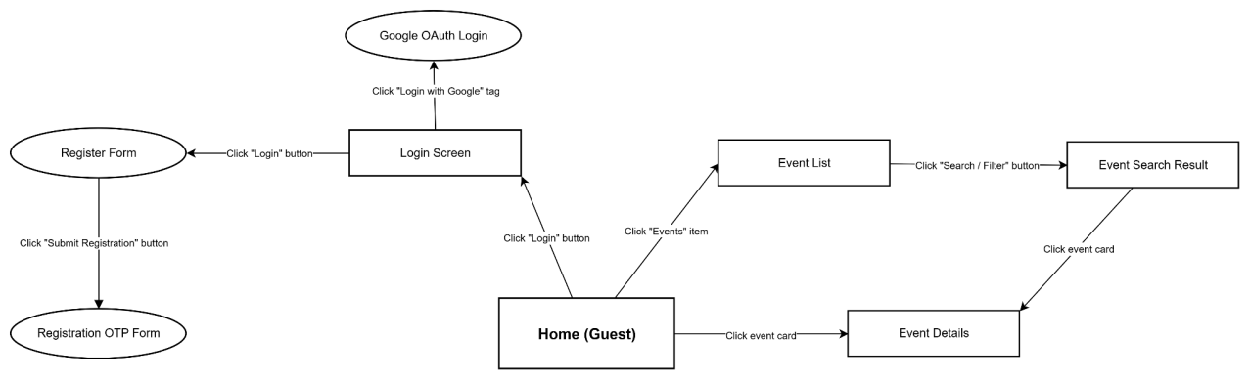
Figure 13: Screen Flow Diagram - Guest¹⁰

¹⁰https://app.diagrams.net/#G1Xwhx-kVWuxR8ICdzqIR-1dtapXswWu-I#%7B%22pageId%22%3A%22Fud2dtko_RpXijVxR87o%22%7D

b. Customer
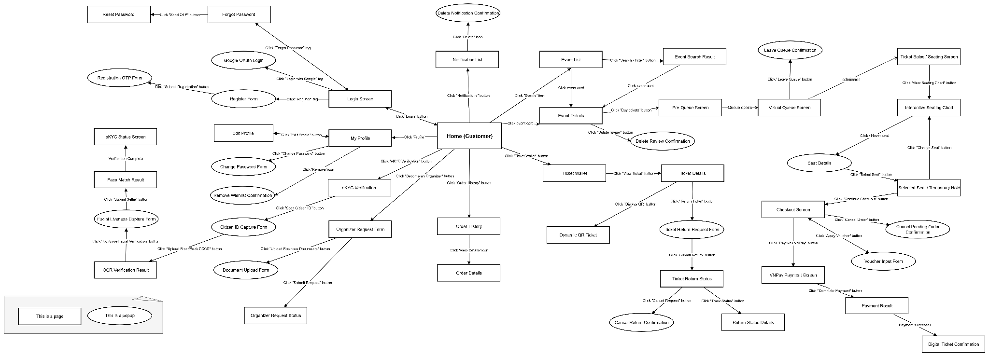
Figure 14 : Screen Flow Diagram - Customer¹¹
¹¹https://app.diagrams.net/#G1Xwhx-kVWuxR8ICdzqIR-1dtapXswWu-I#%7B%22pageId%22%3A%22LlGp95k3SJt1-SdU_VXm%22%7D
c. Staff
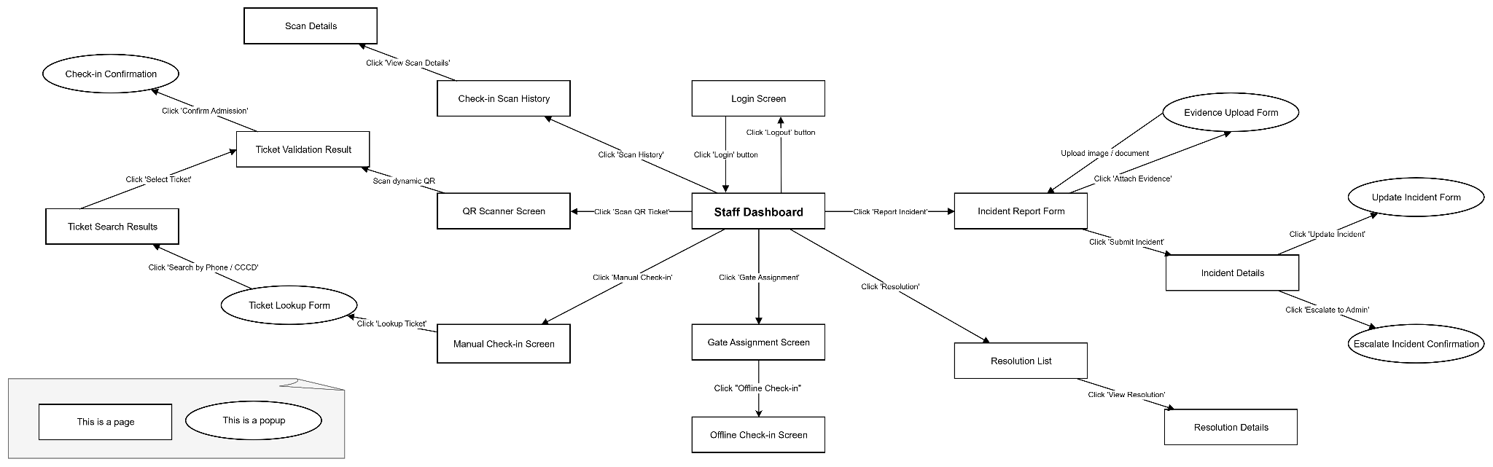
Figure 15: Screen Flow Diagram - Staff¹²

¹²https://app.diagrams.net/#G1Xwhx-kVWuxR8ICdzqIR-1dtapXswWu-I#%7B%22pageId%22%3A%22o4s6LdKIRuw9R31tWT6H%22%7D

d. Organizer

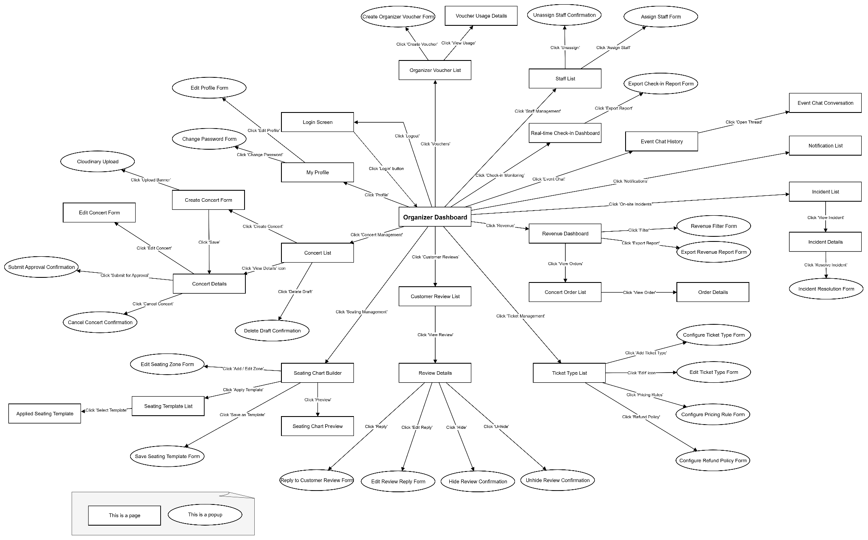
Figure 16: Screen Flow Diagram - Organizer¹³

¹³https://app.diagrams.net/#G1Xwhx-kVWuxR8ICdzqIR-1dtapXswWu-I#%7B%22pageId%22%3A%22kxQ9h7WYvmb2gLB4Vhhj%22%7D

e. Admin

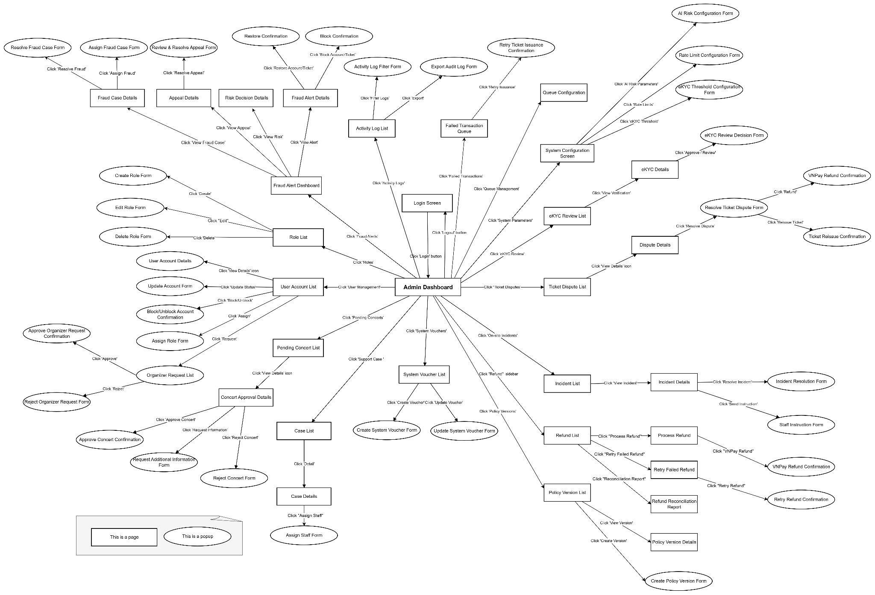
Figure17 : Screen Flow Diagram - Admin¹⁴

¹⁴https://app.diagrams.net/#G1Xwhx-kVWuxR8ICdzqIR-1dtapXswWu-I#%7B%22pageId%22%3A%22FeyesKxkAPJseg4Yj4Fy%22%7D

3.1.2 Screen Descriptions

# | Feature | Screen | Description
1 | Authentication & Account Management | Home (Guest) | Landing page for not-logged-in visitors; links to Login/Register/Event List.
2 | Authentication & Account Management | Login Screen (Customer/Organizer) | Login screen with email/password or Google sign-in, plus links to Register/Forgot Password.
3 | Authentication & Account Management | Login Screen (Staff/Admin) | Dedicated login screen for check-in staff and system administrators.
4 | Authentication & Account Management | Register Form | Form to enter details and create a new account.
5 | Authentication & Account Management | Registration OTP Form | Popup to enter the OTP code to verify a new registration.
6 | Authentication & Account Management | Google OAuth Login | Quick sign-in window using a Google account.
7 | Authentication & Account Management | Forgot Password | Enter email/phone number to request an OTP for password reset.
8 | Authentication & Account Management | Reset Password | Enter a new password after the reset-password OTP is verified.
9 | Authentication & Account Management | My Profile | View personal profile info; links to Edit Profile, Change Password, eKYC, Become an Organizer.
10 | Authentication & Account Management | Edit Profile / Edit Profile Form | Form to update personal profile details.
11 | Authentication & Account Management | Change Password Form | Form to change password (old password + new password).
12 | Authentication & Account Management | Organizer Request Form | Form to submit a request to upgrade the account to an Organizer account.
13 | Authentication & Account Management | Organizer Request Status | Tracks the processing status of the Organizer upgrade request.
14 | eKYC & Identity Verification Flow | eKYC Verification | Starting page of the electronic identity verification (eKYC) flow.
15 | eKYC & Identity Verification Flow | Citizen ID Capture Form | Popup guiding the user to capture front/back photos of the ID card for OCR scanning.
16 | eKYC & Identity Verification Flow | OCR Verification Result | Shows the information extracted from the ID card via OCR for the user to confirm.
17 | eKYC & Identity Verification Flow | Facial Liveness Capture Form | Popup asking the user to record/capture their face to check liveness.
18 | eKYC & Identity Verification Flow | Face Match Result | Shows the result of matching the live face against the ID card photo.
19 | eKYC & Identity Verification Flow | eKYC Status Screen | Overall status of the eKYC profile after verification is complete.
20 | eKYC & Identity Verification Flow | eKYC Review List | List of eKYC submissions awaiting Admin review.
21 | eKYC & Identity Verification Flow | eKYC Details | Detail of one eKYC submission: ID photos, face photo, OCR/liveness results.
22 | eKYC & Identity Verification Flow | eKYC Review Decision Form | Popup for the Admin to approve/reject an eKYC submission with notes.
23 | eKYC & Identity Verification Flow | eKYC Threshold Configuration Form | Form to set the score threshold for auto-approving/rejecting eKYC submissions (incl. data retention settings).
24 | Role-Based Access Control (RBAC) | Role List | List of roles defined in the system.
25 | Role-Based Access Control (RBAC) | Create Role Form | Form to create a new role.
26 | Role-Based Access Control (RBAC) | Edit Role Form | Form to edit a role and its associated permissions.
27 | Role-Based Access Control (RBAC) | Delete Role Form | Popup to confirm deleting a role from the system.
28 | Event Discovery | Event List | List of events currently on sale, with filter/search support.
29 | Event Discovery | Event Search Result | Search/filter result page for events by keyword, date, location.
30 | Event Discovery | Event Details | Event detail page: info, ticket prices, reviews, Buy Tickets/Wishlist buttons.
31 | Event Discovery | Delete Review Confirmation | Popup to confirm deleting a review the customer has written.
32 | Event Discovery | Remove Wishlist Confirmation | Popup to confirm removing an event from the Wishlist.
33 | Virtual Queue & Fair Admission | Pre-Queue Screen | Pre-registration page to hold a place before the queue officially opens for ticket sales.
34 | Virtual Queue & Fair Admission | Virtual Queue Screen | Virtual waiting room showing real-time queue position; redirects to the ticket-sales page on admission.
35 | Virtual Queue & Fair Admission | Leave Queue Confirmation | Popup to confirm leaving the virtual queue.
36 | Virtual Queue & Fair Admission | Queue Configuration | Admin screen to configure the pre-queue window and the admission rate/fairness policy.
37 | Interactive Seating Chart & Ticket Selection | Ticket Sales / Seating Screen | Overview ticket-sales page leading to the interactive seating chart.
38 | Interactive Seating Chart & Ticket Selection | Interactive Seating Chart | Interactive seat map to view/select available seats by zone.
39 | Interactive Seating Chart & Ticket Selection | Seat Details | Detail of one seat (ticket class, price) on hover/click.
40 | Interactive Seating Chart & Ticket Selection | Selected Seat / Temporary Hold | Temporarily holds the selected seat(s) for a limited time before checkout.
41 | Dynamic QR Code & Ticket Wallet | Order History | History of ticket orders placed by the customer.
42 | Dynamic QR Code & Ticket Wallet | Order Details (Customer) | Detail of one order: tickets, price, payment status.
43 | Dynamic QR Code & Ticket Wallet | Ticket Wallet | Digital wallet holding all tickets successfully purchased.
44 | Dynamic QR Code & Ticket Wallet | Ticket Details | Detail of one ticket, with a button to show the QR code or request a return.
45 | Dynamic QR Code & Ticket Wallet | Dynamic QR Ticket | Displays a self-refreshing dynamic QR code used for check-in.
46 | Dynamic QR Code & Ticket Wallet | Ticket Reissue Confirmation | Popup to confirm re-issuing a new ticket to the customer after resolving a dispute.
47 | Ticket Return & Re-Issue Workflow | Ticket Return Request Form | Form to submit a ticket return request, selecting a reason.
48 | Ticket Return & Re-Issue Workflow | Ticket Return Status | Tracks the processing status of a ticket return request.
49 | Ticket Return & Re-Issue Workflow | Cancel Return Confirmation | Popup to confirm cancelling a submitted return request.
50 | Ticket Return & Re-Issue Workflow | Return Status Details | Detailed processing history of a ticket return request.
51 | Event Creation & Lifecycle Management | Concert List | List of events created by the Organizer, by status (Draft/Pending/Approved...).
52 | Event Creation & Lifecycle Management | Create Concert Form | Form to create a new event: name, schedule, venue, description.
53 | Event Creation & Lifecycle Management | Cloudinary Upload | Popup to upload the event banner image to the image-hosting service.
54 | Event Creation & Lifecycle Management | Edit Concert Form | Form to edit an event's information.
55 | Event Creation & Lifecycle Management | Concert Details | Event detail page with Submit for Approval, Cancel, Delete Draft actions.
56 | Event Creation & Lifecycle Management | Submit Approval Confirmation | Popup to confirm submitting the event to the Admin for approval.
57 | Event Creation & Lifecycle Management | Cancel Concert Confirmation | Popup to confirm cancelling a created event.
58 | Event Creation & Lifecycle Management | Delete Draft Confirmation | Popup to confirm deleting an event still in Draft status.
59 | Seating Chart Builder & Ticket Class Configuration | Seating Chart Builder | Tool to build the seating chart for an event.
60 | Seating Chart Builder & Ticket Class Configuration | Edit Seating Zone Form | Form to add/edit a zone within the seating chart.
61 | Seating Chart Builder & Ticket Class Configuration | Seating Template List | List of available seating-chart templates for reuse.
62 | Seating Chart Builder & Ticket Class Configuration | Applied Seating Template | Popup to confirm applying a seating template to the current event.
63 | Seating Chart Builder & Ticket Class Configuration | Save Seating Template Form | Form to save the current seating chart as a new template.
64 | Seating Chart Builder & Ticket Class Configuration | Seating Chart Preview | Preview of the seating chart before publishing.
65 | Seating Chart Builder & Ticket Class Configuration | Ticket Type List | List of ticket classes configured for the event.
66 | Seating Chart Builder & Ticket Class Configuration | Configure Ticket Type Form | Form to add a new ticket class (name, price, quantity, applicable zone).
67 | Seating Chart Builder & Ticket Class Configuration | Edit Ticket Type Form | Form to edit an existing ticket class.
68 | Seating Chart Builder & Ticket Class Configuration | Configure Pricing Rule Form | Form to set pricing rules (early-bird, tiered pricing...).
69 | Seating Chart Builder & Ticket Class Configuration | Configure Refund Policy Form | Form to set the refund/return policy for the event.
70 | Revenue Analytics & Sales Dashboard | Revenue Dashboard | Overview dashboard of revenue across events.
71 | Revenue Analytics & Sales Dashboard | Revenue Filter Form | Form to filter revenue data by time period/event.
72 | Revenue Analytics & Sales Dashboard | Export Revenue Report Form | Form to configure and export a revenue report.
73 | Revenue Analytics & Sales Dashboard | Concert Order List | List of ticket orders sold for an event.
74 | Revenue Analytics & Sales Dashboard | Order Details (Organizer) | Detail of one ticket order from the Organizer's view.
75 | Real-time Check-in Monitoring | Real-time Check-in Dashboard | Monitors real-time check-in status at the event.
76 | Real-time Check-in Monitoring | Export Check-in Report Form | Form to export the event's check-in report.
77 | Real-time Check-in Monitoring | Staff List | List of staff assigned to the event.
78 | Real-time Check-in Monitoring | Assign Staff Form (Check-in) | Form to assign a staff member to a check-in gate/zone.
79 | Real-time Check-in Monitoring | Unassign Staff Confirmation | Popup to confirm unassigning a staff member.
80 | Real-time Check-in Monitoring | Offline Check-in Screen | Screen to enable offline check-in mode when network is unavailable; syncs records once reconnected.
81 | QR Code Scanner & Check-in Interface | Staff Dashboard | Main screen for check-in staff, linking to check-in, incident, and other functions.
82 | QR Code Scanner & Check-in Interface | QR Scanner Screen | Camera screen to scan the dynamic QR code on a ticket.
83 | QR Code Scanner & Check-in Interface | Ticket Validation Result | Shows the validity check result of the scanned/selected ticket.
84 | QR Code Scanner & Check-in Interface | Check-in Confirmation | Popup to confirm admitting the attendee after the ticket is validated.
85 | QR Code Scanner & Check-in Interface | Ticket Lookup Form | Form to enter a phone number/ID number to look up a ticket manually.
86 | QR Code Scanner & Check-in Interface | Ticket Search Results | Search results for a ticket based on customer information.
87 | QR Code Scanner & Check-in Interface | Manual Check-in Screen | Manual check-in screen used when the QR code cannot be scanned.
88 | QR Code Scanner & Check-in Interface | Check-in Scan History | History of all scan/check-in actions performed.
89 | QR Code Scanner & Check-in Interface | Scan Details | Detail of one scan record in the history.
90 | QR Code Scanner & Check-in Interface | Gate Assignment Screen | Shows the gate/zone the staff member is assigned to; entry point to Offline Check-in mode.
91 | Incident Reporting & On-site Support | Incident Report Form | Form to file a report for an on-site incident.
92 | Incident Reporting & On-site Support | Evidence Upload Form | Popup to attach photos/documents as evidence for an incident.
93 | Incident Reporting & On-site Support | Incident Details | Detail of a reported incident: content, evidence, processing status.
94 | Incident Reporting & On-site Support | Update Incident Form | Form to add further information to an incident report.
95 | Incident Reporting & On-site Support | Escalate Incident Confirmation | Popup to confirm escalating the incident to the Admin.
96 | Incident Reporting & On-site Support | Resolution List | List of incidents that have been resolved.
97 | Incident Reporting & On-site Support | Resolution Details | Detail of how a specific incident was resolved.
98 | Incident Reporting & On-site Support | Incident List | List of all incidents reported for the event/system.
99 | Incident Reporting & On-site Support | Incident Resolution Form | Form to enter the resolution plan and notes for an incident.
100 | Incident Reporting & On-site Support | Staff Instruction Form | Form for the Admin to send instructions to on-site staff.
101 | User Mgmt, Event Approval, Review, Wishlist, Support Case & Refund | User Account List | List of all user accounts in the system.
102 | User Mgmt, Event Approval, Review, Wishlist, Support Case & Refund | User Account Details | View detailed information of a user account.
103 | User Mgmt, Event Approval, Review, Wishlist, Support Case & Refund | Update Account Form | Form to update an account's status.
104 | User Mgmt, Event Approval, Review, Wishlist, Support Case & Refund | Block/Unblock Account Confirmation | Popup to confirm blocking/unblocking an account.
105 | User Mgmt, Event Approval, Review, Wishlist, Support Case & Refund | Assign Role Form | Form to assign/unassign a specific role to a user account.
106 | User Mgmt, Event Approval, Review, Wishlist, Support Case & Refund | Organizer Request List | List of pending requests to upgrade to an Organizer account.
107 | User Mgmt, Event Approval, Review, Wishlist, Support Case & Refund | Approve Organizer Request Confirmation | Popup to confirm approving an Organizer upgrade request.
108 | User Mgmt, Event Approval, Review, Wishlist, Support Case & Refund | Reject Organizer Request Form | Form to reject an Organizer upgrade request with a reason.
109 | User Mgmt, Event Approval, Review, Wishlist, Support Case & Refund | Pending Concert List | List of events pending Admin approval.
110 | User Mgmt, Event Approval, Review, Wishlist, Support Case & Refund | Concert Approval Details | Event detail page for the Admin to approve/request info/reject.
111 | User Mgmt, Event Approval, Review, Wishlist, Support Case & Refund | Approve Concert Confirmation | Popup to confirm approving an event.
112 | User Mgmt, Event Approval, Review, Wishlist, Support Case & Refund | Request Additional Information Form | Form to request the Organizer provide additional information for an event.
113 | User Mgmt, Event Approval, Review, Wishlist, Support Case & Refund | Reject Concert Form | Form to reject an event approval with a reason.
114 | User Mgmt, Event Approval, Review, Wishlist, Support Case & Refund | Review List | List of reviews pending moderation.
115 | User Mgmt, Event Approval, Review, Wishlist, Support Case & Refund | Hide Review Confirmation | Popup to confirm hiding a review that violates policy.
116 | User Mgmt, Event Approval, Review, Wishlist, Support Case & Refund | Unhide Review Confirmation | Popup to confirm unhiding a previously hidden review.
117 | User Mgmt, Event Approval, Review, Wishlist, Support Case & Refund | Reply Confirmation | Popup confirming that a reply to a customer review has been sent.
118 | User Mgmt, Event Approval, Review, Wishlist, Support Case & Refund | Ticket Dispute List | List of ticket-related disputes.
119 | User Mgmt, Event Approval, Review, Wishlist, Support Case & Refund | Dispute Details | Detail of a ticket dispute.
120 | User Mgmt, Event Approval, Review, Wishlist, Support Case & Refund | Resolve Ticket Dispute Form | Form for the Admin to resolve a ticket dispute, deciding an outcome (may lead to a reissue or a refund).
121 | User Mgmt, Event Approval, Review, Wishlist, Support Case & Refund | Case List | List of customer support cases created.
122 | User Mgmt, Event Approval, Review, Wishlist, Support Case & Refund | Case Details | Detail of a customer support case.
123 | User Mgmt, Event Approval, Review, Wishlist, Support Case & Refund | Assign Staff Form (Support Case) | Form to assign a support case to a staff member for handling.
124 | User Mgmt, Event Approval, Review, Wishlist, Support Case & Refund | Refund List | List of refund requests awaiting processing.
125 | User Mgmt, Event Approval, Review, Wishlist, Support Case & Refund | Process Refund | Page to process a full or partial refund for an order.
126 | User Mgmt, Event Approval, Review, Wishlist, Support Case & Refund | Retry Failed Refund | Page to retry a failed refund transaction.
127 | User Mgmt, Event Approval, Review, Wishlist, Support Case & Refund | Retry Refund Confirmation | Popup confirming that a refund retry has been performed.
128 | User Mgmt, Event Approval, Review, Wishlist, Support Case & Refund | Refund Reconciliation Report | Reconciliation report for refund transactions.
129 | User Mgmt, Event Approval, Review, Wishlist, Support Case & Refund | VNPay Refund Confirmation | Popup confirming a successful refund processed via the VNPay gateway.
130 | Risk-Based Anti-Fraud | Fraud Alert Dashboard | Dashboard aggregating fraud alerts detected by the AI system.
131 | Risk-Based Anti-Fraud | Fraud Alert Details | Detail of a fraud alert: risk score, abnormal behavior.
132 | Risk-Based Anti-Fraud | Block Confirmation | Popup to confirm blocking an account/ticket suspected of fraud.
133 | Risk-Based Anti-Fraud | Restore Confirmation | Popup to confirm restoring a previously blocked account/ticket.
134 | Risk-Based Anti-Fraud | Risk Decision Details | Detail of the AI risk-scoring decision for a transaction/account.
135 | Risk-Based Anti-Fraud | Appeal Details | Detail of a user's appeal against a risk decision.
136 | Risk-Based Anti-Fraud | Review & Resolve Appeal Form | Form to review and decide the outcome of an appeal.
137 | Risk-Based Anti-Fraud | Fraud Case Details | Detail of a fraud investigation case.
138 | Risk-Based Anti-Fraud | Assign Fraud Case Form | Form to assign a fraud case to an analyst.
139 | Risk-Based Anti-Fraud | Resolve Fraud Case Form | Form to conclude and close a fraud investigation case.
140 | Risk-Based Anti-Fraud | AI Risk Configuration Form | Form to configure parameters for the AI risk-scoring model.
141 | System Activity Log & Audit Trail / System Config | Activity Log List | Log of all actions performed across the system.
142 | System Activity Log & Audit Trail / System Config | Activity Log Filter Form | Form to filter the activity log by user, time, or action type.
143 | System Activity Log & Audit Trail / System Config | Export Audit Log Form | Form to export the audit log to a file.
144 | System Activity Log & Audit Trail / System Config | System Configuration Screen | Central screen for configuring system operating parameters.
145 | System Activity Log & Audit Trail / System Config | Rate Limit Configuration Form | Form to set the rate limit for access/actions.
146 | Real-time Notification Management | Notification List | List of received notifications (orders, favorited events, system alerts...).
147 | Real-time Notification Management | Delete Notification Confirmation | Popup to confirm deleting a notification.
148 | Payment Gateway Integration, Voucher & Checkout | Checkout Screen | Confirms the order, applies a voucher, and selects a payment method.
149 | Payment Gateway Integration, Voucher & Checkout | Voucher Input Form | Popup to enter a discount code to apply to the order.
150 | Payment Gateway Integration, Voucher & Checkout | Cancel Pending Order Confirmation | Popup to confirm cancelling an order pending payment.
151 | Payment Gateway Integration, Voucher & Checkout | VNPay Payment Screen | Redirects to the VNPay payment gateway.
152 | Payment Gateway Integration, Voucher & Checkout | Payment Result | Shows the payment transaction result (success/failure).
153 | Payment Gateway Integration, Voucher & Checkout | Digital Ticket Confirmation | Confirms that the digital ticket has been issued after successful payment.
154 | Payment Gateway Integration, Voucher & Checkout | Organizer Voucher List | List of vouchers created by the Organizer for their events.
155 | Payment Gateway Integration, Voucher & Checkout | Create Organizer Voucher Form | Form to create a new discount voucher for an event.
156 | Payment Gateway Integration, Voucher & Checkout | Voucher Usage Details | Detailed usage statistics for a voucher.
157 | Payment Gateway Integration, Voucher & Checkout | System Voucher List | List of system-wide vouchers managed by the Admin.
158 | Payment Gateway Integration, Voucher & Checkout | Create System Voucher Form | Form to create a new system-wide voucher.
159 | Payment Gateway Integration, Voucher & Checkout | Update System Voucher Form | Form to edit an existing system-wide voucher.
160 | Payment Gateway Integration, Voucher & Checkout | Failed Transaction Queue | List of failed payment/ticket-issuance transactions awaiting a retry.
161 | Payment Gateway Integration, Voucher & Checkout | Retry Ticket Issuance Confirmation | Popup to confirm retrying a failed ticket issuance.
162 | : Governance, Policy Versioning & Compliance | Policy Version List | List of policy versions (pricing/refund/queue/risk) in chronological order.
163 | Governance, Policy Versioning & Compliance | Policy Version Details | Detail of the content of a specific policy version.
164 | Governance, Policy Versioning & Compliance | Create Policy Version Form | Form to create a new policy version.
165 | Governance, Policy Versioning & Compliance | Document Upload Form | Popup to upload business verification documents together with the Organizer upgrade request.

3.1.3 Screen Authorization

Screen | Guest | Customer | Organizer | Staff | Admin
User Account Management & Authentication
Home (Guest) | ✓
Login Screen (Customer/Organizer) | ✓ | ✓ | ✓
Login Screen (Staff/Admin) |  |  |  | ✓ | ✓
Register Form | ✓
Registration OTP Form | ✓
Google OAuth Login | ✓
Forgot Password | ✓ | ✓
Reset Password | ✓ | ✓ | ✓
My Profile |  | ✓ | ✓
Edit Profile / Edit Profile Form |  | ✓ | ✓
Change Password Form |  | ✓
Organizer Request Form |  | ✓
Organizer Request Status |  | ✓
eKYC & Identity Verification Flow
eKYC Verification |  | ✓
Citizen ID Capture Form |  | ✓
OCR Verification Result |  | ✓
Facial Liveness Capture Form |  | ✓
Face Match Result |  | ✓
eKYC Status Screen |  | ✓
eKYC Review List |  | ✓ |  |  | ✓
eKYC Details |  |  |  |  | ✓
eKYC Review Decision Form |  |  |  |  | ✓
eKYC Threshold Configuration Form |  |  |  |  | ✓
Role-Based Access Control (RBAC)
Role List |  |  |  |  | ✓
Create Role Form |  |  |  |  | ✓
Edit Role Form |  |  |  |  | ✓
Delete Role Form |  |  |  |  | ✓
Event Discovery
Event List | ✓ | ✓ | ✓
Event Search Result | ✓ | ✓
Event Details | ✓ | ✓
Delete Review Confirmation |  | ✓
Remove Wishlist Confirmation |  | ✓
Virtual Queue & Fair Admission
Pre-Queue Screen |  | ✓
Virtual Queue Screen |  | ✓
Leave Queue Confirmation |  | ✓
Queue Configuration |  |  |  |  | ✓
Interactive Seating Chart & Ticket Selection
Ticket Sales / Seating Screen |  | ✓
Interactive Seating Chart |  | ✓
Seat Details |  | ✓
Selected Seat / Temporary Hold |  | ✓
Dynamic QR Code & Ticket Wallet
Order History |  | ✓
Order Details |  | ✓
Ticket Wallet |  | ✓
Ticket Details |  | ✓
Dynamic QR Ticket |  | ✓
Ticket Reissue Confirmation |  |  |  |  | ✓
Ticket Return & Re-Issue Workflow
Ticket Return Request Form |  | ✓
Ticket Return Status |  | ✓
Cancel Return Confirmation |  | ✓
Return Status Details |  | ✓
Event Creation & Lifecycle Management
Concert List |  |  | ✓
Create Concert Form |  |  | ✓
Edit Concert Form |  |  | ✓
Concert Details |  |  | ✓
Submit Approval Confirmation |  |  | ✓
Cancel Concert Confirmation |  |  | ✓
Delete Draft Confirmation |  |  | ✓
Cloudinary Upload |  |  | ✓
Seating Chart Builder & Ticket Class Configuration
Seating Chart Builder |  |  | ✓
Edit Seating Zone Form |  |  | ✓
Seating Template List |  |  | ✓
Applied Seating Template |  |  | ✓
Save Seating Template Form |  |  | ✓
Seating Chart Preview |  |  | ✓
Ticket Type List |  |  | ✓
Configure Ticket Type Form |  |  | ✓
Edit Ticket Type Form |  |  | ✓
Configure Pricing Rule Form |  |  | ✓
Configure Refund Policy Form |  |  | ✓
Revenue Analytics & Sales Dashboard
Revenue Dashboard |  |  | ✓
Revenue Filter Form |  |  | ✓
Export Revenue Report Form |  |  | ✓
Concert Order List |  |  | ✓
Order Details (Organizer) |  |  | ✓
Real-time Check-in Monitoring
Real-time Check-in Dashboard |  |  | ✓
Export Check-in Report Form |  |  | ✓
Staff List |  |  | ✓
Assign Staff Form |  |  | ✓
Unassign Staff Confirmation |  |  | ✓
Offline Check-in Screen |  |  |  | ✓
QR Code Scanner & Check-in Interface
Staff Dashboard |  |  |  | ✓
QR Scanner Screen |  |  |  | ✓
Ticket Validation Result |  |  |  | ✓
Check-in Confirmation |  |  |  | ✓
Ticket Lookup Form |  |  |  | ✓
Ticket Search Results |  |  |  | ✓
Manual Check-in Screen |  |  |  | ✓
Check-in Scan History |  |  |  | ✓
Scan Details |  |  |  | ✓
Gate Assignment Screen |  |  |  | ✓
Incident Reporting & On-site Support
Incident Report Form |  |  |  | ✓
Evidence Upload Form |  |  |  | ✓
Incident Details |  |  |  | ✓ | ✓
Update Incident Form |  |  |  | ✓
Escalate Incident Confirmation |  |  |  | ✓
Resolution List |  |  |  | ✓ | ✓
Resolution Details |  |  |  | ✓ | ✓
Incident List |  |  |  |  | ✓
Incident Resolution Form |  |  |  |  | ✓
Staff Instruction Form |  |  |  |  | ✓
User Management, Event Approval, Review, Wishlist & Dispute Resolution
User Account List |  |  |  |  | ✓
User Account Details |  |  |  |  | ✓
Update Account Form |  |  |  |  | ✓
Block/Unblock Account Confirmation |  |  |  |  | ✓
Assign Role Form |  |  |  |  | ✓
Organizer Request List |  |  |  |  | ✓
Approve Organizer Request Confirmation |  |  |  |  | ✓
Reject Organizer Request Form |  |  |  |  | ✓
Pending Concert List |  |  |  |  | ✓
Concert Approval Details |  |  |  |  | ✓
Approve Concert Confirmation |  |  |  |  | ✓
Request Additional Information Form |  |  |  |  | ✓
Reject Concert Form |  |  |  |  | ✓
Review List |  |  | ✓
Hide Review Confirmation |  |  | ✓
Unhide Review Confirmation |  |  | ✓
Reply Confirmation |  |  |  |  | ✓
Ticket Dispute List |  |  |  |  | ✓
Dispute Details |  |  |  |  | ✓
Resolve Ticket Dispute Form |  |  |  |  | ✓
Case List |  |  |  |  | ✓
Case Details |  |  |  |  | ✓
Assign Staff Form (Support Case) |  |  |  |  | ✓
Refund List |  |  |  |  | ✓
Process Refund |  |  |  |  | ✓
Retry Failed Refund |  |  |  |  | ✓
Retry Refund Confirmation |  |  |  |  | ✓
Refund Reconciliation Report |  |  |  |  | ✓
VNPay Refund Confirmation |  |  |  |  | ✓
Risk-Based Anti-Fraud
Fraud Alert Dashboard |  |  |  |  | ✓
Fraud Alert Details |  |  |  |  | ✓
Block Confirmation |  |  |  |  | ✓
Restore Confirmation |  |  |  |  | ✓
Risk Decision Details |  |  |  |  | ✓
Appeal Details |  |  |  |  | ✓
Review & Resolve Appeal Form |  |  |  |  | ✓
Fraud Case Details |  |  |  |  | ✓
Assign Fraud Case Form |  |  |  |  | ✓
Resolve Fraud Case Form |  |  |  |  | ✓
AI Risk Configuration Form |  |  |  |  | ✓
System Activity Log & Audit Trail
Activity Log List |  |  |  |  | ✓
Activity Log Filter Form |  |  |  |  | ✓
Export Audit Log Form |  |  |  |  | ✓
System Configuration Screen |  |  |  |  | ✓
Rate Limit Configuration Form |  |  |  |  | ✓
Real-time Notification Management
Notification List |  | ✓ | ✓ | ✓ | ✓
Delete Notification Confirmation |  | ✓ | ✓ | ✓ | ✓
Payment Gateway, Voucher & Checkout
Checkout Screen |  | ✓
Voucher Input Form |  | ✓
Cancel Pending Order Confirmation |  | ✓
VNPay Payment Screen |  | ✓
Payment Result |  | ✓
Digital Ticket Confirmation |  | ✓
Organizer Voucher List |  |  | ✓
Create Organizer Voucher Form |  |  | ✓
Voucher Usage Details |  |  | ✓
System Voucher List |  |  |  |  | ✓
Create System Voucher Form |  |  |  |  | ✓
Update System Voucher Form |  |  |  |  | ✓
Failed Transaction Queue |  |  |  |  | ✓
Retry Ticket Issuance Confirmation |  |  |  |  | ✓
Governance, Policy Versioning & Compliance
Policy Version List |  |  |  |  | ✓
Policy Version Details |  |  |  |  | ✓
Create Policy Version Form |  |  |  |  | ✓
Document Upload Form |  | ✓

3.1.4 Non-Screen Functions

# | Feature | System Function | Description
1 | User Account Management & Authentication | POST ActionResult RefreshToken() | An access token is reissued based on a valid refresh token (stateless JWT), maintaining the login session without requiring the password to be re-entered.
2 | User Account Management & Authentication | POST ActionResult RevokeToken() | Revoke the refresh token when the user logs out or changes their password, preventing the reuse of the old token.
3 | eKYC & Identity Verification Flow | POST ActionResult VerifyIdentity() | The service calls the AI ​​system to perform CCCD OCR verification, face matching, and liveness detection, and returns the authentication status.
4 | eKYC & Identity Verification Flow | Cron Job PurgeExpiredKycData() | A scheduled task automatically deletes or hides biometric data and identity documents that have exceeded their retention period in accordance with the retention policy.
5 | Role-Based Access Control (RBAC) | Middleware AuthorizationFilter() | Check role-based access for every request before allowing API execution; there is no dedicated screen.
6 | Virtual Queue & Fair Admission | Service InitializeVirtualQueue() | Initializes the Virtual Queue for an eligible event, loads registered Pre-Queue customers, and prepares the queue state for admission processing.
7 | Virtual Queue & Fair Admission | Service RandomizeQueueOrder() | Randomizes eligible Pre-Queue registrations when the Virtual Queue opens, assigning each customer a stable queue position according to the configured fairness policy.
8 | Virtual Queue & Fair Admission | Service ProcessQueueAdmission() | Processes customers waiting in the Virtual Queue according to the configured admission rate and moves eligible customers from WAITING to ADMITTED.
9 | Virtual Queue & Fair Admission | Background Job UpdateQueuePosition() | Periodically updates queue position and estimated waiting time for customers and publishes the latest queue status through SignalR or the configured real-time mechanism.
10 | Virtual Queue & Fair Admission | Service ValidateQueueToken() | Validates the customer's queue token and ensures that the token is active, belongs to the correct event, and has not expired, been revoked, or already been consumed.
11 | Virtual Queue & Fair Admission | Service RevokeQueueToken() | Invalidates a queue token when a customer leaves the queue, an Admin manually revokes it, or the session is blocked due to a security violation.
12 | Seating Chart Builder & Ticket Class Configuration | Service SeatDistributedLock() | Manage distributed locks on seat status to prevent race conditions when multiple customers select the same seat simultaneously.
13 | Seating Chart Builder & Ticket Class Configuration | Cron Job ReleaseExpiredSeatHold() | A scheduled task automatically reverts seats from an expired HELD/PAYMENT_PENDING status back to AVAILABLE.
14 | Dynamic QR Code & Ticket Wallet | Service GenerateDynamicQrToken() | Generates dynamic QR codes that automatically refresh at short intervals to prevent screenshots and unauthorized ticket transfers.
15 | Ticket Return & Re-Issue Workflow | Service ProcessTicketRefund() | Call the payment gateway's (VNPay) refund API and update the ticket status after the ticket return request is approved.
16 | Risk-Based Anti-Fraud | Service RiskScoringEngine() | Real-time risk scoring for each ticket purchase based on configured rules or AI models.
17 | Risk-Based Anti-Fraud | Service DetectScalpingBot() | Detects anomalous ticket-buying behavior or ticket-snatching bots (based on purchase frequency, click patterns, etc.) and generates fraud alerts.
18 | System Activity Log & Audit Trail | Middleware AuditLogWriter() | Record all system operations, administrative actions, and permission changes to an append-only audit trail.
19 | Real-time Notification Management | Service NotificationHub (SignalR) | The hub pushes real-time notifications (queue position, payment confirmation, successful check-in, etc.) to connected clients.
20 | Real-time Notification Management | Cron Job SendEventReminder() | A scheduled task scans for upcoming events and sends reminder notifications to ticket holders.
21 | Real-time Notification Management | Cron Job SendTicketExpirationAlert() | A recurring task that sends alerts to customers when a ticket or seat hold is about to expire.
22 | Payment Gateway Integration, Voucher & Checkout | POST ActionResult VNPayWebhook() | An endpoint that listens for webhooks from the VNPay payment gateway to update the order status after payment.
23 | Payment Gateway Integration, Voucher & Checkout | GET ActionResult ValidateVoucher() | The API validates the voucher and calculates the discount value in real-time during checkout.

3.1.5 Entity Relationship Diagram

1. AuthenticationAPI Database:
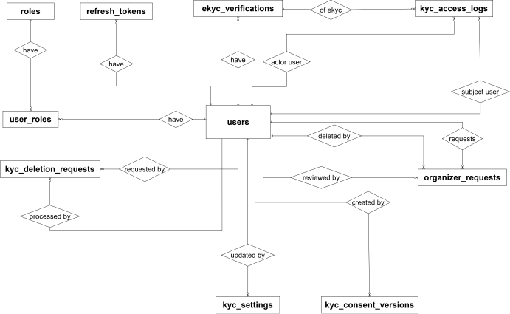
Figure 18 : ERD Diagram - AuthenticationAPI¹⁵
Entities Description
# | Entity | Description
1 | users | A user account in the system, including login credentials, profile information, and verification status.  Beyond its identifiers, the table also stores email, full_name, phone_number, is_verified, ekyc_status, and 5 other fields, capturing the operational details specific to this entity.  An is_active flag supports enabling or disabling accounts without deleting them.  PK: user_id – Unique identifier for each user.  FK: none.  - user_id integer  - email varchar(256)  - password_hash text  - full_name varchar(100)  - phone_number varchar(10)  - avatar_url text  - is_verified boolean  - otp_hash varchar(256)  - otp_expired_at timestamptz  - ekyc_status varchar(20)  - created_at timestamptz  - is_active boolean  - auth_provider — authentication provider: local (email/password signup) or google  - has_password — indicates whether the user has a local password set (false for OAuth users)
2 | refresh_tokens | A refresh token used to renew a user's authenticated session (JWT refresh flow).  Beyond its identifiers, the table also stores token_hash, expires_at, is_revoked, and 1 other field, capturing the operational details specific to this entity.  It maintains a relationship with Users through its foreign key, linking each token to the account it authenticates.  PK: refresh_token_id – Unique identifier for each refresh token.  FK: user_id – Users: the user this refresh token belongs to.  - refresh_token_id integer  - user_id integer  - token_hash varchar(64)  - expires_at timestamptz  - is_revoked boolean  - created_at timestamptz
3 | roles | List of user roles in the system (Admin, Organizer, Customer...).  Beyond its identifiers, the table also stores role_name, capturing the operational details specific to this entity.  PK: role_id – Unique identifier for each role.  FK: none.  - role_id integer  - role_name varchar(50)
4 | user_roles | A many-to-many mapping table linking users to roles, allowing a user to hold multiple roles.  Beyond its identifiers, the table also stores assigned_at, capturing the operational details specific to this entity.  It maintains relationships with Users and Roles through its foreign keys, linking each user to a role they hold.  PK: user_id + role_id – Composite key uniquely identifying a user-role assignment.  FK: user_id – Users: the user holding the role.  FK: role_id – Roles: the role assigned to the user.  - user_id integer  - role_id integer  - assigned_at timestamptz
5 | ekyc_verifications | Electronic identity verification (eKYC) results for a user, based on national ID and facial data.  Beyond its identifiers, the table also stores cccd_number_encrypted, face_match_score, liveness_score, status, and 8 other fields, capturing the operational details specific to this entity.  It maintains a relationship with Users through its foreign key, linking each verification attempt to the account being verified.  PK: ekyc_id – Unique identifier for each eKYC verification attempt.  FK: user_id – Users: the user whose identity is being verified.  - ekyc_id integer  - user_id integer  - cccd_number_encrypted text  - cccd_front_object_key varchar(500)  - cccd_back_object_key varchar(500)  - face_capture_object_key varchar(500)  - face_vector bytea  - ocr_raw_data jsonb  - face_match_score numeric(5,2)  - liveness_score numeric(5,2)  - liveness_passed boolean  - status varchar(20)  - fail_reason varchar(500)  - verified_at timestamptz  - created_at timestamptz
6 | organizer_requests | A request submitted by a user to be upgraded to an organizer account.  Beyond its identifiers, the table also stores reason, company_name, status, review_note, and 10 other fields, capturing the operational details specific to this entity.  It maintains relationships with Users through its foreign keys, connecting the request to the applicant and to the staff member who reviewed it.  Standard created_at/updated_at timestamps and an is_deleted flag support change tracking and safe, reversible removal.  PK: request_id – Unique identifier for each request.  FK: user_id – Users: the user submitting the request.  FK: reviewed_by – Users: the staff member who reviewed the request.  FK: deleted_by – Users: the user who deleted the request, if applicable.  - request_id integer  - user_id integer  - reason varchar(1000)  - company_name varchar(200)  - website varchar(200)  - phone_number varchar(20)  - experience varchar(2000)  - status varchar(20)  - reviewed_by integer  - reviewed_at timestamptz  - review_note varchar(1000)  - rejection_reason varchar(1000)  - created_at timestamptz  - updated_at timestamptz  - is_deleted boolean  - deleted_at timestamptz
7 | kyc_access_logs | Audit log recording who accessed or acted on a user's eKYC data, used for compliance and traceability.  Beyond its identifiers, the table also stores actor_type, action, ip_address, details, and 1 other field, capturing the operational details specific to this entity.  It references Users (the data subject and the actor) and eKYC verifications logically; no foreign key constraints are declared in the schema.  PK: id – Unique identifier for each log entry.  FK: subject_user_id – Users: the user whose eKYC data was accessed (logical, no constraint).  FK: ekyc_id – eKYC_verifications: the verification record involved, if any (logical, no constraint).  FK: actor_user_id – Users: the user who performed the action, if any (logical, no constraint).  - id bigint  - subject_user_id integer  - ekyc_id integer  - actor_user_id integer  - actor_type varchar(20)  - action varchar(50)  - ip_address varchar(45)  - details text  - created_at timestamptz
8 | kyc_consent_versions | Versions of the eKYC data-processing consent text shown to users, with only one version active at a time.  Beyond its identifiers, the table also stores title, content_json, checkbox_text, is_active, and 2 other fields, capturing the operational details specific to this entity.  The version column is unique, and ekyc_verifications.consent_version refers to it logically.  PK: id – Unique identifier for each consent version.  FK: created_by – Users: the user who created this version (logical, no constraint).  - id integer  - version varchar(20)  - title varchar(500)  - content_json text  - checkbox_text text  - is_active boolean  - created_at timestamptz  - created_by integer
9 | kyc_deletion_requests | A request from a user to delete their eKYC data, tracked until it is processed.  Beyond its identifiers, the table also stores status, requested_at, processed_at, processed_by, and 1 other field, capturing the operational details specific to this entity.  PK: id – Unique identifier for each deletion request.  FK: user_id – Users: the user requesting deletion (logical, no constraint).  FK: processed_by – Users: the staff member who processed the request (logical, no constraint).  - id integer  - user_id integer  - status varchar(20)  - requested_at timestamptz  - processed_at timestamptz  - processed_by integer  - note text
10 | kyc_settings | System-wide configuration for eKYC data retention and deletion behavior.  Beyond its identifiers, the table also stores retention_days, keep_document_hash_after_deletion, and 2 other fields, capturing the operational details specific to this entity.  PK: id – Identifier of the settings row (not auto-generated).  FK: updated_by – Users: the user who last updated the settings (logical, no constraint).  - id integer  - retention_days integer  - keep_document_hash_after_deletion boolean  - updated_at timestamptz  - updated_by integer

- users entity:
Attribute | Data type | Primary Key | Foreign Key | Unique | Description
user_id | integer | x |  | x | Primary key, auto-incrementing, uniquely identifies each user.
email | varchar(256) |  |  | x | User's email address, used for login and contact.
password_hash | text |  |  |  | Hashed password (not stored as plaintext).
full_name | varchar(100) |  |  |  | User's full name.
phone_number | varchar(10) |  |  |  | Contact phone number.
avatar_url | text |  |  |  | URL/path to the user's avatar image.
is_verified | boolean |  |  |  | Indicates whether the account has been verified.
otp_hash | varchar(256) |  |  |  | Hashed OTP code, used for verification.
otp_expired_at | timestamptz |  |  |  | Expiration timestamp of the OTP .
ekyc_status | varchar(20) |  |  |  | eKYC verification status .
created_at | timestamptz |  |  |  | Timestamp when the account was created .
is_active | boolean |  |  |  | Account activity status.
auth_provider | varchar(10) |  |  |  | Authentication provider: = local (email/password signup),google.
has_password | Boolean |  |  |  | Indicates whether the user has a local password set. False for users who signed up via OAuth (e.g. Google) and never set a local password.

- roles entity
Attribute | Data type | Primary Key | Foreign Key | Unique | Description
role_id | integer | x |  | x | Primary key, auto-incrementing, uniquely identifies each role
role_name | varchar(50) |  |  | x | Name of the role

- user_roles entity
Attribute | Data type | Primary Key | Foreign Key | Unique | Description
user_id | integer |  |  |  | Foreign key referencing users.user_id; identifies the user
role_id | integer |  | x |  | Foreign key referencing roles.role_id; identifies the role assigned
assigned_at | timestamptz |  |  |  | Timestamp when the role was assigned to the user

- refresh_tokens entity
Attribute | Data type | Primary Key | Foreign Key | Unique | Description
refresh_token_id | integer | x |  | x | Primary key, auto-incrementing, uniquely identifies each refresh token
user_id | integer |  | x |  | Foreign key referencing users.user_id; the user this token belongs to
token_hash | varchar(64) |  |  | x | Hashed value of the refresh token
expires_at | timestamptz |  |  |  | Expiration timestamp of the refresh token
is_revoked | boolean |  |  |  | Indicates whether the token has been manually revoked
created_at | timestamptz |  |  |  | Timestamp when the token was issued

- ekyc_verifications entity

Attribute | Data type | Primary Key | Foreign Key | Unique | Description
ekyc_id | integer | x |  | x | Primary key, auto-incrementing, uniquely identifies each eKYC verification attempt
user_id | integer |  | x |  | Foreign key referencing users.user_id; the user being verified
cccd_number_encrypted | text |  |  |  | Encrypted national ID number (CCCD)
cccd_front_object_key | varchar(500) |  |  |  | Storage object key/path for the front-side ID image
cccd_back_object_key | varchar(500) |  |  |  | Storage object key/path for the back-side ID image
face_capture_object_key | varchar(500) |  |  |  | Storage object key/path for the captured face image
face_vector | bytea |  |  |  | Binary embedding/vector representation of the face, used for face matching
ocr_raw_data | jsonb |  |  |  | Raw OCR extraction result from the ID document
face_match_score | numeric(5,2) |  |  |  | Similarity score between ID photo and captured face
liveness_score | numeric(5,2) |  |  |  | Score from the liveness detection check
liveness_passed | boolean |  |  |  | Whether the liveness check passed
status | varchar(20) |  |  |  | Verification status
fail_reason | varchar(500) |  |  |  | Reason for failure, if verification failed
verified_at | timestamptz |  |  |  | Timestamp when verification was completed
created_at | timestamptz |  |  |  | Timestamp when the verification attempt was created

- organizer_requests entity
Attribute | Data type | Primary Key | Foreign Key | Unique | Description
request_id | integer | x |  | x | Primary key, auto-incrementing, uniquely identifies each organizer request
user_id | integer |  | x |  | Foreign key referencing users.user_id; the user requesting to become an organizer
reason | varchar(1000) |  |  |  | Reason/motivation for the request
company_name | varchar(500) |  |  |  | Name of the company/organization (if applicable)
website | varchar(200) |  |  |  | Company or personal website URL
phone_number | varchar(10) |  |  |  | Contact phone number for this request
experience | varchar(2000) |  |  |  | Description of relevant experience in organizing events
status | varchar(20) |  |  |  | Review status of the request
reviewed_by | integer |  |  |  | Foreign key referencing users.user_id; the admin/reviewer who processed the request
reviewed_at | timestamptz |  |  |  | Timestamp when the request was reviewed
review_note | varchar(1000) |  |  |  | Internal note left by the reviewer
rejection_reason | varchar(1000) |  |  |  | Reason given if the request was rejected
created_at | timestamptz |  |  |  | Timestamp when the request was created
updated_at | timestamptz |  |  |  | Timestamp of the last update to the request
is_deleted | boolean |  |  |  | Soft-delete flag
deleted_at | timestamptz |  |  |  | Timestamp when the request was soft-deleted
deleted_by | integer |  |  |  | Foreign key referencing users.user_id; the user/admin who performed the soft delete

- kyc_access_logs entity

Attribute | Data type | Primary Key | Foreign Key | Unique | Description
id | bigint | x |  | x | Primary key, auto-generated, uniquely identifies each access log entry
subject_user_id | integer |  | x |  | References users.user_id (logical, no constraint); the user whose eKYC data was accessed
ekyc_id | integer |  | x |  | References ekyc_verifications.ekyc_id (logical, no constraint); the verification record involved, if any
actor_user_id | integer |  | x |  | References users.user_id (logical, no constraint); the user who performed the action, if any
actor_type | varchar(20) |  |  |  | Type of actor performing the action; defaults to 'User'
action | varchar(50) |  |  |  | Action performed on the eKYC data
ip_address | varchar(45) |  |  |  | IP address of the actor (long enough for IPv6)
details | text |  |  |  | Additional details about the action
created_at | timestamptz |  |  |  | Timestamp when the log entry was created

- kyc_consent_versions entity
Attribute | Data type | Primary Key | Foreign Key | Unique | Description
id | integer | x |  | x | Primary key, auto-generated, uniquely identifies each consent version
version | varchar(20) |  |  | x | Version identifier of the consent text; must be unique and is referenced by ekyc_verifications.consent_version
title | varchar(500) |  |  |  | Title of the consent document
content_json | text |  |  |  | Consent content stored as JSON
checkbox_text | text |  |  |  | Text displayed next to the consent checkbox
is_active | boolean |  |  |  | Whether this version is currently active; defaults to false
created_at | timestamptz |  |  |  | Timestamp when the version was created
created_by | integer |  |  |  | References users.user_id ; the user who created this version

- kyc_deletion_requests entity

Attribute | Data type | Primary Key | Foreign Key | Unique | Description
id | integer | x |  | x | Primary key, auto-generated, uniquely identifies each deletion request
user_id | integer |  |  |  | References users.user_id (logical, no constraint); the user requesting deletion of their eKYC data
status | varchar(20) |  |  |  | Processing status of the request; defaults to 'Pending'
requested_at | timestamptz |  |  |  | Timestamp when the request was submitted
processed_at | timestamptz |  |  |  | Timestamp when the request was processed
processed_by | integer |  |  |  | References users.user_id (logical, no constraint); the staff member who processed the request
note | text |  |  |  | Optional note about the processing result

- kyc_settings entity

Attribute | Data type | Primary Key | Foreign Key | Unique | Description
id | integer | x |  | x | Primary key (not auto-generated), identifies the settings row
retention_days | integer |  |  |  | Number of days eKYC data is retained; defaults to 30
keep_document_hash_after_deletion | boolean |  |  |  | Whether the document hash is kept after the data is deleted; defaults to false
updated_at | timestamptz |  |  |  | Timestamp when the settings were last updated
updated_by | integer |  |  |  | References users.user_id (logical, no constraint); the user who last updated the settings

2. EventAPI Database:
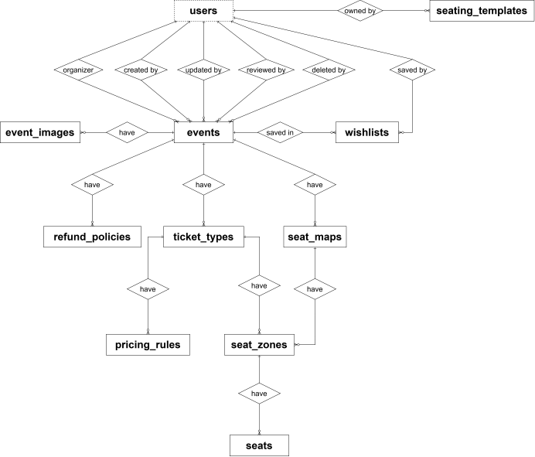
Figure 19: ERD Diagram - EventAPI¹⁶

Entities Description
# | Entity | Description
1 | events | The central entity of the Event microservice — an event created by an organizer, capturing content, location, schedule, and its publishing/approval lifecycle (Draft → Pending → Approved/Rejected/Cancelled).  Beyond its identifiers, the table also stores title, slug, location details, starts_at/ends_at, seating_mode, status, and lifecycle timestamps (submitted_at, approved_at, rejected_at) that support the organizer approval workflow.  organizer_id, created_by, updated_by, reviewed_by, and deleted_by are soft references to users in the Identity service (no physical FK across services, since this is a separate microservice database).  PK: event_id – Unique identifier for each event (identity column).  Soft FK: organizer_id → Users (Identity service): the organizer who owns this event.  Soft FK: created_by / updated_by / reviewed_by / deleted_by → Users (Identity service).  Unique: slug (only enforced while is_deleted = false).  - event_id integer  - organizer_id integer  - category_id integer (default 1)  - title varchar(200)  - slug varchar(250)  - short_description varchar(500)  - description text  - poster_url varchar(500) / poster_public_id varchar(500)  - banner_url varchar(500) / banner_public_id varchar(500)  - location_name varchar(200), address varchar(300), city varchar(100)  - longitude numeric(11,8), latitude numeric(10,8)  - starts_at / ends_at timestamptz  - timezone varchar(50) (default 'SE Asia Standard Time')  - has_seating_chart boolean  - seating_mode varchar(30) — CHECK IN ('GeneralAdmission','StandingZones','ReservedSeating')  - requires_virtual_queue boolean  - status varchar(20) — Draft/Pending/Approved/Rejected/Cancelled  - rejected_reason varchar(500)  - is_featured boolean  - view_count integer  - total_tickets integer, sold_tickets integer  - min_tickets_per_account integer, max_tickets_per_account integer  - meta_title varchar(200), meta_description varchar(500)  - created_at / updated_at timestamptz  - published_at / submitted_at / approved_at / rejected_at timestamptz  - reviewed_by integer (soft ref)  - created_by / updated_by integer (soft ref)  - is_deleted boolean, deleted_at timestamptz, deleted_by integer (soft ref)
2 | event_images | Image assets (poster, gallery, detail) associated with an event, supporting a media gallery per event.  An is_deleted flag with deleted_at/deleted_by supports safe, reversible removal.  PK: image_id – Unique identifier for each image.  FK: event_id → Events (real FK within this service).  Soft FK: deleted_by → Users (Identity service): the user who deleted the image, if applicable.  - image_id integer  - event_id integer  - image_url varchar(500)  - public_id varchar(500) (Cloudinary asset id)  - sort_order integer  - is_main boolean  - created_at timestamptz  - is_deleted boolean, deleted_at timestamptz, deleted_by integer (soft ref)
3 | ticket_types | A ticket tier belonging to an event (e.g., VIP, General, Early Bird), including price, inventory, and sales window.  A unique index prevents two active ticket types with the same name (case-insensitive) on the same event.  PK: ticket_type_id – Unique identifier for each ticket type.  FK: event_id → Events.  Soft FK: deleted_by → Users (Identity service).  - ticket_type_id integer  - event_id integer  - type_name varchar(100)  - description varchar(500)  - price bigint, original_price bigint  - quantity integer, sold_quantity integer  - min_per_order integer, max_per_order integer  - color_code varchar(20)  - sort_order integer  - status varchar(20) (default 'Active')  - sales_starts_at / sales_ends_at timestamptz  - created_at / updated_at timestamptz  - is_deleted boolean, deleted_at timestamptz, deleted_by integer (soft ref)
4 | pricing_rules | A dynamic pricing rule applied to a ticket type (e.g., early-bird discount, volume discount, time-based adjustment).  PK: pricing_rule_id – Unique identifier for each pricing rule.  FK: ticket_type_id → Ticket Types.  - pricing_rule_id integer  - ticket_type_id integer  - rule_name varchar(100)  - rule_type varchar(30)  - adjusted_price bigint  - discount_percent numeric(5,2)  - trigger_from / trigger_to timestamptz  - quantity_threshold integer  - priority integer (default 0)  - is_active boolean  - created_at timestamptz
5 | refund_policies | A refund/return policy defined by an organizer for a specific event (deadline, refund percentage, approval requirement).  PK: refund_policy_id – Unique identifier for each refund policy.  FK: event_id → Events.  - refund_policy_id integer  - event_id integer  - policy_name varchar(150)  - description varchar(1000)  - deadline_before_event_hours integer  - refund_percent numeric(5,2)  - requires_organizer_approval boolean (default true)  - is_active boolean  - created_at timestamptz
6 | seat_maps | The overall seating chart applied to an event that sells seat-based tickets.  PK: seat_map_id – Unique identifier for each seat map.  FK: event_id → Events.  Soft FK: deleted_by → Users (Identity service).  - seat_map_id integer  - event_id integer  - name varchar(150)  - layout_json jsonb  - created_at / updated_at timestamptz  - is_deleted boolean, deleted_at timestamptz, deleted_by integer (soft ref)
7 | seat_zones | A zone within a seat map, linked to a specific ticket type. Can be Seated (individual seats tracked in seats) or Standing (headcount tracked directly on this table via capacity).  PK: seat_zone_id – Unique identifier for each zone.  FK: seat_map_id → Seat Maps.  FK: ticket_type_id → Ticket Types.  - seat_zone_id integer  - seat_map_id integer  - ticket_type_id integer  - zone_name varchar(100)  - zone_type varchar(20) — CHECK IN ('Seated','Standing')  - capacity integer (default 0)  - shape_json jsonb
8 | wishlists | Events that a user has bookmarked/favorited.  PK: wishlist_id – Unique identifier for each wishlist entry.  FK: event_id → Events.  Soft FK: user_id → Users (Identity service): the user who bookmarked the event.  Unique: (event_id, user_id).  - wishlist_id integer  - event_id integer  - user_id integer  - created_at timestamptz
9 | seats | An individual physical seat belonging to a Seated zone; buyers pick their own seat from these rows. Standing zones have no rows here, their headcount is tracked directly in seat_zones.capacity.  PK: seat_id – Unique identifier for each seat (identity column).  FK: seat_zone_id → Seat Zones (real FK within this service, ON DELETE CASCADE).  Unique: (seat_zone_id, row_label, seat_number).  • seat_id integer  • seat_zone_id integer  • row_label varchar(10)  • seat_number varchar(10)  • x_coordinate integer, y_coordinate integer  • status varchar(20) (default 'Available')  • updated_at timestamptz
10 | seating_templates | A reusable venue seating layout saved by an organizer (or provided by an admin as a starter template), which can be applied to new events. It is deliberately not linked to ticket_types: only zone geometry, rows and capacity are stored, and the ticket type binding is chosen again when the template is applied.  Beyond its identifiers, the table also stores name, description, seating_mode, is_public, layout_json, zones_json, and standard lifecycle fields; an is_deleted flag with deleted_at supports safe, reversible removal.  organizer_id and created_by are soft references to users in the Identity service (no physical FK across services, since this is a separate microservice database).  PK: seating_template_id – Unique identifier for each seating template (identity column).  Soft FK: organizer_id → Users (Identity service): the organizer who owns the template.  Soft FK: created_by → Users (Identity service): the user who created the template.  • seating_template_id integer  • organizer_id integer (soft ref)  • name varchar(150)  • description varchar(500)  • seating_mode varchar(30) (default 'ReservedSeating') — CHECK IN ('StandingZones','ReservedSeating')  • is_public boolean (default false; true only for admin-provided starter templates)  • layout_json jsonb  • zones_json jsonb  • created_by integer (soft ref)  • created_at / updated_at timestamptz  • is_deleted boolean, deleted_at timestamptz

- events entity

Attribute | Data type | Primary Key | Foreign Key | Unique | Description
event_id | integer | x |  | x | Primary key, auto-incrementing, uniquely identifies each event
organizer_id | integer |  |  |  | Soft reference to identity_db.users.user_id; the organizer who owns this event
category_id | integer |  | x |  | Category the event belongs to (default 1)
title | varchar(200) |  |  |  | Event title/name
slug | varchar(250) |  |  | x | URL-friendly identifier used in event page links (*unique only while is_deleted = false)
short_description | varchar(500) |  |  |  | Brief summary of the event, shown in listings
description | text |  |  |  | Full detailed description of the event
poster_url | varchar(500) |  |  |  | URL of the event's poster image
poster_public_id | varchar(500) |  |  |  | Cloudinary public ID of the poster image, used to manage/delete the asset
banner_url | varchar(500) |  |  |  | URL of the event's banner image
banner_public_id | varchar(500) |  |  |  | Cloudinary public ID of the banner image
location_name | varchar(200) |  |  |  | Name of the venue/location
address | varchar(300) |  |  |  | Street address of the venue
city | varchar(100) |  |  |  | City where the event takes place
longitude | numeric(11,8) |  |  |  | Longitude coordinate of the venue
latitude | numeric(10,8) |  |  |  | Latitude coordinate of the venue
starts_at | timestamptz |  |  |  | Event start date/time
ends_at | timestamptz |  |  |  | Event end date/time
timezone | varchar(50) |  |  |  | Timezone in which the event's times are set
has_seating_chart | boolean |  |  |  | Whether the event uses a seat map (assigned seating) instead of general admission
seating_mode | varchar(30) |  |  |  | Seating configuration: GeneralAdmission, StandingZones, or ReservedSeating
requires_virtual_queue | boolean |  |  |  | Whether ticket purchase requires a virtual waiting queue (for high-demand events)
status | varchar(20) |  |  |  | Event lifecycle status: Draft, Pending, Approved, Rejected, Cancelled
rejected_reason | varchar(500) |  |  |  | Reason given if the event was rejected during approval
is_featured | boolean |  |  |  | Whether the event is highlighted/featured on the platform
view_count | integer |  |  |  | Number of times the event page has been viewed
total_tickets | integer |  |  |  | Total number of tickets available for the event
sold_tickets | integer |  |  |  | Number of tickets sold so far
min_tickets_per_account | integer |  |  |  | Minimum number of tickets a single account can purchase
max_tickets_per_account | integer |  |  |  | Maximum number of tickets a single account can purchase
meta_title | varchar(200) |  |  |  | SEO meta title for the event page
meta_description | varchar(500) |  |  |  | SEO meta description for the event page
created_at | timestamptz |  |  |  | Timestamp when the event was created
updated_at | timestamptz |  |  |  | Timestamp of the last update
published_at | timestamptz |  |  |  | Timestamp when the event was published
submitted_at | timestamptz |  |  |  | Timestamp when the organizer submitted the event for approval

- event_images entity

Attribute | Data type | Primary Key | Foreign Key | Unique | Description
image_id | integer | x |  | x | Primary key, auto-incrementing, uniquely identifies each image
event_id | integer |  | x |  | Foreign key referencing events.event_id; the event this image belongs to
image_url | varchar(500) |  |  |  | URL of the image file
public_id | varchar(500) |  |  |  | Cloudinary public ID of the image, used to manage/delete the asset
sort_order | integer |  |  |  | Display order of the image within the event's gallery
is_main | boolean |  |  |  | Whether this image is the primary/cover image for the event
created_at | timestamptz |  |  |  | Timestamp when the image was added
is_deleted | boolean |  |  |  | Soft-delete flag
deleted_at | timestamptz |  |  |  | Timestamp when the image was soft-deleted

- ticket_types entity

Attribute | Data type | Primary Key | Foreign Key | Unique | Description
ticket_type_id | integer | x |  | x | Primary key, auto-incrementing, uniquely identifies each ticket type
event_id | integer |  | x |  | Foreign key referencing events.event_id; the event this ticket type belongs to
type_name | varchar(100) |  |  | x | Name of the ticket type (*unique per event, case-insensitive, among active rows)
description | varchar(500) |  |  |  | Description of what this ticket type includes
price | bigint |  |  |  | Current selling price of the ticket
original_price | bigint |  |  |  | Original/list price before any discount
quantity | integer |  |  |  | Total quantity of this ticket type available
sold_quantity | integer |  |  |  | Number of tickets of this type sold so far
min_per_order | integer |  |  |  | Minimum quantity that can be purchased in a single order
max_per_order | integer |  |  |  | Maximum quantity that can be purchased in a single order
color_code | varchar(20) |  |  |  | Color code used for UI display
sort_order | integer |  |  |  | Display order among the event's ticket types
status | varchar(20) |  |  |  | Status of the ticket type (e.g. Active)
sales_starts_at | timestamptz |  |  |  | Timestamp when sale of this ticket type begins
sales_ends_at | timestamptz |  |  |  | Timestamp when sale of this ticket type ends
created_at | timestamptz |  |  |  | Timestamp when the ticket type was created
updated_at | timestamptz |  |  |  | Timestamp of the last update
is_deleted | boolean |  |  |  | Soft-delete flag
deleted_at | timestamptz |  |  |  | Timestamp when soft-deleted
deleted_by | integer |  |  |  | Soft reference to identity_db.users.user_id; who deleted the ticket type

- pricing_rules entity

Attribute | Data type | Primary Key | Foreign Key | Unique | Description
pricing_rule_id | integer | x |  | x | Primary key, auto-incrementing, uniquely identifies each pricing rule
ticket_type_id | integer |  | x |  | Foreign key referencing ticket_types.ticket_type_id; the ticket type this rule applies to
rule_name | varchar(100) |  |  |  | Descriptive name of the pricing rule
rule_type | varchar(30) |  |  |  | Type of rule (e.g. TimeBased)
adjusted_price | bigint |  |  |  | Fixed price to apply when the rule is triggered
discount_percent | numeric(5,2) |  |  |  | Percentage discount to apply when the rule is triggered
trigger_from | timestamptz |  |  |  | Start time from which the rule becomes active
trigger_to | timestamptz |  |  |  | End time until which the rule stays active
quantity_threshold | integer |  |  |  | Quantity threshold that triggers the rule
priority | integer |  |  |  | Priority order used when multiple rules could apply simultaneously
is_active | boolean |  |  |  | Whether the rule is currently active
created_at | timestamptz |  |  |  | Timestamp when the rule was created

- refund_policies entity
Attribute | Data type | Primary Key | Foreign Key | Unique | Description
refund_policy_id | integer | x |  | x | Primary key, auto-incrementing, uniquely identifies each refund policy
event_id | integer |  | x |  | Foreign key referencing events.event_id; the event this policy applies to
refund_percent | numeric(5,2) |  |  |  | Percentage of the ticket price refunded under this policy
requires_organizer_approval | boolean |  |  |  | Whether the organizer must manually approve refund requests under this policy
refund_policy_id | integer | x |  | x | Primary key, auto-incrementing, uniquely identifies each refund policy
requires_organizer_approval | boolean |  |  |  | Whether the organizer must manually approve refund requests under this policy
is_active | boolean |  |  |  | Whether the policy is currently active
created_at | timestamptz |  |  |  | Timestamp when the policy was created

- seat_maps entity

Attribute | Data type | Primary Key | Foreign Key | Unique | Description
seat_map_id | integer | x |  | x | Primary key, auto-incrementing, uniquely identifies each seat map
event_id | integer |  | x |  | Foreign key referencing events.event_id; the event this seat map belongs to
name | varchar(150) |  |  |  | Name of the seat map
layout_json | jsonb |  |  |  | JSON structure describing the seating layout (rows, seats, positions)
created_at | timestamptz |  |  |  | Timestamp when the seat map was created
updated_at | timestamptz |  |  |  | Timestamp of the last update
is_deleted | boolean |  |  |  | Soft-delete flag
deleted_at | timestamptz |  |  |  | Timestamp when soft-deleted
deleted_by | integer |  |  |  | Soft reference to identity_db.users.user_id; who deleted the seat map

• seat_zones entity:
Attribute | Data type | Primary Key | Foreign Key | Unique | Description
seat_zone_id | integer | x |  | x | Primary key, auto-incrementing, uniquely identifies each seat zone
seat_map_id | integer |  | x |  | Foreign key referencing seat_maps.seat_map_id; the seat map this zone belongs to
ticket_type_id | integer |  | x |  | Foreign key referencing ticket_types.ticket_type_id; the ticket type sold for seats in this zone
zone_name | varchar(100) |  |  |  | Name of the zone
zone_type | varchar(20) |  |  |  | Zone type: Seated or Standing
capacity | integer |  |  |  | Headcount capacity of the zone; for Seated zones kept in sync with the seat count, for Standing zones set directly by the organizer
shape_json | jsonb |  |  |  | JSON structure describing the zone's shape/coordinates on the seat map

• seats entity:
Attribute | Data type | Primary Key | Foreign Key | Unique | Description
seat_id | integer | x |  | x | Primary key, auto-incrementing, uniquely identifies each seat
seat_zone_id | integer |  | x |  | Foreign key referencing seat_zones.seat_zone_id (ON DELETE CASCADE); the Seated zone this seat belongs to; part of unique key (seat_zone_id, row_label, seat_number)
row_label | varchar(10) |  |  |  | Row label of the seat (e.g., A, B, C); part of unique key (seat_zone_id, row_label, seat_number)
seat_number | varchar(10) |  |  |  | Seat number within the row; part of unique key (seat_zone_id, row_label, seat_number)
x_coordinate | integer |  |  |  | X position of the seat on the seat map canvas
y_coordinate | integer |  |  |  | Y position of the seat on the seat map canvas
status | varchar(20) |  |  |  | Current seat status; defaults to 'Available'
updated_at | timestamptz |  |  |  | Timestamp of the last update to the seat

• seating_templates entity:
Attribute | Data type | Primary Key | Foreign Key | Unique | Description
seating_template_id | integer | x |  | x | Primary key, auto-incrementing, uniquely identifies each seating template
organizer_id | integer |  |  |  | Soft reference to identity_db.users.user_id; the organizer who owns the template
name | varchar(150) |  |  |  | Name of the seating template
description | varchar(500) |  |  |  | Short description of the template
seating_mode | varchar(30) |  |  |  | Seating configuration: StandingZones or ReservedSeating; defaults to 'ReservedSeating'
is_public | boolean |  |  |  | Whether the template is a public starter template provided by an admin; defaults to false
layout_json | jsonb |  |  |  | Canvas/stage metadata of the layout, mirrors seat_maps.layout_json
zones_json | jsonb |  |  |  | Serialized zone shapes with rows, seats per row and capacity; ticket types are not stored and are chosen again when the template is applied
created_by | integer |  |  |  | Soft reference to identity_db.users.user_id; the user who created the template
created_at | timestamptz |  |  |  | Timestamp when the template was created
updated_at | timestamptz |  |  |  | Timestamp of the last update
is_deleted | boolean |  |  |  | Soft-delete flag; true if the template has been deleted
deleted_at | timestamptz |  |  |  | Timestamp when the template was deleted

3. QueueAPI Database:

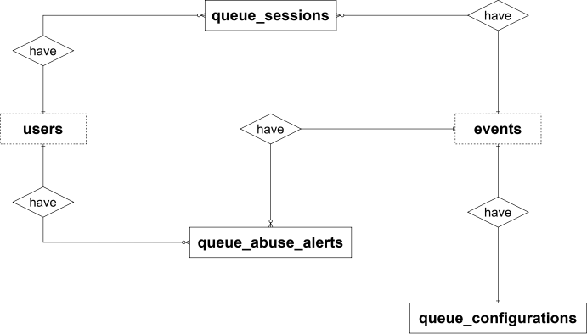
Figure 20 : ERD Diagram - QueueAPI¹⁷
Entities Description
# | Entity | Description
1 | queue_configurations | The virtual queue configuration of an event: the pre-queue window, the admission rate, and the fairness policy used to let buyers into a high-demand sale. Each event has at most one configuration.  Beyond its identifiers, the table also stores pre_queue_start_time, pre_queue_end_time, admission_rate, queue_enabled, and 3 other fields, capturing the operational details specific to this entity.  As this is a microservice database, it does not maintain a real foreign key relationship with any table; instead it holds a soft reference to Events owned by EventAPI, linking the configuration to the event it controls.  PK: queue_configuration_id – Unique identifier for each queue configuration.  Soft ref: event_id – event_db.events: the event this configuration belongs to (no physical FK, cross-service reference).  Unique: event_id – ensures one queue configuration per event.  • queue_configuration_id integer  • event_id integer  • pre_queue_start_time timestamp  • pre_queue_end_time timestamp  • admission_rate integer  • queue_enabled boolean (default true)  • fairness_policy varchar(40) (default 'RANDOMIZED')  • created_at timestamp  • updated_at timestamp
2 | queue_sessions | A virtual queue session for a user waiting to purchase tickets for a high-demand event, used to control traffic during flash sales.  Beyond its identifiers, the table also stores session_id, queue_token, status, position, and 2 other fields, capturing the operational details specific to this entity.  As this is a microservice database, it does not maintain a real foreign key relationship with any table; instead it holds soft references to Events (owned by EventAPI) and Users (owned by Identity service), linking each queue session to the event being queued for and the waiting user.  PK: queue_session_id – Unique identifier for each queue session.  Soft ref: event_id – event_db.events: the event this queue session is for (no physical FK, cross-service reference).  Soft ref: user_id – identity_db.users: the user waiting in the queue (no physical FK, cross-service reference).  Unique: queue_token – each queue token identifies exactly one session.  Unique: (event_id, user_id) – a user can have only one queue session per event.  • queue_session_id bigint  • event_id integer  • user_id integer  • session_id varchar(255)  • queue_token varchar(255)  • status varchar(50) (default 'REGISTERED')  • position integer (nullable)  • created_at timestamp  • updated_at timestamp
3 | queue_abuse_alerts | An alert raised when suspicious behavior is detected in the virtual queue (for example bot-like activity), kept for review and follow-up by administrators.  Beyond its identifiers, the table also stores alert_type, severity, status, detected_behavior, and 3 other fields, capturing the operational details specific to this entity.  As this is a microservice database, it does not maintain a real foreign key relationship with any table; instead it holds soft references to Events (owned by EventAPI) and Users (owned by Identity service), linking each alert to the event and the user that triggered it.  PK: abuse_alert_id – Unique identifier for each abuse alert.  Soft ref: event_id – event_db.events: the event whose queue the alert relates to (no physical FK, cross-service reference).  Soft ref: user_id – identity_db.users: the user whose behavior triggered the alert (no physical FK, cross-service reference).  Index: (event_id, created_at) – supports listing the alerts of an event in time order.  • abuse_alert_id bigint  • event_id integer  • user_id integer  • session_id varchar(255)  • queue_token varchar(255)  • alert_type varchar(100)  • severity varchar(50) (default 'LOW')  • status varchar(50) (default 'OPEN')  • detected_behavior text  • created_at timestamp

• queue_configurations entity:
Attribute | Data type | Primary Key | Foreign Key | Unique | Description
queue_configuration_id | integer | x |  | x | Primary key, auto-incrementing, uniquely identifies each queue configuration
event_id | integer |  |  | x | Soft reference to event_db.events.event_id; the event this configuration belongs to; one configuration per event
pre_queue_start_time | timestamp |  |  |  | Start of the pre-queue period in which users can join the queue
pre_queue_end_time | timestamp |  |  |  | End of the pre-queue period
admission_rate | integer |  |  |  | Rate at which users are admitted from the queue into the purchase flow
queue_enabled | boolean |  |  |  | Whether the virtual queue is enabled for the event; defaults to true
fairness_policy | varchar(40) |  |  |  | Policy used to decide the admission order; defaults to 'RANDOMIZED'
created_at | timestamp |  |  |  | Timestamp when the configuration was created
updated_at | timestamp |  |  |  | Timestamp of the last update
• queue_sessions entity:
Attribute | Data type | Primary Key | Foreign Key | Unique | Description
queue_session_id | bigint | x |  | x | Primary key, auto-incrementing, uniquely identifies each queue session
event_id | integer |  |  |  | Soft reference to event_db.events.event_id; the event being queued for; part of unique key (event_id, user_id)
user_id | integer |  |  |  | Soft reference to identity_db.users.user_id; the waiting user; part of unique key (event_id, user_id)
session_id | varchar(255) |  |  |  | Client session identifier associated with this queue entry
queue_token | varchar(255) |  |  | x | Token identifying this queue session; must be unique
status | varchar(50) |  |  |  | Current status of the queue session; defaults to 'REGISTERED'
position | integer |  |  |  | Current position of the user in the queue; null if not assigned yet
created_at | timestamp |  |  |  | Timestamp when the queue session was created
updated_at | timestamp |  |  |  | Timestamp of the last update
• queue_abuse_alerts entity:
Attribute | Data type | Primary Key | Foreign Key | Unique | Description
abuse_alert_id | bigint | x |  | x | Primary key, auto-incrementing, uniquely identifies each abuse alert
event_id | integer |  |  |  | Soft reference to event_db.events.event_id; the event whose queue the alert relates to
user_id | integer |  |  |  | Soft reference to identity_db.users.user_id; the user whose behavior triggered the alert
session_id | varchar(255) |  |  |  | Client session identifier involved in the alert
queue_token | varchar(255) |  |  |  | Queue token involved in the alert
alert_type | varchar(100) |  |  |  | Type/category of the detected abuse
severity | varchar(50) |  |  |  | Severity level of the alert; defaults to 'LOW'
status | varchar(50) |  |  |  | Handling status of the alert; defaults to 'OPEN'
detected_behavior | text |  |  |  | Description of the suspicious behavior that was detected
created_at | timestamp |  |  |  | Timestamp when the alert was created

4. PaymentAPI Database:
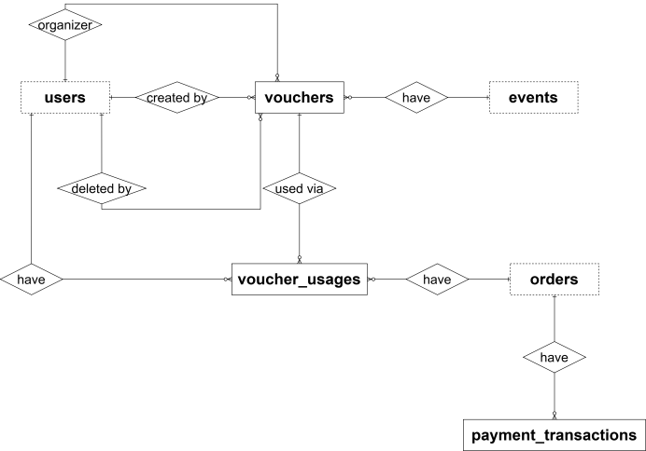
Figure 21 : ERD Diagram - PaymentAPI¹⁸
Entities Description
# | Entity | Description
1 | vouchers | A discount voucher/coupon that can be scoped to a specific event or applied across an organizer's events, defining the discount rules and usage limits.  Beyond its identifiers, the table also stores code, scope, discount_type, discount_amount/discount_percent, total_quantity, used_quantity, and several other fields, capturing the operational details specific to this entity.  As this is a microservice database, it does not maintain a real foreign key relationship with Users or Events; instead it holds soft references to the organizer who issued the voucher, the event it is scoped to, and the users who created or deleted it.  PK: voucher_id – Unique identifier for each voucher.  Unique: code – the redeemable voucher code.  Soft ref: organizer_id – identity_db.users: the organizer who issued the voucher (no physical FK, cross-service reference).  Soft ref: event_id – event_db.events: the event this voucher is scoped to, if any (no physical FK, cross-service reference).  Soft ref: created_by / deleted_by – identity_db.users: the user who created/deleted the voucher (no physical FK, cross-service reference).  • voucher_id integer  • code varchar(50)  • scope varchar(20)  • organizer_id integer  • event_id integer  • discount_type varchar(10)  • discount_amount bigint  • discount_percent numeric(5,2)  • max_discount_amount bigint  • min_order_amount bigint (default 0)  • total_quantity integer  • used_quantity integer (default 0)  • max_usage_per_user integer (default 1)  • starts_at timestamptz  • ends_at timestamptz  • is_active boolean  • created_by integer  • created_at timestamptz  • is_deleted boolean  • deleted_at timestamptz  • deleted_by integer
2 | voucher_usages | Usage history for vouchers, recording each time a voucher is applied to an order, and enforcing per-user redemption limits.  Beyond its identifiers, the table also stores discount_amount and used_at, capturing the operational details specific to this entity.  It maintains a real foreign key relationship with Vouchers within this same database, and holds soft references to Orders and Users owned by other services, recording which voucher was used, on which order, and by whom.  PK: voucher_usage_id – Unique identifier for each usage record.  FK: voucher_id – Vouchers: the voucher that was used (real FK, same database).  Soft ref: order_id – ticket_db.orders: the order the voucher was applied to (no physical FK, cross-service reference).  Soft ref: user_id – identity_db.users: the user who used the voucher (no physical FK, cross-service reference).  Unique: (voucher_id, order_id, user_id) – prevents the same voucher being double-applied to the same order by the same user.  • voucher_usage_id integer  • voucher_id integer  • order_id integer  • user_id integer  • discount_amount bigint  • used_at timestamptz
3 | payment_transactions | A payment transaction processed through a third-party payment gateway (e.g., VNPay) for an order, tracking the request/response lifecycle and webhook confirmation.  Beyond its identifiers, the table also stores gateway, gateway_transaction_ref, amount, status, and 3 other fields, capturing the operational details specific to this entity.  As this is a microservice database, it does not maintain a real foreign key relationship with any table; instead it holds a soft reference to Orders owned by the Ticket service, linking each transaction to the order being paid for.  PK: payment_transaction_id – Unique identifier for each transaction.  Soft ref: order_id – ticket_db.orders: the order this transaction is paying for (no physical FK, cross-service reference).  • payment_transaction_id integer  • order_id integer  • gateway varchar(30) (default 'VNPay')  • gateway_transaction_ref varchar(100)  • amount bigint  • status varchar(20) (default 'Initiated')  • webhook_payload jsonb  • requested_at timestamptz  • responded_at timestamptz

• vouchers entity:
Attribute | Data type | Primary Key | Foreign Key | Unique | Description
voucher_id | integer | x |  | x | Primary key, auto-incrementing, uniquely identifies each voucher
code | varchar(50) |  |  | x | The redeemable voucher code
scope | varchar(20) |  |  |  | Scope of the voucher: applies to a single event or across an organizer's events
organizer_id | integer |  |  |  | Soft reference to identity_db.users.user_id; the organizer who issued the voucher
event_id | integer |  |  |  | Soft reference to event_db.events.event_id; the event this voucher is scoped to, if any
discount_type | varchar(10) |  |  |  | Type of discount: fixed amount or percentage
discount_amount | bigint |  |  |  | Fixed discount amount, used when discount_type is amount-based
discount_percent | numeric(5,2) |  |  |  | Percentage discount, used when discount_type is percent-based
max_discount_amount | bigint |  |  |  | Cap on the discount amount when using a percentage discount
min_order_amount | bigint |  |  |  | Minimum order total required for the voucher to be applicable
total_quantity | integer |  |  |  | Total number of times the voucher can be redeemed
used_quantity | integer |  |  |  | Number of times the voucher has been redeemed so far
max_usage_per_user | integer |  |  |  | Maximum number of times a single user can redeem this voucher
starts_at | timestamptz |  |  |  | Timestamp from which the voucher becomes valid
ends_at | timestamptz |  |  |  | Timestamp after which the voucher is no longer valid
is_active | boolean |  |  |  | Whether the voucher is currently active
created_by | integer |  |  |  | Soft reference to identity_db.users.user_id; who created the voucher
created_at | timestamptz |  |  |  | Timestamp when the voucher was created
is_deleted | boolean |  |  |  | Soft-delete flag
deleted_at | timestamptz |  |  |  | Timestamp when the voucher was soft-deleted
deleted_by | integer |  |  |  | Soft reference to identity_db.users.user_id; who soft-deleted the voucher
• voucher_usages entity:
Attribute | Data type | Primary Key | Foreign Key | Unique | Description
voucher_usage_id | integer | x |  | x | Primary key, auto-incrementing, uniquely identifies each usage record
voucher_id | integer |  | x | x | Foreign key referencing vouchers.voucher_id; the voucher that was used
order_id | integer |  |  | x | Soft reference to ticket_db.orders.order_id; the order the voucher was applied to
user_id | integer |  |  | x | Soft reference to authentication_db.users.user_id; the user who used the voucher
discount_amount | bigint |  |  |  | Actual discount amount applied to this specific order
used_at | timestamptz |  |  |  | Timestamp when the voucher was used
• payment_transactions entity:
Attribute | Data type | Primary Key | Foreign Key | Unique | Description
payment_transaction_id | integer | x |  | x | Primary key, auto-incrementing, uniquely identifies each payment transaction
order_id | integer |  |  |  | Soft reference to ticket_db.orders.order_id; the order this payment is for
gateway | varchar(30) |  |  |  | Payment gateway/provider used
gateway_transaction_ref | varchar(100) |  |  |  | Transaction reference/ID returned by the payment gateway
amount | bigint |  |  |  | Payment amount charged

5. Ticket Database:
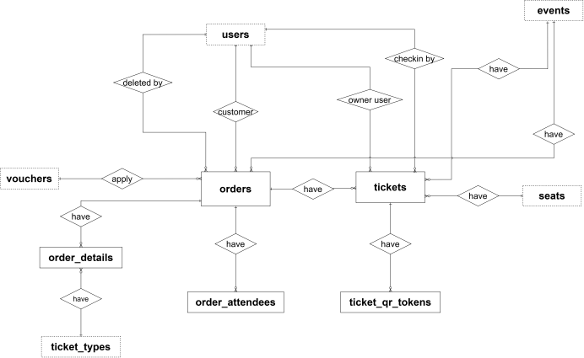

Figure 22 : ERD Diagram - TicketAPI¹⁹

Entities Description
# | Entity | Description
1 | orders | A ticket purchase order placed by a customer for an event, capturing payment details, applied discount, and processing status throughout the checkout lifecycle.  Beyond its identifiers, the table also stores hold_token, payment_gateway_ref, full_name, email, phone, total_amount, final_amount, status, and several other fields, capturing the operational details specific to this entity. It also keeps denormalized snapshots (event_name, poster_url, starts_at, ends_at) so the order remains readable even if the source event changes later.  It maintains a real foreign key relationship with Order Details, Order Attendees and Tickets within this same database, and holds soft references to Users, Events, Queue Sessions, and Vouchers owned by other services, connecting the order to the customer, the event, the queue session it may have come from, and any voucher applied.  PK: order_id – Unique identifier for each order.  Soft ref: customer_id – identity_db.users: the customer who placed the order (no physical FK, cross-service reference).  Soft ref: event_id – event_db.events: the event the order was placed for (no physical FK, cross-service reference).  Soft ref: queue_session_id – queue_db.queue_sessions: the virtual queue session the order originated from, if any (no physical FK, cross-service reference).  Soft ref: voucher_id – payment_db.vouchers: the voucher applied to the order, if any (no physical FK, cross-service reference).  Soft ref: deleted_by – identity_db.users: the user who deleted the order, if applicable (no physical FK, cross-service reference).  • order_id integer  • customer_id integer  • event_id integer  • queue_session_id integer  • voucher_id integer  • hold_token varchar(255)  • payment_gateway_ref varchar(255)  • full_name varchar(255)  • email varchar(255)  • phone varchar(50)  • event_name text  • poster_url text  • order_date timestamptz  • starts_at timestamptz  • ends_at timestamptz  • total_amount bigint  • discount_amount bigint (default 0)  • final_amount bigint  • payment_method varchar(50)  • status varchar(20) (default 'Pending')  • expires_at timestamptz  • is_deleted boolean  • deleted_at timestamptz  • deleted_by integer
2 | order_details | A line item of an order, capturing quantity and unit price for a given ticket type at the moment of purchase.  Beyond its identifiers, the table also stores quantity, unit_price, seat_ids, and a denormalized snapshot field, capturing the operational details specific to this entity. For reserved seating, seat_ids keeps the list of selected seats as a fallback in case the temporary hold in Redis is lost.  It maintains a real foreign key relationship with Orders within this same database, and holds a soft reference to Ticket Types owned by EventAPI, linking each line item to its order and the ticket type purchased.  PK: order_detail_id – Unique identifier for each order line item.  FK: order_id – Orders: the order this line item belongs to (real FK, same database, ON DELETE CASCADE).  Soft ref: ticket_type_id – event_db.ticket_types: the ticket type purchased in this line item (no physical FK, cross-service reference).  • order_detail_id integer  • order_id integer  • ticket_type_id integer  • ticket_type_name varchar(100)  • quantity integer  • unit_price bigint  • seat_ids jsonb
3 | order_attendees | The people attending under an order: the primary buyer and any accompanying attendees, with the identity details (such as citizen ID) that some events, especially concerts, require.  Beyond its identifiers, the table also stores full_name, citizen_id, phone, and is_primary_buyer, capturing the operational details specific to this entity.  It maintains a real foreign key relationship with Orders within this same database, and holds soft references to Ticket Types and Seats owned by EventAPI, linking each attendee to the order and, optionally, to the ticket type and seat assigned to them.  PK: attendee_id – Unique identifier for each attendee.  FK: order_id – Orders: the order this attendee belongs to (real FK, same database, ON DELETE CASCADE).  Soft ref: ticket_type_id – event_db.ticket_types: the ticket type assigned to this attendee, if any (no physical FK, cross-service reference).  Soft ref: seat_id – event_db.seats: the seat assigned to this attendee, if any (no physical FK, cross-service reference).  • attendee_id integer  • order_id integer  • ticket_type_id integer (nullable)  • seat_id integer (nullable)  • full_name varchar(255)  • citizen_id varchar(50)  • phone varchar(50)  • is_primary_buyer boolean (default false)
4 | tickets | A specific ticket issued to a customer after an order has been successfully paid, serving as the source of truth for check-in and ownership.  Beyond its identifiers, the table also stores ticket_code, status, checked_in_at, and several other fields, capturing the operational details specific to this entity. Denormalized snapshot fields (ticket_type_name, owner_name) keep the ticket self-contained for display and check-in purposes.  It maintains a real foreign key relationship with Orders and Ticket QR Tokens within this same database, and holds soft references to Events, Ticket Types, Seats, and Users owned by other services, connecting the ticket to its event, type, seat, owner, and the staff member who checked it in.  PK: ticket_id – Unique identifier for each ticket.  Unique: ticket_code – randomly generated UUID used for secure lookup/scanning.  Unique: seat_id – partial unique index (only when seat_id is not null, status = 'Active' and is_deleted = false) that prevents the same seat from being sold twice.  FK: order_id – Orders: the order this ticket was issued under (real FK, same database, ON DELETE CASCADE).  Soft ref: event_id – event_db.events: the event this ticket admits to (no physical FK, cross-service reference).  Soft ref: ticket_type_id – event_db.ticket_types: the ticket type this ticket belongs to (no physical FK, cross-service reference).  Soft ref: seat_id – event_db.seats: the seat assigned to this ticket, if seat-based (no physical FK, cross-service reference).  Soft ref: owner_user_id / checked_in_by / deleted_by – identity_db.users: the ticket owner, the staff member who checked it in, and who deleted it, if applicable (no physical FK, cross-service reference).  • ticket_id integer  • ticket_code uuid  • order_id integer  • event_id integer  • ticket_type_id integer  • seat_id integer (nullable)  • owner_user_id integer  • ticket_type_name varchar(100)  • owner_name varchar(100)  • status varchar(20) (default 'Active')  • checked_in_at timestamptz  • checked_in_by integer  • is_deleted boolean  • deleted_at timestamptz  • deleted_by integer
5 | ticket_qr_tokens | A rotating QR token bound to a ticket, used for secure check-in and counterfeit prevention — each scan can invalidate the current token and issue a new one.  Beyond its identifiers, the table also stores qr_token, issued_at, expires_at, is_used, and several other fields, capturing the operational details specific to this entity.  It maintains a real foreign key relationship with Tickets within this same database, linking each QR token to the ticket it authenticates.  PK: ticket_qr_token_id – Unique identifier for each QR token.  FK: ticket_id – Tickets: the ticket this QR token authenticates (real FK, same database, ON DELETE CASCADE).  Unique: qr_token – the token string embedded in the QR code.  • ticket_qr_token_id integer  • ticket_id integer  • qr_token varchar(200)  • issued_at timestamptz  • expires_at timestamptz  • is_revoked boolean  • revoked_at timestamptz  • is_used boolean  • used_at timestamptz

• orders entity:
Attribute | Data type | Primary Key | Foreign Key | Unique | Description
order_id | integer | x |  | x | Primary key, auto-incrementing, uniquely identifies each order
customer_id | integer |  |  |  | Soft reference to identity_db.users.user_id; the customer who placed the order
event_id | integer |  |  |  | Soft reference to event_db.events.event_id; the event the order was placed for
queue_session_id | integer |  |  |  | Soft reference to queue_db.queue_sessions.queue_session_id; the virtual queue session the order originated from, if any
voucher_id | integer |  |  |  | Soft reference to payment_db.vouchers; the voucher applied to the order, if any
hold_token | varchar(255) |  |  |  | Token of the temporary ticket hold (from Redis), used for reconciliation if an incident occurs
payment_gateway_ref | varchar(255) |  |  |  | Transaction code returned by the payment gateway (VNPay Vnp_TransactionNo), used for reconciliation
full_name | varchar(255) |  |  |  | Snapshot of the buyer's full name at the time of purchase
email | varchar(255) |  |  |  | Snapshot of the buyer's email
phone | varchar(50) |  |  |  | Snapshot of the buyer's phone number
event_name | text |  |  |  | Snapshot of the event name at the time of purchase
poster_url | text |  |  |  | Snapshot of the event poster URL
order_date | timestamptz |  |  |  | Timestamp when the order was placed; defaults to the current time
starts_at | timestamptz |  |  |  | Snapshot of the event start date/time
ends_at | timestamptz |  |  |  | Snapshot of the event end date/time
total_amount | bigint |  |  |  | Total amount before discount
discount_amount | bigint |  |  |  | Discount applied to the order; defaults to 0
final_amount | bigint |  |  |  | Final amount the customer has to pay after discount
payment_method | varchar(50) |  |  |  | Payment method used for the order
status | varchar(20) |  |  |  | Order status: Pending, Paid, Cancelled, Expired, Refunded; defaults to 'Pending'
expires_at | timestamptz |  |  |  | Time when an unpaid order expires; matches the TTL of the Redis ticket hold
is_deleted | boolean |  |  |  | Soft-delete flag; true if the order has been deleted
deleted_at | timestamptz |  |  |  | Timestamp when the order was deleted
deleted_by | integer |  |  |  | Soft reference to identity_db.users.user_id; the user who deleted the order
• order_details entity:
Attribute | Data type | Primary Key | Foreign Key | Unique | Description
order_detail_id | integer | x |  | x | Primary key, auto-incrementing, uniquely identifies each order line item
order_id | integer |  | x |  | Foreign key referencing orders.order_id (ON DELETE CASCADE); the order this line item belongs to
ticket_type_id | integer |  |  |  | Soft reference to event_db.ticket_types.ticket_type_id; the ticket type purchased
ticket_type_name | varchar(100) |  |  |  | Snapshot of the ticket type name at the time of purchase
quantity | integer |  |  |  | Number of tickets purchased in this line item
unit_price | bigint |  |  |  | Price per ticket at the time of purchase
seat_ids | jsonb |  |  |  | List of selected seat IDs for reserved seating (e.g., [101, 102, 105]); kept as a fallback if the Redis hold is lost
• order_attendees entity:
Attribute | Data type | Primary Key | Foreign Key | Unique | Description
attendee_id | integer | x |  | x | Primary key, auto-incrementing, uniquely identifies each attendee
order_id | integer |  | x |  | Foreign key referencing orders.order_id (ON DELETE CASCADE); the order this attendee belongs to
ticket_type_id | integer |  |  |  | Soft reference to event_db.ticket_types.ticket_type_id; the ticket type assigned to the attendee, if any
seat_id | integer |  |  |  | Soft reference to event_db.seats.seat_id; the seat assigned to the attendee, if any
full_name | varchar(255) |  |  |  | Full name of the attendee
citizen_id | varchar(50) |  |  |  | National ID / identity card / passport number of the attendee
phone | varchar(50) |  |  |  | Phone number of the attendee
is_primary_buyer | boolean |  |  |  | True if the attendee is the account owner who placed the order, false for an accompanying person; defaults to false
• tickets entity:
Attribute | Data type | Primary Key | Foreign Key | Unique | Description
ticket_id | integer | x |  | x | Primary key, auto-incrementing, uniquely identifies each ticket
ticket_code | uuid |  |  | x | Randomly generated UUID used for secure lookup/scanning; defaults to gen_random_uuid()
order_id | integer |  | x |  | Foreign key referencing orders.order_id (ON DELETE CASCADE); the order this ticket was issued under
event_id | integer |  |  |  | Soft reference to event_db.events.event_id; the event this ticket admits to
ticket_type_id | integer |  |  |  | Soft reference to event_db.ticket_types.ticket_type_id; the ticket type of this ticket
seat_id | integer |  |  |  | Soft reference to event_db.seats.seat_id; null for standing zone / general admission; unique among Active, non-deleted tickets (partial unique index) to prevent selling a seat twice
owner_user_id | integer |  |  |  | Soft reference to identity_db.users.user_id; the owner of this ticket
ticket_type_name | varchar(100) |  |  |  | Snapshot of the ticket type name
owner_name | varchar(100) |  |  |  | Snapshot of the ticket owner's name
status | varchar(20) |  |  |  | Ticket status: Active, CheckedIn, Revoked, Refunded; defaults to 'Active'
checked_in_at | timestamptz |  |  |  | Timestamp when the ticket was checked in
checked_in_by | integer |  |  |  | Soft reference to identity_db.users.user_id; the staff member who checked the ticket in
is_deleted | boolean |  |  |  | Soft-delete flag; true if the ticket has been deleted
deleted_at | timestamptz |  |  |  | Timestamp when the ticket was deleted
deleted_by | integer |  |  |  | Soft reference to identity_db.users.user_id; the user who deleted the ticket
• ticket_qr_tokens entity:
Attribute | Data type | Primary Key | Foreign Key | Unique | Description
ticket_qr_token_id | integer | x |  | x | Primary key, auto-incrementing, uniquely identifies each QR token
ticket_id | integer |  | x |  | Foreign key referencing tickets.ticket_id (ON DELETE CASCADE); the ticket this QR token authenticates
qr_token | varchar(200) |  |  | x | Token string embedded in the QR code; must be unique
issued_at | timestamptz |  |  |  | Timestamp when the token was issued; defaults to the current time
expires_at | timestamptz |  |  |  | Timestamp when the token expires
is_revoked | boolean |  |  |  | Whether the token has been revoked; defaults to false
revoked_at | timestamptz |  |  |  | Timestamp when the token was revoked
is_used | boolean |  |  |  | Whether the token has been used for check-in; defaults to false
used_at | timestamptz |  |  |  | Timestamp when the token was used

6. ReturnAPI Database

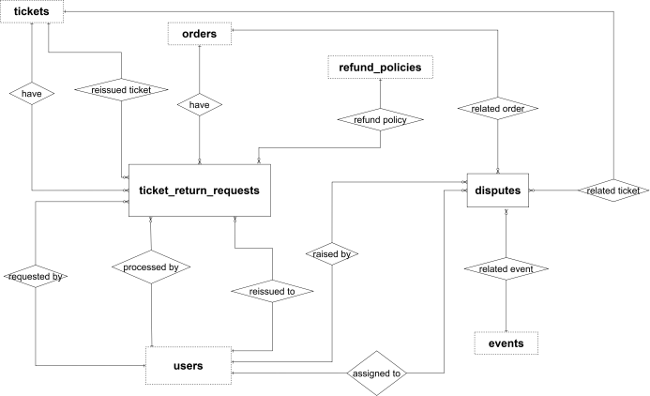
Figure 23 : ERD Diagram - ReturnAPI

Entities Description
# | Entity | Description
1 | ticket_return_requests | A request submitted by a user to return or exchange a ticket, processed according to the applicable refund policy and optionally resulting in a reissued replacement ticket.  Beyond its identifiers, the table also stores reason, status, refund_amount, and several other fields, capturing the operational details specific to this entity.  As this is a microservice database, it does not maintain a real foreign key relationship with any table; instead it holds soft references to Tickets, Orders, Refund Policies, and Users owned by other services, connecting the request to the original ticket and order, the policy applied, and the users involved in requesting, reissuing, and processing it.  PK: return_request_id – Unique identifier for each return request.  Soft ref: ticket_id – ticket_db.tickets: the ticket being returned (no physical FK, cross-service reference).  Soft ref: order_id – ticket_db.orders: the order the ticket was purchased under (no physical FK, cross-service reference).  Soft ref: requested_by – identity_db.users: the user who requested the return (no physical FK, cross-service reference).  Soft ref: refund_policy_id – event_db.refund_policies: the refund policy applied to this request (no physical FK, cross-service reference).  Soft ref: reissued_to_user_id – identity_db.users: the user a replacement ticket was reissued to, if any (no physical FK, cross-service reference).  Soft ref: reissued_ticket_id – ticket_db.tickets: the replacement ticket issued, if any (no physical FK, cross-service reference).  Soft ref: processed_by – identity_db.users: the staff member who processed the request (no physical FK, cross-service reference).  • return_request_id integer  • ticket_id integer  • order_id integer  • requested_by integer  • refund_policy_id integer  • reason varchar(500)  • status varchar(20)  • refund_amount bigint  • reissued_to_user_id integer  • reissued_ticket_id integer  • processed_by integer  • requested_at timestamptz  • processed_at timestamptz
2 | disputes | A dispute or complaint raised by a user, optionally linked to an event, order, or ticket, tracked from opening through resolution.  Beyond its identifiers, the table also stores dispute_type, description, status, resolution, and 1 other field, capturing the operational details specific to this entity.  As this is a microservice database, it does not maintain a real foreign key relationship with any table; instead it holds soft references to Events, Orders, Tickets, and Users owned by other services, connecting a dispute to whichever record it concerns and to the users involved in raising and handling it.  PK: dispute_id – Unique identifier for each dispute.  Soft ref: related_event_id – event_db.events: the event the dispute relates to, if any (no physical FK, cross-service reference).  Soft ref: related_order_id – ticket_db.orders: the order the dispute relates to, if any (no physical FK, cross-service reference).  Soft ref: related_ticket_id – ticket_db.tickets: the ticket the dispute relates to, if any (no physical FK, cross-service reference).  Soft ref: raised_by – identity_db.users: the user who raised the dispute (no physical FK, cross-service reference).  Soft ref: assigned_to – identity_db.users: the staff member assigned to handle the dispute (no physical FK, cross-service reference).  • dispute_id integer  • dispute_type varchar(30)  • related_event_id integer  • related_order_id integer  • related_ticket_id integer  • raised_by integer  • assigned_to integer  • description varchar(2000)  • status varchar(20)  • resolution varchar(2000)  • created_at timestamptz  • resolved_at timestamptz

• ticket_return_requests entity:
Attribute | Data type | Primary Key | Foreign Key | Unique | Description
return_request_id | integer | x |  | x | Primary key, auto-incrementing, uniquely identifies each return request
ticket_id | integer |  |  |  | Soft reference to ticket_db.tickets.ticket_id; the ticket being returned
order_id | integer |  |  |  | Soft reference to ticket_db.orders.order_id; the order the ticket was purchased under
requested_by | integer |  |  |  | Soft reference to identity_db.users.user_id; the user who requested the return
refund_policy_id | integer |  |  |  | Soft reference to event_db.refund_policies.refund_policy_id; the refund policy applied to this request
reason | varchar(500) |  |  |  | Reason given by the user for the return
status | varchar(20) |  |  |  | Return request status lifecycle (default 'Requested')
refund_amount | bigint |  |  |  | Amount refunded to the user, once processed
reissued_to_user_id | integer |  |  |  | Soft reference to identity_db.users.user_id; the user a replacement ticket was reissued to, if any
reissued_ticket_id | integer |  |  |  | Soft reference to ticket_db.tickets.ticket_id; the replacement ticket issued, if any
processed_by | integer |  |  |  | Soft reference to identity_db.users.user_id; the staff member who processed the request
requested_at | timestamptz |  |  |  | Timestamp when the return request was submitted
processed_at | timestamptz |  |  |  | Timestamp when the request was processed
• disputes entity:
Attribute | Data type | Primary Key | Foreign Key | Unique | Description
dispute_id | integer | x |  | x | Primary key, auto-incrementing, uniquely identifies each dispute
dispute_type | varchar(30) |  |  |  | Category/type of the dispute
related_event_id | integer |  |  |  | Soft reference to event_db.events.event_id; the event the dispute relates to, if any
related_order_id | integer |  |  |  | Soft reference to ticket_db.orders.order_id; the order the dispute relates to, if any
related_ticket_id | integer |  |  |  | Soft reference to ticket_db.tickets.ticket_id; the ticket the dispute relates to, if any
raised_by | integer |  |  |  | Soft reference to identity_db.users.user_id; the user who raised the dispute
assigned_to | integer |  |  |  | Soft reference to identity_db.users.user_id; the staff member assigned to handle the dispute
description | varchar(2000) |  |  |  | Detailed description of the dispute
status | varchar(20) |  |  |  | Dispute status lifecycle (default 'Open')
resolution | varchar(2000) |  |  |  | Description of how the dispute was resolved
created_at | timestamptz |  |  |  | Timestamp when the dispute was created
resolved_at | timestamptz |  |  |  | Timestamp when the dispute was resolved

7. CheckinAPI Database
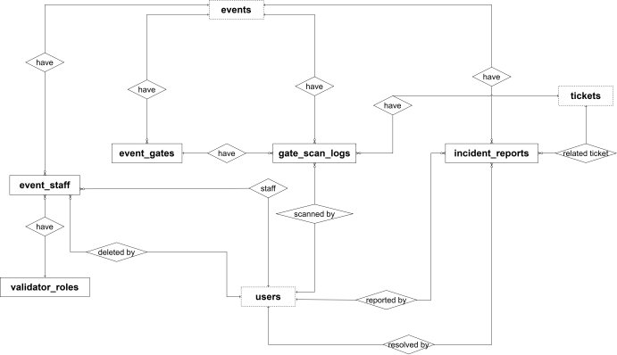
Figure 24 : ERD Diagram - CheckinAPI
Entities Description
# | Entity | Description
1 | validator_roles | List of gate-staff validator roles (e.g., Gate Lead, Ticket Checker), defining what permissions a staff member has during on-site check-in.  Beyond its identifiers, the table also stores role_code, role_name, and description, capturing the operational details specific to this entity.  It maintains a real foreign key relationship with Event Staff within this same database, linking each staff assignment to the role granted.  PK: validator_role_id – Unique identifier for each validator role.  Unique: role_code – short code identifying the role.  FK: none.  • validator_role_id integer  • role_code varchar(30)  • role_name varchar(100)  • description varchar(300)
2 | event_gates | A physical entry gate for an event, used to route attendees during check-in and to attribute scans to a specific entrance.  Beyond its identifiers, the table also stores gate_name, location, and created_at, capturing the operational details specific to this entity.  It maintains a real foreign key relationship with Gate Scan Logs within this same database, and holds a soft reference to Events owned by EventAPI, linking each gate to the event it belongs to.  PK: gate_id – Unique identifier for each gate.  Soft ref: event_id – event_db.events: the event this gate belongs to (no physical FK, cross-service reference).  • gate_id integer  • event_id integer  • gate_name varchar(100)  • location varchar(200)  • created_at timestamptz
3 | event_staff | Staff members (e.g., ticket validators) assigned to work a specific event, including the role they've been granted and whether the assignment is currently active.  Beyond its identifiers, the table also stores assigned_at, expired_at, is_active, and 3 other fields, capturing the operational details specific to this entity.  It maintains a real foreign key relationship with Validator Roles within this same database, and holds soft references to Events and Users owned by other services, connecting a staff assignment to the event, the staff member, and their role.  PK: event_staff_id – Unique identifier for each staff assignment.  Soft ref: event_id – event_db.events: the event this staff member is assigned to (no physical FK, cross-service reference).  Soft ref: staff_id – identity_db.users: the staff member assigned (no physical FK, cross-service reference).  FK: validator_role_id – Validator Roles: the validator role granted for this assignment (real FK, same database).  Soft ref: deleted_by – identity_db.users: the user who removed the assignment, if applicable (no physical FK, cross-service reference).  • event_staff_id integer  • event_id integer  • staff_id integer  • validator_role_id integer  • assigned_at timestamptz  • expired_at timestamptz  • is_active boolean  • is_deleted boolean  • deleted_at timestamptz  • deleted_by integer
5 | incident_reports | An incident report filed during an event (lost ticket, fraud, on-site complaint, etc.), including masked lookup fields to help staff identify the attendee without exposing sensitive data.  Beyond its identifiers, the table also stores incident_type, description, status, resolution_note, and 3 other fields, capturing the operational details specific to this entity.  As this is a microservice database, it does not maintain a real foreign key relationship with any table; instead it holds soft references to Events, Tickets, and Users owned by other services, connecting the incident to the event it occurred at, the ticket it may concern, and the users who reported and resolved it.  PK: incident_report_id – Unique identifier for each incident report.  Soft ref: event_id – event_db.events: the event the incident occurred at (no physical FK, cross-service reference).  Soft ref: reported_by – identity_db.users: the user who reported the incident (no physical FK, cross-service reference).  Soft ref: related_ticket_id – ticket_db.tickets: the ticket the incident concerns, if any (no physical FK, cross-service reference).  Soft ref: resolved_by – identity_db.users: the staff member who resolved the incident (no physical FK, cross-service reference).  • incident_report_id integer  • event_id integer  • reported_by integer  • incident_type varchar(30)  • description varchar(1000)  • related_ticket_id integer  • lookup_phone_masked varchar(20)  • lookup_cccd_last4 varchar(4)  • status varchar(20)  • resolved_by integer  • resolved_at timestamptz  • resolution_note varchar(1000)  • created_at timestamptz

validator_roles entity
Attribute | Data type | Primary Key | Unique | Description
validator_role_id | integer | x | x | Primary key, auto-incrementing, uniquely identifies each validator role
role_code | varchar(30) |  | x | Short code identifying the role
role_name | varchar(100) |  |  | Display name of the role (e.g., Gate Lead, Ticket Checker)
description | varchar(300) |  |  | Description of the role's responsibilities/permissions

- event_gates entity
Attribute | Data type | Primary Key | Unique | Description
gate_id | integer | x | x | Primary key, auto-incrementing, uniquely identifies each gate
event_id | integer |  |  | Soft reference to event_db.events.event_id; the event this gate belongs to
gate_name | varchar(100) |  |  | Name of the gate
location | varchar(200) |  |  | Physical location/description of the gate
created_at | timestamptz |  |  | Timestamp when the gate was created

- event_staff entity

Attribute | Data type | Primary Key | Unique | Description
event_staff_id | integer | x | x | Primary key, auto-incrementing, uniquely identifies each staff assignment
event_id | integer |  |  | Soft reference to event_db.events.event_id; the event this staff member is assigned to
staff_id | integer |  |  | Soft reference to identity_db.users.user_id; the staff member assigned
validator_role_id | integer |  |  | Foreign key referencing validator_roles.validator_role_id; the validator role granted for this assignment
assigned_at | timestamptz |  |  | Timestamp when the staff member was assigned
expired_at | timestamptz |  |  | Timestamp when the assignment expires, if applicable
is_active | boolean |  |  | Whether the assignment is currently active
is_deleted | boolean |  |  | Soft-delete flag
deleted_at | timestamptz |  |  | Timestamp when the assignment was soft-deleted
deleted_by | integer |  |  | Soft reference to identity_db.users.user_id; who removed the assignment, if applicable

- gate_scan_logs entity
Attribute | Data type | Primary Key | Unique | Description
gate_scan_log_id | integer | x | x | Primary key, auto-incrementing, uniquely identifies each scan event
ticket_id | integer |  |  | Soft reference to ticket_db.tickets.ticket_id; the ticket that was scanned
event_id | integer |  |  | Soft reference to event_db.events.event_id; the event the scan took place at
gate_id | integer |  |  | Foreign key referencing event_gates.gate_id; the gate where the scan took place
scanned_by | integer |  |  | Soft reference to identity_db.users.user_id; the staff member who performed the scan
scanner_device_id | varchar(100) |  |  | Identifier of the scanning device used
scan_result | varchar(20) |  |  | Result of the scan (e.g., Valid, Invalid, Duplicate)
face_match_score | numeric(5,2) |  |  | Face-match confidence score, if biometric check-in was used
liveness_score | numeric(5,2) |  |  | Liveness detection confidence score, if biometric check-in was used
device_info | varchar(200) |  |  | Additional metadata about the scanning device
scanned_at | timestamptz |  |  | Timestamp when the scan occurred

- incident_reports entity
Attribute | Data type | Primary Key | Unique | Description
incident_report_id | integer | x | x | Primary key, auto-incrementing, uniquely identifies each incident report
event_id | integer |  |  | Soft reference to event_db.events.event_id; the event the incident occurred at
reported_by | integer |  |  | Soft reference to identity_db.users.user_id; the user who reported the incident
incident_type | varchar(30) |  |  | Type/category of the incident (e.g., lost ticket, fraud, complaint)
description | varchar(1000) |  |  | Description of the incident
related_ticket_id | integer |  |  | Soft reference to ticket_db.tickets.ticket_id; the ticket the incident concerns, if any
lookup_phone_masked | varchar(20) |  |  | Masked phone number used to look up the attendee without exposing full data
lookup_cccd_last4 | varchar(4) |  |  | Last 4 digits of the attendee's national ID, used for lookup verification
status | varchar(20) |  |  | Incident status lifecycle (default 'Open')
resolved_by | integer |  |  | Soft reference to identity_db.users.user_id; the staff member who resolved the incident
resolved_at | timestamptz |  |  | Timestamp when the incident was resolved
resolution_note | varchar(1000) |  |  | Notes describing how the incident was resolved
created_at | timestamptz |  |  | Timestamp when the incident report was created

8. NotificationAPI Database:
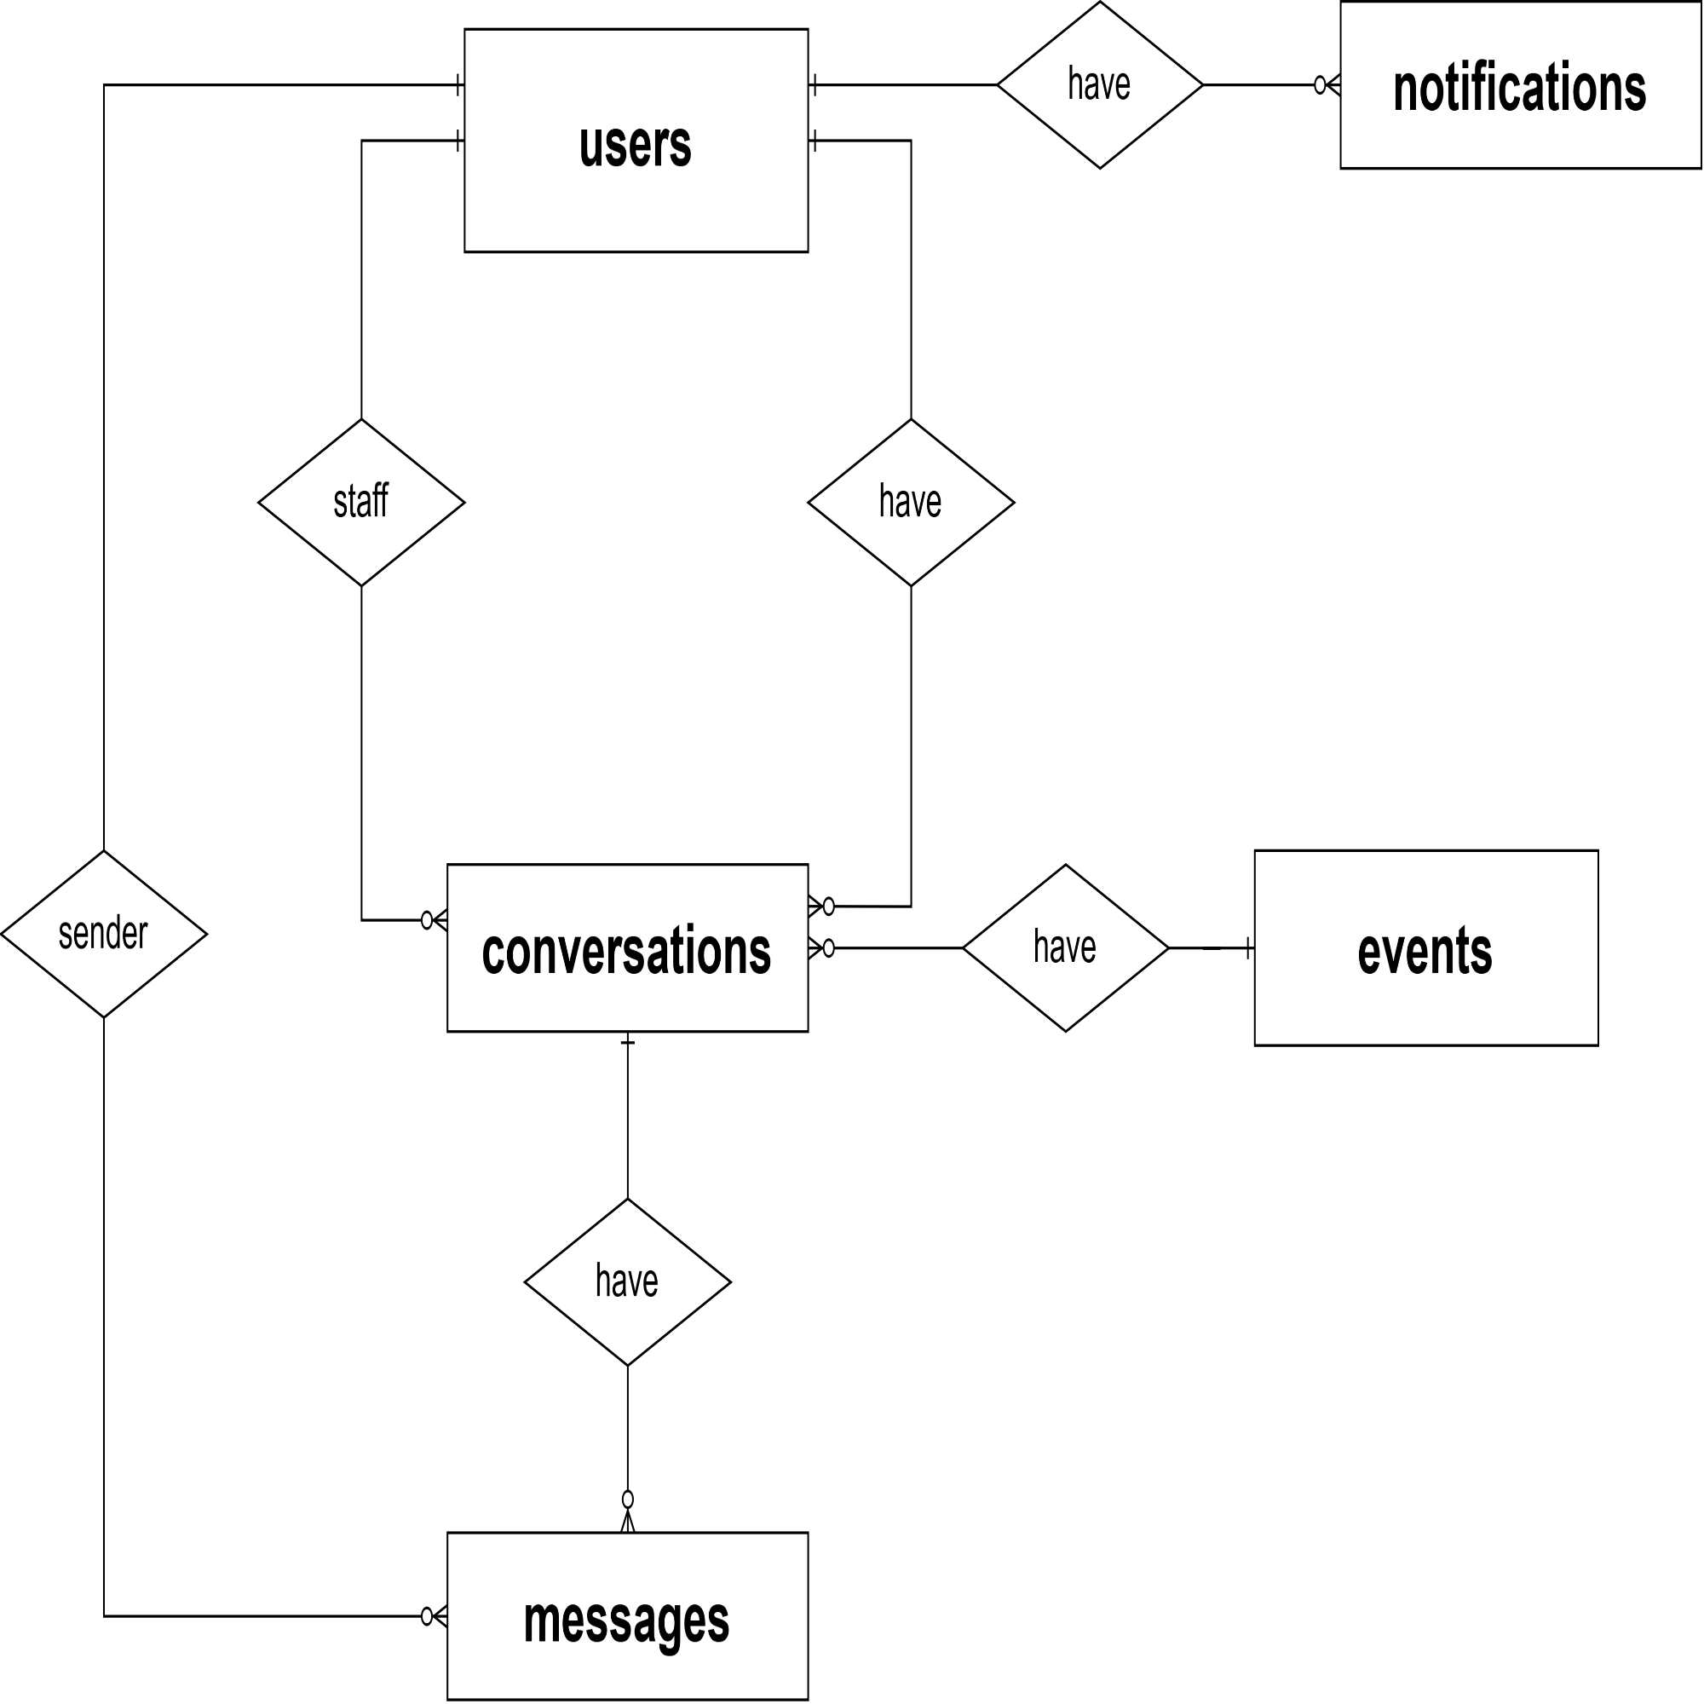
Figure 25 : ERD Diagram - NotificationPI

Entities Description
# | Entity | Description
1 | conversations | A conversation thread between a customer and an organizer, scoped to a specific event, allowing pre-sale or support questions to be threaded per event.  Beyond its identifiers, the table also stores created_at and updated_at, capturing the operational details specific to this entity.  It maintains a real foreign key relationship with Messages within this same database, and holds soft references to Events and Users owned by other services, connecting the conversation to the event and to the two participants involved.  A unique constraint on (event_id, user_id, organizer_id) prevents duplicate threads for the same trio.  PK: conversation_id – Unique identifier for each conversation.  Soft ref: event_id – event_db.events: the event this conversation is scoped to (no physical FK, cross-service reference).  Soft ref: user_id – identity_db.users: the customer participating in the conversation (no physical FK, cross-service reference).  Soft ref: organizer_id – identity_db.users: the organizer participating in the conversation (no physical FK, cross-service reference).  • conversation_id integer  • event_id integer  • user_id integer  • organizer_id integer  • created_at timestamptz  • updated_at timestamptz
2 | messages | An individual message belonging to a conversation between a customer and an organizer.  Beyond its identifiers, the table also stores content, is_read, and created_at, capturing the operational details specific to this entity.  It maintains a real foreign key relationship with Conversations within this same database, and holds a soft reference to Users owned by the Identity service, linking each message to its thread and its sender.  PK: message_id – Unique identifier for each message.  FK: conversation_id – Conversations: the conversation this message belongs to (real FK, same database).  Soft ref: sender_id – identity_db.users: the user who sent the message (no physical FK, cross-service reference).  • message_id integer  • conversation_id integer  • sender_id integer  • content text  • created_at timestamptz  • is_read boolean
3 | notifications | A system notification delivered to a user (reminders, order status updates, etc.), with a polymorphic reference that points to whichever entity triggered it depending on its type.  Beyond its identifiers, the table also stores title, content, type, reference_type, and 2 other fields, capturing the operational details specific to this entity.  As this is a microservice database, it does not maintain a real foreign key relationship with any table; instead it holds a soft reference to Users owned by the Identity service, linking each notification to its recipient. The reference_id field is polymorphic per reference_type (e.g., 'order', 'ticket', 'event') and cannot be constrained by a single FK.  PK: notification_id – Unique identifier for each notification.  Soft ref: user_id – identity_db.users: the recipient of the notification (no physical FK, cross-service reference).  • notification_id integer  • user_id integer  • title varchar(200)  • content text  • type varchar(50)  • reference_type varchar(50)  • reference_id integer  • is_read boolean  • created_at timestamptz

- conversations entity

Attribute | Data type | Primary Key | Unique | Description
conversation_id | integer | x | x | Primary key, auto-incrementing, uniquely identifies each conversation
event_id | integer |  | x | Soft reference to event_db.events.event_id; the event this conversation is scoped to (*unique together with user_id + organizer_id)
user_id | integer |  | x | Soft reference to identity_db.users.user_id; the customer participating in the conversation
organizer_id | integer |  | x | Soft reference to identity_db.users.user_id; the organizer participating in the conversation
created_at | timestamptz |  |  | Timestamp when the conversation was created
updated_at | timestamptz |  |  | Timestamp of the last update (e.g., new message)

- messages entity

Attribute | Data type | Primary Key | Unique | Description
message_id | integer | x | x | Primary key, auto-incrementing, uniquely identifies each message
conversation_id | integer |  |  | Foreign key referencing conversations.conversation_id; the conversation this message belongs to
sender_id | integer |  |  | Soft reference to identity_db.users.user_id; the user who sent the message
content | text |  |  | Message text content
created_at | timestamptz |  |  | Timestamp when the message was sent
is_read | boolean |  |  | Whether the message has been read by the recipient

- notifications entity

Attribute | Data type | Primary Key | Unique | Description
notification_id | integer | x | x | Primary key, auto-incrementing, uniquely identifies each notification
user_id | integer |  |  | Soft reference to identity_db.users.user_id; the recipient of the notification
title | varchar(200) |  |  | Title/headline of the notification
content | text |  |  | Body content of the notification
type | varchar(50) |  |  | Notification type/category
reference_type | varchar(50) |  |  | The kind of entity this notification relates to, e.g. 'order', 'ticket', 'event'
reference_id | integer |  |  | Polymorphic reference to the related entity's ID, interpreted according to reference_type
is_read | boolean |  |  | Whether the notification has been read
created_at | timestamptz |  |  | Timestamp when the notification was created

9. AdminAPI Database
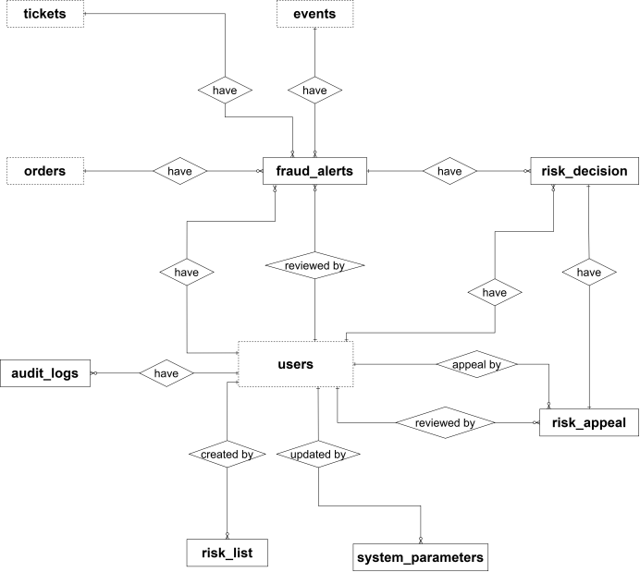
Figure 26 : ERD Diagram - AdminAPI

Entities Description
# | Entity | Description
1 | audit_logs | The Audit Log records significant data-changing actions across the system, supporting traceability and compliance.  Beyond its identifiers, the table also stores actor_type, action, entity_type, old_value, new_value, and 4 other fields, capturing the operational details specific to this entity. The old and new values are kept as JSON snapshots, together with request context (ip_address, request_id, user_agent).  As this is a microservice database, it does not maintain a real foreign key relationship with any table; instead it holds a soft reference to Users owned by the Identity service, linking each audit record to the user who performed the action.  PK: audit_log_id – Unique identifier for each audit record.  Soft ref: user_id – identity_db.users: the user who performed the logged action, if any (no physical FK, cross-service reference).  • audit_log_id bigint  • user_id integer (soft ref)  • actor_type varchar(20) (default 'user')  • action varchar(100)  • entity_type varchar(50)  • entity_id varchar(50)  • old_value jsonb  • new_value jsonb  • ip_address inet  • request_id varchar(100)  • user_agent varchar(500)  • created_at timestamptz
2 | fraud_alerts | A fraud alert raised by the system, related to a user, order, ticket, or event, carrying computed risk scores for staff to triage.  Beyond its identifiers, the table also stores alert_type, risk_score, bot_score, fraud_score, risk_level, status, and several other fields, capturing the operational details specific to this entity. It can also keep an AI-generated summary of the alert (ai_summary, ai_summary_at) to help reviewers.  It maintains a real foreign key relationship with Risk Decisions within this same database, and holds soft references to Users, Orders, Tickets, and Events owned by other services, connecting an alert to whichever record triggered it and to the staff member who reviewed it.  PK: fraud_alert_id – Unique identifier for each alert.  Soft ref: user_id – identity_db.users: the user the alert concerns (no physical FK, cross-service reference).  Soft ref: order_id – ticket_db.orders: the order the alert concerns, if any (no physical FK, cross-service reference).  Soft ref: ticket_id – ticket_db.tickets: the ticket the alert concerns, if any (no physical FK, cross-service reference).  Soft ref: event_id – event_db.events: the event the alert concerns, if any (no physical FK, cross-service reference).  Soft ref: reviewed_by – identity_db.users: the staff member who reviewed the alert (no physical FK, cross-service reference).  • fraud_alert_id integer  • user_id integer  • order_id integer  • ticket_id integer  • event_id integer  • alert_type varchar(30)  • risk_score numeric(5,2)  • details text  • status varchar(20) (default 'Open')  • reviewed_by integer  • reviewed_at timestamptz  • created_at timestamptz  • bot_score numeric(5,2) (default 0)  • fraud_score numeric(5,2) (default 0)  • risk_level varchar(10) (default 'Low')  • session_id varchar(100)  • ai_summary jsonb  • ai_summary_at timestamptz
3 | risk_decision | A decision made by the risk engine (or manually by staff) about a user, order, ticket or session, recording the scores, triggered rules, action taken, and how long it lasts. It also tracks the later restoration of the decision, if any.  Beyond its identifiers, the table also stores decision_code, bot_score, fraud_score, risk_level, triggered_rules, rule_version, action, status, and several other fields, capturing the operational details specific to this entity. Scoring details are kept as JSON (score_by_group, triggered_rules, trust_modifiers, signals_missing), and shadow decisions (is_shadow) are recorded without being enforced.  It maintains a real foreign key relationship with Fraud Alerts within this same database, and holds soft references to Users, Orders, and Tickets owned by other services, linking each decision to the alert it came from and to the staff members who decided or restored it.  PK: risk_decision_id – Unique identifier for each risk decision.  Unique: decision_code – business code identifying the decision.  FK: fraud_alert_id – Fraud Alerts: the alert this decision originates from, if any (real FK, same database, ON DELETE SET NULL).  Soft ref: user_id – identity_db.users: the user the decision applies to (no physical FK, cross-service reference).  Soft ref: order_id – ticket_db.orders: the order the decision applies to, if any (no physical FK, cross-service reference).  Soft ref: ticket_id – ticket_db.tickets: the ticket the decision applies to, if any (no physical FK, cross-service reference).  Soft ref: decided_by / restored_by – identity_db.users: the staff member who made the manual decision and who restored it, if applicable (no physical FK, cross-service reference).  • risk_decision_id integer  • decision_code varchar(30)  • fraud_alert_id integer  • user_id integer  • order_id integer  • ticket_id integer  • session_id varchar(100)  • device_fp varchar(128)  • ip_address inet  • bot_score numeric(5,2) (default 0)  • fraud_score numeric(5,2) (default 0)  • risk_level varchar(10)  • dominant_type varchar(10)  • score_by_group jsonb  • triggered_rules jsonb  • trust_modifiers jsonb  • hard_rule varchar(20)  • signals_missing jsonb  • rule_version varchar(20)  • action varchar(20)  • scope varchar(20)  • reason_public varchar(300)  • escalation_level smallint (default 1)  • is_shadow boolean (default false)  • status varchar(15) (default 'Active')  • expires_at timestamptz  • decided_by_type varchar(10) (default 'SYSTEM')  • decided_by integer  • manual_reason varchar(500)  • restored_by integer  • restored_at timestamptz  • restore_reason varchar(500)  • ai_summary jsonb  • created_at timestamptz
4 | risk_appeal | An appeal submitted by a user against a risk decision, reviewed by staff within a service-level deadline. Each decision can be appealed only once.  Beyond its identifiers, the table also stores reason, evidence, status, sla_due_at, review_note, and several other fields, capturing the operational details specific to this entity. It can also keep an AI-generated summary of the appeal (ai_summary) to help reviewers.  It maintains a real foreign key relationship with Risk Decisions within this same database, and holds soft references to Users owned by the Identity service, linking each appeal to the decision being contested, the user who appealed, and the staff member who reviewed it.  PK: risk_appeal_id – Unique identifier for each appeal.  FK: risk_decision_id – Risk Decisions: the decision being appealed (real FK, same database, ON DELETE CASCADE).  Unique: risk_decision_id – one appeal per risk decision.  Soft ref: user_id – identity_db.users: the user who submitted the appeal (no physical FK, cross-service reference).  Soft ref: reviewed_by – identity_db.users: the staff member who reviewed the appeal (no physical FK, cross-service reference).  • risk_appeal_id integer  • risk_decision_id integer  • user_id integer  • reason varchar(2000)  • evidence jsonb  • status varchar(15) (default 'Pending')  • sla_due_at timestamptz  • reviewed_by integer  • reviewed_at timestamptz  • review_note varchar(1000)  • ai_summary jsonb  • created_at timestamptz
5 | risk_list | A list of risk entries (such as blocked or trusted values) used by the risk engine. Values are stored as hashes, and an entry can be temporary through an expiration time.  Beyond its identifiers, the table also stores list_type, value_type, value_hash, reason, expires_at, and created_at, capturing the operational details specific to this entity.  As this is a microservice database, it does not maintain a real foreign key relationship with any table; instead it holds a soft reference to Users owned by the Identity service, linking each entry to the staff member who created it.  PK: risk_list_id – Unique identifier for each risk list entry.  Unique: (list_type, value_type, value_hash) – prevents duplicate entries in the same list.  Soft ref: created_by – identity_db.users: the staff member who created the entry (no physical FK, cross-service reference).  • risk_list_id integer  • list_type varchar(10)  • value_type varchar(15)  • value_hash varchar(128)  • reason varchar(500)  • expires_at timestamptz  • created_by integer  • created_at timestamptz
6 | system_parameters | System-wide configuration parameters stored as key-value pairs, editable by administrators to tune platform behavior without a code deployment.  Beyond its identifiers, the table also stores param_key, param_value, category, and description, capturing the operational details specific to this entity.  As this is a microservice database, it does not maintain a real foreign key relationship with any table; instead it holds a soft reference to Users owned by the Identity service, linking each parameter to the administrator who last updated it.  PK: system_parameter_id – Unique identifier for each parameter.  Unique: param_key – each parameter key appears only once.  Soft ref: updated_by – identity_db.users: the administrator who last updated this parameter (no physical FK, cross-service reference).  • system_parameter_id integer  • param_key varchar(100)  • param_value varchar(500)  • category varchar(50)  • description varchar(500)  • updated_by integer  • updated_at timestamptz

- audit_logs entity
Attribute | Data type | Primary Key | Unique | Description
audit_log_id | bigint | x | x | Primary key, auto-generated, uniquely identifies each audit record
user_id | integer |  |  | Soft reference to identity_db.users.user_id; the user who performed the action, if any
actor_type | varchar(20) |  |  | Type of actor performing the action; defaults to 'user'
action | varchar(100) |  |  | Action that was performed
entity_type | varchar(50) |  |  | Type of entity affected by the action
entity_id | varchar(50) |  |  | Identifier of the affected entity
old_value | jsonb |  |  | Snapshot of the data before the change
new_value | jsonb |  |  | Snapshot of the data after the change
ip_address | inet |  |  | IP address from which the action was performed
request_id | varchar(100) |  |  | Identifier of the request, used to trace the action across services
user_agent | varchar(500) |  |  | User agent of the client that performed the action
created_at | timestamptz |  |  | Timestamp when the audit record was created

- fraud_alerts entity
Attribute | Data type | Primary Key | Unique | Description
fraud_alert_id | integer | x | x | Primary key, auto-generated, uniquely identifies each fraud alert
user_id | integer |  |  | Soft reference to identity_db.users.user_id; the user the alert concerns
order_id | integer |  |  | Soft reference to ticket_db.orders.order_id; the order the alert concerns, if any
ticket_id | integer |  |  | Soft reference to ticket_db.tickets.ticket_id; the ticket the alert concerns, if any
event_id | integer |  |  | Soft reference to event_db.events.event_id; the event the alert concerns, if any
alert_type | varchar(30) |  |  | Type of the fraud alert
risk_score | numeric(5,2) |  |  | Computed overall risk score of the alert
details | text |  |  | Additional details about the alert
status | varchar(20) |  |  | Handling status of the alert; defaults to 'Open'
reviewed_by | integer |  |  | Soft reference to identity_db.users.user_id; the staff member who reviewed the alert
reviewed_at | timestamptz |  |  | Timestamp when the alert was reviewed
created_at | timestamptz |  |  | Timestamp when the alert was created
bot_score | numeric(5,2) |  |  | Score indicating how likely the activity comes from a bot; defaults to 0
fraud_score | numeric(5,2) |  |  | Score indicating how likely the activity is fraudulent; defaults to 0
risk_level | varchar(10) |  |  | Risk level derived from the scores; defaults to 'Low'
session_id | varchar(100) |  |  | Session identifier related to the alert
ai_summary | jsonb |  |  | AI-generated summary of the alert
ai_summary_at | timestamptz |  |  | Timestamp when the AI summary was generated

- risk_decision entity
Attribute | Data type | Primary Key | Unique | Description
risk_decision_id | integer | x | x | Primary key, auto-generated, uniquely identifies each risk decision
decision_code | varchar(30) |  | x | Business code identifying the decision; must be unique
fraud_alert_id | integer |  |  | Foreign key referencing fraud_alerts.fraud_alert_id (ON DELETE SET NULL); the alert this decision originates from, if any
user_id | integer |  |  | Soft reference to identity_db.users.user_id; the user the decision applies to
order_id | integer |  |  | Soft reference to ticket_db.orders.order_id; the order the decision applies to, if any
ticket_id | integer |  |  | Soft reference to ticket_db.tickets.ticket_id; the ticket the decision applies to, if any
session_id | varchar(100) |  |  | Session identifier related to the decision
device_fp | varchar(128) |  |  | Device fingerprint of the client
ip_address | inet |  |  | IP address of the client
bot_score | numeric(5,2) |  |  | Bot likelihood score at decision time; defaults to 0
fraud_score | numeric(5,2) |  |  | Fraud likelihood score at decision time; defaults to 0
risk_level | varchar(10) |  |  | Risk level resulting from the scores
dominant_type | varchar(10) |  |  | Dominant type of risk (e.g., bot or fraud) behind the decision
score_by_group | jsonb |  |  | Breakdown of the score by rule group
triggered_rules | jsonb |  |  | Rules that were triggered for this decision
trust_modifiers | jsonb |  |  | Trust factors that adjusted the score
hard_rule | varchar(20) |  |  | Hard rule that directly forced the decision, if any
signals_missing | jsonb |  |  | Signals that were unavailable when the decision was made
rule_version | varchar(20) |  |  | Version of the rule set used
action | varchar(20) |  |  | Action taken as a result of the decision
scope | varchar(20) |  |  | Scope the action applies to
reason_public | varchar(300) |  |  | Reason shown to the user
escalation_level | smallint |  |  | Escalation level of the decision; defaults to 1
is_shadow | boolean |  |  | Whether the decision was recorded in shadow mode (evaluated without being enforced); defaults to false
status | varchar(15) |  |  | Status of the decision; defaults to 'Active'
expires_at | timestamptz |  |  | Timestamp when the decision expires
decided_by_type | varchar(10) |  |  | Who made the decision (system or staff); defaults to 'SYSTEM'
decided_by | integer |  |  | Soft reference to identity_db.users.user_id; the staff member who made a manual decision
manual_reason | varchar(500) |  |  | Reason given for a manual decision
restored_by | integer |  |  | Soft reference to identity_db.users.user_id; the staff member who restored the decision
restored_at | timestamptz |  |  | Timestamp when the decision was restored
restore_reason | varchar(500) |  |  | Reason given for the restoration
ai_summary | jsonb |  |  | AI-generated summary of the decision
created_at | timestamptz |  |  | Timestamp when the decision was created

- risk_appeal entity
Attribute | Data type | Primary Key | Unique | Description
risk_appeal_id | integer | x | x | Primary key, auto-generated, uniquely identifies each appeal
risk_decision_id | integer |  | x | Foreign key referencing risk_decision.risk_decision_id (ON DELETE CASCADE); the decision being appealed; one appeal per decision
user_id | integer |  |  | Soft reference to identity_db.users.user_id; the user who submitted the appeal
reason | varchar(2000) |  |  | Reason given by the user for the appeal
evidence | jsonb |  |  | Supporting evidence submitted with the appeal
status | varchar(15) |  |  | Status of the appeal; defaults to 'Pending'
sla_due_at | timestamptz |  |  | Deadline by which the appeal should be reviewed
reviewed_by | integer |  |  | Soft reference to identity_db.users.user_id; the staff member who reviewed the appeal
reviewed_at | timestamptz |  |  | Timestamp when the appeal was reviewed
review_note | varchar(1000) |  |  | Note left by the reviewer
ai_summary | jsonb |  |  | AI-generated summary of the appeal
created_at | timestamptz |  |  | Timestamp when the appeal was created

- risk_list entity
Attribute | Data type | Primary Key | Unique | Description
risk_list_id | integer | x | x | Primary key, auto-generated, uniquely identifies each risk list entry
list_type | varchar(10) |  |  | Type of the list the entry belongs to; part of unique key (list_type, value_type, value_hash)
value_type | varchar(15) |  |  | Type of the listed value (e.g., IP, device); part of unique key (list_type, value_type, value_hash)
value_hash | varchar(128) |  |  | Hash of the listed value; part of unique key (list_type, value_type, value_hash)
reason | varchar(500) |  |  | Reason the value was added to the list
expires_at | timestamptz |  |  | Timestamp when the entry expires, if temporary
created_by | integer |  |  | Soft reference to identity_db.users.user_id; the staff member who created the entry
created_at | timestamptz |  |  | Timestamp when the entry was created

- system_parameters entity
Attribute | Data type | Primary Key | Unique | Description
system_parameter_id | integer | x | x | Primary key, auto-generated, uniquely identifies each parameter
param_key | varchar(100) |  | x | Key of the parameter; must be unique
param_value | varchar(500) |  |  | Value of the parameter
category | varchar(50) |  |  | Category the parameter belongs to
description | varchar(500) |  |  | Description of what the parameter controls
updated_by | integer |  |  | Soft reference to identity_db.users.user_id; the administrator who last updated the parameter
updated_at | timestamptz |  |  | Timestamp of the last update; defaults to the current time

3.2 Feature 1: Authentication & Account Management

3.2.1 Login
FUNCTION TRIGGER:
- The user clicks the "Login" button.
FUNCTION DESCRIPTION:
- Actor(s): Customer, Staff, Event Organizer, Admin
- Purpose:
  - To allow registered users (Customer, Staff, Event Organizer) to log in to the system using their email and password, or their Google account, and access the functions that match their role.
- Main Functionality:
  - The system allows a guest user to log in by entering an email and a password. The system first validates the input, finds the account by email, verifies the password (BCrypt) and checks that the account is active. If the credentials are valid, the system generates an Access Token and a Refresh Token, logs the login event and redirects the user to the homepage of their role. Alternatively, the guest can log in with a Google account: the system verifies the Google ID token, finds the account by email (or creates a new customer account if none exists) and returns the same tokens. The login form also provides links to the Forgot Password and Register functions.
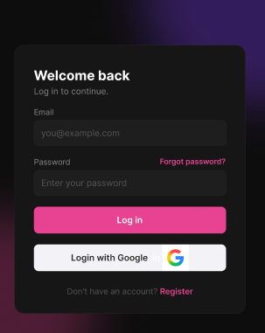

Figure 27 : Login Screen
FUNCTION DETAILS:
- VALIDATION RULES:
  - The email is required, must not be empty, must be in a valid email format, and must not exceed 255 characters.
  - Leading and trailing spaces of the email must be removed, and the email must not be case-sensitive.
  - The password is required and must not be empty.
  - The input must be validated on the client when the guest clicks "Log in", and again on the server.
- NORMAL FLOW:
  - Sub-flow A: Login with a System Account (Email and Password)
Step 1: Guest goes to the Login page.
Step 2: Guest enters the email and password.
Step 3: Guest clicks the "Log in" button.
Step 4: The system validates the input data (email format, password not empty).
Step 5: The AI System screens the login attempt for bot or automated behavior (request rate, device, pattern) and allows it to continue.
Step 6: The system looks up the account by email and checks that the account is verified, not locked, and has a local password set.
Step 7: The system compares the entered password against the stored hashed password.
Step 8: The system generates an Access Token and a Refresh Token and logs the successful login.
Step 9: The system displays a success message and redirects the user to the home page appropriate to the user's role (Customer, Staff, Event Organizer, Admin).
  - Sub-flow B: Login with Google
Step 1: Guest clicks the "Login with Google" button.
Step 2: The system redirects the guest to Google's authentication page.
Step 3: Guest selects a Google account, authenticates and grants access on Google.
Step 4: The system receives the authenticated identity (token and email) from Google and verifies it.
Step 5: The system looks up the account by email:
If the email does not exist, the system creates a new account (AuthProvider = "Google", HasPassword = false).
If the email already exists, the system uses the existing account.
Step 6: The system generates an Access Token and a Refresh Token and logs the successful login.
Step 7: The system displays a success message and redirects the user to the home page of their role (continues at Sub-flow A, Step 9).

- ABNORMAL FLOWS:

  - Abnormal flow 1: Invalid data (occurs at Sub-flow A, Step 4)
Step 1: Guest leaves the email or password empty, or enters an email in an invalid format, and clicks "Log in".
Step 2: The system validates the input and detects errors.
Step 3: The system prevents the login process from continuing.
Step 4: The system displays an error message (invalid email format or missing required field) and highlights the affected fields.
Step 5: Guest corrects the information and submits the form again (returns to Sub-flow A, Step 2).
  - Abnormal flow 2: Suspicious login attempt (occurs at Sub-flow A, Step 5)
Step 1: The AI System detects bot or automated behavior in the login attempt (for example, an abnormal request rate, an unrecognized device or an automated pattern).
Step 2: The system rejects the login attempt before looking up the account.
Step 3: The system logs a warning.
Step 4: The system displays the message "Suspicious activity detected. Please try again later."
Step 5: Guest waits and tries again later.
  - Abnormal flow 3: Account does not exist or wrong password (occurs at Sub-flow A, Steps 6 and 7)
Step 1: Guest enters an email that is not registered, or a password that does not match.
Step 2: The system fails to find the account or to verify the password.
Step 3: The system logs a warning and returns 401 Unauthorized.
Step 4: The system displays the message "Invalid email or password." (does not reveal whether the account exists).
Step 5: Guest re-enters the information (returns to Sub-flow A, Step 2) or selects "Forgot password?".
  - Abnormal flow 4: Local-password login attempted on a Google-registered account (occurs at Sub-flow A, Step 6)
Step 1: Guest enters the email of an account that was created with Google (HasPassword = false) and a password.
Step 2: The system finds the account and detects that it has no local password.
Step 3: The system prevents the login process from continuing.
Step 4: The system displays the message "This account was created with Google Sign-In. Please log in with Google, or use 'Forgot Password' to set a password."
Step 5: Guest returns to Sub-flow A, Step 2, or switches to Sub-flow B (Login with Google), or uses Forgot Password.
  - Abnormal flow 5: Account not verified (occurs at Sub-flow A, Step 6)
Step 1: Guest enters the credentials of an account that has not been verified.
Step 2: The system finds the account and detects that it is not verified.
Step 3: The system prevents the login process from continuing.
Step 4: The system displays the message "Your account has not been verified. Please verify your email to continue."
  - Abnormal flow 6: Account locked (occurs at Sub-flow A, Step 6)
Step 1: Guest enters the credentials of an account that has been locked.
Step 2: The system finds the account and detects that it is locked.
Step 3: The system prevents the login process from continuing.
Step 4: The system displays the message "Your account has been locked. Please contact support."

3.2.2 Register
FUNCTION TRIGGER:
- Trigger 1: Guest clicks the "Register" button on the Login page.
FUNCTION DESCRIPTION:
- Actor(s): Guest
- Secondary actor(s): Email Service
- Purpose:
- To allow a guest to register a new local account on the ConcertShield platform using an email, a password, a full name and an optional phone number, with email verification by OTP.
- Main Functionality:
- The system allows a guest to sign up by entering an email, a password, a full name and, optionally, a phone number. The system first validates the input and checks whether the email is already registered. If valid, the system generates an OTP code, hashes the password (BCrypt), stores the pending registration (full name, email, phone, password hash, OTP and expiry) in the cache for 5 minutes, and sends the OTP to the guest's email through the Email Service. The account is not created at this step; it is created only after the guest verifies the OTP (UC-02 Verify OTP). If the OTP is not verified within 5 minutes, the pending registration expires and the guest must register again.
SCREEN LAYOUT:
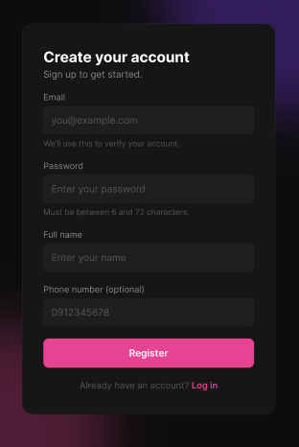
Figure 28 : Register Screen
FUNCTION DETAILS:
- VALIDATION RULES:
  - The email is required, must not be empty, must be in a valid email format, and must not exceed 255 characters.
  - Leading and trailing spaces of the email must be removed, and the email must not be case-sensitive.
  - The email must not already be registered.
  - The password is required, must not be empty, and must be between 6 and 72 characters.
  - The full name is required, must not be empty, must not exceed 100 characters, and leading and trailing spaces must be removed.
  - The phone number is optional. If it is entered, it must be a valid phone number (10 digits starting with 0, for example 0912345678). If it is left empty, it must be skipped.
  - The input must be validated on the client when the guest clicks "Register", and again on the server.

- NORMAL FLOW:
  - Sub-flow A: Register Account
Step 1: Guest goes to the Registration page.
Step 2: Guest enters the email, password, full name and, optionally, the phone number.
Step 3: Guest clicks the "Register" button.
Step 4: The system validates the input data.
Step 5: The system checks whether an account already exists with that email.
Step 6: The system generates an OTP code.
Step 7: The system hashes the password (BCrypt).
Step 8: The system stores the pending registration (full name, email, phone, password hash, OTP, expiry = now + 5 minutes) in the cache, keyed by email.
Step 9: The system sends the OTP code to the guest's email through the Email Service.
Step 10: The system displays the message "Registration successful. Please check your email for the verification OTP code." and redirects the guest to the Email Verification page (UC-02 Verify OTP).
- ABNORMAL FLOWS:
  - Abnormal flow 1: Incomplete or invalid data (occurs at Sub-flow A, Step 4)
Step 1: Guest leaves a required field empty, enters an invalid email or phone number, or enters a password outside 6–72 characters, and clicks "Register".
Step 2: The system validates the input and detects errors.
Step 3: The system prevents the registration process from continuing.
Step 4: The system displays appropriate error messages and highlights the affected fields.
Step 5: Guest corrects the information and submits the form again (returns to Sub-flow A, Step 2).
  - Abnormal flow 2: Email already registered (occurs at Sub-flow A, Step 5)
Step 1: Guest enters an email that already belongs to an existing account.
Step 2: The system finds an existing account with that email.
Step 3: The system logs a warning ("Registration failed: email already exists"). No data is cached and no email is sent.
Step 4: The system returns 400 Bad Request and displays the message "Email already exists."
Step 5: Guest returns to Sub-flow A, Step 2 with a different email, or uses "Forgot Password" if the account is theirs.
  - Abnormal flow 3: System error or Email Service failure (can occur at any step, for example cache failure or the OTP email cannot be sent)
Step 1: An unexpected error occurs while the system processes the registration.
Step 2: The system logs the error, including the attempted email.
Step 3: The system removes any pending registration that was stored, so that no data is left in an inconsistent state.
Step 4: The system returns 500 Internal Server Error and displays the message "An unexpected error occurred while processing your registration. Please try again later."
Step 5: Guest tries again later.
  - Abnormal flow 4: Registration expires before OTP verification
Step 1: Guest does not verify the OTP within 5 minutes.
Step 2: The pending registration expires and is removed from the cache.
Step 3: The system rejects any OTP submitted for that email afterwards.
Step 4: Guest must register again (returns to Sub-flow A, Step 1).

3.2.3 Verify Registration OTP

FUNCTION TRIGGER:
- Trigger 1: Guest is redirected to the Verify OTP page immediately after completing the Register function.
FUNCTION DESCRIPTION:
- Actor(s): Guest
- Purpose:
  - To allow a guest to verify the OTP code sent to their email in order to complete account creation on the ConcertShield platform.
- Main Functionality:
  - The system allows a guest to enter the 6-digit OTP code received by email. The system looks up the pending registration in the cache by email, checks the OTP against the cached OTP and checks that the pending registration has not expired. If valid, the system retrieves the default role, creates a permanent user account from the pending registration data (full name, email, phone, password hash), marked as verified and active, assigns the default role to the user, removes the pending registration from the cache, and confirms that the account has been activated. If the guest did not receive the code, the guest can request a new OTP, which is sent to the same email. The account is created only at this step, not during Register.

SCREEN LAYOUT:
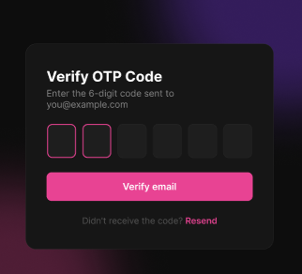\
Figure 29 : Verify Registration OTP Screen
FUNCTION DETAILS:
- VALIDATION RULES:
  - The email is required. It must be carried over from the Register step and shown in the subtitle, and the guest must not type it on this screen.
  - The OTP code is required, must be exactly 6 digits, numeric only, with one digit per box.
  - The input must be validated on the client when the guest clicks "Verify email", and again on the server.

- NORMAL FLOW:
  - Sub-flow A: Verify OTP
Step 1: Guest enters the 6-digit OTP code received by email into the OTP boxes.
Step 2: Guest clicks the "Verify email" button.
Step 3: The system validates the OTP format (6 digits).
Step 4: The system looks up the pending registration in the cache by email.
Step 5: The system checks the submitted OTP against the cached OTP.
Step 6: The system checks that the pending registration has not expired.
Step 7: The system retrieves the default role from the database.
Step 8: The system creates a new user record from the pending registration data (full name, email, phone, password hash), marked as verified and active.
Step 9: The system saves the new user to the database and assigns the default role to the new user.
Step 10: The system removes the pending registration from the cache and logs the account creation.
Step 11: The system displays the message "Email verified successfully. Your account has been activated." and redirects the guest to the Login page.
  - Sub-flow B: Resend OTP
Step 1: Guest clicks the "Resend" link.
Step 2: The system looks up the pending registration in the cache by email.
Step 3: The system generates a new OTP code and updates the pending registration with the new OTP and a new expiry (now + 5 minutes).
Step 4: The system sends the new OTP code to the guest's email through the Email Service.
Step 5: The system displays a confirmation message "A new OTP code has been sent to your email."
- ABNORMAL FLOWS:
  - Abnormal flow 1: Incomplete OTP (occurs at Sub-flow A, Step 3)
Step 1: Guest enters fewer than 6 digits or a non-numeric character, and clicks "Verify email".
Step 2: The system validates the input and detects an error.
Step 3: The system prevents the verification process from continuing.
Step 4: The system displays the message "Please enter the 6-digit code." and highlights the OTP boxes.
Step 5: Guest completes the code and submits again (returns to Sub-flow A, Step 1).
  - Abnormal flow 2: No pending registration found (occurs at Sub-flow A, Step 4 or Sub-flow B, Step 2)
Step 1: The system cannot find a pending registration in the cache for the email (it was never created, already used, or already removed).
Step 2: The system logs a warning ("no pending registration for {Email}").
Step 3: The system returns 404 Not Found and displays the message "No pending registration found for this email. Please register again."
Step 4: Guest restarts from the Register function.
  - Abnormal flow 3: Invalid OTP (occurs at Sub-flow A, Step 5)
Step 1: Guest enters an OTP that does not match the cached OTP.
Step 2: The system logs a warning ("invalid OTP for {Email}").
Step 3: The system returns 400 Bad Request and displays the message "Invalid OTP."
Step 4: The pending registration remains in the cache.
Step 5: Guest re-enters the code (returns to Sub-flow A, Step 1) or clicks "Resend" to receive a new code.
  - Abnormal flow 4: OTP expired (occurs at Sub-flow A, Step 6)
Step 1: Guest submits the OTP after the 5-minute expiry has passed.
Step 2: The system removes the pending registration from the cache.
Step 3: The system logs a warning ("OTP expired for {Email}").
Step 4: The system returns 400 Bad Request and displays the message "OTP has expired. Please register again."
Step 5: Guest restarts from the Register function.
  - Abnormal flow 5: Default role not configured (occurs at Sub-flow A, Step 7)
Step 1: The system cannot find the default role in the database.
Step 2: The system does not create any user account.
Step 3: The system logs the error.
Step 4: The system returns 400 Bad Request with a configuration error message (default role missing in database).
Step 5: The issue is a system setup problem; the administrator must configure the default role before the guest can verify again.
  - Abnormal flow 6: System error or Email Service failure (can occur at any step, for example a database failure while saving the user or role, or the new OTP email cannot be sent)
Step 1: An unexpected error occurs while the system processes the request.
Step 2: The system logs the error, including the attempted email.
Step 3: The system rolls back the operation, so no partial user account is left in the database.
Step 4: The system returns 500 Internal Server Error and displays the message "An unexpected error occurred while verifying your email. Please try again later."
Step 5: Guest tries again later.

3.2.4 Forgot Password
FUNCTION TRIGGER:
- Trigger 1: Guest clicks the "Forgot password?" link on the Login page.
FUNCTION DESCRIPTION:
- Actor(s): Customer
- Secondary actor(s): Email Service
- Purpose:
  - To allow a guest who cannot remember their password to request an OTP code by email, which is then used to reset the password.
- Main Functionality:
  - The system allows a guest to enter the email of their account. The system validates the input and looks up the account by email. If the account exists and is verified, the system generates an OTP code, stores its hash together with an expiry time (5 minutes) on the user record, and sends the OTP to the guest's email through the Email Service. If the email does not exist or the account is not verified, no OTP is generated and no email is sent. In both cases the system returns the same generic success message, so that the response does not reveal whether an email is registered. The guest must then continue to the Reset Password function with the OTP within 5 minutes, otherwise the OTP expires.

SCREEN LAYOUT:
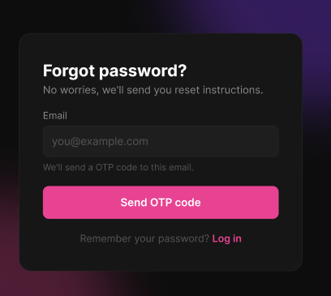
Figure 30 : Forgot Password Screen
FUNCTION DETAILS:
- VALIDATION RULES:
  - The email is required, must not be empty, must be in a valid email format, and must not exceed 255 characters.
  - The input must be validated on the client when the guest clicks "Send OTP code", and again on the server.

- NORMAL FLOW:
  - Sub-flow A: Request Reset OTP
Step 1: Guest goes to the Forgot Password page.
Step 2: Guest enters the email.
Step 3: Guest clicks the "Send OTP code" button.
Step 4: The system validates the input data (email not empty, valid format).
Step 5: The system looks up the account by email.
Step 6: The system checks that the account exists and is verified.
Step 7: The system generates an OTP code.
Step 8: The system hashes the OTP and stores it on the user record, together with an expiry of now + 5 minutes.
Step 9: The system saves the changes to the database.
Step 10: The system sends the OTP code to the guest's email through the Email Service.
Step 11: The system displays the generic message "If this email is registered, you will receive an OTP code to reset your password." and redirects the guest to the OTP verification page to continue with Reset Password.
- ABNORMAL FLOWS:
  - Abnormal flow 1: Incomplete or invalid data (occurs at Sub-flow A, Step 4)
Step 1: Guest leaves the email empty or enters an email in an invalid format, and clicks "Send OTP code".
Step 2: The system validates the input and detects errors.
Step 3: The system prevents the process from continuing.
Step 4: The system displays an appropriate error message and highlights the email field.
Step 5: Guest corrects the email and submits the form again (returns to Sub-flow A, Step 2).
  - Abnormal flow 2: Account does not exist or is not verified (occurs at Sub-flow A, Step 6)
Step 1: Guest enters an email that is not registered, or that belongs to an account that is not verified.
Step 2: The system logs an informational entry ("Forgot-password request for a non-existent/unverified email").
Step 3: The system takes no further action: no OTP is generated, nothing is saved and no email is sent.
Step 4: The system still displays the same generic message as Sub-flow A, Step 11, so as not to reveal whether the account exists.
Step 5: Guest does not receive an email, and may check the email address and try again, or register a new account.
  - Abnormal flow 3: OTP not used within 5 minutes
Step 1: Guest does not continue with the OTP within 5 minutes.
Step 2: The OTP expires.
Step 3: The system rejects the expired OTP in the next step (Reset Password).
Step 4: Guest requests a new OTP (returns to Sub-flow A, Step 1).
  - Abnormal flow 4: System error or Email Service failure (can occur at any step, for example a database save failure or the OTP email cannot be sent)
Step 1: An unexpected error occurs while the system processes the request.
Step 2: The system logs the error, including the attempted email.
Step 3: The system returns 500 Internal Server Error and displays the message "An unexpected error occurred while processing your request. Please try again later."
Step 4: Guest tries again later.

3.2.5 Reset Password
FUNCTION TRIGGER:
- Trigger 1: Guest is redirected to the Reset Password page after successfully verifying the reset OTP (Verify Reset OTP).
- Trigger 2: Guest enters the new password and the confirmation on the Reset Password form and clicks the "Reset password" button.

FUNCTION DESCRIPTION:
- Actor(s): Customer
- Purpose:
  - To allow a guest who has verified the reset OTP to set a new password for their account.
- Main Functionality:
  - The system allows a guest to enter a new password and confirm it. The guest's email and the Reset Token obtained from Verify Reset OTP are carried over from the previous step. The system validates the input, looks up the account by email, and compares the hash of the submitted Reset Token with the Reset Token hash stored in the cache. If they match and the token is still valid, the system hashes the new password (BCrypt), updates the account's password hash, sets HasPassword = true, saves the changes, removes the Reset Token from the cache, and confirms that the password has been reset. The account is marked as having a local password regardless of how it was originally created, so an account created with Google can log in with both Google and the new password.

SCREEN LAYOUT:

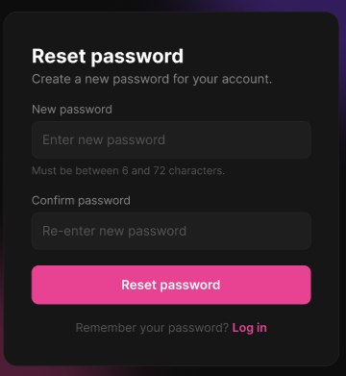
Figure 31 : Reset Password Screen
FUNCTION DETAILS:
- VALIDATION RULES:
  - The new password is required, must not be empty, and must be between 6 and 72 characters.
  - The confirmation of the new password is required, must not be empty, and must be identical to the new password.
  - The input must be validated on the client when the guest clicks "Reset password", and again on the server.

- NORMAL FLOW:
  - Sub-flow A: Reset Password
Step 1: Guest arrives at the Reset Password page after verifying the reset OTP (the email and the Reset Token are carried over).
Step 2: Guest enters the new password and confirms it.
Step 3: Guest clicks the "Reset password" button.
Step 4: The system validates the input data (both fields filled, 6–72 characters, both passwords identical).
Step 5: The system looks up the account by email.
Step 6: The system looks up the stored Reset Token hash in the cache by email.
Step 7: The system compares the hash of the submitted Reset Token against the stored hash.
Step 8: The system hashes the new password (BCrypt) and updates the account's PasswordHash.
Step 9: The system sets HasPassword = true on the account.
Step 10: The system saves the changes to the database.
Step 11: The system removes the Reset Token from the cache.
Step 12: The system logs the successful password reset.
Step 13: The system displays the message "Your password has been reset successfully. Please log in with your new password." and redirects the guest to the Login page.
- ABNORMAL FLOWS:
  - Abnormal flow 1: Incomplete or invalid data
Step 1: Guest leaves a field empty, enters a password outside 6–72 characters, or enters a confirmation that does not match, and clicks "Reset password".
Step 2: The system validates the input and detects errors.
Step 3: The system prevents the process from continuing.
Step 4: The system displays appropriate error messages and highlights the affected fields.
Step 5: Guest corrects the information and submits the form again (returns to Sub-flow A, Step 2).
  - Abnormal flow 2: Account not found or Reset Token mismatch
Step 1: The system cannot find the account by email, or the hash of the submitted Reset Token does not match the stored hash.
Step 2: The system logs a warning ("Password reset OTP verification failed for {Email}").
Step 3: The system does not change the password.
Step 4: The system returns 401 Unauthorized and displays the generic message "Invalid or expired OTP." (it does not distinguish between a wrong token and a non-existent account).
Step 5: Guest restarts from the Forgot Password function.
  - Abnormal flow 3: Reset Token missing or expired
Step 1: The Reset Token no longer exists in the cache, or it has expired.
Step 2: The system logs a warning ("Password reset OTP expired for {Email}").
Step 3: The system does not change the password.
Step 4: The system returns 401 Unauthorized and displays the same generic message "Invalid or expired OTP."
Step 5: Guest restarts from the Forgot Password function.

3.2.6 View Profile
FUNCTION TRIGGER:
- The user clicks the "Profile" icon/menu.

FUNCTION DESCRIPTION:
- Actor(s): Customer, Staff, Event Organizer
- Purpose:
  - To allow a logged-in user to view the personal information of their own account.
- Main Functionality:
  - The system allows a logged-in user to open the Profile page. The system identifies the user from the Access Token, checks that the account exists and is active, and retrieves the profile information: avatar, full name, role, email, phone number and the date the account was created. The page is read-only. From this page the user can go to the Edit Profile function or log out.

SCREEN LAYOUT:

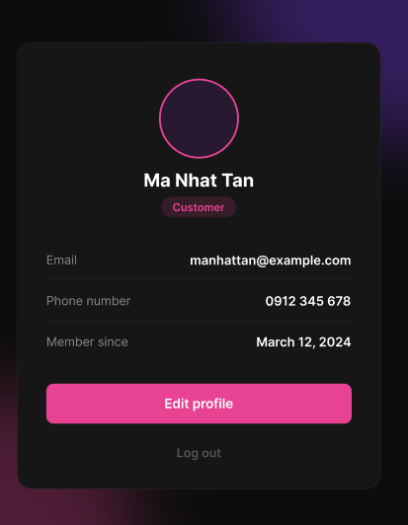
Figure 32 : View Profile Screen
FUNCTION DETAILS:
- VALIDATION RULES:
  - The user must be authenticated. The Access Token must be sent in the Authorization header, and it must be present, valid and not expired. The user must be identified from the claims in the token, so the client must not send a user id.
  - The account referenced by the token must exist and be active.
  - The avatar is optional. It must be shown in a circle, and a default placeholder must be shown if the user has no picture.
  - The full name is required. It must be shown as stored on the account (entered at registration or last updated in Edit Profile) and is read-only on this screen.
  - The role is required. It must be one of Customer, Staff, Event Organizer or Admin, and must be shown as a badge. It is read-only.
  - The email is required. It must be shown as stored on the account and cannot be changed on this screen.
  - The phone number is optional. It must be shown in the format "0912 345 678", and "Not provided" must be shown if the user has not provided one. It is read-only on this screen.
  - The member since date is required. It must be the date the account was created, shown in the format "March 12, 2024". It is read-only.

- NORMAL FLOW:
  - Sub-flow A: View Profile
Step 1: The user clicks on "My Profile" from the navigation menu.
Step 2: The client requests the profile with the Access Token in the Authorization header.
Step 3: The system validates the Access Token and identifies the user from its claims.
Step 4: The system looks up the account and checks that it exists and is active.
Step 5: The system retrieves the profile data (avatar, full name, role, email, phone number, date the account was created).
Step 6: The system returns the profile data.
Step 7: The system displays the full name, avatar, email, phone number, account status, and eKYC verification status (if applicable).
- ABNORMAL FLOWS:
  - Abnormal flow 1: Access Token missing, invalid or expired (occurs at Sub-flow A, Step 2 or 3)
Step 1: The Access Token is missing, invalid or expired when the profile is requested.
Step 2: The system rejects the request and returns 401 Unauthorized.
Step 3: The client tries to obtain a new Access Token with the Refresh Token and repeats the request.
Step 4: If the Refresh Token is also expired or revoked, the client deletes the stored tokens, displays the message "Your session has expired. Please log in again." and redirects the user to the Login page.
  - Abnormal flow 2: Account not found or not active (occurs at Sub-flow A, Step 4)
Step 1: The account referenced by the token no longer exists, or it has been disabled or locked.
Step 2: The system logs a warning and does not return any profile data.
Step 3: The system returns 401 Unauthorized.
Step 4: The client deletes the stored tokens, displays the message "Your account is not available. Please contact support." and redirects the user to the Login page.

3.2.7 Update Profile
FUNCTION TRIGGER:
- Trigger 1: User clicks the "Edit profile" button on the Profile page.
FUNCTION DESCRIPTION:
- Actor(s): Customer, Staff, Event Organizer
- Purpose:
  - To allow a logged-in user to keep their profile details up to date by changing their profile photo, full name and phone number.
- Main Functionality:
  - The system displays the user's current information in a form. The user can change the profile photo (JPG or PNG, maximum 2MB), the full name and the phone number (optional). The email is shown but cannot be changed. When the user clicks "Save changes", the system validates the input, identifies the user from the Access Token, checks that the account exists and is active, uploads the new photo if one was selected, updates the account and confirms the change. If the user clicks "Cancel", the unsaved changes are discarded and the user returns to the Profile page.

SCREEN LAYOUT:
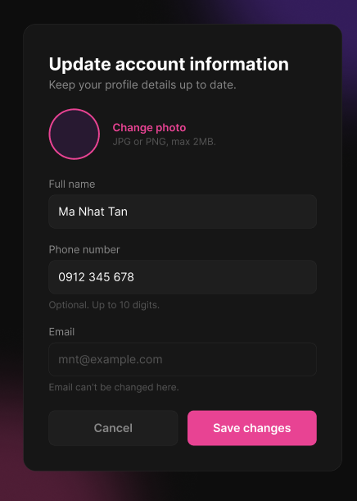
Figure 33 : Update Profile Screen

FUNCTION DETAILS:
- VALIDATION RULES:
  - The user must be authenticated. The Access Token must be sent in the Authorization header, and it must be present, valid and not expired. The user must be identified from the claims in the token, so the client must not send a user id.
  - The photo is optional. If a photo is selected, it must be a JPG or PNG image of at most 2MB. If no new photo is selected, the current photo must be kept.
The full name is required, must not be empty, must not exceed 100 characters, and leading and trailing spaces must be removed.
  - The phone number is optional. If it is entered, it must contain digits only (spaces are ignored) and up to 10 digits. If it is left empty, the phone number must be cleared.
The email is shown for reference only. The field must be disabled and cannot be changed on this screen, and any email value sent by the client must be ignored.
  - The input must be validated on the client when the user selects a photo or clicks "Save changes", and again on the server.

- NORMAL FLOW:
  - Sub-flow A: Update Account Information
Step 1: The logged-in user clicks the "Edit profile" button on the Profile page.
Step 2: The system displays the Update account information form with the current photo, full name, phone number and email (disabled).
Step 3: The user changes the full name and/or the phone number.
Step 4: The user clicks the "Save changes" button.
Step 5: The system validates the input data.
Step 6: The client submits the data with the Access Token in the Authorization header.
Step 7: The system identifies the user from the Access Token claims, looks up the account and checks that it is active.
Step 8: If a new photo was selected, the system uploads it to storage and replaces the previous photo.
Step 9: The system updates the account's full name and phone number.
Step 10: The system saves the changes to the database.
Step 11: The system logs the successful update.
Step 12: The system displays the message "Your profile has been updated successfully." and returns the user to the Profile page showing the new information.
- ABNORMAL FLOWS:
  - Abnormal flow 1: Invalid data Step 1: The user leaves the full name empty, enters a full name longer than 100 characters, or enters a phone number that is not digits only or has more than 10 digits, and clicks "Save changes".
Step 2: The system validates the input and detects errors.
Step 3: The system prevents the update from continuing and saves nothing.
Step 4: The system displays appropriate error messages and highlights the affected fields.
Step 5: The user corrects the information and submits the form again (returns to Sub-flow A, Step 4).
  - Abnormal flow 2: Invalid photo
Step 1: The user selects a file that is not a JPG or PNG image, or that is larger than 2MB.
Step 2: The system validates the file and detects an error.
Step 3: The system does not apply the selected file and keeps the current photo.
Step 4: The system displays the message "Only JPG or PNG images are allowed." or "The image must not exceed 2MB."
Step 5: The user selects another image or continues without changing the photo.
  - Abnormal flow 3: Access Token missing, invalid or expired
Step 1: The Access Token is missing, invalid or expired when the changes are submitted.
Step 2: The system rejects the request, returns 401 Unauthorized and saves nothing.
Step 3: The client tries to obtain a new Access Token with the Refresh Token and repeats the request.
Step 4: If the Refresh Token is also expired or revoked, the client deletes the stored tokens, displays the message "Your session has expired. Please log in again." and redirects the user to the Login page.
  - Abnormal flow 4: Account not found or not active
Step 1: The account referenced by the token no longer exists, or it has been disabled or locked.
Step 2: The system logs a warning and saves nothing.
Step 3: The system returns 401 Unauthorized.
Step 4: The client deletes the stored tokens, displays the message "Your account is not available. Please contact support." and redirects the user to the Login page.
  - Abnormal flow 5: Photo upload failed
Step 1: The storage is unavailable or the upload fails.
Step 2: The system logs the error and does not change the full name, the phone number or the photo.
Step 3: The system returns 500 Internal Server Error and displays the message "Unable to upload the photo. Please try again later."
Step 4: The user tries again, or saves without changing the photo.

3.2.8 Change Password
FUNCTION TRIGGER:
- Trigger 1: User clicks the "Change password" option in the profile settings while logged in.

FUNCTION DESCRIPTION:
- Actor(s): Customer, Staff, Event Organizer
- Purpose:
  - To allow a logged-in user to change the password of their own account by providing the current password and choosing a new one.
- Main Functionality:
  - The system allows a logged-in user to enter the current password, a new password and the confirmation of the new password. The system validates the input, identifies the user from the Access Token, and checks that the account has a local password. It then verifies the current password against the stored password hash (BCrypt) and checks that the new password is different from the current one. If everything is valid, the system hashes the new password (BCrypt), updates the account's password hash, revokes the user's other sessions (Refresh Tokens) while keeping the current session active, and confirms that the password has been changed.
SCREEN LAYOUT:
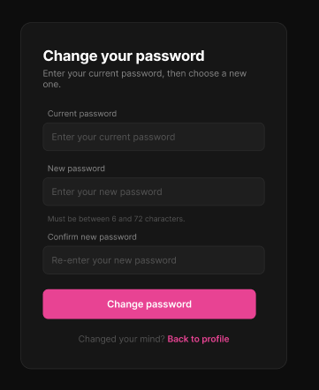
Figure 34 : Change Password Screen

FUNCTION DETAILS:
- VALIDATION RULES:
  - The user must be authenticated. The Access Token must be sent in the Authorization header, and it must be present, valid and not expired. The user must be identified from the claims in the token, so the client must not send a user id.
  - The account referenced by the token must exist, be active and have a local password (HasPassword = true).
  - The current password is required, must not be empty, and must match the password stored on the account.
  - The new password is required, must not be empty, must be between 6 and 72 characters, and must be different from the current password.
  - The confirmation of the new password is required, must not be empty, and must be identical to the new password.
  - The input must be validated on the client when the user clicks "Change password", and again on the server.

- NORMAL FLOW:
  - Sub-flow A: Change Password
Step 1: The logged-in user opens the Change your password page.
Step 2: The user enters the current password, the new password and the confirmation of the new password.
Step 3: The user clicks the "Change password" button.
Step 4: The system validates the input data (all fields filled, new password 6–72 characters, both new passwords identical).
Step 5: The client submits the data with the Access Token in the Authorization header.
Step 6: The system identifies the user from the Access Token claims and looks up the account.
Step 7: The system checks that the account has a local password (HasPassword = true).
Step 8: The system verifies the current password against the stored password hash (BCrypt).
Step 9: The system checks that the new password is different from the current password.
Step 10: The system hashes the new password (BCrypt) and updates the account's PasswordHash.
Step 11: The system saves the changes to the database.
Step 12: The system revokes all other Refresh Tokens of the user, keeping the current session active.
Step 13: The system logs the successful password change.
Step 14: The system displays the message "Your password has been changed successfully." and returns the user to the Profile page.

- ABNORMAL FLOWS:
  - Abnormal flow 1: Incomplete or invalid data (occurs at Sub-flow A, Step 4)
Step 1: The user leaves a field empty, enters a new password outside 6–72 characters, or enters a confirmation that does not match, and clicks "Change password".
Step 2: The system validates the input and detects errors.
Step 3: The system prevents the process from continuing and changes nothing.
Step 4: The system displays appropriate error messages and highlights the affected fields.
Step 5: The user corrects the information and submits the form again (returns to Sub-flow A, Step 3).
  - Abnormal flow 2: Access Token missing, invalid or expired (occurs at Sub-flow A, Step 5 or 6)
Step 1: The Access Token is missing, invalid or expired when the request is submitted.
Step 2: The system rejects the request, returns 401 Unauthorized and changes nothing.
Step 3: The client tries to obtain a new Access Token with the Refresh Token and repeats the request.
Step 4: If the Refresh Token is also expired or revoked, the client deletes the stored tokens, displays the message "Your session has expired. Please log in again." and redirects the user to the Login page.
  - Abnormal flow 3: Account not found or not active (occurs at Sub-flow A, Step 6)
Step 1: The account referenced by the token no longer exists, or it has been disabled or locked.
Step 2: The system logs a warning and changes nothing.
Step 3: The system returns 401 Unauthorized.
Step 4: The client deletes the stored tokens, displays the message "Your account is not available. Please contact support." and redirects the user to the Login page.
  - Abnormal flow 4: Account has no local password (occurs at Sub-flow A, Step 7)
Step 1: The account has no local password (HasPassword = false, for example an account created with Google).
Step 2: The system logs a warning and changes nothing.
Step 3: The system returns 400 Bad Request and displays the message "This account does not have a password yet. Please use the Forgot Password to set one."
Step 4: The user uses the Forgot Password function to set a password, or goes back to the Profile page.
  - Abnormal flow 5: Current password incorrect (occurs at Sub-flow A, Step 8)
Step 1: The user enters a current password that does not match the stored password.
Step 2: The system logs a warning and does not change the password.
Step 3: The system returns 400 Bad Request and displays the message "Current password is incorrect."
Step 4: The user re-enters the current password and submits again (returns to Sub-flow A, Step 3), or uses Forgot Password if the password is forgotten.
  - Abnormal flow 6: New password same as current password (occurs at Sub-flow A, Step 9)
Step 1: The user enters a new password that is identical to the current password.
Step 2: The system detects that the password would not change.
Step 3: The system returns 400 Bad Request and displays the message "New password must be different from the current password."
Step 4: The user enters a different new password and submits again (returns to Sub-flow A, Step 2).

3.2.9 Request Organizer Account
FUNCTION TRIGGER:
- Trigger 1: Customer clicks the "Become an organizer" option on the Account page while logged in.
- FUNCTION DESCRIPTION:
- Actor(s): Customer
- Purpose:
  - To allow a Customer to request an upgrade of their account to an Event Organizer account, by telling the admin why they want to become an organizer and giving information about themselves.
- Main Functionality:
  - The system allows a logged-in Customer to fill in a form with a reason (required) and, optionally, a company name, a website, a phone number and their experience. When the Customer clicks "Submit request", the system validates the input, identifies the user from the Access Token, checks that the account is active, is not already an Event Organizer and has no request waiting for review. If valid, the system creates an organizer request with status Pending and confirms that it has been submitted. The account keeps the Customer role until an Admin approves the request.

SCREEN LAYOUT:
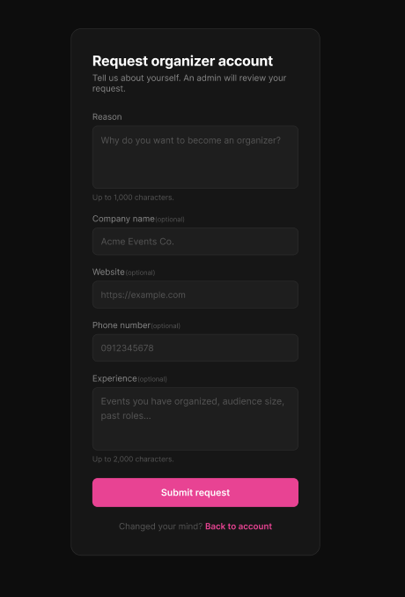

Figure 35 : Request Organizer Screen

FUNCTION DETAILS:
- VALIDATION RULES:
  - The user must be authenticated. The Access Token must be sent in the Authorization header, and it must be present, valid and not expired. The user must be identified from the claims in the token, so the client must not send a user id. If the token is missing, invalid or expired, the message "Your session has expired. Please log in again." must be shown.
  - The account referenced by the token must exist and be active, must have the Customer role (not already an Event Organizer), and must have no organizer request currently in Pending status. If the account is not available, the message "Your account is not available. Please contact support." must be shown; if the user is already an Event Organizer, the message "You are already an Event Organizer." must be shown; if the user already has a pending request, the message "You already have a request that is waiting for review." must be shown.
  - The reason is required. It must not be empty and must not exceed 1,000 characters; leading and trailing spaces must be removed. If empty, the message "Reason is required." must be shown; if it exceeds the limit, the message "Reason must not exceed 1,000 characters." must be shown.
  - The company name is optional. It must not exceed 200 characters. If it exceeds the limit, the message "Company name must not exceed 200 characters." must be shown.
  - The website is optional. If entered, it must be a valid URL starting with http:// or https://, and must not exceed 255 characters. If invalid, the message "Please enter a valid website URL." must be shown; if it exceeds the limit, the message "Website must not exceed 255 characters." must be shown.
  - The phone number is optional. It must not exceed 10 characters, and if entered may contain only digits, spaces and the characters + - ( ). If it exceeds the limit, the message "Phone number must not exceed 10 characters." must be shown; if the format is invalid, the message "Please enter a valid phone number." must be shown.
  - The experience is optional. It must not exceed 2,000 characters. If it exceeds the limit, the message "Experience must not exceed 2,000 characters." must be shown.

- NORMAL FLOW:
  - Sub-flow A: Submit Request
Step 1: The logged-in Customer clicks the "Become an organizer" option on the Account page.
Step 2: The system displays the Request organizer account form.
Step 3: The Customer enters the reason and, optionally, the company name, website, phone number and experience.
Step 4: The Customer clicks the "Submit request" button.
Step 5: The system validates the input data.
Step 6: The client submits the data with the Access Token in the Authorization header.
Step 7: The system identifies the user from the Access Token claims, looks up the account and checks that it is active.
Step 8: The system checks that the account does not already have the Event Organizer role.
Step 9: The system checks that the user has no organizer request in Pending status.
Step 10: The system creates a new organizer request with status Pending, linked to the user, the submitted information and the submission time.
Step 11: The system saves the request to the database.
Step 12: The system logs the successful submission.
Step 13: The system displays the message "Your request has been submitted. An admin will review it soon." and returns the Customer to the Account page.
- ABNORMAL FLOWS:
  - Abnormal flow 1: Incomplete or invalid data Step 1: The Customer leaves the reason empty, enters a value longer than the allowed length, or enters an invalid website or phone number, and clicks "Submit request".
Step 2: The system validates the input and detects errors.
Step 3: The system prevents the process from continuing and creates no request.
Step 4: The system displays appropriate error messages and highlights the affected fields.
Step 5: The Customer corrects the information and submits the form again
  - Abnormal flow 2: Access Token missing, invalid or expired
Step 1: The Access Token is missing, invalid or expired when the request is submitted.
Step 2: The system rejects the request, returns 401 Unauthorized and creates no request.
Step 3: The client tries to obtain a new Access Token with the Refresh Token and repeats the request.
Step 4: If the Refresh Token is also expired or revoked, the client deletes the stored tokens, displays the message "Your session has expired. Please log in again." and redirects the user to the Login page.
  - Abnormal flow 3: Account not found or not active
Step 1: The account referenced by the token no longer exists, or it has been disabled or locked.
Step 2: The system logs a warning and creates no request.
Step 3: The system returns 401 Unauthorized.
Step 4: The client deletes the stored tokens, displays the message "Your account is not available. Please contact support." and redirects the user to the Login page.
  - Abnormal flow 4: Account is already an organizer
Step 1: The account already has the Event Organizer role.
Step 2: The system logs a warning and creates no request.
Step 3: The system returns 409 Conflict and displays the message "You are already an Event Organizer."
Step 4: The Customer returns to the Account page.
  - Abnormal flow 5: Pending request exists
Step 1: The user already has an organizer request in Pending status.
Step 2: The system logs a warning and creates no new request.
Step 3: The system returns 409 Conflict and displays the message "You already have a request that is waiting for review."
Step 4: The Customer returns to the Account page and waits for the Admin's decision.

3.3 Feature 2: eKYC & Identity Verification Flow

3.3.1 Scan Citizen ID Card
FUNCTION TRIGGER:
- Trigger 1: Customer opens the eKYC Verification screen profile and starts scanning the ID card while logged in.
FUNCTION DESCRIPTION:
- Actor(s): Customer
- Secondary actor(s): VNPT AI eKYC Service
- Purpose:
  - To allow a logged-in Customer to scan the front and back of their citizen ID card (CCCD) so that the system can read the card and return the extracted information for the Customer to review.
- Main Functionality:
  - The system guides the Customer through two steps with the camera: first the front side, then the back side of the ID card, each aligned inside a guide frame. After both images are captured, the system validates them, identifies the user from the Access Token and checks that the account is not already verified. It then sends the images to the VNPT AI eKYC service for OCR and card validation, checks the result (the card is recognized, valid, front and back belong to the same card, and the card is not expired), and returns the extracted information (full name, ID number, date of birth, gender, place of origin, place of residence, issue date and expiry date) to the client for the Customer to review. The images are processed in memory and are not stored. This function only reads the card; the verification request is created in UC-06 Submit eKYC Verification, which includes this function.
SCREEN LAYOUT:

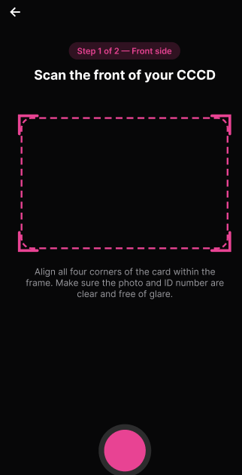
Figure 36 : Scan Citizen ID Card
FUNCTION DETAILS:
- VALIDATION RULES:
  - The user must be authenticated. The Access Token must be sent in the Authorization header, and it must be present, valid and not expired. The user must be identified from the claims in the token, so the client must not send a user id.
  - The account referenced by the token must exist and must not be verified yet.
  - The app must have permission to use the camera to capture the images.
  - The front image is required and must be captured from the camera with all four corners of the card inside the frame. The photo and the ID number must be clear and free of glare.
  - The back image is required and must be captured from the camera with all four corners of the card inside the frame. It must belong to the same card as the front image.
  - Both images must be JPG or PNG files within the allowed size.
  - The ID card must be recognized by VNPT AI as a valid citizen ID card, and all required fields must be extracted.
  - The ID card must not be expired.
  - The images must be validated on the client when the Customer captures them, and again on the server.

- NORMAL FLOW:
  - Sub-flow A: Scan Citizen ID Card
Step 1: The logged-in Customer opens the eKYC Verification screen and starts scanning.
Step 2: The system displays a notice that the ID card images are sent to a third-party verification service, and the Customer gives consent.
Step 3: The system opens the camera and displays the "Step 1 of 2 — Front side" screen with the guide frame.
Step 4: The Customer aligns all four corners of the front of the card within the frame, and checks that the photo and the ID number are clear and free of glare.
Step 5: The Customer taps the capture button.
Step 6: The system displays the "Step 2 of 2 — Back side" screen, and the Customer captures the back of the card in the same way (Steps 4 and 5).
Step 7: The client submits both images with the Access Token in the Authorization header.
Step 8: The system validates the request (both images present, each file has an allowed type and size).
Step 9: The system identifies the user from the Access Token claims and looks up the account.
Step 10: The system checks that the account is not already verified.
Step 11: The system sends the ID card images to the VNPT AI eKYC API for OCR and card validation.
Step 12: VNPT AI returns the extracted information and the validation result.
Step 13: The system checks the result (recognition succeeded, the image is a valid ID card, front and back belong to the same card, required fields were extracted).
Step 14: The system checks that the card is not expired.
Step 15: The system maps the extracted fields (full name, ID number, date of birth, gender, place of origin, place of residence, issue date, expiry date) to the response.
Step 16: The system logs the successful scan (without logging the ID number, extracted data or image content).
Step 17: The system returns the extracted information, and the client displays it for the Customer to review before continuing with UC-06 Submit eKYC Verification.

- ABNORMAL FLOWS:
  - Abnormal flow 1: Camera access denied (occurs at Sub-flow A, Step 3)
Step 1: The Customer has not allowed the app to use the camera.
Step 2: The system cannot open the camera and does not continue the scanning process.
Step 3: The system displays the message "Camera access is required to scan your ID card. Please allow camera access in Settings."
Step 4: The Customer allows camera access and starts scanning again (returns to Sub-flow A, Step 1).
  - Abnormal flow 2: Invalid image (occurs at Sub-flow A, Step 8)
Step 1: An image is missing, its file type is not allowed, or its size exceeds the maximum.
Step 2: The system validates the request and detects the error.
Step 3: The system returns 400 Bad Request and does not send anything to VNPT AI.
Step 4: The system displays the message "Invalid image file. Please upload the front and back of your ID card as JPG or PNG within the allowed size."
Step 5: The Customer captures the images again (returns to Sub-flow A, Step 3).
  - Abnormal flow 3: Access Token missing, invalid or expired (occurs at Sub-flow A, Step 7 or 9)
Step 1: The Access Token is missing, invalid or expired when the images are submitted.
Step 2: The system rejects the request and returns 401 Unauthorized.
Step 3: The client tries to obtain a new Access Token with the Refresh Token and repeats the request.
Step 4: If the Refresh Token is also expired or revoked, the client deletes the stored tokens, displays the message "Your session has expired. Please log in again." and redirects the user to the Login page.
  - Abnormal flow 4: Account not found (occurs at Sub-flow A, Step 9)
Step 1: The account referenced by the token no longer exists.
Step 2: The system logs a warning ("Scan ID card failed: account not found for user {UserId}").
Step 3: The system returns 401 Unauthorized with the generic message "Unauthorized."
Step 4: The client deletes the stored tokens and redirects the user to the Login page.
  - Abnormal flow 5: Account already verified (occurs at Sub-flow A, Step 10)
Step 1: The account has already been verified.
Step 2: The system logs a warning ("Scan ID card rejected: account already verified for {UserId}").
Step 3: The system returns 409 Conflict and displays the message "This account has already been verified."
Step 4: The Customer returns to the previous screen.

  - Abnormal flow 6: VNPT AI service unavailable
Step 1: The request to VNPT AI times out, fails because of a network error, or VNPT AI returns an error response.
Step 2: The system logs the error and returns no data.
Step 3: The system returns 503 Service Unavailable and displays the message "The verification service is temporarily unavailable. Please try again later."
Step 4: The Customer tries again later.
  - Abnormal flow 7: ID card cannot be read or is invalid (occurs at Sub-flow A, Step 13)
Step 1: The image is blurry or has glare, the picture is not an ID card, the front and back do not belong to the same card, required fields are missing, or VNPT AI flags the card as invalid.
Step 2: The system logs a warning ("Scan ID card failed: ID card not recognized for {UserId}").
Step 3: The system returns 400 Bad Request and displays the message "Unable to read your ID card. Please retake clear photos of both sides and try again."
Step 4: The Customer retakes clear photos of both sides (returns to Sub-flow A, Step 3).
  - Abnormal flow 8: ID card expired (occurs at Sub-flow A, Step 14)
Step 1: The expiry date read from the card is in the past.
Step 2: The system logs a warning ("Scan ID card rejected: ID card expired for {UserId}").
Step 3: The system returns 400 Bad Request and displays the message "Your ID card has expired. Please use a valid ID card."
Step 4: The Customer must use a valid ID card and scan again.

3.3.2 Verify Facial Liveness and Match
FUNCTION TRIGGER:
- Trigger 1: After the ID card has been scanned successfully (Scan Citizen ID Card), the Customer is taken to the Liveness check screen while logged in.
FUNCTION DESCRIPTION:
- Actor(s): Customer
- Secondary actor(s): VNPT AI eKYC Service
- Purpose:
  - To confirm that the Customer is a real, live person and that their face matches the portrait on the citizen ID card, as part of the eKYC verification.
- Main Functionality:
  - The system opens the camera and guides the Customer to center their face inside an oval frame and to blink slowly. When the face is ready, the selfie is captured automatically. The client submits the selfie together with the ID card front image (or the scan reference). The system validates the request, identifies the user from the Access Token and checks that the account is not already verified. It sends the selfie to the VNPT AI liveness API and checks that the selfie contains exactly one clear face and that the liveness check passed (a real person, not a printed photo, a screen or a mask). It then sends the selfie and the ID card front image to the VNPT AI face comparison API and checks that the similarity score reaches the configured matching threshold. On success, the system saves the result with an expiry time, so that UC-06 Submit eKYC Verification can confirm it, and returns the result to the client. The images are processed in memory and are not stored. This function only checks the face; the verification request is created in UC-06 Submit eKYC Verification, which includes this function.
SCREEN LAYOUT:
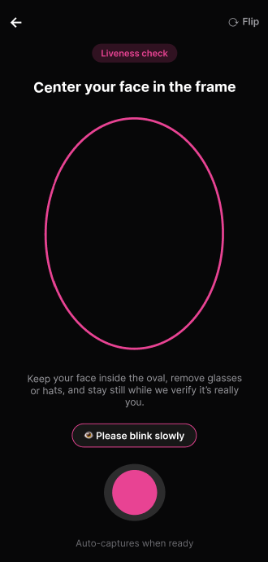
Figure 37 : Verify Facial Liveness Screen

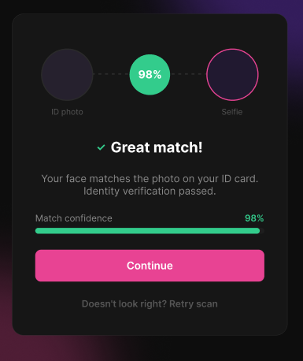
Figure 38 : Check Face Match Screen
FUNCTION DETAILS:
- VALIDATION RULES:
  - The user must be authenticated. The Access Token must be sent in the Authorization header, and it must be present, valid and not expired. The user must be identified from the claims in the token, so the client must not send a user id.
  - The account referenced by the token must exist and must not be verified yet.
  - The app must have permission to use the camera to capture the selfie.
  - The ID card front image (or the scan reference) obtained from Scan Citizen ID Card must be available, because the portrait on it is used for the comparison.
  - The selfie is required and must be captured live from the camera, with the face centered inside the oval, without glasses, hat or mask, and in good lighting.
  - The selfie must be a JPG or PNG file within the allowed size and must contain exactly one clear face.
  - The liveness check (VNPT AI) must pass: the selfie must belong to a real, live person, not a printed photo, a screen replay or a mask.
  - The face match (VNPT AI) must pass: the similarity score between the selfie and the ID card portrait must reach the configured matching threshold.
  - The selfie must be validated on the client when it is captured, and again on the server.

- NORMAL FLOW:
  - Sub-flow A: Verify Facial Liveness and Match
Step 1: After the ID card scan succeeded, the Customer opens the Liveness check screen.
Step 2: The system displays a notice that the facial image is sent to a third-party verification service, and the Customer gives consent.
Step 3: The system opens the camera and displays the "Center your face in the frame" screen with the oval frame.
Step 4: The Customer centers their face inside the oval, removes glasses or hats, stays still and blinks slowly when prompted.
Step 5: The app captures the selfie automatically when ready (or the Customer taps the capture button).
Step 6: The client submits the selfie together with the ID card front image (or the scan reference) with the Access Token in the Authorization header.
Step 7: The system validates the request (both images present, each file has an allowed type and size).
Step 8: The system identifies the user from the Access Token claims and looks up the account.
Step 9: The system checks that the account is not already verified.
Step 10: The system sends the selfie to the VNPT AI liveness API.
Step 11: VNPT AI returns the liveness result.
Step 12: The system checks that the selfie contains exactly one clear face and that the liveness check passed.
Step 13: The system sends the selfie and the ID card front image to the VNPT AI face comparison API.
Step 14: VNPT AI returns the similarity score and the comparison result.
Step 15: The system checks that the similarity score reaches the configured matching threshold.
Step 16: The system saves the successful result with an expiry time.
Step 17: The system logs the successful verification (without logging image content or facial data).
Step 18: The system returns the result, and the client displays the message "Face verified successfully." and continues with UC-06 Submit eKYC Verification.
- ABNORMAL FLOWS:
  - Abnormal flow 1: Camera access denied (occurs at Sub-flow A, Step 3)
Step 1: The Customer has not allowed the app to use the camera.
Step 2: The system cannot open the camera and does not continue the verification process.
Step 3: The system displays the message "Camera access is required to verify your face. Please allow camera access in Settings."
Step 4: The Customer allows camera access and opens the screen again (returns to Sub-flow A, Step 1).
  - Abnormal flow 2: Invalid image (occurs at Sub-flow A, Step 7)
Step 1: The selfie is missing, its file type is not allowed, or its size exceeds the maximum.
Step 2: The system validates the request and detects the error.
Step 3: The system returns 400 Bad Request and does not send anything to VNPT AI.
Step 4: The system displays the message "Invalid image file. Please capture your face again using your camera."
Step 5: The Customer captures the selfie again (returns to Sub-flow A, Step 3).
  - Abnormal flow 3: ID card front image missing (occurs at Sub-flow A, Step 7)
Step 1: The ID card front image (or the scan reference) is not available.
Step 2: The system returns 400 Bad Request and does not send anything to VNPT AI.
Step 3: The system displays the message "Please scan your ID card first."
Step 4: The Customer returns to Scan Citizen ID Card.
  - Abnormal flow 4: Access Token missing, invalid or expired (occurs at Sub-flow A, Step 6 or 8)
Step 1: The Access Token is missing, invalid or expired when the selfie is submitted.
Step 2: The system rejects the request and returns 401 Unauthorized.
Step 3: The client tries to obtain a new Access Token with the Refresh Token and repeats the request.
Step 4: If the Refresh Token is also expired or revoked, the client deletes the stored tokens, displays the message "Your session has expired. Please log in again." and redirects the user to the Login page.
  - Abnormal flow 5: Account not found (occurs at Sub-flow A, Step 8)
Step 1: The account referenced by the token no longer exists.
Step 2: The system logs a warning ("Face verification failed: account not found for user {UserId}").
Step 3: The system returns 401 Unauthorized with the generic message "Unauthorized."
Step 4: The client deletes the stored tokens and redirects the user to the Login page.
  - Abnormal flow 6: Account already verified (occurs at Sub-flow A, Step 9)
Step 1: The account has already been verified.
Step 2: The system logs a warning ("Face verification rejected: account already verified for {UserId}").
Step 3: The system returns 409 Conflict and displays the message "This account has already been verified."
Step 4: The Customer returns to the previous screen.
  - Abnormal flow 7: VNPT AI service unavailable (occurs at Sub-flow A, Step 10 or 13)
Step 1: The request to VNPT AI times out, fails because of a network error, or VNPT AI returns an error response.
Step 2: The system logs the error and saves no result.
Step 3: The system returns 503 Service Unavailable and displays the message "The verification service is temporarily unavailable. Please try again later."
Step 4: The Customer tries again later.
  - Abnormal flow 8: Selfie cannot be processed (occurs at Sub-flow A, Step 12)
Step 1: No face is detected, more than one face is detected, or the image is too dark, blurry or partially covered.
Step 2: The system logs a warning ("Face verification failed: selfie not usable for {UserId}").
Step 3: The system returns 400 Bad Request and displays the message "We could not detect a clear face. Please retake your selfie in good lighting and try again."
Step 4: The Customer retakes the selfie (returns to Sub-flow A, Step 3).
  - Abnormal flow 9: Liveness check failed (occurs at Sub-flow A, Step 12)
Step 1: VNPT AI detects a printed photo, a screen replay or a mask.
Step 2: The system logs a warning ("Face verification rejected: liveness check failed for {UserId}").
Step 3: The system returns 400 Bad Request and displays the message "Liveness check failed. Please capture a live selfie directly with your camera."
Step 4: The Customer captures a live selfie again (returns to Sub-flow A, Step 3).
  - Abnormal flow 10: Face does not match (occurs at Sub-flow A, Step 15)
Step 1: The similarity score is below the matching threshold.
Step 2: The system logs a warning ("Face verification rejected: face does not match ID card for {UserId}").
Step 3: The system saves no result, returns 400 Bad Request and displays the message "Your face does not match the photo on your ID card. Please try again."
Step 4: The Customer tries again (returns to Sub-flow A, Step 3).

3.3.3 Configure eKYC Consent Content
FUNCTION TRIGGER:
- Trigger 1: The Admin selects "eKYC Consent" in the admin menu while logged in.
FUNCTION DESCRIPTION:
- Actor(s): Admin
- Purpose:
To let the Admin manage the notice and consent wording that Customers must accept before submitting an eKYC verification, and to control which version is currently in force.
- Main Functionality:
The system shows all consent versions with their title, status (Active or Inactive), number of consents, creation time and creator. The Admin can view the full content of a version, create a new version, activate an inactive version, or delete an inactive version. A new version contains a version name, a title, one or more sections (each with a heading and content), and the checkbox text the Customer must tick. The Admin can choose to activate the version immediately after it is created. The content of a version cannot be edited once it is created; to change the wording, the Admin creates a new version. When a version is activated, it replaces the current active version, and every Customer must consent again on the next eKYC submission. The system identifies the Admin from the Access Token and records the Admin as the creator of the version. This function only manages the consent content; the Customer gives consent in UC-06 Submit eKYC Verification.
SCREEN LAYOUT:
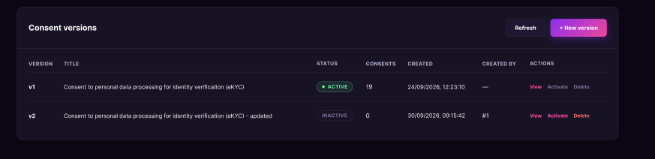
Figure 39 : Consent Version list Screen

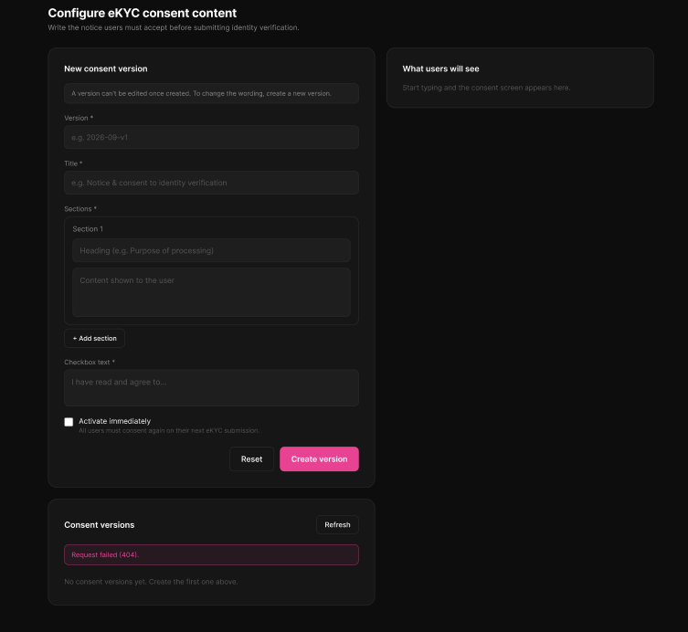
Figure 40 : Create new consent Screen
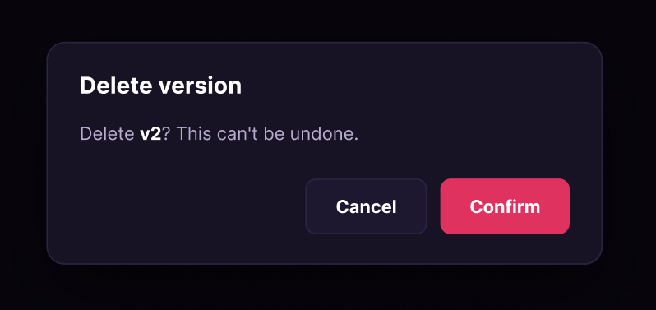
Figure 41 : Delete Consent Screen

FUNCTION DETAILS:
- VALIDATION RULES:
  - The user must be authenticated. The Access Token must be sent in the Authorization header, and it must be present, valid and not expired.
  - The user must have the permission to manage users (policy CanManageUsers).
  - The Admin must be identified from the claims in the token, so the client must not send a user id.
  - The version name is required and must be unique among all consent versions.
  - The title is required.
  - The checkbox text is required.
  - There must be at least one section, and every section must have a heading and content.
  - The version to view, activate or delete must exist.
  - An active version cannot be deleted.
  - The data must be validated on the client when the Admin submits the form, and again on the server.

- NORMAL FLOW:
  - Sub-flow A: View the list of consent versions
Step 1: The Admin opens the "eKYC Consent" page.
Step 2: The client sends the request with the Access Token in the Authorization header.
Step 3: The system checks the token and the permission of the Admin.
Step 4: The system retrieves all consent versions.
Step 5: The system returns the list, and the client displays each version's name, title, status, number of consents, creation time and creator.
  - Sub-flow B: View a consent version
Step 1: The Admin selects "View" on a version.
Step 2: The system checks the token and the permission of the Admin.
Step 3: The system retrieves the version, including its sections and checkbox text.
Step 4: The client displays the version as the Customer will see it: title, sections and checkbox text.
Step 5: The Admin closes the popup.
  - Sub-flow C: Create a new consent version
Step 1: The Admin selects "+ New version".
Step 2: The system displays the New consent version form.
Step 3: The Admin enters the version name and the title.
Step 4: The Admin enters a heading and content for each section, adding or removing sections as needed.
Step 5: The Admin enters the checkbox text and chooses whether to activate the version immediately.
Step 6: The Admin selects "Create version".
Step 7: The client validates the input and submits it with the Access Token in the Authorization header.
Step 8: The system checks the token and the permission of the Admin, and identifies the Admin from the token claims.
Step 9: The system validates the request (required fields, at least one complete section).
Step 10: The system checks that the version name does not already exist.
Step 11: The system saves the new version with the Admin as creator, and with zero consents.
Step 12: If "Activate immediately" was chosen, the system sets the new version as the active version and deactivates the previous one.
Step 13: The system returns the created version, and the client displays the message "Consent version created." and refreshes the list.
  - Sub-flow D: Activate a consent version
Step 1: The Admin selects "Activate" on an inactive version.
Step 2: The system displays a confirmation: "Activate {version}? Every user will have to consent again on their next eKYC submission."
Step 3: The Admin selects "Confirm".
Step 4: The system checks the token and the permission of the Admin.
Step 5: The system checks that the version exists.
Step 6: The system sets the version as the active version and deactivates the previous one.
Step 7: The system returns the message "Consent version activated. Users must consent again on their next submission.", and the client displays it and refreshes the list.
  - Sub-flow E: Delete a consent version
Step 1: The Admin selects "Delete" on an inactive version.
Step 2: The system displays a confirmation: "Delete {version}? This can't be undone."
Step 3: The Admin selects "Confirm".
Step 4: The system checks the token and the permission of the Admin.
Step 5: The system checks that the version exists and is not active.
Step 6: The system deletes the version.
Step 7: The system returns the message "Consent version deleted.", and the client displays it and refreshes the list.

- ABNORMAL FLOWS:
  - Abnormal flow 1: Access Token missing, invalid or expired (occurs at Sub-flow A, B, C, D or E, when the request is sent)
Step 1: The Access Token is missing, invalid or expired.
Step 2: The system rejects the request and returns 401 Unauthorized.
Step 3: The client tries to obtain a new Access Token with the Refresh Token and repeats the request.
Step 4: If the Refresh Token is also expired or revoked, the client deletes the stored tokens, displays the message "Your session has expired. Please log in again." and redirects the user to the Login page.
  - Abnormal flow 2: No permission (occurs at Sub-flow A, B, C, D or E, when the permission is checked)
Step 1: The account does not have the permission to manage users.
Step 2: The system returns 403 Forbidden and does not perform the action.
Step 3: The client displays the message "You do not have permission to perform this action."
Step 4: The user returns to the previous screen.
  - Abnormal flow 3: Required information missing (occurs at Sub-flow C, Step 7 or 9)
Step 1: The version name, the title or the checkbox text is empty.
Step 2: The client detects the error and does not submit the form.
Step 3: The system displays the message "Version, title and checkbox text are required."
Step 4: The Admin completes the fields (returns to Sub-flow C, Step 3).
  - Abnormal flow 4: Section incomplete (occurs at Sub-flow C, Step 7 or 9)
Step 1: There is no section, or a section has no heading or no content.
Step 2: The client detects the error and does not submit the form.
Step 3: The system displays the message "Every section needs a heading and content."
Step 4: The Admin completes or removes the section (returns to Sub-flow C, Step 4).
  - Abnormal flow 5: Version name already exists (occurs at Sub-flow C, Step 10)
Step 1: A consent version with the same name already exists.
Step 2: The system saves nothing and returns 400 Bad Request with an error message.
Step 3: The client displays the error message in the form.
Step 4: The Admin enters a different version name (returns to Sub-flow C, Step 3).
  - Abnormal flow 6: Consent version not found (occurs at Sub-flow B, Step 3; Sub-flow D, Step 5; or Sub-flow E, Step 5)
Step 1: The version no longer exists, for example because another Admin deleted it.
Step 2: The system returns 404 Not Found with an error message.
Step 3: The client closes the popup and displays the error message.
Step 4: The client refreshes the list (returns to Sub-flow A, Step 1).
  - Abnormal flow 7: Active version cannot be deleted (occurs at Sub-flow E, Step 5)
Step 1: The version is currently active.
Step 2: The system does not delete it and returns 400 Bad Request with an error message.
Step 3: The client closes the popup and displays the error message.
Step 4: The Admin activates another version first, then deletes this one (returns to Sub-flow D, Step 1).
  - Abnormal flow 8: Unexpected server error (occurs at Sub-flow A, B, C, D or E)
Step 1: An unexpected error occurs while the system processes the request.
Step 2: The system logs the error and saves no change.
Step 3: The system returns 500 Internal Server Error, and the client displays the message "An unexpected error occurred. Please try again later."
Step 4: The Admin tries again later.

3.3.4 Configure eKYC Data Retention Policy
FUNCTION TRIGGER:
- Trigger 1: The Admin selects "Data retention policy" in the admin menu while logged in.
FUNCTION DESCRIPTION:
- Actor(s): Admin
- Secondary actor(s): None
- Purpose:
  - To let the Admin control how long eKYC data is kept before it is deleted automatically, and whether the hash of the ID document is kept after the data is deleted.
- Main Functionality:
  - The system shows the current retention policy: the retention period in days, whether the document hash is kept after deletion, and when and by whom the policy was last updated. The Admin can change the retention period and the "Keep document hash after deletion" option, then save the change. A retention period of 0 means that automatic deletion is turned off. The system identifies the Admin from the Access Token and records the Admin and the time of the change. The policy is a single setting that applies to the whole system. This function only configures the policy; the automatic deletion itself runs in the system and is not started by this function.

SCREEN LAYOUT:
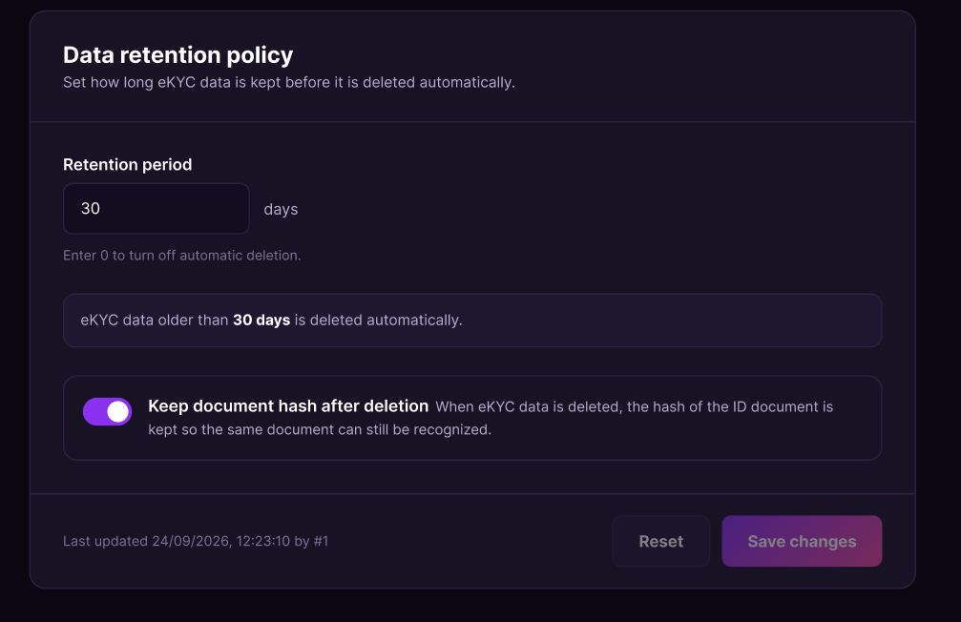
Figure 42 : Configure eKYC Data Retention Policy Screen
FUNCTION DETAILS:
- VALIDATION RULES:
  - The user must be authenticated. The Access Token must be sent in the Authorization header, and it must be present, valid and not expired.
  - The user must have the permission to manage users (policy CanManageUsers).
  - The Admin must be identified from the claims in the token, so the client must not send a user id.
  - The retention period is required and must be a whole number of 0 or more.
  - The "Keep document hash after deletion" option must be true or false.
  - The Save button is enabled only when the Admin has changed a value.
  - The data must be validated on the client when the Admin submits the form, and again on the server.

- NORMAL FLOW:
  - Sub-flow A: View the retention policy
Step 1: The Admin opens the "Data retention policy" page.
Step 2: The client sends the request with the Access Token in the Authorization header.
Step 3: The system checks the token and the permission of the Admin.
Step 4: The system retrieves the current retention policy.
Step 5: The system returns the policy, and the client displays the retention period, the "Keep document hash after deletion" option, and the last update time and the Admin who made it.
  - Sub-flow B: Update the retention policy
Step 1: The Admin enters a new retention period and/or turns the "Keep document hash after deletion" option on or off.
Step 2: The client shows a summary of the new setting, and enables the "Save changes" button.
Step 3: The Admin selects "Save changes".
Step 4: The client validates the input and submits it with the Access Token in the Authorization header.
Step 5: The system checks the token and the permission of the Admin, and identifies the Admin from the token claims.
Step 6: The system validates the request (the retention period is a whole number of 0 or more).
Step 7: The system saves the new policy together with the update time and the Admin who made the change.
Step 8: The system returns the updated policy, and the client displays the message "Retention policy updated." and the new last update information.
  - Sub-flow C: Discard changes
Step 1: The Admin changes the retention period or the option but does not want to keep the change.
Step 2: The Admin selects "Reset".
Step 3: The client restores the values of the saved policy and disables the "Save changes" button. No request is sent to the system.
- ABNORMAL FLOWS:
  - Abnormal flow 1: Access Token missing, invalid or expired (occurs at Sub-flow A or B, when the request is sent)
Step 1: The Access Token is missing, invalid or expired.
Step 2: The system rejects the request and returns 401 Unauthorized.
Step 3: The client tries to obtain a new Access Token with the Refresh Token and repeats the request.
Step 4: If the Refresh Token is also expired or revoked, the client deletes the stored tokens, displays the message "Your session has expired. Please log in again." and redirects the user to the Login page.
  - Abnormal flow 2: No permission (occurs at Sub-flow A or B, when the permission is checked)
Step 1: The account does not have the permission to manage users.
Step 2: The system returns 403 Forbidden and does not perform the action.
Step 3: The client displays the message "You do not have permission to perform this action."
Step 4: The user returns to the previous screen.
  - Abnormal flow 3: Invalid retention period (occurs at Sub-flow B, Step 4 or 6)
Step 1: The retention period is empty, is not a whole number, or is less than 0.
Step 2: The client detects the error, does not submit the form and disables the "Save changes" button.
Step 3: The system displays the message "Retention period must be a whole number of 0 or more."
Step 4: If the invalid value reaches the server, the system saves nothing and returns 400 Bad Request with an error message, which the client displays.
Step 5: The Admin enters a valid value (returns to Sub-flow B, Step 1).
  - Abnormal flow 4: Unexpected server error (occurs at Sub-flow A or B)
Step 1: An unexpected error occurs while the system processes the request.
Step 2: The system logs the error and saves no change.
Step 3: The system returns 500 Internal Server Error, and the client displays the message "An unexpected error occurred. Please try again later."
Step 4: The Admin tries again later.

3.3.5 Request eKYC Data Deletion
FUNCTION TRIGGER:
- Trigger 1: The Customer selects "Request deletion" on the eKYC screen while logged in.
FUNCTION DESCRIPTION:
- Actor(s): Customer
- Purpose:
  - To let a Customer ask for their eKYC data to be deleted.
- Main Functionality:
  - The system shows a notice that deleting the data is permanent if the request is approved, a "Request deletion" button, and the list of the Customer's own requests with their status (Pending, Approved or Rejected), request time, processing time and the Admin's note. When the Customer selects "Request deletion" and confirms, the system identifies the Customer from the Access Token, checks that the Customer has eKYC data and has no other Pending request, and saves the request with the status Pending and the request time. The Customer's data is not deleted by this function; it is deleted only after an Admin approves the request in Approve eKYC Data Deletion.

SCREEN LAYOUT:
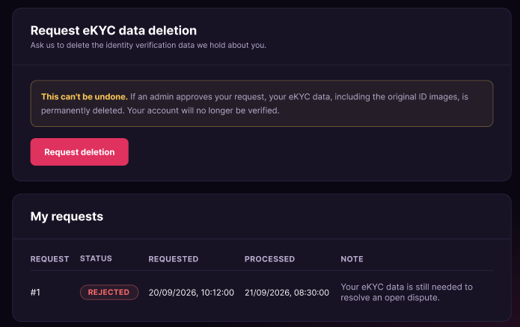
Figure 43 : Request eKYC Data Deletion Screen

FUNCTION DETAILS:
- VALIDATION RULES:
  - The user must be authenticated. The Access Token must be sent in the Authorization header, and it must be present, valid and not expired.
  - The user must be identified from the claims in the token, so the client must not send a user id.
  - The account referenced by the token must exist.
  - The Customer must have eKYC data to delete.
  - The Customer must not already have a Pending deletion request.
  - The "Request deletion" button is disabled while the Customer has a Pending request.
  - The data must be validated on the client when the Customer submits, and again on the server.

- NORMAL FLOW:
  - Sub-flow A: Submit a deletion request
Step 1: The Customer opens the "Request eKYC data deletion" screen.
Step 2: The system displays the notice and the "Request deletion" button.
Step 3: The Customer selects "Request deletion".
Step 4: The system displays a confirmation: "Send a request to delete your eKYC data? An admin will review it. If it is approved, your data is permanently deleted."
Step 5: The Customer selects "Send request".
Step 6: The client submits the request with the Access Token in the Authorization header.
Step 7: The system identifies the Customer from the Access Token claims and looks up the account.
Step 8: The system checks that the Customer has eKYC data.
Step 9: The system checks that the Customer has no Pending deletion request.
Step 10: The system saves the request with the status Pending and the request time.
Step 11: The system returns the request, and the client displays the message "Request sent. An admin will review it." and adds the request to "My requests".
  - Sub-flow B: View my deletion requests
Step 1: The Customer opens the "Request eKYC data deletion" screen.
Step 2: The client sends the request with the Access Token in the Authorization header.
Step 3: The system identifies the Customer from the token and retrieves their requests.
Step 4: The system returns the list, and the client displays each request's number, status, request time, processing time and the Admin's note (if any).

- ABNORMAL FLOWS:
  - Abnormal flow 1: Access Token missing, invalid or expired (occurs at Sub-flow A, Step 6 or Sub-flow B, Step 2)
Step 1: The Access Token is missing, invalid or expired.
Step 2: The system rejects the request and returns 401 Unauthorized.
Step 3: The client tries to obtain a new Access Token with the Refresh Token and repeats the request.
Step 4: If the Refresh Token is also expired or revoked, the client deletes the stored tokens, displays the message "Your session has expired. Please log in again." and redirects the user to the Login page.
  - Abnormal flow 2: Account not found (occurs at Sub-flow A, Step 7)
Step 1: The account referenced by the token no longer exists.
Step 2: The system logs a warning and returns 401 Unauthorized with the generic message "Unauthorized."
Step 3: The client deletes the stored tokens and redirects the user to the Login page.
  - Abnormal flow 3: No eKYC data to delete (occurs at Sub-flow A, Step 8)
Step 1: The Customer has no eKYC data, for example because it was already deleted.
Step 2: The system saves nothing and returns 400 Bad Request.
Step 3: The client displays the message "There is no eKYC data to delete."
Step 4: The Customer returns to the previous screen.
  - Abnormal flow 4: A Pending request already exists (occurs at Sub-flow A, Step 9)
Step 1: The Customer already has a Pending deletion request.
Step 2: The system saves nothing and returns 409 Conflict.
Step 3: The client displays the message "You already have a pending request. Wait for an admin to process it."
Step 4: The Customer waits for the Admin to process the request.
  - Abnormal flow 5: Unexpected server error (occurs at Sub-flow A or B)
Step 1: An unexpected error occurs while the system processes the request.
Step 2: The system logs the error and saves no change.
Step 3: The system returns 500 Internal Server Error, and the client displays the message "An unexpected error occurred. Please try again later."
Step 4: The Customer tries again later.

3.3.6 Approve/Reject eKYC Data Deletion
FUNCTION TRIGGER:
- Trigger 1: The Admin selects "Deletion requests" in the admin menu while logged in.
FUNCTION DESCRIPTION:
- Actor(s): Admin
- Secondary actor(s): None
- Purpose:
  - To let the Admin review the eKYC data deletion requests from Customers and approve a request, so that the Customer's eKYC data is permanently deleted.
- Main Functionality:
  - The system shows the deletion requests with their ID, user, status (Pending, Approved or Rejected), request time, processing time, the Admin who processed it and the note. The Admin can filter the list by status (Pending by default), and the list is shown one page at a time. The "Approve" button is enabled only for Pending requests. When the Admin selects "Approve" and confirms in the popup, the system permanently deletes the user's eKYC data, including the original images, sets the request status to Approved, and records the Admin and the processing time. Deleting the data cannot be undone. The system identifies the Admin from the Access Token. This function only approves requests; rejecting a request is done in Reject eKYC Data Deletion.

SCREEN LAYOUT:
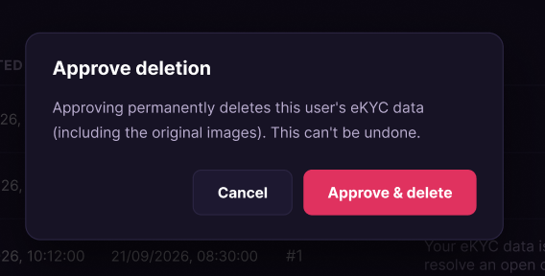
Figure 44 :Approve eKYC Data Deletion

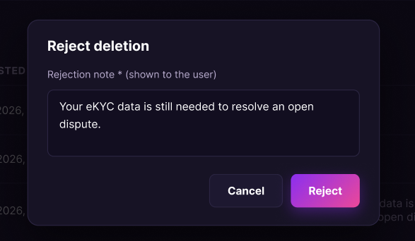
Figure 45 : Reject eKYC Data Deletion Screen

FUNCTION DETAILS:
- VALIDATION RULES:
  - The user must be authenticated. The Access Token must be sent in the Authorization header, and it must be present, valid and not expired.
  - The user must have the permission to manage users (policy CanManageUsers).
  - The Admin must be identified from the claims in the token, so the client must not send a user id.
  - The status filter must be empty (All), Pending, Approved or Rejected.
  - The page number must be a positive whole number.
  - The request to approve must exist and must have the status Pending.
  - The "Approve" button is enabled only for Pending requests.
  - The data must be validated on the client when the Admin submits, and again on the server.

- NORMAL FLOW:
  - Sub-flow A: View the list of deletion requests
Step 1: The Admin opens the "Deletion requests" page.
Step 2: The client sends the request with the status filter (Pending by default) and the page number, with the Access Token in the Authorization header.
Step 3: The system checks the token and the permission of the Admin.
Step 4: The system retrieves the requests that match the filter, one page at a time.
Step 5: The system returns the list, and the client displays each request's ID, user, status, request time, processing time, the Admin who processed it and the note.
Step 6: The client enables the "Approve" button only for Pending requests.
  - Sub-flow B: Approve a deletion request
Step 1: The Admin selects "Approve" on a Pending request.
Step 2: The system displays the "Approve deletion" popup: "Approving permanently deletes this user's eKYC data (including the original images). This can't be undone."
Step 3: The Admin selects "Approve & delete".
Step 4: The client submits the request with the Access Token in the Authorization header.
Step 5: The system checks the token and the permission of the Admin, and identifies the Admin from the token claims.
Step 6: The system checks that the request exists and is Pending.
Step 7: The system permanently deletes the user's eKYC data, including the original images.
Step 8: The system sets the request status to Approved and records the processing time and the Admin.
Step 9: The system returns the result, and the client displays the message "Request approved. The eKYC data has been deleted." and refreshes the list.
  - Sub-flow C: Cancel the approval
Step 1: The Admin selects "Cancel" in the "Approve deletion" popup, or clicks outside it.
Step 2: The client closes the popup. No request is sent, and the request stays Pending.

- ABNORMAL FLOWS:
  - Abnormal flow 1: Access Token missing, invalid or expired (occurs at Sub-flow A, Step 2 or Sub-flow B, Step 4)
Step 1: The Access Token is missing, invalid or expired.
Step 2: The system rejects the request and returns 401 Unauthorized.
Step 3: The client tries to obtain a new Access Token with the Refresh Token and repeats the request.
Step 4: If the Refresh Token is also expired or revoked, the client deletes the stored tokens, displays the message "Your session has expired. Please log in again." and redirects the user to the Login page.
  - Abnormal flow 2: No permission (occurs at Sub-flow A, Step 3 or Sub-flow B, Step 5)
Step 1: The account does not have the permission to manage users.
Step 2: The system returns 403 Forbidden and does not perform the action.
Step 3: The client displays the message "You do not have permission to perform this action."
Step 4: The user returns to the previous screen.
  - Abnormal flow 3: Failed to load the list (occurs at Sub-flow A, Step 4)
Step 1: An error occurs while the system retrieves the requests.
Step 2: The system logs the error and returns an error response.
Step 3: The client displays the message "Failed to load deletion requests." with a "Dismiss" button.
Step 4: The Admin selects "Refresh" to load the list again (returns to Sub-flow A, Step 1).
  - Abnormal flow 4: Request not found (occurs at Sub-flow B, Step 6)
Step 1: The request no longer exists.
Step 2: The system returns 404 Not Found with an error message.
Step 3: The client closes the popup and displays the error message.
Step 4: The client refreshes the list (returns to Sub-flow A, Step 1).
  - Abnormal flow 5: Request already processed (occurs at Sub-flow B, Step 6)
Step 1: The request is no longer Pending, for example because another Admin has already processed it.
Step 2: The system changes nothing and returns 400 Bad Request with an error message.
Step 3: The client displays the error message in the popup, or closes it and displays the message.
Step 4: The client refreshes the list (returns to Sub-flow A, Step 1).
  - Abnormal flow 6: Unable to delete the data (occurs at Sub-flow B, Step 7)
Step 1: An unexpected error occurs while the system deletes the eKYC data.
Step 2: The system logs the error and does not change the request, so it stays Pending.
Step 3: The system returns 500 Internal Server Error, and the client displays the message "An unexpected error occurred. Please try again later."
Step 4: The Admin tries again later (returns to Sub-flow B, Step 1).

3.3.7 View eKYC Data Access Log
FUNCTION TRIGGER:
- Trigger 1: The Admin selects "Access log" in the admin menu while logged in.
FUNCTION DESCRIPTION:
- Actor(s): Admin
- Secondary actor(s): None
- Purpose:
  - To let the Admin review the record of every time a user's eKYC data was viewed or handled, so that access to sensitive identity data can be audited.
- Main Functionality:
  - The system shows the access log entries with their time, subject user, eKYC ID, actor, actor type (User, Admin or System), action, IP address and details. The log is read-only, and the newest entries are shown first. The Admin can filter the log by subject user ID, actor user ID, actor type, action and a date range (From and To), and the log is shown one page at a time (20 entries per page by default). Entries that belong to the same deletion request show the same Request # in Details, for example one "Deletion approved" entry followed by several "Data purged" entries, one per deleted record. When a value does not apply to an entry (for example the eKYC ID of a "Deletion approved" entry, or the actor of an action done by the System), the system shows "-". The system identifies the Admin from the Access Token. This function only views the log; it cannot create, edit or delete entries.

SCREEN LAYOUT:
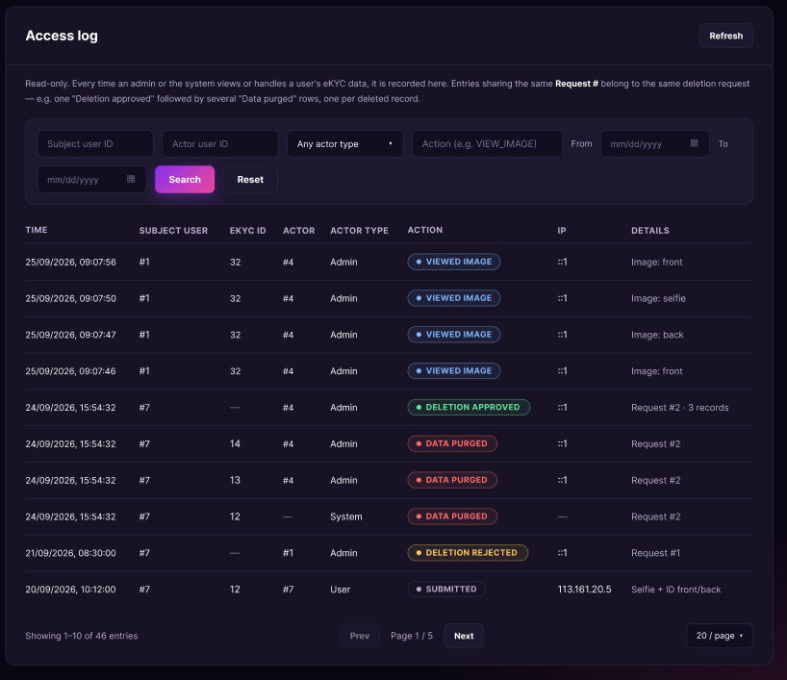
Figure 46 : View eKYC Data Access Log Screen

FUNCTION DETAILS:
- VALIDATION RULES:
  - The user must be authenticated. The Access Token must be sent in the Authorization header, and it must be present, valid and not expired.
  - The user must have the permission to manage users (policy CanManageUsers).
  - The Admin must be identified from the claims in the token, so the client must not send a user id.
  - The subject user ID, if entered, must be a positive whole number.
  - The actor user ID, if entered, must be a positive whole number.
  - The actor type must be empty (Any), User, Admin or System.
  - The action, if entered, must be a valid action code (for example VIEW_IMAGE).
  - If both From and To are entered, From must not be later than To.
  - The page number and the page size must be positive whole numbers.
  - The filters must be validated on the client when the Admin selects "Search", and again on the server.

- NORMAL FLOW:
  - Sub-flow A: View the access log
  - Step 1: The Admin opens the "Access log" page.
  - Step 2: The client sends the request with the default filters (empty) and the page number 1, with the Access Token in the Authorization header.
  - Step 3: The system checks the token and the permission of the Admin.
  - Step 4: The system retrieves the entries that match the filters, newest first, one page at a time.
  - Step 5: The system returns the entries and the total number of pages, and the client displays each entry's time, subject user, eKYC ID, actor, actor type, action, IP address and details.
  - Step 6: The client enables "Prev" and "Next" only when there is a previous or next page.

  - Sub-flow B: Filter the access log
  - Step 1: The Admin enters one or more filters (subject user ID, actor user ID, actor type, action, From, To) and selects "Search".
  - Step 2: The client validates the filters.
  - Step 3: The client sends the request with the filters and the page number 1, with the Access Token in the Authorization header.
  - Step 4: The system checks the token and the permission of the Admin, and validates the filters.
  - Step 5: The system retrieves the entries that match all the filters, newest first, one page at a time.
  - Step 6: The system returns the entries, and the client displays them. If no entry matches, the client displays the message "No entries match these filters"

  - Sub-flow C: Reset the filters
  - Step 1: The Admin selects "Reset".
  - Step 2: The client clears all filters and returns to Sub-flow A, Step 2.
  - Sub-flow D: Change the page or refresh
  - Step 1: The Admin selects "Prev", "Next" or "Refresh".
  - Step 2: The client sends the request with the current filters and the new page number (the current page for "Refresh"), and continues from Sub-flow A, Step 3.

- ABNORMAL FLOWS:
  - Abnormal flow 1: Access Token missing, invalid or expired (occurs at Sub-flow A, B or D, when the client sends the request)
  - Step 1: The Access Token is missing, invalid or expired.
  - Step 2: The system rejects the request and returns 401 Unauthorized.
  - Step 3: The client tries to obtain a new Access Token with the Refresh Token and repeats the request.
  - Step 4: If the Refresh Token is also expired or revoked, the client deletes the stored tokens, displays the message "Your session has expired. Please log in again." and redirects the user to the Login page.

  - Abnormal flow 2: No permission (occurs at Sub-flow A, Step 3 or Sub-flow B, Step 4)
  - Step 1: The account does not have the permission to manage users.
  - Step 2: The system returns 403 Forbidden and does not return any entry.
  - Step 3: The client displays the message "You do not have permission to perform this action."
  - Step 4: The user returns to the previous screen.

  - Abnormal flow 3: Invalid filters (occurs at Sub-flow B, Step 2 or Step 4)
  - Step 1: A filter is invalid, for example the subject user ID is not a positive whole number, or From is later than To.
  - Step 2: If the client detects the error, it does not send the request. Otherwise, the system returns 400 Bad Request with an error message.
  - Step 3: The client highlights the invalid filters and displays the messages "Subject user ID must be a positive whole number." or "From date must not be later than To date."
  - Step 4: The Admin corrects the filters and selects "Search" again (returns to Sub-flow B, Step 1).

  - Abnormal flow 4: No entries found (occurs at Sub-flow B, Step 6)
  - Step 1: No entry matches the filters.
  - Step 2: The system returns an empty list.
  - Step 3: The client displays the message "No entries match these filters" and suggests widening the date range or clearing a filter.
  - Step 4: The Admin selects "Reset" (Sub-flow C) or changes the filters (returns to Sub-flow B, Step 1).
  - Abnormal flow 5: Failed to load the access log (occurs at Sub-flow A, Step 4)
  - Step 1: An error occurs while the system retrieves the entries.
  - Step 2: The system logs the error and returns an error response.
  - Step 3: The client displays the message "Failed to load the access log." with a "Dismiss" button.
  - Step 4: The Admin selects "Refresh" to load the log again (returns to Sub-flow A, Step 1).

3.4 Feature 3: Role-Based Access Control (RBAC)

3.4.1 View Role List
FUNCTION TRIGGER:
- Trigger 1: The Admin selects "Roles" in the admin menu while logged in.
FUNCTION DESCRIPTION:
- Actor(s): Admin
- Secondary actor(s): None
- Purpose:
  - To let the Admin see all the roles in the system, the permissions each role grants and the number of users who hold it, so that the Admin can review how access is organized.
- Main Functionality:
  - The system shows the roles with their ID, name, description, permissions, number of users, type (System or Custom) and creation time. The Admin can search by role name and filter by type (All by default), and the list is shown one page at a time. When a role has more permissions than fit in the row, the system shows the first ones and the number of the remaining ones (for example "+2"). When a role has no permissions, or a value does not apply, the system shows "-". The system identifies the Admin from the Access Token. This function only views the list; it cannot create, edit or delete a role. Viewing the details of a role is done in a separate function.

SCREEN LAYOUT:
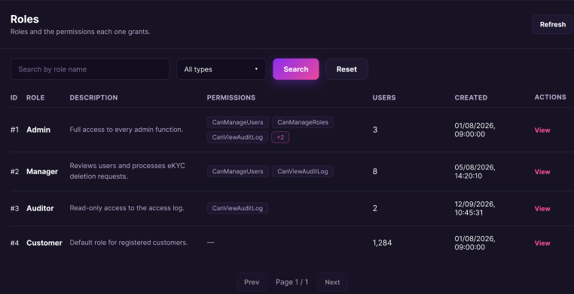
Figure 47 : View Role List Screen
FUNCTION DETAILS:
- VALIDATION RULES:
  - The user must be authenticated. The Access Token must be sent in the Authorization header, and it must be present, valid and not expired.
  - The user must have the permission to manage roles (policy CanManageRoles).
  - The Admin must be identified from the claims in the token, so the client must not send a user id.
  - The search text, if entered, must not be longer than 100 characters.
  - The type filter must be empty (All), System or Custom.
  - The page number and the page size must be positive whole numbers.
  - The filters must be validated on the client when the Admin selects "Search", and again on the server.
- NORMAL FLOW:
  - Sub-flow A: View the list of roles
  - Step 1: The Admin opens the "Roles" page.
  - Step 2: The client sends the request with the default filters (empty search, type All) and the page number 1, with the Access Token in the Authorization header.
  - Step 3: The system checks the token and the permission of the Admin.
  - Step 4: The system retrieves the roles, with their permissions and number of users, one page at a time.
  - Step 5: The system returns the list and the total number of pages, and the client displays each role's ID, name, description, permissions, number of users, type and creation time.
  - Step 6: The client enables "Prev" and "Next" only when there is a previous or next page.

- ABNORMAL FLOWS:
  - Abnormal flow 1: Access Token missing, invalid or expired (occurs at Sub-flow A, B or D, when the client sends the request)
  - Step 1: The Access Token is missing, invalid or expired.
  - Step 2: The system rejects the request and returns 401 Unauthorized.
  - Step 3: The client tries to obtain a new Access Token with the Refresh Token and repeats the request.
  - Step 4: If the Refresh Token is also expired or revoked, the client deletes the stored tokens, displays the message "Your session has expired. Please log in again." and redirects the user to the Login page.

  - Abnormal flow 2: No permission (occurs at Sub-flow A, Step 3 or Sub-flow B, Step 4)
  - Step 1: The account does not have the permission to manage roles.
  - Step 2: The system returns 403 Forbidden and does not return any role.
  - Step 3: The client displays the message "You do not have permission to perform this action."
  - Step 4: The user returns to the previous screen.

  - Abnormal flow 3: Invalid filters (occurs at Sub-flow B, Step 2 or Step 4)
  - Step 1: A filter is invalid, for example the search text is longer than 100 characters, or the type is not All, System or Custom.
  - Step 2: If the client detects the error, it does not send the request. Otherwise, the system returns 400 Bad Request with an error message.
  - Step 3: The client highlights the invalid filter and displays the error message.
  - Step 4: The Admin corrects the filter and selects "Search" again (returns to Sub-flow B, Step 1).

  - Abnormal flow 4: No roles found (occurs at Sub-flow B, Step 6)
  - Step 1: No role matches the filters.
  - Step 2: The system returns an empty list.
  - Step 3: The client displays the message "No roles match your search" and suggests checking the spelling or clearing the filters.
  - Step 4: The Admin selects "Reset" (Sub-flow C) or changes the filters (returns to Sub-flow B, Step 1).

  - Abnormal flow 5: Failed to load the list (occurs at Sub-flow A, Step 4)
  - Step 1: An error occurs while the system retrieves the roles.
  - Step 2: The system logs the error and returns an error response.
  - Step 3: The client displays the message "Failed to load roles." with a "Dismiss" button.

3.5 Feature 4: Event Discovery & Search

3.5.1 View Event List:
FUNCTION TRIGGER:
- Trigger 1: The user accesses the homepage/event list.
FUNCTION DESCRIPTION:
- Actor(s): Guest, Customer
- Purpose:
  - To allow users to discover live music events (concerts, festivals and live shows) by browsing a list and narrowing it down by keyword, location, genre and sort order.
- Main Functionality:
  - The system displays the events that are open to the public as a grid of event cards. By default the list shows all genres, sorted by date with the soonest event first. Each card shows the poster, the genre, the title, the venue and city, the start date and time, and the lowest ticket price. The user can search by keyword (artist, concert or venue), filter by location and genre, and change the sort order. The system also shows how many events match ("N concerts found"). Clicking a card opens the Event Details page. Viewing the list does not require logging in and does not change any data.

SCREEN LAYOUT:
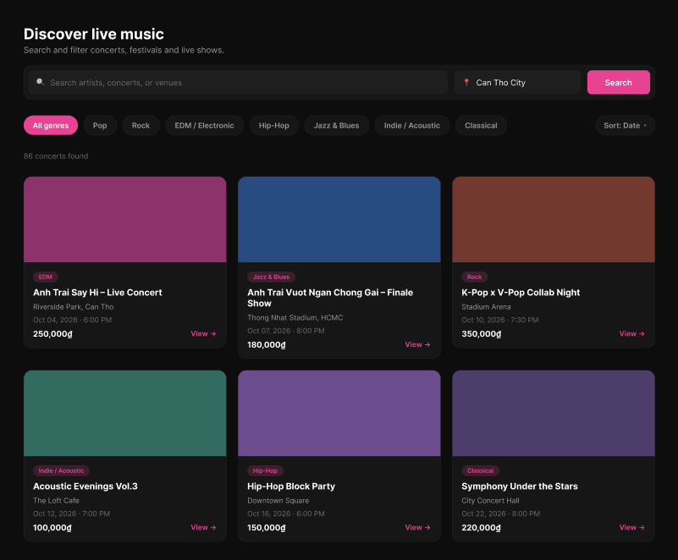
Figure 48 : View Event List Screen

FUNCTION DETAILS:
- VALIDATION RULES:
  - The keyword is optional, must not exceed 100 characters, and leading and trailing spaces must be removed. If the keyword is empty, no keyword filter must be applied.
  - The keyword search must not be case-sensitive and must match the event title, the venue name and the artist names.
  - The location is optional and must not exceed 100 characters. It must match the city of the event. If the location is empty, events from all locations must be shown.
  - The genre is optional. It must be either "All genres" (default) or one genre from the list of genres, and only one genre can be selected at a time.
  - The sort option is optional and must be one of the allowed sort options. The default must be "Date" (soonest event first).
  - The page number must be at least 1 (default 1), and the page size must be within the allowed maximum.
  - Each event card must show the genre badge, the title, the venue and the start time, because these data are required.
  - The poster is optional. If the event has no poster or the image cannot be loaded, a default placeholder must be shown.
  - The genre badge must show the name of the event's genre (category), for example "EDM".
  - The title must not exceed 200 characters. Long titles must be shortened with an ellipsis after two lines.
  - The venue must be shown followed by the city, for example "Riverside Park, Can Tho". The city must be left out if the event has none.
  - The start time must be shown in the time zone of the event, in the format "Oct 04, 2026 · 6:00 PM".
  - The price is optional. It must be the lowest ticket price of the event, in Vietnamese dong with a thousands separator, for example "250,000₫". If the price is not available, it must be left empty.

- NORMAL FLOW:
  - Sub-flow A: View Event List
Step 1: The user opens the Discover page.
Step 2: The client requests the event list with the default filters (all genres, sorted by date, page 1).
Step 3: The system validates the request parameters.
Step 4: The system retrieves the events that are published, not deleted, not ended and that match the filters.
Step 5: The system sorts the events, counts the total number of matching events and takes the requested page.
Step 6: For each event, the system gets the genre name, the poster, the title, the venue, the city, the start time and the lowest ticket price.
Step 7: The system returns the list and the total count.
Step 8: The client displays the result count and the event cards.
- ABNORMAL FLOWS:
  - Abnormal flow 1: Invalid search parameters (occurs at Sub-flow A, Step 3 or Sub-flow B, Step 3)
Step 1: The keyword or location is too long, or the genre, sort option or page is not valid.
Step 2: The system validates the request and detects the error.
Step 3: The system returns 400 Bad Request and does not change the displayed list.
Step 4: The client displays the error message under the affected field.
Step 5: The user corrects the value and searches again.
  - Abnormal flow 2: No events found (occurs at Sub-flow A, Step 4 or Sub-flow B, Step 3)
Step 1: No event matches the keyword, location and genre.
Step 2: The system returns an empty list with a total count of 0.
Step 3: The client displays "0 concerts found" and the message "No concerts found. Try changing your search or filters."
Step 4: The user changes the keyword, location or genre.
  - Abnormal flow 3: Poster image cannot be loaded (occurs at Sub-flow A, Step 8)
Step 1: An event has no poster, or its image cannot be loaded.
Step 2: The client shows the default placeholder image for that card.
Step 3: The rest of the list is displayed as usual.
  - Abnormal flow 4: Event no longer available (occurs at Sub-flow F, Step 2)
Step 1: The user clicks an event that has been unpublished, deleted or has ended since the list was loaded.
Step 2: The system cannot find an available event and returns 404 Not Found.
Step 3: The client displays the message "This event is no longer available." and reloads the list.

3.5.2 View Event Details
FUNCTION TRIGGER:
- Trigger 1: User clicks an event card or its "View" link on the event list (View Event List).
FUNCTION DESCRIPTION:
- Actor(s): Guest, Customer
- Purpose:
  - To allow users to see the full information of an event before deciding to buy tickets.
- Main Functionality:
  - The system displays the event's banner, genre, title, start date and time, and venue and city. Below it, a bar shows the starting ticket price and the "Get Tickets" button. The page has three tabs. "Event Details" (shown first) contains the description ("About this event") and information cards for the organizer, the venue, the time doors open and the age restriction. "Seating Chart" shows the seating chart of the event, and "Ticket Tiers & Availability" lists the ticket tiers with their price and availability. Clicking "Get Tickets" takes the user to ticket purchase, after login if needed. Viewing the event does not require login, and it increases the event's view count.

SCREEN LAYOUT:
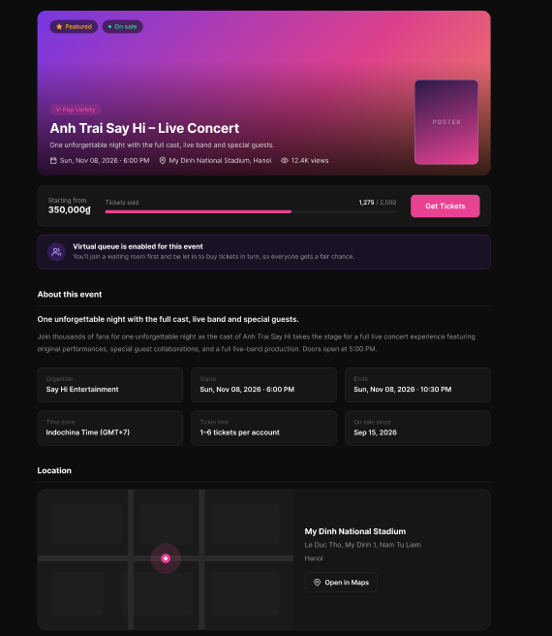
Figure 49 : View Event Detail Screen
FUNCTION DETAILS:
- VALIDATION RULES:
  - The event slug in the link must be valid and must belong to an existing event.
  - The event must be published and must not be deleted.
  - The user is not required to be authenticated to view the event, but must be authenticated to buy tickets.
  - Required event data (title, genre, start time, venue, organizer and time zone) must be available.
  - The banner and the poster are optional; a default image must be shown if they are missing or cannot be loaded.
  - The short description, the description, the end time, the address and the "On sale since" date are optional; the related section must be hidden if the data is empty.
  - The starting price must be the lowest price among the ticket tiers that are still on sale; "Price not available" must be shown if there is none.
  - The number of tickets sold must be shown against the total number of tickets, and the progress bar must not exceed 100% or must be hidden if the total is not set or is 0.
  - The "Get Tickets" button must be enabled only when the event still has tickets available and has not ended.
  - The virtual queue notice must be shown only when the event requires a virtual queue.
  - The ticket limit must be shown only when the minimum and maximum numbers of tickets per account are set.
  - The map must be shown only when the latitude is between -90 and 90 and the longitude is between -180 and 180.
  - The "Open in Maps" button must be shown only when the event has coordinates or an address.
  - Dates and times must be shown in the time zone of the event.

- NORMAL FLOW:
  - Sub-flow A: View Event Details
Step 1: The user clicks an event card on the event list, or opens the event link.
Step 2: The client requests the event details using the event slug.
Step 3: The system validates the slug and looks up the event.
Step 4: The system checks that the event is published and not deleted.
Step 5: The system retrieves the event information (genre, title, start time, venue, city, banner, description, organizer, doors open time, age restriction, seating chart flag, virtual queue flag) and the lowest ticket price.
Step 6: The system increases the event's view count.
Step 7: The system returns the event details.
Step 8: The client displays the banner with the genre, title, date, time and venue, the starting price with the "Get Tickets" button, and the "Event Details" tab with "About this event" and the information cards.
- ABNORMAL FLOWS:
  - Abnormal flow 1: Event not found or not available (occurs at Sub-flow A, Step 3 or 4)
Step 1: The slug does not match any event, or the event is not published, or it has been deleted.
Step 2: The system returns 404 Not Found and does not increase the view count.
Step 3: The client displays the message "This event is no longer available."
Step 4: The user returns to the event list.
  - Abnormal flow 2: Guest clicks Get Tickets (occurs at Sub-flow D, Step 2)
Step 1: A guest who is not logged in clicks "Get Tickets".
Step 2: The system detects that there is no valid login.
Step 3: The client displays the message "Please log in to buy tickets." and redirects the guest to the Login page.
Step 4: After logging in, the user returns to this event page (returns to Sub-flow A).
  - Abnormal flow 3: Event sold out or ended (occurs at Sub-flow D, Step 3)
Step 1: All tickets are sold, or the event has ended.
Step 2: The button "Get Tickets" is disabled and shows "Sold out" or "Event ended". If the request still reaches the system, the system returns 409 Conflict.
Step 3: The client displays the message "Tickets are no longer available for this event."
Step 4: The user returns to the event list.
  - Abnormal flow 4: Tab content cannot be loaded (occurs at Sub-flow B, Step 2 or Sub-flow C, Step 2)
Step 1: The seating chart or the ticket tiers cannot be retrieved.
Step 2: The system logs the error and returns no data for the tab.
Step 3: The client displays the message "Unable to load the seating chart. Please try again." or "Unable to load ticket tiers. Please try again." with a retry option.
Step 4: The user retries. The other tabs and the rest of the page keep working.

3.5.3 Add Wishlist
FUNCTION TRIGGER:
- Trigger 1: Customer clicks the heart button on the event banner of the Event Details page while the event is not in the wishlist.
FUNCTION DESCRIPTION:
- Actor(s): Customer
- Purpose:
  - To allow a logged-in Customer to save an event they are interested in to their wishlist, so that they can find it again quickly.
- Main Functionality:
  - The system allows a logged-in Customer to add an event to their wishlist by clicking the heart button on the event banner. The system identifies the user from the Access Token, checks that the account is active and that the event exists, is published and is not deleted, and checks that the event is not already in the wishlist. If valid, the system creates a wishlist entry that links the user to the event, records the time it was added, and confirms the action. The heart button then changes to its filled state and the event appears in the "My Wishlist" list. A guest who clicks the heart button is asked to log in first.

SCREEN LAYOUT:

Figure 50 : Add Wishlist Screen
FUNCTION DETAILS:
- VALIDATION RULES:
  - The user must be authenticated. The Access Token must be sent in the Authorization header, and it must be present, valid and not expired; the client must not send a user id.
  - The account referenced by the token must exist and be active.
  - The event id is required and must reference an event that exists, is published and is not deleted.
  - The event must not already be in the user's wishlist; if it already is, no duplicate entry is created and the request still returns success.
  - A guest (not logged in) cannot add to the wishlist and must be redirected to log in first.

- NORMAL FLOW:
  - Sub-flow A: Add Event to Wishlist
Step 1: The logged-in Customer opens the Event Details page of an event that is not in their wishlist (the heart button shows the outline state).
Step 2: The Customer clicks the heart button on the event banner.
Step 3: The client sends the request with the event id and the Access Token in the Authorization header.
Step 4: The system validates the Access Token, identifies the user from its claims, looks up the account and checks that it is active.
Step 5: The system validates the event id and looks up the event.
Step 6: The system checks that the event is published and not deleted.
Step 7: The system checks that the event is not already in the user's wishlist.
Step 8: The system creates a wishlist entry linking the user and the event, with the time it was added.
Step 9: The system saves the entry to the database.
Step 10: The system logs the addition.
Step 11: The system returns a success result.
Step 12: The client changes the heart button to the filled state and displays the message "Added to your wishlist." The event now appears in the "My Wishlist" list.

- ABNORMAL FLOWS:
  - Abnormal flow 1: Guest clicks the heart button (occurs at Sub-flow A, Step 2)
Step 1: A guest who is not logged in clicks the heart button.
Step 2: The client does not send the request.
Step 3: The client displays the message "Please log in to add events to your wishlist." and redirects the guest to the Login page.
Step 4: After logging in, the user returns to the event page. The event is not added automatically, and the user can click the heart button again.
  - Abnormal flow 2: Access Token missing, invalid or expired (occurs at Sub-flow A, Step 3 or 4)
Step 1: The Access Token is missing, invalid or expired when the request is sent.
Step 2: The system rejects the request, returns 401 Unauthorized and adds nothing to the wishlist.
Step 3: The client tries to obtain a new Access Token with the Refresh Token and repeats the request.
Step 4: If the Refresh Token is also expired or revoked, the client deletes the stored tokens, displays the message "Your session has expired. Please log in again." and redirects the user to the Login page.
  - Abnormal flow 3: Account not found or not active (occurs at Sub-flow A, Step 4)
Step 1: The account referenced by the token no longer exists, or it has been disabled or locked.
Step 2: The system logs a warning and adds nothing to the wishlist.
Step 3: The system returns 401 Unauthorized.
Step 4: The client deletes the stored tokens, displays the message "Your account is not available. Please contact support." and redirects the user to the Login page.
  - Abnormal flow 4: Event not found or not available (occurs at Sub-flow A, Step 5 or 6)
Step 1: The event id is invalid, or the event does not exist, is not published, or has been deleted.
Step 2: The system returns 404 Not Found and adds nothing to the wishlist.
Step 3: The client keeps the heart button in the outline state and displays the message "This event is no longer available."
Step 4: The user returns to the event list.
  - Abnormal flow 5: Event already in the wishlist (occurs at Sub-flow A, Step 7)
Step 1: The event is already in the user's wishlist, for example because the button was clicked twice or the page state was outdated.
Step 2: The system does not create a duplicate entry and changes nothing.
Step 3: The system returns a success result.
Step 4: The client changes the heart button to the filled state without showing an error.

3.5.4 Remove Wishlist
FUNCTION TRIGGER:
- Trigger 1: Customer clicks the filled heart button of an event in the "My Wishlist" list.
- Trigger 2: Customer clicks the filled heart button on the event banner of the Event Details page while the event is in the wishlist.
FUNCTION DESCRIPTION:
- Actor(s): Customer
- Purpose:
  - To allow a logged-in Customer to remove an event from their wishlist when they are no longer interested in it.
- Main Functionality:
  - The system allows a logged-in Customer to remove an event from their wishlist by clicking its filled heart button. The system first displays a confirmation popup, "Remove from wishlist?", with the title of the event. If the Customer clicks "Remove", the system identifies the user from the Access Token, checks that the account is active, finds the wishlist entry of the user for that event and deletes it. The popup then closes, the event disappears from the "My Wishlist" list and a confirmation message is displayed. If the Customer clicks "Cancel", nothing is changed. An event can be removed even if it has since been unpublished, deleted or has ended.
SCREEN LAYOUT:
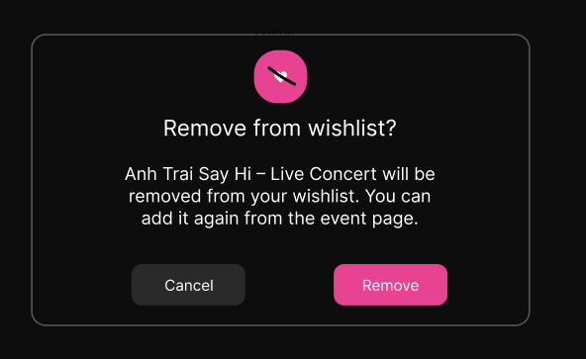
Figure 51 : Remove Wishlist Screen
FUNCTION DETAILS:
- VALIDATION RULES:
  - The user must be authenticated. The Access Token must be sent in the Authorization header, and it must be present, valid and not expired. The user must be identified from the claims in the token, so the client must not send a user id.
  - The account referenced by the token must exist and be active.
  - The event id is required and must be a valid positive number.
  - The wishlist entry must belong to the authenticated user. A user must never be able to remove the entry of another user.
  - If the event is not in the user's wishlist, nothing must be changed and the request must be treated as successful.
  - The status of the event (published, deleted, ended) must not prevent its removal from the wishlist.

- NORMAL FLOW:
  - Sub-flow A: Remove Event from Wishlist
Step 1: The logged-in Customer opens the "My Wishlist" list (or the Event Details page of an event that is in the wishlist, where the heart button shows the filled state).
Step 2: The Customer clicks the filled heart button of the event.
Step 3: The system displays the confirmation popup "Remove from wishlist?" with the title of the event.
Step 4: The Customer clicks the "Remove" button.
Step 5: The client disables the buttons, shows "Removing…" on the "Remove" button, and sends the request with the event id and the Access Token in the Authorization header.
Step 6: The system validates the Access Token, identifies the user from its claims, looks up the account and checks that it is active.
Step 7: The system validates the event id.
Step 8: The system looks up the wishlist entry of the user for that event.
Step 9: The system deletes the wishlist entry.
Step 10: The system saves the change to the database.
Step 11: The system logs the removal.
Step 12: The system returns a success result.
Step 13: The client closes the popup, removes the event from the "My Wishlist" list (and changes its heart button to the outline state on the Event Details page), and displays the message "Removed from your wishlist." If no event is left, the client displays the message "Your wishlist is empty. Tap the heart on an event to save it."
- ABNORMAL FLOWS:
  - Abnormal flow 1: Access Token missing, invalid or expired (occurs at Sub-flow A, Step 5 or 6)
Step 1: The Access Token is missing, invalid or expired when the request is sent.
Step 2: The system rejects the request, returns 401 Unauthorized and removes nothing.
Step 3: The client tries to obtain a new Access Token with the Refresh Token and repeats the request.
Step 4: If the Refresh Token is also expired or revoked, the client closes the popup, deletes the stored tokens, displays the message "Your session has expired. Please log in again." and redirects the user to the Login page.
  - Abnormal flow 2: Account not found or not active (occurs at Sub-flow A, Step 6)
Step 1: The account referenced by the token no longer exists, or it has been disabled or locked.
Step 2: The system logs a warning and removes nothing.
Step 3: The system returns 401 Unauthorized.
Step 4: The client closes the popup, deletes the stored tokens, displays the message "Your account is not available. Please contact support." and redirects the user to the Login page.
  - Abnormal flow 3: Invalid event id (occurs at Sub-flow A, Step 7)
Step 1: The event id is missing, or it is not a valid positive number.
Step 2: The system returns 400 Bad Request and removes nothing.
Step 3: The client keeps the popup open and displays the message "Couldn't remove this event. Please try again."
Step 4: The Customer clicks "Cancel" to close the popup, or tries again.
  - Abnormal flow 4: Event not in the wishlist (occurs at Sub-flow A, Step 8)
Step 1: The wishlist entry does not exist, for example because the event was already removed on another device or the page state was outdated.
Step 2: The system does not change anything.
Step 3: The system returns a success result.
Step 4: The client closes the popup and removes the event from the "My Wishlist" list, without showing an error (continues at Sub-flow A, Step 13).

3.5.5 View Event Review List

FUNCTION TRIGGER:
- Trigger 1: User opens the Event Details page of an event and goes to its reviews section.
- Trigger 2: User scrolls to the end of the review list or clicks "Load more" to see more reviews.
- Trigger 3: Customer clicks the "Edit" or "Delete" action on their own review.
FUNCTION DESCRIPTION:
- Actor(s): Customer
- Purpose:
  - To allow users to read the reviews that other attendees have written about an event, so that they can decide whether to buy tickets.
- Main Functionality:
  - The system displays the reviews of an event, newest first, in pages. Each review shows the reviewer's avatar and name, the star rating, the date and the comment. If the organizer has replied to a review, the reply is displayed under it with the "Organizer" badge, the organizer's name, the date and the text. When the user is logged in, the review that the user wrote is labeled "You" and shows the "Edit" and "Delete" actions. Viewing reviews does not require login and does not change any data.

SCREEN LAYOUT:
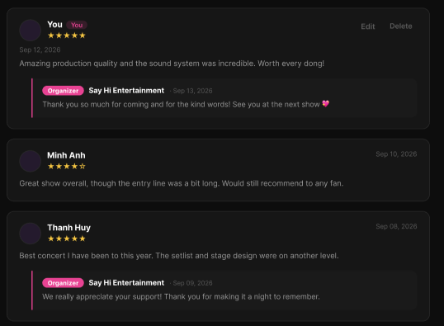
Figure 52 : View Event Review Screen
FUNCTION DETAILS:
- VALIDATION RULES:
  - The event slug in the request must be valid and must belong to an existing event that is published and not deleted.
  - The user is not required to be authenticated. If a valid Access Token is sent, the system must identify the user from its claims so that the user's own review can be labeled "You" and shown with the "Edit" and "Delete" actions.
  - Each review must show the reviewer's name, the star rating, the date and the comment, because these data are required.
.
- NORMAL FLOW:
  - Sub-flow A: View Review List
Step 1: The user opens the Event Details page of an event and goes to the reviews section.
Step 2: The client requests the first page of reviews of the event, and sends the Access Token if the user is logged in.
Step 3: The system validates the event slug and the paging parameters.
Step 4: The system looks up the event and checks that it is published and not deleted.
Step 5: If a valid Access Token was sent, the system identifies the user from its claims.
Step 6: The system retrieves the visible reviews of the event for the requested page, newest first, together with the organizer's reply of each review.
Step 7: The system marks the review written by the current user, if any.
Step 8: The system returns the reviews and whether more pages are available.
Step 9: The client displays each review with the avatar, the name, the star rating, the date and the comment, and the organizer's reply under it if there is one. The user's own review is labeled "You" and shows the "Edit" and "Delete" actions.
- ABNORMAL FLOWS:
  - Abnormal flow 1: Event not found or not available (occurs at Sub-flow A, Step 3 or 4)
Step 1: The slug does not match any event, or the event is not published, or it has been deleted.
Step 2: The system returns 404 Not Found and returns no reviews.
Step 3: The client displays the message "This event is no longer available."
Step 4: The user returns to the event list.
  - Abnormal flow 2: Invalid paging parameters (occurs at Sub-flow A, Step 3 or Sub-flow B, Step 2)
Step 1: The page number is less than 1, or the page size exceeds the allowed maximum.
Step 2: The system returns 400 Bad Request and returns no reviews.
Step 3: The client keeps the reviews that are already displayed and displays the message "Invalid page."
Step 4: The user reloads the reviews from the first page.
  - Abnormal flow 3: Access Token invalid or expired (occurs at Sub-flow A, Step 5)
Step 1: The Access Token sent with the request is invalid or expired.
Step 2: The system does not identify the user, and shows the reviews as for a guest, without the "You" label and without the "Edit" and "Delete" actions.
Step 3: The client tries to obtain a new Access Token with the Refresh Token. If it succeeds, the client requests the reviews again to show the user's own review.
Step 4: If the Refresh Token is also expired or revoked, the reviews stay displayed as for a guest.
  - Abnormal flow 4: No reviews yet (occurs at Sub-flow A, Step 6)
Step 1: The event has no visible review.
Step 2: The system returns an empty list.
Step 3: The client displays the message "No reviews yet."
  - Abnormal flow 5: Avatar cannot be loaded (occurs at Sub-flow A, Step 9)
Step 1: A reviewer has no avatar, or the image cannot be loaded.
Step 2: The client shows the default placeholder image for that review.
Step 3: The rest of the review is displayed as usual.

3.5.6 Add Event Review
FUNCTION TRIGGER:
- Trigger 1: Customer selects a star rating, enters a comment and clicks the "Post review" button on the "Write a review" form in the reviews section of the Event Details page.

FUNCTION DESCRIPTION:
- Actor(s): Customer
- Purpose:
  - To allow a Customer who attended an event to share their experience by giving a star rating and writing a comment, so that other users can read it before buying tickets.
- Main Functionality:
  - The system allows a logged-in Customer to write a review of an event by selecting a rating from 1 to 5 stars and entering a comment. When the Customer clicks "Post review", the system validates the input, identifies the user from the Access Token, checks that the account is active, that the event exists, is published and has ended, that the user has a ticket for the event, and that the user has not already reviewed it. If valid, the system creates the review with the rating, the comment and the time it was posted, and confirms the action. The new review appears at the top of the review list, labeled "You", and the form is no longer shown.

SCREEN LAYOUT:
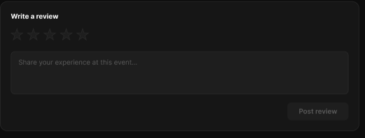
Figure 53 : Add Event Review Screen
FUNCTION DETAILS:
- VALIDATION RULES:
  - The user must be authenticated. The Access Token must be sent in the Authorization header, and it must be present, valid and not expired. The user must be identified from the claims in the token, so the client must not send a user id.
  - The account referenced by the token must exist and be active.
  - The event slug must be valid, and the event must exist, must be published and must not be deleted.
  - The event must have ended.
  - The user must have a valid ticket for the event.
  - The user must not have already reviewed the event.
  - The rating is required and must be a whole number from 1 to 5.
  - The comment is required, must not be empty after leading and trailing spaces are removed, and must not exceed 1,000 characters.
  - The "Post review" button must stay disabled until a rating is selected and a comment is entered.
- NORMAL FLOW:
  - Sub-flow A: Post Review
Step 1: The logged-in Customer opens the reviews section of the Event Details page of an event they attended and have not reviewed yet (the "Write a review" form is shown).
Step 2: The Customer selects a star rating from 1 to 5.
Step 3: The Customer enters the comment in the textarea.
Step 4: The "Post review" button becomes enabled, and the Customer clicks it.
Step 5: The client validates the rating and the comment, disables the button, and sends the request with the rating, the comment and the Access Token in the Authorization header.
Step 6: The system validates the Access Token, identifies the user from its claims, looks up the account and checks that it is active.
Step 7: The system validates the rating and the comment.
Step 8: The system looks up the event and checks that it is published and not deleted.
Step 9: The system checks that the event has ended.
Step 10: The system checks that the user has a valid ticket for the event.
Step 11: The system checks that the user has not already reviewed the event.
Step 12: The system creates the review with the event, the user, the rating, the comment and the time it was posted.
Step 13: The system saves the review to the database.
Step 14: The system logs the review.
Step 15: The system returns the created review.
Step 16: The client displays the message "Your review has been posted.", adds the new review at the top of the review list labeled "You" with the "Edit" and "Delete" actions, and hides the "Write a review" form.

- ABNORMAL FLOWS:
  - Abnormal flow 1: Guest tries to post a review (occurs at Sub-flow A, Step 4)
Step 1: A guest who is not logged in clicks "Post review".
Step 2: The client does not send the request.
Step 3: The client displays the message "Please log in to write a review." and redirects the guest to the Login page.
Step 4: After logging in, the user returns to the event page and can write the review again.
  - Abnormal flow 2: Incomplete or invalid data (occurs at Sub-flow A, Step 5 or 7)
Step 1: The Customer has not selected a rating, has left the comment empty, or has entered a comment longer than 1,000 characters.
Step 2: The client (or the system, with 400 Bad Request) detects the error and no review is created.
Step 3: The client displays the message "Please select a star rating.", "Please write your review." or "Review must not exceed 1,000 characters." and keeps what the Customer has entered.
Step 4: The Customer corrects the information and clicks "Post review" again.
  - Abnormal flow 3: Access Token missing, invalid or expired (occurs at Sub-flow A, Step 5 or 6)
Step 1: The Access Token is missing, invalid or expired when the request is sent.
Step 2: The system rejects the request, returns 401 Unauthorized and creates no review.
Step 3: The client tries to obtain a new Access Token with the Refresh Token and repeats the request.
Step 4: If the Refresh Token is also expired or revoked, the client deletes the stored tokens, displays the message "Your session has expired. Please log in again." and redirects the user to the Login page.
  - Abnormal flow 4: Account not found or not active (occurs at Sub-flow A, Step 6)
Step 1: The account referenced by the token no longer exists, or it has been disabled or locked.
Step 2: The system logs a warning and creates no review.
Step 3: The system returns 401 Unauthorized.
Step 4: The client deletes the stored tokens, displays the message "Your account is not available. Please contact support." and redirects the user to the Login page.
  - Abnormal flow 5: Event not found or not available (occurs at Sub-flow A, Step 8)
Step 1: The slug does not match any event, or the event is not published, or it has been deleted.
Step 2: The system returns 404 Not Found and creates no review.
Step 3: The client displays the message "This event is no longer available."
Step 4: The user returns to the event list.
  - Abnormal flow 6: Event has not ended (occurs at Sub-flow A, Step 9)
Step 1: The event has not ended yet.
Step 2: The system returns 403 Forbidden and creates no review.
Step 3: The client displays the message "You can write a review after the event has ended."
Step 4: The Customer comes back after the event.
  - Abnormal flow 7: No ticket for the event (occurs at Sub-flow A, Step 10)
Step 1: The user has no valid ticket for the event.
Step 2: The system logs a warning and creates no review.
Step 3: The system returns 403 Forbidden.
Step 4: The client displays the message "Only people who bought a ticket for this event can write a review."
  - Abnormal flow 8: Event already reviewed (occurs at Sub-flow A, Step 11)
Step 1: The user has already written a review for this event, for example on another device.
Step 2: The system creates no new review and returns 409 Conflict.
Step 3: The client displays the message "You have already reviewed this event.", hides the "Write a review" form and reloads the review list to show the user's review.

3.5.7 Edit Event Review
FUNCTION TRIGGER:
- Trigger 1: Customer clicks the "Edit" action on their own review in the review list of the Event Details page.
- Trigger 2: Customer changes the rating and/or the comment and clicks the "Edit review" button.
FUNCTION DESCRIPTION:
- Actor(s): Customer
- Purpose:
  - To allow a Customer to change the rating and the comment of a review they wrote earlier, so that it stays accurate.
- Main Functionality:
  - The system allows a logged-in Customer to edit their own review directly in the review list. When the Customer clicks "Edit", the review switches to edit mode with the current rating and comment filled in. After the Customer changes them and clicks "Edit Review", the system validates the input, identifies the user from the Access Token, checks that the account is active, that the event exists and is published, that the review exists, and that the review belongs to the user. If valid, the system updates the rating and the comment, records the time of the update, and confirms the action. The review is then displayed with the new rating and comment. If the Customer clicks "Cancel", nothing is changed. A review can be edited only by its author.
SCREEN LAYOUT:
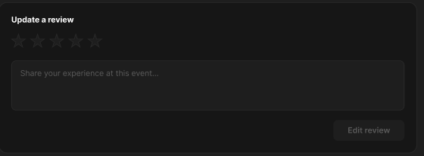
Figure 54 : Edit Event Review Screen
FUNCTION DETAILS:
- VALIDATION RULES:
  - The user must be authenticated. The Access Token must be sent in the Authorization header, and it must be present, valid and not expired. The user must be identified from the claims in the token, so the client must not send a user id.
  - The account referenced by the token must exist and be active.
  - The event slug must be valid, and the event must exist, must be published and must not be deleted.
  - The review id must be a valid positive number, and the review must exist and must not be deleted.
  - The review must belong to the authenticated user. A user must never be able to edit the review of another user.
  - The rating is required and must be a whole number from 1 to 5.
  - The comment is required, must not be empty after leading and trailing spaces are removed, and must not exceed 1,000 characters
  - The comment must be treated as plain text; any HTML in it must be encoded when it is displayed.
  - The "Save changes" button must stay disabled until the rating or the comment has been changed and both values are valid.
- NORMAL FLOW:
  - Sub-flow A: Edit Review
Step 1: The logged-in Customer opens the reviews section of the Event Details page, where their own review is displayed with the "You" label.
Step 2: The Customer clicks the "Edit" action of the review.
Step 3: The client switches the review to edit mode, with the current rating selected, the comment textarea filled with the current comment, and the “Edit Review" and "Cancel" buttons.
Step 4: The Customer changes the rating and/or the comment.
Step 5: The "Save changes" button becomes enabled, and the Customer clicks it.
Step 6: The client validates the rating and the comment, disables the buttons, and sends the request with the review id, the rating, the comment and the Access Token in the Authorization header.
Step 7: The system validates the Access Token, identifies the user from its claims, looks up the account and checks that it is active.
Step 8: The system validates the rating and the comment.
Step 9: The system looks up the event and checks that it is published and not deleted.
Step 10: The system looks up the review and checks that it exists and is not deleted.
Step 11: The system checks that the review belongs to the user.
Step 12: The system updates the rating and the comment of the review and records the time of the update.
Step 13: The system saves the changes to the database.
Step 14: The system logs the update.
Step 15: The system returns the updated review.
Step 16: The client leaves edit mode, displays the review with the new rating and comment, and displays the message "Your review has been updated."
- ABNORMAL FLOWS:
  - Abnormal flow 1: Incomplete or invalid data (occurs at Sub-flow A, Step 6 or 8)
Step 1: The Customer has removed the rating, has left the comment empty, or has entered a comment longer than 1,000 characters.
Step 2: The client (or the system, with 400 Bad Request) detects the error and changes nothing.
Step 3: The client displays the message "Please select a star rating.", "Please write your review." or "Review must not exceed 1,000 characters." and keeps what the Customer has entered.
Step 4: The Customer corrects the information and clicks "Save changes" again.
  - Abnormal flow 2: Access Token missing, invalid or expired (occurs at Sub-flow A, Step 6 or 7)
Step 1: The Access Token is missing, invalid or expired when the request is sent.
Step 2: The system rejects the request, returns 401 Unauthorized and changes nothing.
Step 3: The client tries to obtain a new Access Token with the Refresh Token and repeats the request.
Step 4: If the Refresh Token is also expired or revoked, the client deletes the stored tokens, displays the message "Your session has expired. Please log in again." and redirects the user to the Login page.
  - Abnormal flow 3: Account not found or not active (occurs at Sub-flow A, Step 7)
Step 1: The account referenced by the token no longer exists, or it has been disabled or locked.
Step 2: The system logs a warning and changes nothing.
Step 3: The system returns 401 Unauthorized.
Step 4: The client deletes the stored tokens, displays the message "Your account is not available. Please contact support." and redirects the user to the Login page.
  - Abnormal flow 4: Event not found or not available (occurs at Sub-flow A, Step 9)
Step 1: The slug does not match any event, or the event is not published, or it has been deleted.
Step 2: The system returns 404 Not Found and changes nothing.
Step 3: The client displays the message "This event is no longer available."
Step 4: The user returns to the event list.
  - Abnormal flow 5: Review not found (occurs at Sub-flow A, Step 10)
Step 1: The review does not exist or has been deleted, for example on another device.
Step 2: The system returns 404 Not Found and changes nothing.
Step 3: The client leaves edit mode, displays the message "This review no longer exists.", and reloads the review list.
  - Abnormal flow 6: Review does not belong to the user (occurs at Sub-flow A, Step 11)
Step 1: The review was written by another user.
Step 2: The system logs a warning and changes nothing.
Step 3: The system returns 403 Forbidden.
Step 4: The client displays the message "You can only edit your own review."

3.5.8 Delete Event Review
FUNCTION TRIGGER:
- Trigger 1: Customer clicks the "Delete" action on their own review in the review list of the Event Details page.
FUNCTION DESCRIPTION:
- Actor(s): Customer
- Purpose:
  - To allow a Customer to delete a review they wrote earlier when they no longer want it to be shown.
- Main Functionality:
  - The system allows a logged-in Customer to delete their own review by clicking the "Delete" action on it. The system first displays a confirmation popup with the message "Are you sure to delete your review for this event ?". If the Customer clicks "Delete", the system identifies the user from the Access Token, checks that the account is active, finds the review, checks that it belongs to the user, and deletes it together with the organizer's reply attached to it. The popup then closes, the review disappears from the review list, a confirmation message is displayed, and the "Write a review" form is shown again. If the Customer clicks "Cancel", nothing is changed. A review can be deleted only by its author.
SCREEN LAYOUT:
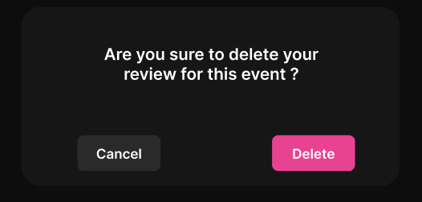
Figure 55 : Delete Event Review Screen
FUNCTION DETAILS:
- VALIDATION RULES:
  - The user must be authenticated. The Access Token must be sent in the Authorization header, and it must be present, valid and not expired. The user must be identified from the claims in the token, so the client must not send a user id.
  - The account referenced by the token must exist and be active.
  - The event slug must be valid, and the review id must be a valid positive number.
  - The review must exist, must not be already deleted, and must belong to the event in the request.
  - The review must belong to the authenticated user. A user must never be able to delete the review of another user.
  - The status of the event (published, ended, deleted) must not prevent the author from deleting their own review.
- NORMAL FLOW:
  - Sub-flow A: Delete Review
Step 1: The logged-in Customer opens the reviews section of the Event Details page, where their own review is displayed with the "You" label and the "Edit" and "Delete" actions.
Step 2: The Customer clicks the "Delete" action of the review.
Step 3: The system displays the confirmation popup "Are you sure to delete your review for this event ?" with the "Cancel" and "Delete" buttons.
Step 4: The Customer clicks the "Delete" button.
Step 5: The client disables the buttons and sends the request with the review id and the Access Token in the Authorization header.
Step 6: The system validates the Access Token, identifies the user from its claims, looks up the account and checks that it is active.
Step 7: The system validates the event slug and the review id.
Step 8: The system looks up the review and checks that it exists, is not already deleted, and belongs to the event.
Step 9: The system checks that the review belongs to the user.
Step 10: The system deletes the review and the organizer's reply attached to it.
Step 11: The system saves the changes to the database.
Step 12: The system logs the deletion.
Step 13: The system returns a success result.
Step 14: The client closes the popup, removes the review from the review list, displays the message "Your review has been deleted.", and shows the "Write a review" form again.

- ABNORMAL FLOWS:
  - Abnormal flow 1: Access Token missing, invalid or expired (occurs at Sub-flow A, Step 5 or 6)
Step 1: The Access Token is missing, invalid or expired when the request is sent.
Step 2: The system rejects the request, returns 401 Unauthorized and deletes nothing.
Step 3: The client tries to obtain a new Access Token with the Refresh Token and repeats the request.
Step 4: If the Refresh Token is also expired or revoked, the client closes the popup, deletes the stored tokens, displays the message "Your session has expired. Please log in again." and redirects the user to the Login page.
  - Abnormal flow 2: Account not found or not active (occurs at Sub-flow A, Step 6)
Step 1: The account referenced by the token no longer exists, or it has been disabled or locked.
Step 2: The system logs a warning and deletes nothing.
Step 3: The system returns 401 Unauthorized.
Step 4: The client closes the popup, deletes the stored tokens, displays the message "Your account is not available. Please contact support." and redirects the user to the Login page.
  - Abnormal flow 3: Invalid event slug or review id (occurs at Sub-flow A, Step 7)
Step 1: The event slug is not valid, or the review id is missing or is not a valid positive number.
Step 2: The system returns 400 Bad Request and deletes nothing.
Step 3: The client keeps the popup open, enables the buttons again and displays the message "Unable to delete your review. Please try again."
Step 4: The Customer clicks "Cancel" to close the popup, or tries again.
  - Abnormal flow 4: Review not found (occurs at Sub-flow A, Step 8)
Step 1: The review does not exist, has already been deleted (for example on another device), or does not belong to the event.
Step 2: The system returns 404 Not Found and deletes nothing.
Step 3: The client closes the popup, removes the review from the review list and displays the message "This review no longer exists."
  - Abnormal flow 5: Review does not belong to the user (occurs at Sub-flow A, Step 9)
Step 1: The review was written by another user.
Step 2: The system logs a warning and deletes nothing.
Step 3: The system returns 403 Forbidden.
Step 4: The client closes the popup and displays the message "You can only delete your own review."

3.5.9 Search Event
FUNCTION TRIGGER:
- Trigger 1: User enters a keyword and/or a location on the Discover page and clicks the "Search" button.
FUNCTION DESCRIPTION:
- Actor(s): Guest, Customer
- Purpose:
  - To allow users to quickly find live music events by typing an artist, a concert name or a venue, and by choosing a location.
- Main Functionality:
  - The system allows a user to search events by a keyword (artist, concert or venue) and by a location. When the user clicks "Search", the system validates the input and looks for the events that are open to the public and that match the keyword and the location, together with the genre and the sort option currently selected. The system then returns the first page of the matching events and their total number, and the page shows "N concerts found" and the event cards. Searching does not require login and does not change any data.
SCREEN LAYOUT:

Figure 56 : Search Event Screen
FUNCTION DETAILS:
- VALIDATION RULES:
  - The keyword is optional, must not exceed 100 characters, and leading and trailing spaces must be removed. If the keyword is empty, no keyword filter must be applied.
  - The keyword search must not be case-sensitive and must match the event title, the venue name and the artist names.
The characters typed in the keyword must be treated as plain text. Wildcard characters such as % and _ must not change the meaning of the search.
  - The location is optional and must not exceed 100 characters. It must match the city of the event, without being case-sensitive. If the location is empty, events from all locations must be searched.
If both the keyword and the location are empty, the search must return all events open to the public.
  - Only events that are published, not deleted and not ended must be searched.
  - The genre and the sort option selected on the page must be kept and applied together with the keyword and the location.
  - The input must be validated on the client when the user clicks "Search" or presses Enter, and again on the server.
- NORMAL FLOW:
  - Sub-flow A: Search Events
Step 1: The user opens the Discover page.
Step 2: The user enters a keyword (artist, concert or venue) and/or a location.
Step 3: The user clicks the "Search" button (or presses Enter).
Step 4: The client validates the input and disables the "Search" button.
Step 5: The client sends the request with the keyword, the location, and the genre and the sort option currently selected.
Step 6: The system validates the request parameters.
Step 7: The system retrieves the events that are published, not deleted and not ended, and that match the keyword, the location and the genre.
Step 8: The system sorts the events, counts the total number of matching events and takes page 1.
Step 9: For each event, the system gets the genre name, the poster, the title, the venue, the city, the start time and the lowest ticket price.
Step 10: The system returns the list and the total count.
Step 11: The client displays the result count and the event cards, and keeps the keyword and the location in their fields.
- ABNORMAL FLOWS:
  - Abnormal flow 1: Invalid search input (occurs at Sub-flow A, Step 4 or 6)
Step 1: The user enters a keyword longer than 100 characters, or a location longer than 100 characters.
Step 2: The client (or the system, with 400 Bad Request) detects the error and does not change the displayed results.
Step 3: The client displays the message "Search keyword must not exceed 100 characters." or "Location must not exceed 100 characters." under the affected field.
Step 4: The user corrects the value and searches again.
  - Abnormal flow 2: No events found (occurs at Sub-flow A, Step 7)
Step 1: No event matches the keyword, the location and the selected genre.
Step 2: The system returns an empty list with a total count of 0.
Step 3: The client displays "0 concerts found" and the message "No concerts found. Try changing your search or filters."
Step 4: The user changes the keyword, the location or the genre.

3.5.10 View Featured Events
FUNCTION TRIGGER:
- Trigger 1: User opens the home page, where the "Featured events" section is displayed.

FUNCTION DESCRIPTION:
- Actor(s): Guest, Customer
- Purpose:
  - To highlight selected live music events so that users can discover the events that deserve attention without searching.
- Main Functionality:
  - The system displays a "Featured events" section as a row of event cards. It retrieves the events that have been marked as featured and that are published, not deleted and not ended, sorts them by start time with the soonest event first, and shows up to a maximum number of them. Each card shows the poster, the "Featured" badge, the genre, the title, the venue and city, the start date and time, and the lowest ticket price. Clicking a card opens the Event Details page. Viewing featured events does not require login and does not change any data. Marking an event as featured is done in another function.

SCREEN LAYOUT:
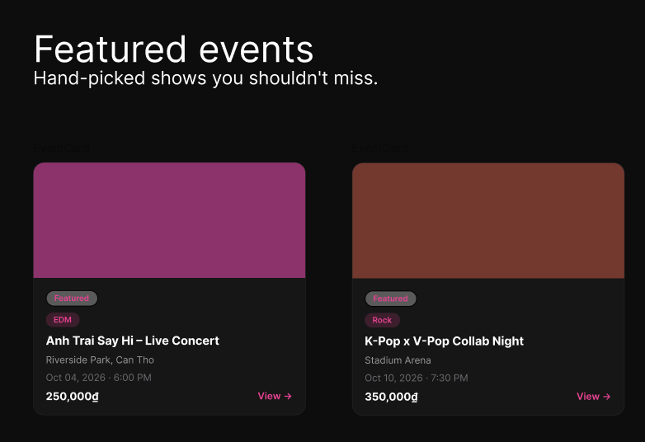
Figure 57 : View Feature Event Screen
FUNCTION DETAILS:
VALIDATION RULES:
- The limit is optional. It must be a positive number within the allowed maximum, and the default must be used if it is not sent.
- Only events that are marked as featured, published, not deleted and not ended must be returned.
- The events must be sorted by start time, with the soonest event first.
- Each event card must show the poster, the "Featured" badge, the genre badge, the title, the venue and the start time, because these data are required.
- The poster is optional. If the event has no poster or the image cannot be loaded, a default placeholder must be shown.
- The title must not exceed 200 characters. Long titles must be shortened with an ellipsis after two lines.
- The venue must be shown followed by the city, for example "Riverside Park, Can Tho". The city must be left out if the event has none.
- The start time must be shown in the time zone of the event, in the format "Oct 04, 2026 · 6:00 PM".
- The price is optional. It must be the lowest ticket price of the event, in Vietnamese dong with a thousands separator, for example "250,000₫". If the price is not available, it must be left empty.
- If there is no featured event, the whole "Featured events" section must be hidden.

- NORMAL FLOW:
  - Sub-flow A: View Featured Events
Step 1: The user opens the home page.
Step 2: The client requests the featured events.
Step 3: The system validates the request parameters.
Step 4: The system retrieves the events that are marked as featured, published, not deleted and not ended.
Step 5: The system sorts the events by start time, with the soonest event first, and takes up to the maximum number.
Step 6: For each event, the system gets the genre name, the poster, the title, the venue, the city, the start time and the lowest ticket price.
Step 7: The system returns the list.
Step 8: The client displays the "Featured events" section with the event cards, each with the "Featured" badge.

- ABNORMAL FLOWS:
  - Abnormal flow 1: Invalid request parameters (occurs at Sub-flow A, Step 3)
Step 1: The limit is not a positive number, or it exceeds the allowed maximum.
Step 2: The system returns 400 Bad Request and returns no events.
Step 3: The client hides the "Featured events" section. The rest of the page is displayed as usual.
  - Abnormal flow 2: No featured events (occurs at Sub-flow A, Step 4)
Step 1: No event is marked as featured, or all featured events are unpublished, deleted or ended.
Step 2: The system returns an empty list.
Step 3: The client hides the "Featured events" section. The rest of the page is displayed as usual.
  - Abnormal flow 3: Poster image cannot be loaded (occurs at Sub-flow A, Step 8)
Step 1: An event has no poster, or its image cannot be loaded.
Step 2: The client shows the default placeholder image for that card.
Step 3: The rest of the section is displayed as usual.
  - Abnormal flow 4: Event no longer available (occurs at Sub-flow B, Step 2)
Step 1: The user clicks an event that has been unpublished, deleted or has ended since the section was loaded.
Step 2: The system cannot find an available event and returns 404 Not Found.
Step 3: The client displays the message "This event is no longer available." and reloads the "Featured events" section.

3.5.11 View Wishlist
FUNCTION TRIGGER:
- Trigger 1: Customer opens the "My Wishlist" page from the account profile menu while logged in.
FUNCTION DESCRIPTION:
- Actor(s): Customer
- Purpose:
  - To allow a logged-in Customer to see all the events they have saved, so that they can come back to them quickly.
- Main Functionality:
  - The system displays the "My Wishlist" list of the logged-in Customer. It identifies the user from the Access Token and retrieves the events the user has saved, the most recently added first, in pages. Each row shows the event thumbnail, the title, the date and the city, a switch and a filled heart button. Clicking an event opens the Event Details page, and the heart button removes the event from the wishlist. An event stays in the wishlist even after it has ended or has been unpublished, and it is then shown as such. The list is read-only.

SCREEN LAYOUT:
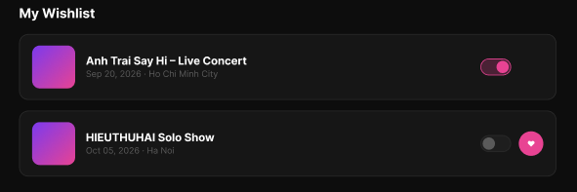
Figure 58 : View Wishlist Screen
FUNCTION DETAILS:
- VALIDATION RULES:
  - The user must be authenticated. The Access Token must be sent in the Authorization header, and it must be present, valid and not expired. The user must be identified from the claims in the token, so the client must not send a user id.
  - The account referenced by the token must exist and be active.
  - The page number must be at least 1 (default 1), and the page size must be within the allowed maximum.
  - Only the wishlist entries of the authenticated user must be returned. A user must never see the wishlist of another user.
  - Each row must show the thumbnail, the title, the date, the switch state and the filled heart button.
  - The thumbnail is optional. If the event has no poster or the image cannot be loaded, a default placeholder must be shown.
  - The title must not exceed 200 characters. A long title must be shortened with an ellipsis on one line.
  - The date must be shown in the time zone of the event, in the format "Sep 20, 2026", followed by the city, for example "Sep 20, 2026 · Ho Chi Minh City". The city must be left out if the event has none.
  - An event that has ended must be shown with the label "Ended".

- NORMAL FLOW:
  - Sub-flow A: View Wishlist
Step 1: The logged-in Customer opens the "My Wishlist" page.
Step 2: The client requests the first page of the wishlist with the Access Token in the Authorization header.
Step 3: The system validates the Access Token, identifies the user from its claims, looks up the account and checks that it is active.
Step 4: The system validates the paging parameters.
Step 5: The system retrieves the wishlist entries of the user for the requested page, the most recently added first, with the poster, the title, the start time, the city and the availability (available, ended, no longer available) of each event, and the state of the switch of each entry.
Step 6: The system returns the entries and whether more pages are available.
Step 7: The client displays the "My Wishlist" list with one row for each event: the thumbnail, the title, the date and the city, the switch and the filled heart button.
- ABNORMAL FLOWS:
  - Abnormal flow 1: Guest opens My Wishlist (occurs at Sub-flow A, Step 1)
Step 1: A guest who is not logged in opens the "My Wishlist" page.
Step 2: The client does not send the request.
Step 3: The client displays the message "Please log in to see your wishlist." and redirects the guest to the Login page.
Step 4: After logging in, the user returns to the "My Wishlist" page (returns to Sub-flow A, Step 1).
  - Abnormal flow 2: Access Token missing, invalid or expired
Step 1: The Access Token is missing, invalid or expired when the request is sent.
Step 2: The system rejects the request and returns 401 Unauthorized.
Step 3: The client tries to obtain a new Access Token with the Refresh Token and repeats the request.
Step 4: If the Refresh Token is also expired or revoked, the client deletes the stored tokens, displays the message "Your session has expired. Please log in again." and redirects the user to the Login page.
  - Abnormal flow 3: Account not found or not active (occurs at Sub-flow A, Step 3)
Step 1: The account referenced by the token no longer exists, or it has been disabled or locked.
Step 2: The system logs a warning and returns no wishlist.
Step 3: The system returns 401 Unauthorized.
Step 4: The client deletes the stored tokens, displays the message "Your account is not available. Please contact support." and redirects the user to the Login page.
  - Abnormal flow 4: Invalid paging parameters (occurs at Sub-flow A, Step 4 or Sub-flow B, Step 2)
Step 1: The page number is less than 1, or the page size exceeds the allowed maximum.
Step 2: The system returns 400 Bad Request and returns no entries.
Step 3: The client keeps the rows that are already displayed and displays the message "Invalid page."
Step 4: The Customer reloads the wishlist from the first page.
  - Abnormal flow 5: Wishlist is empty (occurs at Sub-flow A, Step 5)
Step 1: The user has not saved any event, or has removed all of them.
Step 2: The system returns an empty list.
Step 3: The client displays the message "Your wishlist is empty. Tap the heart on an event to save it."

3.5.12 Reply to Customer Review
FUNCTION TRIGGER:
- Trigger 1: Event Organizer opens the reviews section of the Event Details page of one of their own events. Under each review that has no reply, the reply box is displayed.
FUNCTION DESCRIPTION:
- Actor(s): Event Organizer
- Purpose:
  - To allow the organizer of an event to answer a customer's review publicly, for example to thank the customer or respond to a comment.
- Main Functionality:
  - The system allows a logged-in Event Organizer to reply to a review of one of their own events. Under a review that has no reply yet, the system shows a reply box with the "Organizer" badge, the organizer's name and a text area. When the Organizer enters the reply and clicks "Post reply", the system validates the text, identifies the user from the Access Token, checks that the account is an active Event Organizer, that the event exists and belongs to this Organizer, that the review exists, and that the review has no reply yet. If valid, the system creates the reply with the text and the time it was posted, and confirms the action. The reply is then displayed to all users under the review, with the "Organizer" badge, the organizer's name, the date and the text.
SCREEN LAYOUT:
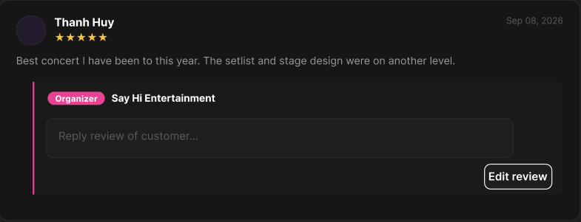
Figure 59 : Reply to Customer Review Screen
FUNCTION DETAILS:
- VALIDATION RULES:
  - The user must be authenticated. The Access Token must be sent in the Authorization header, and it must be present, valid and not expired. The user must be identified from the claims in the token, so the client must not send a user id.
  - The account referenced by the token must exist, be active and have the Event Organizer role.
  - The event slug must be valid, and the event must exist, must be published and must not be deleted.
  - The event must belong to the authenticated Organizer. An Organizer must never be able to reply to a review of another organizer's event.
  - The review id must be a valid positive number, and the review must exist, must not be deleted, and must belong to the event in the request.
  - The review must not already have a reply.
  - The reply is required, must not be empty after leading and trailing spaces are removed, and must not exceed 1,000 characters.
  - The reply must be treated as plain text; any HTML in it must be encoded when it is displayed.
  - The "Post reply" button must stay disabled until a reply is entered.
  - The input must be validated on the client when the Organizer clicks "Post reply", and again on the server.

- NORMAL FLOW:
  - Sub-flow A: Post Reply
Step 1: The logged-in Event Organizer opens the Event Details page of one of their own events and goes to the reviews section.
Step 2: The system displays the reply box under each review that has no reply, with the "Organizer" badge, the organizer's name, the text area "Reply review of customer..." and the "Post reply" button.
Step 3: The Organizer enters the reply.
Step 4: The "Post reply" button becomes enabled, and the Organizer clicks it.
Step 5: The client validates the reply, disables the button, and sends the request with the review id, the reply text and the Access Token in the Authorization header.
Step 6: The system validates the Access Token, identifies the user from its claims, looks up the account and checks that it is active and has the Event Organizer role.
Step 7: The system validates the reply text.
Step 8: The system looks up the event and checks that it is published and not deleted.
Step 9: The system checks that the event belongs to the Organizer.
Step 10: The system looks up the review and checks that it exists, is not deleted, and belongs to the event.
Step 11: The system checks that the review has no reply yet.
Step 12: The system creates the reply with the review, the Organizer, the text and the time it was posted.
Step 13: The system saves the reply to the database.
Step 14: The system logs the reply.
Step 15: The system returns the created reply.
Step 16: The client displays the message "Your reply has been posted." and shows the reply under the review, with the "Organizer" badge, the organizer's name, the date and the text, in place of the reply box.
- ABNORMAL FLOWS:
  - Abnormal flow 1: Access Token missing, invalid or expired (occurs at Sub-flow A, Step 5 or 6)
Step 1: The Access Token is missing, invalid or expired when the request is sent.
Step 2: The system rejects the request, returns 401 Unauthorized and creates no reply.
Step 3: The client tries to obtain a new Access Token with the Refresh Token and repeats the request.
Step 4: If the Refresh Token is also expired or revoked, the client deletes the stored tokens, displays the message "Your session has expired. Please log in again." and redirects the user to the Login page.
  - Abnormal flow 2: Account not found or not active (occurs at Sub-flow A, Step 6)
Step 1: The account referenced by the token no longer exists, or it has been disabled or locked.
Step 2: The system logs a warning and creates no reply.
Step 3: The system returns 401 Unauthorized.
Step 4: The client deletes the stored tokens, displays the message "Your account is not available. Please contact support." and redirects the user to the Login page.
  - Abnormal flow 3: Not the organizer of this event (occurs at Sub-flow A, Step 6 or 9)
Step 1: The account does not have the Event Organizer role, or the event belongs to another organizer.
Step 2: The system logs a warning and creates no reply.
Step 3: The system returns 403 Forbidden.
Step 4: The client displays the message "Only the organizer of this event can reply to reviews."
  - Abnormal flow 4: Incomplete or invalid reply (occurs at Sub-flow A, Step 5 or 7)
Step 1: The Organizer has left the reply empty, or has entered a reply longer than 1,000 characters.
Step 2: The client (or the system, with 400 Bad Request) detects the error and creates no reply.
Step 3: The client displays the message "Please write your reply." or "Reply must not exceed 1,000 characters." and keeps what the Organizer has entered.
Step 4: The Organizer corrects the reply and clicks "Post reply" again.
  - Abnormal flow 5: Event not found or not available (occurs at Sub-flow A, Step 8)
Step 1: The slug does not match any event, or the event is not published, or it has been deleted.
Step 2: The system returns 404 Not Found and creates no reply.
Step 3: The client displays the message "This event is no longer available."
Step 4: The Organizer returns to the event list.
  - Abnormal flow 6: Review not found (occurs at Sub-flow A, Step 10)
Step 1: The review does not exist, has been deleted by the customer (for example while the Organizer was writing), or does not belong to the event.
Step 2: The system returns 404 Not Found and creates no reply.
Step 3: The client displays the message "This review no longer exists." and reloads the review list.
  - Abnormal flow 7: Review already has a reply (occurs at Sub-flow A, Step 11)
Step 1: The review already has a reply, for example because it was posted on another device.
Step 2: The system creates no new reply and returns 409 Conflict.
Step 3: The client displays the message "This review already has a reply." and reloads the review list to show the existing reply.

3.5.13 Receive Wishlist Event Notifications
FUNCTION TRIGGER:
- Trigger 1: Customer clicks the "Notify me" switch of an event in the "My Wishlist" list.
FUNCTION DESCRIPTION:
- Actor(s): Customer
- Purpose:
  - To keep a Customer informed about the events they saved in their wishlist, so that they do not miss an important change such as the opening of ticket sales or a change of time.
- Main Functionality:
  - The system allows a logged-in Customer to turn notifications on or off for each event in their wishlist with the "Notify me" switch. For an event whose switch is on, the system automatically creates a notification when tickets go on sale, when tickets are almost sold out, when the event starts within 24 hours, and when the event details (such as the start time or the venue) change. Each notification appears in the Customer's Notifications list with an icon for its type, the event title, a message, the time, and a dot while it is unread. The number of unread notifications is shown next to the title. Clicking a notification marks it as read and opens the Event Details page of the event.
SCREEN LAYOUT:
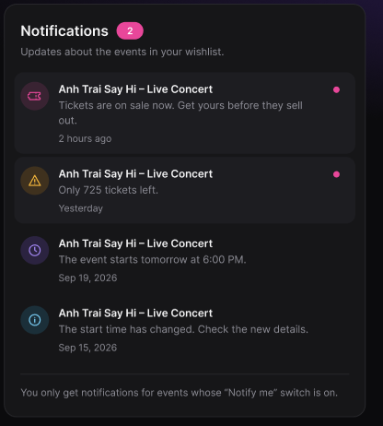
Figure 60 : Receive Wishlist Event Notifications Screen
FUNCTION DETAILS:
- VALIDATION RULES:
  - The user must be authenticated. The Access Token must be sent in the Authorization header, and it must be present, valid and not expired. The user must be identified from the claims in the token, so the client must not send a user id.
  - The account referenced by the token must exist and be active.
  - The event id must be a valid positive number, and the event must be in the user's wishlist to change its switch.
  - A notification must be created only for a user who has the event in their wishlist with the switch on, and only for an event that is published and not deleted.
  - A notification of a given type must be created only once for the same occurrence of a change on the same event for the same user. A duplicate notification must never be created.
  - The "tickets almost sold out" notification must be created when the number of remaining tickets (total tickets minus sold tickets) falls to the configured threshold or below.
  - The "event starts soon" notification must be created when the event starts within the next 24 hours, based on the time zone of the event.
  - The "details changed" notification must be created when the start time, the end time or the venue of the event changes.
  - The page number must be at least 1 (default 1), and the page size must be within the allowed maximum.
  - A user must only see and mark as read their own notifications.
  - Each notification must show the icon of its type, the event title, the message and the time. An unread notification must show a colored dot.
  - The time must be shown as a relative time (for example "2 hours ago" or "Yesterday") for recent notifications, and as a date in the format "Sep 19, 2026" for older ones.
- NORMAL FLOW:
  - Sub-flow A: Turn On Notifications for an Event
Step 1: The logged-in Customer opens the "My Wishlist" list.
Step 2: The Customer clicks the "Notify me" switch of an event whose switch is off.
Step 3: The client disables the switch and sends the request with the event id, the value on, and the Access Token in the Authorization header.
Step 4: The system validates the Access Token, identifies the user from its claims, looks up the account and checks that it is active.
Step 5: The system validates the event id and the switch value.
Step 6: The system checks that the event is in the user's wishlist.
Step 7: The system saves the state of the switch as on.
Step 8: The system logs the change.
Step 9: The system returns a success result.
Step 10: The client shows the switch as on, enables it again, and displays the message "Notifications turned on for this event."
  - Sub-flow B: Turn Off Notifications for an Event
Step 1: The logged-in Customer clicks the "Notify me" switch of an event whose switch is on.
Step 2: The client disables the switch and sends the request with the event id, the value off, and the Access Token in the Authorization header.
Step 3: The system validates the Access Token, identifies the user, and checks that the account is active.
Step 4: The system validates the event id and the switch value, and checks that the event is in the user's wishlist.
Step 5: The system saves the state of the switch as off.
Step 6: The system logs the change and returns a success result.
Step 7: The client shows the switch as off, enables it again, and displays the message "Notifications turned off for this event."
  - Sub-flow C: The System Creates Notifications
Step 1: The system detects a change on an event (when the event changes, or when the scheduled job runs): tickets go on sale, tickets are almost sold out, the event starts within 24 hours, or the event details change.
Step 2: The system checks that the event is published and not deleted.
Step 3: The system finds the users who have the event in their wishlist with the switch on.
Step 4: For each user, the system checks that the same notification has not been created yet.
Step 5: The system creates a notification with the user, the event, the type, the message and the time, marked as unread.
Step 6: The system saves the notifications to the database.
Step 7: The system logs the number of notifications created.
Step 8: The notification appears in each user's Notifications list, and their number of unread notifications increases.
  - Sub-flow D: View Notifications
Step 1: The logged-in Customer opens the notifications.
Step 2: The client requests the first page of notifications with the Access Token in the Authorization header.
Step 3: The system validates the Access Token, identifies the user from its claims, looks up the account and checks that it is active.
Step 4: The system validates the paging parameters.
Step 5: The system retrieves the notifications of the user for the requested page, newest first, and the number of unread notifications.
Step 6: The system returns the notifications and the number of unread notifications.
Step 7: The client displays the number of unread notifications and the list, with the icon, the event title, the message, the time and the dot for each unread notification.
- ABNORMAL FLOWS:
  - Abnormal flow 1: Guest tries to use notifications (occurs at Sub-flow A, Step 2, or Sub-flow D, Step 1)
Step 1: A guest who is not logged in tries to change a switch or to open the notifications.
Step 2: The client does not send the request.
Step 3: The client displays the message "Please log in to manage your notifications." and redirects the guest to the Login page.
Step 4: After logging in, the user returns to the previous page.
  - Abnormal flow 2: Access Token missing, invalid or expired (occurs at Sub-flow A, Step 3 or 4, Sub-flow B, Step 2 or 3, Sub-flow D, Step 2 or 3, or Sub-flow E, Step 2)
Step 1: The Access Token is missing, invalid or expired when the request is sent.
Step 2: The system rejects the request, returns 401 Unauthorized and changes nothing.
Step 3: The client tries to obtain a new Access Token with the Refresh Token and repeats the request.
Step 4: If the Refresh Token is also expired or revoked, the client deletes the stored tokens, displays the message "Your session has expired. Please log in again." and redirects the user to the Login page.
  - Abnormal flow 3: Account not found or not active (occurs at Sub-flow A, Step 4, Sub-flow B, Step 3, or Sub-flow D, Step 3)
Step 1: The account referenced by the token no longer exists, or it has been disabled or locked.
Step 2: The system logs a warning and changes nothing.
Step 3: The system returns 401 Unauthorized.
Step 4: The client deletes the stored tokens, displays the message "Your account is not available. Please contact support." and redirects the user to the Login page.
  - Abnormal flow 4: Invalid request data (occurs at Sub-flow A, Step 5, Sub-flow B, Step 4, or Sub-flow D, Step 4)
Step 1: The event id is not valid, the switch value is missing, or the page number or page size is not valid.
Step 2: The system returns 400 Bad Request and changes nothing.
Step 3: For a switch, the client returns the switch to its previous state and displays the message "Unable to update notifications. Please try again." For the list, the client keeps the notifications already displayed and displays the message "Invalid page."
Step 4: The Customer tries again.
  - Abnormal flow 5: Event not in the wishlist (occurs at Sub-flow A, Step 6, or Sub-flow B, Step 4)
Step 1: The event is not in the user's wishlist, for example because it was removed on another device.
Step 2: The system changes nothing and returns 404 Not Found.
Step 3: The client returns the switch to its previous state, displays the message "This event is not in your wishlist." and reloads the "My Wishlist" list.
  - Abnormal flow 6: Switch cannot be changed (can occur at Sub-flow A, Step 3 to 9, or Sub-flow B, Step 2 to 6)
Step 1: The connection is lost, the request times out, or an unexpected error occurs on the server.
Step 2: The system logs the error and does not change the state of the switch.
Step 3: The client returns the switch to its previous state, enables it again and displays the message "Unable to update notifications. Please try again."
Step 4: The Customer tries again later.
  - Abnormal flow 7: Notification cannot be created (occurs at Sub-flow C, Step 5 or 6)
Step 1: The system cannot create or save the notification of a user (for example a database error).
Step 2: The system logs the error, without stopping the process for the other users.
Step 3: The system does not create a duplicate notification when it tries again at the next run.
  - Abnormal flow 8: Event no longer available (occurs at Sub-flow E, Step 4)
Step 1: The Customer clicks a notification of an event that has been unpublished or deleted.
Step 2: The system cannot find an available event and returns 404 Not Found.
Step 3: The client displays the message "This event is no longer available." The notification stays in the list, marked as read.
  - Abnormal flow 9: No notifications (occurs at Sub-flow D, Step 5)
Step 1: The user has no notification.
Step 2: The system returns an empty list and 0 unread notifications.
Step 3: The client displays the message "You have no notifications yet." and hides the number of unread notifications.

3.6 Feature 5:Virtual Queue & Waiting Room

3.6.1 Configure Pre-Queue Window
FUNCTION TRIGGER:
- Trigger 1: Admin clicks the "Pre-queue window" action of an event on the Events management page.
- Trigger 2: Admin clicks the "Save window" button on the Pre-queue window page.
FUNCTION DESCRIPTION:
- Actor(s): Admin
- Secondary actor(s): System
- Purpose:
  - To let the Admin decide when Customers can register for the pre-queue of a high-demand event, and to turn the pre-queue on or off, so that the registration period is controlled before the virtual queue opens.
- Main Functionality:
  - The Admin opens the Pre-queue window page of an event that requires a virtual queue. The page shows the event (ID and name), the current pre-queue start time, the pre-queue end time and the "Queue enabled" switch. The Admin changes the times and/or the switch, then clicks "Save window". The system validates the request and saves the configuration. From then on, Customers can register or join only while the queue is enabled and the current time is inside the window. Customers who already registered keep their place when the configuration changes. The Admin can click "Cancel" to discard the changes, or "Back to events" to return to the event list.

SCREEN LAYOUT:
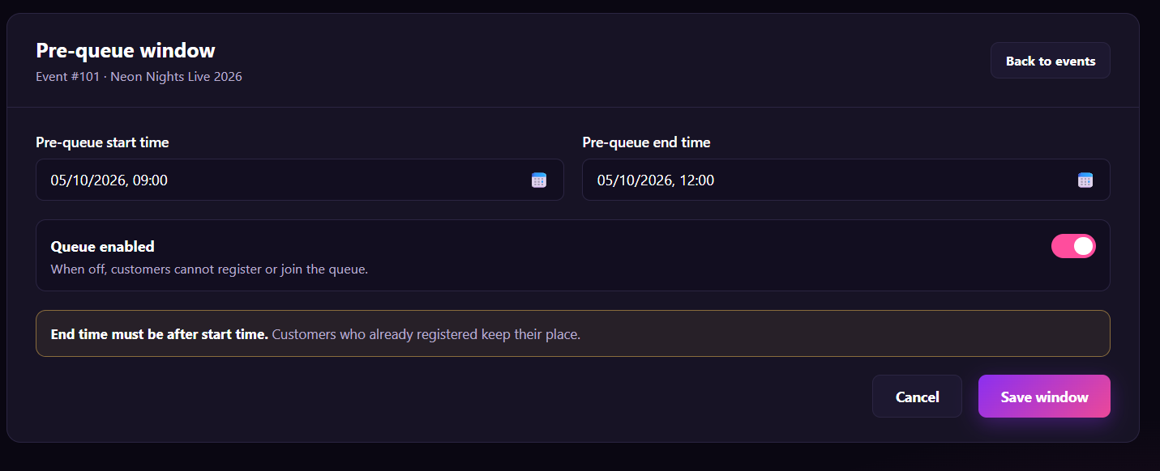
Figure 61 : Configure Pre-Queue Window Screen
FUNCTION DETAILS:
- VALIDATION RULES:
  - The user must be authenticated. The Access Token must be sent in the Authorization header, and it must be present, valid and not expired. The user must be identified from the claims in the token, so the client must not send a user id.
  - The account referenced by the token must exist and be active, and must have the Admin role.
  - The event id must be valid, and the event must exist and must not be deleted.
  - The event must require a virtual queue.
  - The event must not have ended.
  - Pre-queue start time and pre-queue end time are both required and must be valid date-times.
  - The end time must be after the start time.
  - The end time must not be later than the start time of the event's ticket sale (or the event start, if there is no separate sale time).
  - The enabled flag must be a boolean value (on/off).
  - Date-times are entered in the Admin's local time and stored in UTC.
  - If nothing has changed, the system must not save or log a change.
  - The client must send the configuration only for the event in the URL; one request changes one event.

- NORMAL FLOW:
  - Sub-flow A: Open the Configuration
  - Step 1: The logged-in Admin clicks the "Pre-queue window" action of an event on the Events management page.
  - Step 2: The client sends the request with the Access Token in the Authorization header.
  - Step 3: The system validates the Access Token, identifies the user from its claims, looks up the account, and checks that it is active and has the Admin role.
  - Step 4: The system validates the event id, looks up the event, and checks that it is not deleted and that it requires a virtual queue.
  - Step 5: The system returns the event ID, the event name, the current start time, end time and enabled flag (empty times and enabled = off if the event has no configuration yet).
  - Step 6: The client displays the Pre-queue window page with these values.

  - Sub-flow B: Save the Configuration
  - Step 1: The Admin changes the start time, the end time and/or the "Queue enabled" switch.
  - Step 2: The Admin clicks the "Save window" button.
  - Step 3: The client checks that both times are filled and that the end time is after the start time, disables the button and sends the request with the Access Token in the Authorization header.
  - Step 4: The system validates the Access Token, identifies the user from its claims, looks up the account and checks that it is active and has the Admin role.
  - Step 5: The system validates the event id, looks up the event, and checks that it is not deleted, requires a virtual queue and has not ended.
  - Step 6: The system validates the start time, the end time and the enabled flag.
  - Step 7: The system saves the configuration (creates it if it does not exist, otherwise updates it) and does not change any existing place in the queue.
  - Step 8: The system writes the change to the audit log.
  - Step 9: The system returns the saved configuration.
  - Step 10: The client displays the message "Pre-queue window saved." and shows the saved values.

- ABNORMAL FLOWS:
  - Abnormal flow 1: Access Token missing, invalid or expired (occurs at Sub-flow A, Step 2 or 3, or Sub-flow B, Step 3 or 4)
  - Step 1: The Access Token is missing, invalid or expired when the request is sent.
  - Step 2: The system rejects the request, returns 401 Unauthorized and changes nothing.
  - Step 3: The client tries to obtain a new Access Token with the Refresh Token and repeats the request.
  - Step 4: If the Refresh Token is also expired or revoked, the client deletes the stored tokens, displays the message "Your session has expired. Please log in again." and redirects the user to the Login page. The values the Admin entered are not saved.

  - Abnormal flow 2: Account not found or not active (occurs at Sub-flow A, Step 3, or Sub-flow B, Step 4)
  - Step 1: The account referenced by the token no longer exists, or it has been disabled or locked.
  - Step 2: The system logs a warning, changes nothing and returns 401 Unauthorized.
  - Step 3: The client deletes the stored tokens, displays the message "Your account is not available. Please contact support." and redirects the user to the Login page.

  - Abnormal flow 3: Not an Admin (occurs at Sub-flow A, Step 3, or Sub-flow B, Step 4)
  - Step 1: The account is active but does not have the Admin role.
  - Step 2: The system logs a warning, changes nothing and returns 403 Forbidden.
  - Step 3: The client displays the message "You do not have permission to perform this action." and returns to the previous page.

  - Abnormal flow 4: Event not found (occurs at Sub-flow A, Step 4, or Sub-flow B, Step 5)
  - Step 1: The event id does not match any event, or the event has been deleted.
  - Step 2: The system returns 404 Not Found and saves nothing.
  - Step 3: The client displays the message "This event is no longer available."
  - Step 4: The Admin returns to the Events management page.

  - Abnormal flow 5: Event does not require a queue (occurs at Sub-flow A, Step 4, or Sub-flow B, Step 5)
  - Step 1: The event does not require a virtual queue.
  - Step 2: The system returns 409 Conflict and saves nothing.
  - Step 3: The client displays the message "This event does not use a virtual queue."
  - Step 4: The Admin returns to the Events management page.

  - Abnormal flow 6: Event has ended (occurs at Sub-flow B, Step 5)
  - Step 1: The event has already ended.
  - Step 2: The system returns 409 Conflict and saves nothing.
  - Step 3: The client displays the message "This event has ended. The pre-queue window can no longer be changed."

  - Abnormal flow 7: Required time missing (occurs at Sub-flow B, Step 3 or 6)
  - Step 1: The start time or the end time is empty or not a valid date-time.
  - Step 2: The client does not send the request (or the system returns 400 Bad Request) and saves nothing.
  - Step 3: The client highlights the field and displays the message "Please enter a valid start time and end time."

  - Abnormal flow 8: End time is not after start time (occurs at Sub-flow B, Step 3 or 6)
  - Step 1: The end time is equal to or earlier than the start time.
  - Step 2: The client does not send the request (or the system returns 400 Bad Request) and saves nothing.
  - Step 3: The client displays the message "End time must be after start time."

  - Abnormal flow 9: End time is after the ticket sale start (occurs at Sub-flow B, Step 6)
  - Step 1: The end time is later than the start time of the ticket sale of the event.
  - Step 2: The system returns 400 Bad Request and saves nothing.
  - Step 3: The client displays the message "Pre-queue must end before ticket sales start."

3.6.2 Register for Pre-Queue
FUNCTION TRIGGER:
- Trigger 1: Customer clicks the "Get Tickets" button on the Event Details page of an event that has a pre-queue, before ticket sales start.
- Trigger 2: Customer clicks the "Register for pre-queue" button on the Pre-Queue page.
FUNCTION DESCRIPTION:
- Actor(s): Customer
- Secondary actor(s): System
- Purpose:
  - To let Customers register in advance for a high-demand event during the pre-queue window set by the Admin, so that everyone gets a fair spot when tickets go on sale, instead of all rushing in at the same moment.
- Main Functionality:
  - For an event that has a pre-queue, the system opens the Pre-Queue page. The page shows the event name, the status "PRE-QUEUE OPEN", an explanation that registering gives a fair spot but does not reserve a ticket, the time left until the window closes, the time the window opened, and the number of Customers registered so far. The Customer ticks the checkbox to agree to the queue rules (one registration per account) and clicks "Register for pre-queue". The system adds the Customer to the registration list of the event and the page shows that the Customer is registered. While the page is open, the client refreshes the remaining time and the number of registered Customers at regular intervals. When the window closes, the button is disabled and no new registration is accepted. Registering does not reserve or sell any ticket.
SCREEN LAYOUT:
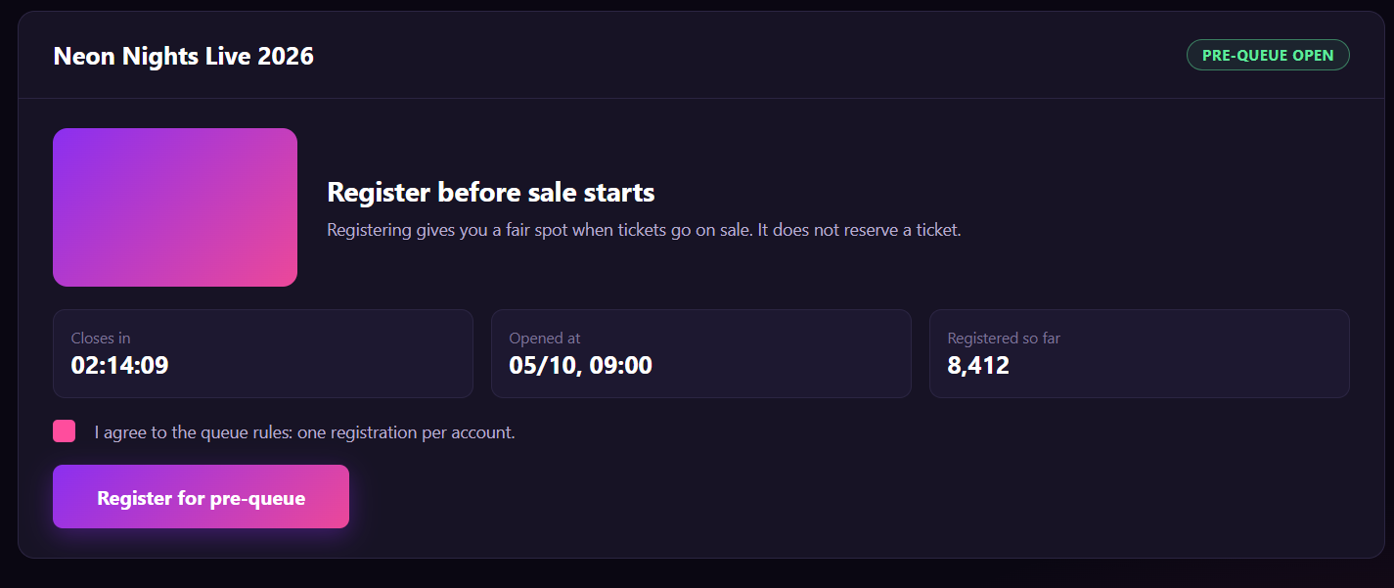
Figure 62 : Register for Pre-Queue Screen

FUNCTION DETAILS:
- VALIDATION RULES:
  - The user must be authenticated. The Access Token must be sent in the Authorization header, and it must be present, valid and not expired. The user must be identified from the claims in the token, so the client must not send a user id.
  - The account referenced by the token must exist and be active.
  - The event slug must be valid, and the event must exist, must be published and must not be deleted.
  - The event must require a virtual queue, and its pre-queue window must be configured.
  - The queue must be enabled ("Queue enabled" is on).
  - The current server time must be between the pre-queue start time and end time. The client's clock must never be used to decide this.
  - The event must not have ended, and it must still have tickets available (sold tickets lower than the total number of tickets).
  - The Customer must have agreed to the queue rules. The agreement flag must be true in the request.
  - A user must have at most one registration per event. A second request to register must return the existing registration and must never create another one.
  - The countdown must be shown as hh:mm:ss, the opened time as dd/MM, HH:mm, and the number of registered Customers with a thousands separator (for example "8,412").
  - The registration must never be made on behalf of another user.

- NORMAL FLOW:
  - Sub-flow A: Register for Pre-Queue
  - Step 1: The Customer ticks the checkbox "I agree to the queue rules: one registration per account."
  - Step 2: The Customer clicks the "Register for pre-queue" button.
  - Step 3: The client disables the button and sends the request with the Access Token in the Authorization header and the agreement flag.
  - Step 4: The system validates the Access Token, identifies the user from its claims, looks up the account and checks that it is active.
  - Step 5: The system validates the event slug, looks up the event, and checks that it is published and not deleted.
  - Step 6: The system checks that the event requires a virtual queue, that the queue is enabled, and that the current time is inside the window.
  - Step 7: The system checks that the event has not ended and still has tickets available.
  - Step 8: The system checks that the agreement flag is true.
  - Step 9: The system checks that the user is not registered yet.
  - Step 10: The system saves the registration with the user, the event and the time.
  - Step 11: The system logs the new registration.
  - Step 12: The system returns the registration result and the updated number of registered Customers.
  - Step 13: The client displays the status "REGISTERED", the message "You are registered for the pre-queue." and replaces the button with a confirmation. The checkbox is locked.

- ABNORMAL FLOWS:
  - Abnormal flow 1: Guest clicks Get Tickets (occurs at Sub-flow A, Step 1)
  - Step 1: A guest who is not logged in clicks "Get Tickets" on an event that has a pre-queue.
  - Step 2: The client does not open the Pre-Queue page.
  - Step 3: The client displays the message "Please log in to register for the pre-queue." and redirects the guest to the Login page.
  - Step 4: After logging in, the user returns to the Pre-Queue page of the event.

  - Abnormal flow 2: Access Token missing, invalid or expired (occurs at Sub-flow A, Step 2 or 3, Sub-flow B, Step 3 or 4, or Sub-flow C, Step 1)
  - Step 1: The Access Token is missing, invalid or expired when the request is sent.
  - Step 2: The system rejects the request, returns 401 Unauthorized and changes nothing.
  - Step 3: The client tries to obtain a new Access Token with the Refresh Token and repeats the request.
  - Step 4: If the Refresh Token is also expired or revoked, the client deletes the stored tokens, displays the message "Your session has expired. Please log in again." and redirects the user to the Login page. No registration is made.

  - Abnormal flow 3: Account not found or not active (occurs at Sub-flow A, Step 3, or Sub-flow B, Step 4)
  - Step 1: The account referenced by the token no longer exists, or it has been disabled or locked.
  - Step 2: The system logs a warning, changes nothing and returns 401 Unauthorized.
  - Step 3: The client deletes the stored tokens, displays the message "Your account is not available. Please contact support." and redirects the user to the Login page.

  - Abnormal flow 4: Event not found or not available (occurs at Sub-flow A, Step 4, or Sub-flow B, Step 5)
  - Step 1: The slug does not match any event, or the event is not published, or it has been deleted.
  - Step 2: The system returns 404 Not Found and adds no registration.
  - Step 3: The client displays the message "This event is no longer available."
  - Step 4: The Customer returns to the event list.

  - Abnormal flow 5: Event has no pre-queue (occurs at Sub-flow A, Step 4, or Sub-flow B, Step 6)
  - Step 1: The event does not use a pre-queue (no window is configured or it does not require a virtual queue).
  - Step 2: The system adds no registration and returns a result that tells the client that no pre-queue is needed.
  - Step 3: The client takes the Customer directly to the next step of the event (the Virtual Queue page or the ticket selection page, depending on the event).

  - Abnormal flow 6: Pre-queue not open yet (occurs at Sub-flow A, Step 5, or Sub-flow B, Step 6)
  - Step 1: The current time is before the start time of the window.
  - Step 2: The system adds no registration and, for a registration request, returns 409 Conflict.
  - Step 3: The client displays the status "NOT OPEN YET", shows the opening time, disables the button and displays the message "The pre-queue has not opened yet."

  - Abnormal flow 7: Pre-queue closed (occurs at Sub-flow B, Step 6)
  - Step 1: The current time is after the end time of the window when the request arrives, for example because the window closed just before the Customer clicked.
  - Step 2: The system adds no registration and returns 409 Conflict.
  - Step 3: The client changes the status to "CLOSED", disables the button and displays the message "The pre-queue has closed."

  - Abnormal flow 8: Queue disabled by Admin (occurs at Sub-flow B, Step 6, or Sub-flow C, Step 2)
  - Step 1: The Admin turned "Queue enabled" off.
  - Step 2: The system adds no registration and returns 409 Conflict.
  - Step 3: The client disables the button and displays the message "Registration is temporarily unavailable." A Customer who already registered keeps the registration.

  - Abnormal flow 9: Tickets no longer available (occurs at Sub-flow B, Step 7)
  - Step 1: The event has ended, or all tickets have been sold.
  - Step 2: The system adds no registration and returns 409 Conflict.
  - Step 3: The client displays the message "Tickets are no longer available for this event."
  - Step 4: The Customer returns to the event list.

  - Abnormal flow 10: Rules not agreed (occurs at Sub-flow B, Step 2 or 8)
  - Step 1: The Customer has not ticked the checkbox.
  - Step 2: The button stays disabled, so the client does not send the request. If a request arrives with the agreement flag not true, the system returns 400 Bad Request and adds no registration.
  - Step 3: The client highlights the checkbox and displays the message "Please agree to the queue rules to continue."

  - Abnormal flow 11: Customer already registered (occurs at Sub-flow A, Step 5, or Sub-flow B, Step 9)
  - Step 1: The user already has a registration for this event, for example because they opened the page in another tab or clicked the button twice.
  - Step 2: The system does not create another registration and returns the existing registration.
  - Step 3: The client displays the status "REGISTERED" without showing an error.

3.6.3 Configure Admission Rate / Fairness Policy
FUNCTION TRIGGER:
- Trigger 1: Admin clicks the "Admission & fairness" action of an event on the Events management page.
- Trigger 2: Admin clicks the "Save policy" button on the Admission & fairness page.

FUNCTION DESCRIPTION:
- Actor(s): Admin
- Secondary actor(s): System (queue process)
- Purpose:
  - To let the Admin control how fast Customers are let in to buy tickets for a high-demand event, and in which order they are let in, so that the ticket purchase system is not overloaded and the order of admission is fair.
- Main Functionality:
  - The Admin opens the Admission & fairness page of an event that requires a virtual queue. The page shows the event (ID and name), the current admission rate (people admitted per minute) and the current fairness policy. There are two policies. "Randomized" gives registered Customers a random order, and it is the default. "First come, first served" orders everyone by the time they joined. The Admin changes the admission rate and/or the policy, then clicks "Save policy". The system validates the request and saves the configuration. From then on, the queue process admits Customers at the configured rate and in the order given by the policy. The estimated wait shown to Customers is recalculated from the new rate. Customers already in the queue keep their place in the queue. The Admin can click "Reset" to discard the unsaved changes.
SCREEN LAYOUT:
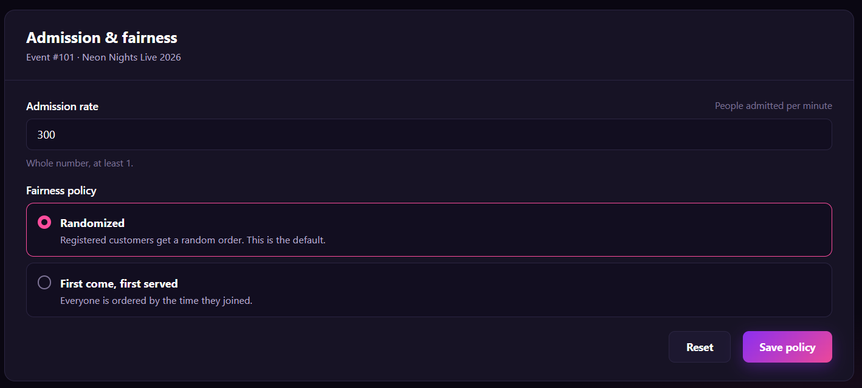
Figure 63 : Configure Admission Rate / Fairness Policy Screen
FUNCTION DETAILS:
- VALIDATION RULES:
  - The user must be authenticated. The Access Token must be sent in the Authorization header, and it must be present, valid and not expired. The user must be identified from the claims in the token, so the client must not send a user id.
  - The account referenced by the token must exist and be active, and must have the Admin role.
  - The event id must be valid, and the event must exist and must not be deleted.
  - The event must require a virtual queue.
  - The event must not have ended.
  - The admission rate is required and must be a whole number (no decimals, no text), at least 1 and not more than the maximum allowed by the system (for example 10,000 people per minute).
  - The fairness policy is required and must be one of the two values: Randomized or First come, first served.
  - If the event has no configuration yet, the default policy is Randomized.
  - If nothing has changed, the system must not save or log a change.
  - One request changes one event only, the event in the URL.

- NORMAL FLOW:
  - Sub-flow A: Open the Configuration
  - Step 1: The logged-in Admin clicks the "Admission & fairness" action of an event on the Events management page.
  - Step 2: The client sends the request with the Access Token in the Authorization header.
  - Step 3: The system validates the Access Token, identifies the user from its claims, looks up the account, and checks that it is active and has the Admin role.
  - Step 4: The system validates the event id, looks up the event, and checks that it is not deleted and that it requires a virtual queue.
  - Step 5: The system returns the event ID, the event name, the current admission rate and the current fairness policy (the default policy Randomized if the event has no configuration yet).
  - Step 6: The client displays the Admission & fairness page with these values.

  - Sub-flow B: Save the Configuration
  - Step 1: The Admin changes the admission rate and/or selects a fairness policy.
  - Step 2: The Admin clicks the "Save policy" button.
  - Step 3: The client checks that the admission rate is a whole number of at least 1 and that a policy is selected, disables the button and sends the request with the Access Token in the Authorization header.
  - Step 4: The system validates the Access Token, identifies the user from its claims, looks up the account and checks that it is active and has the Admin role.
  - Step 5: The system validates the event id, looks up the event, and checks that it is not deleted, requires a virtual queue and has not ended.
  - Step 6: The system validates the admission rate and the fairness policy.
  - Step 7: The system saves the configuration (creates it if it does not exist, otherwise updates it) and does not change the place of any Customer already in the queue.
  - Step 8: The system applies the new admission rate to the queue process and recalculates the estimated wait of the waiting Customers.
  - Step 9: The system writes the change to the audit log.
  - Step 10: The system returns the saved configuration.
  - Step 11: The client displays the message "Admission policy saved." and shows the saved values.

  - Sub-flow C: Reset
  - Step 1: The Admin clicks the "Reset" button.
  - Step 2: The client restores the admission rate and the fairness policy to the last saved values and removes any error message.

- ABNORMAL FLOWS:

  - Abnormal flow 1: Access Token missing, invalid or expired (occurs at Sub-flow A, Step 2 or 3, or Sub-flow B, Step 3 or 4)
  - Step 1: The Access Token is missing, invalid or expired when the request is sent.
  - Step 2: The system rejects the request, returns 401 Unauthorized and changes nothing.
  - Step 3: The client tries to obtain a new Access Token with the Refresh Token and repeats the request.
  - Step 4: If the Refresh Token is also expired or revoked, the client deletes the stored tokens, displays the message "Your session has expired. Please log in again." and redirects the user to the Login page. The values the Admin entered are not saved.

  - Abnormal flow 2: Account not found or not active (occurs at Sub-flow A, Step 3, or Sub-flow B, Step 4)
  - Step 1: The account referenced by the token no longer exists, or it has been disabled or locked.
  - Step 2: The system logs a warning, changes nothing and returns 401 Unauthorized.
  - Step 3: The client deletes the stored tokens, displays the message "Your account is not available. Please contact support." and redirects the user to the Login page.
  - Abnormal flow 3: Not an Admin (occurs at Sub-flow A, Step 3, or Sub-flow B, Step 4)
  - Step 1: The account is active but does not have the Admin role.
  - Step 2: The system logs a warning, changes nothing and returns 403 Forbidden.
  - Step 3: The client displays the message "You do not have permission to perform this action." and returns to the previous page.

  - Abnormal flow 4: Event not found (occurs at Sub-flow A, Step 4, or Sub-flow B, Step 5)
  - Step 1: The event id does not match any event, or the event has been deleted.
  - Step 2: The system returns 404 Not Found and saves nothing.
  - Step 3: The client displays the message "This event is no longer available."
  - Step 4: The Admin returns to the Events management page.
  - Abnormal flow 5: Event does not require a queue (occurs at Sub-flow A, Step 4, or Sub-flow B, Step 5)
  - Step 1: The event does not require a virtual queue.
  - Step 2: The system returns 409 Conflict and saves nothing.
  - Step 3: The client displays the message "This event does not use a virtual queue."
  - Step 4: The Admin returns to the Events management page.

  - Abnormal flow 6: Event has ended (occurs at Sub-flow B, Step 5)
  - Step 1: The event has already ended.
  - Step 2: The system returns 409 Conflict and saves nothing.
  - Step 3: The client displays the message "This event has ended. The admission policy can no longer be changed."

  - Abnormal flow 7: Admission rate missing or not a whole number (occurs at Sub-flow B, Step 3 or 6)
  - Step 1: The admission rate is empty, is not a number, or has decimals.
  - Step 2: The client does not send the request (or the system returns 400 Bad Request) and saves nothing.
  - Step 3: The client highlights the field and displays the message "Admission rate must be a whole number, at least 1."

  - Abnormal flow 8: Admission rate out of range (occurs at Sub-flow B, Step 3 or 6)
  - Step 1: The admission rate is lower than 1 or higher than the maximum allowed.
  - Step 2: The client does not send the request (or the system returns 400 Bad Request) and saves nothing.
  - Step 3: The client highlights the field and displays the message "Admission rate must be between 1 and {max} people per minute."

  - Abnormal flow 9: Fairness policy invalid (occurs at Sub-flow B, Step 3 or 6)
  - Step 1: No policy is selected, or the request contains a value that is not one of the two policies.
  - Step 2: The client does not send the request (or the system returns 400 Bad Request) and saves nothing.
  - Step 3: The client displays the message "Please select a fairness policy."

  - Abnormal flow 10: Configuration changed by another Admin (occurs at Sub-flow B, Step 7)
  - Step 1: Another Admin saved a different configuration for the same event after this Admin opened the page.
  - Step 2: The system returns 409 Conflict and saves nothing.
  - Step 3: The client displays the message "This configuration was changed by someone else. Please reload and try again." and offers a "Reload" button.

3.6.4 Join Virtual Queue
FUNCTION TRIGGER:
- Trigger 1: Customer clicks the "Get Tickets" button on the Event Details page of an event that requires a virtual queue.
- Trigger 2: Customer clicks the "Join queue" button on the Virtual Queue page.
FUNCTION DESCRIPTION:
- Actor(s): Customer
- Secondary actor(s): System (queue process)
- Purpose:
  - To let Customers buy tickets for a high-demand event in a fair order, by making them wait in a virtual queue instead of all entering ticket purchase at the same time.
- Main Functionality:
  - For an event that requires a virtual queue, the system does not send the Customer straight to ticket selection. It opens the Virtual Queue page, which explains how the queue works and shows the number of people in it and the time available to complete an order. When the Customer clicks "Join queue", the system adds them at the end of the queue and shows their position ("#430"), the number of people ahead, the estimated wait, the number of people in the queue and their progress. While the page is open, the client asks the system for the latest status at regular intervals, and the display is updated. When the Customer reaches the front, the system admits them and gives them time-limited access to ticket purchase (10 minutes), and the client takes them to ticket selection automatically. The Customer can leave the queue at any time after confirming. If the connection is lost, the place is held for a short time. Joining the queue does not reserve any ticket.
SCREEN LAYOUT:
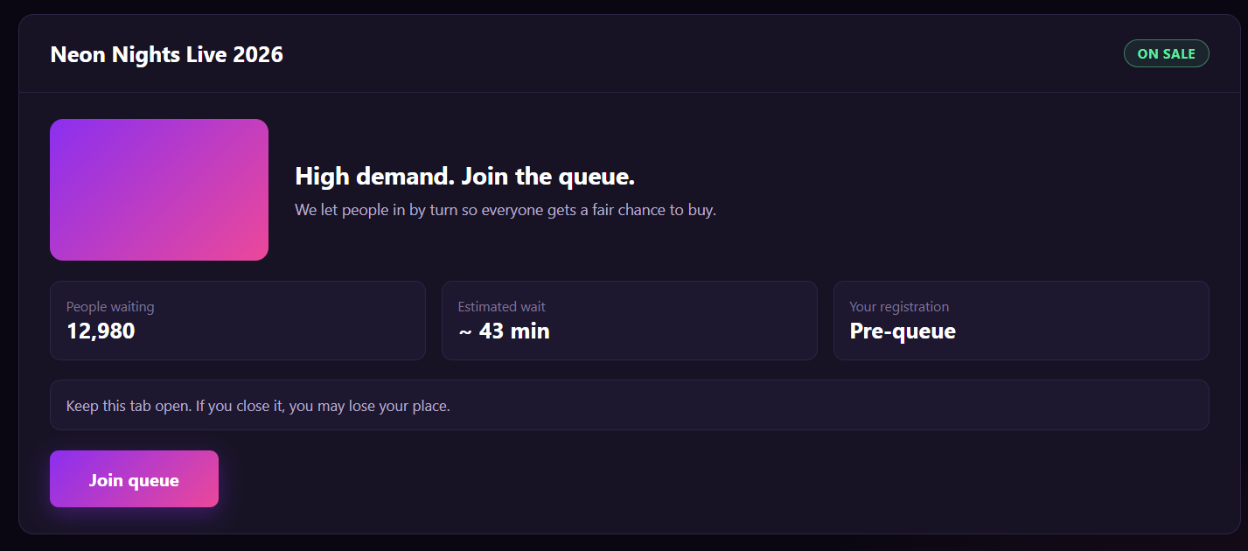
Figure 64 : Join Virtual Queue Screen
FUNCTION DETAILS:
- VALIDATION RULES:
  - The user must be authenticated. The Access Token must be sent in the Authorization header, and it must be present, valid and not expired. The user must be identified from the claims in the token, so the client must not send a user id.
  - The account referenced by the token must exist and be active.
  - The event slug must be valid, and the event must exist, must be published and must not be deleted.
  - The event must require a virtual queue.
  - The event must not have ended, and it must still have tickets available (sold tickets lower than the total number of tickets).
  - A user must have at most one place in the queue of an event. A second request to join must return the existing place and must never create another one.
  - Only a user whose place has the status Waiting can leave the queue.
  - Access to ticket purchase must be granted only to a user whose place has the status Admitted, only for that event, and only while the granted time (10 minutes) has not expired.
  - The position must be shown as "#" followed by the number, the people ahead as the position minus 1, and the estimated wait in minutes with the symbol "~".
  - The progress must be a percentage from 0% to 100%, calculated from the position when the user joined and the current position.
  - A place must be held for a limited time (2 minutes) after the client stops asking for status.
  - The queue must never be joined on behalf of another user.

- NORMAL FLOW:
  - Sub-flow A: Join Queue
Step 1: The logged-in Customer opens the Event Details page of an event that requires a virtual queue and clicks the "Get Tickets" button.
Step 2: The system displays the Virtual Queue page with the explanation, the number of people in the queue, the time to complete the order, and the "Join queue" button.
Step 3: The Customer clicks the "Join queue" button.
Step 4: The client disables the button and sends the request with the Access Token in the Authorization header.
Step 5: The system validates the Access Token, identifies the user from its claims, looks up the account and checks that it is active.
Step 6: The system validates the event slug, looks up the event, and checks that it is published and not deleted.
Step 7: The system checks that the event requires a virtual queue.
Step 8: The system checks that the event has not ended and still has tickets available.
Step 9: The system checks that the user does not already have a place in the queue.
Step 10: The system adds the user at the end of the queue with the time they joined and the status Waiting, and determines their position.
Step 11: The system logs the new place.
Step 12: The system returns the position, the number of people ahead, the estimated wait, the number of people in the queue and the progress.
Step 13: The client displays the waiting view.
  - Sub-flow B: Wait in the Queue
Step 1: While the waiting view is open, the client requests the status of the Customer's place at regular intervals, with the Access Token.
Step 2: The system validates the Access Token and finds the user's place.
Step 3: The system recalculates the position, the number of people ahead, the estimated wait, the number of people in the queue and the progress, and keeps the place active.
Step 4: The system returns the status Waiting with these values.
Step 5: The client updates the display and shows the "Live" indicator. Steps 1 to 5 repeat until the Customer's turn.
- ABNORMAL FLOWS:
  - Abnormal flow 1: Guest clicks Get Tickets (occurs at Sub-flow A, Step 1)
Step 1: A guest who is not logged in clicks "Get Tickets" on an event that requires a virtual queue.
Step 2: The client does not open the queue.
Step 3: The client displays the message "Please log in to join the queue." and redirects the guest to the Login page.
Step 4: After logging in, the user returns to the Virtual Queue page of the event.
  - Abnormal flow 2: Access Token missing, invalid or expired (occurs at Sub-flow A, Step 4 or 5, Sub-flow B, Step 1 or 2, or Sub-flow D, Step 4 or 5)
Step 1: The Access Token is missing, invalid or expired when the request is sent.
Step 2: The system rejects the request, returns 401 Unauthorized and changes nothing.
Step 3: The client tries to obtain a new Access Token with the Refresh Token and repeats the request.
Step 4: If the Refresh Token is also expired or revoked, the client deletes the stored tokens, displays the message "Your session has expired. Please log in again." and redirects the user to the Login page. The place in the queue is kept until it expires.
  - Abnormal flow 3: Account not found or not active (occurs at Sub-flow A, Step 5, Sub-flow B, Step 2, or Sub-flow D, Step 5)
Step 1: The account referenced by the token no longer exists, or it has been disabled or locked.
Step 2: The system logs a warning, removes any place of the user in the queue and changes nothing else.
Step 3: The system returns 401 Unauthorized.
Step 4: The client deletes the stored tokens, displays the message "Your account is not available. Please contact support." and redirects the user to the Login page.
  - Abnormal flow 4: Event not found or not available (occurs at Sub-flow A, Step 6)
Step 1: The slug does not match any event, or the event is not published, or it has been deleted.
Step 2: The system returns 404 Not Found and adds no place.
Step 3: The client displays the message "This event is no longer available."
Step 4: The Customer returns to the event list.
  - Abnormal flow 5: Event does not require a queue (occurs at Sub-flow A, Step 7)
Step 1: The event no longer requires a virtual queue.
Step 2: The system does not add a place and returns a result that tells the client that no queue is needed.
Step 3: The client takes the Customer directly to the ticket selection page of the event.
  - Abnormal flow 6: Tickets no longer available (occurs at Sub-flow A, Step 8, or Sub-flow B, Step 3)
Step 1: The event has ended, or all tickets have been sold.
Step 2: The system adds no place (or closes the existing place) and returns 409 Conflict.
Step 3: The client displays the message "Tickets are no longer available for this event."
Step 4: The Customer returns to the event list.
  - Abnormal flow 7: Customer already in the queue (occurs at Sub-flow A, Step 9)
Step 1: The user already has a place in the queue, for example because they opened the page in another tab or clicked the button twice.
Step 2: The system does not create another place and returns the existing place.
Step 3: The client displays the waiting view with the existing position, without showing an error.
  - Abnormal flow 8: Connection lost while waiting (occurs at Sub-flow B, Step 1 to 5)
Step 1: The connection is lost, or the status request fails.
Step 2: The client displays the "Reconnecting" view with the last known position and the message "Connection lost. Reconnecting… Your place is held for 2:00.", and tries again automatically.
Step 3: If the connection returns within 2 minutes, the system returns the status of the place, and the client displays the waiting view again with the current position.
Step 4: The Customer can also click "Retry now" to try again immediately, or "Leave queue".
  - Abnormal flow 9: Place expired (occurs at Sub-flow B, Step 2)
Step 1: The system has received no status request for more than 2 minutes, and the place has expired.
Step 2: The system returns the status Expired and removes the place from the queue.
Step 3: The client displays the "Expired" view with the message "Your place in line has expired."
Step 4: The Customer clicks "Join queue again" to get a new place at the end of the queue (returns to Sub-flow A, Step 4).
  - Abnormal flow 10: Time to complete the order expired (occurs at Sub-flow C, Step 6)
Step 1: The Customer was let in, but did not complete the order within 10 minutes.
Step 2: The system ends the granted access and refuses further ticket selection and purchase for this event.
Step 3: The client displays the message "Your time to complete the order has ended. Please join the queue again."
Step 4: The Customer returns to the Virtual Queue page and joins again (returns to Sub-flow A, Step 2).

3.6.5 View Real-time Queue Position
FUNCTION TRIGGER:
- Trigger 1: The Customer joins the virtual queue successfully (see Join Virtual Queue) and the Waiting view is displayed.
- Trigger 2: The Customer opens the Virtual Queue page of an event while they already have a place in its queue (for example after reloading the page or from another tab).
- Trigger 3: While the Waiting view is open, the client automatically requests the latest status of the Customer's place at regular intervals.
FUNCTION DESCRIPTION:
- Actor(s): Customer
- Purpose:
  - To let Customers who are waiting in a virtual queue see their current position, the estimated wait and their progress without reloading the page, so that they know how long they may have to wait and whether their place is still valid.
- Main Functionality:
  - While the Customer is waiting in the queue, the system shows the Waiting view with a "Live" indicator, the Customer's position ("#430"), the number of people ahead ("429 people ahead of you"), the estimated wait ("~6 min"), the number of people in the queue ("1,680") and the progress ("66%"). While the page is open, the client asks the system for the latest status at regular intervals, and the values are updated on the same page without reloading. Each status request also keeps the Customer's place active. If the connection is lost, the client shows the last known position and the time the place is still held, and keeps trying again. When the Customer's place is admitted, expired or no longer exists, the client changes to the view that matches the new status. Viewing the position does not change the order of the queue and does not reserve any ticket.

SCREEN LAYOUT:
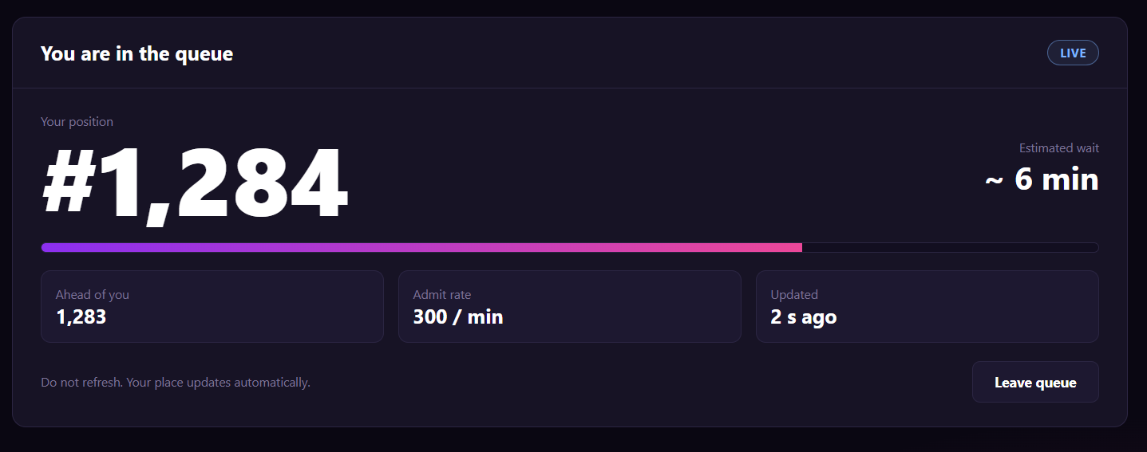
Figure 65 : View Real-time Queue Position Screen

FUNCTION DETAILS:
- VALIDATION RULES:
  - The user must be authenticated. The Access Token must be sent in the Authorization header, and it must be present, valid and not expired. The user must be identified from the claims in the token, so the client must not send a user id.
  - The account referenced by the token must exist and be active.
  - The event slug must be valid, and the event must exist, must be published and must not be deleted.
  - The event must require a virtual queue.
  - The event must not have ended, and it must still have tickets available (sold tickets lower than the total number of tickets).
  - A user must have at most one place in the queue of an event. A second request to join must return the existing place and must never create another one.
  - Only a user whose place has the status Waiting can leave the queue.
  - Access to ticket purchase must be granted only to a user whose place has the status Admitted, only for that event, and only while the granted time (10 minutes) has not expired.
  - The position must be shown as "#" followed by the number, the people ahead as the position minus 1, and the estimated wait in minutes with the symbol "~".
  - The progress must be a percentage from 0% to 100%, calculated from the position when the user joined and the current position.
  - A place must be held for a limited time (2 minutes) after the client stops asking for status.
  - The queue must never be joined on behalf of another user.
- NORMAL FLOW:
  - Sub-flow A: Join Queue
Step 1: The logged-in Customer opens the Event Details page of an event that requires a virtual queue and clicks the "Get Tickets" button.
Step 2: The system displays the Virtual Queue page with the explanation, the number of people in the queue, the time to complete the order, and the "Join queue" button.
Step 3: The Customer clicks the "Join queue" button.
Step 4: The client disables the button and sends the request with the Access Token in the Authorization header.
Step 5: The system validates the Access Token, identifies the user from its claims, looks up the account and checks that it is active.
Step 6: The system validates the event slug, looks up the event, and checks that it is published and not deleted.
Step 7: The system checks that the event requires a virtual queue.
Step 8: The system checks that the event has not ended and still has tickets available.
Step 9: The system checks that the user does not already have a place in the queue.
Step 10: The system adds the user at the end of the queue with the time they joined and the status Waiting, and determines their position.
Step 11: The system logs the new place.
Step 12: The system returns the position, the number of people ahead, the estimated wait, the number of people in the queue and the progress.
Step 13: The client displays the waiting view.
  - Sub-flow B: Wait in the Queue
Step 1: While the waiting view is open, the client requests the status of the Customer's place at regular intervals, with the Access Token.
Step 2: The system validates the Access Token and finds the user's place.
Step 3: The system recalculates the position, the number of people ahead, the estimated wait, the number of people in the queue and the progress, and keeps the place active.
Step 4: The system returns the status Waiting with these values.
Step 5: The client updates the display and shows the "Live" indicator. Steps 1 to 5 repeat until the Customer's turn.

- ABNORMAL FLOWS:
  - Abnormal flow 1: Guest clicks Get Tickets (occurs at Sub-flow A, Step 1)
Step 1: A guest who is not logged in clicks "Get Tickets" on an event that requires a virtual queue.
Step 2: The client does not open the queue.
Step 3: The client displays the message "Please log in to join the queue." and redirects the guest to the Login page.
Step 4: After logging in, the user returns to the Virtual Queue page of the event.
  - Abnormal flow 2: Access Token missing, invalid or expired (occurs at Sub-flow A, Step 4 or 5, Sub-flow B, Step 1 or 2, or Sub-flow D, Step 4 or 5)
Step 1: The Access Token is missing, invalid or expired when the request is sent.
Step 2: The system rejects the request, returns 401 Unauthorized and changes nothing.
Step 3: The client tries to obtain a new Access Token with the Refresh Token and repeats the request.
Step 4: If the Refresh Token is also expired or revoked, the client deletes the stored tokens, displays the message "Your session has expired. Please log in again." and redirects the user to the Login page. The place in the queue is kept until it expires.
  - Abnormal flow 3: Event does not require a queue (occurs at Sub-flow A, Step 7)
Step 1: The event no longer requires a virtual queue.
Step 2: The system does not add a place and returns a result that tells the client that no queue is needed.
Step 3: The client takes the Customer directly to the ticket selection page of the event.
  - Abnormal flow 4: Customer already in the queue (occurs at Sub-flow A, Step 9)
Step 1: The user already has a place in the queue, for example because they opened the page in another tab or clicked the button twice.
Step 2: The system does not create another place and returns the existing place.
Step 3: The client displays the waiting view with the existing position, without showing an error.
  - Abnormal flow 5: Time to complete the order expired (occurs at Sub-flow C, Step 6)
Step 1: The Customer was let in, but did not complete the order within 10 minutes.
Step 2: The system ends the granted access and refuses further ticket selection and purchase for this event.
Step 3: The client displays the message "Your time to complete the order has ended. Please join the queue again."
Step 4: The Customer returns to the Virtual Queue page and joins again (returns to Sub-flow A, Step 2).

3.6.6 Leave Virtual Queue
FUNCTION TRIGGER:
- Trigger 1: The Customer clicks the "Leave queue" button on the Waiting view of the Virtual Queue page.
- Trigger 2: The Customer clicks the "Leave queue" button on the Reconnecting view of the Virtual Queue page.
FUNCTION DESCRIPTION:
- Actor(s): Customer
- Secondary actor(s): System (queue process)
- Purpose:
  - To let a Customer who no longer wants to wait give up their place in the virtual queue at any time, so that the Customers behind them can move forward.
- Main Functionality:
  - While the Customer is waiting in the queue, they can click "Leave queue". The system does not remove the place immediately. It first displays the popup "Leave the queue?" with the message that the Customer will lose their current place (for example "#430") and go to the back of the line if they join again. If the Customer confirms, the system removes the place from the queue with the status Left and moves the positions of the Customers behind forward by one place. The client then shows the message "You left the queue." and returns the Customer to the Join queue view. If the Customer clicks "Stay in queue", presses Esc or clicks outside the popup, the popup closes and nothing changes. Leaving the queue does not affect any ticket, because joining the queue does not reserve any ticket.
SCREEN LAYOUT:
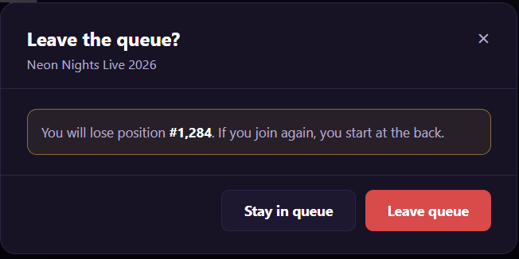
Figure 66 : Leave Virtual Queue Screen
FUNCTION DETAILS:
- VALIDATION RULES:
  - The user must be authenticated. The Access Token must be sent in the Authorization header, and it must be present, valid and not expired. The user must be identified from the claims in the token, so the client must not send a user id.
  - The account referenced by the token must exist and be active.
  - The event slug must be valid, and the event must exist and must not be deleted.
  - The user must have a place in the queue of this event. A user can only leave their own place, and must never be able to remove the place of another user.
  - Only a user whose place has the status Waiting can leave the queue. A place with the status Admitted or Expired must not be changed by this function.
  - The client must display the confirmation popup before it sends the request to leave the queue.
  - The position shown in the popup must be the latest position known to the client, shown as "#" followed by the number.
  - After a place is removed, the positions of the Customers behind it must move forward by one, and the relative order of the other Customers must not change.
  - A place with the status Left must not be used again. If the Customer joins again, the system must create a new place at the end of the queue.
  - While the request is being processed, the buttons of the popup must be disabled to prevent double submission.

- NORMAL FLOW:
  - Sub-flow A: Leave the Queue
Step 1: The Customer is on the Waiting view (or the Reconnecting view) and clicks the "Leave queue" button.
Step 2: The system displays the popup "Leave the queue?" with the message that the Customer will lose their place (for example "#430") and go to the back of the line if they join again.
Step 3: The Customer clicks the "Leave queue" button in the popup.
Step 4: The client disables the buttons of the popup and sends the request with the Access Token in the Authorization header.
Step 5: The system validates the Access Token, identifies the user from its claims, looks up the account and checks that it is active.
Step 6: The system validates the event slug, looks up the event and checks that it exists and is not deleted.
Step 7: The system finds the user's place in the queue of the event and checks that it has the status Waiting.
Step 8: The system removes the place from the queue with the status Left, and moves the positions of the Customers behind forward by one.
Step 9: The system logs the change and returns a success result.
Step 10: The client stops the status requests, closes the popup, displays the message "You left the queue." and returns the Customer to the Join queue view.

ABNORMAL FLOWS:
  - Abnormal flow 1: Leaving the queue not possible
Step 1: The user's place no longer has the status Waiting (it has already been admitted or has expired).
Step 2: The system changes nothing and returns the current status.
Step 3: The client closes the popup and displays the view that matches the status ("Your turn" or "Expired").

3.6.7 Revoke Queue Token
FUNCTION TRIGGER:
- Trigger 1: Admin clicks the "Revoke" action on a queue token row in the Queue monitoring list of an event.
- Trigger 2: Admin clicks the "Confirm revoke" button in the Revoke queue token dialog.
FUNCTION DESCRIPTION:
- Actor(s): Admin
- Secondary actor(s): System (queue process), Customer (affected user)
- Purpose:
  - To let the Admin end a queue token immediately, for example when it is suspected of abuse, so that the user behind it leaves the queue and can no longer continue to ticket purchase.
- Main Functionality:
  - The Admin selects a queue token in the Queue monitoring list of an event and clicks "Revoke". The system opens the Revoke queue token dialog, which shows the masked token (for example "qt_8f21...a9") and the user ("User #2231"), together with a warning that revoking ends the token now, that the user leaves the queue and that the user can no longer continue to checkout. The Admin clicks "Confirm revoke". The system validates the request, changes the status of the token to Revoked, removes the user's place from the queue and ends any time-limited access to ticket purchase. The list is refreshed, and the Customers behind move up by one position. The Admin can click "Cancel" or the close button "×" to close the dialog without any change. On its next status request, the Customer's client receives the status Revoked and displays a message.
SCREEN LAYOUT:
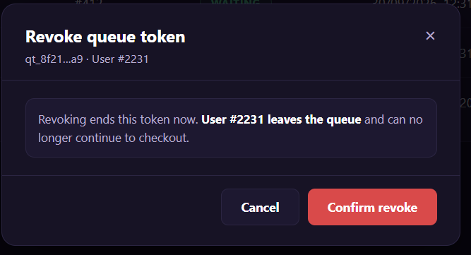
Figure 67 : Revoke Queue Token Screen

FUNCTION DETAILS:
- VALIDATION RULES:
  - The user must be authenticated. The Access Token must be sent in the Authorization header, and it must be present, valid and not expired. The Admin must be identified from the claims in the token, so the client must not send an admin id.
  - The account referenced by the token must exist and be active, and must have the Admin role.
  - The queue token id must be valid and the token must exist. The client sends only the token id of the row, never the user id. The system finds the affected user from the token.
  - The token must belong to the event shown in the Queue monitoring list.
  - Only a token whose status is Waiting or Admitted can be revoked. A token that is Expired, Revoked or already used to complete an order cannot be revoked.
  - One request revokes one token only.
  - The token must be shown masked (first characters and last 2 characters). The full token must never be displayed or written to logs.
  - The revoke request must be confirmed by the Admin in the dialog before it is sent.

- NORMAL FLOW:
  - Sub-flow A: Confirm Revoke
  - Step 1: The Admin clicks the "Confirm revoke" button.
  - Step 2: The client disables the buttons and sends the request with the Access Token in the Authorization header.
  - Step 3: The system validates the Access Token, identifies the Admin from its claims, looks up the account, and checks that it is active and has the Admin role.
  - Step 4: The system validates the queue token id, looks up the token, and checks that it belongs to the event.
  - Step 5: The system checks that the status of the token is Waiting or Admitted.
  - Step 6: The system changes the status of the token to Revoked, removes the user's place from the queue, and ends the granted access to ticket purchase if the token was Admitted.
  - Step 7: The system releases any ticket temporarily held for the user's current purchase.
  - Step 8: The system recalculates the positions and the estimated wait of the Customers behind.
  - Step 9: The system writes the revoke to the audit log.
  - Step 10: The system returns the result with the updated token status.
  - Step 11: The client closes the dialog, displays the message "Queue token revoked." and updates the row with the status Revoked (or removes it from the active list).

- ABNORMAL FLOWS:
  - Abnormal flow 1: Access Token missing, invalid or expired (occurs at Sub-flow B, Step 2 or 3)
  - Step 1: The Access Token is missing, invalid or expired when the request is sent.
  - Step 2: The system rejects the request, returns 401 Unauthorized and changes nothing.
  - Step 3: The client tries to obtain a new Access Token with the Refresh Token and repeats the request.
  - Step 4: If the Refresh Token is also expired or revoked, the client deletes the stored tokens, displays the message "Your session has expired. Please log in again." and redirects the Admin to the Login page. The token is not revoked.

  - Abnormal flow 2: Account not found or not active (occurs at Sub-flow B, Step 3)
  - Step 1: The account referenced by the token no longer exists, or it has been disabled or locked.
  - Step 2: The system logs a warning, changes nothing and returns 401 Unauthorized.
  - Step 3: The client deletes the stored tokens, displays the message "Your account is not available. Please contact support." and redirects the user to the Login page.

  - Abnormal flow 3: Not an Admin (occurs at Sub-flow B, Step 3)
  - Step 1: The account is active but does not have the Admin role.
  - Step 2: The system logs a warning, changes nothing and returns 403 Forbidden.
  - Step 3: The client closes the dialog and displays the message "You do not have permission to perform this action."

  - Abnormal flow 4: Token not found (occurs at Sub-flow B, Step 4)
  - Step 1: The token id does not match any token, or the token does not belong to the event.
  - Step 2: The system returns 404 Not Found and changes nothing.
  - Step 3: The client closes the dialog, displays the message "This queue token no longer exists." and refreshes the list.

  - Abnormal flow 5: Token can no longer be revoked (occurs at Sub-flow B, Step 5)
  - Step 1: The token is no longer Waiting or Admitted when the request arrives. For example, it has expired, another Admin has revoked it, or the Customer has completed the order while the dialog was open.
  - Step 2: The system returns 409 Conflict and changes nothing.
  - Step 3: The client closes the dialog, displays the message "This token is no longer active and cannot be revoked." and refreshes the list with the current status.

  - Abnormal flow 6: Revoke is being processed by another request (occurs at Sub-flow B, Step 6)
  - Step 1: Two Admins confirm the revoke of the same token at the same time.
  - Step 2: The system processes the first request and, for the second, returns 409 Conflict and changes nothing more.
  - Step 3: The client displays the message "This token has already been revoked." and refreshes the list.

3.6.8 View Abuse Alert List
FUNCTION TRIGGER:
- Trigger 1: Admin clicks the "Abuse alerts" menu item in the Admin area.
- Trigger 2: Admin clicks the "Search", "Reset" or "Refresh" button, or the "Prev" / "Next" button on the Abuse alerts page.
FUNCTION DESCRIPTION:
- Actor(s): Admin
- Secondary actor(s): System
- Purpose:
  - To let the Admin see the alerts that the system raises when it detects suspicious behavior in the virtual queue (for example one account joining too quickly, several accounts from one session, or rejoining again and again), so that the Admin can find and handle abuse in time.
- Main Functionality:
  - The Admin opens the Abuse alerts page. The system shows a list of alerts, newest first, with the alert number, type, severity, user, session, status and detection time. By default, the list shows alerts with the status "Open". The Admin can filter the list by status, severity, event ID and user ID, then click "Search". "Reset" clears all filters and returns to the default. "Refresh" loads the list again with the current filters. The list is divided into pages, and the Admin moves between pages with "Prev" and "Next". The Admin clicks "View" on a row to open the detail of the alert (described in a separate function). This function only reads data. It does not change any alert, token or user.

SCREEN LAYOUT:
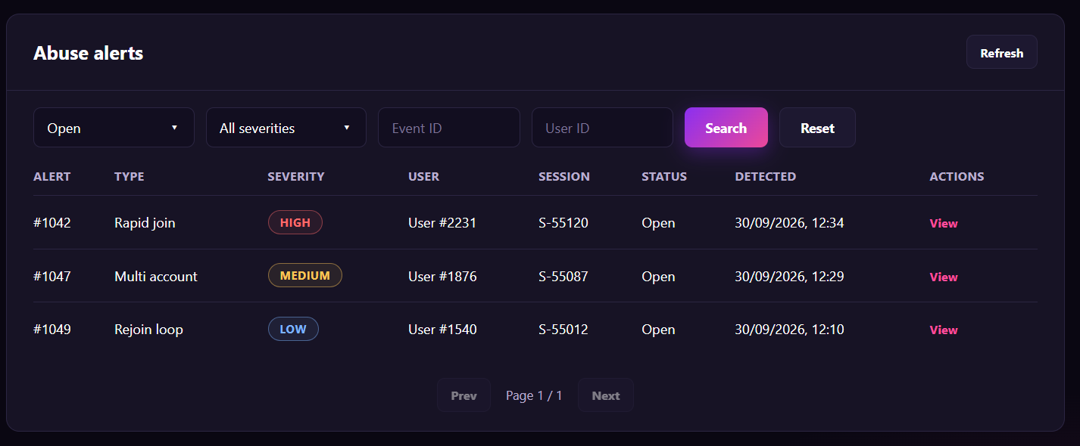
Figure 68 : View Abuse Alert List Screen
FUNCTION DETAILS:
- VALIDATION RULES:
  - The user must be authenticated. The Access Token must be sent in the Authorization header, and it must be present, valid and not expired. The user must be identified from the claims in the token, so the client must not send a user id as the identity of the requester.
  - The account referenced by the token must exist and be active, and must have the Admin role.
  - The status filter must be one of the allowed values (Open, the other statuses, or All statuses). The default is Open.
  - The severity filter must be one of High, Medium, Low, or All severities. The default is All severities.
  - The Event ID and the User ID, if entered, must be whole numbers greater than 0 (no decimals, no text, no spaces). An empty value means "no filter".
  - The page number must be a whole number of at least 1, and the page size must be a fixed value set by the system (for example 10) with a maximum limit. The client cannot request an unlimited page size.
  - If the requested page is greater than the total number of pages, the system returns the last page (or an empty list if there is no result).
  - The list must be sorted by detection time, newest first. Alerts with the same detection time are sorted by alert ID, largest first.
  - The user of an alert is shown only as "User #{id}". The list must not show the email, the phone number or other personal data of the user.

- NORMAL FLOW:
  - Sub-flow A: Open the List
  - Step 1: The logged-in Admin clicks the "Abuse alerts" menu item.
  - Step 2: The client sends the request with the default filters (status Open, all severities, page 1) and the Access Token in the Authorization header.
  - Step 3: The system validates the Access Token, identifies the user from its claims, looks up the account, and checks that it is active and has the Admin role.
  - Step 4: The system validates the filters and the paging values.
  - Step 5: The system finds the alerts that satisfy the filters, sorts them by detection time (newest first) and takes the requested page.
  - Step 6: The system returns the alerts of the page and the paging information (current page, total pages).
  - Step 7: The client displays the list and the pagination. If there is no alert, the client displays the message "No abuse alerts found."

- ABNORMAL FLOWS:
  - Abnormal flow 1: Access Token missing, invalid or expired (occurs at Sub-flow A, Step 2 or 3, )
  - Step 1: The Access Token is missing, invalid or expired when the request is sent.
  - Step 2: The system rejects the request, returns 401 Unauthorized and returns no data.
  - Step 3: The client tries to obtain a new Access Token with the Refresh Token and repeats the request.
  - Step 4: If the Refresh Token is also expired or revoked, the client deletes the stored tokens, displays the message "Your session has expired. Please log in again." and redirects the user to the Login page.

  - Abnormal flow 2: Account not found or not active (occurs at Sub-flow A, Step 3, or the same step of the other sub-flows)
  - Step 1: The account referenced by the token no longer exists, or it has been disabled or locked.
  - Step 2: The system logs a warning, returns no data and returns 401 Unauthorized.
  - Step 3: The client deletes the stored tokens, displays the message "Your account is not available. Please contact support." and redirects the user to the Login page.

  - Abnormal flow 3: Not an Admin (occurs at Sub-flow A, Step 3, or the same step of the other sub-flows)
  - Step 1: The account is active but does not have the Admin role.
  - Step 2: The system logs a warning, returns no data and returns 403 Forbidden.
  - Step 3: The client displays the message "You do not have permission to view this page." and returns to the previous page.

  - Abnormal flow 4: No result (occurs at Sub-flow A, Step 5)
  - Step 1: No alert satisfies the filters.
  - Step 2: The system returns an empty list with 0 pages.
  - Step 3: The client displays the message "No abuse alerts found." and disables the "Prev" and "Next" buttons. The client shows "Page 1 / 1".

3.6.9 View Abuse Alert Details
FUNCTION TRIGGER:
- Trigger 1: Admin clicks the "View" link on an alert row in the Abuse alerts list.
- Trigger 2: Admin opens the detail page of an alert directly by its link (for example from a notification).
FUNCTION DESCRIPTION:
- Actor(s): Admin
- Secondary actor(s): None
- Purpose:
  - To let the Admin see all the information of one abuse alert raised by the system (who, which event, which session and token, and what behavior was detected), so that the Admin can decide how to handle it, for example by flagging or blocking the session.
- Main Functionality:
  - The Admin opens the detail page of an alert. The page shows the alert number, the type of alert, the detection time and the severity badge, followed by the event, the user, the session, the masked queue token, the alert status and a description of the detected behavior (for example "38 join requests in 10 seconds from this session. The pattern matches an automated script."). If the alert can still be handled, the page shows the button "Flag / block session", which starts the function Flag / Block Session (described in a separate function). The Admin clicks "Back to alerts" to return to the Abuse alerts list with the filters and the page that were used before. This function only reads data. It does not change any alert, token, session or user.
SCREEN LAYOUT:
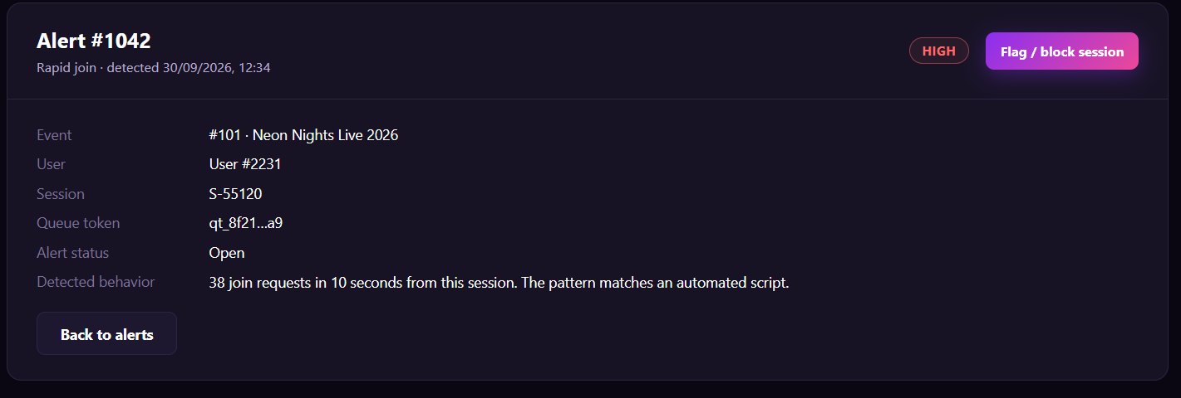
Figure 69 : View Abuse Alert Details Screen
FUNCTION DETAILS:
- VALIDATION RULES:
  - The user must be authenticated. The Access Token must be sent in the Authorization header, and it must be present, valid and not expired. The user must be identified from the claims in the token, so the client must not send a user id as the identity of the requester.
  - The account referenced by the token must exist and be active, and must have the Admin role.
  - The alert id must be a whole number greater than 0, and the alert must exist.
  - The alert shown must be the one in the URL. One request returns one alert only.
  - The user of the alert is shown only as "User #{id}". The page must not show the email, the phone number, the IP address or other personal data.
  - The queue token must be shown masked (first characters and last 2 characters). The full token must never be displayed or written to logs.
  - The severity must be shown as one of High, Medium or Low, and the status as one of the allowed statuses of an alert.
  - If the event of the alert has been deleted, the page still shows the alert, with the event id and the name stored when the alert was created.
  - The "Flag / block session" button must be shown only when the alert status is Open and the session is not already blocked.
- BUSINESS RULES: BR-170, BR-180, BR-181

- NORMAL FLOW:
  - Sub-flow A: Open the Alert
  - Step 1: The logged-in Admin clicks the "View" link on a row in the Abuse alerts list.
  - Step 2: The client sends the request with the alert id and the Access Token in the Authorization header.
  - Step 3: The system validates the Access Token, identifies the user from its claims, looks up the account, and checks that it is active and has the Admin role.
  - Step 4: The system validates the alert id and looks up the alert.
  - Step 5: The system returns the alert id, type, severity, detection time, event (id and name), user id, session code, masked queue token, alert status and detected behavior.
  - Step 6: The client displays the Alert detail page with these values. If the alert is still Open and the session is not blocked, the client shows the "Flag / block session" button.

- ABNORMAL FLOWS:
  - Abnormal flow 1: Access Token missing, invalid or expired
  - Step 1: The Access Token is missing, invalid or expired when the request is sent.
  - Step 2: The system rejects the request, returns 401 Unauthorized and returns no data.
  - Step 3: The client tries to obtain a new Access Token with the Refresh Token and repeats the request.
  - Step 4: If the Refresh Token is also expired or revoked, the client deletes the stored tokens, displays the message "Your session has expired. Please log in again." and redirects the user to the Login page. After logging in, the Admin returns to this alert.

  - Abnormal flow 2: Account not found or not active
  - Step 1: The account referenced by the token no longer exists, or it has been disabled or locked.
  - Step 2: The system logs a warning, returns no data and returns 401 Unauthorized.
  - Step 3: The client deletes the stored tokens, displays the message "Your account is not available. Please contact support." and redirects the user to the Login page.

  - Abnormal flow 3: Not an Admin
  - Step 1: The account is active but does not have the Admin role.
  - Step 2: The system logs a warning, returns no data and returns 403 Forbidden.
  - Step 3: The client displays the message "You do not have permission to view this page." and returns to the previous page.

  - Abnormal flow 4: Alert id invalid
  - Step 1: The alert id in the link is not a whole number greater than 0.
  - Step 2: The system returns 400 Bad Request and returns no data.
  - Step 3: The client displays the message "This alert link is not valid." and offers the "Back to alerts" button.

  - Abnormal flow 5: Alert not found
  - Step 1: The alert id does not match any alert, or the alert has been removed.
  - Step 2: The system returns 404 Not Found and returns no data.
  - Step 3: The client displays the message "This alert no longer exists." and offers the "Back to alerts" button.

  - Abnormal flow 6: Alert already handled
  - Step 1: The alert status is no longer Open (for example another Admin has already flagged or blocked the session), or the session is already blocked.
  - Step 2: The system returns the alert with its current status. This is not an error.
  - Step 3: The client displays the current status and hides the "Flag / block session" button. If the Admin had the page open before the change and clicks the button, the function Flag / Block Session rejects the request and the client refreshes the alert.

3.6.10 Flag/Block Suspicious Session
FUNCTION TRIGGER:
- Trigger 1: Admin clicks the "Flag / block session" button on the Alert detail page.
- Trigger 2: Admin clicks the "Confirm flag" / "Confirm block" button in the Flag or block session dialog.
FUNCTION DESCRIPTION:
- Actor(s): Admin
- Secondary actor(s): System (queue process), Customer (affected user)
- Purpose:
  - To let the Admin act on a suspicious session found by an abuse alert: either mark it for review while it stays in the queue, or remove it from the queue and stop it from joining the queue of the event again, so that abuse does not take places from honest Customers.
- Main Functionality:
  - The Admin clicks "Flag / block session" on the Alert detail page. The system opens the Flag or block session dialog, which shows the session and the user (for example "S-55120 · User #2231") and the field "Action" with two options. "Flag only" keeps the session in the queue and marks it for review. "Block session" removes it from the queue and revokes its queue token. When "Block session" is selected, the dialog shows a warning such as "User #2231 loses position #412 and cannot rejoin this event's queue." and the confirm button is "Confirm block" (red). When "Flag only" is selected, the confirm button is "Confirm flag". The Admin clicks the confirm button. The system validates the request and applies the action. For Flag only, the session is marked as Flagged and the alert changes to the status Flagged (under review). For Block, the session is marked as Blocked, the user's place is removed from the queue, the queue token is revoked, any time-limited access to ticket purchase is ended, the alert is closed, and the Customers behind move up by one position. The Admin can click "Cancel" or the close button "×" to close the dialog without any change. On its next status request, the Customer's client of a blocked session receives the status Blocked and displays a message.
SCREEN LAYOUT:
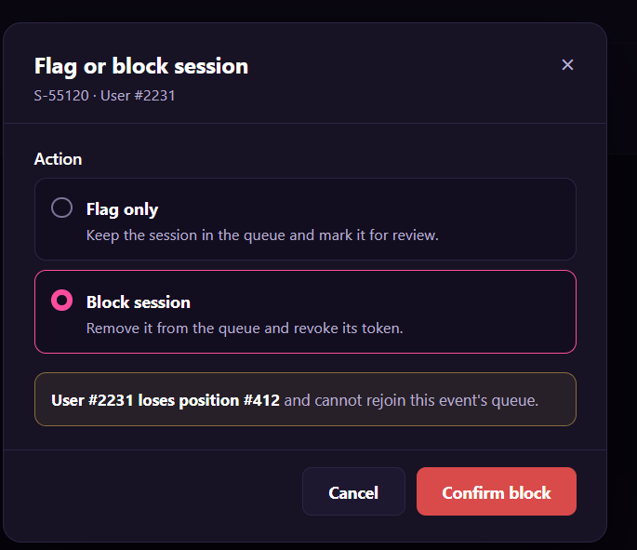
Figure 70 : Flag/Block Suspicious Session Screen
FUNCTION DETAILS:
- VALIDATION RULES:
  - The user must be authenticated. The Access Token must be sent in the Authorization header, and it must be present, valid and not expired. The Admin must be identified from the claims in the token, so the client must not send an admin id.
  - The account referenced by the token must exist and be active, and must have the Admin role.
  - The alert id must be a whole number greater than 0, and the alert must exist. The client sends only the alert id and the action. The system finds the session, the user, the event and the token from the alert, so the client must never send a user id, a session code or a token.
  - The action is required and must be one of the two values: Flag or Block.
  - The alert must have the status Open. If the action is Block, the alert may also have the status Flagged (a flagged session can be blocked later).
  - The session must not be already Blocked.
  - A session that is already Flagged cannot be flagged again.
  - The confirmation of the Admin in the dialog is required before the request is sent.
  - One request handles one session only.
  - The user and the token must be shown in the dialog as "User #{id}" and in masked form. The dialog must not show the email, the phone number, the IP address or the full token. The full token must not be written to logs.

- NORMAL FLOW:
  - Sub-flow A: Confirm Flag
  - Step 1: The Admin selects "Flag only".
  - Step 2: The client changes the confirm button to "Confirm flag" and hides the warning box.
  - Step 3: The Admin clicks the "Confirm flag" button.
  - Step 4: The client disables the buttons and sends the request with the alert id, the action Flag and the Access Token in the Authorization header.
  - Step 5: The system validates the Access Token, identifies the Admin from its claims, looks up the account, and checks that it is active and has the Admin role.
  - Step 6: The system validates the alert id, looks up the alert, and checks that its status is Open and the session is not already Flagged or Blocked.
  - Step 7: The system marks the session as Flagged and changes the status of the alert to Flagged. The place of the user in the queue does not change.
  - Step 8: The system writes the flag to the audit log.
  - Step 9: The system returns the result with the new status of the alert.
  - Step 10: The client closes the dialog, displays the message "Session flagged for review." and refreshes the Alert detail page with the new status.

  - Sub-flow B: Confirm Block
  - Step 1: The Admin keeps "Block session" selected.
  - Step 2: The Admin clicks the "Confirm block" button.
  - Step 3: The client disables the buttons and sends the request with the alert id, the action Block and the Access Token in the Authorization header.
  - Step 4: The system validates the Access Token, identifies the Admin from its claims, looks up the account, and checks that it is active and has the Admin role.
  - Step 5: The system validates the alert id, looks up the alert, and checks that its status is Open or Flagged and the session is not already Blocked.
  - Step 6: The system marks the session as Blocked and adds the ban on joining the queue of the event for this session and this user.
  - Step 7: The system changes the status of the queue token to Revoked, removes the user's place from the queue, and ends the granted access to ticket purchase if the token was Admitted.
  - Step 8: The system releases any ticket temporarily held for the user's current purchase.
  - Step 9: The system recalculates the positions and the estimated wait of the Customers behind.
  - Step 10: The system changes the status of the alert to Closed (Blocked).
  - Step 11: The system writes the block to the audit log.
  - Step 12: The system returns the result with the new status of the alert.
  - Step 13: The client closes the dialog, displays the message "Session blocked." and refreshes the Alert detail page with the new status. The button "Flag / block session" is hidden.

- ABNORMAL FLOWS:
  - Abnormal flow 1: Access Token missing, invalid or expired
  - Step 1: The Access Token is missing, invalid or expired when the request is sent.
  - Step 2: The system rejects the request, returns 401 Unauthorized and changes nothing.
  - Step 3: The client tries to obtain a new Access Token with the Refresh Token and repeats the request.
  - Step 4: If the Refresh Token is also expired or revoked, the client deletes the stored tokens, displays the message "Your session has expired. Please log in again." and redirects the Admin to the Login page. The session is not flagged or blocked.

  - Abnormal flow 2: Account not found or not active
  - Step 1: The account referenced by the token no longer exists, or it has been disabled or locked.
  - Step 2: The system logs a warning, changes nothing and returns 401 Unauthorized.
  - Step 3: The client deletes the stored tokens, displays the message "Your account is not available. Please contact support." and redirects the user to the Login page.

  - Abnormal flow 3: Not an Admin
  - Step 1: The account is active but does not have the Admin role.
  - Step 2: The system logs a warning, changes nothing and returns 403 Forbidden.
  - Step 3: The client closes the dialog and displays the message "You do not have permission to perform this action."
  - Abnormal flow 4: Alert not found
  - Step 1: The alert id does not match any alert, or the alert has been removed.
  - Step 2: The system returns 404 Not Found and changes nothing.
  - Step 3: The client closes the dialog, displays the message "This alert no longer exists." and returns to the Abuse alerts list.

  - Abnormal flow 5: Action missing or invalid
  - Step 1: No action is selected, or the request contains a value that is not Flag or Block.
  - Step 2: The confirm button stays disabled, so the client does not send the request. If a request arrives with an invalid action, the system returns 400 Bad Request and changes nothing.
  - Step 3: The client displays the message "Please select an action."

  - Abnormal flow 6: Alert already handled
  - Step 1: The alert is no longer in a status that allows the action when the request arrives. For example, another Admin has already flagged or blocked the session while the dialog was open, or the alert is Closed.
  - Step 2: The system returns 409 Conflict and changes nothing.
  - Step 3: The client closes the dialog, displays the message "This alert has already been handled." and refreshes the Alert detail page with the current status.

  - Abnormal flow 7: Session already blocked
  - Step 1: The session is already Blocked, for example by another Admin at the same time.
  - Step 2: The system returns 409 Conflict and changes nothing more.
  - Step 3: The client closes the dialog, displays the message "This session has already been blocked." and refreshes the Alert detail page.

3.7 Feature 6: Interactive Seating Chart & Ticket Selection

3.7.1 View Interactive Seating Chart
FUNCTION TRIGGER:
- Trigger 1: User clicks the "Seating Chart" tab on the Event Details page of an event that has a seating chart.
- Trigger 2: Customer arrives at the seat selection page after clicking "Get Tickets" (and after the virtual queue, if the event requires one).
FUNCTION DESCRIPTION:
- Actor(s): Guest, Customer
- Purpose:
  - To let users see the seating layout of an event and which seats are still available, so that they can choose where to sit.
- Main Functionality:
- The system displays the seating chart of an event that has one: the stage, the rows (A, B, C...) and the seats of each row, with the status of each seat: Available, Sold or Held (being kept for another customer who is buying). A legend explains the statuses. When the user moves the pointer over or taps a seat, its details are shown (row, seat number, ticket tier, price and status). The statuses are refreshed automatically while the chart is open, so the user sees changes without reloading. Clicking an available seat starts the seat selection (another function). Viewing the chart does not require login and does not reserve any seat.
SCREEN LAYOUT:
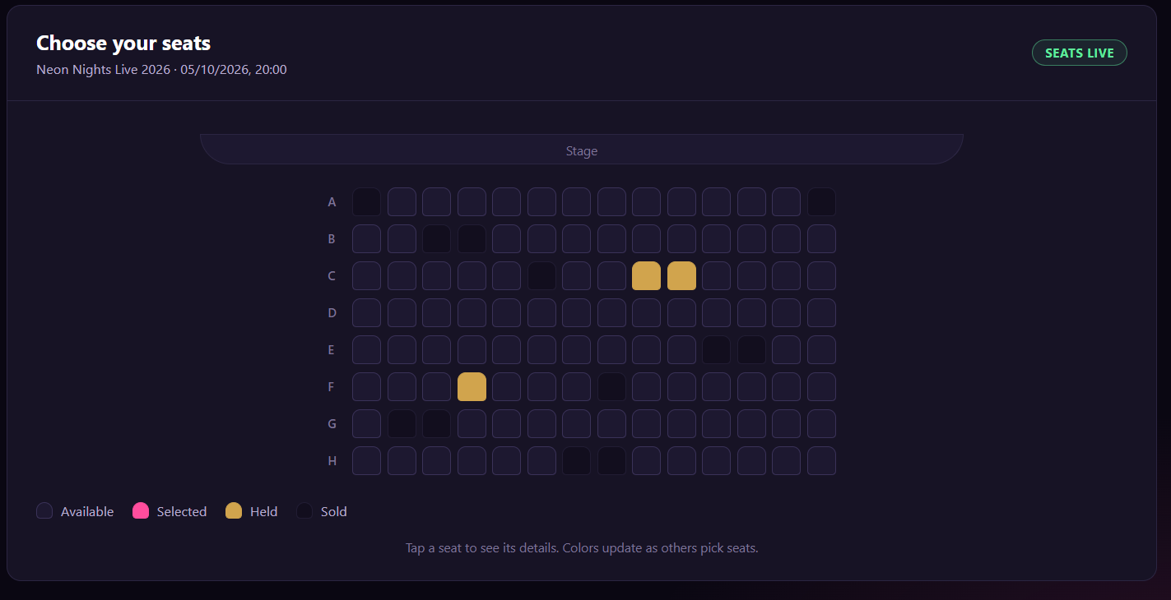
Figure 71 : View Interactive Seating Chart Screen
FUNCTION DETAILS:
- VALIDATION RULES:
  - The event slug must be valid, and the event must exist, must be published and must not be deleted.
  - The event must have a seating chart.
  - Every seat must have exactly one status: Available, Sold or Held.
  - A seat that was held but whose hold time has expired must be shown as Available.
  - The statuses shown must be the latest ones. The chart must be refreshed at regular intervals while it is open.
  - Every seat must be identified by its row and its number in the row.
  - The details of a seat (row, number, ticket tier, price and status) must be shown when the user moves the pointer over or taps the seat.
  - A logged-in user is not required. If a valid Access Token is sent, the seats held by this user must be shown as selected, and not as held by another customer.
  - If the Access Token is missing, invalid or expired, the chart must still be shown as for a guest.

- NORMAL FLOW:
  - Sub-flow A: View Seating Chart
Step 1: The user opens the Event Details page of an event that has a seating chart and clicks the "Seating Chart" tab (or the Customer arrives at the seat selection page).
Step 2: The client requests the seating chart of the event, and sends the Access Token if the user is logged in.
Step 3: The system validates the event slug, looks up the event, and checks that it is published and not deleted.
Step 4: The system checks that the event has a seating chart.
Step 5: The system retrieves the layout of the chart (the stage, the rows and the seats with their row, number and ticket tier) and the status of every seat, counting expired holds as available, and marking the seats held by the current user if the user is logged in.
Step 6: The system returns the chart.
Step 7: The client displays the genre badge and the title, the "Stage" label, the seats of each row with their status, and the legend.
- ABNORMAL FLOWS:
  - Abnormal flow 1: Event not found or not available (occurs at Sub-flow A, Step 3)
Step 1: The slug does not match any event, or the event is not published, or it has been deleted.
Step 2: The system returns 404 Not Found and returns no chart.
Step 3: The client displays the message "This event is no longer available."
Step 4: The user returns to the event list.
  - Abnormal flow 2: Event has no seating chart (occurs at Sub-flow A, Step 4)
Step 1: The event does not have a seating chart.
Step 2: The system returns 404 Not Found and returns no chart.
Step 3: The client hides the "Seating Chart" tab and shows the ticket tiers of the event instead.
  - Abnormal flow 3: Access Token invalid or expired (occurs at Sub-flow A, Step 2 or 5)
Step 1: The Access Token sent with the request is invalid or expired.
Step 2: The system does not identify the user and returns the chart as for a guest.
Step 3: The client tries to obtain a new Access Token with the Refresh Token. If it succeeds, the client requests the chart again to show the seats held by the user.
  - Abnormal flow 4: All seats unavailable (occurs at Sub-flow A, Step 7)
Step 1: Every seat of the event is sold or held.
Step 2: The client displays the chart with all seats marked accordingly.
Step 3: The client displays the message "All seats are taken right now." (or "All seats are sold out." when every seat is sold).
  - Abnormal flow 5: Seat becomes unavailable while viewing (occurs at Sub-flow C, Step 3, or Sub-flow D, Step 1)
Step 1: A seat that was available becomes sold or held by another customer, for example while the Customer is about to click it.
Step 2: The client updates the seat in the chart and cancels the click if it has not been sent.
Step 3: The client displays the message "This seat is no longer available."
  - Abnormal flow 6: Seat status cannot be refreshed (occurs at Sub-flow C, Step 1 or 2)
Step 1: The connection is lost, or the request fails.
Step 2: The client keeps the last known statuses and displays the notice "Seat availability may be out of date. Reconnecting…"
Step 3: The client tries again automatically, and removes the notice when the statuses are refreshed.

3.7.2 View Seat Details
FUNCTION TRIGGER:
- Trigger 1: User moves the pointer over a seat in the seating chart.
- Trigger 2: User taps a seat in the seating chart (touch device).
FUNCTION DESCRIPTION:
- Actor(s): Guest, Customer
- Purpose:
  - To let users know where a seat is, which ticket tier it belongs to, how much it costs and whether it is still available, before they choose it.
- Main Functionality:
  - When the user moves the pointer over a seat, taps it, or moves the keyboard focus to it, the system displays a details card next to the seat. The card shows the row and the seat number (for example "Row C · Seat 8"), the status of the seat (Available, Selected, Held or Sold), the ticket tier, the price, and a short hint that depends on the status. The details come from the seating chart that is already loaded, and they are kept up to date when the statuses of the seats are refreshed. Clicking an available seat starts the seat selection (another function). Viewing the details does not require login and does not reserve the seat.
SCREEN LAYOUT:
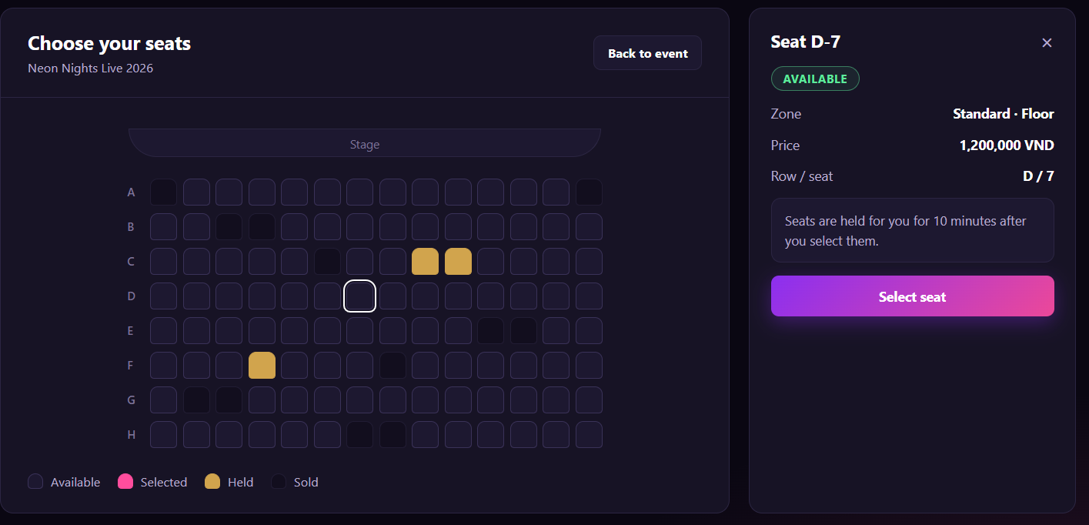
Figure 72 : View Seat Details Screen
FUNCTION DETAILS:
- VALIDATION RULES:
  - The seat must belong to the seating chart of the event that is displayed.
  - Every seat must have a row, a seat number, a ticket tier, a price and exactly one status.
  - The row and the seat number must be shown in the format "Row C · Seat 8".
  - The status must be Available, Selected, Held or Sold, and it must be the same as the status shown in the chart. A seat chosen by the current customer must be shown as Selected, and not as Held.
  - The hint must match the status of the seat.
  - Only the details of one seat must be shown at a time. Showing the details of another seat must close the previous card.
  - The details must not show who holds a seat.
  - The details must be available with the pointer, with touch and with the keyboard, and a screen reader must read them (for example "Row C, seat 8, available, Standard tier, 350,000 dong").
  - The details card must stay inside the visible area of the screen, and it must be moved automatically when the seat is near the edge.
  - A logged-in user is not required.

- NORMAL FLOW:
  - Sub-flow A: View Seat Details
Step 1: The user has the seating chart of an event open.
Step 2: The user moves the pointer over a seat, taps it, or moves the keyboard focus to it.
Step 3: The client finds the seat in the chart data that is already loaded (row, number, ticket tier, price and status).
Step 4: The client checks that the seat has all the data it needs.
Step 5: The client displays the details card next to the seat, with the row and the seat number, the status, the ticket tier, the price and the hint for the status.
Step 6: The user moves the pointer away, taps elsewhere, moves the focus to another seat, or presses Esc, and the client hides the card.
- ABNORMAL FLOWS:
  - Abnormal flow 1: Seat data incomplete (occurs at Sub-flow A, Step 4)
Step 1: The seat has no price or no ticket tier.
Step 2: The client displays the card with the available data and the text "Price not available" (or "Tier not available") for the missing item.
Step 3: The client does not allow the seat to be chosen, and records the problem in its log.
  - Abnormal flow 2: Seat becomes unavailable while the details are open (occurs at Sub-flow B, Step 2)
Step 1: The seat was Available, and it becomes Sold or Held by another customer.
Step 2: The client updates the card with the new status and hint.
Step 3: The client displays the message "This seat has just been taken." in the card, and the seat cannot be chosen.
  - Abnormal flow 3: Customer tries to choose an unavailable seat (occurs at Sub-flow C, Step 1)
Step 1: The Customer clicks a seat that is Sold or Held by another customer.
Step 2: The client does not start the seat selection.
Step 3: The client keeps the details card open and displays the message "This seat is no longer available." (Sold) or "This seat is being kept for another buyer." (Held).

3.7.3 Select Seats
FUNCTION TRIGGER:
Trigger 1: Customer clicks an available seat in the seating chart.
● Trigger 2: Customer clicks a selected seat, or the remove button of a seat in "Your seats".
● Trigger 3: Customer clicks the "Continue" button.
● Trigger 4: The hold time of the seats selected by the Customer ends.
FUNCTION DESCRIPTION:
● Actor(s): Customer
● Purpose:
○ To let a Customer choose the seats they want to buy, and to keep those seats for them while they complete their order.
● Main Functionality:
○ A logged-in Customer clicks an available seat in the seating chart. The system checks the Customer, the event, the queue access (if the event requires a virtual queue) and the seat, and checks that the Customer has not reached the maximum number of seats. If everything is valid, the system holds the seat for the Customer for a limited time and confirms it. The seat is then shown as Selected, and it appears in the "Your seats" summary with the price, the total price and the time left. Other customers see the seat as Held and cannot choose it. The Customer can remove a seat at any time, which makes it available again. When the Customer has selected the required number of seats, they click "Continue" to go to checkout. If the hold time ends, all seats are released.
SCREEN LAYOUT:
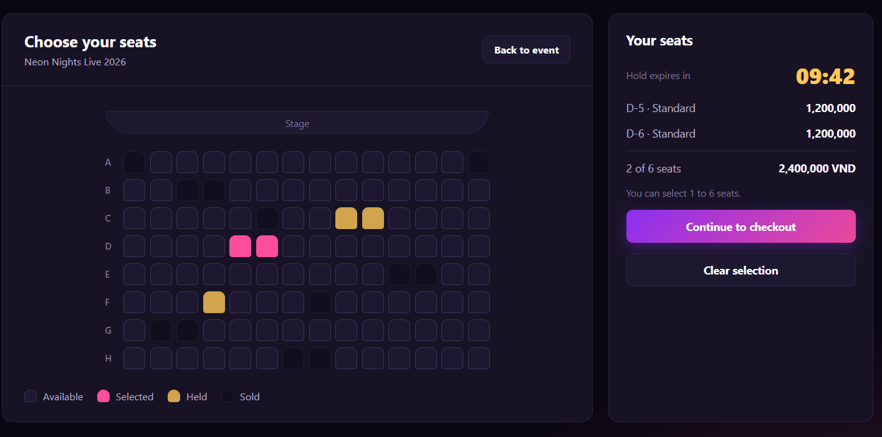
Figure 73 : Select Seats Screen
FUNCTION DETAILS:
- VALIDATION RULES:
  - The user must be authenticated. The Access Token must be sent in the Authorization header, and it must be present, valid and not expired. The user must be identified from the claims in the token, so the client must not send a user id.
  - The account referenced by the token must exist and be active.
  - The event slug must be valid, and the event must exist, must be published, must not be deleted and must not have ended. The event must have a seating chart and must still have tickets available.
  - If the event requires a virtual queue, the user must have valid access granted by the queue, and the granted time must not have expired.
  - The seat id must be valid, the seat must belong to the seating chart of the event, and it must have a price.
  - The seat must be Available: it must not be sold or held by another customer. A hold that has expired must be counted as available.
  - The number of seats held by the customer, including the new seat, must not exceed the maximum number of tickets per account allowed for the event.
  - The number of seats must be at least the minimum number of tickets per account allowed for the event before the customer can continue.
  - Two customers must never hold the same seat at the same time.
  - To remove a seat, the seat must be held by the customer who asks for it. A customer must never release a seat held by another customer.
  - The "Continue" button must stay disabled until the number of selected seats is between the minimum and the maximum.

- NORMAL FLOW:
  - Sub-flow A: Select a Seat
Step 1: The logged-in Customer opens the seating chart of an event (with valid queue access, if the event requires a virtual queue).
Step 2: The Customer clicks an available seat.
Step 3: The client checks that the number of selected seats is below the maximum.
Step 4: The client sends the request with the seat id and the Access Token in the Authorization header.
Step 5: The system validates the Access Token, identifies the user from its claims, looks up the account and checks that it is active.
Step 6: The system validates the event slug, looks up the event, and checks that it is published, not deleted, not ended, has a seating chart and still has tickets available.
Step 7: If the event requires a virtual queue, the system checks that the user has valid queue access.
Step 8: The system validates the seat id and looks up the seat in the seating chart of the event.
Step 9: The system checks that the seat is Available.
Step 10: The system checks that the number of seats held by the customer, including this seat, does not exceed the maximum.
Step 11: The system holds the seat for the customer. The hold ends at the same time as the customer's other held seats, or after the hold time if it is the first seat.
Step 12: The system saves the hold to the database.
Step 13: The system logs the selection.
Step 14: The system returns the seats held by the customer, the total price and the time when the hold ends.
Step 15: The client shows the seat as Selected, adds it to "Your seats" with the total price and the time left, and enables "Continue" when the number of seats is allowed.
- ABNORMAL FLOWS:
  - Abnormal flow 1: Guest clicks a seat (occurs at Sub-flow A, Step 2)
Step 1: A guest who is not logged in clicks an available seat.
Step 2: The client does not send the request.
Step 3: The client displays the message "Please log in to select seats." and redirects the guest to the Login page.
Step 4: After logging in, the user returns to the seating chart. The seat is not selected automatically, and the user can click it again.
  - Abnormal flow 2: Access Token missing, invalid or expired (occurs at Sub-flow A, Step 4 or 5, or Sub-flow B, Step 2 or 3)
Step 1: The Access Token is missing, invalid or expired when the request is sent.
Step 2: The system rejects the request, returns 401 Unauthorized and changes nothing.
Step 3: The client tries to obtain a new Access Token with the Refresh Token and repeats the request.
Step 4: If the Refresh Token is also expired or revoked, the client deletes the stored tokens, displays the message "Your session has expired. Please log in again." and redirects the user to the Login page. The seats already held stay held until their time ends.
  - Abnormal flow 3: Account not found or not active (occurs at Sub-flow A, Step 5, or Sub-flow B, Step 3)
Step 1: The account referenced by the token no longer exists, or it has been disabled or locked.
Step 2: The system logs a warning, releases any seat held by the user, and changes nothing else.
Step 3: The system returns 401 Unauthorized.
Step 4: The client deletes the stored tokens, displays the message "Your account is not available. Please contact support." and redirects the user to the Login page.
  - Abnormal flow 4: Event not found or not available (occurs at Sub-flow A, Step 6)
Step 1: The slug does not match any event, or the event is not published, or it has been deleted, or it has no seating chart.
Step 2: The system returns 404 Not Found and holds no seat.
Step 3: The client displays the message "This event is no longer available."
Step 4: The Customer returns to the event list.
  - Abnormal flow 5: Tickets no longer available (occurs at Sub-flow A, Step 6)
Step 1: The event has ended, or all tickets have been sold.
Step 2: The system returns 409 Conflict and holds no seat.
Step 3: The client displays the message "Tickets are no longer available for this event."
Step 4: The Customer returns to the event list.
  - Abnormal flow 6: No valid queue access (occurs at Sub-flow A, Step 7)
Step 1: The event requires a virtual queue, and the user has no access granted by the queue, or the granted time has expired.
Step 2: The system returns 403 Forbidden and holds no seat.
Step 3: The client displays the message "Please join the queue to select seats." (or "Your time to complete the order has ended. Please join the queue again.") and redirects the Customer to the Virtual Queue page.
  - Abnormal flow 7: Seat not found or cannot be chosen (occurs at Sub-flow A, Step 8)
Step 1: The seat id is not valid, the seat does not belong to the seating chart of the event, or the seat has no price.
Step 2: The system returns 400 Bad Request and holds no seat.
Step 3: The client displays the message "This seat cannot be selected." and reloads the seating chart.
  - Abnormal flow 8: Seat no longer available (occurs at Sub-flow A, Step 9)
Step 1: The seat has been sold, or it is held by another customer, for example because they selected it a moment earlier.
Step 2: The system returns 409 Conflict and holds no seat.
Step 3: The client displays the message "This seat is no longer available." and shows the seat with its current status.
Step 4: The Customer chooses another seat.
  - Abnormal flow 9: Maximum number of seats reached (occurs at Sub-flow A, Step 3 or 10)
Step 1: The Customer already holds the maximum number of seats and clicks another available seat.
Step 2: The client (or the system, with 409 Conflict) does not hold the seat.
Step 3: The client displays the message "You can select up to {max} seats for this event."
Step 4: The Customer removes a seat before choosing another one.
  - Abnormal flow 10: Seat already released when removing (occurs at Sub-flow B, Step 5)
Step 1: The seat is no longer held by the customer, for example because the hold time ended, or it was removed on another device.
Step 2: The system changes nothing and returns a success result with the seats still held.
Step 3: The client updates the seat and "Your seats" without showing an error.
  - Abnormal flow 11: Too few seats selected (occurs at Sub-flow C, Step 1)
Step 1: The Customer tries to continue with fewer seats than the minimum, for example with the keyboard while the button is disabled.
Step 2: The client does not continue.
Step 3: The client displays the message "Please select at least {min} seat(s)."
  - Abnormal flow 12: Hold time expired (occurs at Sub-flow C, Step 1)
Step 1: The hold time of the seats has ended before the Customer clicks "Continue".
Step 2: The system has already released the seats (see Sub-flow D), so the request is refused.
Step 3: The client displays the message "Your seats were released because the time ended. Please select your seats again."
Step 4: The Customer selects the seats again.

3.7.4 Change Seat Selection
FUNCTION TRIGGER:
- Trigger 1: Customer clicks the "Change seats" button in the order summary at checkout, while holding seats.
- Trigger 2: Customer clicks an available seat in the seating chart, in change mode.
- Trigger 3: Customer clicks a new selected seat, or the remove button of a seat in "New seats".
- Trigger 4: Customer clicks the "Confirm change" button.
- Trigger 5: Customer clicks the "Keep current seats" button.
- Trigger 6: The hold time of the seats held by the Customer ends.
FUNCTION DESCRIPTION:
- Actor(s): Customer
- Purpose:
  - To let a Customer who already holds seats replace them with other seats before paying, without losing the current seats if the new seats are taken by someone else.
- Main Functionality:
  - A logged-in Customer who holds seats clicks "Change seats". The system shows the seating chart with the current seats marked as "Current seat" and the time left to keep them. The Customer chooses the same number of new seats. The new seats are only marked on the screen, and they are not held yet. The "Change summary" shows the current seats, the new seats, the total price of each group and the price difference. When the Customer clicks "Confirm change", the system checks the Customer, the event, the queue access (if the event requires a virtual queue) and every new seat. If everything is valid, the system holds the new seats and releases the current seats that are not chosen again, in one single operation. If any new seat is no longer available, nothing changes and the Customer keeps the current seats. The change does not extend the hold time. Clicking "Keep current seats" leaves everything as it was.
SCREEN LAYOUT:
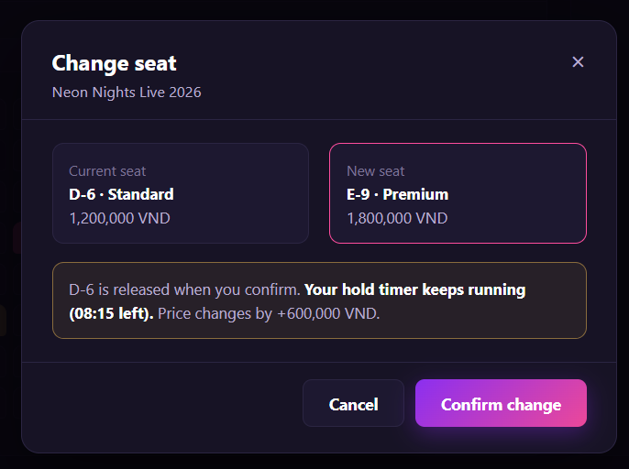
Figure 74 : Change Seat Selection Screen
FUNCTION DETAILS:
- VALIDATION RULES:
  - The user must be authenticated. The Access Token must be sent in the Authorization header, and it must be present, valid and not expired. The user must be identified from the claims in the token, so the client must not send a user id.
  - The account referenced by the token must exist and be active.
  - The event slug must be valid, and the event must exist, must be published, must not be deleted and must not have ended. The event must have a seating chart and must still have tickets available.
  - If the event requires a virtual queue, the user must have valid access granted by the queue, and the granted time must not have expired.
  - The customer must currently hold at least one seat for this event, and the hold time must not have ended.
  - The list of new seat ids must not be empty and must not contain the same seat twice.
  - Every new seat id must be valid, must belong to the seating chart of the event, and must have a price.
  - Every new seat must be Available, or already held by the same customer. A seat that is sold or held by another customer must be refused. A hold that has expired must be counted as available.
  - The number of new seats must be the same as the number of seats the customer holds now, and it must be between the minimum and the maximum number of tickets per account allowed for the event.
  - The new selection must be different from the current seats. At least one seat must change.
  - Two customers must never hold the same seat at the same time.
  - The change must be all-or-nothing: the new seats are held and the current seats are released in one operation, or nothing is changed.
  - The change must not extend the time when the hold ends.
  - The price of every seat must be shown in Vietnamese dong with a thousands separator, and the price difference must be shown with its sign, for example "+500,000₫", "-250,000₫" or "0₫".
  - The "Confirm change" button must stay disabled until the number of new seats is the same as the number of current seats and the selection is different from the current seats.

- NORMAL FLOW:
  - Sub-flow A: Open Change Mode
Step 1: The logged-in Customer is at checkout and holds seats.
Step 2: The Customer clicks "Change seats".
Step 3: The client checks that the hold time has not ended and that the Customer holds at least one seat.
Step 4: The client displays the seating chart in change mode. The current seats are shown as "Current seat", the counter shows "0 / {n} selected", "Confirm change" is disabled, and the time left is shown.
  - Sub-flow B: Confirm the Change
Step 1: The Customer clicks "Confirm change".
Step 2: The client checks that the number of new seats is {n} and that the selection is different from the current seats.
Step 3: The client sends the request with the list of the new seat ids and the Access Token in the Authorization header.
Step 4: The system validates the Access Token, identifies the user from its claims, looks up the account and checks that it is active.
Step 5: The system validates the event slug, looks up the event, and checks that it is published, not deleted, not ended, has a seating chart and still has tickets available.
Step 6: If the event requires a virtual queue, the system checks that the user has valid queue access.
Step 7: The system looks up the seats held by the customer and checks that the customer holds seats and that the hold time has not ended.
Step 8: The system validates the list of seat ids and looks up each seat in the seating chart of the event.
Step 9: The system checks that each new seat is Available, or held by the same customer.
Step 10: The system checks that the number of new seats is the same as the number of current seats, and is between the minimum and the maximum.
Step 11: In one operation, the system holds the new seats until the same time as the current hold, and releases the current seats that are not in the new selection.
Step 12: The system saves the change to the database.
Step 13: The system logs the change.
Step 14: The system returns the seats held by the customer, the total price and the time when the hold ends.
Step 15: The client shows the new seats as Selected, shows the released seats as Available, displays the message "Your seats have been changed." and returns the Customer to checkout with the new total price.

- ABNORMAL FLOWS:
  - Abnormal flow 1: No valid queue access (occurs at Sub-flow D, Step 6)
Step 1: The event requires a virtual queue, and the user has no access granted by the queue, or the granted time has expired.
Step 2: The system returns 403 Forbidden and changes nothing.
Step 3: The client displays the message "Please join the queue to select seats." (or "Your time to complete the order has ended. Please join the queue again.") and redirects the Customer to the Virtual Queue page.
  - Abnormal flow 2: No seat held or hold time expired (occurs at Sub-flow A, Step 3, or Sub-flow D, Step 7)
Step 1: The customer holds no seat, for example because the hold time ended, or the seats were released on another device.
Step 2: The client does not open change mode (or the system returns 409 Conflict) and changes nothing.
Step 3: The client displays the message "Your seats were released because the time ended. Please select your seats again."
Step 4: The Customer returns to the seating chart and selects seats again (see 3.7.3).
  - Abnormal flow 3: Seat not found or cannot be chosen (occurs at Sub-flow D, Step 8)
Step 1: A seat id is not valid, appears twice, does not belong to the seating chart of the event, or the seat has no price.
Step 2: The system returns 400 Bad Request and changes nothing.
Step 3: The client displays the message "This seat cannot be selected." and reloads the seating chart. The current seats stay held.
  - Abnormal flow 4: New seat no longer available (occurs at Sub-flow D, Step 9)
Step 1: A new seat has been sold, or it is held by another customer, for example because they selected it a moment earlier.
Step 2: The system returns 409 Conflict and changes nothing, so the customer keeps all the current seats.
Step 3: The client displays the message "One of the new seats is no longer available. Your current seats are unchanged.", removes that seat from "New seats", and shows it with its current status.
Step 4: The Customer chooses another seat and confirms again.
  - Abnormal flow 5: Too many new seats (occurs at Sub-flow B, Step 2)
Step 1: The Customer has already chosen {n} new seats and clicks another available seat.
Step 2: The client does not add the seat.
Step 3: The client displays the message "You can choose {n} seats to replace your current seats."
Step 4: The Customer removes a new seat before choosing another one.
  - Abnormal flow 5: Too few new seats or no change (occurs at Sub-flow D, Step 2 or 10)
Step 1: The Customer tries to confirm with fewer than {n} new seats (for example with the keyboard while the button is disabled), or with a selection that is the same as the current seats. The system returns 400 Bad Request if the request reaches it.
Step 2: The client does not send the request (or the system changes nothing).
Step 3: The client displays the message "Please choose {n} seat(s) to replace your current seats."
  - Abnormal flow 6: New seat becomes unavailable while choosing (occurs at Sub-flow G, Step 2)
Step 1: A new seat that was Available becomes Sold or Held by another customer.
Step 2: The client removes the seat from "New seats", shows it with its new status, and updates the counter, the totals and the price difference.
Step 3: The client displays the message "This seat has just been taken." and disables "Confirm change".
Step 4: The Customer chooses another seat.

3.7.5 Configure Seat Hold Timeout Policy
FUNCTION TRIGGER:
- Trigger 1: Admin clicks the "Seat hold timeout" action of an event on the Events management page (or on the Event detail page of the Admin area).
- Trigger 2: Admin clicks the "Save policy" button on the Seat hold timeout page.
FUNCTION DESCRIPTION:
- Actor(s): Admin
- Secondary actor(s): System (seat hold process)
- Purpose:
  - To let the Admin decide how long a seat stays held for a Customer while the Customer selects seats and pays, so that seats are not blocked for too long by Customers who do not finish the order, and other Customers get the chance to buy them.
- Main Functionality:
  - The Admin opens the Seat hold timeout page of an event. The page shows the event (ID and name), the current hold timeout in minutes and the scope "Apply to" with two options. "This event only" changes the timeout of the event in the page, and the other events keep their own timeout. "All upcoming events" replaces the timeout on every event that has not started. The page also shows a notice that seats held right now keep their current timer and that the new timeout applies to new holds. The Admin changes the timeout and/or the scope, then clicks "Save policy". The system validates the request and saves the timeout. From then on, every new seat hold of the affected events expires after the new timeout. Seats that are held at the moment of saving are not changed. The Admin can click "Cancel" to discard the changes, or "Back to event" to return to the event.

SCREEN LAYOUT:

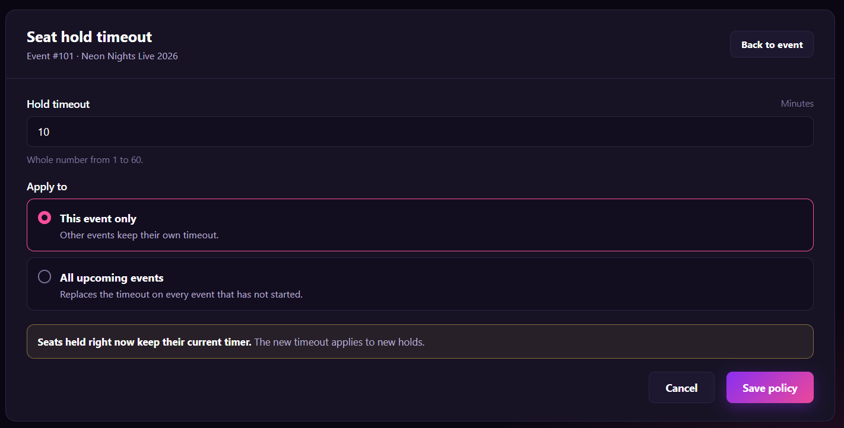
Figure 75 : Configure Seat Hold Timeout Policy Screen
FUNCTION DETAILS:
- VALIDATION RULES:
  - The user must be authenticated. The Access Token must be sent in the Authorization header, and it must be present, valid and not expired. The user must be identified from the claims in the token, so the client must not send a user id.
  - The account referenced by the token must exist and be active, and must have the Admin role.
  - The event id must be valid, and the event must exist and must not be deleted.
  - The event must not have ended.
  - The hold timeout is required and must be a whole number (no decimals, no text) from 1 to 60 minutes.
  - The scope must be one of the two values: This event only or All upcoming events.
  - If the event has no timeout configured yet, the page shows the default timeout of the system (10 minutes).
  - If nothing has changed (same timeout and the scope is This event only), the system must not save or log a change.
  - For the scope "All upcoming events", the system changes only the events that have not started and are not deleted. Events that have started or ended are never changed.
  - The change of one request is applied in one transaction: either every affected event is changed, or none is changed.
- NORMAL FLOW:
  - Sub-flow A: Open the Configuration
  - Step 1: The logged-in Admin clicks the "Seat hold timeout" action of an event.
  - Step 2: The client sends the request with the Access Token in the Authorization header.
  - Step 3: The system validates the Access Token, identifies the user from its claims, looks up the account, and checks that it is active and has the Admin role.
  - Step 4: The system validates the event id, looks up the event, and checks that it is not deleted and has not ended.
  - Step 5: The system returns the event ID, the event name and the current hold timeout (the default timeout if none is set).
  - Step 6: The client displays the Seat hold timeout page with these values. The scope "This event only" is selected.
  - Sub-flow B: Save for This Event
  - Step 1: The Admin enters the hold timeout and keeps "This event only" selected.
  - Step 2: The Admin clicks the "Save policy" button.
  - Step 3: The client checks that the timeout is a whole number from 1 to 60, disables the button and sends the request with the event id, the timeout, the scope and the Access Token in the Authorization header.
  - Step 4: The system validates the Access Token, identifies the user from its claims, looks up the account and checks that it is active and has the Admin role.
  - Step 5: The system validates the event id, looks up the event, and checks that it is not deleted and has not ended.
  - Step 6: The system validates the timeout and the scope.
  - Step 7: The system saves the timeout of the event (creates it if it does not exist, otherwise updates it). Seats held at this moment are not changed.
  - Step 8: The system writes the change to the audit log.
  - Step 9: The system returns the saved timeout.
  - Step 10: The client displays the message "Seat hold policy saved." and shows the saved value.

- ABNORMAL FLOWS:
  - Abnormal flow 1: Access Token missing, invalid or expired (occurs at Sub-flow A, Step 2 or 3, Sub-flow B, Step 3 or 4, or Sub-flow C, Step 4 or 5)
  - Step 1: The Access Token is missing, invalid or expired when the request is sent.
  - Step 2: The system rejects the request, returns 401 Unauthorized and changes nothing.
  - Step 3: The client tries to obtain a new Access Token with the Refresh Token and repeats the request.
  - Step 4: If the Refresh Token is also expired or revoked, the client deletes the stored tokens, displays the message "Your session has expired. Please log in again." and redirects the user to the Login page. The values the Admin entered are not saved.

  - Abnormal flow 2: Account not found or not active
  - Step 1: The account referenced by the token no longer exists, or it has been disabled or locked.
  - Step 2: The system logs a warning, changes nothing and returns 401 Unauthorized.
  - Step 3: The client deletes the stored tokens, displays the message "Your account is not available. Please contact support." and redirects the user to the Login page.

  - Abnormal flow 3: Not an Admin
  - Step 1: The account is active but does not have the Admin role.
  - Step 2: The system logs a warning, changes nothing and returns 403 Forbidden.
  - Step 3: The client displays the message "You do not have permission to perform this action." and returns to the previous page.

  - Abnormal flow 4: Event not found
  - Step 1: The event id does not match any event, or the event has been deleted.
  - Step 2: The system returns 404 Not Found and saves nothing.
  - Step 3: The client displays the message "This event is no longer available."
  - Step 4: The Admin returns to the Events management page.

  - Abnormal flow 5: Event has ended
  - Step 1: The event has already ended.
  - Step 2: The system returns 409 Conflict and saves nothing.
  - Step 3: The client displays the message "This event has ended. The seat hold timeout can no longer be changed."

  - Abnormal flow 6: Hold timeout missing or not a whole number
  - Step 1: The timeout is empty, is not a number, or has decimals.
  - Step 2: The client does not send the request (or the system returns 400 Bad Request) and saves nothing.
  - Step 3: The client highlights the field and displays the message "Hold timeout must be a whole number from 1 to 60."

  - Abnormal flow 7: Hold timeout out of range
  - Step 1: The timeout is lower than 1 or higher than 60.
  - Step 2: The client does not send the request (or the system returns 400 Bad Request) and saves nothing.
  - Step 3: The client highlights the field and displays the message "Hold timeout must be between 1 and 60 minutes."

  - Abnormal flow 8: Scope invalid
  - Step 1: No scope is selected, or the request contains a value that is not one of the two scopes.
  - Step 2: The system returns 400 Bad Request and saves nothing.
  - Step 3: The client displays the message "Please select where to apply the timeout."

  - Abnormal flow 9: No upcoming events to change
  - Step 1: No event satisfies "not started and not deleted" when the request is processed.
  - Step 2: The system saves nothing and returns 409 Conflict.
  - Step 3: The client displays the message "There are no upcoming events to update."

  - Abnormal flow 10: Events changed during the update
  - Step 1: An event starts, or the list of upcoming events changes, between the confirmation and the update, so the number differs from the one shown.
  - Step 2: The system applies the change to the events that are upcoming at the moment of processing and returns the real number of events changed. This is not an error.
  - Step 3: The client displays the message "Seat hold policy saved for {n} events." with the real number.

3.7.6 View Seat/Ticket Status History
FUNCTION TRIGGER:
- Trigger 1: Admin clicks the "Status history" action of an event on the Events management page.
FUNCTION DESCRIPTION:
- Actor(s): Admin
- Purpose:
  - To let the Admin see when and why the status of a seat or a ticket changed, who made the change and which ticket was involved, so that the Admin can check a customer complaint, find out why a seat was released or sold, and trace a ticket from the moment it was sold until it was used at the gate.
- Main Functionality:
  - The Admin opens the Status history page of an event. The page shows the event name and a table of status changes. Each row shows the time of the change, the seat, the ticket code ("—" if the change is not linked to a ticket), the change (old status → new status), who made the change (a Customer, an Admin or the System) and a note with the reason. The status values are Available, Held, Sold and Used. The Admin can filter the list by status, seat and ticket code, then click "Search". "Reset" clears all filters, "Refresh" reloads the list with the current filters, and "Prev" and "Next" move between pages. The page is read-only: opening, searching or paging the history changes no data.
SCREEN LAYOUT:
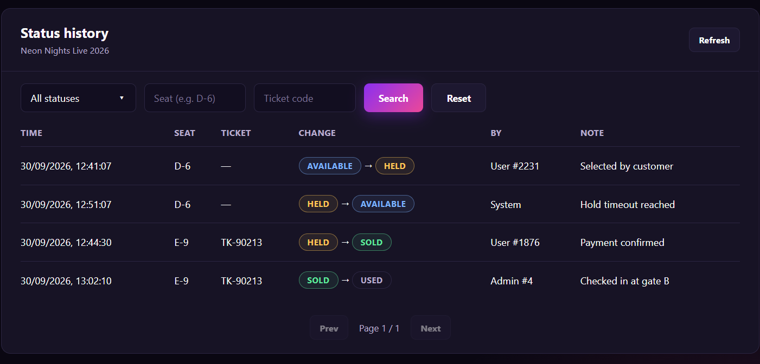
Figure 76 : View Seat/Ticket Status History Screen
FUNCTION DETAILS:
- VALIDATION RULES:
  - The user must be authenticated. The Access Token must be sent in the Authorization header, and it must be present, valid and not expired. The user must be identified from the claims in the token, so the client must not send a user id.
  - The account referenced by the token must exist and be active, and must have the Admin role.
  - The event id must be valid, and the event must exist and must not be deleted. An event that has ended can still be viewed.
  - The status filter must be empty (all statuses) or one of: Available, Held, Sold, Used.
  - The seat filter is optional. It is trimmed, is not case-sensitive, has at most 10 characters, and must follow the format "row letter(s) - seat number" (for example D-6 or AA-12).
  - The ticket code filter is optional. It is trimmed, is not case-sensitive, has at most 30 characters, and contains only letters, digits and "-".
  - The page number must be a whole number greater than or equal to 1. The page size is fixed at 10 rows and cannot be changed by the client. If the page number is greater than the last page, the system returns the last page.
  - The filters are combined with AND. The status filter matches the new status of the change (the status after the arrow).
  - The seat and ticket filters match the exact value, not a part of it.
  - This function is read-only. The system must not change any data and must not write an audit log entry when the Admin views or searches the history.

- NORMAL FLOW:
  - Sub-flow A: Open the Status History
  - Step 1: The logged-in Admin clicks the "Status history" action of an event.
  - Step 2: The client sends the request with the event id, page 1, no filters and the Access Token in the Authorization header.
  - Step 3: The system validates the Access Token, identifies the user from its claims, looks up the account, and checks that it is active and has the Admin role.
  - Step 4: The system validates the event id, looks up the event, and checks that it is not deleted.
  - Step 5: The system reads the status changes of the event, sorts them, and returns the event name, the rows of page 1, the current page and the total number of pages.
  - Step 6: The client displays the Status history page. The status filter is "All statuses" and the Seat and Ticket code fields are empty.

- ABNORMAL FLOWS:
  - Abnormal flow 1: Access Token missing, invalid or expired
  - Step 1: The Access Token is missing, invalid or expired when the request is sent.
  - Step 2: The system rejects the request, returns 401 Unauthorized and changes nothing.
  - Step 3: The client tries to obtain a new Access Token with the Refresh Token and repeats the request.
  - Step 4: If the Refresh Token is also expired or revoked, the client deletes the stored tokens, displays the message "Your session has expired. Please log in again." and redirects the user to the Login page.

  - Abnormal flow 2: Account not found or not active
  - Step 1: The account referenced by the token no longer exists, or it has been disabled or locked.
  - Step 2: The system logs a warning, changes nothing and returns 401 Unauthorized.
  - Step 3: The client deletes the stored tokens, displays the message "Your account is not available. Please contact support." and redirects the user to the Login page.

  - Abnormal flow 3: Not an Admin
  - Step 1: The account is active but does not have the Admin role.
  - Step 2: The system logs a warning, changes nothing and returns 403 Forbidden.
  - Step 3: The client displays the message "You do not have permission to perform this action." and returns to the previous page.

3.8 Feature 7: Dynamic QR Code & Ticket Wallet

3.8.1 View Order History
FUNCTION TRIGGER:
- Trigger 1: Customer opens the "Order history" page.
FUNCTION DESCRIPTION:
- Actor(s): Customer
- Purpose:
  - To let a Customer review the orders they have placed, and to see for each order the event, the number of tickets, the total price and the status, so that they can find an order and open it.

- Main Functionality:
  - A logged-in Customer opens the Order history page. The system returns the orders of that Customer, the newest first, five orders per page. Each order shows the poster of the event, the order code, the event name, the date and time of the event, the number of tickets, the total price and the status of the order (Paid, Pending, Cancelled or Refunded). The Customer can filter the orders by status, search them by the event name or the order code, and move between the pages. The Customer clicks "View details" to open one order (another function). Viewing the order history does not change any order, and a Customer can see only their own orders.
SCREEN LAYOUT:
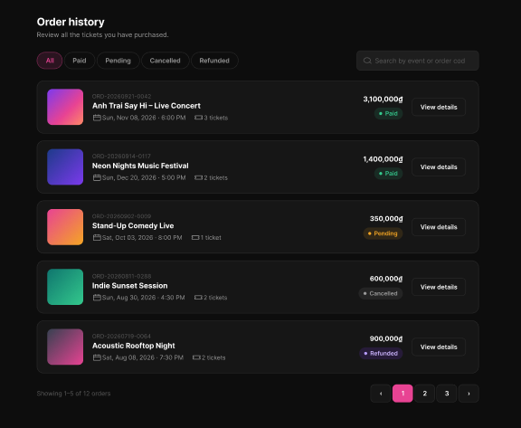
Figure 77 : View Order History Screen
FUNCTION DETAILS:
- VALIDATION RULES:
  - The user must be authenticated. The Access Token must be sent in the Authorization header, and it must be present, valid and not expired. The user must be identified from the claims in the token, so the client must not send a user id.
  - The account referenced by the token must exist and be active.
  - The status must be empty (all orders), or one of Paid, Pending, Cancelled or Refunded.
  - The keyword is optional. It must be trimmed and must not exceed 100 characters. An empty keyword means no search. The keyword must be treated as plain text, and special characters must not change the search.
  - The page must be an integer greater than or equal to 1, and the default is 1. The page size is 5. If the page is greater than the number of pages, the system returns the last page.
  - The system must return only the orders that belong to the account referenced by the token.
  - The orders must be sorted by the date when the order was placed, the newest first. Orders with the same date must be sorted by order code, from the highest to the lowest.
  - The search must match the event name or the order code, must not depend on upper or lower case, and must accept a part of the text. The search and the status filter must work together.
  - Every order must have an order code, an event name, the date and time of the event, a number of tickets, a total price and exactly one status.
  - The order code must be shown in the format "ORD-yyyyMMdd-nnnn".
  - The date and time of the event must be shown in the format "Sun, Nov 08, 2026 · 6:00 PM", in the time zone of the event.
  - The total price must be shown in Vietnamese dong with a thousands separator, for example "3,100,000₫". The number of tickets must be shown as "1 ticket" or "{n} tickets".
  - The counter must show the real position of the orders on the page and the total number of orders that match the filter and the search, for example "Showing 6–10 of 12 orders".
  - The pagination must be displayed only when there is more than one page. The previous button must be disabled on the first page, and the next button must be disabled on the last page.
  - When the Customer changes the status filter or the keyword, the page must go back to 1.
  - When the Customer changes the filter, the keyword or the page quickly, only the result of the last request must be displayed.

- NORMAL FLOW:
  - Sub-flow A: View Order History
Step 1: The logged-in Customer opens the Order history page.
Step 2: The client sends the request with the status "All", an empty keyword, page 1 and page size 5, and the Access Token in the Authorization header.
Step 3: The system validates the Access Token, identifies the user from its claims, looks up the account and checks that it is active.
Step 4: The system validates the status, the keyword and the page.
Step 5: The system looks up the orders of the customer that match the status and the keyword, sorted from the newest to the oldest.
Step 6: For the orders of the requested page, the system gets the order code, the poster and the name of the event, the date and time of the event, the number of tickets, the total price and the status.
Step 7: The system counts all the orders that match the status and the keyword.
Step 8: The system returns the orders of the page, the total number of orders and the page information.
Step 9: The client displays the orders, the counter and the pagination, with the filter "All" selected.
- ABNORMAL FLOWS:
  - Abnormal flow 1: Guest opens the page (occurs at Sub-flow A, Step 1)
Step 1: A user who is not logged in opens the Order history page.
Step 2: The client does not send the request.
Step 3: The client displays the message "Please log in to view your orders." and redirects the user to the Login page.
Step 4: After logging in, the user returns to the Order history page.
  - Abnormal flow 2: Access Token missing, invalid or expired (occurs at Sub-flow A, Step 2 or 3)
Step 1: The Access Token is missing, invalid or expired when the request is sent.
Step 2: The system rejects the request, returns 401 Unauthorized and returns no order.
Step 3: The client tries to obtain a new Access Token with the Refresh Token and repeats the request.
Step 4: If the Refresh Token is also expired or revoked, the client deletes the stored tokens, displays the message "Your session has expired. Please log in again." and redirects the user to the Login page.
  - Abnormal flow 3: The Customer has no order (occurs at Sub-flow A, Step 8)
Step 1: The Customer has not placed any order, and no status filter or keyword is used.
Step 2: The system returns an empty list and the total 0.
Step 3: The client hides the counter and the pagination, and displays the message "You have not purchased any tickets yet." with a link to the event list.
  - Abnormal flow 4: No order matches the status or the keyword (occurs at Sub-flow B, Step 3, or Sub-flow C, Step 5)
Step 1: The Customer has orders, but none of them matches the selected status or the keyword.
Step 2: The system returns an empty list and the total 0.
Step 3: The client hides the counter and the pagination, and displays the message "No orders found." The Customer changes the status or the keyword.

3.8.2 View Order Details

FUNCTION TRIGGER:
- Trigger 1: Customer clicks "View details" of an order in the Order history page (see 3.8.1).
FUNCTION DESCRIPTION:
- Actor(s): Customer
- Purpose:
  - To let a Customer see all the information of one order they have placed: the event, the tickets and their status, the price of each ticket type, the payment and the buyer, and to open the QR code of a ticket.
- Main Functionality:
  - A logged-in Customer opens an order from the Order history page. The system checks that the order belongs to the Customer and returns its details. The page shows the order code, the date and time when the order was placed and the status of the order (Paid, Pending, Cancelled or Refunded). It also shows the event (poster, name, date and time, venue), the tickets of the order (ticket type, ticket code, price and status), the payment summary with the total price, the payment (method and payment time) and the buyer (full name, email and phone number). From this page the Customer can open the event, open the QR code of a valid ticket (another function), or go back to the Order history. Viewing the order details does not change the order, and a Customer can see only their own orders.

SCREEN LAYOUT:
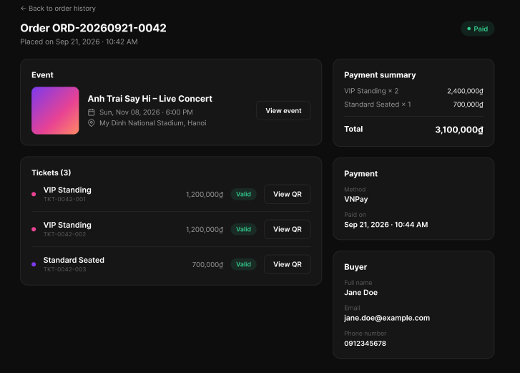
Figure 78 : View Order Details Screen

FUNCTION DETAILS:
- VALIDATION RULES:
  - The user must be authenticated. The Access Token must be sent in the Authorization header, and it must be present, valid and not expired. The user must be identified from the claims in the token, so the client must not send a user id.
  - The account referenced by the token must exist and be active.
  - The order code must be valid, in the format "ORD-yyyyMMdd-nnnn", and the order must exist.
  - The order must belong to the account referenced by the token. An order of another customer must be handled in the same way as an order that does not exist.
  - The order must have an order code, the date and time when it was placed, exactly one status (Paid, Pending, Cancelled or Refunded), an event, at least one ticket, a total price and the buyer information.
  - Every ticket must have a ticket code in the format "TKT-nnnn-nnn", a ticket type, a price and exactly one status (Valid, Used, Cancelled or Pending). The tickets must be sorted by ticket code, from the lowest to the highest.
  - The payment summary must have one line for each ticket type, with the quantity and the amount (price multiplied by quantity). The total must be equal to the sum of the lines, and it must be equal to the total shown in the Order history (see 3.8.1).
  - Every price must be shown in Vietnamese dong with a thousands separator, for example "3,100,000₫".
  - The date and time when the order was placed and the payment time must be shown in the format "Sep 21, 2026 · 10:42 AM", in Vietnam time (GMT+7). The date and time of the event must be shown in the format "Sun, Nov 08, 2026 · 6:00 PM", in the time zone of the event.
  - The venue must be shown in the format "{venue name}, {city}".
  - The "Paid on" line must be shown only when the order was paid. For a Refunded order, a "Refunded on" line with the refund time must also be shown. For an order that was not paid, the payment method must be shown as "Not paid yet".
  - The phone number is optional. When it was not provided, "Not provided" must be shown.
  - The "View QR" button must be shown only for a ticket with the status Valid, in an order with the status Paid.
  - The payment card number, the bank account number and any other secret payment data must never be shown. Only the name of the payment method is shown.
  - The QR code and the data used to build it must never be part of the order details.

- NORMAL FLOW:
  - Sub-flow A: View Order Details
Step 1: The logged-in Customer clicks "View details" of an order in the Order history page (or opens the address of the order).
Step 2: The client sends the request with the order code and the Access Token in the Authorization header.
Step 3: The system validates the Access Token, identifies the user from its claims, looks up the account and checks that it is active.
Step 4: The system validates the order code.
Step 5: The system looks up the order and checks that it belongs to the customer.
Step 6: The system gets the event of the order: the poster, the name, the date and time, the venue and the city.
Step 7: The system gets the tickets of the order: the ticket code, the ticket type, the price and the status.
Step 8: The system groups the tickets by ticket type, and calculates the quantity and the amount of each type and the total price.
Step 9: The system gets the payment of the order: the payment method, the payment time and, if any, the refund time.
Step 10: The system gets the buyer information: the full name, the email and the phone number.
Step 11: The system returns the details of the order.
Step 12: The client displays the order code, the date and time when the order was placed and the status, then the event, the tickets, the payment summary, the payment and the buyer. The "View QR" button is displayed for the Valid tickets.
- ABNORMAL FLOWS:
  - Abnormal flow 1: Guest opens the page (occurs at Sub-flow A, Step 1)
Step 1: A user who is not logged in opens the address of an order.
Step 2: The client does not send the request.
Step 3: The client displays the message "Please log in to view this order." and redirects the user to the Login page.
Step 4: After logging in, the user returns to the same order.
  - Abnormal flow 2: Access Token missing, invalid or expired (occurs at Sub-flow A, Step 2 or 3)
Step 1: The Access Token is missing, invalid or expired when the request is sent.
Step 2: The system rejects the request, returns 401 Unauthorized and returns no data.
Step 3: The client tries to obtain a new Access Token with the Refresh Token and repeats the request.
Step 4: If the Refresh Token is also expired or revoked, the client deletes the stored tokens, displays the message "Your session has expired. Please log in again." and redirects the user to the Login page.

  - Abnormal flow 3: Order not found (occurs at Sub-flow A, Step 4 or 5)
Step 1: The order code is not valid, or no order has this code, or the order belongs to another customer.
Step 2: The system returns 400 Bad Request (invalid code) or 404 Not Found (no order, or order of another customer), and returns no data.
Step 3: The client displays the message "This order was not found." with a link to the Order history.
Step 4: The Customer returns to the Order history.
  - Abnormal flow 4: Order is not in the Paid status (occurs at Sub-flow A, Step 7 to 12)
Step 1: The order has the status Pending, Cancelled or Refunded.
Step 2: The system returns the tickets with their status, and the payment data that exists.
Step 3: The client displays the tickets, and the status of the tickets is:
    - "Pending" for a Pending order. The payment method is shown as "Not paid yet" and the "Paid on" line is hidden.
    - "Cancelled" for a Cancelled order. If the order was never paid, the payment method is shown as "Not paid yet" and the "Paid on" line is hidden.
    - "Cancelled" for a Refunded order. The payment method and "Paid on" are shown, with an additional "Refunded on" line.
Step 4: The client hides the "View QR" button of all the tickets that are not Valid.
Abnormal flow 5: QR code not available (occurs at Sub-flow C, Step 2)
Step 1: The Customer clicks "View QR", but the ticket is no longer Valid, for example because it was scanned at the entrance, or the order was cancelled after the page was loaded.
Step 2: The system does not open the QR code.
Step 3: The client displays the message "The QR code is not available for this ticket.", reloads the order details and updates the status of the ticket.

3.8.3 View Ticket Wallet
FUNCTION TRIGGER:
- Trigger 1: Customer opens the "My tickets" page.
.
FUNCTION DESCRIPTION:
- Actor(s): Customer
- Purpose:
  - To let a Customer see all the tickets they own in one place, with the event, the date, the seat and the status of each ticket, so that they can find the ticket they need and open it at the entrance of the event.
- Main Functionality:
  - A logged-in Customer opens the "My tickets" page. The system returns the tickets of the Customer that belong to paid orders. Each ticket is shown as a card with the poster of the event, the name of the event, the date of the event, the seat (or the ticket type when the ticket has no seat) and the status of the ticket (Still valid, Has used or Has expired). The tickets that can still be used are shown first. The Customer clicks a ticket to open it and to see its QR code (another function). The wallet shows a summary only: it does not show the QR code, and viewing it does not change any ticket. A Customer can see only their own tickets.

SCREEN LAYOUT:
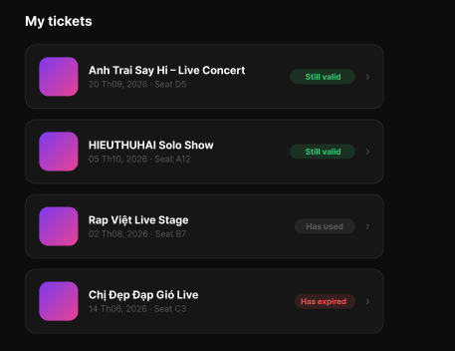
Figure 79 : View Ticket Wallet Screen
FUNCTION DETAILS:
- VALIDATION RULES:
  - The user must be authenticated. The Access Token must be sent in the Authorization header, and it must be present, valid and not expired. The user must be identified from the claims in the token, so the client must not send a user id.
  - The account referenced by the token must exist and be active.
  - The page must be an integer greater than or equal to 1, and the default is 1. The page size is 10. If the page is greater than the number of pages, the system returns an empty list.
  - The system must return only the tickets that belong to the account referenced by the token.
  - The system must return only the tickets of orders with the status Paid. The tickets of Pending, Cancelled and Refunded orders must not be returned.
  - Every ticket must have an event name, the date of the event, a place (a seat, or a ticket type when the ticket has no seat) and exactly one status (Still valid, Has used or Has expired).
  - The status of a ticket must be calculated as follows:
    - "Has used" if the ticket was scanned at the entrance of the event.
    - "Has expired" if the ticket was not scanned and the event has ended.
    - "Still valid" in all other cases.
  - The tickets must be sorted in this order: "Still valid" first, then "Has used", then "Has expired". The "Still valid" tickets must be sorted by the date of the event, the nearest first. The "Has used" tickets and the "Has expired" tickets must be sorted by the date of the event, the most recent first.
  - The date of the event must be shown in the format "dd Thmm, yyyy" (for example "20 Th09, 2026"), in the time zone of the event.
  - For a ticket with an assigned seat, the place must be shown in the format "Seat {row}{number}" (for example "Seat D5"). For a ticket without an assigned seat, the name of the ticket type must be shown (for example "VIP Standing").
  - Each ticket must be shown as one card, so an order of three tickets gives three cards.
  - The QR code and the data used to build it must never be part of the list of tickets.
  - The pagination must not show the same ticket twice, and the order of the tickets must stay the same from one page to the next.

- NORMAL FLOW:
  - Sub-flow A: View the Ticket Wallet
Step 1: The logged-in Customer opens the "My tickets" page.
Step 2: The client sends the request with page 1 and page size 10, and the Access Token in the Authorization header.
Step 3: The system validates the Access Token, identifies the user from its claims, looks up the account and checks that it is active.
Step 4: The system validates the page and the page size.
Step 5: The system looks up the tickets of the customer that belong to Paid orders.
Step 6: The system calculates the status of each ticket, from the scan record of the ticket and the end time of the event.
Step 7: The system sorts the tickets by status and by the date of the event.
Step 8: For the tickets of the requested page, the system gets the poster and the name of the event, the date of the event, the seat (or the ticket type) and the status.
Step 9: The system returns the tickets of the page, the total number of tickets and the page information.
Step 10: The client displays one card for each ticket, with the status label and the arrow.
- ABNORMAL FLOWS:
  - Abnormal flow 1: Guest opens the page (occurs at Sub-flow A, Step 1)
Step 1: A user who is not logged in opens the "My tickets" page.
Step 2: The client does not send the request.
Step 3: The client displays the message "Please log in to view your tickets." and redirects the user to the Login page.
Step 4: After logging in, the user returns to the "My tickets" page.
  - Abnormal flow 2: Access Token missing, invalid or expired (occurs at Sub-flow A, Step 2 or 3, or Sub-flow B, Step 2)
Step 1: The Access Token is missing, invalid or expired when the request is sent.
Step 2: The system rejects the request, returns 401 Unauthorized and returns no ticket.
Step 3: The client tries to obtain a new Access Token with the Refresh Token and repeats the request.
Step 4: If the Refresh Token is also expired or revoked, the client deletes the stored tokens, displays the message "Your session has expired. Please log in again." and redirects the user to the Login page.
  - Abnormal flow 3: The Customer has no ticket (occurs at Sub-flow A, Step 9)
Step 1: The Customer has no ticket in a paid order.
Step 2: The system returns an empty list.
Step 3: The client displays the message "You have no tickets yet." with a link to the event list.
  - Abnormal flow 4: Event data missing (occurs at Sub-flow A, Step 8)
Step 1: The event of a ticket has been deleted or unpublished, or its poster is missing.
Step 2: The system returns the ticket with the event data saved when the order was placed.
Step 3: The client displays the saved event name and date, and a default image in place of the poster. The ticket can still be opened.

3.8.4 View Ticket Detail
FUNCTION TRIGGER:
- Trigger 1: The user clicks/taps a ticket in the "My tickets" list.
FUNCTION DESCRIPTION:
- Actor(s): Guest, Customer
- Purpose:
  - To let users know where a seat is, which ticket tier it belongs to, how much it costs and whether it is still available, before they choose it.
- Main Functionality:
  - When the user moves the pointer over a seat, taps it, or moves the keyboard focus to it, the system displays a details card next to the seat. The card shows the row and the seat number (for example "Row C · Seat 8"), the status of the seat (Available, Selected, Held or Sold), the ticket tier, the price, and a short hint that depends on the status. The details come from the seating chart that is already loaded, and they are kept up to date when the statuses of the seats are refreshed. Clicking an available seat starts the seat selection (another function). Viewing the details does not require login and does not reserve the seat.
SCREEN LAYOUT:
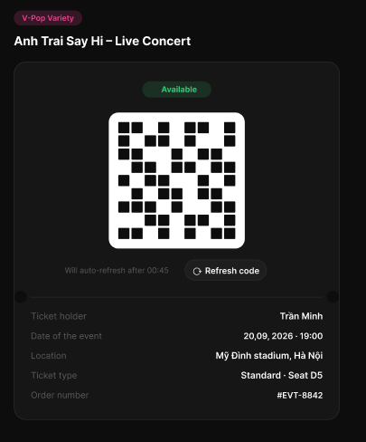
Figure 80 : View Ticket Detail Screen
FUNCTION DETAILS:
- VALIDATION RULES:
  - The seat must belong to the seating chart of the event that is displayed.
  - Every seat must have a row, a seat number, a ticket tier, a price and exactly one status.
  - The row and the seat number must be shown in the format "Row C · Seat 8".
  - The status must be Available, Selected, Held or Sold, and it must be the same as the status shown in the chart. A seat chosen by the current customer must be shown as Selected, and not as Held.
  - The price must be shown in Vietnamese dong with a thousands separator, for example "350,000₫". If a seat has no price, "Price not available" must be shown, and the seat cannot be chosen.
  - The hint must match the status of the seat.
  - Only the details of one seat must be shown at a time. Showing the details of another seat must close the previous card.
  - The details must not show who holds a seat.
  - The details must be available with the pointer, with touch and with the keyboard, and a screen reader must read them (for example "Row C, seat 8, available, Standard tier, 350,000 dong").
  - The details card must stay inside the visible area of the screen, and it must be moved automatically when the seat is near the edge.
  - A logged-in user is not required.
BUSINESS RULES:
- NORMAL FLOW:
  - Sub-flow A: View Seat Details
Step 1: The user has the seating chart of an event open.
Step 2: The user moves the pointer over a seat, taps it, or moves the keyboard focus to it.
Step 3: The client finds the seat in the chart data that is already loaded (row, number, ticket tier, price and status).
Step 4: The client checks that the seat has all the data it needs.
Step 5: The client displays the details card next to the seat, with the row and the seat number, the status, the ticket tier, the price and the hint for the status.
Step 6: The user moves the pointer away, taps elsewhere, moves the focus to another seat, or presses Esc, and the client hides the card.
- ABNORMAL FLOWS:
  - Abnormal flow 1: Seat data incomplete (occurs at Sub-flow A, Step 4)
Step 1: The seat has no price or no ticket tier.
Step 2: The client displays the card with the available data and the text "Price not available" (or "Tier not available") for the missing item.
Step 3: The client does not allow the seat to be chosen, and records the problem in its log.
  - Abnormal flow 2: Seat becomes unavailable while the details are open (occurs at Sub-flow B, Step 2)
Step 1: The seat was Available, and it becomes Sold or Held by another customer.
Step 2: The client updates the card with the new status and hint.
Step 3: The client displays the message "This seat has just been taken." in the card, and the seat cannot be chosen.
  - Abnormal flow 3: Customer tries to choose an unavailable seat (occurs at Sub-flow C, Step 1)
Step 1: The Customer clicks a seat that is Sold or Held by another customer.
Step 2: The client does not start the seat selection.
Step 3: The client keeps the details card open and displays the message "This seat is no longer available." (Sold) or "This seat is being kept for another buyer." (Held).

3.8.5 Display Dynamic QR Code
FUNCTION TRIGGER:
- Trigger 1: The ticket details page (see 3.8.4) of an available ticket has been loaded.
- Trigger 2: The countdown "Will auto-refresh after {mm:ss}" reaches 00:00.
FUNCTION DESCRIPTION:
- Actor(s): Customer
- Purpose:
  - To let a Customer show a QR code at the entrance of the event, and to make sure that the code changes every short time, so that a screenshot or a copy of the code cannot be used by another person.
- Main Functionality:
  - When the Customer opens an available ticket, the system creates a QR code that is valid for a short time (60 seconds) and returns it with its remaining time. The page draws the QR code and shows a countdown ("Will auto-refresh after 00:45"). When the countdown reaches 00:00, the page gets a new code automatically. The Customer can also click "Refresh code" to get a new code at any time. When a new code is created, the previous code is no longer valid. No code is created for a ticket that is already used or expired. Displaying or refreshing the code does not change the status of the ticket. The code is scanned at the entrance (another function).

SCREEN LAYOUT:
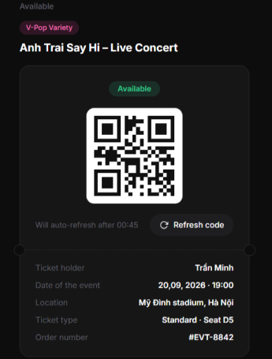
Figure 81 : Display Dynamic QR Code Screen
FUNCTION DETAILS:
- VALIDATION RULES:
  - The user must be authenticated. The Access Token must be sent in the Authorization header, and it must be present, valid and not expired. The user must be identified from the claims in the token, so the client must not send a user id.
  - The account referenced by the token must exist and be active.
  - The ticket code must be valid, in the format "TKT-nnnn-nnn", and the ticket must exist.
  - The ticket must belong to the account referenced by the token, and it must belong to an order with the status Paid. A ticket of another customer, or a ticket of an order that is not Paid, must be handled in the same way as a ticket that does not exist.
  - A QR code must be created only for a ticket with the status "Available" (see 3.8.3, BR-3 for the calculation of the status). No code must be created, returned or displayed for a ticket that is "Used" or "Expired".
  - The code must be created by the system. It must contain a signed code text that is valid for 60 seconds, and it must not contain any personal information of the customer. The client must draw the QR code from the code text returned by the system, and it must not create or change the code text.
  - The system must return the remaining time of the code. The countdown must be based on this remaining time, and it must be shown in the format "mm:ss". When the page comes back from the background, the client must calculate the remaining time again and get a new code if the code has expired.
  - When a new code is created for a ticket, the previous code of that ticket must become invalid at once.
  - A new code must not be created more than once every 5 seconds for the same ticket. The "Refresh code" button must be disabled for 5 seconds after it is clicked.
  - The QR code must be displayed with dark squares on a white background and a white margin around it, so that it can be scanned.
  - The code must not be stored on the device after the page is closed, and the system must not write the code text in its logs.

- NORMAL FLOW:
  - Sub-flow A: Display the First Code
Step 1: The ticket details page has been loaded and the ticket is "Available".
Step 2: The client sends the request for a code, with the ticket code and the Access Token in the Authorization header.
Step 3: The system validates the Access Token, identifies the user from its claims, looks up the account and checks that it is active.
Step 4: The system validates the ticket code, and checks that the ticket belongs to the customer and that its order is Paid.
Step 5: The system checks that the status of the ticket is "Available".
Step 6: The system checks that no code was created for this ticket less than 5 seconds ago.
Step 7: The system creates a signed code valid for 60 seconds, and makes the previous code of the ticket invalid.
Step 8: The system saves the validity of the new code and logs its creation, without the code text.
Step 9: The system returns the code text and the remaining time.
Step 10: The client draws the QR code, displays the text "Will auto-refresh after {mm:ss}" and the "Refresh code" button, and starts the countdown.
  - Sub-flow B: Refresh the Code Automatically
Step 1: The countdown reaches 00:00 (or the Customer comes back to the page and the code has expired).
Step 2: The client sends the request for a new code (Sub-flow A, Step 2 to 9).
Step 3: The client replaces the QR code with the new one and restarts the countdown with the new remaining time.
  - Sub-flow C: Refresh the Code on Request
Step 1: The Customer clicks "Refresh code".
Step 2: The client checks that at least 5 seconds have passed since the last new code, disables the button for 5 seconds and shows that the code is being refreshed.
Step 3: The client sends the request for a new code (Sub-flow A, Step 2 to 9).
Step 4: The client replaces the QR code with the new one and restarts the countdown with the new remaining time.
- ABNORMAL FLOWS:
  - Abnormal flow 1: Ticket not found (occurs at Sub-flow A, Step 4)
Step 1: The ticket code is not valid, or no ticket has this code, or the ticket belongs to another customer, or its order is not Paid.
Step 2: The system returns 400 Bad Request (invalid code) or 404 Not Found (other cases), and creates no code.
Step 3: The client displays the message "This ticket was not found." with a link to "My tickets".
  - Abnormal flow 2: Ticket already used (occurs at Sub-flow A, Step 5)
Step 1: The ticket was scanned at the entrance, for example while the Customer had the page open.
Step 2: The system returns 409 Conflict and creates no code.
Step 3: The client shows the status "Used" in the ticket details, replaces the QR code with the message "This ticket has already been used.", and hides the countdown and the "Refresh code" button.
  - Abnormal flow 3: Ticket expired (occurs at Sub-flow A, Step 5)
Step 1: The event has ended and the ticket was never scanned.
Step 2: The system returns 409 Conflict and creates no code.
Step 3: The client shows the status "Expired" in the ticket details, replaces the QR code with the message "This ticket has expired.", and hides the countdown and the "Refresh code" button.
  - Abnormal flow 4: Ticket no longer available (occurs at Sub-flow A, Step 4)
Step 1: The order of the ticket was cancelled or refunded while the page was open.
Step 2: The system returns 404 Not Found and creates no code.
Step 3: The client displays the message "This ticket is no longer available." and returns the Customer to "My tickets".
  - Abnormal flow 5: Code refreshed too fast (occurs at Sub-flow A, Step 6, or Sub-flow C, Step 2)
Step 1: The Customer clicks "Refresh code" less than 5 seconds after the last new code (for example when the request is sent directly).
Step 2: The client does not send the request, or the system returns 429 Too Many Requests and creates no code.
Step 3: The client keeps the current code and displays the message "Please wait a few seconds before refreshing the code."
  - Abnormal flow 6: The first code cannot be loaded (can occur at Sub-flow A, Step 2 to 9)
Step 1: The connection is lost, the request times out, or an unexpected error occurs on the server when the page is opened.
Step 2: The system logs the error and creates no code.
Step 3: The client keeps the details of the ticket displayed, replaces the QR code with the message "Unable to load the QR code. Please try again.", and displays the "Refresh code" button.
Step 4: The Customer clicks "Refresh code" to try again.

3.9 Feature 8: Ticket Return & Re-Issue Workflow

3.9.1 Submit Ticket Return Request
FUNCTION TRIGGER
- Trigger 1: The Customer clicks the "Return ticket" button on the ticket details page (see 3.8.4) of an available ticket. The Refund request screen is opened.
- Trigger 2: The Customer clicks the "Send request" button on the Refund request screen.
FUNCTION DESCRIPTION
- Actor(s): Customer
- Purpose:
  - To let a Customer who cannot use a ticket ask for a refund of that ticket, by choosing a reason and, if needed, adding a note, so that the request can be reviewed by the system staff.
Main Functionality:
- When the Customer chooses to return an available ticket, the system shows the Refund request screen with a summary of the ticket (event name, event date and seat). The Customer chooses one reason for the refund (Cannot attend, Change personal schedule, Event postponed or Others reason) and can write an additional note. When the Customer clicks "Send request", the system checks the ticket and the data, creates a return request with the status "Pending", and changes the ticket status to "Return Requested". The message "Your request will be reviewed within 1–2 business days." is shown on the screen. The review, the approval or rejection, and the payment of the refund are done by other functions. After a return request has been sent, the QR code of the ticket is no longer created.
SCREEN LAYOUT :
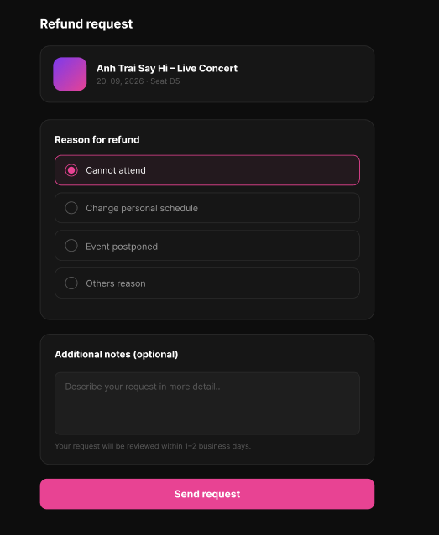
Figure 82 : Submit Ticket Return Request Screen
FUNCTION DETAILS
- VALIDATION RULES
  - The user must be authenticated. The Access Token must be sent in the Authorization header, and it must be present, valid and not expired. The user must be identified from the claims in the token, so the client must not send a user id.
  - The account referenced by the token must exist and be active.
  - The ticket code must be valid, in the format "TKT-nnnn-nnn", and the ticket must exist.
  - The ticket must belong to the account referenced by the token, and it must belong to an order with the status Paid. A ticket of another customer, or a ticket of an order that is not Paid, must be handled in the same way as a ticket that does not exist.
  - The ticket must have the status "Available" (see 3.8.3, BR-3 for the calculation of the status). A ticket that is "Used", "Expired", "Return Requested" or "Returned" cannot be returned.
  - The request must be sent before the return deadline of the ticket. [Assumption: the deadline is a configurable time before the start of the event, for example 24 hours. After this time, the ticket cannot be returned.]
  - There must be no return request with the status "Pending" or "Approved" for the same ticket.
  - The client must disable the "Send request" button as soon as it is clicked, until the response is received, to prevent double submission. The system must not create two requests for the same ticket, even if the request is received twice.
  - The notes may contain personal information, so the system must not write the notes in its logs.

- NORMAL FLOW
  - Sub-flow A: Open the Refund Request Screen
Step 1: The Customer is on the ticket details page (see 3.8.4) and the ticket is "Available". The Customer clicks "Return ticket".
Step 2: The client opens the Refund request screen and displays the summary of the ticket: the event image, the event name, the event date and the seat.
Step 3: The client displays the reason options with "Cannot attend" selected by default, an empty notes box, and the "Send request" button.
  - Sub-flow B: Submit the Request
Step 1: The Customer selects a reason, optionally writes an additional note, and clicks "Send request".
Step 2: The client checks the data (a reason is selected, notes are not longer than 500 characters, and notes are filled when the reason is "Others reason"), disables the button and shows that the request is being sent.
Step 3: The client sends the request with the ticket code, the reason and the notes, and the Access Token in the Authorization header.
Step 4: The system validates the Access Token, identifies the user from its claims, looks up the account and checks that it is active.
Step 5: The system validates the reason and the notes.
Step 6: The system validates the ticket code, and checks that the ticket belongs to the customer and that its order is Paid.
Step 7: The system checks that the status of the ticket is "Available" and that the return deadline has not passed.
Step 8: The system checks that the ticket has no active return request.
Step 9: The system creates the return request with the status "Pending" and changes the ticket status to "Return Requested", in one transaction.
Step 10: The system logs the creation of the request (request id, ticket code, reason), without the notes.
Step 11: The system returns 201 Created with the request id, the status and the time of the request.
Step 12: The client displays the message "Your refund request has been sent. We will review it within 1–2 business days." and returns the Customer to the ticket details page, where the ticket now shows the status "Return Requested" and no QR code.
- ABNORMAL FLOWS
  - Abnormal flow 1: Access Token missing, invalid or expired (occurs at Sub-flow B, Step 3 or 4)
Step 1: The Access Token is missing, invalid or expired when the request is sent.
Step 2: The system rejects the request, returns 401 Unauthorized and creates no return request.
Step 3: The client tries to obtain a new Access Token with the Refresh Token and repeats the request.
Step 4: If the Refresh Token is also expired or revoked, the client deletes the stored tokens, displays the message "Your session has expired. Please log in again." and redirects the user to the Login page.
  - Abnormal flow 2: Account not found or not active (occurs at Sub-flow B, Step 4)
Step 1: The account referenced by the token no longer exists, or it has been disabled or locked.
Step 2: The system logs a warning and creates no return request.
Step 3: The system returns 401 Unauthorized.
Step 4: The client deletes the stored tokens, displays the message "Your account is not available. Please contact support." and redirects the user to the Login page.
  - Abnormal flow 3: Invalid reason or notes (occurs at Sub-flow B, Step 2 or 5)
Step 1: No reason is selected, the reason is not one of the allowed values, the notes are longer than 500 characters, or the notes are empty while the reason is "Others reason".
Step 2: The client shows the error message under the related field and does not send the request. If the check is done by the system, it returns 400 Bad Request and creates no return request.
Step 3: The client keeps the data typed by the Customer and enables the "Send request" button again.
  - Abnormal flow 4: Ticket not found (occurs at Sub-flow B, Step 6)
Step 1: The ticket code is not valid, or no ticket has this code, or the ticket belongs to another customer, or its order is not Paid.
Step 2: The system returns 400 Bad Request (invalid code) or 404 Not Found (other cases), and creates no return request.
Step 3: The client displays the message "This ticket was not found." with a link to "My tickets".
  - Abnormal flow 5: Ticket already used (occurs at Sub-flow B, Step 7)
Step 1: The ticket was scanned at the entrance while the Customer had the screen open.
Step 2: The system returns 409 Conflict and creates no return request.
Step 3: The client displays the message "This ticket has already been used.", shows the status "Used" in the ticket details, and hides the "Send request" button.
  - Abnormal flow 6: Ticket expired (occurs at Sub-flow B, Step 7)
Step 1: The event has ended and the ticket was never scanned.
Step 2: The system returns 409 Conflict and creates no return request.
Step 3: The client displays the message "This ticket has expired.", shows the status "Expired" in the ticket details, and hides the "Send request" button.

  - Abnormal flow 7: Return deadline passed (occurs at Sub-flow B, Step 7)
Step 1: The return deadline of the ticket has passed while the Customer had the screen open (or the Customer sends the request directly).
Step 2: The system returns 409 Conflict and creates no return request.
Step 3: The client displays the message "This ticket can no longer be returned." and returns the Customer to the ticket details page, where the "Return ticket" button is hidden.
  - Abnormal flow 8: Return request already exists (occurs at Sub-flow B, Step 7 or 8)
Step 1: The ticket already has a request that is Pending or Approved (for example, sent from another device, or the Customer clicked twice).
Step 2: The system returns 409 Conflict and creates no new return request.
Step 3: The client displays the message "You have already sent a refund request for this ticket." and returns the Customer to the ticket details page, which shows the status "Return Requested".

3.9.2 Track Ticket Return Status
FUNCTION TRIGGER:
- Trigger 1: Customer clicks the "View request status" link on the ticket details page (see 3.8.4) of a ticket with the status "Return Requested", and the Refund request status screen is loaded.
- Trigger 2: Customer comes back to the Refund request status screen after it was hidden (for example after switching to another application).
FUNCTION DESCRIPTION:
- Actor(s): Customer
- Purpose:
  - To let a Customer follow the progress of a return request (see 3.8.6), and to cancel the request while it is not yet reviewed, so that the Customer can keep and use the ticket.
- Main Functionality:
  - When the Customer opens the Refund request status screen, the system returns the current return request of the ticket. The screen shows a summary of the ticket (event name, event date and seat) and the progress of the request in 3 steps: "Request submitted" (with the date and time of the request), "Pending review" (with the expected time of 1-2 business days) and "Has been refunded".
  - The step that has been reached is highlighted, and the steps that have not been reached are shown in grey. While the request is "Pending", the screen shows the message "Your request is being reviewed by the organizing team." and the "Cancel Request" button.
  - When the Customer clicks "Cancel Request", the client asks for confirmation. After the Customer confirms, the system changes the status of the request to "Cancelled" and changes the status of the ticket from "Return Requested" back to "Available" (see 3.8.3, BR-3 for the calculation of the status). A request that is already approved, rejected or cancelled cannot be cancelled.
  - The review of the request and the payment of the refund are done by other functions.
SCREEN LAYOUT :
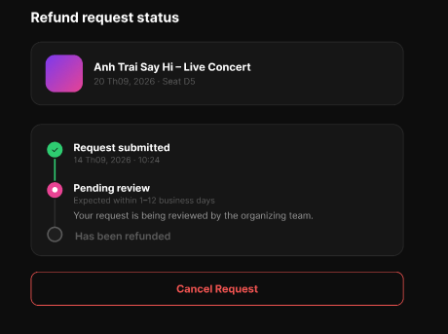
Figure 83 : Track Ticket Return Status Screen
FUNCTION DETAILS:
- VALIDATION RULES
  - The user must be authenticated. The Access Token must be sent in the Authorization header, and it must be present, valid and not expired. The user must be identified from the claims in the token, so the client must not send a user id.
  - The account referenced by the token must exist and be active.
  - The ticket code must be valid, in the format "TKT-nnnn-nnn", and the ticket must exist.
  - The ticket must belong to the account referenced by the token. A ticket of another customer must be handled in the same way as a ticket that does not exist.
  - There must be a return request associated with the ticket (in any status: Pending, Approved, Rejected, Refunded or Cancelled). A ticket with no return request must be handled as "not found" for this function.
  - Only the most recent return request for the ticket is returned/displayed.
  - For cancellation, the return request must currently have the status "Pending". A request that is "Approved", "Rejected", "Refunded" or already "Cancelled" cannot be cancelled.
  - The client must disable the "Cancel Request" button as soon as it is clicked, until the response is received, to prevent double submission. The system must not process two cancellations for the same request, even if the request is received twice.

- NORMAL FLOW:
  - Sub-flow A: Open the Refund Status Screen
Step 1: The Customer is on the ticket details page and the ticket status is "Return Requested". The Customer taps the ticket / taps "Track refund status".
Step 2: The client sends a GET request with the ticket code and the Access Token in the Authorization header.
Step 3: The system validates the Access Token, identifies the user, and checks that the account is active.
Step 4: The system validates the ticket code, checks that the ticket belongs to the customer, and retrieves the latest return request for the ticket.
Step 5: The system returns 200 OK with: the event image, event name, event date and seat; the return request id, status, submission date/time, and expected review window (e.g. 5–12 business days); and whether the request is cancellable.
Step 6: The client renders the summary card and the status timeline:
"Request submitted" — always shown as completed, with the submission date/time.
"Pending review" — shown as the current step while status is Pending, with the expected review window and the note "Your request is being reviewed by the organizing team."
"Has been refunded" — shown as completed once status is Refunded; shown as upcoming/greyed out otherwise.
Step 7: If the status is "Pending", the client shows the "Cancel Request" button. If the status is "Approved", "Rejected", "Refunded" or "Cancelled", the button is hidden (or replaced with the appropriate final-state message).

- ABNORMAL FLOWS:
  - Abnormal flow 1: Ticket not found or not owned by the customer (occurs at Sub-flow A Step 4)
Step 1: The ticket code is invalid, the ticket does not exist, or it belongs to another customer.
Step 2: The system returns 400 Bad Request (invalid code) or 404 Not Found (other cases).
Step 3: The client displays "This ticket was not found." with a link to "My tickets".
  - Abnormal flow 2: No return request exists for the ticket (occurs at Sub-flow A Step 4)
Step 1: The ticket exists and belongs to the customer, but it has no return request (e.g. it is still "Available", or the link/deep-link is stale).
Step 2: The system returns 404 Not Found.
Step 3: The client displays "No refund request was found for this ticket." and returns the Customer to the ticket details page.
  - Abnormal flow 3: Request no longer cancellable (occurs at Sub-flow B Step 6)
Step 1: The request has already moved to "Approved", "Rejected", "Refunded" or "Cancelled" (e.g. reviewed by staff, or cancelled from another device) while the Customer had the screen open.
Step 2: The system returns 409 Conflict and makes no change.
Step 3: The client displays "This request can no longer be cancelled." and refreshes the screen to show the current status, hiding the "Cancel Request" button as appropriate.
  - Abnormal flow 4: Double cancellation (race condition) (occurs at Sub-flow B Step 6/7)
Step 1: Two cancellation requests for the same return request arrive nearly simultaneously (e.g. double tap, or two devices).
Step 2: The system processes the first request normally; the second finds the status no longer "Pending" and returns 409 Conflict, making no change.
Step 3: The client handles this the same as Abnormal flow 5.
  - Abnormal flow 5: Status changed to a final state while viewing (occurs at Sub-flow A Step 6, on refresh/polling)
Step 1: The request is approved, rejected or refunded by staff while the Customer has the status screen open.
Step 2: On the next refresh/poll, the system returns the updated status.
Step 3: The client updates the timeline accordingly (e.g. marks "Has been refunded" as completed, or shows a "Request rejected" state with the reason if provided) and hides the "Cancel Request" button.

3.9.3 Cancel Ticket Return Request
FUNCTION TRIGGER:
- Trigger 1: Customer taps "Cancel Request" on the Refund request status screen (see 3.9.2), while the return request status is "Pending", and confirms the action in the confirmation dialog.
FUNCTION DESCRIPTION:
- Actor(s): Customer
- Purpose:
  - To let a Customer withdraw a return request that has not yet been reviewed, so that the Customer keeps the ticket and can use it to attend the event.
- Main Functionality:
  - When the Customer taps "Cancel Request" on the Refund request status screen, the client opens a confirmation dialog titled "Cancel refund request?" with the message "Your ticket will remain in its current status and this refund request will not be processed further.", and two actions: "Close" and "Cancel request".
  - If the Customer taps "Close", the dialog is dismissed and nothing changes. If the Customer taps "Cancel request", the system changes the status of the return request from "Pending" to "Cancelled" and changes the status of the ticket from "Return Requested" back to "Available" (see 3.8.3, BR-3 for the calculation of the status), restoring its QR code. A request that is already "Approved", "Rejected", "Refunded" or already "Cancelled" cannot be cancelled.
  - The review of the request and the payment of the refund are done by other functions.
SCREEN LAYOUT :
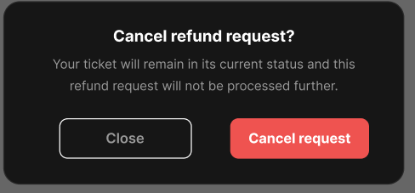
Figure 84 : Cancel Ticket Return Request Screen
FUNCTION DETAILS:
- VALIDATION RULES
  - The user must be authenticated. The Access Token must be sent in the Authorization header, and it must be present, valid and not expired. The user must be identified from the claims in the token, so the client must not send a user id.
  - The account referenced by the token must exist and be active.
  - The return request id (or ticket code) must be valid and the return request must exist.
  - The return request must belong to the account referenced by the token. A return request of another customer must be handled in the same way as a return request that does not exist.
  - The return request must currently have the status "Pending". A request that is "Approved", "Rejected", "Refunded" or already "Cancelled" cannot be cancelled.
  - The client must disable the "Cancel request" button as soon as it is clicked, until the response is received, to prevent double submission. The system must not process two cancellations for the same request, even if the request is received twice.

- NORMAL FLOW
  - Sub-flow A: Open the Confirmation Dialog
Step 1: The Customer is on the Refund request status screen and the request status is "Pending". The Customer taps "Cancel Request".
Step 2: The client opens a confirmation dialog titled "Cancel refund request?" with the message "Your ticket will remain in its current status and this refund request will not be processed further."
Step 3: The client displays two actions: "Close" and "Cancel request".
  - Sub-flow B: Confirm Cancellation
Step 1: The Customer taps "Cancel request" in the dialog.
Step 2: The client disables the "Cancel request" button and shows that the cancellation is being sent.
Step 3: The client sends the cancellation request with the return request id (or ticket code) and the Access Token in the Authorization header.
Step 4: The system validates the Access Token, identifies the user from its claims, looks up the account and checks that it is active.
Step 5: The system validates the return request id, and checks that the request belongs to the customer.
Step 6: The system checks that the request status is still "Pending".
Step 7: The system updates the return request status to "Cancelled" and reverts the ticket status to "Available" (restoring its QR code), in one transaction.
Step 8: The system logs the cancellation (request id, ticket code, previous status).
Step 9: The system returns 200 OK with the updated request status and the time of cancellation.
Step 10: The client closes the dialog, displays the message "Your refund request has been cancelled.", and returns the Customer to the ticket details page, where the ticket now shows status "Available" with its QR code and the "Return ticket" button restored.
- ABNORMAL FLOWS
  - Abnormal flow 1: Customer closes the dialog without confirming (occurs at Sub-flow A, Step 3)
Step 1: The Customer taps "Close".
Step 2: The client closes the dialog without sending any request, and returns to the Refund request status screen unchanged.
  - Abnormal flow 2: Access Token missing, invalid or expired (occurs at Sub-flow B, Step 3 or 4)
Step 1: The Access Token is missing, invalid or expired when the request is sent.
Step 2: The system rejects the request, returns 401 Unauthorized and makes no change.
Step 3: The client tries to obtain a new Access Token with the Refresh Token and repeats the request.
Step 4: If the Refresh Token is also expired or revoked, the client deletes the stored tokens, displays "Your session has expired. Please log in again." and redirects the user to the Login page.
  - Abnormal flow 3: Account not found or not active (occurs at Sub-flow B, Step 4)
Step 1: The account referenced by the token no longer exists, or it has been disabled or locked.
Step 2: The system logs a warning and makes no change.
Step 3: The system returns 401 Unauthorized.
Step 4: The client deletes the stored tokens, displays "Your account is not available. Please contact support." and redirects the user to the Login page.
  - Abnormal flow 4: Return request not found or not owned by the customer (occurs at Sub-flow B, Step 5)
Step 1: The return request id is invalid, does not exist, or belongs to another customer.
Step 2: The system returns 400 Bad Request (invalid id) or 404 Not Found (other cases), and makes no change.
Step 3: The client closes the dialog, displays "This refund request was not found." and returns the Customer to the ticket details page.
  - Abnormal flow 5: Request no longer cancellable (occurs at Sub-flow B, Step 6)
Step 1: The request has already moved to "Approved", "Rejected" or "Refunded" (e.g. reviewed by staff in the meantime), or was already cancelled from another device.
Step 2: The system returns 409 Conflict and makes no change.
Step 3: The client closes the dialog, displays "This request can no longer be cancelled." and refreshes the Refund request status screen to show the current status.
  - Abnormal flow 6: Double cancellation (race condition) (occurs at Sub-flow B, Step 6/7)
Step 1: Two cancellation requests for the same return request arrive nearly simultaneously (e.g. double tap, or two devices/tabs open).
Step 2: The system processes the first request normally (status becomes "Cancelled", ticket becomes "Available"); the second request finds the status no longer "Pending" and returns 409 Conflict, making no further change.
Step 3: The client handles the second response the same as Abnormal flow 5.

3.10 Feature 9: Event Creation & Lifecycle Management

3.10.1 View Concert List
FUNCTION TRIGGER:
- Trigger 1: Organizer opens "Concerts Management" from the dashboard/side menu. The default tab "All" is loaded automatically.
FUNCTION DESCRIPTION:
- Actor(s): Organizer
- Purpose:
  - To let an Organizer see all concerts they have created, grouped by approval/publication status, so they can track which concerts are still drafts, awaiting admin approval, already approved, or cancelled.
- Main Functionality:
  - The Concerts Management screen shows a horizontal set of status tabs — All, Draft, Pending, Approved, Cancelled — and a "+ Create Concert" button. Under the selected tab, the system lists only the concerts belonging to the current Organizer, each shown as a card with a thumbnail, concert title, date and venue, and a colored status badge (e.g. green "Approved", yellow "Pending Approval", red "Cancelled"; Draft cards show no date if the concert has not been scheduled yet). Tapping a card opens that concert's details. Creating, editing, submitting for approval, and cancelling a concert are handled by other functions.

SCREEN LAYOUT :
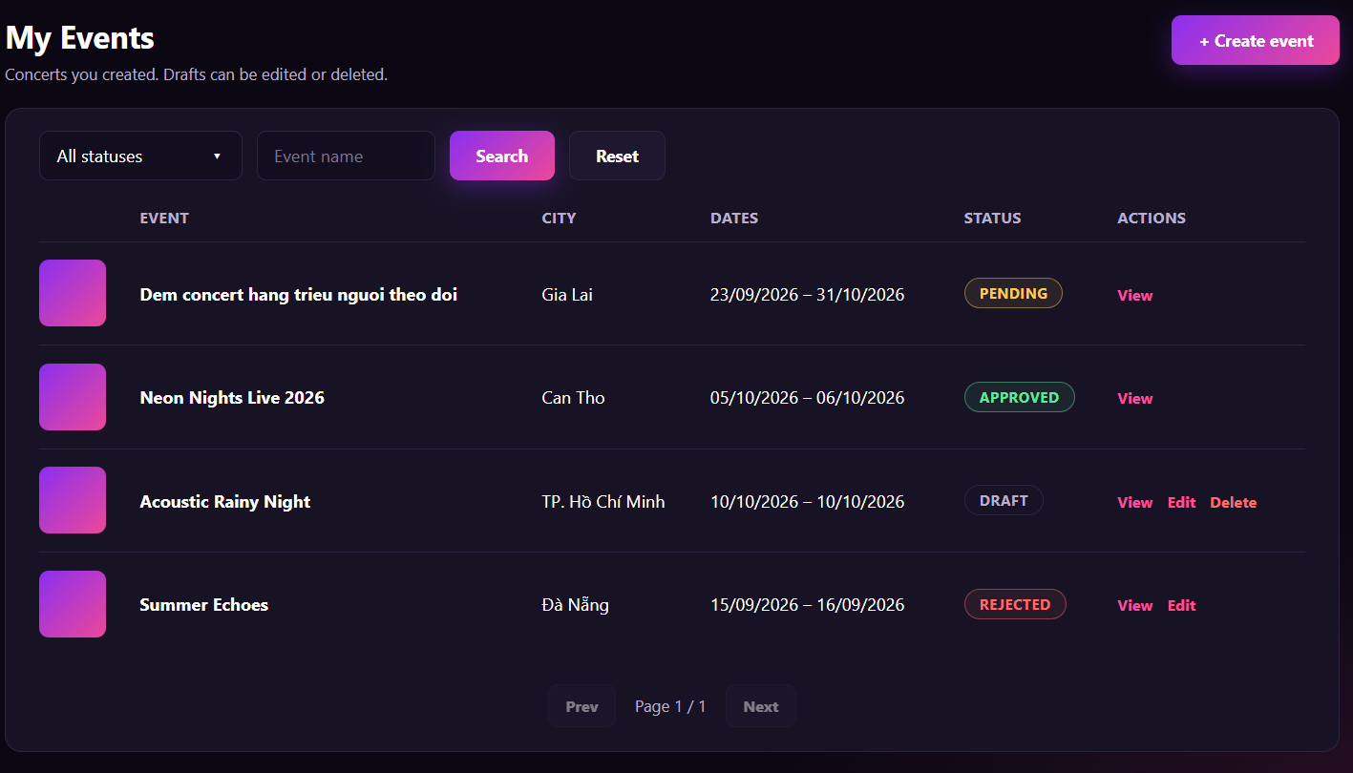
Figure 85 : View Concert List Screen

FUNCTION DETAILS:
- VALIDATION RULES:
  - The user must be authenticated. The Access Token must be sent in the Authorization header, and it must be present, valid and not expired. The user must be identified from the claims in the token, so the client must not send an organizer id.
  - The account referenced by the token must exist, be active, and have the Organizer role.
  - The client must always send a status filter value (one of All, Draft, Pending, Approved, Cancelled); if omitted, the system treats it as All.
  - The system must only return concerts whose organizer_id matches the organizer identified from the token; an organizer must never see another organizer's concerts through this function.
  - The list must be paginated (e.g. page/page size or infinite scroll); the client must not request the entire dataset at once.
- NORMAL FLOW:
  - Sub-flow A: Load Concert List (default "All" tab)
Step 1: The Organizer navigates to the Concerts Management screen.
Step 2: The client requests the concert list with filter = "All" and the Access Token in the Authorization header.
Step 3: The system validates the Access Token, identifies the organizer from its claims, and checks that the account is active.
Step 4: The system queries all concerts where organizer_id = the current organizer, ordered by most recently updated first.
Step 5: The system returns 200 OK with the list (concert id, title, thumbnail, date, venue, status) and the total count.
Step 6: The client highlights the "All" tab, renders each concert as a card with thumbnail, title, date/venue and status badge, and shows the "+ Create Concert" button. If the list is empty, the client shows an empty-state message and a prompt to create the first concert.
- ABNORMAL FLOWS:
  - Abnormal flow 1: Access Token missing, invalid or expired (occurs at Sub-flow A/B, Step 2 or 3)
Step 1: The Access Token is missing, invalid or expired when the request is sent.
Step 2: The system rejects the request, returns 401 Unauthorized and returns no data.
Step 3: The client tries to obtain a new Access Token with the Refresh Token and repeats the request.
Step 4: If the Refresh Token is also expired or revoked, the client deletes the stored tokens, displays "Your session has expired. Please log in again." and redirects the user to the Login page.
  - Abnormal flow 2: Account not found, not active, or not an Organizer (occurs at Sub-flow A/B, Step 3)
Step 1: The account referenced by the token no longer exists, has been disabled/locked, or does not have the Organizer role.
Step 2: The system logs a warning and returns 401 Unauthorized (or 403 Forbidden if the account is valid but lacks the Organizer role).
Step 3: The client deletes the stored tokens (for 401) or shows an access-denied message (for 403), and redirects accordingly.

3.10.2 View Concert Details
FUNCTION TRIGGER:
- Trigger 1: Organizer clicks an event row (or the "View" action) in the "My events" list.
- Trigger 2: Organizer opens the detail page of an event directly by its link, for example after creating or editing the event.
FUNCTION DESCRIPTION:
- Actor(s): Organizer
- Secondary actor(s): System
- Purpose:
  - To let the Organizer see all the information of an event they created (basic information, schedule, venue, ticket rules, refund policies, ticket types with quantity sold) and its approval status, so that the Organizer can follow the event and decide whether to edit it.
- Main Functionality:
  - The Organizer opens the detail page of one of their own events. The page shows the event image, name, category, city and the status badge (for example PENDING). Below it, the page shows the start time, end time, venue, address, the minimum and maximum number of tickets per account, and the number of refund policies configured. A table lists each ticket type with its price, total quantity and the number sold. If the event can be edited, the "Edit event" button is enabled. If the event is Pending, the button is disabled and the note "Pending events cannot be edited until approved or rejected." is shown. The Organizer clicks "Back to my events" to return to the list. This function only reads data. It does not change the event, the ticket types or the status.

SCREEN LAYOUT:
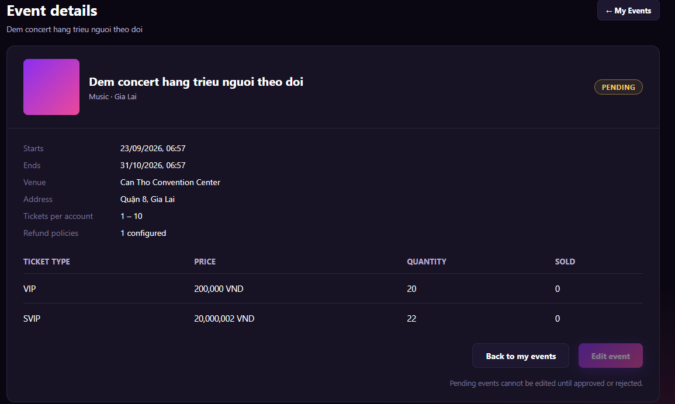
Figure 86 : View Concert Detail Screen
FUNCTION DETAILS:
- VALIDATION RULES:
  - The user must be authenticated. The Access Token must be sent in the Authorization header, and it must be present, valid and not expired. The user must be identified from the claims in the token, so the client must not send a user id.
  - The account referenced by the token must exist and be active, and must have the Organizer role.
  - The event id must be a whole number greater than 0, and the event must exist and must not be deleted.
  - The event must belong to the Organizer identified from the token. An Organizer can never view the detail of an event of another Organizer through this function.
  - One request returns one event only, the event in the URL.
  - The status must be shown as one of the allowed statuses of an event.
  - The "Edit event" button must be enabled only when the status of the event allows editing (see Business Rules). It must be disabled when the status is Pending.
  - Dates are stored in UTC and displayed in the Organizer's local time. Prices are shown with a thousands separator and the currency.
  - The number SOLD must be between 0 and QUANTITY.

- NORMAL FLOW:
  - Sub-flow A: Open the Event Detail
  - Step 1: The logged-in Organizer clicks an event in the "My events" list.
  - Step 2: The client sends the request with the event id and the Access Token in the Authorization header.
  - Step 3: The system validates the Access Token, identifies the user from its claims, looks up the account, and checks that it is active and has the Organizer role.
  - Step 4: The system validates the event id, looks up the event, and checks that it is not deleted and belongs to this Organizer.
  - Step 5: The system returns the event image, name, category, city, status, start time, end time, venue, address, the minimum and maximum tickets per account, the number of refund policies, and the list of ticket types with price, quantity and sold.
  - Step 6: The client displays the Concert detail page with these values.
  - Step 7: The client enables the "Edit event" button if the status allows editing. If the status is Pending, the client disables the button and shows the note "Pending events cannot be edited until approved or rejected."

- ABNORMAL FLOWS:
  - Abnormal flow 1: Access Token missing, invalid or expired (occurs at Sub-flow A, Step 2 or 3)
  - Step 1: The Access Token is missing, invalid or expired when the request is sent.
  - Step 2: The system rejects the request, returns 401 Unauthorized and returns no data.
  - Step 3: The client tries to obtain a new Access Token with the Refresh Token and repeats the request.
  - Step 4: If the Refresh Token is also expired or revoked, the client deletes the stored tokens, displays the message "Your session has expired. Please log in again." and redirects the user to the Login page. After logging in, the Organizer returns to this event.

  - Abnormal flow 2: Account not found or not active (occurs at Sub-flow A, Step 3)
  - Step 1: The account referenced by the token no longer exists, or it has been disabled or locked.
  - Step 2: The system logs a warning, returns no data and returns 401 Unauthorized.
  - Step 3: The client deletes the stored tokens, displays the message "Your account is not available. Please contact support." and redirects the user to the Login page.

  - Abnormal flow 3: Not an Organizer (occurs at Sub-flow A, Step 3)
  - Step 1: The account is active but does not have the Organizer role.
  - Step 2: The system logs a warning, returns no data and returns 403 Forbidden.
  - Step 3: The client displays the message "You do not have permission to view this page." and returns to the previous page.

  - Abnormal flow 4: Event id invalid (occurs at Sub-flow A, Step 4)
  - Step 1: The event id in the link is not a whole number greater than 0.
  - Step 2: The system returns 400 Bad Request and returns no data.
  - Step 3: The client displays the message "This event link is not valid." and offers the "Back to my events" button.

3.10.3 Edit Concert Information
FUNCTION TRIGGER:
- Trigger 1: Organizer clicks the enabled "Edit event" button on the Concert detail page (3.9.2).
- Trigger 2: Organizer clicks the "Save draft" or "Save & Next →" button on the Event Info step of the Edit Event page.
FUNCTION DESCRIPTION:
- Actor(s): Organizer
- Secondary actor(s): System
- Purpose:
  - To let the Organizer change the basic information of an event they created (name, public link, descriptions, schedule, venue and the number of tickets per account), and to save it as a draft at any time or continue to the next step of the Edit Event process.
- Main Functionality:
  - The Organizer opens the Edit Event page of one of their own events. The page shows the four steps (Info, Images, Tickets & Seating, Review & Submit) and the form of step 1 "Event Info", filled with the current data of the event. The form has the fields: Event name, Public URL slug, Short description, Full description, Starts, Ends, Venue name, Address, City, Min tickets / account and Max tickets / account. The fields marked with * are required. The Organizer changes the data and clicks "Save draft" to save without leaving the step, or "Save & Next " to save and go to the step "Images". The Organizer can click " My Events" to return to the list. The Organizer can come back later and continue, because the data is kept. Saving does not submit the event for approval. Submitting is done only in the last step, "Review & Submit".

SCREEN LAYOUT:
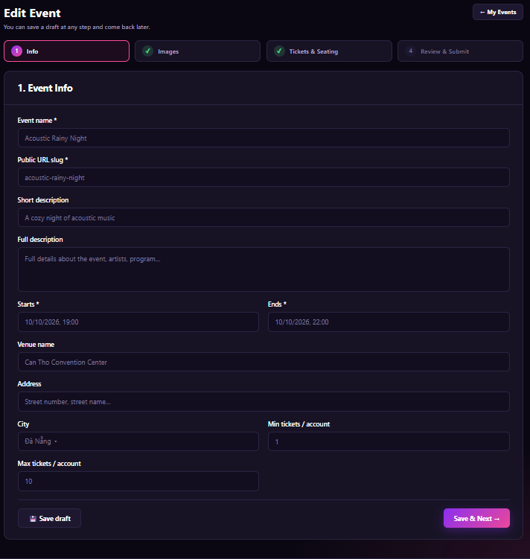
Figure 87 : Edit Concert Screen

FUNCTION DETAILS:
- VALIDATION RULES:
  - The user must be authenticated. The Access Token must be sent in the Authorization header, and it must be present, valid and not expired. The user must be identified from the claims in the token, so the client must not send a user id.
  - The account referenced by the token must exist and be active, and must have the Organizer role.
  - The event id must be a whole number greater than 0, and the event must exist and must not be deleted.
  - The event must belong to the Organizer identified from the token.
  - The status of the event must allow editing (Draft or Rejected). A Pending event cannot be edited. An Approved, Ended or Cancelled event cannot be edited in this function.
  - Event name is required, 3 to 150 characters, and must not contain only spaces. Leading and trailing spaces are removed.
  - Public URL slug is required, 3 to 100 characters, only lowercase letters (a-z), digits (0-9) and hyphens, must not start or end with a hyphen, and must not have two hyphens in a row. The slug must be unique among all events. The event itself is not counted as a duplicate.
  - Short description must be at most 200 characters. Full description must be at most 5,000 characters.
  - Starts and Ends are required (for "Save & Next") and must be valid date-times. Ends must be after Starts. Starts must be later than the current time.
  - Venue name must be at most 150 characters. Address must be at most 255 characters.
  - City, if chosen, must be one of the cities in the list of the system.
  - Min tickets / account and Max tickets / account must be whole numbers. Min must be at least 1, Max must be at least Min and must not be more than the limit of the system (for example 20).
  - "Save draft" requires only a valid Event name and a valid Public URL slug. The other fields may be empty, but any value that is entered must pass its own rule. "Save & Next " requires every required field to be valid.
  - If the event already has ticket types, Max tickets / account must not be more than the total number of tickets of the event.
  - Date-times are entered in the Organizer's local time and stored in UTC.
  - If nothing has changed, the system must not save a new version or write to the audit log.
  - One request changes one event only, the event in the URL.

- NORMAL FLOW:
  - Sub-flow A: Open the Edit Page
  - Step 1: The logged-in Organizer clicks the "Edit event" button on the Concert detail page.
  - Step 2: The client sends the request with the event id and the Access Token in the Authorization header.
  - Step 3: The system validates the Access Token, identifies the user from its claims, looks up the account, and checks that it is active and has the Organizer role.
  - Step 4: The system validates the event id, looks up the event, and checks that it is not deleted, belongs to this Organizer and has a status that allows editing.
  - Step 5: The system returns the data of step 1, the list of cities, the limits of the system, and the state of each step (completed or not).
  - Step 6: The client displays the Edit Event page at step 1 with the current data.

  - Sub-flow B: Save Draft
  - Step 1: The Organizer changes one or more fields.
  - Step 2: The Organizer clicks the "Save draft" button.
  - Step 3: The client checks Event name and Public URL slug, disables the buttons and sends the request with the Access Token in the Authorization header.
  - Step 4: The system validates the Access Token, identifies the user from its claims, looks up the account and checks that it is active and has the Organizer role.
  - Step 5: The system validates the event id, looks up the event, and checks that it belongs to this Organizer and has a status that allows editing.
  - Step 6: The system validates the data of the fields that are filled in (as in the Validation Rules for "Save draft").
  - Step 7: The system checks that the Public URL slug is not used by another event.
  - Step 8: The system saves the data of step 1.
  - Step 9: The system writes the change to the audit log.
  - Step 10: The system returns the saved data.
  - Step 11: The client displays the message "Draft saved." and enables the buttons again. The Organizer stays on step 1.

  - Sub-flow C: Save and Go to the Next Step
  - Step 1: The Organizer fills in all required fields.
  - Step 2: The Organizer clicks the "Save & Next " button.
  - Step 3: The client checks every field, disables the buttons and sends the request with the Access Token in the Authorization header.
  - Step 4: The system validates the Access Token and the Organizer role (as in Sub-flow B, Step 4) and validates the event (as in Sub-flow B, Step 5).
  - Step 5: The system validates all fields, including the times and the number of tickets per account.
  - Step 6: The system checks that the Public URL slug is not used by another event.
  - Step 7: The system saves the data of step 1 and marks step 1 as completed.
  - Step 8: The system writes the change to the audit log.
  - Step 9: The system returns the saved data.
  - Step 10: The client opens the step "Images" of the Edit Event page (see the function that edits the images).

- ABNORMAL FLOWS:
  - Abnormal flow 1: Access Token missing, invalid or expired (occurs at Sub-flow A, Step 2 or 3, Sub-flow B, Step 3 or 4, or Sub-flow C, Step 3 or 4)
  - Step 1: The Access Token is missing, invalid or expired when the request is sent.
  - Step 2: The system rejects the request, returns 401 Unauthorized and changes nothing.
  - Step 3: The client tries to obtain a new Access Token with the Refresh Token and repeats the request.
  - Step 4: If the Refresh Token is also expired or revoked, the client deletes the stored tokens, displays the message "Your session has expired. Please log in again." and redirects the user to the Login page. The data entered is not saved.

  - Abnormal flow 2: Account not found or not active (occurs at Sub-flow A, Step 3, Sub-flow B, Step 4, or Sub-flow C, Step 4)
  - Step 1: The account referenced by the token no longer exists, or it has been disabled or locked.
  - Step 2: The system logs a warning, changes nothing and returns 401 Unauthorized.
  - Step 3: The client deletes the stored tokens, displays the message "Your account is not available. Please contact support." and redirects the user to the Login page.

  - Abnormal flow 3: Not an Organizer (occurs at Sub-flow A, Step 3, Sub-flow B, Step 4, or Sub-flow C, Step 4)
  - Step 1: The account is active but does not have the Organizer role.
  - Step 2: The system logs a warning, changes nothing and returns 403 Forbidden.
  - Step 3: The client displays the message "You do not have permission to perform this action." and returns to the previous page.

  - Abnormal flow 4: Required field missing (occurs at Sub-flow B, Step 3 or 6, or Sub-flow C, Step 3 or 5)
  - Step 1: A required field is empty. For "Save draft" these are Event name and Public URL slug. For "Save & Next →" these are Event name, Public URL slug, Starts and Ends.
  - Step 2: The client does not send the request (or the system returns 400 Bad Request) and saves nothing.
  - Step 3: The client highlights each empty field and displays the message "This field is required." under it.

  - Abnormal flow 5: Text too long or too short (occurs at Sub-flow B, Step 3 or 6, or Sub-flow C, Step 3 or 5)
  - Step 1: A text field is shorter or longer than allowed (for example Event name shorter than 3 characters).
  - Step 2: The client does not send the request (or the system returns 400 Bad Request) and saves nothing.
  - Step 3: The client highlights the field and displays the message "{Field} must be between {min} and {max} characters."

  - Abnormal flow 6: Public URL slug invalid (occurs at Sub-flow B, Step 3 or 6, or Sub-flow C, Step 3 or 5)
  - Step 1: The slug has capital letters, spaces, special characters, accents, or starts or ends with a hyphen.
  - Step 2: The client does not send the request (or the system returns 400 Bad Request) and saves nothing.
  - Step 3: The client highlights the field and displays the message "Use only lowercase letters, digits and hyphens."

  - Abnormal flow 7: Public URL slug already used (occurs at Sub-flow B, Step 7, or Sub-flow C, Step 6)
  - Step 1: Another event already uses the same slug.
  - Step 2: The system returns 409 Conflict and saves nothing.
  - Step 3: The client highlights the field and displays the message "This URL is already used. Please choose another."

  - Abnormal flow 8: Start or end time invalid (occurs at Sub-flow B, Step 3 or 6, or Sub-flow C, Step 3 or 5)
  - Step 1: A date-time is not valid, Ends is equal to or earlier than Starts, or Starts is not later than the current time.
  - Step 2: The client does not send the request (or the system returns 400 Bad Request) and saves nothing.
  - Step 3: The client highlights the fields and displays the message "Ends must be after Starts." or "Starts must be in the future."

  - Abnormal flow 9: City invalid (occurs at Sub-flow B, Step 6, or Sub-flow C, Step 5)
  - Step 1: The request contains a city that is not in the list of the system. This usually happens only when the request is changed manually.
  - Step 2: The system returns 400 Bad Request and saves nothing.
  - Step 3: The client displays the message "Please select a valid city."

  - Abnormal flow 10: Tickets per account invalid (occurs at Sub-flow B, Step 3 or 6, or Sub-flow C, Step 3 or 5)
  - Step 1: Min or Max is not a whole number, Min is lower than 1, Max is lower than Min, Max is more than the limit of the system, or Max is more than the total number of tickets of the event.
  - Step 2: The client does not send the request (or the system returns 400 Bad Request) and saves nothing.
  - Step 3: The client highlights the fields and displays the message "Max tickets must be a whole number, not less than Min tickets, and not more than {limit}."

3.10.4 Submit Concert for Approval
FUNCTION TRIGGER:
- Trigger 1: Organizer opens the step "Review & Submit" (by clicking "Save & Next" on the step "Tickets & Seating", or by clicking the step on the step bar).
- Trigger 2: Organizer clicks the "Submit for review" button.
FUNCTION DESCRIPTION:
- Actor(s): Organizer
- Secondary actor(s): System, Admin (reviews the event later)
- Purpose:
  - To let the Organizer check all the information of the event one last time and send it to the Admin for approval, so that the event can be published.
- Main Functionality:
  - The Organizer opens the step "Review & Submit". The page shows a notice that once submitted, the event moves to Pending and cannot be edited until it is approved or rejected. A box "Ready to submit" shows the result of the system check, with warnings that do not block submission (for example "Latitude/Longitude are not set. The venue won't show on a map." or "Ticket type 'SVIP': no sale window set. Tickets go on sale as soon as the concert is published."). Below it, a summary shows the event image, name, dates, venue and address, the ticket table (ticket type, price, quantity) and the number of refund policies. The Organizer clicks "Submit for review". The system checks that the event is complete, changes the status to Pending and sends it to the Admin. The Organizer can click "Back" to return to the previous step, "Save draft" to keep the event as a draft, or "My Events" to return to the list.
SCREEN LAYOUT:
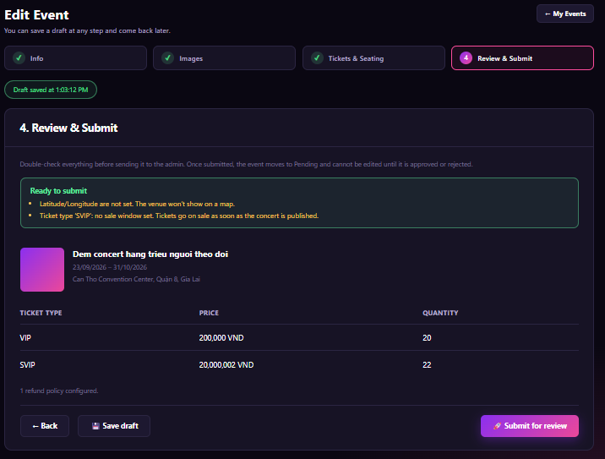
Figure 88 : Submit Concert for Approval Screen

FUNCTION DETAILS:
- VALIDATION RULES:
  - The user must be authenticated. The Access Token must be sent in the Authorization header, and it must be present, valid and not expired. The user must be identified from the claims in the token, so the client must not send a user id.
  - The account referenced by the token must exist, be active and have the Organizer role.
  - The event must exist, must not be deleted and must belong to the Organizer identified from the token.
  - The status of the event must be Draft or Rejected. A Pending, Approved, Ended or Cancelled event cannot be submitted.
  - Blocking checks (all must pass): Event name, Public URL slug, Starts and Ends are filled and valid; Starts is later than the current time; at least one image; at least one ticket type, each with a price (0 or more) and a quantity of at least 1.
  - Non-blocking warnings (shown, but do not stop submission): Latitude/Longitude not set; a ticket type with no sale window; no refund policy configured.
  - The system must check again every blocking condition when "Submit for review" is sent. It must not trust the result shown on the page.
  - One request submits one event only, the event in the URL.

- NORMAL FLOW:
  - Sub-flow A: Open the Review Step
  - Step 1: The Organizer opens the step "Review & Submit".
  - Step 2: The client sends the request with the event id and the Access Token in the Authorization header.
  - Step 3: The system validates the Access Token, identifies the user from its claims, looks up the account, and checks that it is active and has the Organizer role.
  - Step 4: The system looks up the event and checks that it belongs to this Organizer and has the status Draft or Rejected.
  - Step 5: The system checks the blocking conditions and the warnings, and returns the summary of the event, the ticket types, the number of refund policies, the errors and the warnings.
  - Step 6: The client displays the page. If there is no blocking error, it shows "Ready to submit" with the warnings and enables "Submit for review".

  - Sub-flow B: Submit for Review
  - Step 1: The Organizer clicks the "Submit for review" button.
  - Step 2: The client asks for confirmation: "Submit this event for review? You cannot edit it until the Admin approves or rejects it."
  - Step 3: The Organizer confirms. The client disables the buttons and sends the request with the Access Token in the Authorization header.
  - Step 4: The system validates the Access Token, the Organizer role and the event (as in Sub-flow A, Steps 3 and 4).
  - Step 5: The system checks every blocking condition again.
  - Step 6: The system changes the status of the event to Pending.
  - Step 7: The system writes the submit to the audit log and notifies the Admin that a new event is waiting for review.
  - Step 8: The system returns the new status.
  - Step 9: The client displays the message "Your event has been submitted for review." and opens the Concert detail page (3.9.2) with the status PENDING.

- ABNORMAL FLOWS:
  - Abnormal flow 1: Not authenticated or no permission (occurs at Sub-flow A, Step 2 to 4, or Sub-flow B, Step 3 or 4)
  - Step 1: The Access Token is missing, invalid or expired, or the account is not found, not active, or does not have the Organizer role.
  - Step 2: The system changes nothing. It returns 401 Unauthorized (token or account problem) or 403 Forbidden (not an Organizer).
  - Step 3: For 401, the client tries to get a new Access Token with the Refresh Token and repeats the request. If this fails, the client deletes the stored tokens, displays "Your session has expired. Please log in again." and redirects to the Login page. For 403, the client displays "You do not have permission to perform this action." and returns to the previous page.

  - Abnormal flow 2: Event not found or not owned by the Organizer (occurs at Sub-flow A, Step 4, or Sub-flow B, Step 4)
  - Step 1: The event does not exist, has been deleted, or belongs to another Organizer.
  - Step 2: The system returns 404 Not Found and changes nothing.
  - Step 3: The client displays "This event is no longer available." and returns to the "My events" list.

  - Abnormal flow 3: Event cannot be submitted (occurs at Sub-flow A, Step 4, or Sub-flow B, Step 4)
  - Step 1: The status of the event is not Draft or Rejected. For example, the event is already Pending because it was submitted in another tab.
  - Step 2: The system returns 409 Conflict and changes nothing.
  - Step 3: The client displays "This event has already been submitted or can no longer be submitted." and opens the Concert detail page with the current status.

  - Abnormal flow 4: Event is not complete (occurs at Sub-flow A, Step 5, or Sub-flow B, Step 5)
  - Step 1: A blocking condition is not met (for example no image, no ticket type, or Starts is not later than the current time).
  - Step 2: The system does not change the status and returns 400 Bad Request with the list of errors.
  - Step 3: The client shows the box "Not ready to submit" with each error and a link to the step to fix it, and disables "Submit for review".

3.10.5 Create Concert Event
FUNCTION TRIGGER:
- Trigger 1: Organizer clicks the "Create event" button on the "My events" page.
- Trigger 2: Organizer clicks the "Save draft" or "Save & Next →" button on the Info step of the Create New Event page.
FUNCTION DESCRIPTION:
- Actor(s): Organizer
- Secondary actor(s): System
- Purpose:
  - To let the Organizer start a new concert event by entering its basic information, and save it as a draft or continue to the next step of the creation process.
- Main Functionality:
  - The Organizer opens the Create New Event page. The page shows the four steps and the empty form of step 1 "Event Info". The page notes that events are always in the Music category. The form has the fields: Event name, Public URL slug, Short description, Full description, Starts, Ends, Venue name, Address, City, Min tickets / account, Max tickets / account, and an optional section "SEO options". The fields marked with * are required. The Organizer clicks "Save draft" to create the event with the status Draft and stay on the step, or "Save & Next " to create (or update) the event and go to the step "Images". After the first save, the event exists in the system, so the Organizer can leave and continue later from the "My events" list. Saving does not submit the event for approval. Submitting is done in "Review & Submit".

SCREEN LAYOUT:
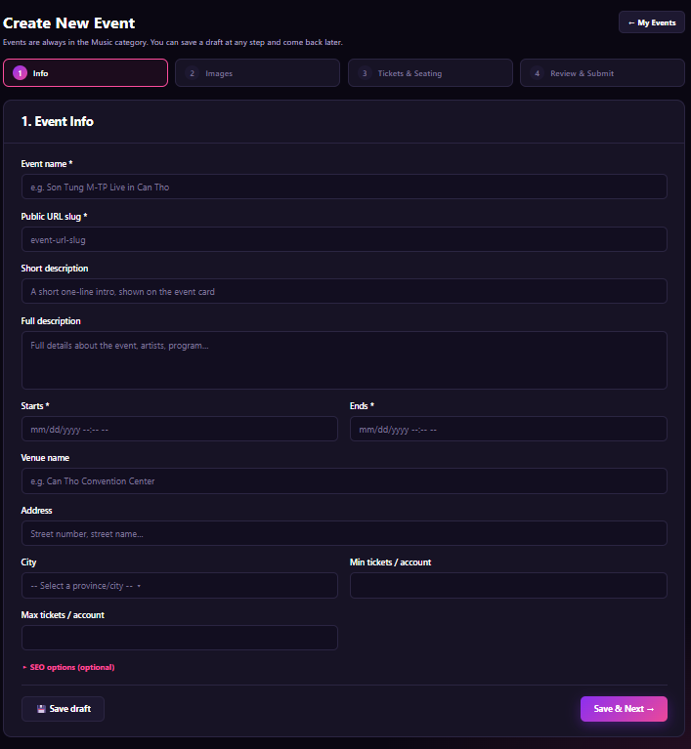
Figure 89 : Create Concert Event Screen

FUNCTION DETAILS:
- VALIDATION RULES:
  - The user must be authenticated. The Access Token must be sent in the Authorization header, and it must be present, valid and not expired. The user must be identified from the claims in the token, so the client must not send a user id. The event is created for the Organizer in the token.
  - The account referenced by the token must exist, be active and have the Organizer role.
  - Event name: required, 3 to 150 characters, not only spaces, leading and trailing spaces removed.
  - Public URL slug: required, 3 to 100 characters, only a-z, 0-9 and hyphens, not starting or ending with a hyphen, no two hyphens in a row, and unique among all events.
  - Short description at most 200 characters, Full description at most 5,000 characters, Venue name at most 150, Address at most 255.
  - Starts and Ends: required for "Save & Next →", valid date-times, Ends after Starts, Starts later than the current time. Entered in the Organizer's local time, stored in UTC.
  - City, if chosen, must be in the list of the system.
  - Min and Max tickets / account: whole numbers, Min at least 1, Max at least Min and not more than the system limit (for example 20). If both are empty, the system uses the defaults (Min 1, Max 10).
  - SEO fields, if entered, must respect their length limits (for example SEO title up to 70 and SEO description up to 160 characters).
  - "Save draft" requires only a valid Event name and Public URL slug. Other fields may be empty, but any value entered must be valid. "Save & Next →" requires every required field to be valid.
  - The category is always Music. The client cannot send or change it.

- NORMAL FLOW:
  - Sub-flow A: Open the Create Page
  - Step 1: The logged-in Organizer clicks "Create event" on the "My events" page.
  - Step 2: The client sends the request with the Access Token. The system validates the token and checks that the account is active and has the Organizer role.
  - Step 3: The system returns the list of cities and the system limits.
  - Step 4: The client displays the Create New Event page, step 1, with an empty form.

  - Sub-flow B: Save Draft
  - Step 1: The Organizer enters at least the Event name and the Public URL slug.
  - Step 2: The Organizer clicks "Save draft".
  - Step 3: The client checks the two required fields, disables the buttons and sends the request with the Access Token.
  - Step 4: The system validates the Access Token and the Organizer role, then validates the fields that are filled in.
  - Step 5: The system checks that the slug is not used by another event.
  - Step 6: The system creates the event with the status Draft (or updates it, if it was already created in this process) and writes the audit log.
  - Step 7: The system returns the event id and the saved data.
  - Step 8: The client displays "Draft saved at {time}" and stays on step 1. The next saves update the same event.

  - Sub-flow C: Save and Go to the Next Step
  - Step 1: The Organizer fills in all required fields.
  - Step 2: The Organizer clicks "Save & Next →".
  - Step 3: The client checks every field, disables the buttons and sends the request with the Access Token.
  - Step 4: The system validates the token, the role and all fields, including the times and the tickets per account.
  - Step 5: The system checks that the slug is not used by another event.
  - Step 6: The system creates (or updates) the event as Draft, marks step 1 as completed and writes the audit log.
  - Step 7: The system returns the event id and the saved data.
  - Step 8: The client opens the step "Images".

- ABNORMAL FLOWS:
  - Abnormal flow 1: Not authenticated or no permission (occurs at Sub-flow A, Step 2, Sub-flow B, Step 3 or 4, or Sub-flow C, Step 3 or 4)
  - Step 1: The Access Token is missing, invalid or expired, or the account is not found, not active, or not an Organizer.
  - Step 2: The system changes nothing and returns 401 Unauthorized (token or account problem) or 403 Forbidden (not an Organizer).
  - Step 3: For 401, the client tries to get a new Access Token with the Refresh Token and repeats the request. If this fails, the client deletes the stored tokens, displays "Your session has expired. Please log in again." and redirects to the Login page. For 403, the client displays "You do not have permission to perform this action." and returns to the previous page.

  - Abnormal flow 2: Invalid or missing data (occurs at Sub-flow B, Step 3 or 4, or Sub-flow C, Step 3 or 4)
  - Step 1: A required field is empty, a text is too short or too long, the slug has invalid characters, Ends is not after Starts, Starts is not in the future, the city is invalid, or the tickets per account are not valid.
  - Step 2: The client does not send the request (or the system returns 400 Bad Request) and saves nothing.
  - Step 3: The client highlights each wrong field and shows a message under it, for example "This field is required.", "Use only lowercase letters, digits and hyphens.", "Ends must be after Starts." or "Max tickets must not be less than Min tickets."

  - Abnormal flow 3: Public URL slug already used (occurs at Sub-flow B, Step 5, or Sub-flow C, Step 5)
  - Step 1: Another event already uses the same slug.
  - Step 2: The system returns 409 Conflict and saves nothing.
  - Step 3: The client highlights the field and displays "This URL is already used. Please choose another."

3.10.6 Delete Draft Concert
FUNCTION TRIGGER:
- Trigger 1: Organizer clicks the "Delete" action on a Draft event in the "My events" list.
- Trigger 2: Organizer clicks the "Delete draft" button in the Delete draft concert dialog.
FUNCTION DESCRIPTION:
- Actor(s): Organizer
- Secondary actor(s): System
- Purpose:
To let the Organizer remove a concert that is still a draft and is no longer needed, together with all of its data, so that the "My events" list stays clean.
- Main Functionality:
The Organizer clicks "Delete" on a Draft event in the "My events" list. The system opens the dialog "Delete draft concert?", which shows the event name (for example "Acoustic Rainy Night") and a warning: "This cannot be undone. The draft, its images, tickets and seating setup will be removed." The Organizer clicks "Delete draft". The system checks that the event is still a Draft and belongs to the Organizer, then deletes the event with its images, ticket types and seating setup. The list is refreshed without the event. The Organizer can click "Cancel" or the close button to close the dialog without any change. Only a Draft can be deleted. An event that was submitted (Pending, Approved, Rejected, Ended or Cancelled) cannot be deleted in this function.

SCREEN LAYOUT:
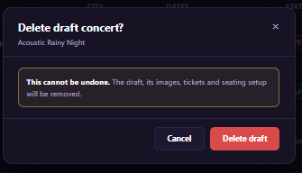
Figure 90 : Delete Draft Concert Screen

FUNCTION DETAILS:
- VALIDATION RULES:
  - The user must be authenticated. The Access Token must be sent in the Authorization header, and it must be present, valid and not expired. The user must be identified from the claims in the token, so the client must not send a user id.
  - The account referenced by the token must exist, be active and have the Organizer role.
  - The event id must be a whole number greater than 0, and the event must exist and must not be already deleted.
  - The event must belong to the Organizer identified from the token.
  - The status of the event must be Draft. Any other status cannot be deleted.
  - The Organizer must confirm in the dialog before the request is sent.
  - One request deletes one event only.

- NORMAL FLOW:
  - Sub-flow A: Open the Dialog
  - Step 1: The logged-in Organizer opens the "My events" list.
  - Step 2: The Organizer clicks "Delete" on a Draft event.
  - Step 3: The client displays the dialog with the event name. No request is sent.
  - Sub-flow B: Confirm Delete
  - Step 1: The Organizer clicks "Delete draft".
  - Step 2: The client disables the buttons and sends the request with the event id and the Access Token in the Authorization header.
  - Step 3: The system validates the Access Token, identifies the user from its claims, looks up the account, and checks that it is active and has the Organizer role.
  - Step 4: The system looks up the event and checks that it belongs to this Organizer and its status is Draft.
  - Step 5: The system deletes the event with its images, ticket types and seating setup, and writes the audit log.
  - Step 6: The system returns the result.
  - Step 7: The client closes the dialog, displays "Draft deleted." and removes the event from the list.
  - Sub-flow C: Cancel
  - Step 1: The Organizer clicks "Cancel".
  - Step 2: The client closes the dialog. Nothing is sent and nothing is changed.

- ABNORMAL FLOWS:
  - Abnormal flow 1: Not authenticated or no permission (occurs at Sub-flow B, Step 2 or 3)
  - Step 1: The Access Token is missing, invalid or expired, or the account is not found, not active, or not an Organizer.
  - Step 2: The system changes nothing and returns 401 Unauthorized (token or account problem) or 403 Forbidden (not an Organizer).
  - Step 3: For 401, the client tries to get a new Access Token with the Refresh Token and repeats the request. If this fails, the client deletes the stored tokens, displays "Your session has expired. Please log in again." and redirects to the Login page. For 403, the client closes the dialog and displays "You do not have permission to perform this action."

  - Abnormal flow 2: Event not found or not owned by the Organizer (occurs at Sub-flow B, Step 4)
  - Step 1: The event does not exist, was already deleted (for example in another tab), or belongs to another Organizer.
  - Step 2: The system returns 404 Not Found and changes nothing.
  - Step 3: The client closes the dialog, displays "This event no longer exists." and refreshes the list.

  - Abnormal flow 3: Event is no longer a draft (occurs at Sub-flow B, Step 4)
  - Step 1: The status of the event is not Draft when the request arrives (for example it was submitted in another tab).
  - Step 2: The system returns 409 Conflict and changes nothing.
  - Step 3: The client closes the dialog, displays "Only draft events can be deleted." and refreshes the list with the current status.

3.10.7 Cancel Concert
FUNCTION TRIGGER:
- Trigger 1: Organizer clicks the "Cancel concert" action on an Approved (published) event in the "My events" list or on the Concert detail page (3.9.2).
- Trigger 2: Organizer clicks the "Cancel concert" button in the Cancel concert dialog.
FUNCTION DESCRIPTION:
Actor(s): Organizer
Secondary actor(s): System (refund process, notification process), Customer (affected user)
- Purpose:
  - To let the Organizer cancel a concert that can no longer take place, so that it is hidden from sale, and Customers who bought tickets are told the reason and refunded in full.
- Main Functionality:
  - The Organizer clicks "Cancel concert" on an event. The system opens the dialog "Cancel concert", which shows the event name and date (for example "Neon Nights Live 2026 · 15/10/2026") and a warning with the number of affected orders and tickets (for example "312 orders (540 tickets) will be affected. Customers are notified and refunded in full. The concert is hidden from sale right away."). The Organizer enters a reason of at least 10 characters (the counter shows "0 / 10 characters minimum"), ticks "I understand this cannot be undone." and clicks "Cancel concert". The button is enabled only when the reason is long enough and the checkbox is ticked. The system changes the status of the event to Cancelled, hides it from sale, ends all virtual queue and seat holds of the event, and starts the full refund and the notification of every affected order. The Organizer can click "Keep concert" or the close button to close the dialog without any change.
\

SCREEN LAYOUT:
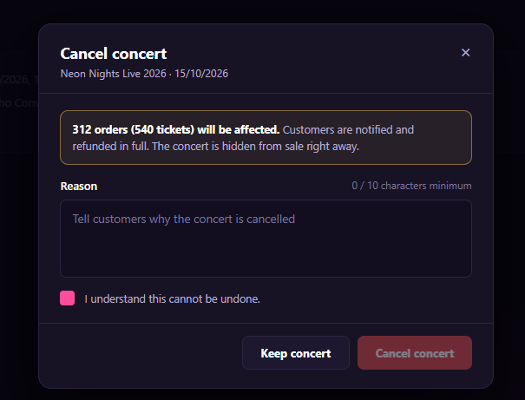
Figure 91 : Cancel Concert Screen

FUNCTION DETAILS:
- VALIDATION RULES:
  - The user must be authenticated. The Access Token must be sent in the Authorization header, and it must be present, valid and not expired. The user must be identified from the claims in the token, so the client must not send a user id.
  - The account referenced by the token must exist, be active and have the Organizer role.
  - The event id must be a whole number greater than 0, and the event must exist, must not be deleted and must belong to the Organizer identified from the token.
  - The status of the event must be Approved (published). A Draft, Pending, Rejected, Ended or already Cancelled event cannot be cancelled in this function.
  - The event must not have ended.
  - The reason is required, 10 to 1,000 characters after leading and trailing spaces are removed, and must not contain only spaces.
  - The confirmation flag must be true in the request.
  - One request cancels one event only.

- NORMAL FLOW:
  - Sub-flow A: Open the Dialog
  - Step 1: The logged-in Organizer clicks "Cancel concert" on an Approved event.
  - Step 2: The client sends the request with the event id and the Access Token.
  - Step 3: The system validates the Access Token and the Organizer role, checks the event (ownership, status Approved, not ended), and counts the paid orders and tickets.
  - Step 4: The system returns the event name, the event date, the number of orders and the number of tickets.
  - Step 5: The client displays the dialog with the warning. The "Cancel concert" button is disabled.

  - Sub-flow B: Confirm Cancel
  - Step 1: The Organizer enters the reason and ticks the checkbox. The client enables the "Cancel concert" button.
  - Step 2: The Organizer clicks "Cancel concert". The client disables the buttons and sends the request with the event id, the reason, the confirmation flag and the Access Token.
  - Step 3: The system validates the Access Token and the Organizer role, and checks the event (as in Sub-flow A, Step 3).
  - Step 4: The system validates the reason and the confirmation flag.
  - Step 5: The system changes the status of the event to Cancelled and hides it from sale.
  - Step 6: The system closes the queue and releases all seat holds of the event.
  - Step 7: The system starts the full refund of every paid order and sends the notification with the reason to each Customer.
  - Step 8: The system writes the audit log and returns the result.
  - Step 9: The client closes the dialog, displays "Concert cancelled. Customers will be notified and refunded." and shows the event with the status CANCELLED.

  - Sub-flow C: Keep Concert
  - Step 1: The Organizer clicks "Keep concert" or "Cancel".
  - Step 2: The client closes the dialog. Nothing is sent and nothing is changed.
- ABNORMAL FLOWS:
  - Abnormal flow 1: Not authenticated or no permission (occurs at Sub-flow A, Step 2 or 3, or Sub-flow B, Step 2 or 3)
  - Step 1: The Access Token is missing, invalid or expired, or the account is not found, not active, or not an Organizer.
  - Step 2: The system changes nothing and returns 401 Unauthorized (token or account problem) or 403 Forbidden (not an Organizer).
  - Step 3: For 401, the client tries to get a new Access Token with the Refresh Token and repeats the request. If this fails, the client deletes the stored tokens, displays "Your session has expired. Please log in again." and redirects to the Login page. For 403, the client closes the dialog and displays "You do not have permission to perform this action."

  - Abnormal flow 2: Event not found or not owned by the Organizer (occurs at Sub-flow A, Step 3, or Sub-flow B, Step 3)
  - Step 1: The event does not exist, has been deleted, or belongs to another Organizer.
  - Step 2: The system returns 404 Not Found and changes nothing.
  - Step 3: The client closes the dialog, displays "This event is no longer available." and returns to the "My events" list.

  - Abnormal flow 3: Event cannot be cancelled (occurs at Sub-flow A, Step 3, or Sub-flow B, Step 3)
  - Step 1: The status is not Approved, the event has ended, or it was already cancelled (for example in another tab).
  - Step 2: The system returns 409 Conflict and changes nothing.
  - Step 3: The client closes the dialog, displays "This concert can no longer be cancelled." and refreshes the page with the current status.

  - Abnormal flow 4: Reason or confirmation invalid (occurs at Sub-flow B, Step 1 or 4)
  - Step 1: The reason is shorter than 10 characters or longer than 1,000, or the checkbox is not ticked.
  - Step 2: The button stays disabled, so the client does not send the request. If a request arrives with invalid data, the system returns 400 Bad Request and changes nothing.
  - Step 3: The client shows "Please enter a reason of at least 10 characters." or "Please confirm that you understand."

3.10.8 Postpone/Reschedule Event
FUNCTION TRIGGER:
- Trigger 1: Organizer clicks the "Postpone / Reschedule" action on an Approved event in the "My events" list or on the Concert detail page (3.9.2).
- Trigger 2: Organizer clicks the "Review change" button on the Postpone / Reschedule page, and then the "Confirm" button on the review step.
FUNCTION DESCRIPTION:
- Actor(s): Organizer
- Secondary actor(s): System (notification process), Customer (affected user)
- Purpose:
  - To let the Organizer change the date of a published concert (reschedule), or postpone it with a date to be announced later, so that existing tickets stay valid and Customers are told about the change and the reason.
- Main Functionality:
  - The Organizer opens the Postpone / Reschedule page of an Approved event. The page shows the event name, the current start time (for example "Neon Nights Live 2026 · currently 15/10/2026, 19:00") and the status badge. The form "New schedule" has the field "Change type" with two options. "Reschedule" asks for a new start and a new end. "Postpone" means the date will be announced later, so the new start and new end are hidden. The Organizer enters a reason, then clicks "Review change". The system shows a review step with the old schedule, the new schedule and the number of affected orders and tickets. After the Organizer confirms, the system saves the new schedule (or marks the event as Postponed), keeps all tickets valid, and notifies every Customer who has a ticket. A notice on the page says "540 tickets in 312 orders stay valid for the new date. Customers can request a refund within the policy window." The Organizer can click "Cancel" to leave without any change.

SCREEN LAYOUT:
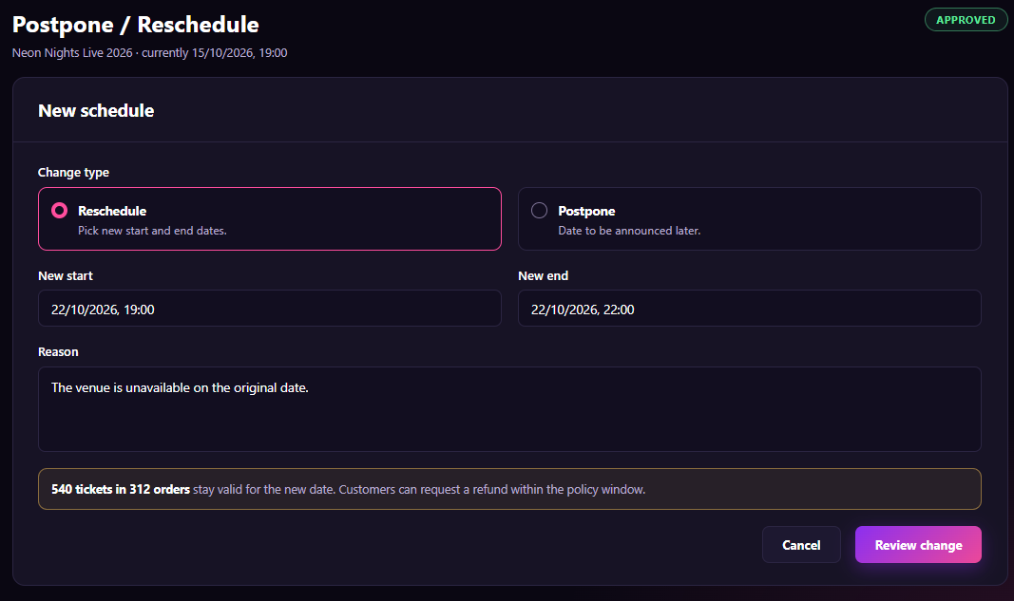
Figure 92 : Postpone/Reschedule Event Screen
FUNCTION DETAILS:
- VALIDATION RULES:
  - The user must be authenticated. The Access Token must be sent in the Authorization header, and it must be present, valid and not expired. The user must be identified from the claims in the token, so the client must not send a user id.
  - The account referenced by the token must exist, be active and have the Organizer role.
  - The event id must be a whole number greater than 0, and the event must exist, must not be deleted and must belong to the Organizer identified from the token.
  - The status of the event must be Approved (published). A Draft, Pending, Rejected, Ended, Cancelled or already Postponed event cannot be changed in this function (a Postponed event gets its new date by Reschedule, see the assumptions).
  - The event must not have ended, and the current start time must be later than the current time.
  - Change type is required and must be Reschedule or Postpone.
  - For Reschedule: New start and New end are required and valid. New end must be after New start. New start must be later than the current time and must be different from the current start time.
  - For Postpone: no new date is sent. The system ignores any date in the request.
  - The reason is required, 10 to 1,000 characters after leading and trailing spaces are removed, and must not contain only spaces.
  - Date-times are entered in the Organizer's local time and stored in UTC.
  - One request changes one event only.

- NORMAL FLOW:
  - Sub-flow A: Open the Page
  - Step 1: The logged-in Organizer clicks "Postpone / Reschedule" on an Approved event.
  - Step 2: The client sends the request with the event id and the Access Token.
  - Step 3: The system validates the Access Token and the Organizer role, checks the event (ownership, status Approved, not ended), and counts the paid orders and tickets.
  - Step 4: The system returns the event name, the current schedule, the status, the number of orders and the number of tickets.
  - Step 5: The client displays the page with "Reschedule" selected and the notice.

  - Sub-flow B: Review the Change
  - Step 1: The Organizer selects the change type, enters the new dates (for Reschedule) and the reason.
  - Step 2: The Organizer clicks "Review change".
  - Step 3: The client checks the fields, disables the buttons and sends the request with the event id, the change type, the dates, the reason and the Access Token.
  - Step 4: The system validates the Access Token, the Organizer role and the event, then validates the change type, the dates and the reason.
  - Step 5: The system returns the old schedule, the new schedule (or "To be announced") and the number of affected orders and tickets. Nothing is saved.
  - Step 6: The client displays the review step with these values, a "Back" button and a "Confirm" button.

  - Sub-flow C: Confirm the Change
  - Step 1: The Organizer clicks "Confirm". The client disables the buttons and sends the confirmation with the Access Token.
  - Step 2: The system validates the Access Token, the Organizer role and the event again, and validates the data again.
  - Step 3: The system saves the new schedule (Reschedule) or changes the status to Postponed (Postpone) and keeps the old schedule in the history.
  - Step 4: The system sends the notification with the reason to every Customer who has a ticket, and writes the audit log.
  - Step 5: The system returns the result.
  - Step 6: The client displays "Event rescheduled. Customers will be notified." or "Event postponed. Customers will be notified." and opens the Concert detail page (3.9.2) with the new data.

- ABNORMAL FLOWS:
  - Abnormal flow 1: Not authenticated or no permission (occurs at Sub-flow A, Step 2 or 3, Sub-flow B, Step 3 or 4, or Sub-flow C, Step 1 or 2)
  - Step 1: The Access Token is missing, invalid or expired, or the account is not found, not active, or not an Organizer.
  - Step 2: The system changes nothing and returns 401 Unauthorized (token or account problem) or 403 Forbidden (not an Organizer).
  - Step 3: For 401, the client tries to get a new Access Token with the Refresh Token and repeats the request. If this fails, the client deletes the stored tokens, displays "Your session has expired. Please log in again." and redirects to the Login page. For 403, the client displays "You do not have permission to perform this action." and returns to the previous page.

  - Abnormal flow 2: Event not found or not owned by the Organizer (occurs at Sub-flow A, Step 3, Sub-flow B, Step 4, or Sub-flow C, Step 2)
  - Step 1: The event does not exist, has been deleted, or belongs to another Organizer.
  - Step 2: The system returns 404 Not Found and changes nothing.
  - Step 3: The client displays "This event is no longer available." and returns to the "My events" list.

  - Abnormal flow 3: Event cannot be changed (occurs at Sub-flow A, Step 3, Sub-flow B, Step 4, or Sub-flow C, Step 2)
  - Step 1: The status is not Approved, the event has ended or already started, or it was cancelled or changed in another tab.
  - Step 2: The system returns 409 Conflict and changes nothing.
  - Step 3: The client displays "The schedule of this event can no longer be changed." and returns to the Concert detail page with the current status.

  - Abnormal flow 4: Invalid data (occurs at Sub-flow B, Step 3 or 4, or Sub-flow C, Step 2)
  - Step 1: The new start or end is empty or not valid, New end is not after New start, New start is not in the future or equals the current start, the reason is shorter than 10 or longer than 1,000 characters, or the change type is missing.
  - Step 2: The client does not send the request (or the system returns 400 Bad Request) and saves nothing.
  - Step 3: The client highlights each wrong field and shows a message, for example "End must be after start.", "The new date must be in the future and different from the current date." or "Please enter a reason of at least 10 characters."

3.10.9 Submit Event Change Request
FUNCTION TRIGGER:
- Trigger 1: Organizer clicks the "Review change" button on the Postpone / Reschedule page (3.10.8).
- Trigger 2: Organizer clicks the "Submit for approval" button on the Submit change request page.
FUNCTION DESCRIPTION:
- Actor(s): Organizer
- Secondary actor(s): System, Admin (reviews the request later)
- Purpose:
  - To let the Organizer check a change to an approved event (for example a new date) and send it to the Admin for approval, so that the change is applied only after it is approved, and the current schedule stays live until then.
- Main Functionality:
  - The page shows the event name, the status badge (APPROVED) and the card "Review your change". A table compares each changed field: FIELD, CURRENT (old value, crossed out) and REQUESTED (new value in green, or "No change"). Below the table the page shows the change type (for example Reschedule), the reason, and the number of affected orders and tickets (for example "312 orders · 540 tickets"). A notice says "The change takes effect only after an admin approves it. Until then the current schedule stays live." The Organizer clicks "Submit for approval". The system creates a change request with the status Pending and a code (for example CR-2041), and shows "After submit: Change request CR-2041 sent. Status: Pending". The event itself stays Approved and keeps its current data. The Organizer can click "Back" to return to the form without sending anything.

SCREEN LAYOUT:
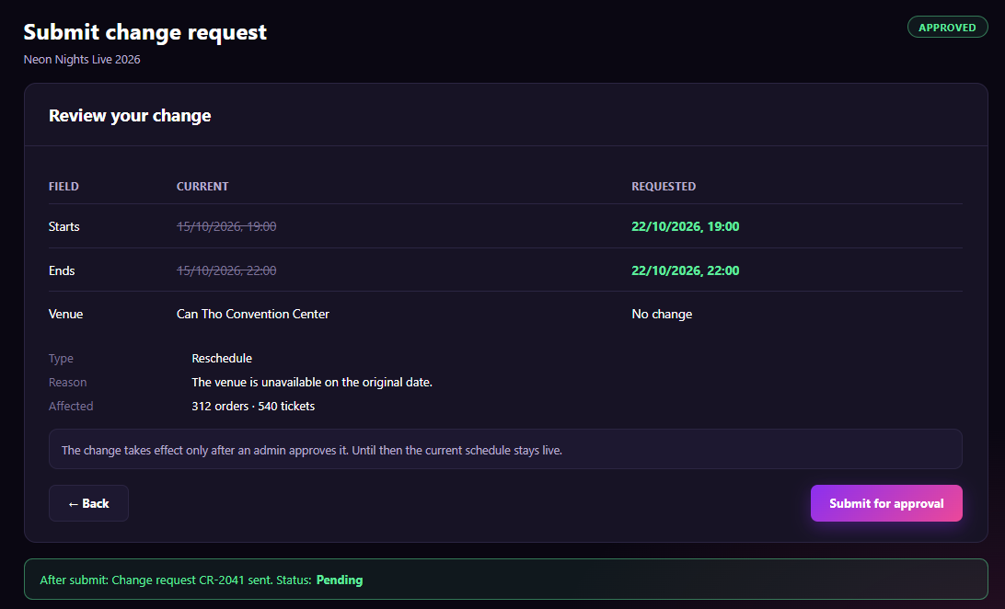
Figure 93 : Submit Event Change Request Screen
FUNCTION DETAILS:
- VALIDATION RULES:
  - The user must be authenticated. The Access Token must be sent in the Authorization header, and it must be present, valid and not expired. The user must be identified from the claims in the token, so the client must not send a user id.
  - The account referenced by the token must exist, be active and have the Organizer role.
  - The event must exist, must not be deleted, must belong to the Organizer in the token, and must have the status Approved.
  - The event must not have ended or started.
  - The change data (type, new dates, reason) must pass the same rules as in 3.10.8. The system checks them again at submit and must not trust the page.
  - The change must differ from the current data of the event. A request with no difference is refused.
  - The event must not already have a change request in the status Pending. One event has at most one Pending request.
  - The number of affected orders and tickets is calculated by the system, never sent by the client.
  - One request creates one change request for one event.

- NORMAL FLOW:
  - Sub-flow A: Open the Review Page
  - Step 1: The Organizer fills in the form of 3.10.8 and clicks "Review change".
  - Step 2: The client sends the change data and the Access Token to the system.
  - Step 3: The system validates the Access Token and the Organizer role, checks the event (ownership, status Approved, not started, no Pending request), and validates the change data.
  - Step 4: The system compares the new data with the current data and returns the changed fields, the type, the reason and the number of affected orders and tickets. Nothing is saved.
  - Step 5: The client displays the page "Submit change request" with the table and the notice.

  - Sub-flow B: Submit for Approval
  - Step 1: The Organizer clicks "Submit for approval".
  - Step 2: The client disables the buttons and sends the request with the Access Token.
  - Step 3: The system validates the token, the role, the event and the data again, and checks that there is no Pending request.
  - Step 4: The system creates the change request with the status Pending and a new code.
  - Step 5: The system writes the audit log and notifies the Admin.
  - Step 6: The system returns the code and the status.
  - Step 7: The client displays "Change request {code} sent. Status: Pending", keeps the event as Approved, and offers a link back to the Concert detail page (3.9.2), which shows that a change request is pending.

- ABNORMAL FLOWS:
  - Abnormal flow 1: Not authenticated or no permission (occurs at Sub-flow A, Step 2 or 3, or Sub-flow B, Step 2 or 3)
  - Step 1: The Access Token is missing, invalid or expired, or the account is not found, not active, or not an Organizer.
  - Step 2: The system changes nothing and returns 401 Unauthorized (token or account problem) or 403 Forbidden (not an Organizer).
  - Step 3: For 401, the client tries to get a new Access Token with the Refresh Token and repeats the request. If this fails, the client deletes the stored tokens, displays "Your session has expired. Please log in again." and redirects to the Login page. For 403, the client displays "You do not have permission to perform this action." and returns to the previous page.
  - Abnormal flow 2: Event not found, not owned, or cannot be changed (occurs at Sub-flow A, Step 3, or Sub-flow B, Step 3)
  - Step 1: The event does not exist, was deleted, or belongs to another Organizer (404 Not Found). Or the status is not Approved, or the event has started, ended or been cancelled (409 Conflict).
  - Step 2: The system changes nothing.
  - Step 3: The client displays "This event is no longer available." (404) or "This event can no longer be changed." (409) and returns to the "My events" list or the Concert detail page.

  - Abnormal flow 3: A change request is already pending (occurs at Sub-flow A, Step 3, or Sub-flow B, Step 3)
  - Step 1: The event already has a change request in the status Pending (for example submitted in another tab).
  - Step 2: The system returns 409 Conflict and creates nothing.
  - Step 3: The client displays "This event already has a change request waiting for approval." with the code of that request.

  - Abnormal flow 4: Invalid data or no difference (occurs at Sub-flow A, Step 3, or Sub-flow B, Step 3)
  - Step 1: The dates or the reason are not valid, or the change is the same as the current data.
  - Step 2: The system returns 400 Bad Request and creates nothing.
  - Step 3: The client returns to the form of 3.10.8 and displays the error, for example "Please change at least one field."

3.10.10 Approve Event Change Request
FUNCTION TRIGGER:
- Trigger 1: Admin clicks the "Review" link on a Pending request (or "View" on a handled request) in the Change requests list.
- Trigger 2: Admin clicks the "Approve change" or "Reject" button on the request detail panel.
FUNCTION DESCRIPTION:
- Actor(s): Admin
- Secondary actor(s):None
- Purpose:
To let the Admin check a change that an Organizer wants to make to an approved event (reschedule, postpone or cancel), and approve it so that it takes effect, or reject it so that the event stays as it is.
- Main Functionality:
The Admin opens the page "Change requests" ("Review requests from organizers."). The list shows REQUEST (for example CR-2041), EVENT, TYPE (Reschedule, Cancel, ...), ORGANIZER, STATUS (PENDING, APPROVED, ...) and SUBMITTED, with a "Review" link for Pending requests and a "View" link for the others. "Refresh" loads the list again. When the Admin opens a request, the detail panel shows the code, the type, the event, the Organizer and the status badge. A table compares FIELD, CURRENT (old value crossed out) and REQUESTED (new value in green, or "No change"), followed by the Reason, the number of affected orders and tickets with the link "View affected orders", and the field "Admin note" ("Required when rejecting"). The Admin clicks "Approve change" to apply the change, or "Reject" with a note to refuse it. After approval, the system applies the change to the event, notifies the affected Customers and the Organizer, and the request becomes Approved. After rejection, the event keeps its current data and the Organizer receives the note. The request panel of a handled request is read-only.
SCREEN LAYOUT:

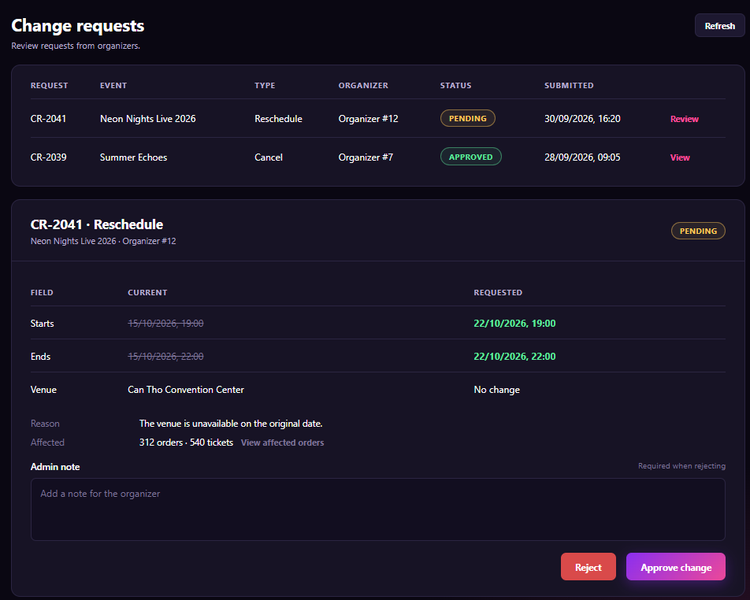
Figure 94 : Approve Event Change Request Screen

FUNCTION DETAILS:
- VALIDATION RULES:
  - The user must be authenticated. The Access Token must be sent in the Authorization header, and it must be present, valid and not expired. The Admin is identified from the claims in the token, so the client must not send an admin id.
  - The account referenced by the token must exist, be active and have the Admin role.
  - The request code must be valid and the request must exist. The client sends only the request id and the decision, never the new values: the system uses the values stored in the request.
  - The request must have the status Pending. A request that is Approved or Rejected cannot be decided again.
  - The decision must be Approve or Reject.
  - Admin note: required when the decision is Reject (10 to 1,000 characters after trimming, not only spaces). Optional when Approve, up to 1,000 characters.
  - When approving, the system checks again that the event still exists, is Approved, has not started or ended, and that the requested data is still valid (for example the new start is still in the future). The event must not have changed since the request was made.
  - The numbers of affected orders and tickets are calculated by the system.
  - One request decides one change request only.

- NORMAL FLOW:
  - Sub-flow A: View the List and Open a Request
  - Step 1: The logged-in Admin opens "Change requests". The client sends the request with the Access Token.
  - Step 2: The system validates the token and the Admin role, and returns the list of requests, newest first.
  - Step 3: The client displays the list. The Admin clicks "Review" on a Pending request (or "View" on a handled one).
  - Step 4: The system returns the detail: type, event, Organizer, current and requested values, reason, affected orders and tickets, status and Admin note.
  - Step 5: The client displays the detail panel.

  - Sub-flow B: Approve
  - Step 1: The Admin checks the change, optionally enters a note and clicks "Approve change".
  - Step 2: The client asks for confirmation: "Approve this change? Customers will be notified." After the Admin confirms, it disables the buttons and sends the request with the request id, the decision Approve, the note and the Access Token.
  - Step 3: The system validates the Access Token and the Admin role, and checks that the request is Pending.
  - Step 4: The system checks the event and the requested data again.
  - Step 5: The system applies the change to the event, keeps the old values in the history and changes the request status to Approved.
  - Step 6: The system sends the notification to every affected Customer and to the Organizer, starts the refunds if the type is Cancel, and writes the audit log.
  - Step 7: The system returns the result.
  - Step 8: The client displays "Change request {code} approved." and updates the status badge and the list.

  - Sub-flow C: Reject
  - Step 1: The Admin enters the note (required) and clicks "Reject".
  - Step 2: The client checks the note, asks for confirmation "Reject this change request?", disables the buttons and sends the request with the request id, the decision Reject, the note and the Access Token.
  - Step 3: The system validates the Access Token and the Admin role, checks that the request is Pending and validates the note.
  - Step 4: The system changes the request status to Rejected, saves the note, notifies the Organizer and writes the audit log.
  - Step 5: The system returns the result.
  - Step 6: The client displays "Change request {code} rejected." and updates the status badge and the list.

- ABNORMAL FLOWS:
  - Abnormal flow 1: Not authenticated or no permission (occurs at Sub-flow A, Step 1 to 4, Sub-flow B, Step 2 or 3, or Sub-flow C, Step 2 or 3)
  - Step 1: The Access Token is missing, invalid or expired, or the account is not found, not active, or not an Admin.
  - Step 2: The system changes nothing and returns 401 Unauthorized (token or account problem) or 403 Forbidden (not an Admin).
  - Step 3: For 401, the client tries to get a new Access Token with the Refresh Token and repeats the request. If this fails, the client deletes the stored tokens, displays "Your session has expired. Please log in again." and redirects to the Login page. For 403, the client displays "You do not have permission to perform this action." and returns to the previous page.

  - Abnormal flow 2: Request not found or already handled (occurs at Sub-flow A, Step 4, Sub-flow B, Step 3, or Sub-flow C, Step 3)
  - Step 1: The request does not exist (404 Not Found), or it is no longer Pending, for example another Admin has already decided it or the Organizer's event changed (409 Conflict).
  - Step 2: The system changes nothing.
  - Step 3: The client displays "This request no longer exists." (404) or "This request has already been handled." (409), and refreshes the list and the panel with the current status.

  - Abnormal flow 3: Event can no longer be changed (occurs at Sub-flow B, Step 4)
  - Step 1: The event has started, ended, been cancelled, or the requested date is no longer in the future.
  - Step 2: The system returns 409 Conflict and applies nothing. The request stays Pending.
  - Step 3: The client displays "This change can no longer be applied. Please reject the request and explain the reason." The Admin can then reject the request with a note.

  - Abnormal flow 4: Admin note missing or invalid (occurs at Sub-flow C, Step 2 or 3)
  - Step 1: The Admin clicks "Reject" with an empty note, or a note shorter than 10 or longer than 1,000 characters.
  - Step 2: The client does not send the request (or the system returns 400 Bad Request) and changes nothing.
  - Step 3: The client highlights the field and displays "Please enter a note of at least 10 characters when rejecting."

3.10.11 View Affected Orders/Tickets by Change

FUNCTION TRIGGER:
- Trigger 1: Admin clicks "View affected orders" on the request detail panel of the Change requests page (3.10.10).
- Trigger 2: Admin clicks "Search", "Reset", a tab ("Orders" / "Tickets"), or "Prev" / "Next" on the Affected orders page.
FUNCTION DESCRIPTION:
- Actor(s): Admin
- Secondary actor(s): System
- Purpose:
  - To let the Admin see which orders and tickets are affected by a change request (reschedule, postpone or cancel), and how much money is involved, so that the Admin can judge the impact before approving or rejecting.

- Main Functionality:
  - The Admin opens the Affected orders page of a change request. The header shows the request code, the type and the event name (for example "CR-2041 · Reschedule · Neon Nights Live 2026") and a "← Back" button. Three summary boxes show the number of affected orders, the number of affected tickets and the total paid amount. Two tabs switch the list between "Orders" and "Tickets". On the Orders tab, the Admin can filter by status, order code and user ID, then click "Search"; "Reset" clears the filters. The list shows ORDER, USER, TICKETS, AMOUNT and STATUS (for example NOTIFIED, REFUND PENDING, REFUNDED), with a "View" link. The list is divided into pages with "Prev" and "Next". This function only reads data and changes nothing.
SCREEN LAYOUT:
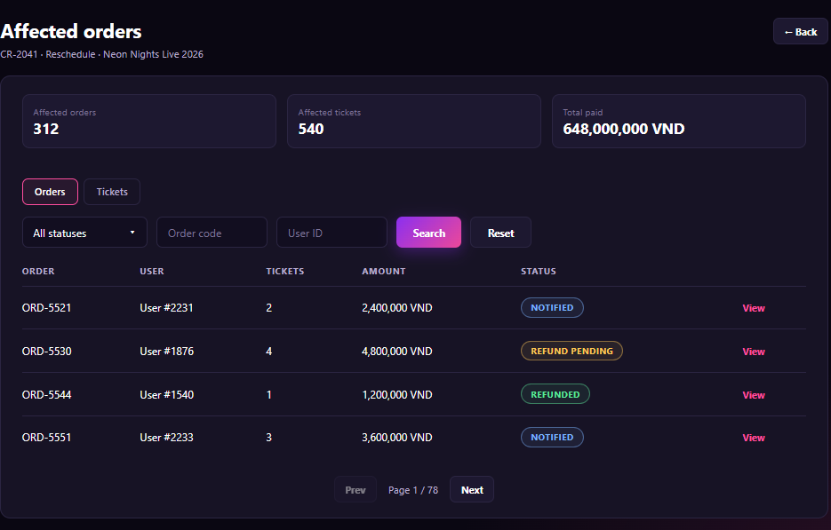
Figure 95 : View Affected Orders/Tickets by Change Screen

FUNCTION DETAILS:
- VALIDATION RULES:
  - The user must be authenticated. The Access Token must be sent in the Authorization header, and it must be present, valid and not expired. The user must be identified from the claims in the token.
  - The account referenced by the token must exist, be active and have the Admin role.
  - The change request id must be valid and the request must exist. The list is always the one of that request.
  - The status filter must be one of the allowed values. The User ID, if entered, must be a whole number greater than 0. The order code, if entered, must have a valid format (for example "ORD-5521" or digits only).
  - The page number must be a whole number of at least 1. The page size is fixed by the system (for example 4 to 10) and has a maximum limit.
  - If the page is greater than the total, the system returns the last page.
  - The list is sorted by order code ascending. Filters are combined with AND.
  - The user is shown only as "User #{id}". No email, phone number or address is shown.

- NORMAL FLOW:
  - Sub-flow A: Open the Page
  - Step 1: The Admin clicks "View affected orders" on the request detail panel.
  - Step 2: The client sends the request with the change request id, default filters, page 1 and the Access Token.
  - Step 3: The system validates the token and the Admin role, and finds the request.
  - Step 4: The system calculates the summary (orders, tickets, total paid) and returns the first page of orders.
  - Step 5: The client displays the page on the "Orders" tab with the summary, the table and the pagination. If there is no order, it shows "No affected orders found."

  - Sub-flow B: Search, Reset and Change Page
  - Step 1: The Admin sets the filters and clicks "Search", or clicks "Reset", "Prev" or "Next".
  - Step 2: The client checks the filters, then sends the request with the filters, the page and the Access Token.
  - Step 3: The system validates the request (as in Sub-flow A, Step 3) and returns the matching page and the paging information. The summary does not change with the filters.
  - Step 4: The client updates the table and "Page {current} / {total}".

  - Sub-flow C: Switch to Tickets
  - Step 1: The Admin clicks the "Tickets" tab.
  - Step 2: The system returns the first page of the affected tickets of the same request.
  - Step 3: The client displays the tickets table with the same paging.

- ABNORMAL FLOWS:
  - Abnormal flow 1: Not authenticated or no permission (occurs at Sub-flow A, Step 2 or 3, Sub-flow B, Step 2 or 3, or Sub-flow C, Step 2)
  - Step 1: The Access Token is missing, invalid or expired, or the account is not found, not active, or not an Admin.
  - Step 2: The system returns no data and returns 401 Unauthorized (token or account problem) or 403 Forbidden (not an Admin).
  - Step 3: For 401, the client tries to get a new Access Token with the Refresh Token and repeats the request. If this fails, the client deletes the stored tokens, displays "Your session has expired. Please log in again." and redirects to the Login page. For 403, the client displays "You do not have permission to view this page." and returns to the previous page.

  - Abnormal flow 2: Change request not found (occurs at Sub-flow A, Step 3)
  - Step 1: The request id does not match any change request.
  - Step 2: The system returns 404 Not Found and returns no data.
  - Step 3: The client displays "This request no longer exists." and returns to the Change requests page.

  - Abnormal flow 3: Invalid filter or paging value (occurs at Sub-flow B, Step 2 or 3)
  - Step 1: The User ID is not a whole number greater than 0, the order code has an invalid format, or the status or page is not allowed.
  - Step 2: The client does not send the request (or the system returns 400 Bad Request) and returns no data.
  - Step 3: The client highlights the field and displays "Please enter a valid value." or "Invalid filter. Please reset the filters and try again."

  - Abnormal flow 4: No result (occurs at Sub-flow A, Step 4, or Sub-flow B, Step 3)
  - Step 1: No order or ticket satisfies the filters.
  - Step 2: The system returns an empty list with 0 pages. The summary is still returned.
  - Step 3: The client displays "No orders found." (or "No tickets found."), shows "Page 1 / 1" and disables "Prev" and "Next".

3.11 Feature 10: Seating Chart Builder & Ticket Class Configuration

3.11.1 Build Seating Chart
FUNCTION TRIGGER:
- Trigger 1: Organizer opens the step "Tickets & Seating" (by clicking "Save & Next" on the step "Images", or by clicking the step on the step bar).
- Trigger 2: Organizer clicks "Save draft" or "Save chart & Next " on the step "Tickets & Seating".
FUNCTION DESCRIPTION:
- Actor(s): Organizer
- Secondary actor(s): System
- Purpose:
  - To let the Organizer decide how tickets are sold for the event: as general admission with ticket types only, or with a seating chart that combines standing zones and numbered seated zones, so that Customers see the same layout when they choose tickets.
- Main Functionality:
  - The Organizer opens the step "Tickets & Seating". The field "Seating chart" has two options. "No chart (general admission)": buyers choose a ticket type only. "Has seating chart": the page shows the chart builder. In the builder, the Organizer enters the Chart name (for example "Main hall layout") and uses the buttons "+ Standing zone", "+ Seated zone", "Apply template" and "Save as template". The canvas shows the stage and the zones (for example POP · Standing · 20, VIP · Standing · 22, Block A · Seated · 24). The Organizer drags the zones to arrange the layout. The right panel lists the ticket types with their prices (POP 200,000 VND, VIP 20,000,002 VND, Standard 1,200,000 VND). The table below the canvas lists each zone with its ZONE, TYPE (STANDING or SEATED), TICKET TYPE and CAPACITY, with an "Edit" link. A notice says "Every zone must be linked to a ticket type. Total zone capacity cannot exceed the ticket quantity." The Organizer clicks "Save draft" to keep the data and stay, or "Save chart & Next →" to save and go to "Review & Submit". Saving does not submit the event.

SCREEN LAYOUT:
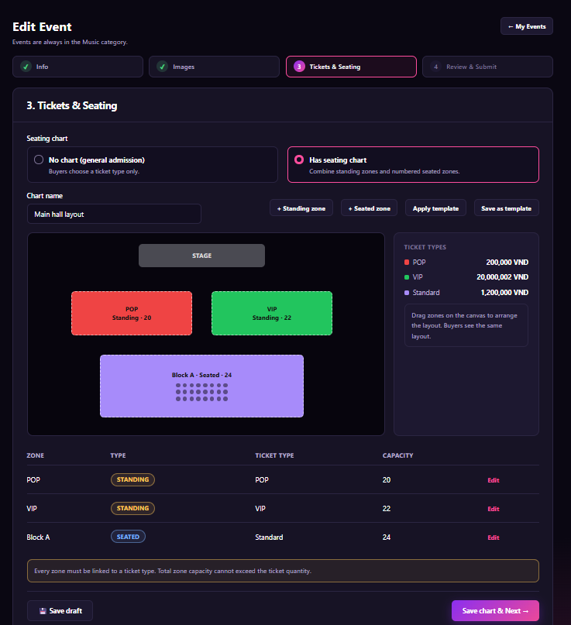
Figure 96 : Build Seating Chart Screen

FUNCTION DETAILS:
- VALIDATION RULES:
  - The user must be authenticated. The Access Token must be sent in the Authorization header, and it must be present, valid and not expired. The user must be identified from the claims in the token, so the client must not send a user id.
  - The account referenced by the token must exist, be active and have the Organizer role.
  - The event must exist, must not be deleted, must belong to the Organizer in the token, and must have the status Draft or Rejected.
  - The seating mode is required and must be "No chart" or "Has seating chart".
  - For "Has seating chart": Chart name is required (3 to 100 characters, not only spaces); at least one zone is required; the number of zones must not exceed the system limit (for example 50).
  - Each zone: a name (required, 1 to 50 characters, unique in the chart); a type (Standing or Seated); a ticket type (required, must be a ticket type of this event); a position on the canvas inside the drawing area; zones must not overlap.
  - Standing zone: capacity is a whole number of at least 1.
  - Seated zone: rows and seats per row are whole numbers of at least 1 (within the system limit), and capacity is rows × seats per row. Seat labels must be unique in the zone.
  - Every zone must be linked to a ticket type. A ticket type may be linked to more than one zone.
  - For each ticket type, the total capacity of its zones must not exceed the quantity of that ticket type. The total capacity of all zones must not exceed the total ticket quantity of the event.
  - "Save draft" accepts an incomplete chart (for example zones not yet linked), but any value entered must pass its own rule. "Save chart & Next →" requires the full chart to be valid.
  - A template name (for "Save as template") is required, 3 to 100 characters, unique among the Organizer's templates.
  - If nothing has changed, the system must not save or write to the audit log.
  - One request changes one event only.

- NORMAL FLOW:
  - Sub-flow A: Open the Step
  - Step 1: The Organizer opens the step "Tickets & Seating".
  - Step 2: The client sends the request with the event id and the Access Token.
  - Step 3: The system validates the Access Token and the Organizer role, and checks the event (ownership, status Draft or Rejected).
  - Step 4: The system returns the seating mode, the chart (name, zones, positions), the ticket types with price and quantity, the templates of the Organizer and the system limits.
  - Step 5: The client displays the step. If there is no chart yet, "No chart (general admission)" is selected.

  - Sub-flow B: Build the Chart
  - Step 1: The Organizer selects "Has seating chart".
  - Step 2: The client shows the builder with an empty canvas (the stage only) and the Chart name.
  - Step 3: The Organizer enters the Chart name and clicks "+ Standing zone" or "+ Seated zone".
  - Step 4: The client shows a form for the zone (name, ticket type, capacity for Standing; name, ticket type, rows and seats per row for Seated). The Organizer fills it in and confirms.
  - Step 5: The client draws the zone on the canvas, coloured by its ticket type, and adds it to the zone table. No request is sent.
  - Step 6: The Organizer drags the zones to arrange the layout, and clicks "Edit" on a row to change or remove a zone. The client keeps the changes on the page until they are saved.

  - Sub-flow C: Apply or Save a Template
  - Step 1: The Organizer clicks "Apply template" and selects a template. If the canvas already has zones, the client asks "Replace the current zones?".
  - Step 2: After confirmation, the client loads the zones of the template onto the canvas.
  - Step 3: To save, the Organizer clicks "Save as template" and enters a name. The system validates the name and the Organizer role, saves the template and returns "Template saved."

  - Sub-flow D: Save Draft
  - Step 1: The Organizer clicks "Save draft".
  - Step 2: The client disables the buttons and sends the request with the seating mode, the chart and the Access Token.
  - Step 3: The system validates the Access Token, the Organizer role and the event, then validates the filled-in values.
  - Step 4: The system saves the seating mode and the chart, and writes the audit log.
  - Step 5: The system returns the saved data.
  - Step 6: The client displays "Draft saved at {time}" and stays on the step.

- ABNORMAL FLOWS:

  - Abnormal flow 1: Not authenticated or no permission (occurs at Sub-flow A, Step 2 or 3, Sub-flow C, Step 3, Sub-flow D, Step 2 or 3, or Sub-flow E, Step 2 or 3)
  - Step 1: The Access Token is missing, invalid or expired, or the account is not found, not active, or not an Organizer.
  - Step 2: The system changes nothing and returns 401 Unauthorized (token or account problem) or 403 Forbidden (not an Organizer).
  - Step 3: For 401, the client tries to get a new Access Token with the Refresh Token and repeats the request. If this fails, the client deletes the stored tokens, displays "Your session has expired. Please log in again." and redirects to the Login page. For 403, the client displays "You do not have permission to perform this action." and returns to the previous page.

  - Abnormal flow 2: Event not found or cannot be edited (occurs at Sub-flow A, Step 3, Sub-flow D, Step 3, or Sub-flow E, Step 3)
  - Step 1: The event does not exist, was deleted, or belongs to another Organizer (404 Not Found). Or the status is not Draft or Rejected, for example it was submitted in another tab (409 Conflict).
  - Step 2: The system changes nothing.
  - Step 3: The client displays "This event is no longer available." (404) and returns to the "My events" list, or "The status of this event has changed, so it cannot be edited now." (409) and returns to the Concert detail page (3.9.2).

  - Abnormal flow 3: Invalid zone or chart data (occurs at Sub-flow B, Step 4, Sub-flow D, Step 2 or 3, or Sub-flow E, Step 2 or 3)
  - Step 1: The Chart name or a zone name is missing or invalid, a zone is not linked to a ticket type, a capacity or the rows and seats are not valid, a zone name is duplicated, zones overlap or lie outside the canvas, or there is no zone.
  - Step 2: The client does not send the request (or the system returns 400 Bad Request) and saves nothing.
  - Step 3: The client highlights each wrong zone or field and shows a message, for example "Every zone must be linked to a ticket type.", "Zone names must be different." or "Add at least one zone."

  - Abnormal flow 4: Capacity exceeds ticket quantity (occurs at Sub-flow E, Step 2 or 3)
  - Step 1: The total capacity of the zones of a ticket type, or of the whole chart, is more than the ticket quantity.
  - Step 2: The client does not send the request (or the system returns 400 Bad Request) and saves nothing.
  - Step 3: The client highlights the zones and the ticket type, and displays "Total zone capacity cannot exceed the ticket quantity. {Ticket type}: {capacity} of {quantity}."

3.11.2 Edit Seating Zone
FUNCTION TRIGGER:
- Trigger 1: Organizer clicks the "Edit" link of a zone in the zone table, or clicks a zone on the canvas, on the step "Tickets & Seating".
- Trigger 2: Organizer clicks the "Save zone" or "Delete zone" button in the Edit zone dialog.
FUNCTION DESCRIPTION:
- Actor(s): Organizer
- Secondary actor(s): None
- Purpose:
  - To let the Organizer change one zone of the seating chart (name, type, ticket type and size) or remove it, so that the layout and the capacity match the tickets the Organizer wants to sell.
- Main Functionality:
  - The Organizer opens the dialog "Edit zone", which shows the zone and the chart (for example "Block A · Main hall layout"). The form has: Zone name; Zone type with two options, "Seated" ("Buyers pick their own seat.") and "Standing" ("Headcount only, no seat rows."); Ticket type, chosen from the ticket types of the event with the price (for example "Standard · 1,200,000 VND"); and, for a Seated zone, Rows and Seats per row. For a Standing zone, the two fields Rows and Seats per row are replaced by one field Capacity. A box shows the capacity (for example "Capacity: 24 seats. For seated zones it always equals the number of seats."). A warning says "Changing the type or the rows removes the existing seats of this zone." The Organizer clicks "Save zone" to apply the change to the chart, "Cancel" to close the dialog without change, or "Delete zone" to remove the zone. The change is kept in the builder and is saved with the event when the Organizer clicks "Save draft" or "Save chart & Next " (3.9.7).

SCREEN LAYOUT:
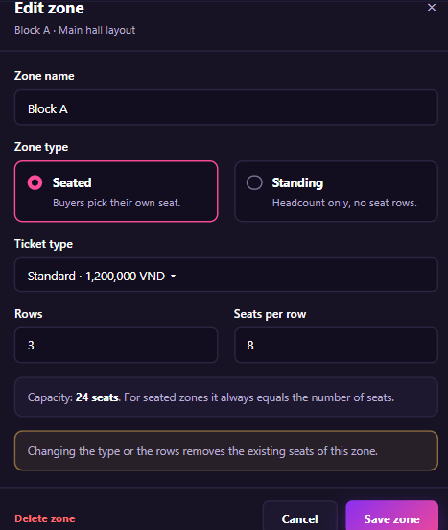
Figure 97 : Edit Seating Zone Screen
FUNCTION DETAILS:
- VALIDATION RULES:
  - The user must be authenticated. The Access Token must be sent in the Authorization header, and it must be present, valid and not expired. The user must be identified from the claims in the token, so the client must not send a user id.
  - The account referenced by the token must exist, be active and have the Organizer role.
  - The event must exist, must not be deleted, must belong to the Organizer in the token, and must have the status Draft or Rejected.
  - The zone must exist in the chart of the event.
  - Zone name is required, 1 to 50 characters after trimming, not only spaces, and different from the name of every other zone in the chart.
  - Zone type is required and must be Seated or Standing.
  - Ticket type is required and must be a ticket type of this event.
  - Seated: Rows and Seats per row are whole numbers of at least 1 and within the system limit (for example 50 rows and 100 seats per row). The capacity is rows × seats per row, and the client cannot send it.
  - Standing: Capacity is a whole number of at least 1 and within the system limit.
  - After the change, the total capacity of the zones of the ticket type must not exceed the quantity of that ticket type, and the total capacity of all zones must not exceed the total ticket quantity of the event.
  - A zone cannot be deleted or have its type or size changed if its seats are already sold or held. Draft and Rejected events have no sold seats, so this rule protects data in case of an inconsistent state.
  - One request changes one zone only.

- NORMAL FLOW:
  - Sub-flow A: Open the Dialog
  - Step 1: The Organizer clicks "Edit" on a zone.
  - Step 2: The client displays the dialog with the current values of the zone (name, type, ticket type, rows and seats per row or capacity). No request is sent.
  - Step 3: The Organizer changes the fields. When the type, the rows or the seats per row change, the client shows the warning and recalculates the capacity.
  - Sub-flow B: Save Zone
  - Step 1: The Organizer clicks "Save zone".
  - Step 2: The client checks the fields and the capacity totals.
  - Step 3: The client updates the zone in the builder (canvas and zone table) and closes the dialog. If the seats were regenerated, the zone shows the new seats.
  - Step 4: The change is sent to the system when the Organizer clicks "Save draft" or "Save chart & Next →". The system then validates the token, the role, the event and the zone (as in 3.9.7, Sub-flow D and E), saves the zone and writes the audit log.

- ABNORMAL FLOWS:
  - Abnormal flow 1: Not authenticated or no permission (occurs at Sub-flow B, Step 4)
  - Step 1: The Access Token is missing, invalid or expired, or the account is not found, not active, or not an Organizer.
  - Step 2: The system changes nothing and returns 401 Unauthorized (token or account problem) or 403 Forbidden (not an Organizer).
  - Step 3: For 401, the client tries to get a new Access Token with the Refresh Token and repeats the request. If this fails, the client deletes the stored tokens, displays "Your session has expired. Please log in again." and redirects to the Login page. For 403, the client displays "You do not have permission to perform this action." and returns to the previous page.

  - Abnormal flow 2: Invalid zone data (occurs at Sub-flow B, Step 2 or 4)
  - Step 1: The zone name is empty, too long or already used, the ticket type is missing, or Rows, Seats per row or Capacity is empty, not a whole number, less than 1 or over the limit.
  - Step 2: The client disables "Save zone" and does not change the zone (or the system returns 400 Bad Request and saves nothing).
  - Step 3: The client highlights each wrong field and shows a message, for example "Zone name is required.", "This zone name is already used." or "Enter a whole number of at least 1."

  - Abnormal flow 3: Capacity exceeds the quantity, or the zone does not fit (occurs at Sub-flow B, Step 2 or 4)
  - Step 1: The total capacity of the zones of the ticket type, or of the whole chart, is more than the ticket quantity, or the new size makes the zone overlap another zone or go outside the canvas.
  - Step 2: The client does not apply the change (or the system returns 400 Bad Request and saves nothing).
  - Step 3: The client displays "Total zone capacity cannot exceed the ticket quantity. {Ticket type}: {capacity} of {quantity}." or "This zone does not fit here. Move it or make it smaller."

3.11.3 Apply Seating Template
FUNCTION TRIGGER:
- Trigger 1: Organizer clicks the "Apply template" button on the step "Tickets & Seating" (3.9.7).
- Trigger 2: Organizer clicks the "Apply template" button in the Apply seating template dialog.
FUNCTION DESCRIPTION:
- Actor(s): Organizer
- Secondary actor(s): System
- Purpose:
  - To let the Organizer start a seating chart from a saved layout instead of drawing every zone again, so that building the chart is faster.
- Main Functionality:
  - The Organizer clicks "Apply template". The system opens the dialog "Apply seating template" ("Pick a saved layout to start from."). The dialog has two tabs. "My templates" lists the layouts the Organizer saved with "Save as template" (3.9.7). "Starter templates" lists layouts provided by the system. Each template is a card with a small preview of the layout, the name (for example "Main hall layout"), and a summary such as "Reserved seating · 3 zones · 66 capacity", "Standing zones · 1 zone · 2,000 capacity" or "Reserved seating · 3 zones · 240 capacity". The Organizer selects one card (highlighted). A warning says "This replaces the current chart. After applying, link each zone to a ticket type before you continue." The Organizer clicks "Apply template" to load the zones onto the canvas, or "Cancel" or "×" to close the dialog without change. Applying only changes the chart in the builder. It is saved with the event when the Organizer clicks "Save draft" or "Save chart & Next "
SCREEN LAYOUT:
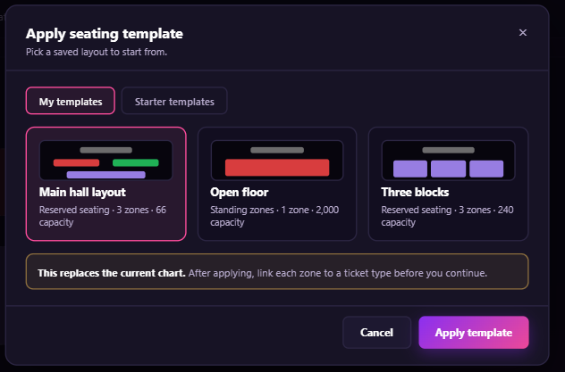
Figure 98 : Apply Seating Template Screen

FUNCTION DETAILS:
- VALIDATION RULES:
  - The user must be authenticated. The Access Token must be sent in the Authorization header, and it must be present, valid and not expired. The user must be identified from the claims in the token, so the client must not send a user id.
  - The account referenced by the token must exist, be active and have the Organizer role.
  - The event must exist, must not be deleted, must belong to the Organizer in the token, and must have the status Draft or Rejected.
  - The template id must be valid and the template must exist. A template is allowed only if it is a starter template, or it belongs to the Organizer in the token. An Organizer can never apply the template of another Organizer.
  - Exactly one template must be selected.
  - The total capacity of the template does not have to fit the ticket quantity at this step, because the zones are not linked yet. The capacity rules are checked when the step is saved (3.9.7).
  - One request applies one template to one event.

- NORMAL FLOW:
  - Sub-flow A: Open the Dialog
  - Step 1: The Organizer clicks "Apply template".
  - Step 2: The client sends the request with the Access Token.
  - Step 3: The system validates the Access Token and the Organizer role, checks the event, and finds the templates.
  - Step 4: The system returns the templates of the Organizer ("My templates") and the starter templates, each with the preview, name, number of zones, type and capacity.
  - Step 5: The client displays the dialog on the tab "My templates" with no card selected and "Apply template" disabled. If the Organizer has no template, the tab shows "You have no saved templates yet. Try a starter template." and the Organizer can switch to "Starter templates".

  - Sub-flow B: Select and Apply
  - Step 1: The Organizer clicks a template card. The client highlights it and enables "Apply template".
  - Step 2: The Organizer clicks "Apply template".
  - Step 3: If the canvas already has zones, the client asks "Replace the current chart with this template?". The Organizer confirms.
  - Step 4: The client disables the buttons and sends the request with the template id and the Access Token.
  - Step 5: The system validates the Access Token, the Organizer role, the event and the template, then returns the zones of the template (name, type, size, position, seats).
  - Step 6: The client replaces the zones on the canvas and in the zone table, marks every zone "not linked", closes the dialog and displays "Template applied. Link each zone to a ticket type."
  - Step 7: The new chart is saved when the Organizer saves.

- ABNORMAL FLOWS:
  - Abnormal flow 1: Not authenticated or no permission (occurs at Sub-flow A, Step 2 or 3, or Sub-flow B, Step 4 or 5)
  - Step 1: The Access Token is missing, invalid or expired, or the account is not found, not active, or not an Organizer.
  - Step 2: The system changes nothing and returns 401 Unauthorized (token or account problem) or 403 Forbidden (not an Organizer).
  - Step 3: For 401, the client tries to get a new Access Token with the Refresh Token and repeats the request. If this fails, the client deletes the stored tokens, displays "Your session has expired. Please log in again." and redirects to the Login page. For 403, the client displays "You do not have permission to perform this action." and returns to the previous page.

  - Abnormal flow 2: Event cannot be edited (occurs at Sub-flow A, Step 3, or Sub-flow B, Step 5)
  - Step 1: The event does not exist, was deleted, or belongs to another Organizer (404 Not Found); or its status is no longer Draft or Rejected (409 Conflict).
  - Step 2: The system changes nothing.
  - Step 3: The client closes the dialog and displays "This event is no longer available." (404) and returns to the "My events" list, or "The status of this event has changed, so it cannot be edited now." (409) and returns to the Concert detail page (3.9.2).

  - Abnormal flow 3: Template not found or not allowed (occurs at Sub-flow B, Step 5)
  - Step 1: The template was deleted after the dialog was opened (404 Not Found), or it belongs to another Organizer (the system also returns 404 and does not say it exists).
  - Step 2: The system changes nothing.
  - Step 3: The client displays "This template is no longer available.", reloads the list and keeps the dialog open.

  - Abnormal flow 4: No template selected (occurs at Sub-flow B, Step 2)
  - Step 1: The Organizer has not selected a template.
  - Step 2: The button "Apply template" stays disabled, so the client does not send the request. If a request arrives without a valid template id, the system returns 400 Bad Request and changes nothing.
  - Step 3: The client displays "Please select a template."

3.11.4 Save Seating Chart as Template
FUNCTION TRIGGER:
- Trigger 1: Organizer clicks the "Save as template" button on the step "Tickets & Seating" (3.9.7).
- Trigger 2: Organizer clicks the "Save template" button in the Save as template dialog.
FUNCTION DESCRIPTION:
- Actor(s): Organizer
- Secondary actor(s): None
- Purpose:
  - To let the Organizer keep the current seating layout as a template, so that the Organizer can reuse it for future events instead of drawing it again.
- Main Functionality:
  - The Organizer clicks "Save as template". The system opens the dialog "Save as template" ("Reuse this layout for future events."). The dialog has the field "Template name" (required, filled with the chart name, for example "Main hall layout"), the field "Description" (optional, placeholder "Optional, e.g. 2 standing zones and one seated block"), and the line "Seating mode" showing "Reserved seating" (read-only, taken from the chart). A note says "Saved: zone shapes, rows and seats per row, capacity, stage position. Not saved: ticket types, prices and sales." Another note says "Only you can see this template." The Organizer clicks "Save template" and the system saves the layout as a template of the Organizer. The template then appears in the tab "My templates" of 3.11.3. The Organizer can click "Cancel" to close the dialog without change. Saving a template does not change the chart or the event.

SCREEN LAYOUT:
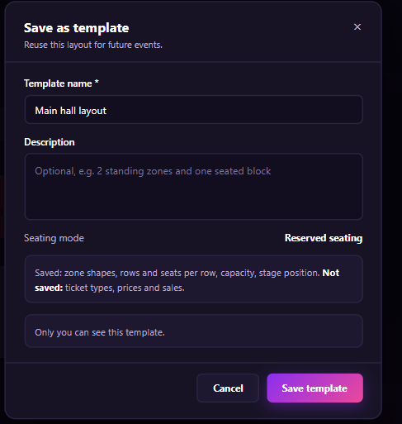
Figure 99 : Save Seating Chart as Template Screen
FUNCTION DETAILS:
- VALIDATION RULES:
  - The user must be authenticated. The Access Token must be sent in the Authorization header, and it must be present, valid and not expired. The user must be identified from the claims in the token, so the client must not send a user id. The template is created for the Organizer in the token.
  - The account referenced by the token must exist, be active and have the Organizer role.
  - The event must exist, must not be deleted and must belong to the Organizer in the token. The event status may be any status in which the Organizer can open the chart (Draft or Rejected).
  - The chart must have at least one zone. A chart with no zone cannot be saved as a template.
  - Template name is required, 3 to 100 characters after trimming, not only spaces, and unique among the templates of this Organizer (not case sensitive).
  - Description, if entered, is at most 500 characters.
  - The seating mode is decided by the system from the chart. The client cannot send it.
  - The number of templates of one Organizer must not exceed the system limit (for example 50).
  - The system saves only the layout (zones, types, rows, seats per row, capacity, positions, stage position). It must not save ticket types, prices, sales, or the links between zones and ticket types.
  - One request saves one template.

- NORMAL FLOW:
  - Sub-flow A: Open the Dialog
  - Step 1: The Organizer builds or edits the chart and clicks "Save as template".
  - Step 2: The client checks that the canvas has at least one zone.
  - Step 3: The client displays the dialog with the chart name as the template name, an empty description and the seating mode of the chart. No request is sent.

  - Sub-flow B: Save Template
  - Step 1: The Organizer changes the name and, if wanted, enters a description.
  - Step 2: The Organizer clicks "Save template".
  - Step 3: The client checks the name, disables the buttons and sends the request with the name, the description, the layout of the chart and the Access Token in the Authorization header.
  - Step 4: The system validates the Access Token, identifies the user from its claims, looks up the account and checks that it is active and has the Organizer role.
  - Step 5: The system checks the event (ownership and status) and validates the layout, the name, the description and the number of templates.
  - Step 6: The system checks that the name is not used by another template of this Organizer.
  - Step 7: The system saves the template (layout only), and writes the audit log.
  - Step 8: The system returns the template id and the saved data.
  - Step 9: The client closes the dialog and displays "Template saved." The chart on the page does not change.

- ABNORMAL FLOWS:
  - Abnormal flow 1: Not authenticated or no permission (occurs at Sub-flow B, Step 3 or 4)
  - Step 1: The Access Token is missing, invalid or expired, or the account is not found, not active, or not an Organizer.
  - Step 2: The system changes nothing and returns 401 Unauthorized (token or account problem) or 403 Forbidden (not an Organizer).
  - Step 3: For 401, the client tries to get a new Access Token with the Refresh Token and repeats the request. If this fails, the client deletes the stored tokens, displays "Your session has expired. Please log in again." and redirects to the Login page. For 403, the client displays "You do not have permission to perform this action." and returns to the previous page.

  - Abnormal flow 2: Event not found or cannot be edited (occurs at Sub-flow B, Step 5)
  - Step 1: The event does not exist, was deleted or belongs to another Organizer (404 Not Found), or its status is no longer Draft or Rejected (409 Conflict).
  - Step 2: The system changes nothing.
  - Step 3: The client closes the dialog and displays "This event is no longer available." (404) and returns to the "My events" list, or "The status of this event has changed, so it cannot be edited now." (409) and returns to the Concert detail page (3.9.2).

  - Abnormal flow 3: Invalid data (occurs at Sub-flow A, Step 2, or Sub-flow B, Step 3 or 5)
  - Step 1: The chart has no zone, the template name is empty, too short, too long or only spaces, or the description is longer than 500 characters.
  - Step 2: The client does not open the dialog or does not send the request (or the system returns 400 Bad Request) and saves nothing.
  - Step 3: The client displays "Add at least one zone before saving a template.", "Template name must be between 3 and 100 characters." or "Description must be at most 500 characters."

  - Abnormal flow 4: Name already used or limit reached (occurs at Sub-flow B, Step 5 or 6)
  - Step 1: The Organizer already has a template with the same name, or the Organizer has reached the maximum number of templates.
  - Step 2: The system returns 409 Conflict and saves nothing.
  - Step 3: The client keeps the dialog open and displays "You already have a template with this name. Please choose another." or "You have reached the maximum number of templates. Delete one to continue."

3.11.5 Preview Seating Chart
FUNCTION TRIGGER:
- Trigger 1: Organizer clicks the "Preview" button on the step "Tickets & Seating" (3.9.7), or on the Concert detail page (3.9.2).
- Trigger 2: Organizer clicks the "Back to editor" button on the Preview seating chart page.
FUNCTION DESCRIPTION:
- Actor(s): Organizer
- Secondary actor(s): None
- Purpose:
  - To let the Organizer see the seating chart exactly as Customers will see it, with zones, prices and capacity, so that the Organizer can check the layout before submitting the event.
- Main Functionality:
  - The Organizer opens the page "Preview seating chart". The header shows the event name and the note "This is how buyers will see it." The canvas shows the stage and the zones in the same positions and colours as in the builder. Each zone shows its name and the price of its ticket type (for example "POP 200,000 VND"), and a seated zone shows its seats as dots. The right panel "Zones" lists each zone with its type and capacity (POP · Standing 20, VIP · Standing 22, Block A · Seated 24) and the total capacity (66), with the note "Preview only. Nothing can be selected or bought here." A legend below the canvas explains the seat states: Available, Sold, Held. The Organizer clicks " Back to editor" to return to the step. This function only reads data and changes nothing.

SCREEN LAYOUT:
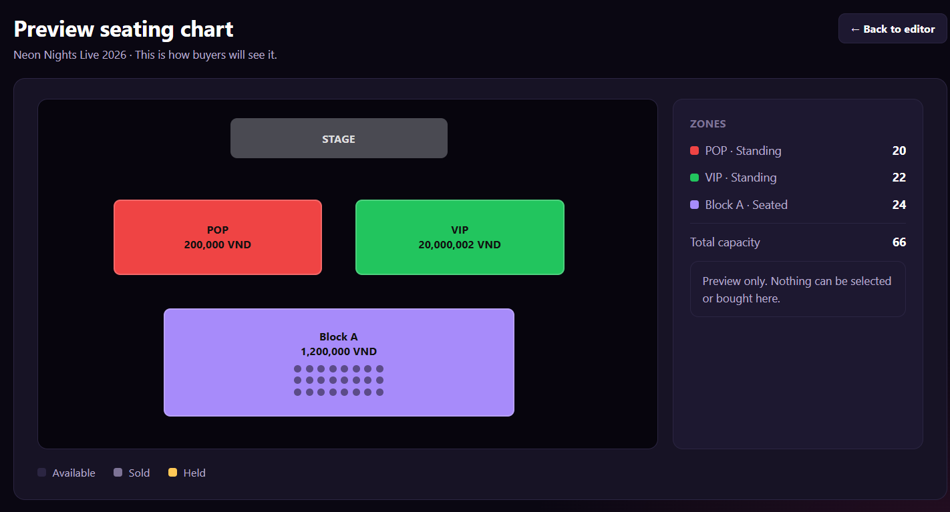
Figure 100 : Preview Seating Chart Screen
FUNCTION DETAILS:
- VALIDATION RULES:
  - The user must be authenticated. The Access Token must be sent in the Authorization header, and it must be present, valid and not expired. The user must be identified from the claims in the token, so the client must not send a user id.
  - The account referenced by the token must exist, be active and have the Organizer role.
  - The event id must be a whole number greater than 0, and the event must exist, must not be deleted and must belong to the Organizer in the token.
  - The event must have a seating chart ("Has seating chart") with at least one zone.
  - The preview always shows the saved chart. Changes made on the page but not saved are not shown.
  - Price is shown with a thousands separator and the currency. Total capacity is the sum of the zone capacities.
  - One request returns one chart only.

- NORMAL FLOW:
  - Sub-flow A: Open the Preview
  - Step 1: The Organizer clicks "Preview".
  - Step 2: The client sends the request with the event id and the Access Token.
  - Step 3: The system validates the Access Token and the Organizer role, and checks the event (ownership, has a chart).
  - Step 4: The system returns the event name, the zones (name, type, position, size, seats, capacity, colour), the ticket type price of each zone, the stage position and the total capacity.
  - Step 5: The client displays the canvas, the Zones panel, the total capacity and the legend.

- ABNORMAL FLOWS:
  - Abnormal flow 1: Not authenticated or no permission (occurs at Sub-flow A, Step 2 or 3)
  - Step 1: The Access Token is missing, invalid or expired, or the account is not found, not active, or not an Organizer.
  - Step 2: The system returns no data and returns 401 Unauthorized (token or account problem) or 403 Forbidden (not an Organizer).
  - Step 3: For 401, the client tries to get a new Access Token with the Refresh Token and repeats the request. If this fails, the client deletes the stored tokens, displays "Your session has expired. Please log in again." and redirects to the Login page. For 403, the client displays "You do not have permission to view this page." and returns to the previous page.

  - Abnormal flow 2: Event not found or not owned (occurs at Sub-flow A, Step 3)
  - Step 1: The event does not exist, was deleted, or belongs to another Organizer.
  - Step 2: The system returns 404 Not Found and returns no data.
  - Step 3: The client displays "This event is no longer available." and returns to the "My events" list.

  - Abnormal flow 3: No seating chart (occurs at Sub-flow A, Step 3 or 4)
  - Step 1: The event uses "No chart (general admission)", or the saved chart has no zone.
  - Step 2: The system returns an empty chart. This is not an error.
  - Step 3: The client displays "There is no seating chart to preview. Save a chart first." with the "← Back to editor" button.

  - Abnormal flow 4: Zone not linked to a ticket type (occurs at Sub-flow A, Step 4)
  - Step 1: A saved zone is not linked to a ticket type, so it has no price.
  - Step 2: The system returns the zone without a price. This is not an error.
  - Step 3: The client shows the zone in grey with the label "Not linked" and the message "Some zones are not linked to a ticket type."

3.11.6 Configure Ticket Types

FUNCTION TRIGGER:
- Trigger 1: Organizer clicks the "Add ticket type" button on the step "Tickets & Seating".
- Trigger 2: Organizer clicks the "Edit" button of a ticket type on the step "Tickets & Seating" .
FUNCTION DESCRIPTION:
- Actor(s): Organizer
- Secondary actor(s): None
- Purpose:
  - To let the Organizer create a ticket type or change an existing one, with its price, quantity, order limits and sales period, so that Customers can buy tickets of this type for the event.
- Main Functionality:
  - The Organizer opens the dialog "Add ticket type" or "Edit ticket type". The header shows the dialog title and the line "<Ticket type name> · <Event name>" (for example "VIP · Neon Nights Live 2026"). The form contains: "Ticket type name" (required), "Description" (optional, shown to buyers), "Price (VND)" (required), "Original price (VND)" (optional, shown crossed out to buyers), "Quantity" (required, with the note "Cannot be lower than tickets already sold."), "Color" , "Min per order", "Max per order", "Sales start" and "Sales end" (both show "Not set" when empty). In edit mode the form is filled with the saved values. The Organizer enters the values and clicks "Save ticket type". The system validates and saves the ticket type, closes the dialog and refreshes the ticket type list. The Organizer can click "Cancel"to close the dialog without saving.

SCREEN LAYOUT:
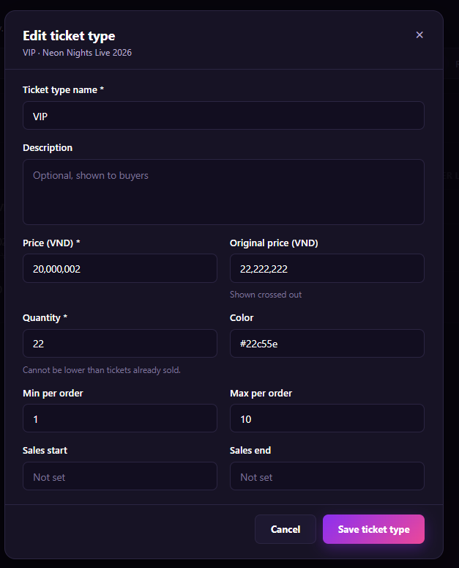
Figure 101 : Configure Ticket Types Screen

FUNCTION DETAILS:
- VALIDATION RULES:
  - The user must be authenticated. The Access Token must be sent in the Authorization header, and it must be present, valid and not expired. The user must be identified from the claims in the token, so the client must not send a user id.
  - The account referenced by the token must exist, be active and have the Organizer role.
  - The event id must be a whole number greater than 0, and the event must exist, must not be deleted and must belong to the Organizer in the token.
  - In edit mode, the ticket type id must be a whole number greater than 0, and the ticket type must exist and belong to the event.
  - Ticket type name: required, 1 to 100 characters after trimming spaces, and unique within the event (not case-sensitive).
  - Description: optional, up to 1,000 characters.
  - Price (VND): required, a whole number greater than or equal to 0. It is shown with a thousands separator.
  - Original price (VND): optional, a whole number. If entered, it must be greater than Price.
  - Quantity: required, a whole number greater than 0. In edit mode it must not be lower than the number of tickets already sold or held.
  - Color: optional, in the format #RRGGBB. If empty, the system uses a default colour.
  - Min per order: a whole number greater than or equal to 1. The default is 1.
  - Max per order: a whole number greater than or equal to Min per order and not greater than Quantity. The default is 10.
  - Sales start and Sales end: optional. If both are entered, Sales end must be later than Sales start.
  - One request creates or updates one ticket type only.

- NORMAL FLOW:
  - Sub-flow A: Open the form
  - Step 1: The Organizer clicks "Add ticket type" or "Edit"
  - Step 2: For "Edit", the client sends the request with the event id, the ticket type id and the Access Token.
  - Step 3: The system validates the Access Token and the Organizer role, and checks the event and the ticket type (ownership).
  - Step 4: The system returns the ticket type data (name, description, price, original price, quantity, sold quantity, colour, min and max per order, sales start and end).
  - Step 5: The client displays the dialog, empty for "Add" or filled with the returned data for "Edit".

  - Sub-flow B: Save the ticket type
  - Step 1: The Organizer enters or changes the values and clicks "Save ticket type".
  - Step 2: The client checks the fields and sends the request with the event id, the form data and the Access Token (create for "Add", update for "Edit").
  - Step 3: The system validates the Access Token, the Organizer role, the event and the data.
  - Step 4: The system creates or updates the ticket type and returns the saved data.
  - Step 5: The client closes the dialog, displays "Ticket type saved." and refreshes the ticket type list on the step "Tickets & Seating".

- ABNORMAL FLOWS:
  - Abnormal flow 1: Not authenticated or no permission (occurs at Sub-flow A, Step 2 or 3, and Sub-flow B, Step 2 or 3)
Step 1: The Access Token is missing, invalid or expired, or the account is not found, not active, or not an Organizer.
Step 2: The system returns no data, saves nothing and returns 401 Unauthorized (token or account problem) or 403 Forbidden (not an Organizer).
Step 3: For 401, the client tries to get a new Access Token with the Refresh Token and repeats the request. If this fails, the client deletes the stored tokens, displays "Your session has expired. Please log in again." and redirects to the Login page. For 403, the client displays "You do not have permission to do this action." and closes the dialog.

  - Abnormal flow 2: Event or ticket type not found (occurs at Sub-flow A, Step 3, and Sub-flow B, Step 3)
Step 1: The event does not exist, was deleted or belongs to another Organizer, or the ticket type does not exist in the event.
Step 2: The system returns 404 Not Found and saves nothing.
Step 3: The client displays "This event or ticket type is no longer available." and returns to the "My events" list.

  - Abnormal flow 3: Invalid data (occurs at Sub-flow B, Step 2 or 3)
Step 1: A required field is empty, or a value breaks a validation rule (for example Original price is not higher than Price, Max per order is lower than Min per order, or Sales end is not later than Sales start).
Step 2: The client or the system rejects the request (400 Bad Request from the system) and saves nothing.
Step 3: The client keeps the dialog open, keeps the entered values and displays the error message under each invalid field.

  - Abnormal flow 4: Duplicate ticket type name (occurs at Sub-flow B, Step 3)
Step 1: Another ticket type of the same event already has the same name.
Step 2: The system returns 409 Conflict and saves nothing.
Step 3: The client keeps the dialog open and displays "This ticket type name already exists in this event." under the field "Ticket type name".

  - Abnormal flow 5: Quantity lower than tickets already sold (occurs at Sub-flow B, Step 3)
Step 1: In edit mode, the Quantity is lower than the number of tickets already sold or held.
Step 2: The system returns 409 Conflict and saves nothing.
Step 3: The client keeps the dialog open and displays "Quantity cannot be lower than tickets already sold (<sold quantity>)." under the field "Quantity".

3.11.7 Configure Pricing Rule
FUNCTION TRIGGER:
- Trigger 1: Organizer clicks the "Add pricing rule" button on the step "Tickets & Seating".
- Trigger 2: Organizer clicks the "Edit" button of a pricing rule on the step "Tickets & Seating".
FUNCTION DESCRIPTION:
- Actor(s): Organizer
- Secondary actor(s): None
- Purpose:
  - To let the Organizer create a pricing rule or change an existing one for a ticket type (early bird, time window, bulk or fixed price), so that Customers get the discounted or adjusted price when the rule applies.
- Main Functionality:
  - The Organizer opens the dialog "Add pricing rule" or "Edit pricing rule". The header shows the dialog title and the event name (for example "Neon Nights Live 2026"). The form contains: "Ticket type" (required, a list of the ticket types of the event), "Rule name" (required), "Rule type" (required, one of four options: "Early bird – Discount until a date.", "Time window – Discount between two dates.", "Bulk – Discount from a quantity.", "Fixed price – Set a new price."), "Discount %", "Or adjusted price (VND)", "Applies from", "Applies until", "Quantity threshold" (with the note "Only for bulk rules."), "Priority" (with the note "Higher number wins if rules overlap.") and the switch "Active" (with the note "Turn off to pause this rule."). "Applies from" and "Applies until" show "Not set" when empty. In edit mode the form is filled with the saved values. The Organizer enters the values and clicks "Save rule". The system validates and saves the rule, closes the dialog and refreshes the pricing rule list. The Organizer can click "Cancel" or "×" to close the dialog without saving.
SCREEN LAYOUT:
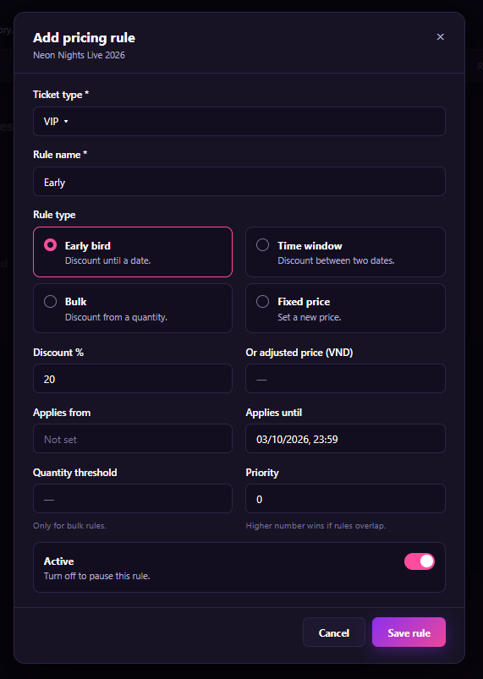
Figure 102 : Configure Pricing Rule Screen

FUNCTION DETAILS:
- VALIDATION RULES:
  - The user must be authenticated. The Access Token must be sent in the Authorization header, and it must be present, valid and not expired. The user must be identified from the claims in the token, so the client must not send a user id.
  - The account referenced by the token must exist, be active and have the Organizer role.
  - The event id must be a whole number greater than 0, and the event must exist, must not be deleted and must belong to the Organizer in the token.
  - In edit mode, the pricing rule id must be a whole number greater than 0, and the rule must exist and belong to the event.
  - Ticket type: required, and it must exist and belong to the event.
  - Rule name: required, 1 to 100 characters after trimming spaces, and unique within the same ticket type (not case-sensitive).
  - Rule type: required, one of Early bird, Time window, Bulk, Fixed price. The default is Early bird.
  - Discount % and Adjusted price: enter one of them, not both. Discount % is a number greater than 0 and less than 100 (up to 2 decimal places). Adjusted price is a whole number greater than or equal to 0, shown with a thousands separator.
  - For Early bird, Time window and Bulk, the final price after the rule must be lower than the price of the ticket type.
  - For Fixed price, Adjusted price is required and Discount % is not accepted.
  - Early bird: "Applies until" is required. "Applies from" is not used and is ignored.
  - Time window: "Applies from" and "Applies until" are both required, and "Applies until" must be later than "Applies from".
  - Bulk: "Quantity threshold" is required, a whole number greater than or equal to 2 and not greater than Max per order of the ticket type. For other rule types it is not used and is ignored.
  - Fixed price: "Applies from" and "Applies until" are optional. If both are entered, "Applies until" must be later than "Applies from".
  - Date and time are entered in the format dd/MM/yyyy, HH:mm.
  - Priority: a whole number greater than or equal to 0. The default is 0.
  - Active: on or off. The default is on.
  - One request creates or updates one pricing rule only.

- NORMAL FLOW:
  - Sub-flow A: Open the form
  - Step 1: The Organizer clicks "Add pricing rule" or "Edit".
  - Step 2: The client sends the request to get the ticket type list of the event and, for "Edit", the pricing rule, with the event id, the rule id and the Access Token.
  - Step 3: The system validates the Access Token and the Organizer role, and checks the event and the rule (ownership).
  - Step 4: The system returns the ticket types (id, name, price) and, for "Edit", the rule data (ticket type, name, rule type, discount %, adjusted price, applies from, applies until, quantity threshold, priority, active).
  - Step 5: The client displays the dialog, with default values for "Add" or filled with the returned data for "Edit".
- Sub-flow B: Save the pricing rule
  - Step 1: The Organizer enters or changes the values and clicks "Save rule".
  - Step 2: The client checks the fields and sends the request with the event id, the form data and the Access Token (create for "Add", update for "Edit").
  - Step 3: The system validates the Access Token, the Organizer role, the event, the ticket type and the data.
  - Step 4: The system creates or updates the pricing rule and returns the saved data.
  - Step 5: The client closes the dialog, displays "Pricing rule saved." and refreshes the pricing rule list on the step "Tickets & Seating".

- ABNORMAL FLOWS:
  - Abnormal flow 1: Not authenticated or no permission (occurs at Sub-flow A, Step 2 or 3, and Sub-flow B, Step 2 or 3)
  - Step 1: The Access Token is missing, invalid or expired, or the account is not found, not active, or not an Organizer.
  - Step 2: The system returns no data, saves nothing and returns 401 Unauthorized (token or account problem) or 403 Forbidden (not an Organizer).
  - Step 3: For 401, the client tries to get a new Access Token with the Refresh Token and repeats the request. If this fails, the client deletes the stored tokens, displays "Your session has expired. Please log in again." and redirects to the Login page. For 403, the client displays "You do not have permission to do this action." and closes the dialog.

  - Abnormal flow 2: Event, ticket type or rule not found (occurs at Sub-flow A, Step 3, and Sub-flow B, Step 3)
  - Step 1: The event does not exist, was deleted or belongs to another Organizer, or the ticket type or the pricing rule does not exist in the event.
  - Step 2: The system returns 404 Not Found and saves nothing.
  - Step 3: The client displays "This event, ticket type or pricing rule is no longer available." and returns to the "My events" list.

  - Abnormal flow 3: Invalid data (occurs at Sub-flow B, Step 2 or 3)
  - Step 1: A required field is empty, or a value breaks a validation rule (for example both Discount % and Adjusted price are entered, "Applies until" is not later than "Applies from", or the Quantity threshold is missing for a Bulk rule).
  - Step 2: The client or the system rejects the request (400 Bad Request from the system) and saves nothing.
  - Step 3: The client keeps the dialog open, keeps the entered values and displays the error message under each invalid field.

  - Abnormal flow 4: Duplicate rule name (occurs at Sub-flow B, Step 3)
  - Step 1: Another pricing rule of the same ticket type already has the same name.
  - Step 2: The system returns 409 Conflict and saves nothing.
  - Step 3: The client keeps the dialog open and displays "This rule name already exists for this ticket type." under the field "Rule name".

  - Abnormal flow 5: Price after rule is not lower than the ticket price (occurs at Sub-flow B, Step 3)
  - Step 1: For Early bird, Time window or Bulk, the price after the rule is not lower than the price of the ticket type.
  - Step 2: The system returns 400 Bad Request and saves nothing.
  - Step 3: The client keeps the dialog open and displays "The price after the rule must be lower than the ticket type price." under the field "Discount %" or "Or adjusted price (VND)".

3.11.8 Configure Refund Policy
FUNCTION TRIGGER:
- Trigger 1: Organizer clicks the "Add refund policy" button in the refund policy section of the event.
- Trigger 2: Organizer clicks the "Edit" button of a refund policy in the refund policy section of the event.

FUNCTION DESCRIPTION:
- Actor(s): Organizer
- Secondary actor(s): None
- Purpose:
  - To let the Organizer create a refund policy or change an existing one for an event, with its refund percent, deadline and approval setting, so that Customers know when and how much they can get back if they cancel their tickets.
- Main Functionality:
  - The Organizer opens the dialog "Add refund policy" or "Edit refund policy". The header shows the dialog title and the event name (for example "Neon Nights Live 2026"). The form contains: "Policy name" (required), "Description" (optional), "Refund percent" (required, with the note "0 to 100."), "Deadline" (required, with the note "Hours before the event starts."), the switch "Requires organizer approval" (with the note "Each refund request waits for your decision.") and the switch "Active" (with the note "Turn off to stop offering this policy."). In edit mode the form is filled with the saved values. The Organizer enters the values and clicks "Save policy". The system validates and saves the policy, closes the dialog and refreshes the refund policy list. The Organizer can click "Cancel" to close the dialog without saving.
SCREEN LAYOUT:
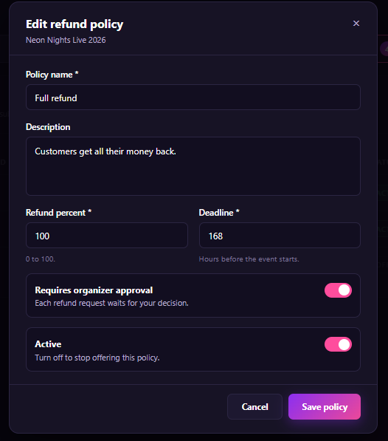
Figure 103 : Configure Refund Policy Screen

FUNCTION DETAILS:
- VALIDATION RULES:
  - The user must be authenticated. The Access Token must be sent in the Authorization header, and it must be present, valid and not expired. The user must be identified from the claims in the token, so the client must not send a user id.
  - The account referenced by the token must exist, be active and have the Organizer role.
  - The event id must be a whole number greater than 0, and the event must exist, must not be deleted and must belong to the Organizer in the token.
  - In edit mode, the refund policy id must be a whole number greater than 0, and the policy must exist and belong to the event.
  - Policy name: required, 1 to 100 characters after trimming spaces, and unique within the event (not case-sensitive).
  - Description: optional, up to 1,000 characters.
  - Refund percent: required, a whole number from 0 to 100.
  - Deadline: required, a whole number of hours greater than or equal to 0.
  - Requires organizer approval: on or off. The default is on.
  - Active: on or off. The default is on.
  - One request creates or updates one refund policy only.

- NORMAL FLOW:
  - Sub-flow A: Open the form
  - Step 1: The Organizer clicks "Add refund policy" or "Edit".
Step 2: For "Edit", the client sends the request with the event id, the refund policy id and the Access Token.
  - Step 3: The system validates the Access Token and the Organizer role, and checks the event and the policy (ownership).
  - Step 4: The system returns the policy data (name, description, refund percent, deadline, requires approval, active).
  - Step 5: The client displays the dialog, with default values for "Add" or filled with the returned data for "Edit".

  - Sub-flow B: Save the refund policy
  - Step 1: The Organizer enters or changes the values and clicks "Save policy".
  - Step 2: The client checks the fields and sends the request with the event id, the form data and the Access Token (create for "Add", update for "Edit").
  - Step 3: The system validates the Access Token, the Organizer role, the event and the data.
  - Step 4: The system creates or updates the refund policy and returns the saved data.
  - Step 5: The client closes the dialog, displays "Refund policy saved." and refreshes the refund policy list.

- ABNORMAL FLOWS:
  - Abnormal flow 1: Not authenticated or no permission (occurs at Sub-flow A, Step 2 or 3, and Sub-flow B, Step 2 or 3)
  - Step 1: The Access Token is missing, invalid or expired, or the account is not found, not active, or not an Organizer.
  - Step 2: The system returns no data, saves nothing and returns 401 Unauthorized (token or account problem) or 403 Forbidden (not an Organizer).
  - Step 3: For 401, the client tries to get a new Access Token with the Refresh Token and repeats the request. If this fails, the client deletes the stored tokens, displays "Your session has expired. Please log in again." and redirects to the Login page. For 403, the client displays "You do not have permission to do this action." and closes the dialog.

  - Abnormal flow 2: Event or refund policy not found (occurs at Sub-flow A, Step 3, and Sub-flow B, Step 3)
  - Step 1: The event does not exist, was deleted or belongs to another Organizer, or the refund policy does not exist in the event.
  - Step 2: The system returns 404 Not Found and saves nothing.
  - Step 3: The client displays "This event or refund policy is no longer available." and returns to the "My events" list.

  - Abnormal flow 3: Invalid data (occurs at Sub-flow B, Step 2 or 3)
  - Step 1: A required field is empty, or a value breaks a validation rule (for example Refund percent is not between 0 and 100, or Deadline is negative or not a whole number).
  - Step 2: The client or the system rejects the request (400 Bad Request from the system) and saves nothing.
  - Step 3: The client keeps the dialog open, keeps the entered values and displays the error message under each invalid field.

  - Abnormal flow 4: Duplicate policy name (occurs at Sub-flow B, Step 3)
  - Step 1: Another refund policy of the same event already has the same name.
  - Step 2: The system returns 409 Conflict and saves nothing.
  - Step 3: The client keeps the dialog open and displays "This policy name already exists in this event." under the field "Policy name".

3.12 Revenue Analytics & Sales Dashboard

3.12.1 View Revenue Dashboard
FUNCTION TRIGGER:
- Organizer opens the Revenue Dashboard.
FUNCTION DESCRIPTION:
- Actor(s): Organizer.
- Purpose:
  - To allow the Organizer to view the ticket-sales and gross-revenue summary currently supported by the system.
- Main Functionality:
  - The system identifies the logged-in Organizer, retrieves their concerts and ticket-sales data, calculates summary values, and displays event counts, published/on-sale counts, total tickets sold, gross revenue, and per-event summaries. This is a strictly read-only operation.
SCREEN LAYOUT:
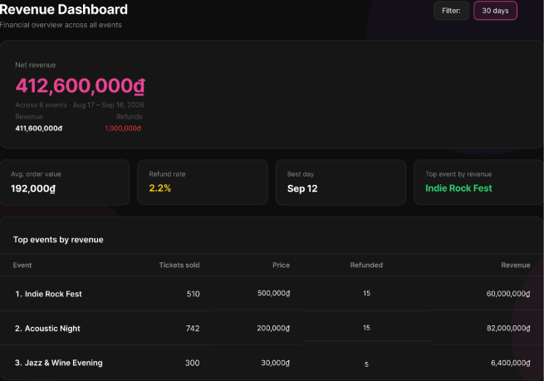
Figure 104 : View Revenue Dashboard Screen
FUNCTION DETAILS:
- VALIDATION RULES:
  - User must be authenticated and logged in with the Organizer role.
  - System must successfully retrieve the Organizer's associated concert and sales data.
- NORMAL FLOW:
  - Step 1: Organizer opens the Revenue Dashboard.
  - Step 2: System identifies the current logged-in Organizer.
  - Step 3: System retrieves the Organizer's concerts.
  - Step 4: System retrieves available ticket-sales information for those concerts.
  - Step 5: System calculates supported summary values.
  - Step 6: System displays total event counts.
  - Step 7: System displays published/on-sale counts where applicable.
  - Step 8: System displays total tickets sold.
  - Step 9: System displays gross revenue.
  - Step 10: System displays available per-event summaries.
  - Step 11: Organizer reviews the dashboard.
- ABNORMAL FLOWS:
  - Step 1: System encounters missing sales data, connection issues, or server/data errors during retrieval.
  - Step 2: System validates data availability and connection status.
  - Step 3: Depending on the scenario, the system responds accordingly:
  - No Sales Data: System displays zero values or an empty state for sales metrics, while event information remains available.
  - Connection Error: System cannot reach the server, displays an appropriate error message, and ensures no invalid partial update is committed.
  - Server/Data Error: Requested data cannot be loaded, system displays an appropriate error message, and the last valid UI state is preserved.
  - Step 4: Client displays the corresponding error message, empty state, or zero values, ensuring UI stability without committing any partial updates.

3.12.2 Filter Revenue Dashboard
FUNCTION TRIGGER:
- Organizer applies filters on the Revenue Dashboard.
FUNCTION DESCRIPTION:
- Actor(s): Organizer.
- Purpose:
  - To allow the Organizer to refine revenue analytics by supported filters such as date range, concert/event, ticket type, payment channel, or showtime.
- Main Functionality:
  - The system provides filter controls, validates the selected filter values, retrieves matching revenue data, recalculates summary values, and refreshes the dashboard charts and summaries while displaying the active filter criteria.
SCREEN LAYOUT:
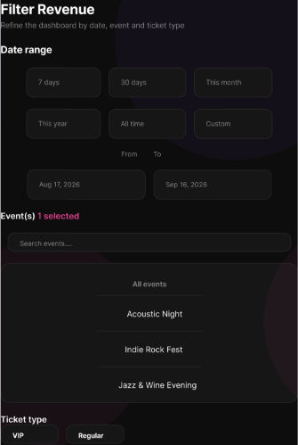
Figure 105 : Filter Revenue Dashboard Screen
FUNCTION DETAILS:
- VALIDATION RULES:
  - User must be authenticated and logged in with the Organizer role.
  - The Revenue Dashboard must be accessible.
  - Selected filter values must be valid (e.g., logical date ranges, existing event IDs).
- NORMAL FLOW:
  - Step 1: Organizer opens the Revenue Dashboard.
  - Step 2: System displays the current revenue summary.
  - Step 3: Organizer opens the filter controls.
  - Step 4: Organizer selects one or more supported filters.
  - Step 5: Organizer selects "Apply".
  - Step 6: System validates the filter values.
  - Step 7: System retrieves revenue data matching the selected criteria.
  - Step 8: System recalculates the supported summary values.
  - Step 9: System refreshes the dashboard charts/summary.
  - Step 10: System displays the active filter criteria.
- ABNORMAL FLOWS:
  - Step 1: Organizer applies no filters, or the system encounters no matching data, connection issues, or server/data errors during retrieval.
  - Step 2: System processes the action or validates the request constraints and connection status.
  - Step 3: Depending on the scenario, the system responds accordingly:
    - No Filter Selected: System uses the default dashboard scope.
    - No Matching Data: System returns zero values or an empty state for the selected criteria; the selected filters remain visible.
    - Connection Error: System cannot reach the server, displays an appropriate error message, and ensures no invalid partial update is committed.
    - Server/Data Error: Requested data cannot be loaded, system displays an appropriate error message, and the last valid UI state is preserved.
  - Step 4: Client updates the UI accordingly (showing default scope, empty state, or error messages), ensuring UI stability without modifying any business data.

3.12.3 Export Revenue Report
FUNCTION TRIGGER:
- Organizer selects "Export Revenue Report" on the Revenue Dashboard.
FUNCTION DESCRIPTION:
- Actor(s): Organizer.
- Purpose:
  - To allow the Organizer to export revenue and sales information for owned concerts in a supported report format.
- Main Functionality:
  - The system displays export options, allowing the Organizer to select report scope/filter criteria and a supported export format (e.g., Excel .xlsx or CSV). Upon confirmation, the system validates access, retrieves matching records, generates the report file, and provides it to the Organizer for download.
SCREEN LAYOUT:
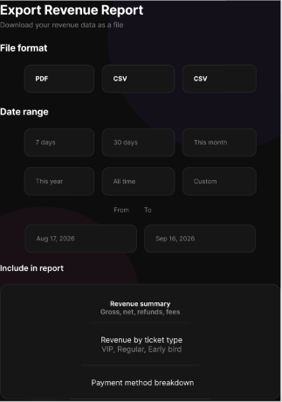
Figure 106 : Export Revenue Report Screen
FUNCTION DETAILS:
- VALIDATION RULES:
  - User must be authenticated and logged in with the Organizer role.
  - Organizer must have access to revenue data for at least one owned concert within the selected scope.
  - Selected export format must be a supported type (e.g., .xlsx, .csv).
  - Selected scope and filter criteria must be valid.
- NORMAL FLOW:
  - Step 1: Organizer opens the Revenue Dashboard.
  - Step 2: Organizer selects "Export Revenue Report".
  - Step 3: System displays the supported export options (form/modal).
  - Step 4: Organizer selects the report scope/filter criteria.
  - Step 5: Organizer selects a supported export format.
  - Step 6: Organizer confirms "Export".
  - Step 7: System validates the Organizer's access to the selected concert data.
  - Step 8: System retrieves the matching revenue and sales records.
  - Step 9: System generates the report file.
  - Step 10: System provides the generated file to the Organizer for download.
- ABNORMAL FLOWS:
  - Step 1: Organizer cancels the export, or the system encounters no matching data, connection issues, or server/data errors during the process.
  - Step 2: System processes the cancellation or validates access, data availability, and connection status.
  - Step 3: Depending on the scenario, the system responds accordingly:
    - Cancel Export: Organizer cancels the action. No report is generated.
    - No Data: System informs the Organizer that no data matches the selected scope. No empty report is generated (unless explicitly supported by implementation).
    - Connection Error: System cannot reach the server, displays an appropriate error message, and ensures no invalid partial update is committed.
    - Server/Data Error: Requested data cannot be loaded or processed, system displays an appropriate error message, and the last valid UI state is preserved.
  - Step 4: Client updates the UI accordingly (closes modal on cancel, shows a warning for no data, or displays error messages for connection/server failures), preserving the last valid state without modifying any business data.

3.12.4 View Concert Order List
FUNCTION TRIGGER:
- Organizer opens the order list from the Revenue/Sales area or a concert dashboard.
FUNCTION DESCRIPTION:
- Actor(s): Organizer .
- Purpose:
  - To allow the Organizer to view, search, and monitor customer purchase orders placed for concerts owned by the Organizer.
- Main Functionality:
  - The system retrieves and displays a list of orders associated with the Organizer's concerts, including buyer details, ticket/seat information, amount, and payment status. Organizers can search and filter the list to monitor sales effectively.
SCREEN LAYOUT:
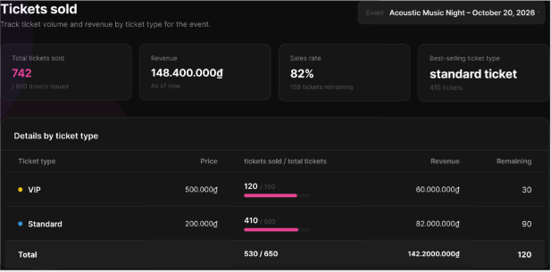
Figure 107 : View Concert Order List Screen
FUNCTION DETAILS:
- VALIDATION RULES:
  - User must be authenticated and logged in with the Organizer role.
  - The selected concert (if specified) must belong to the current Organizer.
  - Search and filter parameters must be valid strings or recognized enums.
- NORMAL FLOW:
  - Step 1: Organizer opens the Concert Order List from the Revenue/Sales area or concert dashboard.
  - Step 2: System identifies the current logged-in Organizer.
  - Step 3: Organizer selects an owned concert (where applicable).
  - Step 4: System validates ownership of the selected concert.
  - Step 5: System retrieves orders associated with that concert.
  - Step 6: System displays available order information (buyer, ticket/seat info, amount, payment status).
  - Step 7: Organizer applies search or filter criteria to the displayed orders.
  - Step 8: System refreshes the list according to the selected criteria.
  - Step 9: Organizer reviews the filtered order information.
- ABNORMAL FLOWS:
  - Step 1: Organizer encounters no orders, unauthorized access, connection issues, or server/data errors during retrieval.
  - Step 2: System validates concert ownership, data availability, and connection status.
  - Step 3: Depending on the scenario, the system responds accordingly:
    - No Orders: System displays an empty order-list state; Organizer may select another concert.
    - Unauthorized Concert: System denies access to orders for a concert not owned by the Organizer (e.g., 403 Forbidden).
    - Connection Error: System cannot reach the server, displays an appropriate error message, and ensures no invalid partial update is committed.
    - Server/Data Error: Requested data cannot be loaded, system displays an appropriate error message, and the last valid UI state is preserved.
  - Step 4: Client updates the UI accordingly (showing empty state, access denied message, or error notifications), preserving the last valid state without modifying any business data.

3.13 Real-time Check-in Monitoring

3.13.1 Monitor Real-time Check-in Status
FUNCTION TRIGGER:
- Organizer opens the real-time Check-in Dashboard for an owned concert.
FUNCTION DESCRIPTION:
- Actor(s): Organizer .
- Purpose:
  - To allow the Organizer to supervise attendee admission flow in real time, including scan rates, checked-in totals, tickets sold, and gate throughput.
- Main Functionality:
  - The system retrieves and displays current check-in/scan information, calculates summaries (total tickets sold, total checked in, scan rates, gate info), and continuously refreshes the dashboard as new records become available for real-time monitoring.
SCREEN LAYOUT:
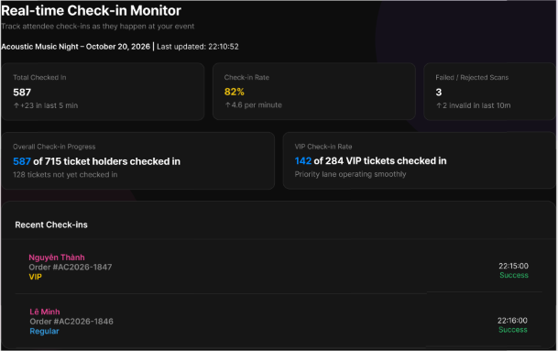
Figure 108 : View Monitor Real-time Check-in Status Screen
FUNCTION DETAILS:
- VALIDATION RULES:
  - User must be authenticated and logged in with the Organizer role.
  - The selected concert must belong to the current Organizer.
- NORMAL FLOW:
  - Step 1: Organizer opens the Check-in Dashboard for a specific concert.
  - Step 2: System identifies the selected concert.
  - Step 3: System validates that the concert belongs to the Organizer.
  - Step 4: System retrieves current check-in/scan information.
  - Step 5: System calculates the available check-in summary.
  - Step 6: System displays total tickets sold (where available).
  - Step 7: System displays total attendees checked in.
  - Step 8: System displays current scan/check-in rates and gate information (where available).
  - Step 9: Dashboard automatically refreshes the displayed information as new check-in records become available.
  - Step 10: Organizer monitors the admission status.
- ABNORMAL FLOWS:
  - Step 1: System encounters no check-in data, unauthorized access, connection issues, or server/data errors during retrieval.
  - Step 2: System validates concert ownership, data availability, and connection status.
  - Step 3: Depending on the scenario, the system responds accordingly:
    - No Check-in Data: System displays zero values or an empty state; the dashboard remains available.
    - Unauthorized Concert: System denies access to check-in data for concerts not owned by the Organizer (e.g., 403 Forbidden).
    - Connection Error: System cannot reach the server, displays an appropriate error message, and ensures no invalid partial update is committed.
    - Server/Data Error: Requested data cannot be loaded, system displays an appropriate error message, and the last valid UI state is preserved.
  - Step 4: Client updates the UI accordingly (showing empty state, access denied message, or error notifications), preserving the last valid state without modifying any check-in data.

3.13.2 Export Check-in Report
FUNCTION TRIGGER:
- Organizer selects "Export Check-in Report" from the Check-in Dashboard.
FUNCTION DESCRIPTION:
- Actor(s): Organizer .
- Purpose:
  - To allow the Organizer to export admission audit logs and gate reconciliation information for an owned
- Main Functionality:
  - The system displays supported report options, validates concert ownership, retrieves matching admission/check-in records based on the selected scope or date range, generates the report file, and provides it to the Organizer for download.
SCREEN LAYOUT:
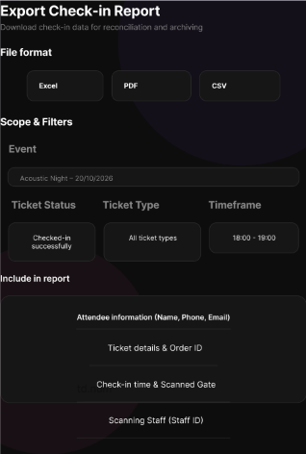
Figure 109 : Export Check-in Report Screen
FUNCTION DETAILS:
- VALIDATION RULES:
  - User must be authenticated and logged in with the Organizer role.
  - The selected concert must belong to the current Organizer.
  - Check-in data for the selected concert/scope must be accessible.
  - Selected scope and date range parameters must be valid.
- NORMAL FLOW:
  - Step 1: Organizer opens the Check-in Dashboard.
  - Step 2: Organizer selects "Export Check-in Report".
  - Step 3: System displays the supported report options (form/modal).
  - Step 4: Organizer selects the report scope/date range (where supported).
  - Step 5: Organizer confirms "Export".
  - Step 6: System validates concert ownership.
  - Step 7: System retrieves matching admission/check-in records.
  - Step 8: System generates the check-in report.
  - Step 9: System provides the generated report to the Organizer for download.
- ABNORMAL FLOWS:
  - Step 1: Organizer cancels the export, or the system encounters no matching records, connection issues, or server/data errors during the process.
  - Step 2: System processes the cancellation or validates ownership, data availability, and connection status.
  - Step 3: Depending on the scenario, the system responds accordingly:
    - Cancel Export: Organizer cancels the operation. No report is generated.
    - No Check-in Records: System informs the Organizer that no records match the selected scope. No report is generated (unless empty-report export is explicitly supported).
    - Connection Error: System cannot reach the server, displays an appropriate error message, and ensures no invalid partial update is committed.
    - Server/Data Error: Requested data cannot be loaded or processed, system displays an appropriate error message, and the last valid UI state is preserved.
  - Step 4: Client updates the UI accordingly (closes modal on cancel, shows a warning for no data, or displays error messages for connection/server failures), preserving the last valid state without modifying any check-in data.

3.13.3 View Staff List
FUNCTION TRIGGER:
- Organizer opens Staff Management for a specific concert.
FUNCTION DESCRIPTION:
- Actor(s): Organizer .
- Purpose:
  - To allow the Organizer to view on-site Staff members assigned to an owned concert together with their operational roles and gate assignments.
- Main Functionality:
  - The system retrieves and displays the current staff assignments for the selected concert, including staff details, operational roles, and gate assignments, allowing the Organizer to review the on-site team.
SCREEN LAYOUT:

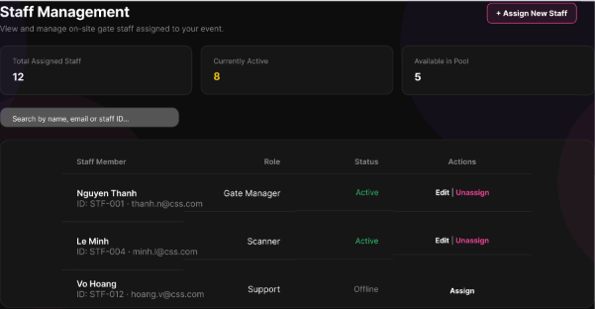
Figure 110 : View Staff List Screen
FUNCTION DETAILS:
- VALIDATION RULES:
  - User must be authenticated and logged in with the Organizer role.
  - The selected concert must belong to the current Organizer.
- NORMAL FLOW:
  - Step 1: Organizer opens Staff Management for a specific concert.
  - Step 2: System identifies the selected concert.
  - Step 3: System validates concert ownership.
  - Step 4: System retrieves Staff assignments for the concert.
  - Step 5: System displays the assigned Staff list.
  - Step 6: System displays available operational role and gate assignment information.
  - Step 7: Organizer reviews the current assignments.
- ABNORMAL FLOWS:
  - Step 1: Organizer encounters no assigned staff, unauthorized access, connection issues, or server/data errors during retrieval.
  - Step 2: System validates concert ownership, data availability, and connection status.
  - Step 3: Depending on the scenario, the system responds accordingly:
    - No Staff Assigned: System displays an empty Staff list and provides the "Assign Staff" action (where available).
    - Unauthorized Concert: System denies access to Staff assignments for concerts not owned by the Organizer (e.g., 403 Forbidden).
    - Connection Error: System cannot reach the server, displays an appropriate error message, and ensures no invalid partial update is committed.
    - Server/Data Error: Requested data cannot be loaded, system displays an appropriate error message, and the last valid UI state is preserved.
  - Step 4: Client updates the UI accordingly (showing empty state with action button, access denied message, or error notifications), preserving the last valid state without modifying any staff assignment data.

3.13.4 Assign/Unassign Staff
FUNCTION TRIGGER:
- Organizer selects "Assign Staff" or "Unassign" for a Staff assignment in Staff Management.
FUNCTION DESCRIPTION:
- Actor(s): Organizer .
- Purpose:
  - To allow the Organizer to assign an authorized Staff account to a designated admission gate/area for an owned concert, or to remove an existing assignment.
- Main Functionality:
  - The system provides interfaces to assign staff (selecting staff member, gate/area, and operational role) or unassign existing staff. It validates concert ownership, staff eligibility, and potential conflicts, then updates the assignment state and refreshes the staff list.
SCREEN LAYOUT:
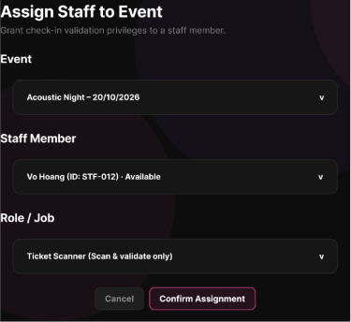
Figure 111: Assign Staff Screen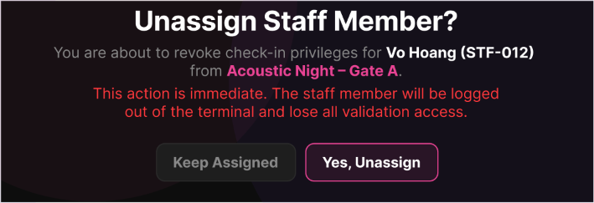
Figure 112 : Unassign Staff Screen
FUNCTION DETAILS:
- VALIDATION RULES:
  - User must be authenticated and logged in with the Organizer role.
  - The selected concert must belong to the current Organizer.
  - Target Staff account must be eligible for assignment.
  - No conflicting or duplicate assignments for the same gate/area (where applicable).
- NORMAL FLOW(ASSIGN STAFF):
  - Step 1: Organizer opens Staff Management and selects "Assign Staff".
  - Step 2: System displays eligible Staff and assignment fields.
  - Step 3: Organizer selects a Staff member.
  - Step 4: Organizer selects the designated gate/area and supported operational role.
  - Step 5: Organizer confirms the assignment.
  - Step 6: System validates concert ownership and Staff eligibility.
  - Step 7: System checks for conflicting or duplicate assignments.
  - Step 8: System stores the new assignment.
  - Step 9: System refreshes the Staff list and confirms success.
- NORMAL FLOW(UNASSIGN STAFF):
  - Step 1: Organizer selects "Unassign" for an existing assignment.
  - Step 2: System displays a confirmation prompt.
  - Step 3: Organizer confirms the unassignment.
  - Step 4: System validates that the assignment belongs to the Organizer's concert.
  - Step 5: System removes or deactivates the assignment according to current data rules.
  - Step 6: System refreshes the Staff list and confirms success.
- ABNORMAL FLOWS:
  - Step 1: Organizer cancels the unassignment, or the system encounters conflicting assignments, connection issues, or server/data errors during the process.
  - Step 2: System processes the cancellation or validates constraints (ownership, eligibility, conflicts, connection status).
  - Step 3: Depending on the scenario, the system responds accordingly:
    - Cancel Unassign: Organizer cancels the confirmation. The existing assignment remains unchanged.
    - Conflicting/Duplicate Assignment: System rejects the invalid assignment (e.g., 400 Bad Request).
    - Connection Error: System cannot reach the server, displays an appropriate error message, and ensures no invalid partial update is committed.
    - Server/Data Error: Requested data cannot be loaded or saved, system displays an appropriate error message, and the last valid UI state is preserved.
  - Step 4: Client updates the UI accordingly (keeps modal open for correction on conflict, closes modal on cancel, or displays error notifications), preserving the last valid state without committing invalid changes.

3.14 QR Code Scanner & Check-in Interface

3.14.1 View Gate Assignment
FUNCTION TRIGGER:
- The staff member checks in and opens the Gate Allocation screen.
FUNCTION DESCRIPTION:
- Actor(s): Staff.
- Purpose:
  - To allow check-in staff to view their assigned concert event, gate identifier, validator role permissions, and active operational hours before starting their shift.
- Main Functionality:
  - The system displays the Gate Assignment screen showing the event status, assigned gate details, role permissions, operational hours, and terminal device connection status. It provides an action button for the staff to navigate directly to the Ticket Check-in screen to begin scanning.
SCREEN LAYOUT:
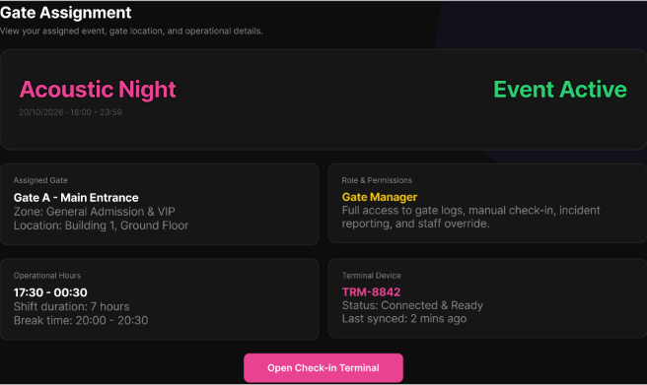
Figure 113: View Gate Assignment Screen
FUNCTION DETAILS:
- VALIDATION RULES:
  - The screen must clearly indicate if the event is currently "Active" or "Inactive".
  - Staff assignments and terminal device pairings are pre-configured by the Event Organizer/Admin before the event starts.
  - Only staff with "Check-in Staff" or "Validator" roles can access this screen.
  - Viewing this screen is a read-only operation; no assignment data is modified.
- NORMAL FLOW:
  - Step 1: The Check-in Staff opens the Gate Assignment screen in the Check-in App.
  - Step 2: The client sends the request with the Access Token in the Authorization header.
  - Step 3: The system validates the Access Token, identifies the staff member, and verifies they have the required Check-in/Validator role.
  - Step 4: The system retrieves the staff member's current active assignment, including event details, assigned gate, role permissions, operational hours, and linked terminal device status.
  - Step 5: The system returns the assignment details to the client.
  - Step 6: The client displays the Gate Assignment screen with all retrieved information: Event Name & "Event Active" status, Assigned Gate (e.g., Gate A - Main Entrance, Zones, Location), Role & Permissions (e.g., Gate Manager), Operational Hours (Shift duration, Break time), Terminal Device status (e.g., TRM-8842 Connected & Ready), and the "Open Check-in Terminal" button.
- ABNORMAL FLOWS:
  - Step 1: Staff accesses the screen or clicks the "Open Check-in Terminal" button.
  - Step 2: System validates authentication, authorization (role), and active gate assignment existence.
  - Step 3: If validation fails or errors occur, system returns appropriate error (401 Unauthorized for invalid token, 403 Forbidden for insufficient role, 404 Not Found for no active assignment) and displays corresponding messages (redirecting to login, showing "Access Denied", or "No active assignment found").
  - Step 4: If staff clicks "Open Check-in Terminal", client navigates to the Ticket Check-in screen; if a system error occurs during navigation, an error toast is displayed and staff remains on the current screen.

3.14.2 Scan Dynamic QR Ticket
FUNCTION TRIGGER:
- Check-in Staff points the active device camera or optical scanner at an attendee's dynamic QR code on the Scan Terminal screen.
FUNCTION DESCRIPTION:
- Actor(s): Staff.
- Purpose:
  - To allow staff to scan attendee dynamic QR codes via device camera or optical scanner for instantaneous cryptographic validation and admission recording.
- Main Functionality:
  - The system displays the Scan Terminal with an active camera viewfinder, gate information, and real-time scan feed. Upon scanning a QR code, the system validates it cryptographically, checks event/gate assignment and ticket status, updates the ticket to "Used", and instantly updates the Real-time Scan Feed table with the result (Success, Already Used, or Invalid QR).
SCREEN LAYOUT:
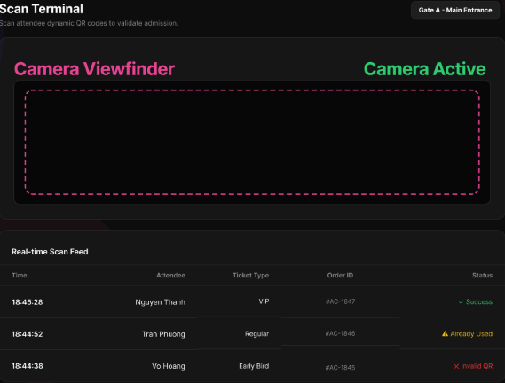
Figure 114: Scan Dynamic QR Ticket Screen
FUNCTION DETAILS:
- VALIDATION RULES:
  - Staff must be authenticated and have an active gate assignment.
  - The Check-in Terminal must be connected and camera/scanner hardware must be functional.
  - The scanned QR code must contain a valid cryptographic signature and not be expired.
  - The ticket must belong to the current event and assigned gate.
  - The ticket status must be "Available" (not already "Used").
- NORMAL FLOW:
  - Step 1: The Check-in Staff opens the Check-in Terminal screen, where the Camera Viewfinder is active and "Camera Active" status is displayed.
  - Step 2: The Staff points the camera/scanner at the attendee's dynamic QR code.
  - Step 3: The client captures the QR code data and sends an instantaneous validation request to the system.
  - Step 4: The system performs cryptographic validation on the QR payload, verifies the ticket belongs to the current event and assigned gate, and checks that the ticket status is "Available".
  - Step 5: The system updates the ticket status to "Used" (Checked-in) and records the exact admission time.
  - Step 6: The system returns a success result along with the attendee's details (Name, Ticket Type, Order ID).
  - Step 7: The client plays a success cue (sound/visual) and adds a new row to the top of the "Real-time Scan Feed" showing the Time, Attendee Name, Ticket Type, Order ID, and a green "Success" status.
- ABNORMAL FLOWS:
  - Step 1: Staff scans a QR code or the system encounters hardware/network issues during the scanning process.
  - Step 2: System validates the QR payload, ticket status, event/gate assignment, and checks device/network connectivity.
  - Step 3: If validation fails (e.g., already used, invalid signature, wrong gate), system rejects admission and returns specific error status ("Already Used" in yellow, "Invalid QR" in red). If hardware/network fails, returns corresponding error (Camera not available, Network disconnected).
  - Step 4: Client adds a new row to the top of the "Real-time Scan Feed" with the corresponding error status and message, or displays a system warning prompt to the staff, keeping the camera active for the next scan.

3.14.3 Manual Check-in
FUNCTION TRIGGER:
- Check-in Staff enters a Ticket ID into the input field and clicks "Validate Ticket".
FUNCTION DESCRIPTION:
- Actor(s): Staff.
- Purpose:
  - To allow staff to manually verify and check-in attendees when dynamic QR codes cannot be scanned, by directly entering the Ticket ID or using a hardware scanner.
- Main Functionality:
  - The system displays a manual input screen with a text field and a "Validate Ticket" button. Staff can type the Ticket ID or use a connected hardware scanner. The system validates the format, authenticates the staff, verifies the ticket against the current event and assigned gate, updates the ticket status to "Used", and instantly updates the Real-time Scan Feed.
SCREEN LAYOUT:
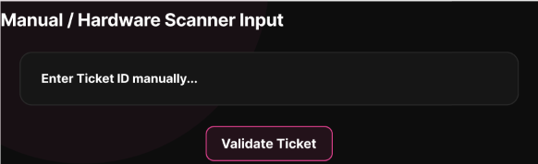
Figure 115: Manual Check-in Screen
FUNCTION DETAILS:
- VALIDATION RULES:
  - Staff must be authenticated with a valid Access Token and have an active gate assignment.
  - Ticket ID must match the expected format (e.g., "TKT-nnnn-nnn").
  - Ticket ID must exist, be valid, not expired, and belong to the current event/assigned gate.
  - Ticket status must be "Available" (not already "Used").
- NORMAL FLOW:
  - Step 1: The Check-in Staff navigates to the Manual / Hardware Scanner Input screen.
  - Step 2: The Staff enters the Ticket ID manually into the text field, or uses a connected hardware barcode scanner to scan the physical ticket.
  - Step 3: The Staff clicks the "Validate Ticket" button (or presses Enter).
  - Step 4: The client validates the input format and sends the Ticket ID with the Access Token in the Authorization header.
  - Step 5: The system validates the Access Token, staff role, and gate assignment.
  - Step 6: The system validates the Ticket ID, verifies it belongs to the current event and assigned gate, and checks that the ticket status is "Available".
  - Step 7: The system updates the ticket status to "Used" and records the exact admission time.
  - Step 8: The system returns a success result along with the attendee's details. The client clears the input field, provides success feedback, and adds a new row to the "Real-time Scan Feed" with a "Success" status.
- ABNORMAL FLOWS:
  - Step 1: Staff enters a Ticket ID, clicks "Validate Ticket", or the system processes the validation request.
  - Step 2: System validates authentication, input format, ticket existence, event/gate assignment, and ticket status.
  - Step 3: If validation fails or errors occur, system returns appropriate error (401 Unauthorized for invalid token, 400 Bad Request for invalid format/already used/wrong gate) or displays client-side format error.
  - Step 4: System displays corresponding error message, adds an error row to the "Real-time Scan Feed" (e.g., yellow "Already Used" or red "Invalid Ticket"), and keeps the input field active for the next attempt.

3.14.5 Lookup Ticket
FUNCTION TRIGGER:
- Check-in Staff enters a Phone Number or CCCD into the search field and clicks the "Search" button on the Manual Ticket Lookup screen.
FUNCTION DESCRIPTION:
- Actor(s): Staff.
- Purpose:
  - To allow staff to search for valid tickets using the attendee's phone number or verified eKYC CCCD identity number when QR codes or ticket IDs are unavailable.
- Main Functionality:
  - The system displays a Manual Ticket Lookup screen with search criteria toggle (Phone Number/CCCD), input field, and Search button. Upon search, the system retrieves and displays the attendee's profile (Name, Phone, CCCD, Email) and their associated tickets for the current event with status indicators. Staff can directly check-in unused tickets via the "Check-in Now" button.
SCREEN LAYOUT:
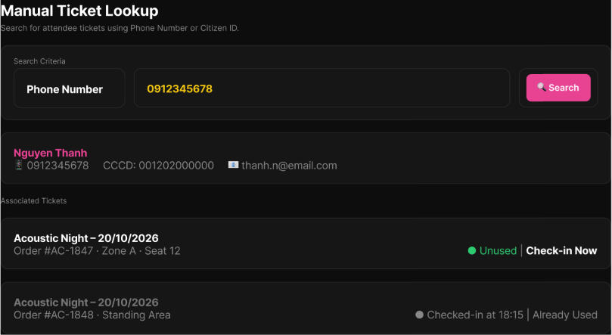
Figure 116: Lookup Ticket Screen
FUNCTION DETAILS:
- VALIDATION RULES:
  - Staff must be authenticated with a valid Access Token and have an active gate assignment.
  - Search input must match the expected format:
    - Phone Number: Valid Vietnamese phone format (10-11 digits)
    - CCCD: Valid Citizen ID format (12 digits)
- NORMAL FLOW:
  - Step 1: The Check-in Staff opens the Manual Ticket Lookup screen.
  - Step 2: The Staff selects the search criteria (Phone Number or CCCD) and enters the value in the input field.
  - Step 3: The Staff clicks the "Search" button.
  - Step 4: The client validates the input format and sends the request with the Access Token in the Authorization header.
  - Step 5: The system validates the Access Token, staff role, and gate assignment.
  - Step 6: The system searches for the attendee using the provided Phone Number or CCCD.
  - Step 7: The system retrieves the attendee's details (Name, Phone, CCCD, Email) and their associated tickets for the current event.
  - Step 8: The system returns the results to the client.
  - Step 9: The client displays the attendee's profile section (showing Name, Phone, CCCD, Email) and the "Associated Tickets" section listing each ticket with Order ID, Zone/Seat, and current status (Unused/Already Used).
  - Step 10: For an "Unused" ticket, the Staff clicks the "Check-in Now" button.
  - Step 11: The system validates the ticket, updates its status to "Used", records the admission time, and returns a success result.
  - Step 12: The client updates the ticket status in the UI to "Checked-in at [time] | Already Used" and adds the entry to the Real-time Scan Feed.
- ABNORMAL FLOWS:
  - Step 1: Staff enters search criteria, clicks Search, or attempts to check-in a ticket from the results.
  - Step 2: System validates authentication, input format (Phone/CCCD), and searches for matching attendee/ticket.
  - Step 3: If validation fails or errors occur, system returns appropriate error (401 Unauthorized, 400 Bad Request for invalid format, empty result for not found) or displays client-side validation error.
  - Step 4: System displays corresponding message ("No attendee found with this information", "Invalid format", or keeps ticket status as "Already Used"), clears or maintains results area as appropriate, and keeps the search interface active for retry.

3.14.5 View Check-in Scan History
FUNCTION TRIGGER:
- Staff opens the "Scan History" screen from the Check-in Terminal.
FUNCTION DESCRIPTION:
- Actor(s): Staff.
- Purpose:
  - To allow staff to inspect the real-time chronological log of tickets scanned at their gate station, including summary statistics and status filters.
- Main Functionality:
  - The system displays the Scan History dashboard with summary statistics (Total Scans, Approved, Already Used, Errors/Invalid), a search bar, and status filter tabs. It renders a chronological table of scanned tickets showing time, attendee details, ticket type, and validation status, with real-time updates pushed via WebSocket or polling.
SCREEN LAYOUT:
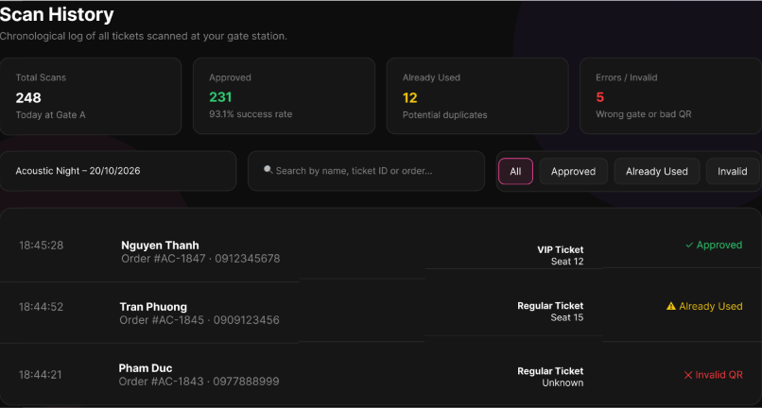
Figure 117 : View Check-in Scan History Screen
FUNCTION DETAILS:
- VALIDATION RULES:
  - User must be authenticated with a valid, unexpired Access Token.
  - User must have an active gate assignment for the current shift.
  - Filter parameters (All, Approved, Already Used, Invalid) must be valid enum values.
  - Search queries must be sanitized to prevent injection attacks.
- NORMAL FLOW:
  - Step 1: The Check-in Staff opens the Scan History screen.
  - Step 2: The client sends a request for the current gate's scan logs and summary statistics, along with the Access Token.
  - Step 3: The system validates the Access Token, staff role, and gate assignment.
  - Step 4: The system retrieves the chronological scan log for the assigned gate and calculates the summary statistics (Total Scans, Approved, Already Used, Warn/Invalid).
  - Step 5: The system returns the data to the client.
  - Step 6: The client displays the Scan History UI, including:
    - Summary Statistics Cards: Total Scans, Approved (with success rate %), Already Used (Potential duplicates), and Errors/Invalid (Wrong gate or bad QR).
    - Controls: Event name/date header, Search bar (by name, ticket ID, or order), and Filter tabs (All, Approved, Already Used, Invalid).
    - Data Table: Chronological list showing Time, Attendee (Name, Order ID, Phone), Ticket Type (Type, Seat), and Status (color-coded: Approved, Already Used, Invalid QR).
- ABNORMAL FLOWS:
  - Step 1: Staff accesses the screen or applies search/filter operations.
  - Step 2: System validates authentication (Access Token) and checks for an active gate assignment.
  - Step 3: If validation fails or errors occur, system returns appropriate error (401 Unauthorized for invalid token, 403/404 for no active gate assignment) and displays corresponding messages (redirecting to login or showing "No active gate assignment found").
  - Step 4: If no records match the search/filter criteria, system displays an empty state in the table; otherwise, system updates the table with the filtered results in real-time.

3.15 Incident Reporting & On-site Support

3.15.1 Report On-site Incident
FUNCTION TRIGGER:
- Check-in Staff encounters an on-site issue at the gate (e.g., duplicate ticket, lost ticket, fraud) and clicks "Report Incident".
FUNCTION DESCRIPTION:
- Actor(s): Check-in Staff..
- Purpose:
  - To allow staff to file an immediate incident log at the gate for issues such as duplicate ticket presentation, lost ticket claims, or fraudulent scalper activity.
- Main Functionality:
  - The system displays an incident reporting form where staff can select the incident type, provide a description, and optionally upload evidence (images/videos) via Cloudinary. The system validates the input, uploads media to Cloudinary, saves the immutable incident log, and notifies relevant supervisors.
SCREEN LAYOUT:
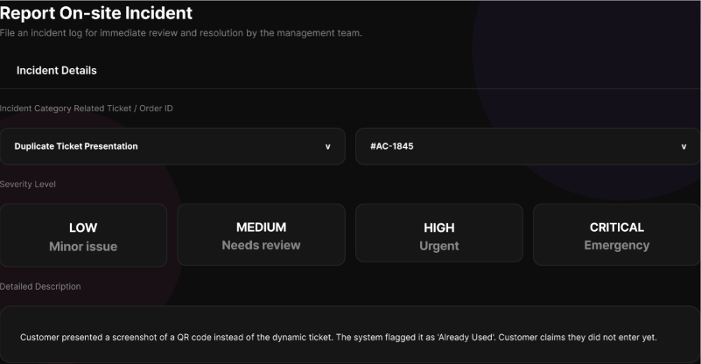
Figure 118: Report On-site Incident Screen
FUNCTION DETAILS:
- VALIDATION RULES:
  - User must be authenticated and logged in with the Check-in Staff role.
  - Incident Type must be selected.
  - Description must not be empty (minimum character limit applies).
  - Uploaded evidence (if any) must meet file size and format constraints (e.g., max 10MB, JPEG/PNG/MP4) before being sent to Cloudinary.
- NORMAL FLOW:
  - Step 1: Check-in Staff encounters an issue at the gate and clicks "Report Incident".
  - Step 2: System displays the incident reporting form.
  - Step 3: Staff selects the Incident Type (e.g., Duplicate Ticket, Lost Ticket, Fraud).
  - Step 4: Staff enters a detailed description of the incident.
  - Step 5: Staff optionally uploads evidence (photos/videos) via the Cloudinary integration.
  - Step 6: Staff clicks "Submit Report".
  - Step 7: Client validates the form fields and file constraints.
  - Step 8: System uploads the evidence to Cloudinary and receives the secure media URLs.
  - Step 9: System saves the incident log (Incident Type, Description, Media URLs, Staff ID, Gate ID, Timestamp) to the database.
  - Step 10: System triggers a notification to the Event Organizer/Supervisor regarding the new incident.
  - Step 11: Client displays a success message ("Incident reported successfully") and returns to the check-in screen.
- ABNORMAL FLOWS:
  - Step 1: Staff cancels the report, or the system encounters validation errors, Cloudinary upload failures, or server errors during the process.
  - Step 2: System processes the cancellation or validates constraints (role, required fields, file limits, external API status).
  - Step 3: Depending on the scenario, the system responds accordingly:
    - Cancel Report: Staff cancels the action. No data is saved, and the modal closes.
    - Validation Error: Missing required fields or invalid file format. Client displays inline error messages on the form.
    - Cloudinary Upload Failure: Media upload fails (e.g., network timeout, file too large). System displays "Failed to upload evidence. Please check file size or try again."
    - Server/Database Error: Incident log fails to save. System returns 500 Internal Server Error. Client displays "Failed to submit incident report. Please try again."
  - Step 4: Client updates the UI accordingly (keeps modal open with data preserved for correction on validation/upload errors, or shows specific error notifications), ensuring no partial incident logs are saved if mandatory media fails to upload.

3.15.2 Attach Evidence
FUNCTION TRIGGER:
- Check-in Staff needs to attach photographic evidence or scanned documents to an incident report and initiates the upload process.
FUNCTION DESCRIPTION:
- Actor(): Check-in Staff..
- Purpose:
  - To allow staff to upload photographic evidence or scanned documents to Cloudinary as part of an incident report.
- Main Functionality:
  - The system provides a file selection interface, validates the file type and size, uploads the file to Cloudinary, retrieves the secure media URL, and attaches it to the current incident report draft for final submission.
SCREEN LAYOUT:
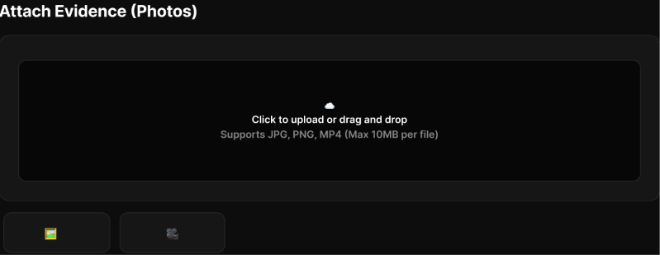
Figure 119 : Attach Evidence Screen
FUNCTION DETAILS:
- VALIDATION RULES:
  - User must be authenticated with the Check-in Staff role.
  - File must be of an allowed type (e.g., JPEG, PNG, PDF).
  - File size must not exceed the maximum limit (e.g., 10MB per file).
  - Maximum number of attachments per incident report must not be exceeded (e.g., max 5 files).
- NORMAL FLOW:
  - Step 1: Check-in Staff clicks the "Attach Evidence" or "Upload" button within the incident report form.
  - Step 2: System opens the file picker dialog or activates the drag-and-drop zone.
  - Step 3: Staff selects one or more photographic evidence files or scanned documents.
  - Step 4: Client validates the selected files against type and size constraints.
  - Step 5: Client requests an upload signature/token from the system backend.
  - Step 6: Client uploads the file directly to Cloudinary using the secure credentials.
  - Step 7: Cloudinary processes the upload and returns the secure media URL and metadata.
  - Step 8: Client updates the UI to show the upload progress and displays the file preview upon success.
  - Step 9: The secure media URL is stored in the client state to be submitted with the final incident report.
- ABNORMAL FLOWS:
  - Step 1: Staff cancels the upload, selects an invalid file, or the system encounters network/Cloudinary API errors.
  - Step 2: Client validates file constraints or handles external API responses.
  - Step 3: Depending on the scenario, the system responds accordingly:
  - Invalid File: File type or size exceeds limits. Client displays "Invalid file format or size. Please select a JPEG, PNG, or PDF under 10MB."
  - Upload Failure: Network error or Cloudinary API rejection. Client displays "Failed to upload file. Please check your connection and try again."
  - Cancel/Remove: Staff cancels the file picker or removes an uploaded file. Client clears the file state and removes the preview.
  - Step 4: Client updates the UI accordingly, keeping the form open and allowing the staff to retry the upload or select a different file without losing other incident report data.

3.15.3 Update Incident Report
FUNCTION TRIGGER:
- Check-in Staff selects "Update" on an open incident report.
FUNCTION DESCRIPTION:
- Actor(s): Staff.
- Purpose:
  - To allow staff to append progress notes or on-site resolution outcomes to an open incident report.
- Main Functionality:
  - The system displays the current incident details and history. The staff member enters a progress note or outcome, confirms the update, and the system appends the new entry with the author and timestamp, refreshing the incident history while strictly preserving all previous records.
SCREEN LAYOUT:
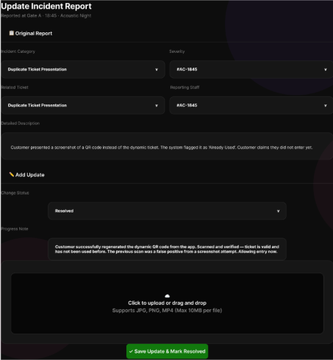
Figure 120: Update Incident Report Screen
FUNCTION DETAILS:
- VALIDATION RULES:
  - User must be authenticated with the Check-in Staff role.
  - Target incident report must exist and currently be in an "Open" status.
  - Progress note or on-site outcome text must not be empty.

- NORMAL FLOW:
  - Step 1: Staff member opens an open incident report.
  - Step 2: System displays the current incident details and history.
  - Step 3: Staff member selects "Update Incident".
  - Step 4: Staff member enters a progress note or on-site outcome.
  - Step 5: System validates the update input and incident status.
  - Step 6: Staff member confirms the update.
  - Step 7: System appends the update with the author (Staff ID) and timestamp to the incident history.
  - Step 8: System displays the refreshed incident history to the staff member.

- ABNORMAL FLOWS:
  - Step 1: Staff member cancels the update, or the system encounters status conflicts or server/data errors.
  - Step 2: System processes the cancellation or validates constraints (authentication, incident status, input requirements).
  - Step 3: Depending on the scenario, the system responds accordingly:
    - Cancel Update: Staff member cancels before confirmation. No new incident update is recorded; modal closes.
    - Incident No Longer Open (EX-01): System rejects the update (e.g., 409 Conflict or 400 Bad Request) because the incident was closed by another user or process. Client refreshes the incident status and displays "This incident is no longer open for updates."
    - Server/Data Error (EX-02): The update cannot be saved. System returns 500 Internal Server Error. Client displays "Failed to save update. Please try again later."
  - Step 4: Client updates the UI accordingly (keeps form open for retry on server errors, or shows specific error notifications and refreshes the view for status conflicts), ensuring no partial updates are committed and previous history remains intact.

3.15.4 Escalate Incident to Admin
FUNCTION TRIGGER:
- Check-in Staff selects "Escalate to Admin" for an open incident.
FUNCTION DESCRIPTION:
- Actor(s): Staff.
- Purpose:
  - To allow staff to escalate complex disputes or detected counterfeiting activity to platform administrators for urgent resolution.
- Main Functionality:
  - The system displays an escalation confirmation prompt, captures the mandatory escalation reason, records the escalation status with actor and timestamp, appends the action to the incident history, and flags the incident for administrator handling.
SCREEN LAYOUT:
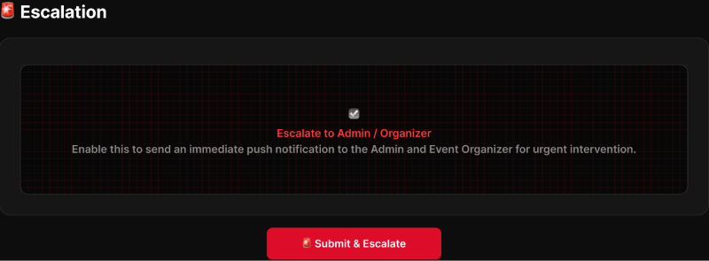
Figure 121: Escalate Incident to Admin Screen
FUNCTION DETAILS:
- VALIDATION RULES:
  - User must be authenticated with the Check-in Staff role.
  - Target incident must exist and currently be in an "Open" status.
  - The incident must not already be resolved or have an active, duplicate escalation.
  - Escalation reason must not be empty.

- NORMAL FLOW:
  - Step 1: Staff member opens the target incident.
  - Step 2: Staff member selects "Escalate to Admin".
  - Step 3: System displays an escalation confirmation modal.
  - Step 4: Staff member provides a mandatory escalation reason.
  - Step 5: Staff member confirms the escalation.
  - Step 6: System validates the incident status and input constraints.
  - Step 7: System records the escalation status, reason, actor (Staff ID), and timestamp.
  - Step 8: System flags the incident as available for administrator handling and updates the incident history.
  - Step 9: System displays the updated incident status to the staff member.

- ABNORMAL FLOWS:
  - Step 1: Staff member cancels the escalation, or the system encounters status conflicts or server/data errors.
  - Step 2: System processes the cancellation or validates constraints (authentication, incident status, duplicate check).
  - Step 3: Depending on the scenario, the system responds accordingly:
    - Cancel Escalation: Staff member cancels the confirmation. The incident remains unchanged; modal closes.
    - Incident Already Resolved (EX-01): System prevents escalation (e.g., 400 Bad Request or 409 Conflict). Client refreshes the incident status and displays "This incident is already resolved and cannot be escalated."
    - Server/Data Error (EX-02): The escalation cannot be recorded. System returns 500 Internal Server Error. Client displays "Failed to escalate incident. Please try again later."
  - Step 4: Client updates the UI accordingly (keeps form open for retry on server errors, or shows specific error notifications and refreshes the view for status conflicts), ensuring no partial state changes are committed.

3.15.5 View Resolution
FUNCTION TRIGGER:
- Check-in Staff opens the resolution information for a specific incident.
FUNCTION DESCRIPTION:
- Actor(s): Staff.
- Purpose:
  - To allow staff to check directives and resolution instructions returned by organizers or administrators for open or resolved incident tickets.
- Main Functionality:
  - The system retrieves and displays the latest resolution status, administrative instructions, notes, and relevant timestamps for a selected incident. This is a strictly read-only operation that does not modify the incident record.
SCREEN LAYOUT:
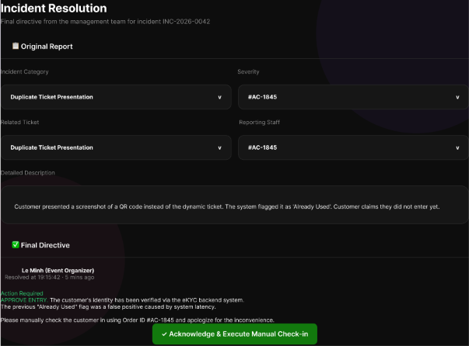
Figure 122 : View Resolution Screen
FUNCTION DETAILS:
- VALIDATION RULES:
  - User must be authenticated with the Check-in Staff role.
  - Target incident must exist and be accessible to the requesting staff member.

- NORMAL FLOW:
  - Step 1: Staff member opens the incident/resolution list.
  - Step 2: Staff member selects a specific incident.
  - Step 3: System retrieves the incident resolution/directive information.
  - Step 4: System displays the resolution status, instructions, notes, and relevant timestamps.
  - Step 5: Staff member reviews the instructions.

- ABNORMAL FLOWS:
  - Step 1: Staff member attempts to view an incident, but it lacks a resolution, is inaccessible, or a server error occurs.
  - Step 2: System validates authentication, incident accessibility, and data availability.
  - Step 3: Depending on the scenario, the system responds accordingly:
    - Resolution Not Yet Available: Incident has no final resolution/directive. System displays the current processing status (e.g., "Pending Admin Review").
    - Incident Not Found/Inaccessible (EX-01): System denies access or displays a "Not Found" message (e.g., 403 Forbidden or 404 Not Found).
    - Server/Data Error (EX-02): Resolution cannot be loaded. System returns 500 Internal Server Error. Client displays "Failed to load resolution details. Please try again later."
  - Step 4: Client updates the UI accordingly (showing processing status, error messages, or access denied notifications), preserving the read-only nature of the operation without modifying any data.

3.16 User Management, Event Approval, Review, Wishlist & Dispute Resolution

3.16.1 View User Account List
FUNCTION TRIGGER:
- Admin clicks "User Accounts" from the admin navigation menu.
FUNCTION DESCRIPTION:
- Actor(s): Admin.
- Purpose:
  - To allow Admin to view the list of all user accounts in the system with filtering and search options for administrative management.
- Main Functionality:
  - The system displays the User Account Management dashboard with summary statistics (Total Users, Active Accounts, Banned, Pending eKYC), search and filter options (by name/email/ID, role, status, eKYC level), and a paginated data table showing user details including name, email, role, status, eKYC verification level, and action buttons (View, Ban/Unban).
SCREEN LAYOUT:
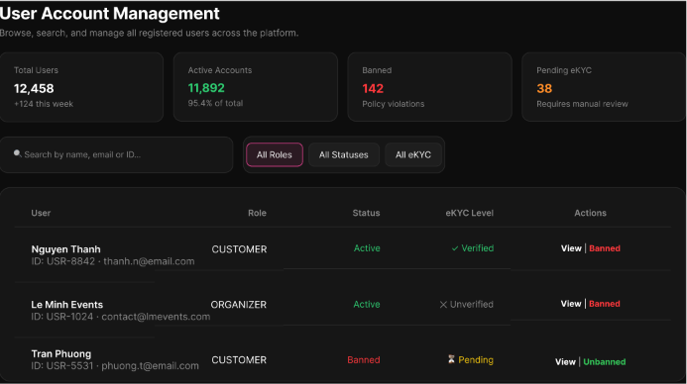
Figure 123: View User Account List Screen
FUNCTION DETAILS:
- VALIDATION RULES:
  - User must be authenticated with Admin role.
  - Admin must have successfully logged in with valid Access Token.
  - Only user accounts with is_deleted = false should be displayed.
  - Pagination parameters must be valid (page number >= 1, page size within allowed range).
  - Search keywords must be sanitized to prevent injection attacks.
- NORMAL FLOW:
  - Step 1: The Admin navigates to "User Accounts" from the admin navigation menu.
  - Step 2: The system retrieves all user accounts from the database, paginated, including user ID, name, email, role, status (active/blocked), and eKYC level.
  - Step 3: The system calculates and displays summary statistics: Total Users count, Active Accounts count, Banned accounts count, and Pending eKYC count.
  - Step 4: The system displays each account in a data table with columns: User (name, email, ID), Role, Status, eKYC Level, and Actions (View, Ban/Unban).
  - Step 5: The system renders filter options: "All Roles", "All Statuses", "All eKYC" dropdowns, and a search bar for searching by name, email, or ID.
- ABNORMAL FLOWS:
  - Step 1: Admin accesses the User Account Management screen or applies search/filter operations.
  - Step 2: System validates authentication (Admin role), authorization, and database connectivity.
  - Step 3: If validation fails or errors occur, system returns appropriate error:
    - 403 Forbidden: If user lacks Admin role.
    - 500 Internal Server Error: For database timeout or system failures.
  - Step 4: System handles response:
    - If no accounts found: Display empty state message.
    - If error: Display error toast "Unable to load user accounts. Please try again later."
    - If search/filter applied: Re-query and display filtered results matching the criteria.

3.16.2 View User Account Details
FUNCTION TRIGGER:
- Admin clicks on a user account row or the "View" button in the User Account List.
FUNCTION DESCRIPTION:
- Actor(s): Admin.
- Purpose:
  - To allow Admin to view detailed information about a specific user account, including profile data, role, eKYC status, order history, and recent activity.
- Main Functionality:
  - The system displays a detailed view of the selected user, showing Profile Information, eKYC Verification status (including AI match score and ID card thumbnails), Order Transaction History, and Recent Activity Log. It also provides administrative action buttons to ban/unban the user or edit profile information.
SCREEN LAYOUT:
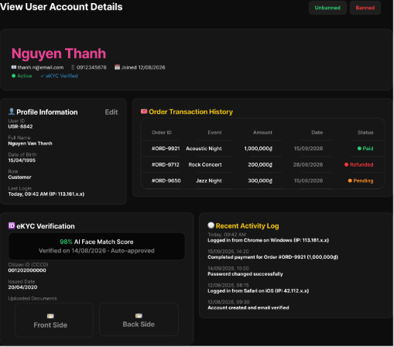
Figure 124 : View User Account Details Screen
FUNCTION DETAILS:
- VALIDATION RULES:
  - User must be authenticated with Admin role.
  - Target user account must exist in the system.
  - Target user account must not be soft-deleted (is_deleted = false).
  - User ID provided in the request must be valid.
- NORMAL FLOW:
  - Step 1: The Admin clicks on a user account row or the "View" button in the User Account List.
  - Step 2: The system retrieves the full account record, including profile data, role, eKYC status, order transaction history, and recent activity logs.
  - Step 3: The system displays the detailed information on the screen, structured into sections:
    - Profile Information: User ID, Name, Email, Phone, Role, Status, and Joined date (with an "Edit" button).
    - eKYC Verification: AI Face Match Score, verification date, approval status, and thumbnails of the Front/Back ID card sides.
    - Order Transaction History: A table listing Order ID, Event, Amount, Date, and Status (Paid, Refunded, Pending).
    - Recent Activity Log: A chronological list of user actions (e.g., logged in, password changed, account created) with timestamps and device/IP info.
  - Step 4: The system displays the "Unbanned" and "Banned" action buttons at the top right corner for account status management.
- ABNORMAL FLOWS:
  - Step 1: Admin attempts to view user details or the system processes the data retrieval request.
  - Step 2: System validates authentication (Admin role) and checks if the target user account exists and is accessible.
  - Step 3: If validation fails or errors occur, system returns appropriate error:
    - 404 Not Found: If the account no longer exists or has been deleted.
    - 500 Internal Server Error: For database timeout or system failures.
  - Step 4: System displays error message "Unable to load account details" and keeps the Admin on the User Account List screen.

3.16.3 Update Account Status
FUNCTION TRIGGER:
- Trigger: Admin clicks the "Block" or "Unblock" button on a user account row and confirms the action.
FUNCTION DESCRIPTION:
- Actor(s): Admin.
- Purpose:
  - To allow Admin to block or unblock a user account, restricting or restoring the user's ability to log in and use the system.
- Main Functionality:
  - The system displays a confirmation modal detailing the consequences of the action. For blocking, it shows an "Irreversible Action" warning and requires a mandatory reason for the audit log. Upon confirmation, the system updates the account status, immediately revokes active sessions (if blocking), and logs the action to the Audit Trail.
SCREEN LAYOUT:
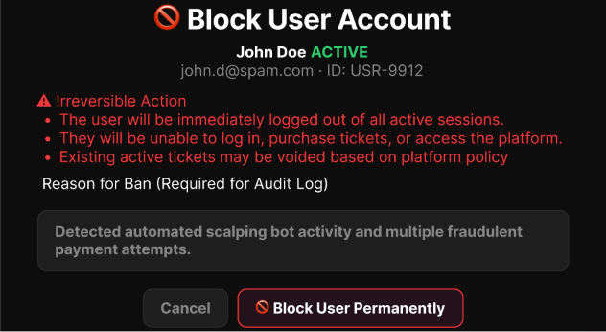
Figure 125 : Update Account Status Screen
FUNCTION DETAILS:
- VALIDATION RULES:
  - User must be authenticated with Admin role.
  - Target user account must exist and must not be the Admin's own account.
  - If blocking, the "Reason for Ban" field is required and must not be empty.
- BUSINESS RULES: BR-111, BR-112, BR-127
- NORMAL FLOW:
  - Step 1: The Admin clicks "Block" (or "Unblock") on a user account.
  - Step 2: The system displays a confirmation popup. If blocking, it shows an "Irreversible Action" warning (red text) detailing consequences (immediate logout, access restriction, ticket voiding) and displays a "Reason for Ban" input field.
  - Step 3: The Admin enters the reason for the ban (if blocking) and confirms the action by clicking "Block User Permanently" (or "Unblock").
  - Step 4: The system validates the input and updates the account's status to "blocked" (or "active") in the database.
  - Step 5: If blocking, the system immediately revokes all active sessions/tokens for that account.
  - Step 6: The system logs the action (including the ban reason) to the Audit Trail.
  - Step 7: The system returns a success message ("Account has been blocked/unblocked") and updates the UI status.
- ABNORMAL FLOWS:
  - Step 1: Admin interacts with the confirmation modal or the system processes the status update.
  - Step 2: System validates authentication, authorization (not own account), and input data (ban reason if blocking).
  - Step 3: If the Admin clicks "Cancel", the system closes the modal without changing the account status.
  - Step 4: If validation fails or system errors occur (e.g., database write failure), the system returns the appropriate error (403 Forbidden for self-blocking, 500 Internal Server Error for system failures) and displays an error message.

3.16.4 Assign/Unassign User Role
FUNCTION TRIGGER:
- Admin clicks the "Assign Role" or "Manage Roles" button on a user account's detail page.
FUNCTION DESCRIPTION:
- Actor(s): Admin.
- Purpose:
  - To allow Admin to assign or change a specific role for a user account, updating the user's access rights within the system.
- Main Functionality:
  - The system displays the Assign Roles modal showing the user's current role and a list of available roles (Event Organizer, Staff, Customer) with their descriptions. The Admin selects a new role, clicks "Save changes", and the system updates the role assignment, logs the audit trail, and applies the changes on the user's next session.
SCREEN LAYOUT:
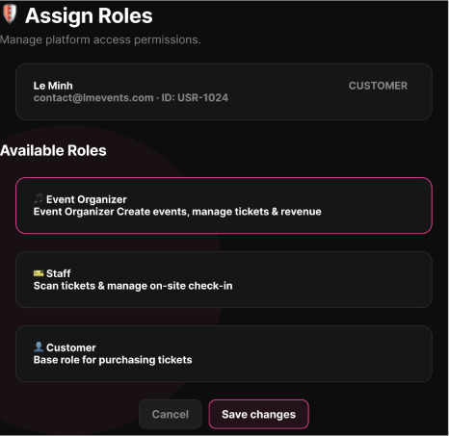
Figure 126 : Assign/Unassign User Role Screen
FUNCTION DETAILS:
- VALIDATION RULES:
  - User must be authenticated with Admin role.
  - Target user account must exist and be active.
  - Selected role must exist in the system's predefined role list.
  - Admin cannot remove the last remaining role from a user (must always have >= 1 role).
- BUSINESS RULES: BR-129, BR-249
- NORMAL FLOW:
  - Step 1: The Admin opens a user account's detail page and clicks "Assign Role".
  - Step 2: The system displays the "Assign Roles" modal, showing the user's current role at the top (e.g., CUSTOMER) and the list of "Available Roles" (Event Organizer, Staff, Customer) with their respective descriptions.
  - Step 3: The Admin selects a new role from the available list (e.g., clicking the "Event Organizer" card).
  - Step 4: The Admin clicks the "Save changes" button.
  - Step 5: The system validates the selection and updates the user's role assignment in the database.
  - Step 6: The system logs the role change action to the Audit Trail.
  - Step 7: The system returns a success message ("Role assigned successfully") and closes the modal, updating the user's role display on the detail page.
- ABNORMAL FLOWS:
  - Step 1: Admin interacts with the Assign Roles modal or system processes the role update request.
  - Step 2: System validates authentication, user existence, and role constraints (ensuring user retains at least one role).
  - Step 3: If Admin clicks "Cancel", system closes modal without changes. If errors occur, system returns appropriate error (500 Internal Server Error for DB failures).
  - Step 4: System displays error message if failed, or simply closes modal if canceled, keeping the previous role assignment intact.

3.16.5 View Organizer Request List
FUNCTION TRIGGER:
- Admin clicks "Organizer Requests" from the admin navigation menu.
FUNCTION DESCRIPTION:
- Actor(s): Admin.
- Purpose:
  - To allow Admin to view and manage applications from customers requesting organizer privileges.
- Main Functionality:
  - The system displays the Organizer Account Requests dashboard with summary statistics (Total Applications, Pending Review, Approved, Rejected), search and filter options, and a data table listing all requests. It shows applicant details, company info, experience, submission date, status, and provides a "Review" action button for each request.
SCREEN LAYOUT:
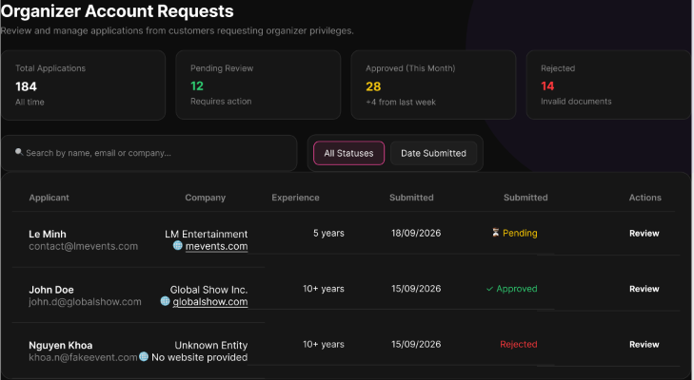
Figure 127 : View Organizer Request List Screen
FUNCTION DETAILS:
- VALIDATION RULES:
  - User must be authenticated with Admin role.
  - Search queries (name, email, company) must be sanitized to prevent injection attacks.
  - Pagination and sorting parameters (e.g., Date Submitted) must be valid.
- BUSINESS RULES: BR-130.
- NORMAL FLOW:
  - Step 1: The Admin navigates to "Organizer Account Requests" from the admin navigation menu.
  - Step 2: The system retrieves all organizer upgrade requests with statuses "Pending", "Approved", and "Rejected", along with summary statistics.
  - Step 3: The system displays summary cards: Total Applications, Pending Review, Approved (This Month), and Rejected.
  - Step 4: The system renders the data table displaying Applicant (Name, Email), Company (Name, Website), Experience, Submitted Date, Status (with color-coded pills), and an "Actions" column with a "Review" button.
  - Step 5: The system renders search and filter options: Search by name/email/company, "All Statuses" dropdown, and "Date Submitted" sorting.
- ABNORMAL FLOWS:
  - Step 1: Admin accesses the screen or applies search/filter operations.
  - Step 2: System validates authentication (Admin role) and database connectivity.
  - Step 3: If validation fails or errors occur, system returns appropriate error (500 Internal Server Error for system failures).
  - Step 4: System handles response: If no requests are found, display "No pending organizer requests."; if error, display error toast "Unable to load organizer requests. Please try again later."

3.16.6 Approve/Reject Organizer Request
FUNCTION TRIGGER:
- Admin clicks "Review" on a pending organizer request, then clicks "Approve" or "Reject".
FUNCTION DESCRIPTION:
- Actor(s): Admin.
- Purpose:
  - To allow Admin to review a Customer's supporting documents and either approve the request (upgrading the account to Organizer) or reject it with a reason.
- Main Functionality:
  - To allow Admin to review a Customer's supporting documents and either approve the request (upgrading the account to Organizer) or reject it with a reason.
SCREEN LAYOUT:
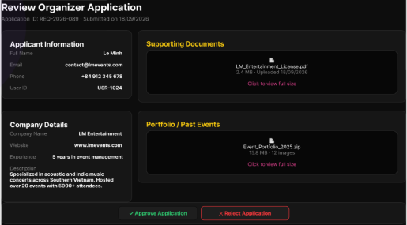
Figure 128 : Approve/Reject Organizer Request Screen
FUNCTION DETAILS:
- VALIDATION RULES:
  - User must be authenticated with Admin role.
  - Selected request must exist and be in "Pending" status.
  - If rejecting, the rejection reason is required and must not be empty.
  - Supporting documents must be accessible and viewable by the Admin.
  - User notification/email service should be operational (but failure doesn't block the approval/rejection).
- BUSINESS RULES: BR-130, BR-249.
- NORMAL FLOW:
  - Step 1: The Admin opens a pending organizer request by clicking "Review" from the request list.
  - Step 2: The system displays the request detail page showing:
    - Event Overview: Event name, date/time, venue, category, seat count
    - Ticket Types: List of proposed ticket types with prices and quantities
    - Supporting Documents: Downloadable/viewable legal documents uploaded by the applicant
    - Refund Policy: The applicant's proposed refund policy text
  - Step 3: The Admin reviews all information and supporting documents.
  - Step 4: If approving, the Admin clicks "Approve Request" button.
  - Step 5: The system displays an "Approve Organizer Request Confirmation" popup.
  - Step 6: The Admin confirms the approval.
  - Step 7: The system updates the request status to "Approved" and upgrades the user's account role to "Organizer".
  - Step 8: The system sends a notification/email to the user informing them of the approval.
  - Step 9: The system logs the action to the Audit Trail.
  - Step 10: If rejecting, the Admin clicks "Reject Request" button, enters a mandatory rejection reason in the text area, and clicks "Save changes".
  - Step 11: The system updates the request status to "Rejected" with the given reason, sends a notification/email to the user, and logs the action.
- ABNORMAL FLOWS:
  - Step 1: Admin interacts with the approval/rejection process or system processes the status update.
  - Step 2: System validates authentication (Admin role), request existence, pending status, and rejection reason (if applicable).
  - Step 3: If Admin clicks "Cancel", system closes popup/modal without changes. If errors occur (database failure, email service failure), system returns 500 Internal Server Error and rolls back partial changes if needed.
  - Step 4: System displays error message "Unable to process this request. Please try again later." and keeps the request in its original state.

3.16.7 View Pending Concert List
FUNCTION TRIGGER:
- Admin navigates to the Concert Approval page.
FUNCTION DESCRIPTION:
- Actor(s): Admin.
- Purpose:
  - To allow Admin to view concerts submitted by Organizers that are currently awaiting review.
- Main Functionality:
  - The system retrieves and displays a list of pending concerts along with their summary information. The Admin can review this list and select a specific concert to open its detailed view for further inspection.
SCREEN LAYOUT:
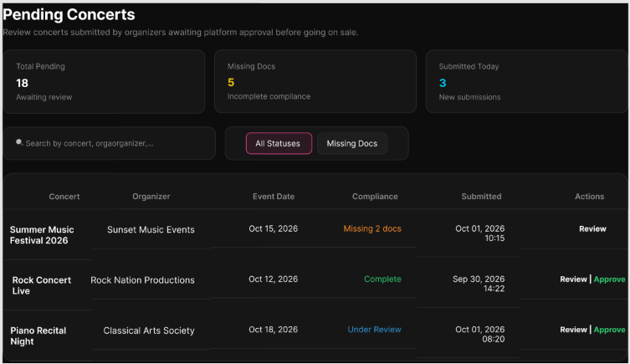
Figure 129: Approve/Reject Organizer Request Screen
FUNCTION DETAILS:
- VALIDATION RULES:
  - User must be authenticated and authorized with the Admin role.
- NORMAL FLOW:
  - Step 1: Admin opens the Concert Approval page.
  - Step 2: System verifies Admin authorization.
  - Step 3: System retrieves the list of Pending concerts.
  - Step 4: System displays the Pending list with summary information for each concert.
  - Step 5: Admin reviews the list.
  - Step 6: Admin selects a specific Pending concert.
  - Step 7: System retrieves the latest detailed information for that concert.
  - Step 8: System opens the detailed concert view for review.

- ABNORMAL FLOWS:
  - Step 1: Admin encounters an empty list, connection issues, or server/data errors during retrieval.
  - Step 2: System validates authorization, data availability, and connection status.
  - Step 3: Depending on the scenario, the system responds accordingly:
  - No Pending Concert: System displays an empty state message (e.g., "No pending concerts to review."). The use case ends.
  - Connection Error: System cannot reach the server, displays an appropriate error message, and ensures no invalid partial update is committed.
  - Server/Data Error: Requested data cannot be loaded. System displays an appropriate error message, and the last valid UI state is preserved.
  - Step 4: Client updates the UI accordingly (showing the empty state or error notifications), preserving the read-only nature of the operation without modifying any data..

3.16.8 Approve/Reject Concert
FUNCTION TRIGGER:
- Admin clicks "Review" on a pending concert submission from the Event Management dashboard.
FUNCTION DESCRIPTION:
- Actor(s): Admin.
- Purpose:
  - To allow Admin to review detailed concert submission information, verify supporting documents, and either approve the event for publication or reject it with a specific reason.
- Main Functionality:
  - The system displays a comprehensive review page containing Event Overview (poster, description, venue, date), Ticket Types, Supporting Documents, and Refund Policy. Admins can take action using "Approve Concert" or "Reject Concert". If rejecting, a mandatory "Reason for Rejection" must be provided before saving changes.
SCREEN LAYOUT:
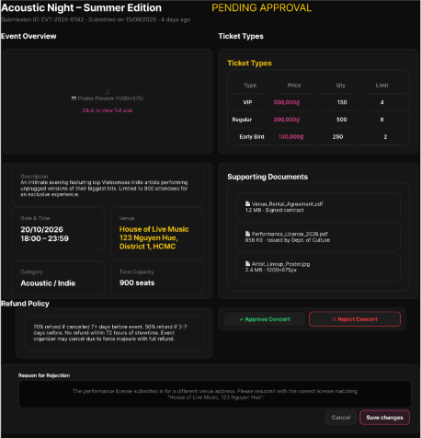
Figure 130 : Approve/Reject Organizer Request Screen

FUNCTION DETAILS:
- VALIDATION RULES:
  - User must be authenticated with Admin role.
  - Target concert submission must exist and be in "Pending Approval" status.
  - If rejecting, the "Reason for Rejection" field must not be empty and must provide clear feedback to the organizer.
  - Supporting documents must be successfully parsed, viewable, and downloadable by the Admin.
- NORMAL FLOW:
  - Step 1: Admin navigates to the concert review page for a pending submission (e.g., "Acoustic Night - Summer Edition").
  - Step 2: System displays the "Event Overview" section including Poster Preview, Description, Date & Time, Venue (e.g., House of Live Music), Category, and Total Seats.
  - Step 3: System displays the "Ticket Types" table showing Type (VIP, Regular, Early Bird), Price, Quantity, and Purchase Limit.
  - Step 4: System displays the "Supporting Documents" section with downloadable files (e.g., Venue Rental Agreement, Performance License) and the "Refund Policy" text.
  - Step 5: Admin reviews all information. To approve, Admin clicks the "Approve Concert" button.
  - Step 6: System updates the concert status to "Approved", notifies the organizer, and logs the action.
  - Step 7: To reject, Admin enters a mandatory explanation in the "Reason for Rejection" text area (e.g., "The performance license submitted is for a different venue address...").
  - Step 8: Admin clicks "Reject Concert" (or "Save changes"). System updates the status to "Rejected", attaches the rejection reason, notifies the organizer, and logs the action.
- ABNORMAL FLOWS:
  - Step 1: Admin interacts with the review page, fills the rejection reason, or clicks action buttons.
  - Step 2: System validates authentication, submission status, and ensures rejection reason is not empty (if rejecting).
  - Step 3: If Admin clicks "Cancel", system discards changes and returns to the previous list. If system/DB errors occur, returns 500 Internal Server Error.
  - Step 4: System displays error message (e.g., "Reason for rejection is required" or "Unable to process request") and keeps the Admin on the review page to retry.

3.16.9 View Ticket Dispute List
FUNCTION TRIGGER:
- Administrator opens the "Ticket Dispute Management" page.
FUNCTION DESCRIPTION:
- Actor(s): Admin.
- Purpose:
  - To allow administrators to monitor formal disputes arising from ticket returns, failed check-ins, or unauthorized resale reports.
- Main Functionality:
  - The system displays the Resolve Dispute screen with dispute summary (Customer, Order ID, Claim Amount) and three resolution action options: Authorize Refund via VNPay, Reissue Admission Ticket(s), or Reject Claim. The Admin selects an action, configures details (refund amount, ticket quantity/type, or rejection reason), adds an internal admin note, and executes the resolution. The system validates the request, executes the selected action (voiding original tickets), updates dispute status to "Resolved", and logs the action.
SCREEN LAYOUT:

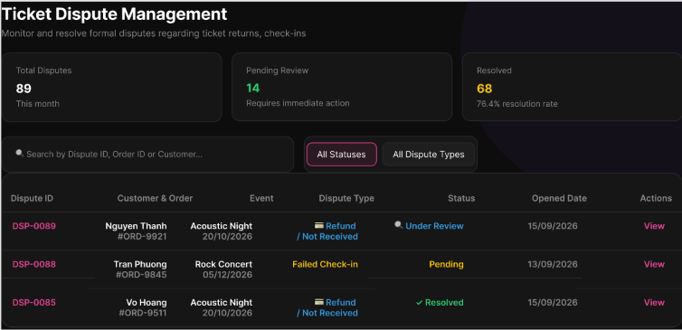
Figure 131: View Ticket Dispute List Screen
FUNCTION DETAILS:
- VALIDATION RULES:
  - User must be authenticated with a valid, unexpired Access Token.
  - User must have Administrator or Support Manager role.
  - Filter parameters (Status, Dispute Type) must be valid enum values.
  - Search queries must be sanitized to prevent injection attacks.
  - Pagination parameters must be within acceptable ranges.
- NORMAL FLOW:
  - Step 1: The Administrator opens the Ticket Dispute Management page.
  - Step 2: The client sends a request for the dispute summary statistics and the dispute list, along with the Access Token.
  - Step 3: The system validates the Access Token and verifies the Administrator role.
  - Step 4: The system retrieves the dispute records (sorted by Opened Date, newest first) and calculates the summary statistics (Total Disputes, Pending Review, Resolved).
  - Step 5: The system returns the data to the client.
  - Step 6: The client displays the summary statistics cards and the dispute list table showing: Dispute ID (e.g., DSP-0089), Customer & Order (Name + Order ID), Event name, Dispute Type (Refund/Not Received, Failed Check-in), Status (Under Review, Pending, Resolved), Opened Date, and Actions (View button).
- ABNORMAL FLOWS:
  - Step 1: Admin accesses the page or applies filters/search.
  - Step 2: System validates authentication, authorization (Admin role), and data retrieval.
  - Step 3: If validation fails or errors occur, system returns appropriate error (401 Unauthorized for invalid token, 403 Forbidden for insufficient permissions, 500 for system errors).
  - Step 4: System handles response: If no disputes found, display "No disputes found."; if error, display error message and redirect to login or show access denied as appropriate.

3.16.10 View Dispute Details
FUNCTION TRIGGER:
- Administrator clicks the "View" button on a dispute in the Ticket Dispute List.
FUNCTION DESCRIPTION:
- Actor(s): Admin.
- Purpose:
  - To allow administrators to review evidence, payment records, eKYC credentials, and statements from all involved parties for a specific ticket dispute.
- Main Functionality:
  - The system displays a comprehensive dispute review page containing the Issue Description, Payment Record, Attached Evidence files, and Customer eKYC Credential. It handles missing data gracefully by displaying "N/A" and provides a "Resolve Dispute" action button for the Admin to proceed with the investigation.
SCREEN LAYOUT:
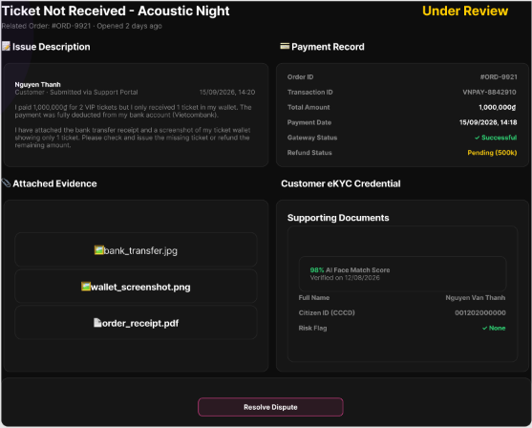
Figure 132: View Dispute Details Screen
FUNCTION DETAILS:
- VALIDATION RULES:
  - User must be authenticated with a valid, unexpired Access Token.
  - User must have the Administrator role.
  - Dispute ID must be valid and exist in the system.
- NORMAL FLOW:
  - Step 1: The Administrator clicks the "View" button for a specific dispute in the Ticket Dispute List.
  - Step 2: The client sends a request with the Dispute ID and the Access Token in the Authorization header.
  - Step 3: The system validates the Access Token and verifies the Administrator role.
  - Step 4: The system validates the Dispute ID and checks that it exists.
  - Step 5: The system retrieves the full dispute details: Issue Description (customer statement), Payment Record (Order ID, Transaction ID, Amount, Gateway/Refund Status), Attached Evidence files, and Customer eKYC Credential (Name, CCCD, Risk Flag).
  - Step 6: The system returns the dispute details.
  - Step 7: The client displays the "View Dispute Details" screen with all retrieved information organized into sections:
    - Issue Description: Customer statement and submission date.
    - Payment Record: Order ID, Transaction ID, Total Amount, Payment Date, Gateway Status, Refund Status.
    - Attached Evidence: List of downloadable files (images, PDFs).
    - Customer eKYC Credential: AI Face Match Score, Full Name, Citizen ID (CCCD), Risk Flag.
    - Action: "Resolve Dispute" button at the bottom.
- ABNORMAL FLOWS:
  - Step 1: Admin requests dispute details or system processes the data retrieval.
  - Step 2: System validates authentication, authorization, and Dispute ID existence.
  - Step 3: If validation fails or errors occur, system returns appropriate error (401 Unauthorized, 403 Forbidden, 404 Not Found) or handles missing data by returning "N/A" for unavailable sections (eKYC, Payment).
  - Step 4: System displays the corresponding error message (redirecting to login or dispute list) or renders the detail screen with "N/A" placeholders for missing data.

3.16.11 Resolve Ticket Dispute
FUNCTION TRIGGER:
- Administrator clicks the "Resolve Dispute" button on the View Dispute Details screen.
FUNCTION DESCRIPTION:
- Actor(s): Admin.
- Purpose:
  - To allow administrators to execute a binding dispute judgment, authorizing full/partial refund via VNPay or reissuing valid admission tickets.
- Main Functionality:
  - The system displays a comprehensive dispute review page containing the Issue Description, Payment Record, Attached Evidence files, and Customer eKYC Credential. It handles missing data gracefully by displaying "N/A" and provides a "Resolve Dispute" action button for the Admin to proceed with the investigation.
SCREEN LAYOUT:
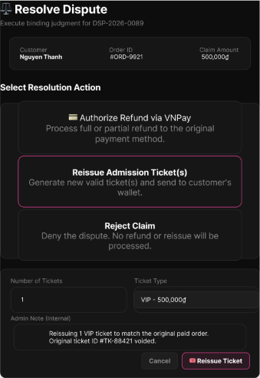
Figure 133: Resolve Ticket Dispute Screen
FUNCTION DETAILS:
- VALIDATION RULES:
  - User must be authenticated with a valid, unexpired Access Token.
  - User must have the Administrator role.
  - Dispute must exist and be in a resolvable state (not already resolved).
  - For Refund: Refund amount must be > 0 and <= claim amount.
  - For Reissue: Number of tickets must be > 0 and valid ticket type must be selected.
  - For Reject: Rejection reason must be provided.
  - Admin Note is optional but recommended for audit purposes.
- NORMAL FLOW:
  - Step 1: The Administrator clicks "Resolve Dispute" on the dispute details screen.
  - Step 2: The client opens the Resolve Dispute screen, displaying the dispute summary (Customer name, Order ID, Claim Amount) and the three resolution action options: "Authorize Refund via VNPay", "Reissue Admission Ticket(s)", and "Reject Claim".
  - Step 3: The Administrator selects one resolution action (e.g., "Reissue Admission Ticket(s)"), configures the required details (Number of Tickets: 1, Ticket Type: VIP - 500,000đ), and writes an internal Admin Note (e.g., "Reissuing 1 VIP ticket to match the original paid order. Original ticket ID #TK-88421 voided.").
  - Step 4: The Administrator clicks the corresponding confirmation button (e.g., "Reissue Ticket", "Authorize Refund", or "Reject Claim").
  - Step 5: The client validates the input and sends the resolution request with the Access Token.
  - Step 6: The system validates the Admin role, verifies the dispute is still in a resolvable state, and validates the input data.
  - Step 7: The system executes the selected resolution action:
    - If Reissue: Generates new valid ticket(s) based on configuration and automatically sends them to the customer's digital wallet.
    - If Refund: Processes full or partial refund via VNPay to the original payment method.
    - If Reject: Denies the dispute with no refund or reissue.
  - Step 8: The system voids the original disputed ticket(s) associated with the claim, updates the dispute status to "Resolved", saves the Admin Note, and logs the resolution action.
  - Step 9: The system returns a success result.
  - Step 10: The client displays a success message and returns the Administrator to the Ticket Dispute List.
- ABNORMAL FLOWS:
  - Step 1: Admin interacts with the resolution form, selects an action, or system processes the resolution request.
  - Step 2: System validates authentication, authorization (Admin role), dispute status (resolvable state), and input data based on selected action.
  - Step 3: If validation fails or errors occur, system returns appropriate error (401 Unauthorized, 403 Forbidden, 409 Conflict if already resolved, 500 for system failures). If Admin clicks "Cancel", system discards changes and returns to View Dispute Details.
  - Step 4: System displays error message and keeps Admin on the resolution screen to retry, or returns to Dispute List if dispute was already resolved by another admin.

3.16.12 Review eKYC
FUNCTION TRIGGER:
- Admin selects an eKYC submission with a "Borderline Match Score" from the Manual eKYC Review Queue.
FUNCTION DESCRIPTION:
- Actor(s): Admin.
- Purpose:
  - To allow Admins to manually review and make a final decision on eKYC submissions where the automated AI biometric matching system could not confidently approve or reject.
- Main Functionality:
  - The system displays the applicant's profile, AI analysis (borderline match score and flags), OCR extracted data compared against system data, and uploaded credentials (CCCD front/back, liveness selfie). The Admin visually compares the documents and either approves the verification or rejects it with a mandatory reason, updating the user's KYC status, logging the audit trail, and notifying the customer.
SCREEN LAYOUT:
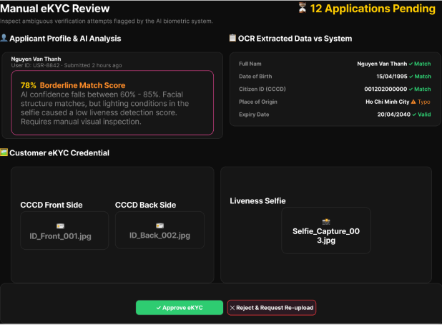
Figure 134 : Review eKYC Screen
FUNCTION DETAILS:
- VALIDATION RULES:
  - User must be authenticated and have the "eKYC Reviewer" permission.
  - Target eKYC submission must exist and be in "Pending Manual Review" status.
  - If rejecting, a rejection reason must be provided and cannot be empty.
  - The submission must not have been already resolved by another admin (concurrency check).
- NORMAL FLOW:
  - Step 1: The Admin navigates to the eKYC Review Queue and selects a submission flagged with a "Borderline Match Score".
  - Step 2: The system displays the "Manual eKYC Review" screen showing the total pending application count and the submission details.
  - Step 3: The system displays the "Applicant Profile & AI Analysis" section, highlighting the AI confidence score (e.g., 78% Borderline) and specific flags (e.g., lighting conditions, liveness detection issues).
  - Step 4: The system displays the "OCR Extracted Data vs System" section, comparing fields like Full Name, Date of Birth, Citizen ID, Place of Origin, and Expiry Date, indicating matches, typos, or validity.
  - Step 5: The system displays the "Customer eKYC Credential" section with viewable/downloadable images for the CCCD Front Side, CCCD Back Side, and Liveness Selfie.
  - Step 6: The Admin visually compares the document photos against the selfie and checks the OCR data for consistency.
  - Step 7: The Admin clicks the "Approve eKYC" button.
  - Step 8: The system updates the submission status to "Verified" and marks the customer's account as KYC-verified.
  - Step 9: The system logs the decision (Admin ID, timestamp, decision = Approved) in the audit log.
  - Step 10: The system sends a notification email to the customer confirming successful verification.
  - Step 11: The system displays a success confirmation to the Admin, removes the submission from the queue, and updates the "Applications Pending" count.
- ABNORMAL FLOWS:
  - Step 1: Admin interacts with the review screen (approves, rejects, or system processes the request).
  - Step 2: System validates authentication, permissions, submission status, and concurrency (checks if already resolved by another admin).
  - Step 3: If Admin clicks "Reject & Request Re-upload", system prompts for a mandatory reason, updates status to "Rejected", logs the action, and notifies the customer. If concurrency fails, system returns 409 Conflict and refreshes the queue.
  - Step 4: If a system error occurs (500 Internal Server Error), system logs the error, rolls back any partial changes, keeps the submission in "Pending Manual Review", and displays an error message to the Admin.

3.16.13 Moderate Reviews
FUNCTION TRIGGER:
- Admin clicks "Reviews" from the admin moderation menu.
FUNCTION DESCRIPTION:
- Actor(s): Admin.
- Purpose:
  - To allow Admins to monitor and manage user-submitted reviews to enforce community standards and identify content that violates platform policies.
- Main Functionality:
  - The system displays the Review Moderation dashboard with summary statistics (Total, Visible, Hidden, Reported), search and filter options, and a comprehensive data table. Admins can view review details and toggle the visibility status (Hide/Unhide) of reviews directly from the list.
SCREEN LAYOUT:
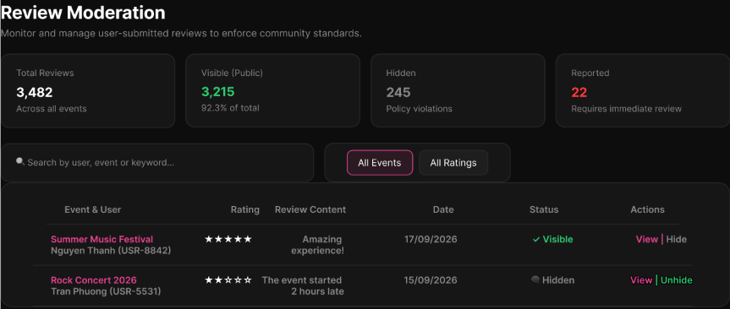
Figure 135: Moderate Reviews Screen
FUNCTION DETAILS:
- VALIDATION RULES:
  - User must be authenticated with Admin role.
  - Search queries (user, event, keyword) must be sanitized to prevent injection attacks.
  - Filter parameters (All Events, All Ratings) must be valid enum values.
- BUSINESS RULES: BR-120, BR-126, BR-131
- NORMAL FLOW:
  - Step 1: The Admin navigates to "Reviews" under the admin moderation tools.
  - Step 2: The system retrieves all reviews across all events, calculates summary statistics, and sorts them chronologically.
  - Step 3: The system displays the summary statistics cards at the top: Total Reviews, Visible (Public), Hidden (Policy violations), and Reported (Requires immediate review).
  - Step 4: The system renders the search bar ("Search by user, event or keyword...") and filter dropdowns ("All Events", "All Ratings").
  - Step 5: The system displays the review data table with columns: Event & User (Event name, Reviewer name, User ID), Rating (star icons), Review Content, Date, Status (Visible/Hidden), and Actions (View/Hide or View/Unhide buttons).
- ABNORMAL FLOWS:
  - Step 1: Admin accesses the page or applies search/filter operations.
  - Step 2: System validates authentication (Admin role) and retrieves review data.
  - Step 3: If validation fails or errors occur (e.g., database timeout), system returns 500 Internal Server Error. If no reviews match the criteria, system returns an empty list.
  - Step 4: System displays "Unable to load reviews" error toast or "No reviews found" empty state in the table area.

3.16.14 Hide/Unhide Review
FUNCTION TRIGGER:
- Admin clicks the "Hide" or "Unhide" (Show) button on a review in the Review List.
FUNCTION DESCRIPTION:
- Actor(s): Admin.
- Purpose:
  - To allow Admins to hide reviews that violate platform policies from public view, or restore previously hidden reviews.
- Main Functionality:
  - The system displays a "Moderate Review" confirmation modal showing the full review details (reviewer, event, rating, content). The Admin confirms the action to change the visibility status. The system updates the status, logs the action to the Audit Trail, and ensures Admin moderation takes precedence over Organizer settings.
SCREEN LAYOUT:
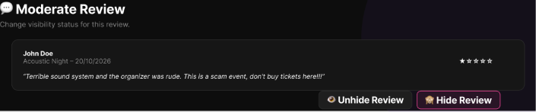
Figure 136 : Hide/Unhide Review Screen
FUNCTION DETAILS:
- VALIDATION RULES:
  - User must be authenticated with Admin role.
  - Target review must exist in the system.
- BUSINESS RULES: BR-126, BR-131
- NORMAL FLOW:
  - Step 1: The Admin clicks "Hide" or "Unhide" on a review in the Review List.
  - Step 2: The system displays the "Moderate Review" modal with the subtitle "Change visibility status for this review."
  - Step 3: The modal displays the review details: Reviewer Name (e.g., John Doe), Event & Date (e.g., Acoustic Night - 20/10/2026), Star Rating, and Review Content.
  - Step 4: The Admin clicks the corresponding action button ("Hide Review" or "Unhide Review").
  - Step 5: The system updates the review's visibility status to "hidden" or "visible".
  - Step 6: The system logs the action to the Audit Trail.
  - Step 7: The system returns success, closes the modal, and updates the review's status in the UI list. (If hidden, the review no longer appears publicly).
- ABNORMAL FLOWS:
  - Step 1: Admin interacts with the moderation modal or system processes the status update request.
  - Step 2: System validates authentication (Admin role) and review existence.
  - Step 3: If Admin closes/cancels the modal, system discards changes. If a system error occurs (e.g., database write failure), system returns 500 Internal Server Error.
  - Step 4: System displays an error message ("Unable to update the review's visibility. Please try again later."), keeps the modal open, and leaves the review's visibility status unchanged.

3.16.15 Create Support Case
FUNCTION TRIGGER:
- Authorized actor selects "Create Support Case" while handling a customer issue.
FUNCTION DESCRIPTION:
- Actor(s): Admin, .Security/Support Staff
- Purpose:
  - To allow authorized staff to open a support case for a customer issue, optionally linking it to related orders, tickets, or payments for context.
- Main Functionality:
  - The system displays a case creation form. The actor enters the issue description, priority, and optional transaction references. The system validates the inputs, creates the case with an initial status, links valid references, and displays the newly created case.
SCREEN LAYOUT:
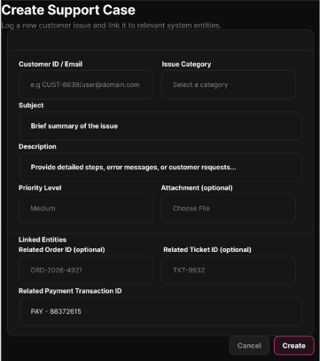
Figure 137 : Create Support Case Screen

FUNCTION DETAILS:
- VALIDATION RULES:
  - User must be authenticated and authorized to manage support cases.
  - Issue description and priority are mandatory fields.
  - If provided, referenced Order/Ticket/Payment IDs must exist and be accessible to the actor.

- NORMAL FLOW:
  - Step 1: Actor opens the support case management page.
  - Step 2: Actor selects "Create Support Case".
  - Step 3: System displays the case creation form.
  - Step 4: Actor enters the issue description, priority, and any available related transaction references.
  - Step 5: Actor submits the case.
  - Step 6: System validates the input information and referenced IDs.
  - Step 7: System creates the case with the creator ID, timestamp, and initial status/priority.
  - Step 8: System links valid references and displays the newly created case details.

- ABNORMAL FLOWS:
  - Step 1: Actor cancels the action, omits optional references, or the system encounters validation or server errors.
  - Step 2: System processes the action or validates constraints (authentication, required fields, reference validity).
  - Step 3: Depending on the scenario, the system responds accordingly:
    - Cancel: Actor cancels the action. No case is created; the form closes.
    - No Optional Reference (A.1): Actor submits without transaction references. System successfully creates the case using only the required customer and issue information.
    - Invalid Linked Reference (EX-01): System rejects the invalid reference (e.g., 400 Bad Request). Client displays "Invalid reference ID. Please check and correct."
    - Server/Data Error (EX-02): System fails to create the case (e.g., 500 Internal Server Error). Client displays "Failed to create support case. Please try again later."
  - Step 4: Client updates the UI accordingly (keeps the form open with data preserved for correction on validation errors, or shows specific error notifications), ensuring no partial or invalid cases are committed.

3.16.16 View Support Case List
FUNCTION TRIGGER:
- Authorized actor opens the Support Case List page.
FUNCTION DESCRIPTION:
- Actor(s): Admin, .Security/Support Staff
- Purpose:
  - To allow authorized staff to browse and filter support cases by status, priority, and assignee.

- Main Functionality:
  - The system retrieves and displays support cases within the actor's authorized scope, including case identifiers, status, priority, assignee, and summary information. The actor can apply filters to refine the list.
SCREEN LAYOUT:
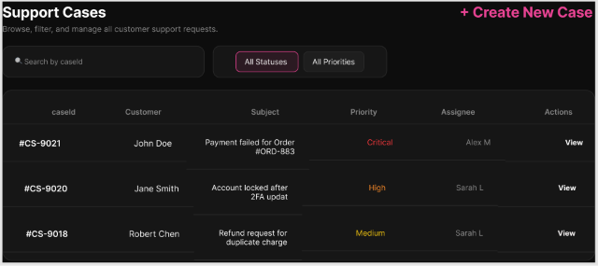
Figure 138 : View Support Case List Screen
FUNCTION DETAILS:
- VALIDATION RULES:
  - User must be authenticated and authorized to view support cases.
  - Filter parameters (if applied) must be valid enums or strings.

- NORMAL FLOW:
  - Step 1: Actor opens the Support Case List.
  - Step 2: System retrieves support cases within the actor's authorized scope.
  - Step 3: System displays case identifiers, status, priority, assignee, and summary information.
  - Step 4: Actor optionally applies filters by status, priority, or assignee.
  - Step 5: System refreshes the list using the selected filters.
  - Step 6: Actor may select a specific case to view its details.

- ABNORMAL FLOWS:
  - Step 1: Actor applies filters that yield no results, or the system encounters a server/data error.
  - Step 2: System validates the request and data availability.
  - Step 3: Depending on the scenario, the system responds accordingly:
  - No Matching Cases: System returns an empty list. Client displays an empty-state message (e.g., "No support cases match the selected filters.").
  - Server/Data Error: System fails to load the list (e.g., 500 Internal Server Error). Client displays "Failed to load support case list. Please try again later."
  - Step 4: Client updates the UI accordingly, preserving the read-only state without modifying any data.

3.16.17 View Support Case Details
FUNCTION TRIGGER:
- Authorized actor selects a support case from the case list.
FUNCTION DESCRIPTION:
- Actor(s): Admin, Security/Support Staff
- Purpose:
  - To allow authorized staff to view a support case in full, including linked transactions, message history, and handling notes.
- Main Functionality:
  - The system validates access, retrieves full case details (linked order/ticket/payment references, message history, handling notes, status, priority, and assignee), and displays them for review.
SCREEN LAYOUT:
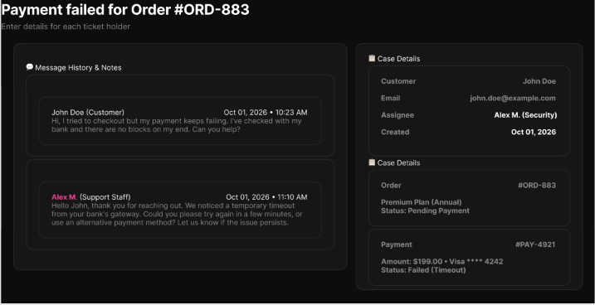
Figure 139 : View Support Case Details Screen
FUNCTION DETAILS:
- VALIDATION RULES:
  - User must be authenticated and authorized.
  - Target support case must exist and be accessible to the requesting actor.

- NORMAL FLOW:
  - Step 1: Actor selects a support case from the list.
  - Step 2: System validates access to the selected case.
  - Step 3: System retrieves the case information, linked transaction references, message history, handling notes, status, priority, and assignee.
  - Step 4: System displays the full support case details.
  - Step 5: Actor reviews the details and may continue to an allowed handling action.

- ABNORMAL FLOWS:
  - Step 1: Actor attempts to view a case, but linked data is unavailable, access is denied, or a server error occurs.
  - Step 2: System validates access permissions and data availability.
  - Step 3: Depending on the scenario, the system responds accordingly:
    - Linked Transaction Unavailable: A previously linked transaction is no longer accessible. System displays the case details but marks that specific reference as "Unavailable" or "Restricted".
    - Case Not Found/Inaccessible: System denies access (e.g., 403 Forbidden or 404 Not Found). Client displays "Case not found or you do not have permission to view it."
    - Server/Data Error: System fails to load details (e.g., 500 Internal Server Error). Client displays "Failed to load case details. Please try again later."
  - Step 4: Client updates the UI accordingly, preserving the read-only state without modifying any data.

3.16.18 Assign Support Case to Staff
FUNCTION TRIGGER:
- Platform Administrator selects "Assign Staff" for a support case.
FUNCTION DESCRIPTION:
- Actor(s): Admin.
- Purpose:
  - To allow platform administrators to assign or reassign a support case to an eligible Security/Support Staff member for handling.
- Main Functionality:
  - The system displays a list of eligible Security/Support Staff accounts. The administrator selects a staff member and confirms the assignment. The system validates eligibility, updates the case assignee, records the action in the case history, and displays the updated case details.
SCREEN LAYOUT:
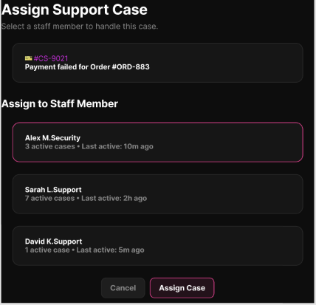
Figure 140 : Assign Support Case to Staff Screen
FUNCTION DETAILS:
- VALIDATION RULES:
  - User must be authenticated and authorized as a Platform Administrator.
  - Target support case must exist and must not be in a "Closed" status.
  - Selected staff member must be an active, eligible account with the Security/Support Staff role.

- NORMAL FLOW:
  - Step 1: Platform Administrator opens the target support case.
  - Step 2: Platform Administrator selects "Assign Staff".
  - Step 3: System displays a list of eligible Security/Support Staff accounts.
  - Step 4: Platform Administrator selects a staff member.
  - Step 5: System validates the selected staff member's eligibility.
  - Step 6: Platform Administrator confirms the assignment.
  - Step 7: System records the new assignee and assignment timestamp.
  - Step 8: System appends the assignment action to the case history and displays the updated case.

- ABNORMAL FLOWS:
  - Step 1: Administrator cancels the action, reassigns an existing case, or the system encounters eligibility or status conflicts.
  - Step 2: System processes the cancellation or validates constraints (admin role, case status, staff eligibility).
  - Step 3: Depending on the scenario, the system responds accordingly:
  - Cancel: Administrator cancels the action. No changes are made; the modal closes.
  - Reassign Case (A.1): The case already has an assignee. Administrator selects a new eligible staff member. System records the new assignment while preserving the previous assignment history.
  - Staff No Longer Eligible (EX-01): System rejects the assignment (e.g., 400 Bad Request or 409 Conflict). Client refreshes the eligible-staff list and displays "Selected staff is no longer eligible. Please select another."
  - Case Already Closed (EX-02): System prevents assignment (e.g., 400 Bad Request). Client displays "This case is already closed and cannot be assigned."
  - Step 4: Client updates the UI accordingly (keeps the modal open with data preserved for correction on eligibility errors, or shows specific error notifications), ensuring no invalid assignments are committed.

3.16.19 Resolve/Close Support Case
FUNCTION TRIGGER:
- Assigned Security/Support Staff selects "Resolve/Close" for a support case.
FUNCTION DESCRIPTION:
- Actor(s): Security/Support Staff.
- Purpose:
  - To allow staff to record the resolution of an assigned support case, close it, and notify the customer of the outcome.
- Main Functionality:
  - The system displays the case details, prompts the staff to enter a resolution, validates the input, records the resolution and closure timestamp, updates the case status to "Closed", and initiates a customer outcome notification.
SCREEN LAYOUT:
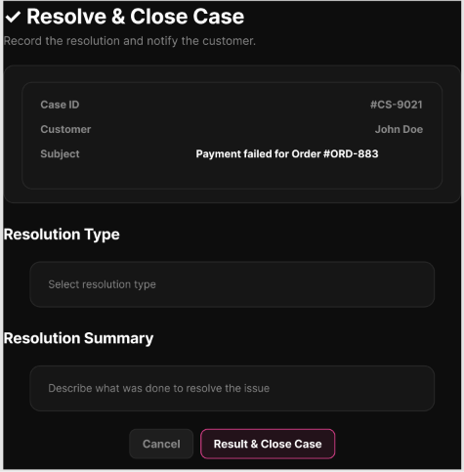
Figure 141 : Resolve/Close Support Case Screen
FUNCTION DETAILS:
- VALIDATION RULES:
  - User must be authenticated with the Security/Support Staff role.
  - User must be assigned to the case or have authorized handling access.
  - Target case must exist and must not already be in a "Closed" status.
  - Resolution details must not be empty.

- NORMAL FLOW:
  - Step 1: Staff member opens the assigned support case.
  - Step 2: System displays the current case details and history.
  - Step 3: Staff member selects "Resolve/Close Case".
  - Step 4: Staff member enters the resolution details.
  - Step 5: Staff member confirms closure.
  - Step 6: System validates that a resolution has been provided and the case is eligible for closure.
  - Step 7: System records the resolution, updates the case status to "Closed", and logs the resolver ID and closure time.
  - Step 8: System initiates the customer outcome notification (e.g., email) when applicable.
  - Step 9: Client displays a success message and refreshes the case view to reflect the "Closed" status.

- ABNORMAL FLOWS:
  - Step 1: Staff member cancels the action, omits the resolution, or the system encounters status conflicts.
  - Step 2: System processes the cancellation or validates constraints (assignment, current status, required fields).
  - Step 3: Depending on the scenario, the system responds accordingly:
    - Keep Case Open (Cancel): Staff member cancels closure. No state change occurs; modal closes. Staff may add handling notes instead.
    - Missing Resolution: System prevents closure (e.g., 400 Bad Request). Client displays inline error: "Resolution details are required to close the case."
    - Case Already Closed: System detects the case was closed concurrently. Client refreshes the current case status and displays "This case has already been closed."
  - Step 4: Client updates the UI accordingly (keeps form open for correction on validation errors, or shows specific error notifications), ensuring no partial or invalid closures are committed.

3.16.20 Process Full/Partial Refund
FUNCTION TRIGGER:
- Authorized actor selects "Refund" for an eligible order or ticket.
FUNCTION DESCRIPTION:
- Actor(s): Admin, Ticketing/Operations Staff
- Purpose:
  - To allow authorized staff to process a full or partial refund for an order or ticket through VNPay, strictly adhering to the refund policy version applicable at the time of purchase.
- Main Functionality:
  - The system displays the applicable refund policy and maximum refundable amount. The actor selects a full refund or enters a partial amount. The system validates eligibility and amount, sends the refund request to VNPay, records the gateway result, and updates the internal refund/order/ticket status.
SCREEN LAYOUT:
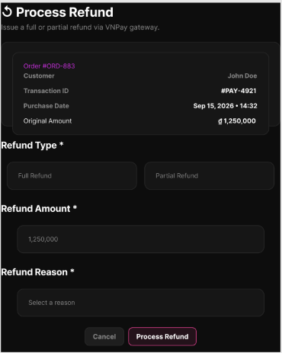
Figure 142 : Process Full/Partial Refund Screen
FUNCTION DETAILS:
- VALIDATION RULES:
  - User must be authenticated and authorized to process refunds.
  - Target order/ticket must exist and be eligible for refund.
  - The applicable refund policy version and maximum refundable amount must be determinable.
  - Requested refund amount must be <= maximum refundable amount.

- NORMAL FLOW:
  - Step 1: Actor opens an eligible order or ticket.
  - Step 2: Actor selects "Process Refund".
  - Step 3: System displays the applicable refund policy and maximum refundable amount.
  - Step 4: Actor selects "Full Refund" or enters a "Partial Refund" amount.
  - Step 5: System validates refund eligibility and the requested amount.
  - Step 6: Actor confirms the refund.
  - Step 7: System sends the refund request to VNPay.
  - Step 8: VNPay returns the refund result.
  - Step 9: System records the successful refund reference, amount, actor ID, and timestamp.
  - Step 10: System updates the relevant refund, order, or ticket status.

- ABNORMAL FLOWS:
  - Step 1: Actor cancels the action, enters an invalid amount, or the system encounters external API or server errors.
  - Step 2: System processes the cancellation or validates constraints (eligibility, amount limits, VNPay response).
  - Step 3: Depending on the scenario, the system responds accordingly:
    - Cancel: Actor cancels before confirmation. No refund is processed; modal closes.
    - Partial Refund (Valid Variant): Actor enters an amount lower than the maximum. System validates and processes only that specific amount (continues Normal Flow).
    - Refund Amount Exceeds Limit (EX-01): System rejects the request (e.g., 400 Bad Request). Client displays "Refund amount exceeds the maximum refundable amount."
    - VNPay Refund Failure/Timeout (EX-02): System records the failed attempt without marking the refund as successful. Client displays "Refund request failed or timed out at the payment gateway. The attempt is logged for review/retry."
  - Step 4: Client updates the UI accordingly (keeps form open for correction on validation errors, or shows specific error notifications), ensuring no partial or unverified refunds are committed.

3.16.21 Retry Failed Refund
FUNCTION TRIGGER:
- Authorized actor selects "Retry" for a failed refund record.
FUNCTION DESCRIPTION:
- Actor(s): Admin, Ticketing/Operations Staff.
- Purpose:
  - To allow authorized staff to retry a refund that previously failed at VNPay without creating a duplicate refund transaction.
- Main Functionality:
  - The system verifies that no successful refund already exists for the target record, reuses the existing refund request/idempotency reference, sends the retry request to VNPay, and updates the refund status based on the new gateway result.
SCREEN LAYOUT:
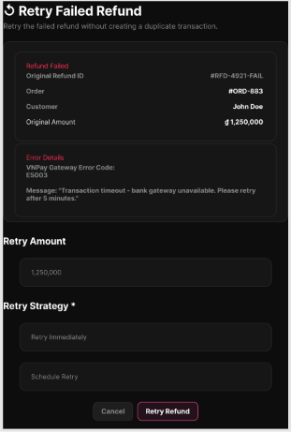
Figure 143 : Retry Failed Refund Screen
FUNCTION DETAILS:
- VALIDATION RULES:
  - User must be authenticated and authorized to process refunds.
  - A failed refund record must exist for the target transaction.
  - The refund must not have already been successfully completed.

- NORMAL FLOW:
  - Step 1: Actor opens the failed refund record.
  - Step 2: System displays the previous refund attempt details and current status.
  - Step 3: Actor selects "Retry Refund".
  - Step 4: System verifies that no successful refund already exists for this transaction.
  - Step 5: System prepares to reuse the existing refund request/idempotency reference.
  - Step 6: Actor confirms the retry.
  - Step 7: System sends the retry request to VNPay using the idempotency reference.
  - Step 8: VNPay returns the result.
  - Step 9: System records the new attempt result.
  - Step 10: On success, the system updates the refund status to successful without creating a duplicate refund record.

- ABNORMAL FLOWS:
  - Step 1: Actor cancels the retry, the refund was already confirmed, or the system encounters gateway/server errors.
  - Step 2: System processes the cancellation or validates constraints (current status, idempotency, external API response).
  - Step 3: Depending on the scenario, the system responds accordingly:
  - Cancel: Actor cancels the confirmation. No action is taken; modal closes.
    - Previous Refund Already Confirmed (A.1): System detects the refund was already successfully processed. System prevents another gateway request and displays the confirmed result.
    - VNPay Retry Fails (EX-01): System records the failed retry. Client displays "Retry failed. The refund remains available for permitted follow-up handling."
    - Server/Data Error (EX-02): The retry result cannot be committed. System returns 500 Internal Server Error. Client displays "Failed to save retry result. The system will not assume refund success."
  - Step 4: Client updates the UI accordingly (shows specific error notifications or refreshes the status), ensuring data integrity and preventing duplicate financial transactions.

3.16.22 View Refund Reconciliation Report
FUNCTION TRIGGER:
- Platform Administrator opens the Refund Reconciliation Report page.
FUNCTION DESCRIPTION:
- Actor(s): Admin.
- Purpose:
  - To allow platform administrators to view a reconciliation report comparing refunds requested in ConcertShield against those confirmed by the payment gateway, highlighting any mismatches.
- Main Functionality:
  - The system retrieves ConcertShield refund records and corresponding gateway results, compares them by reference, identifies mismatches (amount, status, or reference), and displays a reconciliation summary and detailed records for inspection and follow-up.
SCREEN LAYOUT:
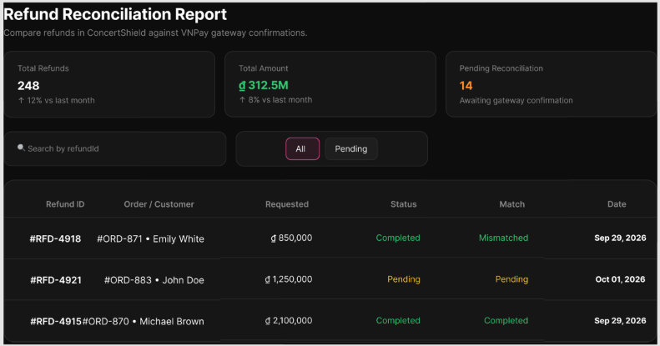
Figure 144 : View Refund Reconciliation Report Screen
FUNCTION DETAILS:
- VALIDATION RULES:
  - User must be authenticated and authorized as a Platform Administrator.
  - Refund records and corresponding payment-gateway reconciliation data must be accessible.

- NORMAL FLOW:
  - Step 1: Platform Administrator opens the refund reconciliation page.
  - Step 2: System retrieves ConcertShield refund records and corresponding gateway results.
  - Step 3: System compares records by the applicable refund/payment reference.
  - Step 4: System identifies amount, status, or reference mismatches.
  - Step 5: System displays the reconciliation summary and detailed records.
  - Step 6: Platform Administrator may filter the data or inspect a specific mismatch for follow-up.

- ABNORMAL FLOWS:
  - Step 1: System encounters no mismatches, unavailable gateway data, or server/data errors during report generation.
  - Step 2: System validates data availability and connection status.
  - Step 3: Depending on the scenario, the system responds accordingly:
    - No Mismatches (A.1): All compared refund records reconcile successfully. System displays the report with zero mismatches highlighted.
    - Gateway Reconciliation Data Unavailable (EX-01): System displays the available local ConcertShield data and indicates that full reconciliation cannot be completed at this time.
    - Server/Data Error (EX-02): Report cannot be generated (e.g., 500 Internal Server Error). Client displays "Failed to generate reconciliation report. Please try again later."
  - Step 4: Client updates the UI accordingly (showing the zero-mismatch state, partial data warnings, or error notifications), preserving the read-only nature of the operation.

3.17 Risk-Based Anti-Fraud

3.17.1 View Fraud Alert Dashboard
FUNCTION TRIGGER:
- Trigger 1: The Admin selects "Fraud alerts" in the admin menu while logged in.
FUNCTION DESCRIPTION:
- Actor(s): Admin
- Secondary actor(s): None
- Purpose:
  - To let the Admin see how many fraud alerts the system has raised, which ones need attention first, and review the list of alerts, so that the Admin can respond to risky activity quickly.
- Main Functionality:
  - The system shows a summary of the fraud alerts in the selected period: the total number of alerts, the number of open alerts with a High or Critical risk level, the number of alerts that are past their SLA, and the number of alerts by risk level, by alert type and by status. Below the summary, the system shows the list of alerts with their ID, user, alert type, risk level, risk score, bot score, fraud score, status, creation time, the Admin who reviewed it and the review time. The Admin can filter by risk level, alert type, status, user ID and a date range (From and To), and the list is shown one page at a time (20 alerts per page by default). When a value does not apply (for example an alert that has not been reviewed, or an alert without a user), the system shows "—". The Admin can open an alert to see its details; viewing the details is done in a separate function. The system identifies the Admin from the Access Token. This function only views alerts; it cannot block, restore or change an alert.
SCREEN LAYOUT:

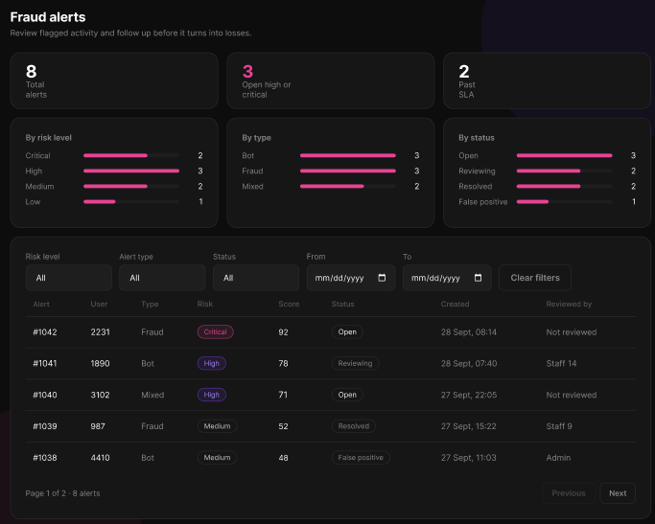
Figure 145 : View Fraud Alert Dashboard Screen
FUNCTION DETAILS:
- VALIDATION RULES:
  - The user must be authenticated. The Access Token must be sent in the Authorization header, and it must be present, valid and not expired.
  - The user must have the permission to view fraud alerts (policy CanViewFraudAlerts).
  - The Admin must be identified from the claims in the token, so the client must not send a user id.
  - The risk level, if selected, must be one of the defined risk levels (Low, Medium, High or Critical).
  - The alert type, if selected, must be one of the defined alert types.
  - The status, if selected, must be one of the defined alert statuses.
  - The user ID, if entered, must be a positive whole number.
  - If both From and To are entered, From must not be later than To.
  - The page number and the page size must be positive whole numbers.
  - The filters must be validated on the client when the Admin selects "Search", and again on the server.

- NORMAL FLOW:
  - Sub-flow A: View the dashboard
  - Step 1: The Admin opens the "Fraud alerts" page.
  - Step 2: The client sends the request with the default filters (empty, default period) and the page number 1, with the Access Token in the Authorization header.
  - Step 3: The system checks the token and the permission of the Admin.
  - Step 4: The system calculates the summary for the period and retrieves the alerts that match the filters, one page at a time.
  - Step 5: The system returns the summary, the list and the total number of pages.
  - Step 6: The client displays the summary (total, open High/Critical, overdue SLA, and the counts by risk level, alert type and status) and each alert's ID, user, alert type, risk level, risk score, bot score, fraud score, status, creation time, reviewer and review time.
  - Step 7: The client enables "Prev" and "Next" only when there is a previous or next page.

  - Sub-flow B: Filter the alerts
  - Step 1: The Admin selects one or more filters (risk level, alert type, status, user ID, From, To) and selects "Search".
  - Step 2: The client validates the filters.
  - Step 3: The client sends the request with the filters and the page number 1, with the Access Token in the Authorization header.
  - Step 4: The system checks the token and the permission of the Admin, and validates the filters.
  - Step 5: The system calculates the summary and retrieves the alerts that match all the filters.
  - Step 6: The system returns the summary and the list, and the client displays them. If no alert matches, the client displays the message "No alerts match these filters" and shows zero in the summary.
- ABNORMAL FLOWS:

  - Abnormal flow 1: Access Token missing, invalid or expired (occurs at Sub-flow A, B or D, when the client sends the request)
  - Step 1: The Access Token is missing, invalid or expired.
  - Step 2: The system rejects the request and returns 401 Unauthorized.
  - Step 3: The client tries to obtain a new Access Token with the Refresh Token and repeats the request.
  - Step 4: If the Refresh Token is also expired or revoked, the client deletes the stored tokens, displays the message "Your session has expired. Please log in again." and redirects the user to the Login page.

  - Abnormal flow 2: No permission (occurs at Sub-flow A, Step 3 or Sub-flow B, Step 4)
  - Step 1: The account does not have the permission to view fraud alerts.
  - Step 2: The system returns 403 Forbidden and does not return any alert.
  - Step 3: The client displays the message "You do not have permission to perform this action."
  - Step 4: The user returns to the previous screen.

  - Abnormal flow 3: Invalid filters (occurs at Sub-flow B, Step 2 or Step 4)
  - Step 1: A filter is invalid, for example the user ID is not a positive whole number, or From is later than To.
  - Step 2: If the client detects the error, it does not send the request. Otherwise, the system returns 400 Bad Request with an error message.
  - Step 3: The client highlights the invalid filters and displays the messages "User ID must be a positive whole number." or "From date must not be later than To date."
  - Step 4: The Admin corrects the filters and selects "Search" again (returns to Sub-flow B, Step 1).

  - Abnormal flow 4: No alerts found (occurs at Sub-flow B, Step 6)
  - Step 1: No alert matches the filters.
  - Step 2: The system returns an empty list and a summary with zero counts.
  - Step 3: The client displays the message "No alerts match these filters" and suggests widening the date range or clearing a filter.
  - Step 4: The Admin selects "Reset" (Sub-flow C) or changes the filters (returns to Sub-flow B, Step 1).

  - Abnormal flow 5: Failed to load the dashboard (occurs at Sub-flow A, Step 4)
  - Step 1: An error occurs while the system calculates the summary or retrieves the alerts.
  - Step 2: The system logs the error and returns an error response.
  - Step 3: The client displays the message "Failed to load fraud alerts." with a "Dismiss" button.
  - Step 4: The Admin selects "Refresh" to load the dashboard again (returns to Sub-flow A, Step 1).

3.17.2 View Fraud Alert Details
FUNCTION TRIGGER:
- Trigger 1: The Admin selects an alert in the list on the "Fraud alerts" page while logged in.
FUNCTION DESCRIPTION:
- Actor(s): Admin
- Secondary actor(s): None
- Purpose:
  - To let the Ad
- Main Functionality:
  - The system shows the alert with its ID, creation time, risk level and status, and three scores: the risk score, the bot score and the fraud score. It also shows the context of the alert (user, order, ticket, event, session, and the Admin who reviewed it or "Not reviewed"), the details text, and the AI summary. Below these, the system shows the decisions the system or an Admin made for this alert. For each decision, the system shows the decision code and action (for example "DEC-7781 · BLOCK"), its status (for example Active), the scope, who decided it (System or an Admin), the expiry time, the rule version, the device and the IP address. It also shows the rules that were triggered (with the value measured for each), the trust modifiers (for example "VIP: no", "Account age: 2 days"), and the signals that were missing (for example "3DS result"). When the decision was made or undone manually, the system also shows the reason, and who restored it, when and why. When a value does not apply, the system shows "—". The Admin can go back to the list with "Back to alerts". The system identifies the Admin from the Access Token. This function only views an alert; blocking or restoring is done in separate functions.

SCREEN LAYOUT:
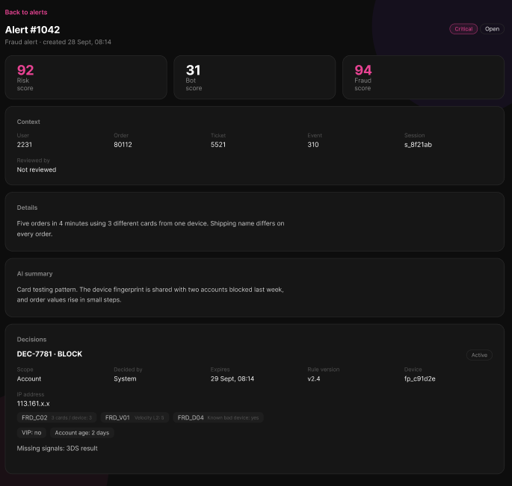
Figure 146 : View Fraud Alert Details Screen
FUNCTION DETAILS:
- VALIDATION RULES:
  - The user must be authenticated. The Access Token must be sent in the Authorization header, and it must be present, valid and not expired.
  - The user must have the permission to view fraud alerts (policy CanViewFraudAlerts).
  - The Admin must be identified from the claims in the token, so the client must not send a user id.
  - The alert ID must be a positive whole number.
  - The alert must exist.

- NORMAL FLOW:
  - Sub-flow A: View the alert details
  - Step 1: The Admin selects an alert in the list, or opens the alert page directly.
  - Step 2: The client sends the request with the alert ID and the Access Token in the Authorization header.
  - Step 3: The system checks the token and the permission of the Admin.
  - Step 4: The system checks that the alert exists.
  - Step 5: The system retrieves the alert, its context, details, AI summary and decisions.
  - Step 6: The system returns the result, and the client displays the risk level, status, creation time, the three scores, the context, the details, the AI summary and the decisions with their triggered rules, trust modifiers and missing signals.

- ABNORMAL FLOWS:
  - Abnormal flow 1: Access Token missing, invalid or expired (occurs at Sub-flow A, Step 2)
  - Step 1: The Access Token is missing, invalid or expired.
  - Step 2: The system rejects the request and returns 401 Unauthorized.
  - Step 3: The client tries to obtain a new Access Token with the Refresh Token and repeats the request.
  - Step 4: If the Refresh Token is also expired or revoked, the client deletes the stored tokens, displays the message "Your session has expired. Please log in again." and redirects the user to the Login page.

  - Abnormal flow 3: Invalid alert ID (occurs at Sub-flow A, Step 2 or Step 4)
  - Step 1: The alert ID is not a positive whole number.
  - Step 2: The system returns 400 Bad Request with an error message.
  - Step 3: The client displays the error message and a "Back to alerts" link.
  - Step 4: The Admin selects "Back to alerts" (Sub-flow C).

  - Abnormal flow 4: Alert not found (occurs at Sub-flow A, Step 4)
  - Step 1: The alert does not exist.
  - Step 2: The system returns 404 Not Found with an error message.
  - Step 3: The client displays the message "This alert was not found." and a "Back to alerts" link.

3.17.3 Block Account/Ticket
FUNCTION TRIGGER:
- Trigger 1: The Admin selects "Block" on a fraud alert (in the alert list or on the alert details page) while logged in.
FUNCTION DESCRIPTION:
- Actor(s): Admin
- Secondary actor(s): None
- Purpose:
  - To let the Admin manually block a session, IP address, device, account or ticket that is linked to a fraud alert, for a set time, so that the risky activity stops while the alert is being handled.
- Main Functionality:
  - When the Admin selects "Block", the system shows the "Block for alert #ID" popup with three inputs: the scope (Session, IP address, Device, Ticket or Account), the duration in hours (24 by default) and the reason (at least 10 characters). When the Admin selects "Confirm block", the system creates a block that is Active until the expiry time (the current time plus the duration), records the Admin, the reason and the alert it belongs to, and returns the result. The block stops the chosen target from using the system until it expires or an Admin restores it. Restoring is done in a separate function. The system identifies the Admin from the Access Token, and takes the user, ticket, session, device and IP address from the alert, so the Admin only chooses the scope, the duration and the reason.

SCREEN LAYOUT:
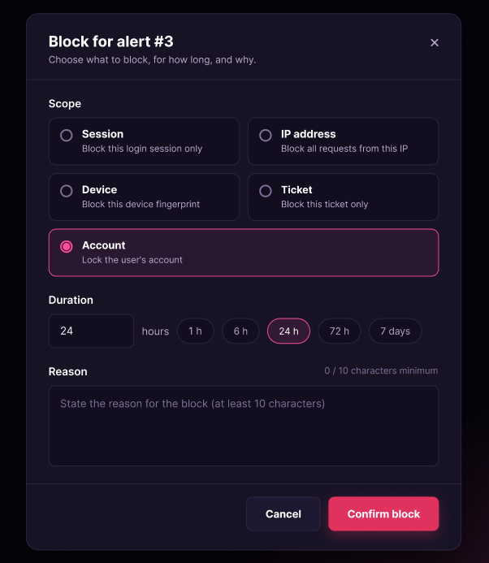
Figure 147 : Block Account/Ticket Screen
FUNCTION DETAILS:
- VALIDATION RULES:
  - The user must be authenticated. The Access Token must be sent in the Authorization header, and it must be present, valid and not expired.
  - The user must have the permission to manage fraud alerts (policy CanManageFraudAlerts).
  - The Admin must be identified from the claims in the token, so the client must not send a user id as the Admin.
  - The scope is required and must be Session, IP, Device, Account or Ticket.
  - The target of the chosen scope must exist on the alert: a Session needs a session ID, an IP block needs an IP address, a Device block needs a device fingerprint, an Account block needs a user ID and a Ticket block needs a ticket ID.
  - The duration is required and must be a positive whole number of hours, not more than 720 hours (30 days).
  - The reason is required and must be from 10 to 500 characters, not counting spaces at the start and the end.
  - If a fraud alert ID is sent, the alert must exist.
  - The data must be validated on the client when the Admin submits, and again on the server.

- NORMAL FLOW:
  - Sub-flow A: Open the Block popup
  - Step 1: The Admin selects "Block" on a fraud alert.
  - Step 2: The client displays the "Block for alert #ID" popup with the scope Account, the duration 24 hours and an empty reason.
  - Sub-flow B: Block
  - Step 1: The Admin chooses the scope, enters the duration (or selects a quick option such as 1 h, 6 h, 24 h, 72 h or 7 days) and enters the reason.
  - Step 2: The Admin selects "Confirm block".
  - Step 3: The client validates the inputs.
  - Step 4: The client submits the request with the alert ID, the scope, the duration and the reason, with the Access Token in the Authorization header.
  - Step 5: The system checks the token and the permission of the Admin, and identifies the Admin from the token claims.
  - Step 6: The system validates the inputs and checks that the alert exists and that the target of the scope is available on the alert.
  - Step 7: The system checks that there is no Active block for the same scope and the same target.
  - Step 8: The system creates the block with the status Active, the expiry time, the Admin and the reason.
  - Step 9: The system returns the result (decision ID, decision code, alert ID, user, scope, status and expiry time).
  - Step 10: The client closes the popup, displays the message "Block applied until <expiry time>." and refreshes the alert.
- ABNORMAL FLOWS:
  - Abnormal flow 1: Access Token missing, invalid or expired (occurs at Sub-flow B, Step 4)
  - Step 1: The Access Token is missing, invalid or expired.
  - Step 2: The system rejects the request and returns 401 Unauthorized.
  - Step 3: The client tries to obtain a new Access Token with the Refresh Token and repeats the request.
  - Step 4: If the Refresh Token is also expired or revoked, the client deletes the stored tokens, displays the message "Your session has expired. Please log in again." and redirects the user to the Login page.

  - Abnormal flow 2: No permission (occurs at Sub-flow B, Step 5)
  - Step 1: The account does not have the permission to manage fraud alerts.
  - Step 2: The system returns 403 Forbidden and does not create the block.
  - Step 3: The client displays the message "You do not have permission to perform this action."
  - Step 4: The user returns to the previous screen.
  - Abnormal flow 3: Invalid input (occurs at Sub-flow B, Step 3 or Step 6)
  - Step 1: An input is invalid, for example the duration is 0 or more than 720, the reason has fewer than 10 characters, or the scope is not one of the five values.
  - Step 2: If the client detects the error, it does not send the request. Otherwise, the system returns 400 Bad Request with an error message.
  - Step 3: The client keeps the popup open, highlights the invalid inputs and displays the messages, for example "Duration must be a positive whole number of hours." or "Reason must be at least 10 characters."
  - Step 4: The Admin corrects the inputs and selects "Confirm block" again (returns to Sub-flow B, Step 2).

  - Abnormal flow 6: Already blocked (occurs at Sub-flow B, Step 7)
  - Step 1: An Active block already exists for the same scope and the same target.
  - Step 2: The system changes nothing and returns 409 Conflict with an error message.
  - Step 3: The client displays the message "This target is already blocked." in the popup, or closes it and displays the message.
  - Step 4: The client refreshes the alert.

  - Abnormal flow 7: Unable to block (occurs at Sub-flow B, Step 8)
  - Step 1: An unexpected error occurs while the system creates the block.
  - Step 2: The system logs the error and does not create the block.
  - Step 3: The system returns 500 Internal Server Error, and the client displays the message "An unexpected error occurred. Please try again later."
  - Step 4: The Admin tries again later (returns to Sub-flow B, Step 2).

3.17.4 Restore Account/Ticket
FUNCTION TRIGGER:
- Trigger 1: The Admin selects "Restore" on an Active block in the "Blocks" list while logged in.
FUNCTION DESCRIPTION:
- Actor(s): Admin
- Secondary actor(s): None
- Purpose:
  - To let the Admin lift a block on an account or a ticket before it expires, for example when the block was wrong, so that the Customer can use the account or the ticket again.
- Main Functionality:
  - The system shows the blocks with their decision code, alert, user, scope, status (Active, Expired, Restored or Overturned), who decided it, creation time and expiry time. The Admin can filter the list by status, scope, user ID and alert ID, and the list is shown one page at a time (20 blocks per page by default). The "Restore" button is enabled only for Active blocks whose scope is Account or Ticket. When the Admin selects "Restore", the system shows the "Restore account" or "Restore ticket" popup with the user or the ticket, the decision code, the expiry time and a Reason input (at least 10 characters). When the Admin selects "Confirm restore", the system lifts the block at once, sets its status to Restored, and records the Admin, the reason and the time. The Customer can then use the account or the ticket again. Restoring is done for one block at a time. The system identifies the Admin from the Access Token. This function only restores blocks; creating a block is done in Block.

SCREEN LAYOUT:
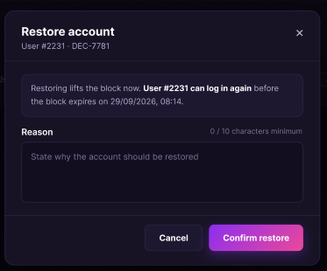
Figure 148 : Restore Account/Ticket Screen
FUNCTION DETAILS:
- VALIDATION RULES:
  - The user must be authenticated. The Access Token must be sent in the Authorization header, and it must be present, valid and not expired.
  - The user must have the permission to manage fraud alerts (policy CanManageFraudAlerts).
  - The Admin must be identified from the claims in the token, so the client must not send a user id as the Admin.
  - The status filter must be empty (All), Active, Expired, Restored or Overturned.
  - The scope filter must be empty (All), Session, IP, Device, Account or Ticket.
  - The user ID and the alert ID, if entered, must be positive whole numbers.
  - The page number and the page size must be positive whole numbers.
  - The block to restore must exist and must have the status Active.
  - The scope of the block to restore must be Account or Ticket.
  - The reason is required and must be from 10 to 500 characters, not counting spaces at the start and the end.
  - The "Restore" button is enabled only for Active blocks whose scope is Account or Ticket.
  - The data must be validated on the client when the Admin submits, and again on the server.

- NORMAL FLOW:
  - Sub-flow A: View the list of blocks
  - Step 1: The Admin opens the "Blocks" page.
  - Step 2: The client sends the request with the filters (status Active by default) and the page number, with the Access Token in the Authorization header.
  - Step 3: The system checks the token and the permission of the Admin.
  - Step 4: The system retrieves the blocks that match the filters, one page at a time.
  - Step 5: The system returns the list, and the client displays each block's decision code, alert, user, scope, status, who decided it, creation time and expiry time.
  - Step 6: The client enables the "Restore" button only for Active blocks whose scope is Account or Ticket.

  - Sub-flow B: Restore a block
  - Step 1: The Admin selects "Restore" on an Active Account or Ticket block.
  - Step 2: The client displays the "Restore account" or "Restore ticket" popup with the user or the ticket, the decision code, the expiry time and an empty Reason input.
  - Step 3: The Admin enters the reason and selects "Confirm restore".
  - Step 4: The client validates the reason.
  - Step 5: The client submits the request with the block ID and the reason, with the Access Token in the Authorization header.
  - Step 6: The system checks the token and the permission of the Admin, and identifies the Admin from the token claims.
  - Step 7: The system validates the reason and checks that the block exists, is Active and has the scope Account or Ticket.
  - Step 8: The system lifts the block, sets its status to Restored, and records the Admin, the reason and the time.
  - Step 9: The system returns the result (decision ID, decision code, alert ID, user, scope, status and expiry time).
  - Step 10: The client closes the popup, displays the message "Restored. The account can be used again." or "Restored. The ticket can be used again.", and refreshes the list.

- ABNORMAL FLOWS:

  - Abnormal flow 1: Access Token missing, invalid or expired (occurs at Sub-flow A, Step 2 or Sub-flow B, Step 5)
  - Step 1: The Access Token is missing, invalid or expired.
  - Step 2: The system rejects the request and returns 401 Unauthorized.
  - Step 3: The client tries to obtain a new Access Token with the Refresh Token and repeats the request.
  - Step 4: If the Refresh Token is also expired or revoked, the client deletes the stored tokens, displays the message "Your session has expired. Please log in again." and redirects the user to the Login page.

  - Abnormal flow 2: No permission (occurs at Sub-flow A, Step 3 or Sub-flow B, Step 6)
  - Step 1: The account does not have the permission to manage fraud alerts.
  - Step 2: The system returns 403 Forbidden and does not perform the action.
  - Step 3: The client displays the message "You do not have permission to perform this action."
  - Step 4: The user returns to the previous screen.

  - Abnormal flow 3: Failed to load the list (occurs at Sub-flow A, Step 4)
  - Step 1: An error occurs while the system retrieves the blocks.
  - Step 2: The system logs the error and returns an error response.
  - Step 3: The client displays the message "Failed to load blocks." with a "Dismiss" button.
  - Step 4: The Admin selects "Refresh" to load the list again (returns to Sub-flow A, Step 1).

  - Abnormal flow 4: Invalid reason (occurs at Sub-flow B, Step 4 or Step 7)
  - Step 1: The reason is empty, shorter than 10 characters or longer than 500 characters.
  - Step 2: If the client detects the error, it does not send the request. Otherwise, the system returns 400 Bad Request with an error message.
  - Step 3: The client keeps the popup open, highlights the Reason input and displays the message "Reason must be at least 10 characters."
  - Step 4: The Admin corrects the reason and selects "Confirm restore" again (returns to Sub-flow B, Step 3).

  - Abnormal flow 5: Block not found (occurs at Sub-flow B, Step 7)
  - Step 1: The block no longer exists.
  - Step 2: The system returns 404 Not Found with an error message.
  - Step 3: The client closes the popup and displays the message "This block was not found."
  - Step 4: The client refreshes the list (returns to Sub-flow A, Step 1).

  - Abnormal flow 6: Block is no longer active (occurs at Sub-flow B, Step 7)
  - Step 1: The block is not Active, for example because it has expired or another Admin has already restored it.
  - Step 2: The system changes nothing and returns 400 Bad Request with an error message.
  - Step 3: The client displays the message "This block is no longer active." in the popup, or closes it and displays the message.
  - Step 4: The client refreshes the list (returns to Sub-flow A, Step 1).

3.17.5 View Risk Decision Details
FUNCTION TRIGGER:
- Trigger 1: Admin clicks a decision on the Risk decision list.
- Trigger 2: Admin clicks the decision link on the Fraud alert detail page.
FUNCTION DESCRIPTION:
- Actor(s): Admin
- Secondary actor(s): None
- Purpose:
  - To let the Admin see the full detail of one risk decision, including its action, scores, triggered rules and reasons, so that the Admin can understand why the system acted and decide whether to review the appeal or restore the account.
- Main Functionality:
  - The Admin opens the page "Risk decision". The header shows the title, the decision code (for example "RD-20260928-0031") and the buttons "View appeal", "Restore" and " Back". The summary card shows the action and target (for example "Block · Account"), the line "Decided by SYSTEM · 28/09/2026, 08:14:02 · Expires 29/09/2026, 08:14:02", the risk level badge (for example "HIGH") and the status badge (for example "ACTIVE"). Below are three score boxes: "Bot score", "Fraud score" and "Dominant type". The detail list shows: User, Alert, Order / Ticket, Session, Device fingerprint, IP address, Rule version, Escalation level, Shadow mode and Hard rule. The table "Score by group" shows each group (for example Velocity, Device, Behavior) with its score. The page also shows "Triggered rules", "Trust modifiers" and "Signals missing" as tags, the "Public reason" (marked "Shown to the customer") and the "AI summary". The Admin can click "View appeal" to open the appeal of this decision, click "Restore" to start the restore function, or click "← Back" to return to the previous page. This function only reads data and changes nothing.
SCREEN LAYOUT:
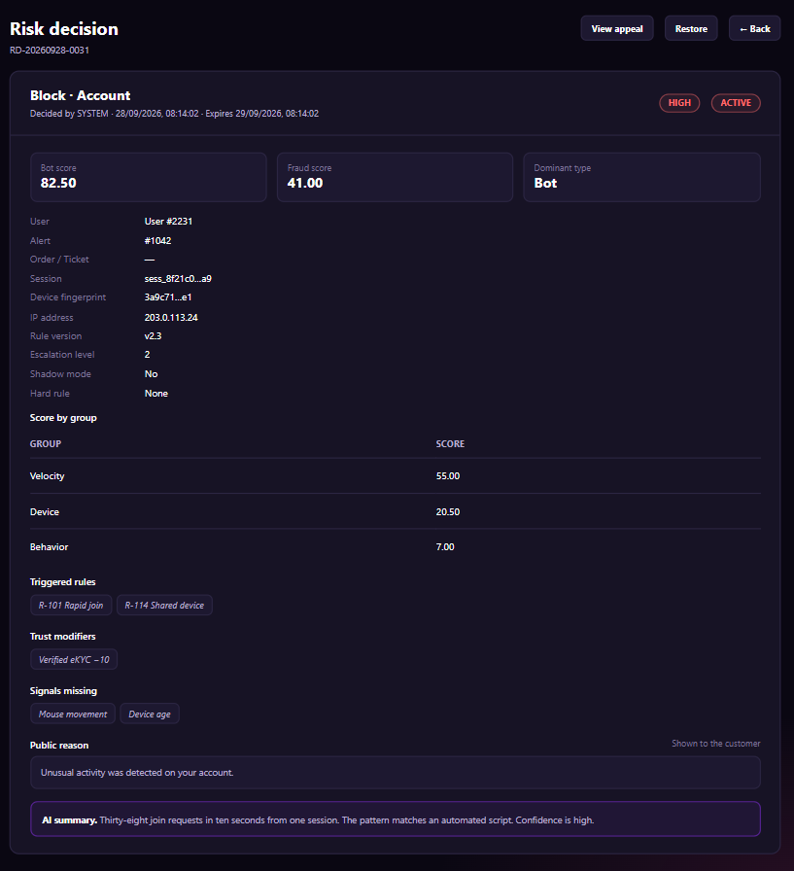
Figure 149 : View Risk Decision Details Screen
FUNCTION DETAILS:
- VALIDATION RULES:
  - The user must be authenticated. The Access Token must be sent in the Authorization header, and it must be present, valid and not expired. The user must be identified from the claims in the token, so the client must not send a user id.
  - The account referenced by the token must exist, be active and have the Admin role.
  - The decision id must be a valid identifier, and the decision must exist.
  - Scores are shown with 2 decimal places.
  - Date and time are shown in the format dd/MM/yyyy, HH:mm:ss.
  - The session and the device fingerprint are shown shortened (first and last characters only).
  - A field with no value is shown as "_". An empty list (Triggered rules, Trust modifiers, Signals missing) is shown as "None".
  - The button "View appeal" is shown only if the decision has an appeal.
  - The button "Restore" is enabled only if the status is Active.
  - One request returns one decision only.

- NORMAL FLOW:
  - Sub-flow A: View the decision
  - Step 1: The Admin clicks a decision on the list or the decision link on the Fraud alert detail page.
  - Step 2: The client sends the request with the decision id and the Access Token.
  - Step 3: The system validates the Access Token and the Admin role, and checks that the decision exists.
  - Step 4: The system returns the decision data (code, action, target, decided by, decided time, expiry time, risk level, status, bot score, fraud score, dominant type, user, alert, order/ticket, session, device fingerprint, IP address, rule version, escalation level, shadow mode, hard rule, score by group, triggered rules, trust modifiers, missing signals, public reason, AI summary, appeal flag).
  - Step 5: The client displays the page.

- ABNORMAL FLOWS:
  - Abnormal flow 1: Not authenticated or no permission (occurs at Sub-flow A, Step 2 or 3)
  - Step 1: The Access Token is missing, invalid or expired, or the account is not found, not active, or not an Admin.
  - Step 2: The system returns no data and returns 401 Unauthorized (token or account problem) or 403 Forbidden (not an Admin).
  - Step 3: For 401, the client tries to get a new Access Token with the Refresh Token and repeats the request. If this fails, the client deletes the stored tokens, displays "Your session has expired. Please log in again." and redirects to the Login page. For 403, the client displays "You do not have permission to view this page." and returns to the previous page.

  - Abnormal flow 2: Decision not found (occurs at Sub-flow A, Step 3)
  - Step 1: The decision id is not valid or the decision does not exist.
  - Step 2: The system returns 404 Not Found and returns no data.
  - Step 3: The client displays "This risk decision is no longer available." and returns to the Risk decision list.

3.17.6 Submit Appeal Request
FUNCTION TRIGGER:
- Trigger 1: Customer clicks the "Appeal" button on the restriction notice shown after the account or action was blocked.
- Trigger 2: Customer clicks the "Appeal" link of a restricted decision on the page "My restrictions".
FUNCTION DESCRIPTION:
- Actor(s): Customer
- Secondary actor(s): None
- Purpose:
  - To let the Customer who was restricted by a risk decision explain why the restriction should be lifted and send evidence, so that a reviewer can check the decision and restore the account if the restriction is wrong.
- Main Functionality:
  - The Customer opens the page "Appeal a decision". The header shows the title, the decision code (for example "RD-20260928-0031") and the button "Back". The card "Tell us what happened" shows a summary of the decision: "Your account is restricted." followed by the public reason (for example "Unusual activity was detected on your account.") and the line "Action: Block · Scope: Account · Expires 29/09/2026, 08:14". The form contains: "Why should this be lifted?" (required, a text area with a counter such as "0 / 2,000" and the note "At least 20 characters, up to 2,000.") and "Evidence" (optional, a drop zone with the text "Drop files here or browse · images or PDF, up to 5 MB"). The notice below the form says "You can send one appeal per decision. A reviewer answers within 48 hours." The Customer enters the explanation, adds files if needed and clicks "Submit appeal". The system validates and saves the appeal, and the client displays a success message and returns to the previous page. The Customer can click "Cancel" or " Back" to leave the page without sending.

SCREEN LAYOUT:
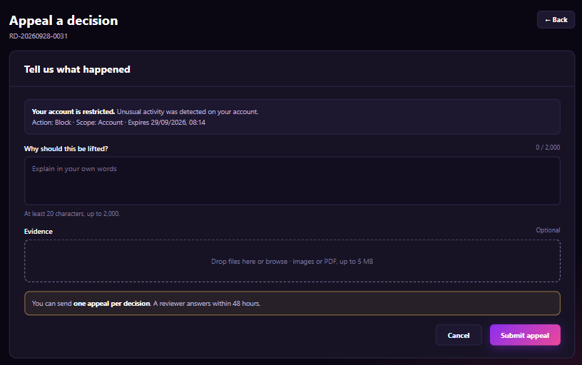
Figure 150 : Submit Appeal Request Screen
FUNCTION DETAILS:
- VALIDATION RULES:
  - The user must be authenticated. The Access Token must be sent in the Authorization header, and it must be present, valid and not expired. The user must be identified from the claims in the token, so the client must not send a user id.
  - The account referenced by the token must exist, be active or restricted, and have the Customer role.
  - The decision id must be a valid identifier, the decision must exist and it must belong to the Customer in the token.
  - The decision must be Active and must be an action that can be appealed (for example Block).
  - The decision must not have an appeal already. One decision can have one appeal only.
  - Reason ("Why should this be lifted?"): required, 20 to 2,000 characters after trimming spaces. The counter shows the number of characters entered.
  - Evidence: optional. Each file must be an image (JPG, PNG) or a PDF, and up to 5 MB. The number of files is up to 5 in total.
  - The Customer must not send the request again while the previous request is being processed.
  - One request creates one appeal only.

- NORMAL FLOW:
  - Sub-flow A: Open the appeal form
  - Step 1: The Customer clicks "Appeal".
  - Step 2: The client sends the request with the decision id and the Access Token.
  - Step 3: The system validates the Access Token and the Customer role, and checks the decision (ownership, active, can be appealed, no appeal yet).
  - Step 4: The system returns the decision summary (code, public reason, action, scope, expiry time).
  - Step 5: The client displays the page with an empty form.

  - Sub-flow B: Submit the appeal
  - Step 1: The Customer enters the reason, optionally adds evidence files and clicks "Submit appeal".
  - Step 2: The client checks the reason length and the files, then sends the request with the decision id, the reason, the evidence files and the Access Token.
  - Step 3: The system validates the Access Token, the Customer role, the decision and the data.
  - Step 4: The system saves the appeal with the status Pending and the evidence files, and returns the appeal data.
  - Step 5: The client displays "Your appeal has been sent. A reviewer will answer within 48 hours." and returns to the previous page.

- ABNORMAL FLOWS:
  - Abnormal flow 1: Not authenticated or no permission (occurs at Sub-flow A, Step 2 or 3, and Sub-flow B, Step 2 or 3)
  - Step 1: The Access Token is missing, invalid or expired, or the account is not found, not active or restricted, or not a Customer.
  - Step 2: The system returns no data, saves nothing and returns 401 Unauthorized (token or account problem) or 403 Forbidden (not a Customer).
  - Step 3: For 401, the client tries to get a new Access Token with the Refresh Token and repeats the request. If this fails, the client deletes the stored tokens, displays "Your session has expired. Please log in again." and redirects to the Login page. For 403, the client displays "You do not have permission to do this action." and returns to the previous page.

  - Abnormal flow 2: Decision not found (occurs at Sub-flow A, Step 3, and Sub-flow B, Step 3)
  - Step 1: The decision does not exist or belongs to another Customer.
  - Step 2: The system returns 404 Not Found and saves nothing.
  - Step 3: The client displays "This decision is no longer available." and returns to the previous page.

  - Abnormal flow 3: Decision cannot be appealed (occurs at Sub-flow A, Step 3, and Sub-flow B, Step 3)
  - Step 1: The decision is expired, restored, or is not an action that can be appealed.
  - Step 2: The system returns 409 Conflict and saves nothing.
  - Step 3: The client displays "This decision can no longer be appealed." and returns to the previous page.

  - Abnormal flow 4: Appeal already sent (occurs at Sub-flow A, Step 3, and Sub-flow B, Step 3)
  - Step 1: The decision already has an appeal.
  - Step 2: The system returns 409 Conflict and saves nothing.
  - Step 3: The client displays "You have already sent an appeal for this decision." and returns to the previous page.

  - Abnormal flow 5: Invalid reason (occurs at Sub-flow B, Step 2 or 3)
  - Step 1: The reason is empty, has fewer than 20 characters or has more than 2,000 characters.
  - Step 2: The client or the system rejects the request (400 Bad Request from the system) and saves nothing.
  - Step 3: The client keeps the entered values and displays "Please enter between 20 and 2,000 characters." under the field "Why should this be lifted?".

  - Abnormal flow 6: Invalid evidence file (occurs at Sub-flow B, Step 2 or 3)
  - Step 1: A file is not an image or a PDF, is larger than 5 MB, or the number of files is more than 5.
  - Step 2: The client or the system rejects the request (400 Bad Request from the system for 413 when the file is too large) and saves nothing.
  - Step 3: The client keeps the entered values, does not add the invalid file and displays "Only images or PDF files up to 5 MB are accepted." under the field "Evidence".

3.17.7 Review & Resolve Appeal
FUNCTION TRIGGER:
- Trigger 1: Admin clicks an appeal on the Appeals list.
- Trigger 2: Admin clicks the "View appeal" button on the Risk decision detail page.
FUNCTION DESCRIPTION:
- Actor(s): Admin
- Secondary actor(s): None
- Purpose:
  - To let the Admin read an appeal sent by a Customer, check the decision and the evidence, and approve or reject the appeal with a review note, so that a wrong restriction is lifted and the Customer is informed of the result.
- Main Functionality:
  - The Admin opens the page "Appeal #<id>". The header shows the appeal number, the line "<Decision code> · User #<id>" (for example "RD-20260928-0031 · User #2231") and the button " Appeals". The card "Appeal" shows the submitted time, the status badge (for example "PENDING") and the SLA badge (for example "SLA DUE IN 18 H"). The detail list shows: Decision (for example "Block · Account · Active"), Alert (for example "#1042 · High"), Customer says (the reason written by the Customer) and Evidence (the uploaded files, for example "office-letter.pdf"). The Admin can click a file to open it. The box "AI summary" shows a short analysis of the appeal. The section "Outcome" has two options: "Approve - Restore the account now. The customer can log in again." and "Reject – Keep the block until it expires." The field "Review note" is a text area with a counter such as "0 / 1,000" and the note "The customer sees this note." The Admin chooses the outcome, enters the review note and clicks "Resolve appeal". The system validates and saves the result, and the client displays a success message and returns to the Appeals list. The Admin can click "Cancel" or " Appeals" to leave the page without resolving.

SCREEN LAYOUT:
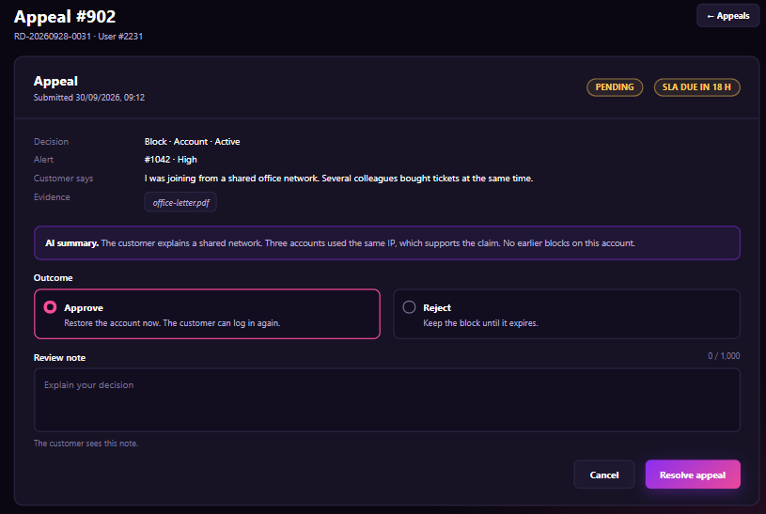
Figure 151 : Review & Resolve Appeal Screen
FUNCTION DETAILS:
- VALIDATION RULES:
  - The user must be authenticated. The Access Token must be sent in the Authorization header, and it must be present, valid and not expired. The user must be identified from the claims in the token, so the client must not send a user id.
  - The account referenced by the token must exist, be active and have the Admin role.
  - The appeal id must be a whole number greater than 0, and the appeal must exist.
  - The appeal must have the status Pending to be resolved.
  - Outcome: required, one of Approve or Reject. The default is Approve.
  - Review note: up to 1,000 characters after trimming spaces. It is required when the outcome is Reject, and optional when the outcome is Approve. The counter shows the number of characters entered.
  - Date and time are shown in the format dd/MM/yyyy, HH:mm.
  - The SLA badge shows the remaining time until the answer deadline. It shows "SLA OVERDUE" when the deadline has passed.
  - The Admin must not send the request again while the previous request is being processed.
  - One request resolves one appeal only.

- NORMAL FLOW:
  - Sub-flow A: View the appeal
  - Step 1: The Admin clicks an appeal on the Appeals list or the "View appeal" button on the Risk decision detail page.
  - Step 2: The client sends the request with the appeal id and the Access Token.
  - Step 3: The system validates the Access Token and the Admin role, and checks that the appeal exists.
  - Step 4: The system returns the appeal data (number, decision code, user, submitted time, status, SLA remaining time, decision action, scope and status, alert and risk level, Customer reason, evidence files, AI summary, review note and outcome if already resolved).
  - Step 5: The client displays the page. If the appeal is already resolved, the client shows the saved outcome and review note, and disables the Outcome options, the Review note field and the button "Resolve appeal".

  - Sub-flow B: Resolve the appeal
  - Step 1: The Admin chooses the outcome, enters the review note and clicks "Resolve appeal".
  - Step 2: The client checks the outcome and the review note, then sends the request with the appeal id, the outcome, the review note and the Access Token.
  - Step 3: The system validates the Access Token, the Admin role, the appeal status and the data.
  - Step 4: The system saves the outcome, the review note, the reviewer and the resolved time, and changes the appeal status to Approved or Rejected. For Approve, the system also restores the decision. The system notifies the Customer and returns the saved data.
  - Step 5: The client displays "Appeal resolved." and returns to the Appeals list.

- ABNORMAL FLOWS:
  - Abnormal flow 1: Not authenticated or no permission (occurs at Sub-flow A, Step 2 or 3, and Sub-flow B, Step 2 or 3)
  - Step 1: The Access Token is missing, invalid or expired, or the account is not found, not active, or not an Admin.
  - Step 2: The system returns no data, saves nothing and returns 401 Unauthorized (token or account problem) or 403 Forbidden (not an Admin).
  - Step 3: For 401, the client tries to get a new Access Token with the Refresh Token and repeats the request. If this fails, the client deletes the stored tokens, displays "Your session has expired. Please log in again." and redirects to the Login page. For 403, the client displays "You do not have permission to do this action." and returns to the previous page.
  - Abnormal flow 2: Appeal not found (occurs at Sub-flow A, Step 3, and Sub-flow B, Step 3)
  - Step 1: The appeal id is not valid or the appeal does not exist.
  - Step 2: The system returns 404 Not Found and saves nothing.
  - Step 3: The client displays "This appeal is no longer available." and returns to the Appeals list.

  - Abnormal flow 3: Appeal already resolved (occurs at Sub-flow B, Step 3)
  - Step 1: The appeal is no longer Pending, for example another Admin resolved it first.
  - Step 2: The system returns 409 Conflict and saves nothing.
  - Step 3: The client displays "This appeal has already been resolved." and reloads the page to show the saved result.

  - Abnormal flow 4: Decision cannot be restored (occurs at Sub-flow B, Step 3 or 4)
  - Step 1: The outcome is Approve, but the decision is already expired or restored.
  - Step 2: The system returns 409 Conflict and saves nothing.
  - Step 3: The client keeps the page open and displays "This decision is no longer active and cannot be restored."

  - Abnormal flow 5: Invalid review note (occurs at Sub-flow B, Step 2 or 3)
  - Step 1: The outcome is Reject and the review note is empty, or the review note has more than 1,000 characters.
  - Step 2: The client or the system rejects the request (400 Bad Request from the system) and saves nothing.
  - Step 3: The client keeps the entered values and displays "Please enter a review note (up to 1,000 characters)." under the field "Review note".

3.17.8 View Fraud Case List
FUNCTION TRIGGER:
- Trigger 1: Admin clicks the menu item "Fraud cases" on the sidebar.
FUNCTION DESCRIPTION:
- Actor(s): Admin
- Secondary actor(s): None
- Purpose:
  - To let the Admin see the fraud alerts that need an analyst, filter and search them, and open one alert for review, so that the Admin can find and handle risky cases quickly.

- Main Functionality:
  - The Admin opens the page "Fraud cases". The header shows the title, the subtitle "Alerts that need an analyst." and the button "Refresh". The filter bar contains three drop-down lists: "All statuses", "All risk levels" and "All types", the field "User ID", and the buttons "Search" and "Reset". The table lists the alerts with the columns: ALERT (for example "#1042"), TYPE (for example "Rapid join"), RISK SCORE (the score and a level badge such as HIGH, MEDIUM, LOW), USER (for example "User #2231"), ORDER / TICKET (for example "Order #7710" or "-"), EVENT, STATUS (a badge such as OPEN, REVIEWED), REVIEWED BY (for example "Analyst #1" or "-"), CREATED (for example "30/09/2026, 12:34") and a "View" link. Below the table, the pagination shows "Prev", "Page 1 / 1" and "Next". The Admin can change the filters and click "Search" to filter the list, click "Reset" to clear all filters, click "Refresh" to reload the list, or click "View" to open the Fraud alert detail page. This function only reads data and changes nothing.
SCREEN LAYOUT:
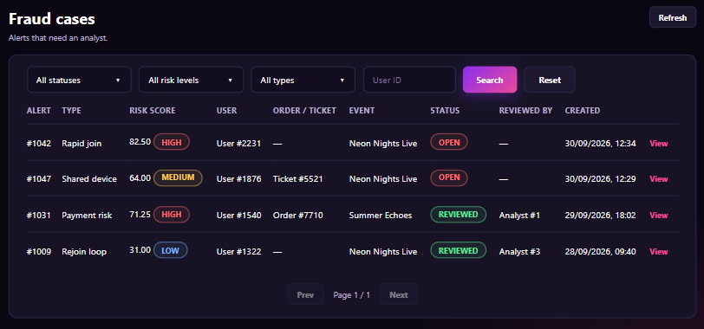
Figure 152 : View Fraud Case List Screen
FUNCTION DETAILS:
- VALIDATION RULES:
  - The user must be authenticated. The Access Token must be sent in the Authorization header, and it must be present, valid and not expired. The user must be identified from the claims in the token, so the client must not send a user id.
  - The account referenced by the token must exist, be active and have the Admin role.
  - Status filter: optional, one of All statuses, Open, Reviewed. The default is All statuses.
  - Risk level filter: optional, one of All risk levels, High, Medium, Low. The default is All risk levels.
  - Type filter: optional, one of All types or an alert type (for example Rapid join, Shared device, Payment risk, Rejoin loop). The default is All types.
  - User ID: optional, a whole number greater than 0. Other characters are rejected.
  - The filters are combined (AND).
  - Page number: a whole number greater than or equal to 1. The default is 1. Page size is fixed (for example 10 alerts per page).
  - The list is sorted by created time, newest first.
  - Risk score is shown with 2 decimal places. Date and time are shown in the format dd/MM/yyyy, HH:mm.
  - A field with no value is shown as "—".
  - "Prev" is disabled on the first page and "Next" is disabled on the last page.
  - "Reset" sets all filters to their default values and loads page 1.
  - Changing a filter or clicking "Search" loads page 1.

- NORMAL FLOW:
  - Sub-flow A: Open the list
  - Step 1: The Admin clicks "Fraud cases" on the sidebar.
  - Step 2: The client sends the request with the default filters, page 1 and the Access Token.
  - Step 3: The system validates the Access Token and the Admin role.
  - Step 4: The system returns the alerts of the page (alert id, type, risk score, risk level, user, order/ticket, event, status, reviewed by, created time) and the paging data (current page, total pages).
  - Step 5: The client displays the table and the pagination.

- ABNORMAL FLOWS:
  - Abnormal flow 1: Not authenticated or no permission (occurs at Sub-flow A)
  - Step 1: The Access Token is missing, invalid or expired, or the account is not found, not active, or not an Admin.
  - Step 2: The system returns no data and returns 401 Unauthorized (token or account problem) or 403 Forbidden (not an Admin).
  - Step 3: For 401, the client tries to get a new Access Token with the Refresh Token and repeats the request. If this fails, the client deletes the stored tokens, displays "Your session has expired. Please log in again." and redirects to the Login page. For 403, the client displays "You do not have permission to view this page." and returns to the previous page.

  - Abnormal flow 2: No result (occurs at Sub-flow A)
  - Step 1: No alert matches the filters, or there is no alert in the system.
  - Step 2: The system returns an empty list. This is not an error.
  - Step 3: The client displays "No fraud cases found." in place of the table rows and disables "Prev" and "Next".

3.17.9 Assign Fraud Case to Analyst
FUNCTION TRIGGER:
- Trigger 1: Admin clicks the "Assign" button on the Fraud alert detail page.
- Trigger 2: Admin clicks the "Assign" button of an alert on the Fraud cases list.
FUNCTION DESCRIPTION:
- Actor(s): Admin
- Secondary actor(s): Analyst (receives the notification)
- Purpose:
  - To let the Admin assign a fraud alert to an analyst with an optional note, so that the alert is reviewed by the right person.
- Main Functionality:
  - The Admin opens the dialog "Assign case". The header shows the dialog title and the line "Alert #<id> · <risk level> · User #<id>" (for example "Alert #1042 · High · User #2231"). The form contains: "Analyst" (required, a drop-down list where each item shows the analyst name and the number of open cases, for example "Analyst #3 · 4 open cases") and "Note" (optional, a text area with the placeholder "Optional note for the analyst"). The notice below the form says "The analyst is notified. The note is saved in the audit log." The Admin selects an analyst, enters a note if needed and clicks "Assign case". The system validates and saves the assignment, notifies the analyst, closes the dialog and refreshes the page. The Admin can click "Cancel" to close the dialog without saving.
SCREEN LAYOUT:
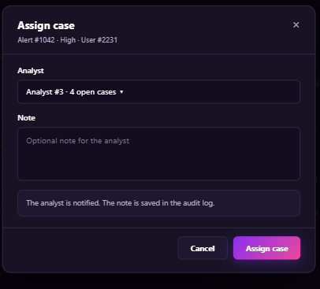
Figure 153 : Assign Fraud Case to Analyst Screen
FUNCTION DETAILS:
- VALIDATION RULES:
  - The user must be authenticated. The Access Token must be sent in the Authorization header, and it must be present, valid and not expired. The user must be identified from the claims in the token, so the client must not send a user id.
  - The account referenced by the token must exist, be active and have the Admin role.
  - The alert id must be a whole number greater than 0, and the alert must exist.
  - The alert must have the status Open.
  - Analyst: required. The analyst must exist, be active and have the Analyst role. The list shows the analyst name and the number of open cases.
  - Note: optional, up to 500 characters after trimming spaces.
  - The Admin must not send the request again while the previous request is being processed.
  - One request assigns one alert to one analyst only.

- NORMAL FLOW:
  - Sub-flow A: Open the dialog
  - Step 1: The Admin clicks "Assign".
  - Step 2: The client sends the request to get the analyst list with the alert id and the Access Token.
  - Step 3: The system validates the Access Token and the Admin role, and checks the alert.
  - Step 4: The system returns the alert summary (id, risk level, user) and the active analysts (id, name, open case count).
  - Step 5: The client displays the dialog with an empty form.

  - Sub-flow B: Assign the case
  - Step 1: The Admin selects an analyst, enters the note and clicks "Assign case".
  - Step 2: The client checks that an analyst is selected and the note length, then sends the request with the alert id, the analyst id, the note and the Access Token.
  - Step 3: The system validates the Access Token, the Admin role, the alert status, the analyst and the note.
  - Step 4: The system saves the assignment, writes the audit log with the note, sends the notification to the analyst and returns the saved data.
  - Step 5: The client closes the dialog, displays "Case assigned." and refreshes the page.

- ABNORMAL FLOWS:
  - Abnormal flow 1: Not authenticated or no permission (occurs at Sub-flow A, Step 2 or 3, and Sub-flow B, Step 2 or 3)
  - Step 1: The Access Token is missing, invalid or expired, or the account is not found, not active, or not an Admin.
  - Step 2: The system returns no data, saves nothing and returns 401 Unauthorized (token or account problem) or 403 Forbidden (not an Admin).
  - Step 3: For 401, the client tries to get a new Access Token with the Refresh Token and repeats the request. If this fails, the client deletes the stored tokens, displays "Your session has expired. Please log in again." and redirects to the Login page. For 403, the client displays "You do not have permission to do this action." and closes the dialog.

  - Abnormal flow 2: Alert not found (occurs at Sub-flow A, Step 3, and Sub-flow B, Step 3)
  - Step 1: The alert id is not valid or the alert does not exist.
  - Step 2: The system returns 404 Not Found and saves nothing.
  - Step 3: The client displays "This alert is no longer available." and returns to the Fraud cases list.

  - Abnormal flow 3: Alert cannot be assigned (occurs at Sub-flow A, Step 3, and Sub-flow B, Step 3)
  - Step 1: The alert is no longer Open, for example another Admin assigned it or an analyst already reviewed it.
  - Step 2: The system returns 409 Conflict and saves nothing.
  - Step 3: The client displays "This alert can no longer be assigned." and reloads the page to show the current status.

  - Abnormal flow 4: Analyst not selected or not available (occurs at Sub-flow B, Step 2 or 3)
  - Step 1: No analyst is selected, or the selected analyst does not exist, is not active or is not an Analyst.
  - Step 2: The client or the system rejects the request (400 Bad Request from the system) and saves nothing.
  - Step 3: The client keeps the dialog open and displays "Please select an analyst." under the field "Analyst". If the analyst is no longer available, the client also reloads the analyst list.

  - Abnormal flow 5: Invalid note (occurs at Sub-flow B, Step 2 or 3)
  - Step 1: The note has more than 500 characters.
  - Step 2: The client or the system rejects the request (400 Bad Request from the system) and saves nothing.
  - Step 3: The client keeps the dialog open, keeps the entered values and displays "The note must not exceed 500 characters." under the field "Note".

3.17.10 Resolve Fraud Case
FUNCTION TRIGGER:
- Trigger 1: Analyst clicks the "Resolve" button on the Fraud alert detail page.
- Trigger 2: Analyst clicks the "Resolve" button of an alert on the Fraud cases list.
FUNCTION DESCRIPTION:
- Actor(s): Analyst
- Secondary actor(s): None

- Purpose:
  - To let the Analyst close a fraud alert with a result (confirmed fraud or false positive) and a note, so that the block is kept for real fraud or the user is restored when the alert was wrong.
- Main Functionality:
  - The Analyst opens the dialog "Resolve case". The header shows the dialog title and the line "Alert #<id> · User #<id> · Ticket #<id>" (for example "Alert #1047 · User #1876 · Ticket #5521"). The form contains: "Outcome" (required, one of two options: "Confirmed fraud - Keep the block. The alert is closed." and "False positive – Restore the user now. The alert is closed.") and "Note" (a text area with the placeholder "State your finding" and the note "Saved in the audit log with your name and time."). The Analyst chooses the outcome, enters the note and clicks "Resolve case". The system validates and saves the result, closes the dialog and refreshes the page. The Analyst can click "Cancel" to close the dialog without saving.
SCREEN LAYOUT:
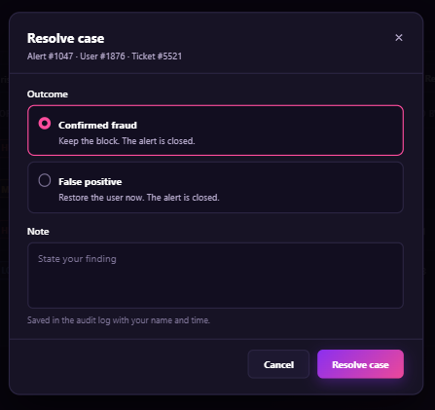
Figure 154 : Resolve Fraud Case Screen

FUNCTION DETAILS:
- VALIDATION RULES:
  - The user must be authenticated. The Access Token must be sent in the Authorization header, and it must be present, valid and not expired. The user must be identified from the claims in the token, so the client must not send a user id.
  - The account referenced by the token must exist, be active and have the Analyst role.
  - The alert id must be a whole number greater than 0, and the alert must exist.
  - The alert must be assigned to the Analyst in the token.
  - The alert must not be closed yet.
  - Outcome: required, one of Confirmed fraud or False positive. The default is Confirmed fraud.
  - Note: required, 1 to 500 characters after trimming spaces.
  - The Analyst must not send the request again while the previous request is being processed.
  - One request resolves one alert only.

- NORMAL FLOW:
  - Sub-flow A: Open the dialog
  - Step 1: The Analyst clicks "Resolve".
  - Step 2: The client sends the request with the alert id and the Access Token.
  - Step 3: The system validates the Access Token and the Analyst role, and checks the alert (exists, assigned to this Analyst, not closed).
  - Step 4: The system returns the alert summary (id, user, order/ticket).
  - Step 5: The client displays the dialog with the default outcome and an empty note.

  - Sub-flow B: Resolve the case
  - Step 1: The Analyst chooses the outcome, enters the note and clicks "Resolve case".
  - Step 2: The client checks the outcome and the note, then sends the request with the alert id, the outcome, the note and the Access Token.
  - Step 3: The system validates the Access Token, the Analyst role, the alert and the data.
  - Step 4: The system saves the outcome and the note, changes the alert status to Closed and records the audit log. For False positive, the system also restores the user. The system returns the saved data.
  - Step 5: The client closes the dialog, displays "Case resolved." and refreshes the page.

- ABNORMAL FLOWS:
  - Abnormal flow 1: Not authenticated or no permission (occurs at Sub-flow A, Step 2 or 3, and Sub-flow B, Step 2 or 3)
  - Step 1: The Access Token is missing, invalid or expired, or the account is not found, not active, or not an Analyst.
  - Step 2: The system returns no data, saves nothing and returns 401 Unauthorized (token or account problem) or 403 Forbidden (not an Analyst, or the alert is not assigned to this Analyst).
  - Step 3: For 401, the client tries to get a new Access Token with the Refresh Token and repeats the request. If this fails, the client deletes the stored tokens, displays "Your session has expired. Please log in again." and redirects to the Login page. For 403, the client displays "You do not have permission to do this action." and closes the dialog.

  - Abnormal flow 2: Alert not found (occurs at Sub-flow A, Step 3, and Sub-flow B, Step 3)
  - Step 1: The alert id is not valid or the alert does not exist.
  - Step 2: The system returns 404 Not Found and saves nothing.
  - Step 3: The client displays "This alert is no longer available." and returns to the Fraud cases list.

  - Abnormal flow 3: Alert already closed (occurs at Sub-flow A, Step 3, and Sub-flow B, Step 3)
  - Step 1: The alert is already closed, for example it was resolved from another session.
  - Step 2: The system returns 409 Conflict and saves nothing.
  - Step 3: The client displays "This alert has already been closed." and reloads the page to show the saved result.

  - Abnormal flow 4: Invalid note (occurs at Sub-flow B, Step 2 or 3)
  - Step 1: The note is empty, or has more than 500 characters.
  - Step 2: The client or the system rejects the request (400 Bad Request from the system) and saves nothing.
  - Step 3: The client keeps the dialog open, keeps the entered values and displays "Please enter a note (up to 500 characters)." under the field "Note".

3.17.11 Configure Risk Policy Parameters
FUNCTION TRIGGER:
- Trigger 1: Admin clicks the menu item "Risk policy" on the sidebar.
FUNCTION DESCRIPTION:
- Actor(s): Admin
- Secondary actor(s): None
- Purpose:
  - To let the Admin view and change the system parameters that control flagging, blocking and appeals, so that the risk system works with the thresholds, block durations and appeal limits that the business needs.
- Main Functionality:
  - The Admin opens the page "Risk policy". The header shows the title, the subtitle "System parameters that control flagging, blocking and appeals." and the button "Refresh". The filter bar contains the drop-down list "All categories", the field "Search key" and the button "Search". The table lists the parameters with the columns: PARAMETER (the key, for example "risk.threshold.review"), VALUE (an editable field), CATEGORY (Thresholds, Block duration, Appeals, Rollout), DESCRIPTION (for example "Score that opens a case") and UPDATED (for example "Admin #1 · 20/09/2026"). The parameters include: review threshold, block threshold, block hours for account, ticket and IP, appeal window in days, appeal SLA in hours, and shadow mode. The notice below the table says "Changes apply to new decisions only. Existing blocks keep their current expiry. Every change is saved in the audit log." The Admin edits one or more values and clicks "Save changes". The system validates and saves the changed values, and the client refreshes the table. The Admin can click "Reset" to discard the unsaved changes and restore the saved values.

SCREEN LAYOUT:
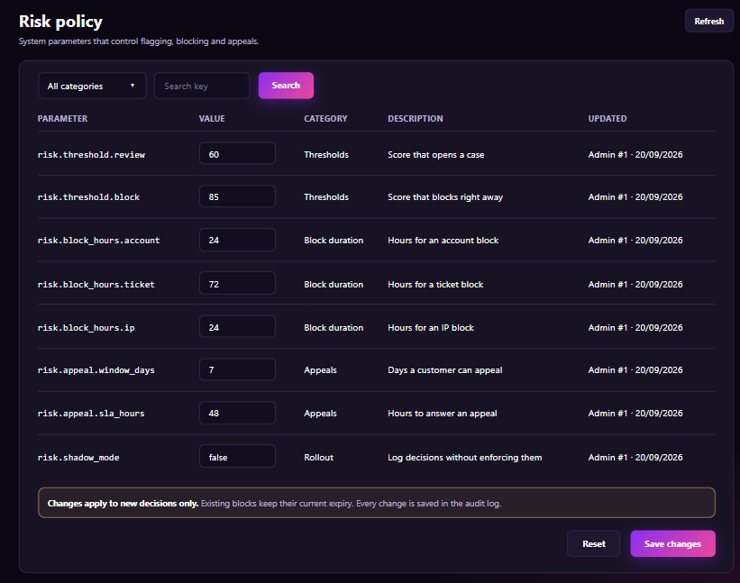
Figure 155 : Configure Risk Policy Parameters Screen
FUNCTION DETAILS:
- VALIDATION RULES:
  - The user must be authenticated. The Access Token must be sent in the Authorization header, and it must be present, valid and not expired. The user must be identified from the claims in the token, so the client must not send a user id.
  - The account referenced by the token must exist, be active and have the Admin role.
  - Category filter: optional, one of All categories, Thresholds, Block duration, Appeals, Rollout. The default is All categories.
  - Search key: optional, up to 100 characters. It matches part of the parameter key (not case-sensitive).
  - The parameter key cannot be edited. Only the value can be changed.
  - risk.threshold.review and risk.threshold.block: a number from 0 to 100 (up to 2 decimal places). The review threshold must be lower than the block threshold.
  - risk.block_hours.account, risk.block_hours.ticket and risk.block_hours.ip: a whole number of hours, at least 1 and at most 8,760.
  - risk.appeal.window_days: a whole number of days, at least 1 and at most 365.
  - risk.appeal.sla_hours: a whole number of hours, at least 1 and at most 720.
  - risk.shadow_mode: true or false.
  - The value must not be empty.
  - When the Admin saves, only the changed values are sent. If nothing changed, the client does not send the request.
  - Date is shown in the format dd/MM/yyyy.
  - The Admin must not send the request again while the previous request is being processed.
  - All changed values are validated together and saved together, or none is saved.

- NORMAL FLOW:
  - Sub-flow A: View the parameters
  - Step 1: The Admin clicks "Risk policy" on the sidebar.
  - Step 2: The client sends the request with the default filter and the Access Token.
  - Step 3: The system validates the Access Token and the Admin role.
  - Step 4: The system returns the parameters (key, value, category, description, updated by, updated date).
  - Step 5: The client displays the table.

  - Sub-flow B: Search and filter
  - Step 1: The Admin selects a category, enters a key and clicks "Search".
  - Step 2: The client sends the request with the filters and the Access Token.
  - Step 3: The system validates the Access Token and the Admin role, and filters the parameters.
  - Step 4: The system returns the matching parameters.
  - Step 5: The client displays the result.

  - Sub-flow C: Save the changes
  - Step 1: The Admin edits one or more values and clicks "Save changes".
  - Step 2: The client checks the values and sends the request with the changed parameters (key and new value) and the Access Token.
  - Step 3: The system validates the Access Token, the Admin role, the keys and the values.
  - Step 4: The system saves the new values, records the audit log for each change and returns the saved data.
  - Step 5: The client displays "Risk policy saved." and refreshes the table.

- ABNORMAL FLOWS:
  - Abnormal flow 1: Not authenticated or no permission (occurs at Sub-flow A, B, C or E, Step 2 or 3)
  - Step 1: The Access Token is missing, invalid or expired, or the account is not found, not active, or not an Admin.
  - Step 2: The system returns no data, saves nothing and returns 401 Unauthorized (token or account problem) or 403 Forbidden (not an Admin).
  - Step 3: For 401, the client tries to get a new Access Token with the Refresh Token and repeats the request. If this fails, the client deletes the stored tokens, displays "Your session has expired. Please log in again." and redirects to the Login page. For 403, the client displays "You do not have permission to do this action." and returns to the previous page.

  - Abnormal flow 2: Invalid value (occurs at Sub-flow C, Step 2 or 3)
  - Step 1: A value is empty, is not in the allowed format or range, or the review threshold is not lower than the block threshold.
  - Step 2: The client or the system rejects the request (400 Bad Request from the system) and saves nothing, not even the valid values.
  - Step 3: The client keeps the entered values and displays the error message under each invalid field (for example "Enter a whole number from 1 to 8,760." or "The review threshold must be lower than the block threshold.").

  - Abnormal flow 3: Parameter not found (occurs at Sub-flow C, Step 3)
  - Step 1: A parameter key sent by the client does not exist.
  - Step 2: The system returns 404 Not Found and saves nothing.
  - Step 3: The client displays "This parameter is no longer available." and refreshes the table.

  - Abnormal flow 4: Value changed by another Admin (occurs at Sub-flow C, Step 3)
  - Step 1: Another Admin has changed the same parameter after the page was loaded.
  - Step 2: The system returns 409 Conflict and saves nothing.
  - Step 3: The client displays "These parameters were changed by another admin. Please review and save again." and reloads the table.

3.18 System Activity Log & Audit Trail

3.18.1 View Activity Log List
FUNCTION TRIGGER:
- User clicks on the notification bell icon on the top navigation bar or accesses the Notification Center page.
FUNCTION DESCRIPTION:
- Actor(s): Customer, Event Organizer.
- Purpose:
  - To allow logged-in users across roles to view a real-time chronological list of in-app notifications, such as queue admission alerts, payment receipts, event schedule reminders, check-in confirmations, and event approval updates.
- Main Functionality:
  - The system displays the Notifications screen with filter tabs (All, Unread, Payments), a notification list showing status indicators, category icons, titles, message bodies, and relative timestamps. Unread items are highlighted with badges. The system maintains a real-time WebSocket/SignalR connection to push new notifications instantly and updates the unread counter badge dynamically.
SCREEN LAYOUT:
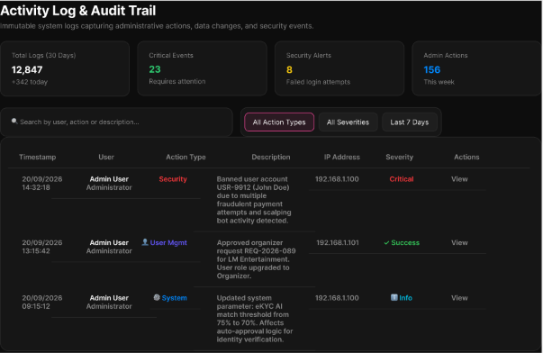
Figure 156 : View Activity Log List Screen
FUNCTION DETAILS:
- VALIDATION RULES:
  - User must be authenticated with a valid Access Token.
  - User must be viewing the notification list (UC_22).
  - Target notification record(s) must belong to the logged-in user's User_ID.
  - Notification ID must exist in the system.
- NORMAL FLOW:
  - Step 1: The user selects a specific unread notification item or taps "Mark all as read".
  - Step 2: The client sends a PUT/PATCH request to /api/notifications/{id}/read (or /api/notifications/read-all) with the Access Token.
  - Step 3: The system validates the request and extracts User_ID from the token.
  - Step 4: The system verifies that the target notification ID(s) belong strictly to the authenticated User_ID.
  - Step 5: The system sets is_read = true and read_at = CURRENT_TIMESTAMP in the database for the specified record(s).
  - Step 6: The system recalculates the remaining unread count for the user.
  - Step 7: The system returns a success response with the updated unread count.
  - Step 8: The client updates the UI in real time, removing the unread highlight and decrementing/resetting the unread badge counter.
- ABNORMAL FLOWS:
  - Step 1: User attempts to mark notification(s) as read or system processes the update request.
  - Step 2: System validates authentication, notification existence, and ownership (User_ID match).
  - Step 3: If validation fails or errors occur, system returns appropriate error:
    - 404 Not Found / 403 Forbidden: If notification doesn't exist or belongs to another user.
    - 500 Internal Server Error: For database update failures.
  - Step 4: System handles response:
    - If notification already read: Skip database update and directly redirect to target action URL.
    - If error: Display error message and keep user on notification list.

3.18.2 Export Audit Log
FUNCTION TRIGGER:
- User clicks on the notification bell icon on the top navigation bar or accesses the Notification Center page.
FUNCTION DESCRIPTION:
- Actor(s): Customer, Event Organizer.
- Purpose:
  - To allow logged-in users across roles to view a real-time chronological list of in-app notifications, such as queue admission alerts, payment receipts, event schedule reminders, check-in confirmations, and event approval updates.
- Main Functionality:
  - The system displays the Notifications screen with filter tabs (All, Unread, Payments), a notification list showing status indicators, category icons, titles, message bodies, and relative timestamps. Unread items are highlighted with badges. The system maintains a real-time WebSocket/SignalR connection to push new notifications instantly and updates the unread counter badge dynamically.
SCREEN LAYOUT:
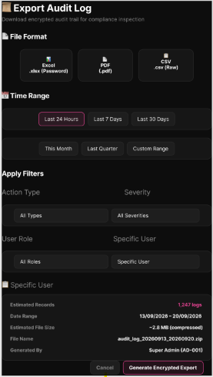
Figure 1567 : Export Audit Log Screen
FUNCTION DETAILS:
- VALIDATION RULES:
  - User must be authenticated with a valid Access Token.
  - User must be viewing the notification list (UC_22).
  - Target notification record(s) must belong to the logged-in user's User_ID.
  - Notification ID must exist in the system.
- NORMAL FLOW:
  - Step 1: The user selects a specific unread notification item or taps "Mark all as read".
  - Step 2: The client sends a PUT/PATCH request to /api/notifications/{id}/read (or /api/notifications/read-all) with the Access Token.
  - Step 3: The system validates the request and extracts User_ID from the token.
  - Step 4: The system verifies that the target notification ID(s) belong strictly to the authenticated User_ID.
  - Step 5: The system sets is_read = true and read_at = CURRENT_TIMESTAMP in the database for the specified record(s).
  - Step 6: The system recalculates the remaining unread count for the user.
  - Step 7: The system returns a success response with the updated unread count.
  - Step 8: The client updates the UI in real time, removing the unread highlight and decrementing/resetting the unread badge counter.
- ABNORMAL FLOWS:
  - Step 1: User attempts to mark notification(s) as read or system processes the update request.
  - Step 2: System validates authentication, notification existence, and ownership (User_ID match).
  - Step 3: If validation fails or errors occur, system returns appropriate error:
    - 404 Not Found / 403 Forbidden: If notification doesn't exist or belongs to another user.
    - 500 Internal Server Error: For database update failures.
  - Step 4: System handles response:
    - If notification already read: Skip database update and directly redirect to target action URL.
    - If error: Display error message and keep user on notification list.

3.19 Real-time Notification Management

3.19.1 View Notifications
FUNCTION TRIGGER:
- User clicks on the notification bell icon on the top navigation bar or accesses the Notification Center page.
FUNCTION DESCRIPTION:
- Actor(s): Customer, Event Organizer.
- Purpose:
  - To allow logged-in users across roles to view a real-time chronological list of in-app notifications, such as queue admission alerts, payment receipts, event schedule reminders, check-in confirmations, and event approval updates.
- Main Functionality:
  - The system displays the Notifications screen with filter tabs (All, Unread, Payments), a notification list showing status indicators, category icons, titles, message bodies, and relative timestamps. Unread items are highlighted with badges. The system maintains a real-time WebSocket/SignalR connection to push new notifications instantly and updates the unread counter badge dynamically.
SCREEN LAYOUT:
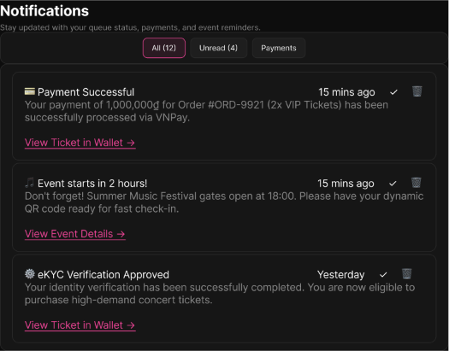
Figure 158 : View Notifications Screen
FUNCTION DETAILS:
- VALIDATION RULES:
  - User must be authenticated with a valid, unexpired Access Token.
  - User account must be active in the system (is_active = true).
  - User must have permission to view their own notifications only.
  - Notification list must be filtered by the authenticated User_ID.
- BUSINESS RULES:
  - BR-116, BR-117
- NORMAL FLOW:
  - Step 1: The user clicks on the notification bell icon or navigates to the notification page.
  - Step 2: The client sends a request to the Notification API passing the Access Token in the Authorization header.
  - Step 3: The system validates the token and identifies the User_ID from the token claims.
  - Step 4: The system queries the notification store for records matching the User_ID ordered by created_at descending.
  - Step 5: The system calculates the count of unread items (is_read = false).
  - Step 6: The system returns the list of notifications along with the unread badge count to the client.
  - Step 7: The client renders notification cards displaying status indicators (unread badge/highlight), title, message body, category icon, and relative timestamp, with filter tabs (All, Unread, Payments).
  - Step 8: The real-time WebSocket/SignalR connection remains open to push new incoming notifications instantly.
- ABNORMAL FLOWS:
  - Step 1: User accesses the notification screen or system processes the notification query.
  - Step 2: System validates authentication (valid Access Token), user account status, and notification data retrieval.
  - Step 3: If validation fails or errors occur, system returns appropriate error:
    - 401 Unauthorized: For missing, invalid, or expired Access Token (redirects to login).
    - 500 Internal Server Error: For database/Redis connection failures or unexpected system errors.
  - Step 4: System handles response:
    - If notification list is empty: Display empty-state message "Chưa có thông báo nào".
    - If real-time push received: Prepend new item to top of list and increment unread badge counter.
    - If error: Display error notification toast and keep user on current page.

3.19.2 Mark Notification as Read
FUNCTION TRIGGER:
- User clicks on a specific unread notification card or clicks the "Mark all as read" button.
FUNCTION DESCRIPTION:
- Actor(s): Customer, Event Organizer.
- Purpose:
  - To allow users to mark a single notification or all unread notification entries as read, immediately updating the read status, timestamp, and unread badge count in real time.
- Main Functionality:
  - The system displays a confirmation modal when user attempts to mark notification as read. Upon confirmation, the system validates ownership, updates the is_read flag and read_at timestamp, recalculates the unread count, and updates the UI in real-time by removing unread highlights and decrementing/resetting the badge counter. For already-read notifications, the system skips the update and directly navigates to the target URL.
SCREEN LAYOUT:
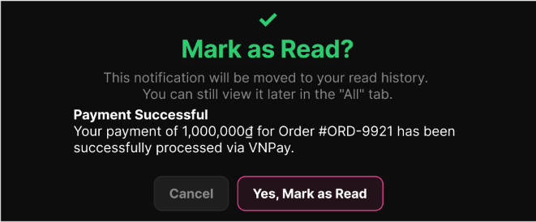
Figure 159 : Mark Notification as Read Screen
FUNCTION DETAILS:
- VALIDATION RULES:
  - User must be authenticated with a valid Access Token.
  - User must be viewing the notification list (UC_22).
  - Target notification record(s) must belong to the logged-in user's User_ID.
  - Notification ID must exist in the system.
- BUSINESS RULES:
  - BR-116, BR-118
- NORMAL FLOW:
  - Step 1: The user selects a specific unread notification item or taps "Mark all as read".
  - Step 2: The client sends a PUT/PATCH request to /api/notifications/{id}/read (or /api/notifications/read-all) with the Access Token.
  - Step 3: The system validates the request and extracts User_ID from the token.
  - Step 4: The system verifies that the target notification ID(s) belong strictly to the authenticated User_ID.
  - Step 5: The system sets is_read = true and read_at = CURRENT_TIMESTAMP in the database for the specified record(s).
  - Step 6: The system recalculates the remaining unread count for the user.
  - Step 7: The system returns a success response with the updated unread count.
  - Step 8: The client updates the UI in real time, removing the unread highlight and decrementing/resetting the unread badge counter.
- ABNORMAL FLOWS:
  - Step 1: User attempts to mark notification(s) as read or system processes the update request.
  - Step 2: System validates authentication, notification existence, and ownership (User_ID match).
  - Step 3: If validation fails or errors occur, system returns appropriate error:
    - 404 Not Found / 403 Forbidden: If notification doesn't exist or belongs to another user.
    - 500 Internal Server Error: For database update failures.
  - Step 4: System handles response:
    - If notification already read: Skip database update and directly redirect to target action URL.
    - If error: Display error message and keep user on notification list.

3.19.3 Delete Notification
FUNCTION TRIGGER:
- User clicks the "Delete" (or "Dismiss") button on a specific notification card.
FUNCTION DESCRIPTION:
- Actor(s): Customer, Event Organizer.
- Purpose:
  - To allow users to dismiss or remove specific notification entries from their active notification tray without affecting underlying business entities.
- Main Functionality:
  - The system displays a confirmation modal warning the user about permanent removal and the potential loss of important receipts. Upon confirmation, the system verifies ownership, executes a soft delete or tray dismissal without altering related business records (Orders, Tickets), and updates the UI by removing the card and adjusting the unread count.
SCREEN LAYOUT:
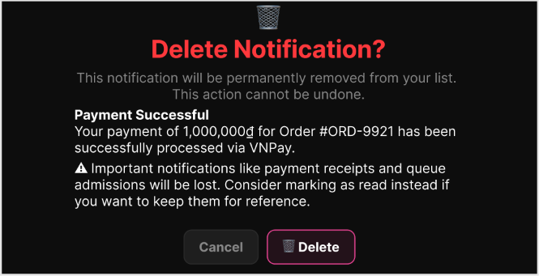
Figure 160 : Delete Notification Screen
FUNCTION DETAILS:
- VALIDATION RULES:
  - User must be authenticated with a valid Access Token.
  - User must be viewing the notification list.
  - Target notification record must exist and belong to the authenticated user.
- BUSINESS RULES:
  - BR-116, BR-119
- NORMAL FLOW:
  - Step 1: The user clicks the delete/dismiss icon on a specific notification item.
  - Step 2: The system displays a confirmation prompt with the warning: "This notification will be permanently removed from your list. This action cannot be undone." and a secondary warning: "⚠ Important notifications like payment receipts and queue admissions will be lost. Consider marking as read instead if you want to keep them for reference."
  - Step 3: The user confirms the deletion by clicking the "Delete" button.
  - Step 4: The client sends a DELETE request to /api/notifications/{id} with the Access Token.
  - Step 5: The system verifies that the notification belongs to the requesting User_ID.
  - Step 6: The system executes a removal/user-specific dismissal on the notification record without modifying or deleting related domain entities (orders, tickets, events).
  - Step 7: The system returns success response MSG07 ("Delete asset(s) successfully.").
  - Step 8: The client removes the notification card from the active tray view and adjusts the unread count if the deleted item was unread.
- ABNORMAL FLOWS:
  - Step 1: User interacts with the deletion modal or the system processes the delete request.
  - Step 2: System validates authentication and verifies the notification exists and belongs to the user.
  - Step 3: If the user clicks "Cancel", the system closes the modal and makes no data changes.
  - Step 4: If validation fails or errors occur, the system returns the appropriate error (404 Not Found if already removed from another session, 500 Internal Server Error for system failures). For a 404 error, the client automatically removes the stale item from the UI.

3.20 Payment Gateway Integration, Voucher & Checkout

3.20.1 Checkout
FUNCTION TRIGGER:
- Customer clicks the "Checkout" button after selecting seats.
FUNCTION DESCRIPTION:
- Actor(s): Customer, Payment Gateway - VNPay.
- Purpose:
  - To enable customers holding reserved seats to review ticket order summary, input attendee identification details, apply discount vouchers, and initialize payment through VNPay gateway.
- Main Functionality:
  - The system displays the Checkout screen with Ticket Holder Information forms for each reserved seat, Linked Attendees list for quick selection, Voucher Code input field, and Order Summary. Customers must fill in identification details (Full Name, Citizen ID/CCCD, ID-REAR Number, Phone Number, Email) for each ticket holder. The system validates voucher codes, recalculates order totals with discounts, validates all required fields, checks seat reservation timer, creates Order records with "Pending" status, and initializes payment session with VNPay gateway before redirecting customers to complete the transaction.
SCREEN LAYOUT:
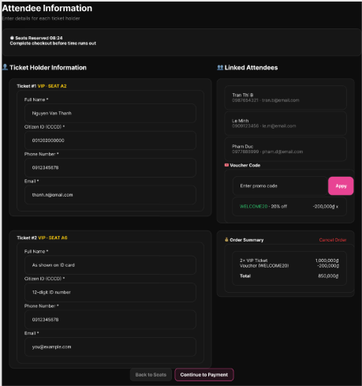
Figure 161 : Checkout Screen
FUNCTION DETAILS:
- VALIDATION RULES:
  - User must be authenticated with valid Access Token.
  - User account must exist and be active.
  - User must have completed eKYC verification.
  - Seat reservation must exist and be active (not expired).
  - Reserved seats must still be available.
- NORMAL FLOW:
  - Step 1: The system displays the Checkout screen with Ticket Holder Information forms, Linked Attendees list, Voucher Code input field with "Apply" button, Order Summary, and seat reservation countdown timer.
  - Step 2: The customer reviews and fills in attendee identification details for each ticket holder.
  - Step 3: The customer enters a voucher code and clicks "Apply".
  - Step 4: The system validates the voucher code (format, existence, expiry date, usage limits).
  - Step 5: The system recalculates and updates the Order Summary with the discounted total.
  - Step 6: The customer clicks "Continue to Payment" button.
  - Step 7: The system validates all required attendee information fields (CCCD format, phone number format, email format, no empty required fields).
  - Step 8: The system checks that the seat reservation timer has not expired.
  - Step 9: The system creates an Order record in the database with status "Pending" and associates it with the reserved seats and attendee information.
  - Step 10: The system sends a payment initialization request to VNPay gateway with order details (order ID, amount, customer info, return URL, IPN URL).
  - Step 11: VNPay gateway confirms that the payment session is created successfully and returns the payment URL.
  - Step 12: The system logs the payment initialization event.
  - Step 13: The system redirects the customer to the VNPay payment page to complete the transaction.
- ABNORMAL FLOWS:
  - Step 1: Customer performs an action (applying voucher, filling details, clicking Continue to Payment) or the system performs background checks during the checkout process.
  - Step 2: System validates authentication (Access Token), authorization (account existence, eKYC status), input data (attendee info, voucher format), business rules (seat reservation timer), and external dependencies (VNPay gateway).
  - Step 3: If any validation, authorization, or processing error occurs, the system rejects the operation and returns the specific error response:
    - 400 Bad Request: For invalid/missing attendee info or invalid/expired voucher.
    - 401 Unauthorized: For invalid/expired token or account not found.
    - 403 Forbidden: If eKYC is not completed.
    - 409 Conflict: If the seat reservation timer has expired.
    - 500 Internal Server Error: For unexpected system/database failures.
    - 503 Service Unavailable: If VNPay gateway is unavailable.
  - Step 4: System displays the appropriate error message on the UI. Based on the error type, the system either keeps the customer on the Checkout screen (for form/voucher errors) or redirects them to the relevant page (Seat Selection screen for expired timer/VNPay failure, Login screen for token issues, or eKYC screen for verification issues).
  - Step 5: If the error occurs after partial data processing (e.g., Order created but VNPay fails, or unexpected system error), the system rolls back the transaction, releases the reserved seats back to the available pool, and deletes any temporary checkout data to maintain data consistency.

3.20.2 Apply Voucher
FUNCTION TRIGGER:
- Customer opens the voucher modal/screen on the Checkout page to view available vouchers or manually enters a promo code.
FUNCTION DESCRIPTION:
- Actor(s): Customer
- Purpose:
  - To allow customers to enter an organizer-issued or system-wide promotional code to receive an immediate order discount during checkout.
- Main Functionality:
  - The system displays the Apply Voucher modal with manual promo code input, System Vouchers list (available across all events), and Organizer Vouchers list (event-specific). Customers can either enter a code manually or select from available vouchers. The system validates voucher eligibility, calculates discount amounts server-side, applies the voucher to lock it for the order, and updates the Order Summary with the discounted total.
SCREEN LAYOUT:
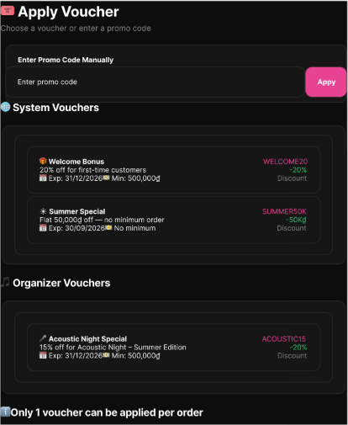
Figure 162 : Apply Voucher Screen
FUNCTION DETAILS:
- VALIDATION RULES:
  - Customer must be authenticated with a valid Access Token.
  - Customer must be on the Checkout page with reserved seats and an active order summary.
  - Order must contain at least one ticket.
  - No voucher has already been applied to this order.
  - Voucher code must exist and be active in the system.
  - Voucher must not be expired (expiration date must be in the future).
  - Voucher usage limit must not be reached.
  - Customer must meet eligibility criteria (e.g., first-time customer for Welcome Bonus).
  - Order subtotal must meet the minimum order value requirement.
  - Voucher must be applicable to the ticket types in the order.

- NORMAL FLOW:
  - Step 1: The system displays the Apply Voucher modal/screen with: "Enter Promo Code Manually" section with text input field and "Apply" button; "System Vouchers" section listing available system-wide vouchers (e.g., Welcome Bonus, Summer Special) with details: name, discount value/percentage, minimum order requirement, expiration date; "Organizer Vouchers" section listing event-specific vouchers issued by event organizers; and note: "Only 1 voucher can be applied per order".
  - Step 2: The customer either enters a promo code manually in the text field and clicks "Apply" (Option A), or selects a voucher from the available list (System Vouchers or Organizer Vouchers) (Option B).
  - Step 3: The system validates that no voucher has already been applied to this order.
  - Step 4: The system validates the voucher: voucher code exists and is active, voucher has not expired, voucher usage limit has not been reached, customer meets eligibility criteria (e.g., first-time customer for Welcome Bonus), order meets minimum order value requirement, and voucher is applicable to the ticket types in the order.
  - Step 5: The system calculates the discount amount based on voucher type (percentage or fixed amount).
  - Step 6: The system recalculates the order total.
  - Step 7: The system applies the voucher to the order and locks it (marks as "in use" for this order).
  - Step 8: The system updates the Order Summary display with the discount amount and new total.
  - Step 9: The system closes the voucher modal and returns to the Checkout page with updated pricing.

- ABNORMAL FLOWS:
  - Step 1: Customer performs an action (enters promo code, selects voucher from list, or clicks Apply) during the voucher application process.
  - Step 2: System validates authentication (valid Access Token), authorization, input data, business rules (only 1 voucher per order, voucher existence, expiry date, usage limits, customer eligibility, minimum order value, ticket type applicability), and system dependencies.
  - Step 3: If any validation or processing error occurs, the system rejects the operation, keeps the voucher modal open, and returns the appropriate error response:
    - 400 Bad Request: For invalid/non-existent promo code, expired voucher, usage limit reached, minimum order value not met, or voucher not applicable to ticket types.
    - 401 Unauthorized: For missing, invalid, or expired Access Token.
    - 403 Forbidden: If customer is not eligible for the voucher (e.g., not a first-time customer).
    - 409 Conflict: If a voucher has already been applied to this order.
    - 500 Internal Server Error: For unexpected system errors (database failure, calculation error).
  - Step 4: System displays the appropriate error message on the UI and highlights the input field if applicable. The customer remains on the voucher modal to try another voucher or correct the information.
  - Step 5: If a system error occurs after partial processing, the system rolls back any partial changes, logs the error with full stack trace, and ensures no voucher is incorrectly applied or locked.

3.20.3 Process VNPay Payment
FUNCTION TRIGGER:
- Customer is redirected to the VNPay payment page after clicking "Pay" on the Checkout screen.
FUNCTION DESCRIPTION:
- Actor(s): Customer, Payment Gateway - VNPay.
- Purpose:
  - To allow customers to complete payment through the VNPay gateway, validate the webhook callback securely, and issue confirmed digital tickets upon successful payment.
- Main Functionality:
  - The system redirects the customer to the VNPay payment page where they select a bank and complete the transaction. VNPay processes the payment and sends a callback (IPN/Webhook) to the system. The system validates the secure hash signature, verifies payment status and amount, updates the Order status to "Paid/Confirmed", generates digital tickets with unique QR codes, sends tickets to customer's email, and displays a success confirmation screen.
SCREEN LAYOUT:
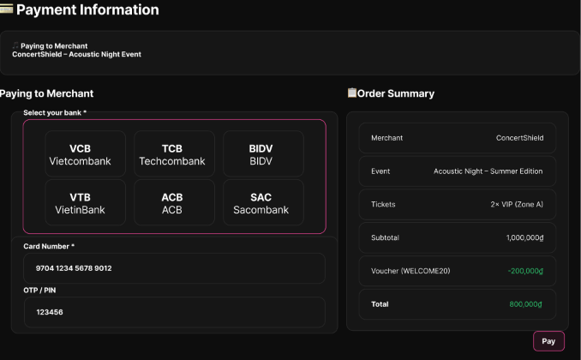
Figure 163 : Process VNPay Payment Screen
FUNCTION DETAILS:
- VALIDATION RULES:
  - Customer must be authenticated with a valid Access Token.
  - Customer must have successfully completed eKYC verification.
  - Order must exist with status "Pending".
  - Seat reservation timer must still be active.
  - VNPay callback must contain valid secure hash signature.
  - Payment status must be "Success" (ResponseCode = 00).
  - Transaction amount paid must match the Order total in the database.
  - Email service must be operational for sending digital tickets.
- NORMAL FLOW:
  - Step 1: The system redirects the customer to the VNPay payment page.
  - Step 2: The customer selects a payment method/bank and completes the transaction on VNPay's interface.
  - Step 3: VNPay processes the payment and sends a callback (IPN/Webhook) to the system's configured return URL.
  - Step 4: The system receives the callback and validates the secure hash (signature) from VNPay to ensure data integrity.
  - Step 5: The system checks that the payment status is "Success" (ResponseCode = 00).
  - Step 6: The system verifies that the transaction amount matches the Order total in the database.
  - Step 7: The system updates the Order status to "Paid/Confirmed".
  - Step 8: The system generates digital tickets for each attendee in the order.
  - Step 9: The system sends the digital tickets to the customer's email (and/or displays them in the app).
  - Step 10: The system displays a "Payment Successful" screen to the customer with ticket details.

- ABNORMAL FLOWS:
  - Step 1: Customer cancels/fails payment on VNPay, the seat timer expires, or the system receives an invalid callback.
  - Step 2: System validates the callback signature, amount, and seat timer. If the data is invalid (e.g., tampered signature, amount mismatch), it rejects the callback (returning 400 Bad Request) and logs the security alert.
  - Step 3: System displays the corresponding error message on the UI (e.g., "Payment Cancelled", "Payment Failed", "Session Expired", or "System Error").
  - Step 4: System handles the order state: keeps the Order "Pending" to allow retry if the seat timer is still active, or releases the seats and cancels the Order if the timer expired. For unexpected system errors (500), it rolls back partial changes and advises the customer to contact support.

3.20.4 Cancel Pending Order
FUNCTION TRIGGER:
- Customer clicks the "Cancel Order" button on the Checkout page.
FUNCTION DESCRIPTION:
- Actor(s): Customer
- Purpose:
  - To allow customers to cancel their pending orders before payment completion, which releases reserved seats back to the available pool.
- Main Functionality:
  - The system displays a confirmation modal warning the customer about the immediate release of their reserved seats. Upon confirmation, the system validates the order, updates its status to "Cancelled", atomically releases the reserved seats back to the pool, and redirects the user to the appropriate page.
SCREEN LAYOUT:
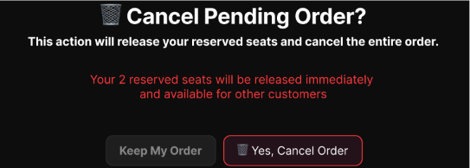
Figure 164 : Cancel Pending Order Screen
FUNCTION DETAILS:
- VALIDATION RULES:
  - Customer must be authenticated with a valid, unexpired Access Token.
  - An Order with status "Pending" must exist for the current customer.
  - The seat reservation timer must still be active.
- NORMAL FLOW:
  - Step 1: The customer clicks the "Cancel Order" button on the Checkout page.
  - Step 2: The system displays a confirmation modal with the warning: "This action will release your reserved seats and cancel the entire order. Your reserved seats will be released immediately and available for other customers."
  - Step 3: The customer clicks the "Yes, Cancel Order" button.
  - Step 4: The system validates that the Order exists, belongs to the current user, and is in "Pending" status.
  - Step 5: The system updates the Order status to "Cancelled".
  - Step 6: The system releases the reserved seats back to the available pool immediately.
  - Step 7: The system displays a success message and redirects the customer (e.g., back to the event details or seat selection page).
- ABNORMAL FLOWS:
  - Step 1: Customer interacts with the modal (clicks "Keep My Order") or the system encounters validation/system errors during the cancellation process.
  - Step 2: If the customer clicks "Keep My Order", the system simply closes the modal and keeps the customer on the Checkout page with the order and seats unchanged.
  - Step 3: If validation or system errors occur (e.g., invalid token, order not found, access denied, or unexpected database failure), the system rejects the operation and returns the appropriate error response (401 Unauthorized, 403/404 Not Found, or 500 Internal Server Error).
  - Step 4: System displays the corresponding error message via a toast or inline alert, keeps the modal open (if applicable), and ensures no partial changes are saved (rolling back if necessary) to maintain data consistency.

3.20.5 View Organizer Vouchers
FUNCTION TRIGGER:
- Organizer clicks on the "Vouchers & Promotions" menu item in the Organizer Portal.
FUNCTION DESCRIPTION:
- Actor(s): Organizer
- Purpose:
  - To allow organizers to view all promotional discount vouchers created for their specific concerts/events, including redemption metrics, usage caps, validity periods, and active operational status.
- Main Functionality:
  - The system displays the Voucher Management screen with summary statistics (Total Vouchers, Active Vouchers, Total Redemptions), filter options (search by code, status, event), and a data table listing all vouchers with details: Voucher Code, Discount Type/Value, Validity Period, Status (Active/Inactive/Expired), Event name, and Actions (Edit, Delete/Activate). The system dynamically computes operational status based on validity dates, active flag, and usage limits.
SCREEN LAYOUT:
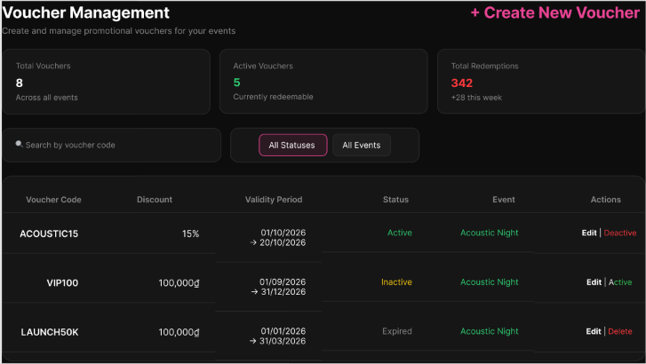
Figure 165 : View Organizer Vouchers Screen
FUNCTION DETAILS:
- VALIDATION RULES:
  - User must be authenticated with a valid Access Token.
  - User must have the Organizer role.
  - User must own at least one published or approved event (organizer_id = CurrentUserId).
  - Only non-deleted vouchers (is_deleted = false) are displayed.
  - Voucher list must be filtered by organizer_id matching the authenticated user.
- BUSINESS RULES:
  - BR-124, BR-127
- NORMAL FLOW:
  - Step 1: The Organizer navigates to the Voucher Management screen in the Organizer Portal.
  - Step 2: The client sends a GET request to /api/v1/vouchers with the Access Token.
  - Step 3: The system extracts organizer_id from token claims and queries the vouchers table where organizer_id = CurrentUserId and is_deleted = false.
  - Step 4: The system evaluates the dynamic operational status for each voucher (Active, Inactive, or Expired) based on is_active, starts_at, ends_at, and used_quantity vs total_quantity.
  - Step 5: The system returns the voucher list along with total redemption counts to the client.
  - Step 6: The client renders the summary cards displaying Total Vouchers count, Active Vouchers count, and Total Redemptions count.
  - Step 7: The client renders the data table displaying Voucher Code, Discount Type/Value, Validity Period, Status Pill, Event name, and Actions (Edit, Delete/Activate) for each voucher.
- ABNORMAL FLOWS:
  - Step 1: Organizer accesses the Voucher Management screen or the system processes the voucher list query.
  - Step 2: System validates authentication (valid Access Token), authorization (Organizer role), and organizer ownership (at least one event).
  - Step 3: If validation fails or system errors occur, the system returns the appropriate error response:
    - 403 Forbidden: If user is not an Organizer or attempts unauthorized access.
    - 500 Internal Server Error: For unexpected system/database failures.
  - Step 4: System handles the response:
    - If no vouchers exist: Display empty state screen with prominent "+ Create Your First Voucher" button.
    - If unauthorized: Display error message and redirect to appropriate page (login or dashboard).
    - If system error: Display error toast/notification and keep user on current page or redirect to dashboard.

3.20.6 Create Organizer Voucher
FUNCTION TRIGGER:
- Organizer clicks the "+ Create New Voucher" button in the Organizer Portal.
FUNCTION DESCRIPTION:
- Actor(s): Organizer
- Purpose:
  - To allow organizers to issue event-specific or organizer-wide discount codes, setting discount percentage/amount, max discount caps, minimum order thresholds, usage caps, and validity dates.
- Main Functionality:
  - The system displays the Create Voucher modal form where organizers input voucher parameters including code, scope (Organizer/Event), discount type (Percentage/Fixed Amount), discount value, minimum order value, maximum discount cap, usage limits (total and per-user), and validity period. The system validates code uniqueness, normalizes the code format, verifies ownership, validates discount rules and date ranges, then creates the voucher record and activates it for checkout redemption.
SCREEN LAYOUT:
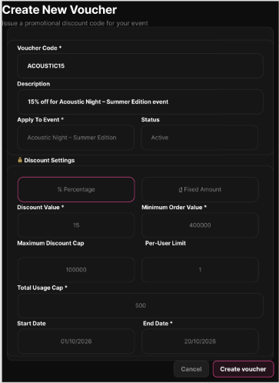
Figure 166 : Create Organizer Voucher Screen
FUNCTION DETAILS:
- VALIDATION RULES:
  - User must be authenticated with Organizer role.
  - For EVENT scope vouchers, the target event must exist, be in APPROVED or PUBLISHED state, and be owned by the current organizer.
  - Voucher code is required and must be unique across the platform.
  - Voucher code must be normalized (trimmed, uppercase).
  - Discount Type must be either PERCENT or FIXED.
  - For PERCENT discount: Discount Value must be > 0 and <= 100.
  - For FIXED discount: Discount Value must be > 0.
  - Minimum Order Value must be >= 0.
  - Maximum Discount Cap (if provided) must be > 0.
  - Total Usage Cap must be > 0.
  - Max Usage Per User (if provided) must be > 0.
  - Start Date must be provided and valid.
  - End Date must be provided and valid.
  - Start Date must be before End Date (starts_at < ends_at).
  - All required fields (marked with *) must be completed.
- BUSINESS RULES:
  - BR-124, BR-125, BR-126, BR-127

- NORMAL FLOW:
  - Step 1: The Organizer opens the Create Voucher modal form.
  - Step 2: The Organizer enters parameters: Voucher Code (e.g., SUMMER2026), Scope (ORGANIZER or EVENT), Event ID (if EVENT scope), Discount Type (PERCENT or FIXED), Discount Value, Max Discount Amount (optional for PERCENT), Min Order Value, Total Quantity, Max Usage Per User, Start Date, and End Date.
  - Step 3: The Organizer submits the form.
  - Step 4: The system validates the inputs:
    - a. Normalizes the voucher code: trims whitespace, converts to uppercase.
    - b. Checks that the code is unique across the entire platform.
    - c. Verifies scope ownership (organizer_id matches CurrentUserId).
    - d. Validates discount rules: for PERCENT, 0 < discount_percent <= 100; for FIXED, discount_amount > 0.
    - e. Validates date range: starts_at < ends_at.
  - Step 5: The system creates the new voucher record in the vouchers table with created_by = CurrentUserId, used_quantity = 0, is_active = true, and is_deleted = false.
  - Step 6: The system logs the creation event in the activity log.
  - Step 7: The system returns success response MSG04 ("Add asset successfully.").
  - Step 8: The client closes the modal and refreshes the voucher list view.
- ABNORMAL FLOWS:
  - Step 1: Organizer submits the voucher creation form or the system processes the request.
  - Step 2: System validates authentication (Organizer role), authorization (event ownership for EVENT scope), input data (voucher code format, discount values, date range), business rules (code uniqueness, discount constraints), and database operations.
  - Step 3: If any validation or processing error occurs, the system rejects the operation and returns the appropriate error response:
    - 400 Bad Request / 409 Conflict: For duplicate voucher code already existing in the system.
    - 400 Bad Request: For invalid discount percentage (>100 or <=0), invalid date range (start date after end date), or other validation errors.
    - 403 Forbidden: If organizer attempts to create voucher for an event they don't own.
    - 500 Internal Server Error: For database transaction failures or unexpected system errors.
  - Step 4: System displays the corresponding error message on the modal form (inline validation errors or toast notification), keeps the modal open with entered data preserved, and allows the organizer to correct the issues and resubmit.

3.20.7 View Voucher Usage Details
FUNCTION TRIGGER:
- Organizer clicks "View Usages" or "Usage History" on a specific voucher row in the voucher table.
FUNCTION DESCRIPTION:
- Actor(s): Organizer
- Purpose:
  - To allow organizers to inspect detailed read-only redemption records of a specific voucher code, tracking orders where discounts were applied, applied discount amounts, customer IDs, and exact redemption timestamps.
- Main Functionality:
  - The system displays a modal or dedicated page showing voucher usage history with search/filter options (by voucher code, event, date range), and a data table listing all redemption records including Order ID, Customer name, Event name, Original Price, Discount Amount, Final Price, and Redemption Timestamp. All records are read-only audit logs.
SCREEN LAYOUT:
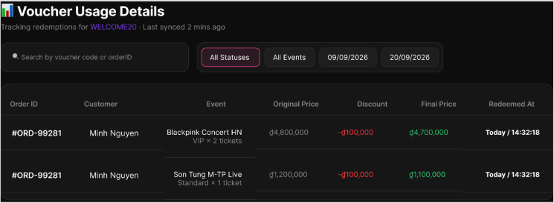
Figure 167 : View Voucher Usage Details Screen
FUNCTION DETAILS:
- VALIDATION RULES:
  - User must be authenticated with Organizer role.
  - Target voucher must exist in the system.
  - Target voucher must belong to the authenticated organizer (organizer_id = CurrentUserId).
  - Voucher ID must be valid and accessible.
  - User must have permission to view the specific voucher's usage history.
- BUSINESS RULES:
  - BR-124, BR-130
- NORMAL FLOW:
  - Step 1: The Organizer clicks "View Usages" on a voucher card/row.
  - Step 2: The client sends a GET request to /api/v1/vouchers/{id}/usages with the Access Token.
  - Step 3: The system extracts CurrentUserId from token and checks that the targeted Voucher_ID belongs to the organizer.
  - Step 4: The system queries the voucher_usages table joined with order details.
  - Step 5: The system formats the read-only audit records containing voucher_usage_id, order_id, user_id, discount_amount, and used_at timestamp.
  - Step 6: The system returns the usage dataset to the client.
  - Step 7: The client renders the modal/table displaying order redemption history with columns: Order ID, Customer, Event, Original Price, Discount, Final Price, and Redeemed At timestamp.
- ABNORMAL FLOWS:
  - Step 1: Organizer requests voucher usage details or system processes the query.
  - Step 2: System validates authentication, authorization (voucher ownership), and voucher existence.
  - Step 3: If validation fails or errors occur, system returns appropriate error:
    - 403 Forbidden: If organizer attempts to view another organizer's voucher usage.
    - 404 Not Found: If voucher doesn't exist.
    - 500 Internal Server Error: For system/query failures.
  - Step 4: System handles response:
    - If zero usage records: Display empty state message "Chưa có đơn hàng nào sử dụng voucher này."
    - If unauthorized/error: Display error message and close modal or keep user on current page.

3.20.8 View System Vouchers
FUNCTION TRIGGER:
- Admin clicks the "Platform Vouchers" item in the Admin Navigation sidebar.
FUNCTION DESCRIPTION:
- Actor(s): Admin.
- Purpose:
  - To allow system administrators to browse platform-sponsored promotional discount campaigns, global voucher codes, total budget consumption, global usage caps, and campaign statuses.
- Main Functionality:
  - The system displays the System Vouchers dashboard with summary statistics (Total Vouchers, Active Vouchers, Total Redemptions), search and filter options (by code, status, event), and a data table listing all system-level vouchers. It dynamically computes operational statuses and provides action buttons to edit, toggle status, or delete vouchers.
SCREEN LAYOUT:
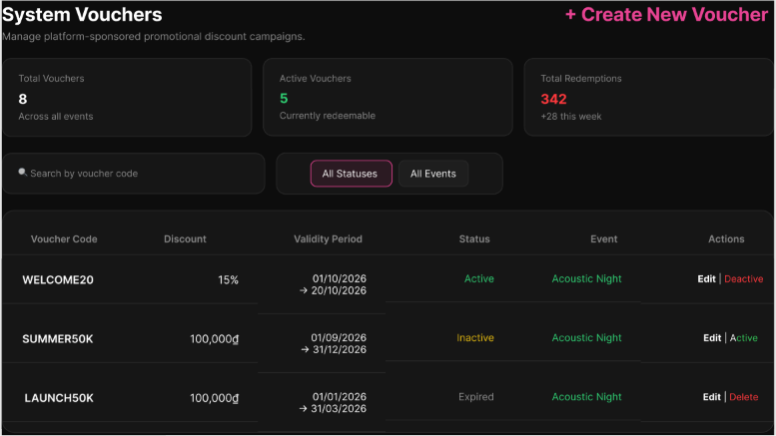
Figure 168 : View System Vouchers Screen
FUNCTION DETAILS:
- VALIDATION RULES:
  - User must be authenticated with a valid Access Token.
  - User must have the System Administrator role.
  - The system must only query and display vouchers with scope = 'SYSTEM' or is_system_wide = true.
- BUSINESS RULES:
  - BR-127
- NORMAL FLOW:
  - Step 1: The Admin accesses the Platform Vouchers administration screen.
  - Step 2: The client sends a GET request to /api/v1/vouchers?scope=SYSTEM (or /api/vouchers) with the Admin Access Token.
  - Step 3: The system verifies Admin role claims.
  - Step 4: The system queries all system-level vouchers (scope = 'SYSTEM' / is_system_wide = true) from the vouchers table.
  - Step 5: The system computes operational status (ACTIVE, INACTIVE, EXPIRED, EXHAUSTED) for each campaign.
  - Step 6: The system returns the list of system vouchers along with overall campaign statistics to the client.
  - Step 7: The client renders the summary cards (Total Vouchers, Active Vouchers, Total Redemptions) and the data table displaying Voucher Code, Discount, Validity Period, Status, Event, and Action Buttons (Edit, Deactive/Active, Delete).

- ABNORMAL FLOWS:
  - Step 1: Admin accesses the screen or applies search/filters.
  - Step 2: System validates authentication, authorization (Admin role), and database connectivity.
  - Step 3: If errors occur, system returns appropriate responses (403 Forbidden for non-admin access, 500 Internal Server Error for DB failures) and displays the corresponding error message on the UI.
  - Step 4: If no records match the filters or search query, the system displays an empty state message in the data table.

3.20.9 Create System Voucher
FUNCTION TRIGGER:
- Admin clicks the "Create System Voucher" button on the Platform Vouchers dashboard.
FUNCTION DESCRIPTION:
- Actor(s): Admin.
- Purpose:
  - To allow administrators to configure new platform-wide vouchers, setting global budgets, max discount caps, minimum order thresholds, per-user usage limits, and event eligibility.
- Main Functionality:
  - The system displays the Create System Voucher form where admins input voucher parameters including code, description, discount type (Percentage/Fixed Amount), discount value, minimum order value, maximum discount cap, total usage cap (global budget), per-user limit, validity dates, event eligibility rules, and target audience. The system validates code uniqueness, normalizes the code format, validates discount rules and date ranges, then creates the system-wide voucher with scope = 'SYSTEM'.
SCREEN LAYOUT:
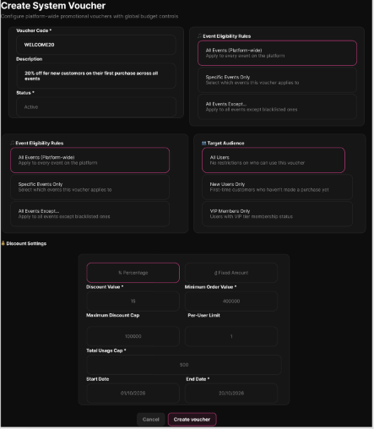
Figure 169 : Create System Voucher Screen
FUNCTION DETAILS:
- VALIDATION RULES:
  - User must be authenticated with Admin role.
  - Voucher code is required and must be unique across the platform.
  - Voucher code must be normalized (trimmed, uppercase).
  - Discount Type must be either PERCENT or FIXED.
  - For PERCENT discount: Discount Value must be > 0 and <= 100.
  - For FIXED discount: Discount Value must be > 0.
  - Minimum Order Value must be >= 0.
  - Maximum Discount Cap (if provided) must be > 0.
  - Total Usage Cap (global budget) must be > 0.
  - Per-User Limit (if provided) must be >= 1 (defaults to 1).
  - Start Date must be provided and valid.
  - End Date must be provided and valid.
  - Start Date must be before End Date (starts_at < ends_at).
  - All required fields (marked with *) must be completed.
- BUSINESS RULES:
  - BR-125, BR-126, BR-127, BR-128, BR-129
- NORMAL FLOW:
  - Step 1: Admin opens the Create System Voucher form.
  - Step 2: Admin enters parameters: Voucher Code, Discount Type (PERCENT / FIXED), Discount Value, Max Discount Amount (cap), Min Order Value, Total Quantity (global budget cap), Max Usage Per User (default 1), Start Date, and End Date.
  - Step 3: Admin submits the form.
  - Step 4: System validates parameters:
    - a. Normalizes code (trim whitespace, uppercase) and verifies uniqueness across platform.
    - b. Validates discount rules: PERCENT between 0-100%, FIXED amount > 0.
    - c. Validates date range (starts_at < ends_at).
    - d. Sets scope = 'SYSTEM', organizer_id = NULL, event_id = NULL.
  - Step 5: System inserts system voucher into vouchers table (is_active = true, is_deleted = false).
  - Step 6: System logs administrative audit trail entry.
  - Step 7: System returns success message MSG04 ("Add asset successfully.").
  - Step 8: Client closes modal and refreshes dashboard.
- ABNORMAL FLOWS:
  - Step 1: Admin submits the voucher creation form or system processes the request.
  - Step 2: System validates authentication (Admin role), input data (code format, discount values, date range), business rules (code uniqueness, discount constraints), and database operations.
  - Step 3: If validation fails or errors occur, system returns appropriate error:
    - 400 Bad Request / 409 Conflict: For duplicate voucher code or invalid parameters.
    - 500 Internal Server Error: For database constraint errors or system failures.
  - Step 4: System displays error message on the form (inline validation or toast notification), keeps modal open with data preserved, and allows admin to correct and resubmit.

3.20.10 Update System Voucher
FUNCTION TRIGGER:
- Admin clicks "Edit" or "Toggle Status" on a system voucher item.
FUNCTION DESCRIPTION:
- Actor(s): Admin.
- Purpose:
  - To allow administrators to pause, activate, adjust total quantity/budget, extend validity dates, or update operational status of platform-wide vouchers.
- Main Functionality:
  - The system displays the Update System Voucher form with pre-filled voucher details including voucher code, discount type/value, maximum discount cap, validity dates, event eligibility rules, and target audience. Admins can modify editable fields (extend end date, increase total quantity, toggle active status, adjust discount parameters). The system validates changes, updates the voucher record, and logs audit trail entries.
SCREEN LAYOUT:
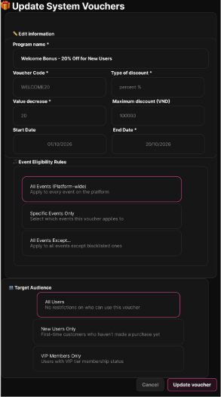
Figure 170 : Update System Voucher Screen
FUNCTION DETAILS:
- VALIDATION RULES:
  - User must be authenticated with Admin role.
  - Target system voucher must exist and not be soft-deleted (is_deleted = false).
  - End Date must be >= Start Date (ends_at >= starts_at).
  - Total Quantity must be >= current used_quantity (cannot reduce below redeemed amount).
  - Discount rules must remain valid (PERCENT 0-100%, FIXED > 0).
  - Minimum Order Value must be >= 0.
  - Maximum Discount Cap (if provided) must be > 0.
  - Per-User Limit (if provided) must be >= 1.
  - At least one field must be modified for the update to proceed.

- BUSINESS RULES:
  - BR-125, BR-126, BR-127
- NORMAL FLOW:
  - Step 1: Admin selects a system voucher and clicks "Edit" or toggles is_active.
  - Step 2: Admin updates editable fields (e.g., extending ends_at, increasing total_quantity, or setting is_active = false to pause).
  - Step 3: Admin saves changes.
  - Step 4: System validates modified fields (ensuring ends_at >= starts_at, total_quantity >= used_quantity, discount rules remain valid).
  - Step 5: System updates vouchers record and updates updated_at timestamp.
  - Step 6: System logs audit trail entry ("System voucher {Code} updated by Admin {AdminId}").
  - Step 7: System returns success message MSG03 ("Update asset(s) successfully.").
  - Step 8: Client refreshes table view with updated status.
ABNORMAL FLOWS:
  - Step 1: Admin attempts to edit a voucher or system processes the update request.
  - Step 2: System validates authentication (Admin role), voucher existence, deletion status (is_deleted = false), and modified field constraints.
  - Step 3: If validation fails or errors occur, system returns appropriate error:
    - 400 Bad Request: For invalid date range, insufficient total quantity, or invalid discount rules.
    - 403 Forbidden: If attempting to edit deleted/terminated campaigns.
    - 409 Conflict: For concurrent update conflicts (another admin modified simultaneously).
    - 500 Internal Server Error: For system/database failures.
  - Step 4: System displays error message on the form, keeps modal open with data preserved, and allows admin to correct issues or retry.

3.20.11 Delete System Voucher
FUNCTION TRIGGER:
- Admin clicks the "Delete" button on a system voucher record.
FUNCTION DESCRIPTION:
- Actor(s): Admin.
- Purpose:
  - To allow administrators to remove a platform-wide voucher campaign from active circulation via soft delete, preventing new order redemptions while preserving historical financial records.
- Main Functionality:
  - The system displays a confirmation modal warning the Admin about the soft delete action and the permanent recording of their Admin ID and timestamp. Upon confirmation, the system executes a soft delete (updating is_deleted, deleted_at, deleted_by), removes the voucher from active checkout validation, logs the audit trail, and updates the UI, while keeping historical redemption logs intact.
SCREEN LAYOUT:
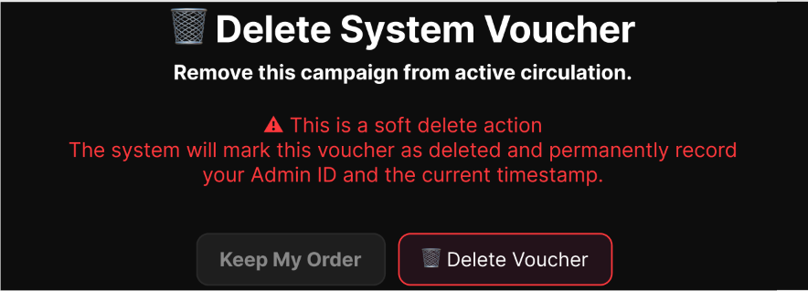
Figure 171 : Delete System Voucher Screen
FUNCTION DETAILS:
- VALIDATION RULES:
  - User must be authenticated with Admin role.
  - Target system voucher must exist and not be already soft-deleted (is_deleted = false).
- BUSINESS RULES:

- NORMAL FLOW:
  - Step 1: Admin selects a system voucher and clicks "Delete".
  - Step 2: System prompts confirmation modal with the warning: "This is a soft delete action. The system will mark this voucher as deleted and permanently record your Admin ID and the current timestamp."
  - Step 3: Admin confirms deletion by clicking "Delete Voucher".
  - Step 4: Client sends DELETE request to /api/v1/vouchers/{id} with Admin Access Token.
  - Step 5: System verifies Admin role.
  - Step 6: System executes soft delete on the record: sets is_deleted = true, is_active = false, deleted_at = CURRENT_TIMESTAMP, deleted_by = Admin_ID.
  - Step 7: Historical redemption logs in voucher_usages remain untouched to preserve financial audit integrity.
  - Step 8: System removes the voucher from active checkout validation search.
  - Step 9: System logs audit trail entry ("System voucher {Code} soft-deleted by Admin {AdminId}").
  - Step 10: System returns success message MSG07 ("Delete asset(s) successfully.").
  - Step 11: Client removes item from active display table.
- ABNORMAL FLOWS:
  - Step 1: Admin interacts with the deletion modal or the system processes the delete request.
  - Step 2: System validates authentication (Admin role) and verifies the voucher exists and is not already deleted.
  - Step 3: If the Admin clicks "Keep My Order" (Cancel), the system simply closes the modal with no data changes.
  - Step 4: If validation fails or system errors occur, the system returns the appropriate error (404 Not Found if already deleted, 500 Internal Server Error for system failures) and displays the corresponding error message to the Admin.

3.20.12 View Payment Reconciliation Exception List
FUNCTION TRIGGER:
- Admin or Staff navigates to the Finance/Reconciliation Dashboard and clicks "View Exception List" or selects a flagged reconciliation alert.
FUNCTION DESCRIPTION:
- Actor(s): Admin, Staff.
- Purpose:
  - To allow Platform Administrators and Ticketing/Operations Staff to review and investigate payments where the ConcertShield order status does not match the payment gateway (VNPay) records (e.g., "paid-without-ticket", "duplicate payment", or "late callback").
- Main Functionality:
  - The system displays a filtered, paginated list of payment reconciliation exceptions with details including Order ID, VNPay Transaction ID, Amount, ConcertShield Status, VNPay Status, Exception Type, and Timestamp. Users can apply advanced filters (date range, exception type, event ID) and view detailed audit logs (raw VNPay callback logs and ConcertShield state transition logs) for specific exceptions to aid investigation.
SCREEN LAYOUT:
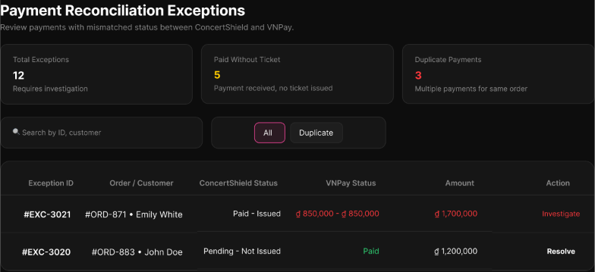
Figure 172 : View Payment Reconciliation Exception List Screen
FUNCTION DETAILS:
- VALIDATION RULES:
  - User must be authenticated with a valid, unexpired Access Token.
  - User must have the required role: Platform Administrator (global access) or Ticketing/Operations Staff (access limited to assigned events or global, depending on policy).
  - Date range filters (if provided) must be logically valid (Start Date <= End Date).
  - Filter parameters (Exception Type, Event ID) must match valid existing values in the system.
- NORMAL FLOW:
  - Step 1: Admin or Staff navigates to the Finance/Reconciliation Dashboard and clicks "View Exception List" (or the system loads it by default with standard filters, e.g., "Last 7 days").
  - Step 2: Client sends a request to the system to fetch the exception list, including optional parameters (date range, exception type, event ID).
  - Step 3: System validates the Access Token, user role, and data access scope.
  - Step 4: System queries the reconciliation database for records where ConcertShield order status != VNPay status.
  - Step 5: System formats the response, including Order ID, VNPay Transaction ID, Amount, ConcertShield Status, VNPay Status, Exception Type, and Timestamp.
  - Step 6: Client displays the formatted, paginated exception list to the user, ready for review.
- ABNORMAL FLOWS:
  - Step 1: User applies advanced filters, clicks "View Details", or the system encounters an error/empty state during the process.
  - Step 2: System processes the specific action (filtering, fetching logs) or validates the request for authorization/system errors.
  - Step 3: Depending on the scenario, the system responds accordingly:
    - If advanced filters are applied: System returns only matching records.
    - If "View Details" is clicked: System retrieves and returns raw VNPay callback logs and ConcertShield state transition logs for that specific Order/Transaction ID.
    - If the query returns zero records: System returns an empty list.
    - 401 Unauthorized: If Access Token is missing, invalid, or expired.
    - 403 Forbidden: If user has insufficient permissions (e.g., regular Customer or Event Organizer without finance privileges).
    - 500 Internal Server Error: If database or reconciliation service failure occurs.
  - Step 4: Client updates the UI accordingly:
    - Displays the filtered list or opens a modal/side panel with the detailed timeline for logs.
    - Shows "No reconciliation exceptions found for the selected criteria." if the list is empty.
    - Attempts to refresh the token (redirects to Login if it fails) for 401 errors.
    - Displays "You do not have permission to view financial reconciliation data." for 403 errors.
    - Displays "Failed to load reconciliation data. Please try again later." for 500 errors.

3.20.13 Manually Resolve Reconciliation Exception
FUNCTION TRIGGER:
- Administrator or Staff clicks the "Resolve" or "Take Action" button on a specific pending exception in the Reconciliation Exception List.
FUNCTION DESCRIPTION:
- Actor(s): Admin, Staff.
- Purpose:
  - To allow Platform Administrators and Ticketing/Operations Staff to manually resolve a reconciliation exception by confirming, correcting, or refunding the transaction, with strict audit recording.
- Main Functionality:
  - The system displays the exception details and a "Resolution Action" dropdown (Confirm Order, Correct Amount, Issue Refund). The user selects an action, provides a mandatory resolution reason, and confirms. The system validates the request, executes the corresponding backend logic (e.g., updating order status, adjusting amount, or triggering the VNPay Refund API), updates the exception status to "Resolved", and creates an immutable audit log entry.
SCREEN LAYOUT:
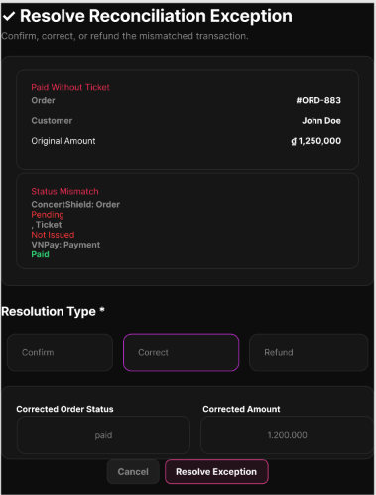
Figure 173 : Manually Resolve Reconciliation Exception Screen
FUNCTION DETAILS:
- VALIDATION RULES:
  - User must be authenticated with a valid, unexpired Access Token.
  - User must have the Platform Administrator or Ticketing/Operations Staff role.
  - The selected reconciliation exception must exist and be in a "Pending" or "Unresolved" state.
  - A Resolution Action must be selected.
  - The "Resolution Reason" text area must not be empty.
  - Resolution parameters must be valid (e.g., requested refund amount must not exceed the original paid amount).
- NORMAL FLOW:
  - Step 1: Admin or Staff clicks "Resolve" on a specific pending exception.
  - Step 2: System displays the exception details and a "Resolution Action" dropdown (Confirm Order, Correct Amount, Issue Refund).
  - Step 3: User selects the appropriate Resolution Action (system displays refundable amount if "Issue Refund" is selected).
  - Step 4: User enters a mandatory "Resolution Reason" in the provided text area.
  - Step 5: User clicks "Confirm Resolution".
  - Step 6: Client validates that an action is selected and the reason field is not empty.
  - Step 7: System validates the user's Access Token, role, and verifies the exception is still in a "Pending" state.
  - Step 8: System executes the backend logic for the selected action (e.g., updates ConcertShield order status to 'Paid', adjusts the recorded amount, or triggers the VNPay Refund API).
  - Step 9: System updates the exception record status to "Resolved" and creates an immutable audit log entry (Actor ID, Action Taken, Reason, Timestamp).
  - Step 10: Client displays "Exception resolved successfully" and refreshes the Reconciliation Exception List.
- ABNORMAL FLOWS:
  - Step 1: User cancels the resolution, or the system encounters validation, concurrency, or external API errors during the process.
  - Step 2: System processes the cancellation or validates the request constraints (token, role, pending state, parameter validity).
  - Step 3: If validation fails or errors occur, system returns appropriate error:
    - 400 Bad Request: For invalid resolution parameters (e.g., refund amount exceeds original paid amount).
    - 401 Unauthorized: If Access Token is missing, invalid, or expired.
    - 403 Forbidden: If user lacks Admin or Operations Staff privileges.
    - 409 Conflict: If the exception was already resolved by another user concurrently.
    - 502 Bad Gateway: If the external VNPay Refund API fails or times out.
  - Step 4: System handles the error and updates the UI accordingly:
    - For cancellation: Client discards input and returns user to the exception list; exception remains "Pending".
    - For 401: Client attempts to refresh token; redirects to Login if it fails.
    - For 403: Client displays "You do not have permission to resolve financial exceptions."
    - For 409: Client displays "This exception has already been resolved by another user." and refreshes the list to show the updated status.
    - For 400: Client displays "Invalid resolution parameters. Please check the amount and try again."
    - For 502: System rolls back any internal state changes to maintain consistency. Client displays "Failed to process the refund via the payment gateway. The exception remains unresolved. Please try again or contact support." Exception remains "Pending".

3.20.14 Retry Failed Ticket Issuance
FUNCTION TRIGGER:
- Platform Administrator navigates to the Order Management or Failed Issuance Dashboard, selects a specific paid order with a "Failed" issuance status, and clicks the "Retry Issuance" button.
FUNCTION DESCRIPTION:
- Actor(s): Admin.
- Purpose:
  - To allow platform administrators to re-run ticket issuance for paid orders whose issuance previously failed, ensuring that no duplicate tickets are created.
- Main Functionality:
  - The system displays a confirmation modal with order details. Upon confirmation, the system validates the order state, performs an idempotency check to prevent duplicate ticket generation, triggers the ticket generation service, updates the order status to "Success", logs the audit trail, and triggers the customer email notification.
SCREEN LAYOUT:
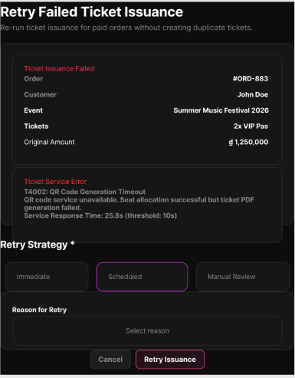
Figure 174 : Retry Failed Ticket Issuance Screen
FUNCTION DETAILS:
- VALIDATION RULES:
  - User must be authenticated with a valid, unexpired Access Token.
  - User must have Platform Administrator privileges.
  - Target order must exist.
  - Order payment status must be "Paid" (or "Completed").
  - Order ticket issuance status must be explicitly "Failed".
  - Associated event and ticket inventory/seats must be valid for issuance.

- NORMAL FLOW:
  - Step 1: Admin navigates to the Failed Issuance Dashboard and selects a specific failed order.
  - Step 2: Admin clicks "Retry Issuance".
  - Step 3: System displays a confirmation modal showing Order ID, Event Name, Ticket Types, and Quantities.
  - Step 4: Admin clicks "Confirm Retry".
  - Step 5: Client sends a request to the system with the Order ID and Access Token.
  - Step 6: System validates the Access Token and verifies Platform Administrator privileges.
  - Step 7: System retrieves order details and verifies payment status is "Paid" and issuance status is "Failed".
  - Step 8: System performs an idempotency check by querying the ticket database for existing tickets for this Order ID.
  - Step 9: If no existing tickets are found, system triggers the ticket generation service (using a unique idempotency key) to create unique ticket codes/QRs.
  - Step 10: System updates the order's issuance status to "Success" and records the retry action (Administrator ID, Timestamp) in the audit log.
  - Step 11: System triggers the notification service to email the tickets to the customer.
  - Step 12: Client displays success message ("Ticket issuance retry successful. Tickets have been sent to the customer.") and refreshes the order status.
- ABNORMAL FLOWS:
  - Step 1: Admin cancels the retry, or the system encounters validation, idempotency, or external service errors during the process.
  - Step 2: System processes the cancellation or validates request constraints (token, role, order state, idempotency).
  - Step 3: Depending on the scenario, the system responds accordingly:
    - For cancellation (before Step 5): Client discards the action and returns to the dashboard. No request is sent.
    - Idempotency triggered (Tickets already exist): System skips ticket generation, updates order status to "Success", and resends the email notification. Client displays "Tickets were already issued in the background. Status updated and emails resent."
    - 400 Bad Request / 404 Not Found: If order ID is invalid, not paid, or already successfully issued. Client displays "This order cannot be retried. Please check the order status."
    - 401 Unauthorized: If Access Token is missing, invalid, or expired. Client attempts to refresh token; redirects to Login if it fails.
    - 403 Forbidden: If user lacks Platform Administrator privileges. Client displays "You do not have permission to retry ticket issuance."
    - 500 Internal Server Error: If ticket generation fails again (e.g., service down, inventory revoked). System leaves order status as "Failed" and logs the detailed error. Client displays "Ticket issuance failed again. Please check the system logs and try again later."
    - Warning (Non-blocking): If email notification fails, system still marks issuance as "Success" (since tickets are generated) but logs a warning. Client displays "Tickets issued successfully, but email delivery failed. Please manually resend the tickets."
  - Step 4: System updates the UI accordingly, keeping the modal open for correction if applicable, or closing it and refreshing the dashboard list to reflect the new state or error message.

3.20.15 View Failed Transaction Queue
FUNCTION TRIGGER:
- Platform Administrator navigates to the "Failed Transaction Queue" management page.
FUNCTION DESCRIPTION:
- Actor(s): Admin.
- Purpose:
  - To allow platform administrators to view transactions that failed at ticket issuance or processing and are waiting for retry or manual handling, ensuring platform reliability.
- Main Functionality:
  - The system displays a chronological list of failed transactions (sorted newest first) with details such as Order ID, Event Name, Error Reason, Timestamp, and Status. It also provides summary statistics (Total Failed, Pending Retry, Requires Manual Handling). Admins can filter by status/error type, search by keywords, and navigate to detailed views for deeper investigation.
SCREEN LAYOUT:
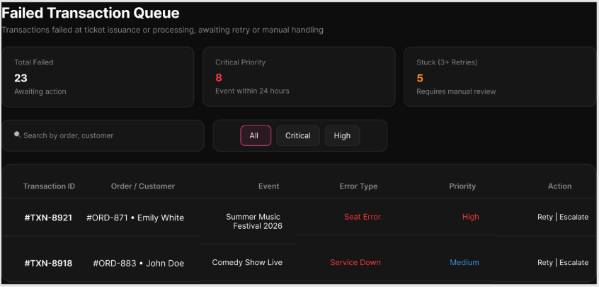
Figure 175 : View Failed Transaction Queue Screen
FUNCTION DETAILS:
- VALIDATION RULES:
  - User must be authenticated with a valid, unexpired Access Token.
  - User must have the "Platform Administrator" or equivalent system monitoring role.
  - Filter and search parameters must be valid strings or recognized enums.
- NORMAL FLOW:
  - Step 1: Admin opens the Failed Transaction Queue page.
  - Step 2: Client sends a request for the failed transaction list and summary statistics, along with the Access Token.
  - Step 3: System validates the Access Token and verifies the Administrator role.
  - Step 4: System retrieves the queue of failed transactions (sorted by timestamp, newest first) including Order ID, Event Name, Error Reason, Timestamp, and Status.
  - Step 5: System calculates summary statistics (Total Failed, Pending Retry, Requires Manual Handling) and returns the data.
  - Step 6: Client displays the summary statistics cards and the chronological list of failed transactions.
- ABNORMAL FLOWS:
  - Step 1: Admin applies filters/searches, clicks "View Details", or the system encounters an error/empty state during data retrieval.
  - Step 2: System processes the specific action (filtering, searching, navigation) or validates the request constraints.
  - Step 3: Depending on the scenario, the system responds accordingly:
    - If filters/search applied: System returns the filtered list/matching records and updated statistics.
    - If "View Details" clicked: Client triggers navigation to the "View Failed Transaction Details" screen.
    - Empty State: System returns an empty list and zero counts.
    - 401 Unauthorized: If Access Token is missing, invalid, or expired.
    - 403 Forbidden: If user lacks sufficient permissions.
    - 500 Internal Server Error: If an unexpected system/database error occurs.
  - Step 4: Client updates the UI accordingly:
    - Updates the table and summary cards for filters/search.
    - Navigates the Admin to the details screen.
    - Displays "No failed transactions found." in the table area for empty states.
    - Redirects the Admin to the Login page for 401 errors.
    - Displays an "Access Denied" message for 403 errors.
    - Displays a generic error message and advises the Admin to retry for 500 errors.

3.21 Governance, Policy, Versioning & Compliance

3.21.1 View Policy Version History
FUNCTION TRIGGER:
- Platform Administrator navigates to the Policy Management or Audit section and requests to view the version history of a specific policy type (Price, Refund, Queue, or Risk).
FUNCTION DESCRIPTION:
- Actor(s): Admin.
- Purpose:
  - To allow administrators to view all historical versions of platform policies with effective dates and authors, ensuring any transaction can be accurately traced to the policy version that applied to it.
- Main Functionality:
  - The system retrieves and displays a chronological list of policy versions, including version ID, policy type, effective dates, author, and status. Admins can filter by policy type or date range and view detailed changes for each specific version.
SCREEN LAYOUT:
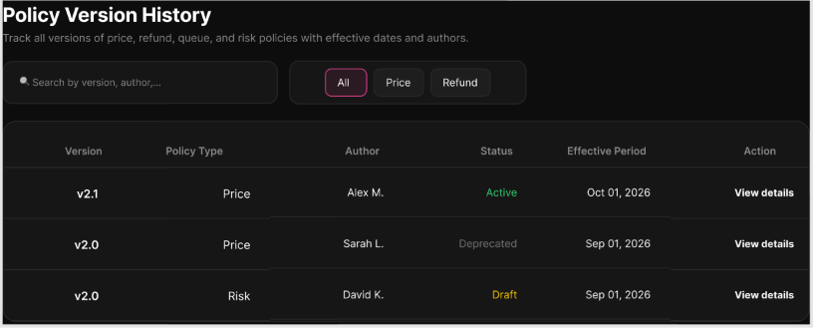
Figure 176 : View Policy Version History Screen
FUNCTION DETAILS:
- VALIDATION RULES:
  - User must be authenticated with a valid, unexpired Access Token.
  - User must have the Platform Administrator role.
  - Selected policy type filter (if applied) must be valid (Price, Refund, Queue, or Risk).
  - Date range filters (if applied) must be logically valid (Start Date <= End Date).

- BUSINESS RULES:
  - BR-150, BR-233, BR-236

- NORMAL FLOW:
  - Step 1: Admin navigates to the Policy Version History section.
  - Step 2: Admin optionally applies filters (e.g., Policy Type: Refund, specific Date Range).
  - Step 3: Client sends a request to fetch the policy version history with any applied filter parameters.
  - Step 4: System validates the Access Token and Platform Administrator role.
  - Step 5: System queries the database for historical policy versions matching the criteria, sorted chronologically (newest first).
  - Step 6: System returns the list including Version ID, Policy Type, Effective Dates, Author, and Status.
  - Step 7: Client displays the formatted version history list to the Admin.
  - Step 8: Admin reviews the history or clicks "View Details" to inspect specific changes within a version.

- ABNORMAL FLOWS:
  - Step 1: Admin applies invalid filters, or the system encounters empty states, connection issues, or server errors during retrieval.
  - Step 2: System validates request constraints, data availability, and connection status.
  - Step 3: Depending on the scenario, the system responds accordingly:
    - No History Found: System returns an empty list. Client displays "No policy version history found for the selected criteria."
    - 401 Unauthorized: Access Token is missing, invalid, or expired. Client redirects to Login.
    - 403 Forbidden: User lacks Platform Administrator privileges. Client displays "Access Denied."
    - 500 Internal Server Error: Database or system failure occurs. Client displays a generic error message and advises the Admin to retry.
  - Step 4: Client updates the UI accordingly (showing empty state, error notifications, or access denied messages), preserving the last valid state without modifying any policy data.

3.21.2 Create New Policy Version
FUNCTION TRIGGER:
- Platform Administrator navigates to the Policy Management section and clicks "Create New Version" for a specific policy type (Price, Refund, Queue, or Risk).
FUNCTION DESCRIPTION:
- Actor(s): Admin.
- Purpose:
  - To allow platform administrators to publish a new version of a policy without affecting transactions made under earlier versions.
- Main Functionality:
  - The system displays a policy creation form pre-loaded with the current active version's parameters as a baseline. The admin modifies the desired fields, sets a future effective date, and submits. The system validates the new version against existing active versions, archives or schedules the current version, saves the new version as immutable, and logs the audit trail.
SCREEN LAYOUT:
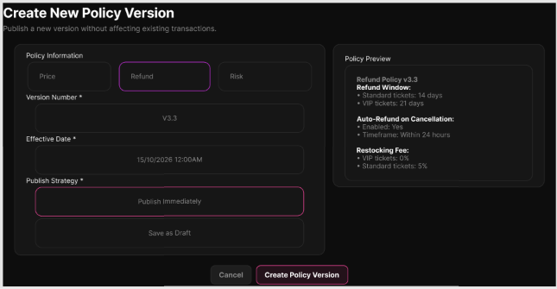
Figure 177 : Create New Policy Version Screen
FUNCTION DETAILS:
- VALIDATION RULES:
  - User must be authenticated with a valid, unexpired Access Token.
  - User must have the Platform Administrator role.
  - Policy Type must be valid (Price, Refund, Queue, or Risk).
  - Effective Date must be a future date (>= current date).
  - Policy parameters must be valid for the selected type (e.g., percentages within 0–100%, monetary values > 0).
  - No existing active version may have an overlapping effective period.
  - At least one parameter must differ from the current active version.

- BUSINESS RULES:
  - BR-150, BR-233, BR-238
- NORMAL FLOW:
  - Step 1: Admin navigates to Policy Management and clicks "Create New Version" for a specific policy type.
  - Step 2: System displays the creation form with the current active version's parameters pre-filled as a baseline.
  - Step 3: Admin modifies the desired policy parameters.
  - Step 4: Admin sets the Effective Date for the new version.
  - Step 5: Admin optionally enters Change Notes describing the reason for the update.
  - Step 6: Admin clicks "Publish".
  - Step 7: System validates the Access Token, Admin role, effective date, parameter constraints, and checks for overlapping active versions.
  - Step 8: System schedules the current active version to be archived/superseded as of the new version's effective date.
  - Step 9: System saves the new policy version as an immutable record with a new Version ID, Effective Date, Author (Admin ID), and Status ("Scheduled" or "Active").
  - Step 10: System logs an audit trail entry ("New {PolicyType} policy version {VersionId} created by Admin {AdminId}").
  - Step 11: Client displays success message ("New policy version published successfully.") and refreshes the policy version history list.

- ABNORMAL FLOWS:
  - Step 1: Admin cancels the creation, or the system encounters validation errors, overlapping version conflicts, or server errors during the process.
  - Step 2: System processes the cancellation or validates constraints (token, role, date, parameters, overlap check).
  - Step 3: Depending on the scenario, the system responds accordingly:
    - Cancel: Admin cancels the action. No data is saved; the form closes.
    - 400 Bad Request: Invalid parameters, past effective date, or no changes from the current version. Client displays specific inline validation errors.
    - 409 Conflict: Overlapping active version detected. Client displays "An active policy version already exists for this period. Please adjust the effective date."
    - 401 Unauthorized: Access Token is missing, invalid, or expired. Client redirects to Login.
    - 403 Forbidden: User lacks Platform Administrator privileges. Client displays "Access Denied."
    - 500 Internal Server Error: Database or system failure. Client displays a generic error message and advises retry.
  - Step 4: Client updates the UI accordingly (keeps form open with data preserved for correction on validation/conflict errors, or shows specific error notifications), ensuring no partial policy versions are committed.

3.21.3 Submit Organizer Verification Documents
FUNCTION TRIGGER:
- Event Organizer navigates to the Account Verification section and initiates the document submission process.
FUNCTION DESCRIPTION:
- Actor(s): Organizer.
- Purpose:
  - To allow event organizers to upload legal and business verification documents to be verified by the platform before they are permitted to sell tickets.
- Main Functionality:
  - The system displays a verification form listing required document types. The organizer uploads files, which are validated and sent to Cloudinary. Upon successful upload, the system saves the secure media URLs, updates the organizer's account status to "Pending Verification", and notifies platform administrators for review.
SCREEN LAYOUT:
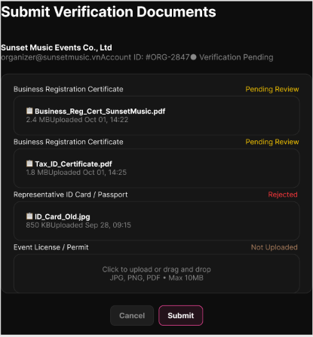
Figure 178 : Submit Organizer Verification Documents Screen
FUNCTION DETAILS:
- VALIDATION RULES:
  - User must be authenticated and logged in with the Event Organizer role.
  - Organizer account must be in an eligible state for verification (e.g., "Unverified" or "Rejected").
  - All mandatory document types must have at least one file attached.
  - Uploaded files must meet format constraints (e.g., PDF, JPEG, PNG only).
  - Uploaded files must not exceed the maximum size limit (e.g., 10MB per file).
- BUSINESS RULES:
  - BR-61, BR-435
- NORMAL FLOW:
  - Step 1: Organizer opens the Account Verification page.
  - Step 2: System displays the required document list and upload fields.
  - Step 3: Organizer selects a document type and uploads the corresponding file(s).
  - Step 4: Client validates the file format and size constraints.
  - Step 5: Client uploads the file directly to Cloudinary and receives the secure media URL.
  - Step 6: Organizer repeats Steps 3-5 for all required document types.
  - Step 7: Organizer clicks "Submit for Verification".
  - Step 8: System validates the organizer's account state and ensures all mandatory fields are populated with valid Cloudinary URLs.
  - Step 9: System saves the document records, updates the organizer's account status to "Pending Verification", and logs the submission timestamp.
  - Step 10: System triggers a notification to Platform Administrators regarding the new verification request.
  - Step 11: Client displays a success message ("Documents submitted successfully. Pending admin review.") and updates the UI to reflect the "Pending" status, disabling further edits.

- ABNORMAL FLOWS:
  - Step 1: Organizer cancels the submission, uploads invalid files, or the system encounters Cloudinary/server errors during the process.
  - Step 2: Client or System validates file constraints, account state, and external API status.
  - Step 3: Depending on the scenario, the system responds accordingly:
    - Cancel Submission: Organizer cancels the action. No data is saved, and the form closes.
    - Invalid File: File type or size exceeds limits. Client displays "Invalid file format or size. Please upload a PDF, JPEG, or PNG under 10MB."
    - Cloudinary Upload Failure: Network error or API rejection. Client displays "Failed to upload file. Please check your connection and try again."
    - 409 Conflict: Organizer account is already "Verified" or currently "Pending Verification". Client displays "Your account is already under review or verified."
    - 500 Internal Server Error: Database failure during submission. Client displays "Failed to submit documents. Please try again later."
  - Step 4: Client updates the UI accordingly (keeps the form open with data preserved for retry on upload/validation errors, or shows specific error notifications), ensuring no partial or invalid verification requests are committed.

3.21.4 Review Organizer Verification Documents
FUNCTION TRIGGER:
- Platform Administrator navigates to the Organizer Verification Queue and selects a pending organizer's submission to review.
FUNCTION DESCRIPTION:
- Actor(s): Admin.
- Purpose:
  - To allow platform administrators to inspect verification documents submitted by an organizer, make an approval/rejection decision, and record review notes.
- Main Functionality:
  - The system displays the organizer's profile, submitted document details (with secure Cloudinary links/previews), and a review form. The admin inspects the documents, selects an action (Approve or Reject), enters mandatory review notes, and submits. The system updates the organizer's verification status accordingly, saves the audit log, and notifies the organizer.
SCREEN LAYOUT:
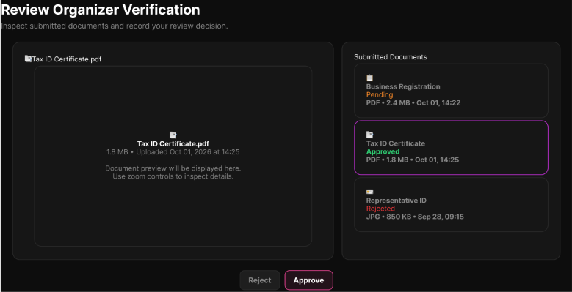
Figure 179 : Review Organizer Verification Documents Screen
FUNCTION DETAILS:
- VALIDATION RULES:
  - User must be authenticated with a valid, unexpired Access Token.
  - User must have the Platform Administrator role.
  - Target organizer account must exist and currently be in "Pending Verification" status.
  - Review Action (Approve or Reject) must be explicitly selected.
  - Review Notes must not be empty (e.g., minimum 10 characters required).

- BUSINESS RULES:
  - BR-61, BR-435
- NORMAL FLOW:
  - Step 1: Admin navigates to the Organizer Verification Queue and selects a pending submission.
  - Step 2: System retrieves and displays the organizer's details and submitted document links/previews.
  - Step 3: Admin inspects the documents (e.g., clicks links to view Cloudinary-hosted files).
  - Step 4: Admin selects a Review Action (Approve or Reject).
  - Step 5: Admin enters mandatory Review Notes explaining the decision.
  - Step 6: Admin clicks "Submit Review".
  - Step 7: System validates the Admin's role, the organizer's current "Pending" status, and the form inputs.
  - Step 8: System updates the organizer's account status to "Verified" (if Approved) or "Rejected" (if Rejected).
  - Step 9: System saves the review notes, reviewer ID, and timestamp to the audit log.
  - Step 10: System triggers an automated notification (email/in-app) to the Organizer regarding the verification outcome.
  - Step 11: Client displays a success message ("Verification review submitted successfully.") and refreshes the verification queue.

- ABNORMAL FLOWS:
  - Step 1: Admin cancels the review, or the system encounters validation errors, concurrency issues, or server errors during the process.
  - Step 2: System processes the cancellation or validates constraints (role, current status, required fields).
  - Step 3: Depending on the scenario, the system responds accordingly:
    - Cancel Review: Admin cancels the action. No data is saved; client returns to the verification queue.
    - Validation Error: Missing action or insufficient review notes. Client displays inline error messages on the form.
    - 409 Conflict: Organizer status is no longer "Pending" (e.g., already reviewed by another admin concurrently). Client displays "This submission has already been reviewed."
    - 401 Unauthorized / 403 Forbidden: Invalid token or insufficient privileges. Client redirects to Login or displays "Access Denied."
    - 500 Internal Server Error: Database or system failure during status update. Client displays "Failed to submit review. Please try again later."
  - Step 4: Client updates the UI accordingly (keeps the form open with data preserved for correction on validation/conflict errors, or shows specific error notifications), ensuring no partial status updates are committed.

3.21.5 Approve/Reject Organizer Verification
FUNCTION TRIGGER:
- Platform Administrator selects "Approve" or "Reject" on a pending organizer verification request and confirms the decision.
FUNCTION DESCRIPTION:
- Actor(s): Admin.
- Purpose:
  - To allow platform administrators to formally approve or reject an organizer's verification request and notify them of the outcome via email.
- Main Functionality:
  - The system processes the admin's decision, updates the organizer's account status accordingly (to "Verified" or "Rejected"), records the decision and notes in the audit log, and triggers the Email Service to send an automated outcome notification to the organizer.
SCREEN LAYOUT:
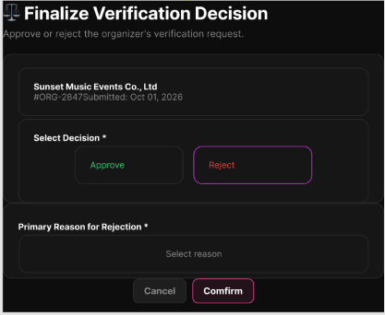
Figure 180 : Approve/Reject Organizer Verification Screen
FUNCTION DETAILS:
- VALIDATION RULES:
  - User must be authenticated with a valid, unexpired Access Token.
  - User must have the Platform Administrator role.
  - Target organizer account must exist and currently be in "Pending Verification" status.
  - Decision must be explicitly "Approve" or "Reject".
  - Review notes must be provided (mandatory if Reject, optional if Approve).

- BUSINESS RULES:
  - BR-61, BR-152, BR-435
- NORMAL FLOW:
  - Step 1: Admin selects "Approve" or "Reject" on a pending verification request.
  - Step 2: System displays a confirmation prompt with the decision and a notes field.
  - Step 3: Admin enters review notes and clicks "Confirm".
  - Step 4: System validates the admin's role, token, and verifies the organizer's current status is still "Pending Verification".
  - Step 5: System updates the organizer's account status to "Verified" or "Rejected".
  - Step 6: System logs the audit trail (Admin ID, Decision, Timestamp, Notes).
  - Step 7: System triggers the Email Service to send the outcome notification to the organizer's registered email.
  - Step 8: Client displays a success message ("Verification decision submitted and organizer notified.") and refreshes the verification queue.

- ABNORMAL FLOWS:
  - Step 1: Admin cancels the action, or the system encounters validation errors, concurrency conflicts, or external service failures.
  - Step 2: System processes the cancellation or validates constraints (role, current status, required fields, email service status).
  - Step 3: Depending on the scenario, the system responds accordingly:
    - Cancel: Admin cancels the action. No state change occurs; modal closes.
    - Validation Error: Missing notes for a rejection. Client displays inline error messages on the form.
    - 409 Conflict: Organizer status is no longer "Pending" (e.g., reviewed concurrently by another admin). Client displays "This submission has already been reviewed."
    - Email Service Failure: Internal status updates successfully, but the external email fails. System logs a warning. Client displays "Status updated, but email notification failed. Please notify the organizer manually."
    - 500 Internal Server Error: Database or system failure during status update. Client displays "Failed to process verification. Please try again later." No state change occurs.
  - Step 4: Client updates the UI accordingly (keeps form open for correction on validation errors, or shows specific error/warning notifications), ensuring data integrity and clear admin feedback.

3.21.6 Submit Event Compliance Documents
FUNCTION TRIGGER:
- Event Organizer selects "Submit Compliance Documents" for a specific concert.
FUNCTION DESCRIPTION:
- Actor(s): Organizer.
- Purpose:
  - To allow event organizers to upload event permits and safety/compliance documents for a specific event, stored securely on Cloudinary for later platform compliance review.
- Main Functionality:
  - The system displays the concert details and supported document types. The organizer selects a document type and file. The system validates authorization and file constraints, uploads the file to Cloudinary, receives the stored document reference, and records the submission metadata (document type, concert ID, organizer ID, timestamp) linked to the concert.
SCREEN LAYOUT:
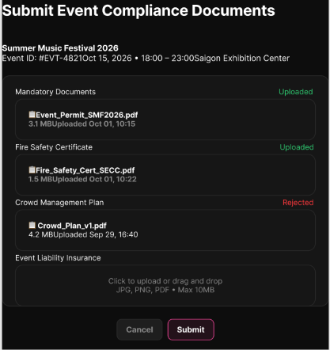
Figure 181 : Submit Event Compliance Documents Screen
FUNCTION DETAILS:
- VALIDATION RULES:
  - User must be authenticated.
  - The selected concert must be within the Organizer's authorized scope.
  - File must meet system constraints (supported format, maximum size limit).
  - Document type must be a valid, supported compliance category.

- BUSINESS RULES:
  - BR-61, BR-436
- NORMAL FLOW:
  - Step 1: Organizer opens the selected concert.
  - Step 2: Organizer opens the Compliance Documents section.
  - Step 3: System displays the concert and supported document information.
  - Step 4: Organizer selects a document type and file.
  - Step 5: System validates authorization, concert linkage, and file constraints.
  - Step 6: Organizer selects "Submit".
  - Step 7: System uploads the file to Cloudinary.
  - Step 8: Cloudinary returns the stored document reference.
  - Step 9: System records the reference, document type, concert, Organizer, and submission time.
  - Step 10: System confirms successful submission.

- ABNORMAL FLOWS:
  - Step 1: Organizer replaces the file, cancels the submission, or the system encounters validation, upload, or server errors.
  - Step 2: System or Client processes the action and validates constraints (authorization, file limits, external API status).
  - Step 3: Depending on the scenario, the system responds accordingly:
    - Replace Selected File: Organizer selects another file before submission. Flow returns to Step 5 for re-validation.
    - Cancel Submission: Organizer cancels. No document is submitted; the action is aborted.
    - Invalid/Unsupported File (EX-1): System rejects the file. Client displays the specific validation error (e.g., "Invalid file format or size").
    - Cloudinary Upload Failure (EX-2): Document cannot be stored. System reports the failure (e.g., "Upload failed. Please check your connection and try again.").
    - Server/Data Error (EX-3): Document reference cannot be linked to the concert. Operation is not completed. Client displays "Failed to save document reference. Please try again later."
  - Step 4: Client updates the UI accordingly (keeps the form open with data preserved for correction on validation/upload errors, or shows specific error notifications), ensuring no partial or unlinked document records are committed.

3.21.7 Review Event Compliance Record
FUNCTION TRIGGER:
- Platform Administrator navigates to the Event Compliance Review queue and selects a specific event pending compliance approval.
FUNCTION DESCRIPTION:
- Actor(s): Admin.
- Purpose:
  - To allow platform administrators to review an event's submitted compliance documents and record the compliance status, which is a mandatory prerequisite before ticket sales can open.
- Main Functionality:
  - The system displays the event details and submitted compliance documents (e.g., permits, safety plans). The admin reviews the documents, selects a compliance status (Approved, Rejected, or Request More Info), provides mandatory review notes, and submits. The system updates the event's compliance status, logs the audit trail, and notifies the organizer.
SCREEN LAYOUT:
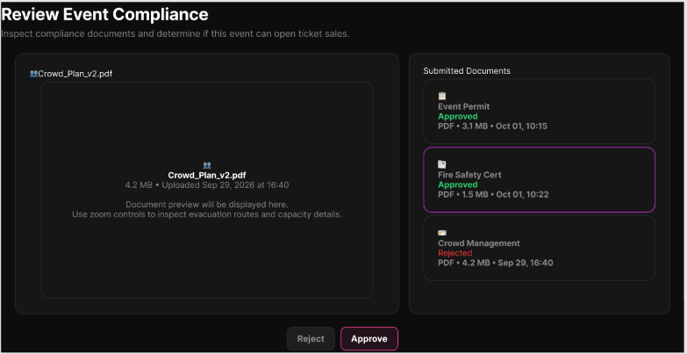
Figure 182 : Review Event Compliance Record Screen
FUNCTION DETAILS:
- VALIDATION RULES:
  - User must be authenticated with the Platform Administrator role.
  - Target event must exist and have submitted compliance documents pending review.
  - Compliance Status must be explicitly selected.
  - Review Notes must not be empty (mandatory for all decisions to ensure auditability).

- BUSINESS RULES:
  - BR-433
- NORMAL FLOW:
  - Step 1: Admin navigates to the Event Compliance Review queue and selects a pending event.
  - Step 2: System retrieves and displays event details and submitted compliance documents.
  - Step 3: Admin reviews the documents (views or downloads files).
  - Step 4: Admin selects a Compliance Status (Approved, Rejected, or Request More Info).
  - Step 5: Admin enters mandatory Review Notes explaining the decision.
  - Step 6: Admin clicks "Submit Review".
  - Step 7: System validates the admin's role, the event's current pending state, and form inputs.
  - Step 8: System updates the event's compliance status accordingly.
  - Step 9: System logs the audit trail (Admin ID, Status, Timestamp, Notes).
  - Step 10: System triggers an automated notification to the Event Organizer regarding the compliance outcome.
  - Step 11: Client displays a success message ("Compliance review submitted successfully.") and refreshes the review queue.

- ABNORMAL FLOWS:
  - Step 1: Admin cancels the review, or the system encounters validation errors, concurrency conflicts, or server errors.
  - Step 2: System processes the cancellation or validates constraints (role, current status, required fields).
  - Step 3: Depending on the scenario, the system responds accordingly:
    - Cancel Review: Admin cancels the action. No data is saved; client returns to the queue.
    - Validation Error: Missing status or insufficient review notes. Client displays inline error messages on the form.
    - 409 Conflict: Event compliance has already been reviewed or the event state has changed concurrently. Client displays "This event's compliance has already been reviewed."
    - 401 Unauthorized / 403 Forbidden: Invalid token or insufficient privileges. Client redirects to Login or displays "Access Denied."
    - 500 Internal Server Error: Database or system failure during status update. Client displays "Failed to save compliance review. Please try again later."
  - Step 4: Client updates the UI accordingly (keeps the form open with data preserved for correction on validation/conflict errors, or shows specific error notifications), ensuring no partial status updates are committed and sales remain blocked until successful approval.View Pending Concert List

4. Non-Functional Requirements

4.1 External Interfaces
This section describes how the ConcertShield System interacts with users, external services, hardware devices, and other system components.

4.1.1 User Interfaces
ConcertShield is a web-based system that users can access through a web browser.
The system provides different interfaces based on user roles:
- Guest: Uses the website to browse concerts, search for events, view event details, register, and log in.
- Customer: Uses the website to manage their account, complete eKYC when required, browse concerts, join virtual queues, select tickets or seats, place and pay for orders, access purchased tickets, request ticket returns, receive notifications, and contact support.
- Event Organizer: Uses the Organizer Dashboard to create and manage concerts, compliance documents, seating charts, ticket types, pricing and refund policies, vouchers, orders, revenue, staff, and concert operations.
- Event Manager: Uses the authorized concert management interface to manage assigned concert operations and approved event changes within the permissions granted by the Event Organizer.
- Ticketing/Operations Staff: Uses role-specific interfaces to perform assigned ticket, order, refund, and reconciliation operations.
- Check-in Staff: Uses the check-in interface to scan Dynamic QR tickets, perform manual check-in, look up tickets, view check-in history, use offline check-in when enabled, and report on-site incidents.
- Security/Support Staff: Uses support and security interfaces to handle incidents, support cases, suspicious sessions, fraud-related operational follow-up, and escalation according to assigned permissions.
- Platform Administrator: Uses a separate Admin interface to manage users, roles and permissions, organizer verification and approval, concert approval, system vouchers, disputes and refunds, fraud/risk controls, system policies, audit logs, and system parameters.
The website supports major web browsers such as Google Chrome, Microsoft Edge, and Mozilla Firefox.
The web interface uses responsive design to support common desktop, tablet, and mobile screen sizes through a web browser. ConcertShield does not require a separate mobile application.
The main language of the system is English.

4.1.2 Software Interfaces
ConcertShield connects with the following software and external services:
- PostgreSQL: Stores system data such as users, concerts, tickets, orders, payments, reviews, check-in records, and other business data.
- Cloudinary: Stores avatars, concert media, organizer verification documents, event compliance documents, and incident evidence.
- VNPay: Processes online ticket payments, refunds, payment callbacks/webhooks, and provides payment data used for reconciliation.
- Email/Notification Service: Sends OTPs, password reset emails, approval results, event/ticket updates, and other system-generated notifications.
- Google OAuth Service: Allows users to register or sign in using a Google account.
- VNPT AI eKYC Service: Provides citizen ID (CCCD) OCR, facial liveness detection, and face matching for the eKYC verification process.
- Risk Engine / AI Service: Provides risk evaluation signals used for anti-fraud and bot-detection controls. It supports risk-based actions rather than acting as the sole automatic fraud verdict.
The frontend communicates with backend services through APIs. Data is mainly exchanged in JSON format.

4.1.3 Hardware Interfaces
ConcertShield is a web-based system and does not require special hardware for normal use. Users need a device with a supported web browser and an Internet connection.
Some functions may use a camera:
- Camera for eKYC: Used to capture citizen ID (CCCD) and facial images during the identity verification process.
- Camera for Check-in: Used by Check-in Staff to scan ticket QR codes during check-in.
No dedicated ConcertShield hardware device is required.

4.1.4 Communications Interfaces
ConcertShield uses Internet connections for communication between the frontend, backend services, and external services.
- HTTPS: Used for secure communication between the frontend and backend APIs.
- REST API: Used for API-based communication between system components and supported external services.
- JSON: Mainly used as the data exchange format for APIs.
- SignalR: May be used for real-time functions such as notifications, chat, virtual queue updates, and check-in updates.
- UTF-8: Used for text data encoding.
External services such as VNPay, Cloudinary, Google OAuth Service, Email/Notification Service, VNPT AI eKYC Service, and Risk Engine / AI Service communicate with ConcertShield through their supported APIs or protocols.

4.2 Quality Attributes
ConcertShield must meet quality requirements to ensure that the system is easy to use, reliable, secure, and suitable for concert ticket booking and management.
The main quality attributes of the system include Usability, Reliability, Performance, Security, Maintainability, Scalability, and Compatibility. These requirements should be measurable and verifiable through system testing.

4.2.1 Usability
The system shall provide a clear and user-friendly web interface for Customers, Organizers, Staff, and Admins. Customers shall be able to browse concerts, join the virtual queue when required, select tickets or seats, complete payment, access purchased tickets, and use tickets for check-in with minimal and understandable steps. The main ticket-purchasing flow shall be understandable without special training.
The system shall use consistent layouts, labels, buttons, colors, navigation, and status indicators across the web application. Required fields shall be clearly marked, and validation messages shall be displayed near the related input fields. The system shall clearly display important states such as queue position, seat availability, seat-hold expiration, payment status, and ticket/check-in status so that users know what happened and what action should be taken.
Management users such as Organizers, Staff, and Admins shall be able to perform common tasks after a short introduction to the system. Common actions such as viewing lists, searching, filtering, creating or updating concert information, managing tickets and seating, reviewing concerts, monitoring orders and check-in status, and assigning Staff shall follow consistent interaction patterns. High-impact actions such as deleting a draft or cancelling a concert shall require confirmation before execution.

4.2.2 Reliability
- Availability: The system must achieve a minimum availability of 99.5% per month, excluding scheduled maintenance time.
- Error Recovery: The system must support automatic rollback and recover from failures without loss of successfully saved data.
- Data Backup: System data must be automatically backed up at least once a day and retained for a minimum of 7 days.
- Data Integrity: The system must ensure data consistency and prevent duplicate or incomplete records when a transaction (e.g., seat holding, payment) is interrupted.
- Tính sẵn sàng: Hệ thống phải đạt mức độ sẵn sàng tối thiểu 99,5% mỗi tháng, không bao gồm thời gian bảo trì đã lên lịch.
- Khôi phục khi xảy ra lỗi: Hệ thống phải có khả năng tự động rollback và phục hồi hoạt động sau sự cố mà không làm mất dữ liệu đã được lưu thành công.
- Sao lưu dữ liệu: Cơ sở dữ liệu của hệ thống phải được tự động sao lưu định kỳ ít nhất 1 lần mỗi ngày và lưu giữ tối thiểu 7 ngày.
- Tính toàn vẹn dữ liệu: Hệ thống phải đảm bảo dữ liệu không bị sai lệch hay trùng lặp khi một giao dịch (như giữ ghế, thanh toán) bị gián đoạn giữa chừng.

4.2.3 Performance
- Response Time: Under normal operating conditions, at least 95% of user requests (viewing events, login, search) must be responded to within a maximum of 2 seconds.
- Transaction Speed: Seat holding and order creation operations must be processed and responded to within a maximum of 3 second.
- Concurrent Users: The system must support a minimum of 200 concurrent active users without significant degradation of performance.
- System Capacity: The system must be capable of managing at least 50,000 user accounts and storing up to 500,000 transaction records.
- Thời gian phản hồi: Trong điều kiện bình thường, ít nhất 95% yêu cầu của người dùng (xem danh sách, đăng nhập, tìm kiếm) phải được phản hồi trong vòng tối đa 2 giây.
- Tốc độ xử lý giao dịch: Các thao tác giữ ghế và tạo đơn hàng phải được xử lý và phản hồi trong vòng tối đa 3 giây.
- Số người dùng đồng thời: Hệ thống phải hỗ trợ tối thiểu 200 người dùng truy cập và thao tác đồng thời mà không làm suy giảm đáng kể hiệu năng.
- Dung lượng hệ thống: Hệ thống phải có khả năng lưu trữ và quản lý tối thiểu 50.000 tài khoản người dùng và 500.000 bản ghi giao dịch.

4.2.4 Security
- Authentication & Authorization: Users must log in to access authenticated features and can only perform actions permitted by their assigned role (Admin, Organizer, Staff, Customer).
- Password Encryption: Passwords must never be stored in plain text and must be hashed using a secure algorithm (Bcrypt/Argon2) before being saved to the database.
- Data Transmission: All sensitive data and transaction information must be transmitted securely over HTTPS (TLS).
- Application Security: The system must validate all input data to prevent common vulnerabilities such as SQL Injection and Cross-Site Scripting (XSS).
- Audit Trail: All critical administrative actions and system transactions must be recorded in system audit logs.
- Xác thực & Phân quyền: Người dùng phải đăng nhập để sử dụng các chức năng yêu cầu xác thực và chỉ được truy cập đúng các chức năng tương ứng với vai trò (Admin, Organizer, Staff, Customer).
- Mã hóa mật khẩu: Mật khẩu người dùng tuyệt đối không lưu dạng văn bản thuần túy (plain-text) mà phải được mã hóa băm bằng thuật toán an toàn (Bcrypt/Argon2) trước khi lưu vào cơ sở dữ liệu.
- An toàn truyền tải: Toàn bộ dữ liệu nhạy cảm và thông tin giao dịch phải được truyền tải thông qua giao thức mã hóa HTTPS (TLS).
- An toàn ứng dụng: Hệ thống phải kiểm tra chặt chẽ dữ liệu đầu vào để phòng chống các lỗ hổng bảo mật phổ biến như SQL Injection và XSS.
- Nhật ký hệ thống: Các thao tác quản trị quan trọng và giao dịch hệ thống bắt buộc phải được ghi lại trong nhật ký hệ thống (Audit Log).

2.4.5 Maintainability
Modular Design: The system must be designed with a layered, modular architecture (Microservices) to minimize tight coupling between components.
Coding Standards: Source code must adhere strictly to agreed-upon team coding conventions and be systematically version-controlled via Git.
Error Logging: All application errors and system exceptions must be automatically captured and logged to facilitate rapid diagnosis and debugging.

4.2.6 Scalability
Infrastructure Scaling: The system architecture must support horizontal scaling (adding instances/containers) to absorb sudden traffic spikes during flash sales.
Service Independence: High-load modules (such as Virtual Queue, Redis Lock) must be independently scalable without impacting other system services.
Database Optimization: Databases must implement proper indexing, pagination, and query optimization for high-frequency operations to sustain performance as data volume grows.
Logic Decoupling for Growth: The system must accommodate significant growth in users and transaction records without requiring structural changes to core business logic.
4.2.7 Compatibility
Web Browser Compatibility: The Web Portal (Admin, Organizer, Customer) must be fully functional on major web browsers, including Google Chrome, Microsoft Edge, Mozilla Firefox.
Responsive Layout: The web interface must adopt responsive design principles to ensure usability across desktops, tablets, and mobile devices.
Character Encoding: The system must fully support UTF-8 encoding to accurately display Vietnamese text and special characters across all user interfaces.

5. Requirement Appendix

5.1 Business Rules

ID | Rule Definition
BR-01 | Once eKYC is completed, each user account is uniquely associated with one verified phone number and one identity document (CCCD). One CCCD can be used to verify only one account.
BR-02 | eKYC is a one-time verification per account. A user who is not yet eKYC-verified must complete it to purchase tickets for restricted events, exceed standard purchase limits, or request ticket returns/re-issues. Once approved, the account remains eKYC-verified and the user is not asked to scan the ID card or face again for each later purchase (until consent is withdrawn, see BR-56).
BR-03 | If eKYC verification fails 3 consecutive times, the account's eKYC function is locked for 24 hours.
BR-04 | Each account can hold at most one queue token and one queue session per event, so a Customer can be in the queue only once per event. Queue position follows the randomized fairness policy of BR-172, not arrival order.
BR-05 | Each admitted user receives a purchase window of 10 minutes (600 seconds) upon entering the booking page from the queue, to select seats and proceed to checkout. The window is independent of the seat hold timer (BR-06), which starts when seats are selected.
BR-06 | Selected seats are held for 10 minutes by default before automatic release if checkout is not completed. The hold timeout is configurable within the limits of BR-181 to BR-183.
BR-07 | Simultaneous seat hold requests for the same seat are resolved in favor of the first request received by the server.
BR-08 | Ticket QR codes are dynamic, and dynamic validation is required for entry. A static or duplicated QR code must not be accepted. This prevents duplication or sharing of fake tickets.
BR-09 | Each ticket must be bound to a specific attendee's identification information (provided at checkout, see BR-134) before ticket issuance.
BR-10 | Each ticket can be checked in successfully only once per entry. A later scan or manual entry of a ticket that is already checked in is flagged as "Already Used" (see BR-289), unless the event's re-entry policy allows re-entry (BR-209 to BR-212).
BR-11 | Peer-to-peer ticket transfers are prohibited. Returned tickets can be re-issued only through the platform's official re-issue channel, and re-issued tickets must be listed strictly at face value.
BR-12 | Ticket return requests are allowed only for unused tickets, submitted at least 72 hours before the event start time (system minimum), and only within the return window of the Organizer's refund policy. The Organizer's refund policy may set a longer deadline but not a shorter one.
BR-13 | Refunds for returned tickets are subject to an Organizer-defined processing fee and issued only after successful re-issuance.
BR-14 | A payment result received more than once from the payment gateway must be processed only once. The time limit for payment is the reservation timer of BR-132.
BR-15 | Only one valid promotion voucher can be applied per order, provided the order subtotal meets the voucher's minimum purchase threshold.
BR-16 | The AI Risk Score is mapped to the risk levels of BR-239: below 0.3 = Low (allowed); 0.3 to 0.79 = Medium or High (step-up verification required; at High the transaction is also held and an alert is raised); 0.8 or higher = Critical (blocked automatically as a temporary block, BR-243). The boundary between Medium and High is a configurable risk parameter (BR-113). Hard rules (whitelist/blacklist) are applied first (BR-241), and a Critical result requires signals from at least two independent groups, otherwise it is downgraded to High (BR-242).
BR-17 | An event must be officially approved by a Admin, and its required compliance status (BR-312) must be satisfied, before tickets can be published for public sale.
BR-18 | An email can belong to only one account. A person who already has an account with an email cannot register again with it and must use "Forgot Password" if they forgot their password. The email is checked again when the account is created.
BR-19 | An account is created only after the user has proved that they own the email, by entering the OTP sent to that email. Until then the email is not considered registered, and no account exists.
BR-20 | An OTP is valid for 5 minutes from the time it was sent. After that time it can no longer be used: for a registration the user must register again, and for a password reset the user must ask for a new OTP.
BR-21 | For the same email, only the most recent request is valid. A new registration request replaces the previous one, and a new password reset OTP cancels the previous OTP.
BR-22 | A user can enter a wrong registration OTP at most 5 times for the same registration. On the 5th wrong entry the registration is cancelled, and the user must register again. The 5 attempts are counted for the whole registration, including after a new OTP has been sent.
BR-23 | An OTP can be used only once. After the account has been created, the same OTP cannot create another account.
BR-24 | A newly verified account is email-verified and active immediately, without approval from an Admin.
BR-25 | A new account, whether created by registration or by Google login, receives only the Customer role. The roles Staff, Event Organizer and Admin cannot be chosen by the user.
BR-26 | Only a user who has an account can log in. Whatever the login method, the account must be email-verified and active. A locked or banned account cannot log in.
BR-27 | A user can log in with the email and password of their account, or with their Google account.
BR-28 | When a user logs in with Google and the email has no account yet, a Customer account is created automatically. It is considered email-verified, because Google has already verified the email. If the email already has an account, the user logs in to that account.
BR-29 | An account created with Google has no password until the user sets one with "Forgot Password". Until then it can log in only with Google. After a password is set, both login methods can be used.
BR-30 | After logging in, the user is taken to the home page that matches their role (Customer, Staff, Event Organizer or Admin).
BR-31 | Features that need an account, such as booking tickets, managing events and scanning tickets at check-in, can be used only after login. A user who tries to use them without being logged in is taken to the login page.
BR-32 | A login attempt that the AI risk assessment rates Critical is refused. A High or Critical result also notifies the Admin; a Medium result requires step-up verification (see BR-239 and BR-240).
BR-33 | Any email-verified account can ask to reset its password, including an account created with Google.
BR-34 | A new password can be set after a reset only by a user who has proved that they own the email with the OTP, and who therefore holds a valid Reset Token.
BR-35 | A Reset Token can be used only once and only within 10 minutes of being issued. Otherwise the user must start again from Forgot Password.
BR-36 | Only the owner of an account, while logged in, can change its password, and must enter the current password to do so.
BR-37 | The new password must be different from the current password.
BR-38 | Only an account that already has a password can use Change Password. An account without a password must set one with "Forgot Password" first.
BR-39 | After a password is reset or changed, the old password can no longer be used, and all devices logged in with it are logged out. When the password is changed, the device used for the change stays logged in.
BR-40 | Only a Customer whose account is not yet eKYC-verified can scan an ID card, verify their face or submit an eKYC request.
BR-41 | A user can have only one eKYC request waiting for review. A user whose request was rejected can submit a new one.
BR-42 | Only a citizen ID card (CCCD) is accepted. Both the front and the back are required, and both must belong to the same card.
BR-43 | An expired ID card is not accepted.
BR-44 | The identity information of a request comes from the ID card and cannot be changed by the user. The user reviews it before continuing.
BR-45 | Only a user who is 18 or older, according to the date of birth on the ID card, can be verified. The data of children is not processed for eKYC.
BR-46 | The face can be verified only after a valid ID card has been scanned, because the portrait on the card is used for the comparison.
BR-47 | The face must belong to a real person who is present at the time of verification. A printed photo, a screen or a mask is not accepted, and the selfie must be taken live with the camera, not chosen from the gallery.
BR-48 | The face is compared with the ID card only after the liveness check has been passed, and it must match the portrait on the card. Only the owner of the ID card can be verified.
BR-49 | An eKYC request needs both sides of a valid ID card and a valid result of the liveness check and face match. The result is valid for 10 minutes from the time it is obtained, and only for the user who obtained it.
BR-50 | Until the request is approved, the account is not treated as eKYC-verified.
BR-51 | Before any ID card image or face image is sent, the user must be told clearly which data is collected, the purpose (verifying identity), who processes it (the platform and the external verification provider), and their rights, including that facial data is sensitive. The user must then clearly agree to the currently effective consent content. Without this consent the user cannot scan the card, verify the face or submit a request, and silence is not consent.
BR-52 | The consent is recorded (who, when, and which version of the text) as proof. When the consent content changes, the user must read and confirm it again.
BR-53 | The ID card and face data is used only to verify the identity of the account. It is never used for other purposes and never sold. It is shared only with a verification provider that has an agreement with the platform to process it for this purpose.
BR-54 | Only the data needed for verification is collected. Scanning the card and verifying the face alone do not keep any image. When the user submits a request, the ID card images and the selfie are kept only as long as needed to review the request and to prove the verification, according to the retention periods of the retention policy (BR-217 to BR-220), and are deleted after that.
BR-55 | Only the Admins who review the request can see the ID card and face images, and only to review the request.
BR-56 | A user can withdraw their consent or ask for the deletion of their ID card and face data at any time. The platform stops using the data and deletes it within 72 hours of the request (counted from submission), unless the law requires it to be kept (BR-227) or it is under legal hold (BR-220). The request follows the review rules in BR-225 to BR-231. After deletion the account is no longer eKYC-verified.
BR-57 | Only concerts in Published status and eligible for public visibility appear in public event browsing and search, and search uses only supported filter parameters.
BR-58 | Public event views are read-only and must not modify event configuration.
BR-59 | An Organizer may manage only concerts within their authorized scope.
BR-60 | Concert information may be edited by the Organizer only in lifecycle states that permit editing: Draft or Rejected. Pending and Published concerts are read-only in the Organizer editor.
BR-61 | A concert may be submitted only when all configuration required by the submission flow is complete and valid.
BR-62 | Submission records the official submission timestamp and moves the concert to Pending (review) status; a rejected concert must be corrected and resubmitted.
BR-63 | Concert cancellation must be confirmed, recorded, and allowed only when the current lifecycle permits it.
BR-64 | A draft may be deleted only if it has not been submitted and has no registered/sold ticket dependency.
BR-65 | The project event category is Music; unsupported categories must not be required by the create flow.
BR-66 | Minimum/maximum tickets per account must be positive valid quantities, internally consistent, and enforced per account within the configured event and/or ticket-tier scope.
BR-67 | Creating an event profile does not by itself authorize public ticket sales.
BR-68 | A seating chart belongs to one concert and is configured only when that concert uses seating.
BR-69 | For seating-enabled layouts, seating/zone configuration is the authoritative source for capacity.
BR-70 | Standing and seated zones follow different rules. Seated zones require individual seats; Standing zones require Capacity > 0 and have no individual seats.
BR-71 | Invalid, incomplete, or conflicting seating configuration must not be finalized.
BR-72 | Zone-to-ticket-tier linkage, when required, must reference a valid ticket tier of the same concert.
BR-73 | Applying a template must not bypass seating validation for the target concert.
BR-74 | Imported template zones may be reviewed/adjusted before final chart save.
BR-75 | Only a valid seating chart may be saved as a reusable template.
BR-76 | Each ticket type belongs to one concert and must have valid quota, price, and purchase limits.
BR-77 | Ticket quota/zone linkage must not contradict the seating chart configuration.
BR-78 | Ticket configuration changes must not create an invalid state for tickets already sold/registered.
BR-79 | A pricing rule must belong to a valid ticket type.
BR-80 | Invalid or conflicting pricing rules must be rejected before activation.
BR-81 | Organizer refund policy must remain within system-wide return/refund constraints.
BR-82 | Refund deadline, percentage/fee and approval settings must be valid before save: the refund percentage must be between 0% and 100%, and the return deadline before showtime must be greater than zero and not shorter than the system minimum of 72 hours (BR-12).
BR-83 | An Organizer may view/export revenue only for concerts within their authorized scope.
BR-84 | Revenue values must come from recorded sales/payment data; missing data must not be fabricated.
BR-85 | A selected revenue filter must be applied consistently to all metrics/charts in the same dashboard context.
BR-86 | Revenue export must use the current authorized scope/filter and a supported Excel/CSV format.
BR-87 | Only authorized Admin users may access concert approval functions.
BR-88 | Admin approval is review-only; Admin must not edit Organizer-owned event/seating/ticket content from the approval screen.
BR-89 | A request for additional information must be linked to the relevant concert/review and contain meaningful content.
BR-90 | Requesting additional information does not approve the concert.
BR-91 | At submission, each ticket type using a seating chart must be placed in at least one zone and its zone capacity must equal ticket quantity.
BR-92 | Ticket sale end time must be later than sale start time and must not exceed the concert completion time.
BR-93 | Dynamic pricing rules can apply based on sales volume thresholds or scheduled promotional windows, but each rule type must define valid trigger boundaries.
BR-94 | Approval or rejection is allowed only for a concert in Pending status. Approval must rerun publication validation before changing the event to Published.
BR-95 | Rejection is allowed only from Pending and requires a non-empty rejection reason, which is preserved and shown to the Organizer for correction and resubmission.
BR-96 | System notifications are strictly private; users are only permitted to view, update, or remove notifications addressed directly to themselves.
BR-97 | Critical operational events (such as queue admission, payment confirmation, event reminders, and gate check-in) must be delivered to users in real time and recorded in system history.
BR-98 | Deleting a notification performs a permanent removal or user-specific dismissal from the active tray without affecting underlying business entities (such as orders or event records).
BR-99 | A direct support chat session can only be initiated by an authenticated Customer for an event where the customer holds active tickets or an open order inquiry.
BR-100 | Staff can only view, access, and reply to customer inquiries for the specific event and gate they are currently assigned to by the Event Organizer.
BR-101 | Chat messages are immutable once sent (cannot be edited or deleted by users) and must record sender ID, role badge, timestamp, and read status for audit and dispute resolution.
BR-102 | When no Staff member is active on the channel, the customer inquiry is logged into the support queue and the customer receives an automated offline response.
BR-103 | Event Organizers may only create, modify, and monitor promotional vouchers for concerts owned by their own organization.
BR-104 | Voucher codes must be unique across the platform and formatted in uppercase alphanumeric characters without whitespace. Codes are case-insensitive for input: they are normalized to uppercase before storage and matching.
BR-105 | For percentage-based vouchers, the discount rate must be between 1% and 100% and can have a maximum discount cap; for fixed-amount vouchers, the discount cannot exceed total order value.
BR-106 | A voucher is valid only during its active campaign period, provided it is enabled, has not been deleted, and has remaining usage quota.
BR-107 | Each customer account is limited to a defined maximum number of redemptions per voucher code (defaulting to once per account).
BR-108 | Historical records of voucher redemptions must be preserved immutably to safeguard transactional auditability, even if the promotion is later deactivated or removed.
BR-109 | An eKYC request whose automated biometric match score falls within a threshold range too uncertain for the system to decide automatically must be routed to an Admin for manual review; automatic approval or rejection applies only to scores outside that range.
BR-110 | Every system-generated fraud alert must retain enough investigative information (e.g. the abnormal behavior detected, device information, and the tickets affected) for an Admin to review before deciding how to act on it.
BR-111 | Only an Admin may manually block or unlock an account or a ticket suspected of fraud, and every manual block/unlock must have a documented reason based on fraud-risk evidence. Automatic blocks are applied only by the risk engine under BR-239 and BR-243.
BR-112 | When an account is blocked, all of its active login sessions must end immediately; when a ticket is blocked, it can no longer be used for entry until it is unlocked again.
BR-113 | Only an Admin with the appropriate permission may change risk policy parameters (risk-scoring, rate-limit, alert thresholds, whitelists, blacklists). Every change must state a reason and be recorded with its old and new values for audit purposes.
BR-114 | If a parameter change cannot be applied consistently across all affected modules, the previously active configuration must remain in effect until the change succeeds.
BR-115 | Activity logs are immutable and read-only: they cannot be edited or deleted by any user through the system (only the automatic retention purge may remove entries after the prescribed retention period, BR-233). Only authorized personnel (an Admin with the appropriate permission, auditors, compliance) may view them.
BR-116 | Only authorized personnel may export activity/audit logs, and each export must state its purpose. Every export is treated as an audit event in its own right, recorded with who performed it, when, the criteria used, and the purpose.
BR-117 | A user may only view their own profile information.
BR-118 | The email address cannot be changed through the Update Profile Details use case; it requires a separate verification flow.
BR-119 | A user cannot add the same event to their wishlist more than once.
BR-120 | Hidden reviews must never be shown to Guest or Customer users.
BR-121 | Only customers holding a ticket with Checked-in status for the event may submit a review.
BR-122 | Only the original author may edit their review.
BR-123 | Only the original author may delete their review.
BR-124 | Only an Admin may reply to a customer review. An Admin may submit at most one reply per review.
BR-125 | Only the Admin who authored the reply may edit it.
BR-126 | An Organizer may only hide/unhide reviews on events they own; system-wide moderation remains the responsibility of the Admin.
BR-127 | An Admin cannot block their own account. Blocking an account follows BR-112 (all active sessions are ended immediately).
BR-128 | A role must always retain at least one permission. Permission changes take effect immediately without requiring affected users to log out.
BR-129 | A user must always have at least one assigned role.
BR-130 | An Organizer request can only be approved after the Admin has reviewed the uploaded legal/supporting documents. A rejected request must include a reason visible to the applicant.
BR-131 | System-wide moderation by Admin takes precedence over Organizer-level visibility settings; if a review is hidden by an Admin, an Organizer cannot unhide it.
BR-132 | The payment timer starts at the moment of seat reservation and runs continuously through the checkout process. Its duration equals the seat hold timeout (10 minutes by default, configurable per BR-06 and BR-181), and it must be strictly checked during payment processing.
BR-133 | Upon proceeding to checkout, the system initializes an order with a Pending status to hold the reservations while awaiting the payment response from VNPay. The order is updated to Paid upon successful payment.
BR-134 | Each selected seat/ticket requires complete attendee identification information before checkout can be finalized.
BR-135 | Applied vouchers must pass validation checks: correct format, existence in the system, unexpired date, and within usage limits. Voucher information (discount type, amount, minimum order, eligibility criteria) is stored in the database and validated server-side.
BR-136 | Seats undergoing checkout must remain in a valid status, belong to the user's active reservation, and not be revoked by the system.
BR-137 | The system must automatically release reserved seats back to the available pool (Available) if the payment fails, is cancelled, or the timer expires; the order is set to Cancelled with the matching reason.
BR-138 | Once applied, the voucher is locked to the specific order and cannot be used by other customers (it is released if the order is cancelled, BR-163).
BR-139 | System Vouchers are available across all events, while Organizer Vouchers are event-specific.
BR-140 | The order subtotal is calculated before applying any voucher discount.
BR-141 | Digital tickets must contain a unique QR code or barcode for event entry scanning.
BR-142 | Releasing seats must be an atomic operation together with order cancellation to avoid data conflicts, and seat availability must be updated immediately in the database so other customers can book.
BR-143 | Dispute types include Refund / Not Received, Failed Check-in, Unauthorized Resale, and other customer-initiated dispute categories.
BR-144 | Only Admins can access dispute management, including the dispute list and the detailed dispute view.
BR-145 | Admins can view sensitive customer and order information within dispute details for investigation purposes, subject to the masking rules of BR-146.
BR-146 | Sensitive data (eKYC, payment records) must be displayed securely and masked if necessary according to privacy policies.
BR-147 | Re-issuing tickets or issuing a refund will automatically void the original disputed ticket code to prevent duplicate usage.
BR-148 | Only disputes in "Under Review" or "Pending" status can be resolved (race condition protection).
BR-149 | All resolution actions must be logged with Admin notes for auditing purposes.
BR-150 | Re-issued tickets must be automatically sent to the customer's ticket wallet.
BR-151 | Refunds must be processed through the original payment method (VNPay gateway).
BR-152 | Tickets must be cryptographically validated to prevent forgery or tampering.
BR-153 | Tickets must belong to the current event and the specific assigned gate (e.g., Gate A - Main Entrance), for both scanning and manual entry. Scan staff are restricted to their assigned event and gate.
BR-154 | Search results must exactly match the CCCD number verified via eKYC to ensure identity accuracy.
BR-155 | The phone number and CCCD used for ticket lookup come from the buyer's eKYC verification, which is completed once per account (BR-02).
BR-156 | Only tickets for the current event are displayed in search results.
BR-157 | The virtual queue is activated by the event's Pre-Queue schedule, not by traffic thresholds. When QueueEnabled = true, users may register only during the Pre-Queue window and are placed into the queue; admission starts only after PreQueueEndTime.
BR-158 | The user's current position in the queue and the estimated wait time must be updated dynamically in real time. The estimated wait time is a heuristic based on position, not on exact batch scheduling.
BR-159 | Users have the right to proactively leave the queue at any time, and the system will automatically cancel their queue token and release their position.
BR-160 | Users are allowed to select up to the maximum regulated number of seats per transaction session, and the system immediately triggers the Reservation Timer.
BR-161 | Users have the right to deselect their current seat and choose another within the permitted zone before proceeding to checkout, while the system automatically releases the old seat back to the pool.
BR-162 | Users have the right to proactively cancel orders in Pending status before the reservation timer expires.
BR-163 | When a pending order is cancelled, the system must immediately release all reserved seats and vouchers back to the common pool (see BR-142).
BR-164 | The digital ticket wallet only displays tickets belonging to successfully paid orders (Paid) that have not been revoked.
BR-165 | A return request requires selecting a specific reason and attaching relevant information/evidence (if applicable).
BR-166 | Users can track the processing progress of return requests through visual statuses: Pending Review (Pending), Refund Approved (Approved), or Rejected (Rejected).
BR-167 | Users are allowed to cancel their return request when it is still in the Pending Review status.
BR-168 | One configuration per event. Each event has at most one Queue Configuration (unique by EventId).
BR-169 | Only Organizer and Admin roles may configure the queue.
BR-170 | Only Admin and Staff roles may revoke queue tokens, view abuse alerts, and flag, block or unblock queue sessions. Blocking an account or a ticket follows BR-111.
BR-171 | Sessions in LEFT or EXPIRED status may register again and receive a new token; REGISTERED, WAITING, ADMITTED, REVOKED and BLOCKED sessions may not create a new one.
BR-172 | Queue position is determined randomly, not by arrival order. A Customer who rejoins gets a new random position.
BR-173 | Leaving sets the session status to LEFT and revoking sets it to REVOKED; in both cases the old token is invalidated permanently and cannot be used again.
BR-174 | A BLOCKED session cannot join the queue or reuse its token until it is unblocked.
BR-175 | A Customer who leaves, including while ADMITTED, loses the current position and any purchase window.
BR-176 | Revoke only invalidates the token/session (status REVOKED). Block additionally sets status BLOCKED, keeps the user blocked and creates a SESSION_BLOCKED abuse alert.
BR-177 | Flagging does not remove the Customer from the queue; it only records a MANUAL_FLAG abuse alert.
BR-178 | Every flag or block action must create an abuse alert for audit.
BR-179 | Alert types include MANUAL_FLAG and SESSION_BLOCKED. Severity is one of LOW, MEDIUM, HIGH, CRITICAL.
BR-180 | Viewing the alert list or alert details never changes the alert or the session.
BR-181 | The seat hold timeout is 10 minutes by default. A configured value must be greater than 0 and not more than 30 minutes.
BR-182 | Organizers can only configure timeouts for events they own or manage. Admins can configure global defaults and override event-specific settings.
BR-183 | If the policy is applied to active holds, the new expiration time is recalculated as: current_time + new_timeout_duration.
BR-184 | Customers can only view the history of tickets/seats associated with their own account.
BR-185 | Staff can only view the history of tickets/seats for events they are assigned to, or customers they are actively supporting.
BR-186 | Admins have unrestricted access to view the history of any ticket/seat in the system.
BR-187 | The history must include immutable audit fields: Timestamp, New Status, Previous Status, and Actor (User ID, Staff ID, or "System").
BR-188 | Sensitive information (e.g., internal staff notes, refund approval details) must be masked or hidden from the Customer view, but visible to Staff and Admin.
BR-189 | Only Admins and authorized Staff can access payment reconciliation data. Event Organizers and Customers cannot access it.
BR-190 | The system must clearly categorize the exception type (e.g., "Paid-without-ticket", "Duplicate payment", "Late callback") to streamline the investigation process.
BR-191 | Sensitive financial data (e.g., full customer bank account numbers) must be masked in accordance with data protection policies.
BR-192 | Viewing and investigating a reconciliation exception does not change it. Resolving the exception (e.g., manually issuing a ticket, processing a refund) is a separate action.
BR-193 | A Resolution Reason is required for every resolution action, for financial audit compliance.
BR-194 | If "Issue Refund" is selected, the refund amount cannot exceed the original transaction amount recorded by the payment gateway.
BR-195 | Once an exception is marked as "Resolved", it cannot be reopened. If a mistake was made, a new manual adjustment exception must be created.
BR-196 | Only Admins and authorized Staff can resolve a payment reconciliation exception. Event Organizers and Customers cannot.
BR-197 | Before generating tickets for an order, the system must check for existing tickets of that Order ID so that no duplicate tickets are created.
BR-198 | Only Admins can manually trigger a retry for a failed ticket issuance. Staff and Organizers cannot.
BR-199 | Every retry must be recorded in the audit trail with the Admin's ID and the exact timestamp.
BR-200 | If the event is fully sold out or the specific seats are no longer available, the retry must fail gracefully without altering the financial status of the paid order.
BR-201 | Event-level bulk ticket revocation must be atomic: either all targeted tickets are revoked, or none are. Partial revocation is not allowed.
BR-202 | A mandatory, immutable reconciliation/audit record must be generated for every bulk revocation, capturing the "who, what, when, and why".
BR-203 | Revoked tickets must be immediately and synchronously invalidated in the ticket validation system to prevent any possibility of gate entry.
BR-204 | Only Admins can execute event-level bulk ticket revocation. Event Organizers can request a cancellation, but the actual ticket revocation must be performed by an Admin.
BR-205 | When a ticket is re-issued, the old ticket must be revoked and its QR code invalidated before, or together with, the generation of the new ticket, to prevent double entry at the gate.
BR-206 | A new, cryptographically secure QR identity/UUID must be generated for every re-issuance. Old QR codes must never be reactivated or reused.
BR-207 | An immutable audit trail explicitly linking the Old Ticket ID to the New Ticket ID is mandatory for fraud investigation and reconciliation.
BR-208 | A re-issue reason is required for every re-issue.
BR-209 | Event Organizers may configure re-entry policies only for their assigned events. Admins have global override capability.
BR-210 | If "Time-limited Re-entry" is selected, the allowed re-entry duration must be at least 5 minutes and at most 120 minutes, to prevent operational abuse.
BR-211 | Any change to the re-entry policy, especially during an active event, must be immutably logged in the audit trail with the User ID, Timestamp, Old Policy, and New Policy.
BR-212 | The default policy for newly created events is the Admin's global default setting, unless the Organizer explicitly overrides it.
BR-213 | Consent content must clearly state the purpose of use, the types of data collected, the retention period, and the data subject's rights.
BR-214 | Only one consent version can be effective at any given time.
BR-215 | A consent version that has been accepted by users cannot be edited or deleted; it can only be replaced by a new version.
BR-216 | When the consent content changes the purpose or scope of data use, users must re-consent.
BR-217 | The retention period must not be shorter than the minimum required by law, and must not be longer than necessary for the declared purpose.
BR-218 | Each type of eKYC data (ID document image, face image, biometric data, verification result) may have its own retention period.
BR-219 | A policy change must not shorten the retention period of existing data below the legally required minimum.
BR-220 | Data under legal hold (investigation, dispute, request from authorities) is not treated as expired until the reason for the hold ends.
BR-221 | Only data whose retention period has expired may be purged.
BR-222 | Data under legal hold must not be purged.
BR-223 | Purged data cannot be restored.
BR-224 | A purge must leave evidence (time, data type, basis for deletion) that contains no personal data.
BR-225 | Data subjects have the right to request deletion of their own eKYC data.
BR-226 | Each user can have only one pending deletion request at a time.
BR-227 | Data still within a legally mandatory retention period cannot be deleted upon request. This is the exception to the 72-hour deletion rule of BR-56.
BR-228 | A request may only be rejected on valid grounds (legal retention obligation, legal hold, request from authorities), and the reason must be recorded.
BR-229 | The approver must be authorized and must not be the person who submitted the request.
BR-230 | When a request is approved, the data must be deleted; a processed request's decision cannot be changed.
BR-231 | The user must be notified of the outcome, including the reason if rejected.
BR-232 | Every access to eKYC data must be logged (who, when, purpose).
BR-233 | Access logs must not be edited or deleted during the prescribed retention period.
BR-234 | Only authorized personnel (Admins with the appropriate permission, compliance, data protection officers) may view access logs.
BR-235 | Data subjects have the right to know who has accessed their eKYC data and for what purpose.
BR-236 | Only Admins with fraud/risk permission may view fraud alerts, alert details, risk decision details, and fraud cases.
BR-237 | Users may only be informed of the outcome and general reason of a risk decision, not its full details.
BR-238 | Personal data shown in alerts and logs must be limited to what is necessary for risk assessment or audit.
BR-239 | The risk level determines the response: Low is allowed, Medium requires a challenge, High holds the transaction and raises an alert, Critical blocks temporarily.
BR-240 | Alerts are created only for High and Critical levels and must be handled within the committed SLA (2 hours).
BR-241 | Hard rules are checked before any scoring, in this order: whitelist, card blacklist, device blacklist, IP blacklist. Whitelisted internal, partner, or staff accounts are allowed (and still logged); blacklisted cards, devices, or IPs are blocked immediately. A match ends the evaluation without scoring.
BR-242 | A Critical decision requires risk signals from at least two independent groups; otherwise it is downgraded to High.
BR-243 | Automatic blocks are temporary and never permanent: 24 hours for the first block, 72 hours for the second within 30 days, and the third is decided manually by staff.
BR-244 | A blocked account cannot purchase tickets, request returns, or list tickets for re-issue; a blocked ticket cannot be used for entry or listed for re-issue.
BR-245 | An account or ticket may only be restored when the block reason no longer applies, the block period has ended, an appeal is accepted, or the case is resolved as not fraud; a manual restoration requires a documented reason and may only be performed by an Admin.
BR-246 | An accepted appeal or a "not fraud" conclusion requires the related block to be lifted; a "confirmed fraud" conclusion keeps it in place.
BR-247 | A restored ticket keeps its validity for the original event and its original ownership rights.
BR-248 | The affected user must be notified of a block (including the right to appeal), a restoration, and the outcome of an appeal.
BR-249 | Every significant business action (block, restoration, assignment, policy change, export) must be logged with who, what, when, and reason or outcome.
BR-250 | Risk decisions must not be edited or deleted. Activity logs follow BR-115.
BR-251 | Every risk decision must be explainable, showing the risk level and the rules that triggered it.
BR-252 | A risk decision must be based on the risk policy version in effect at the time it was made.
BR-253 | Only the owner of the blocked account or ticket may submit an appeal.
BR-254 | An appeal may only be made against an active block or an adverse risk decision.
BR-255 | Each block or decision may have only one open appeal at a time.
BR-256 | An appeal must be submitted within 7 days from the time the user is notified of the block or decision.
BR-257 | An appeal must include the user's explanation and may include supporting evidence.
BR-258 | An appeal must be resolved within 48 hours from its submission.
BR-259 | The appeal reviewer must be an authorized Admin and must not be the person who made the original block or decision.
BR-260 | An appeal must be resolved as accepted or rejected with a documented reason, and a resolved appeal cannot be changed.
BR-261 | Every fraud case must have a status and a risk level.
BR-262 | Related alerts about the same user, account, or ticket must be grouped into one case.
BR-263 | Only an Admin with the appropriate permission may assign fraud cases.
BR-264 | A case may only be assigned to an Admin who holds fraud-analysis permission.
BR-265 | A case has only one responsible Admin at a time.
BR-266 | An Admin must not handle a case in which they are personally involved.
BR-267 | A resolved case cannot be reassigned or changed.
BR-268 | Only the assigned Admin (or an Admin with case-management permission) may resolve a case.
BR-269 | A case must be resolved with a conclusion (confirmed fraud or not fraud) and a documented reason.
BR-270 | A case cannot be resolved while a related appeal is pending.
BR-271 | Risk thresholds must be consistent: a higher risk level must not have a lower threshold than a lower level.
BR-272 | Safeguards against false blocks (the two-group requirement for Critical and temporary blocks only) must not be disabled.
BR-273 | A parameter change must not override mandatory legal or compliance requirements.
BR-274 | A policy change applies only to future decisions; past decisions are not re-evaluated.
BR-275 | While the policy is in monitoring mode, decisions are recorded only and no block is enforced.
BR-276 | Exported logs remain subject to data protection rules and may only be used for the stated purpose.
BR-277 | An export must reflect the original log content without modification.
BR-278 | Bot risk is assessed from five groups of signals: Speed, Request Identity (Header), Environment, Behavior, and Scale.
BR-279 | Each matched rule counts once regardless of how many times the violation repeats; only events within the rule's time window are considered.
BR-280 | For rules with two severity levels, only the highest matched level counts.
BR-281 | The contribution of a single signal group is capped so that one group alone cannot drive the risk to Critical.
BR-282 | Matching signals from three or more groups increases the risk score.
BR-283 | Trusted behavior reduces the risk score up to a maximum limit, but not for chargeback cases or blacklist matches.
BR-284 | A rule with missing data is skipped and must not be treated as a clean result.
BR-285 | The platform's Risk Engine owns the risk policy and alone decides scores and outcomes; the detecting side (e.g., gateway or bot-detection components) reports matched rules only.
BR-286 | The Organizer Dashboard measures: Total Issued (tickets sold/issued), Checked-in (tickets successfully processed), Pending (tickets not yet checked in), and Occupancy Rate (%) = Checked-in / Total Issued x 100.
BR-287 | Access to the check-in monitoring Dashboard is restricted to the event's Organizer and Admin accounts.
BR-288 | The system shall enforce that Staff accounts can only activate the check-in scanner interface at the specific Gate assigned to them by the Organizer or Admin for the active shift.
BR-289 | A scan of a ticket that is already checked in must be rejected as ALREADY_USED, and the previous entry time, gate name and staff name must be available to the scanning Staff.
BR-290 | The system shall permit Staff to perform Manual Check-in exclusively when customers experience technical issues such as dead battery, damaged screen, or customer-side network unavailability.
BR-291 | Manual ticket lookup is supported by Order Code, Ticket Code/Serial, Customer Name, Phone Number, Email, Buyer CCCD, or Seat/Zone Number.
BR-292 | The system shall require Staff to physically verify the customer's original CCCD matching the system record prior to clicking "Confirm Manual Check-in".
BR-293 | The system shall mandate Staff to select a manual check-in reason code and automatically log the Staff_ID and timestamp into the System Audit Trail for compliance verification.
BR-294 | The system shall automatically mask sensitive customer PII (Email, Phone Number) for standard Staff accounts, and restrict unmasked data visibility exclusively to Organizer accounts.
BR-295 | The system shall restrict the scan history log visibility for standard Staff accounts exclusively to entries scanned by their own account during the active shift, while granting Organizer accounts access to the aggregated scan history across all staff at the assigned gate.
BR-296 | Transactions must be classified by failure type (e.g., "Payment Gateway Timeout", "Ticket Issuance Failed", "Database Error").
BR-297 | Only transactions with status "Pending Retry" can be automatically retried by the system.
BR-298 | Failed transactions must be retained in the queue for a minimum of 30 days for audit and compliance purposes.
BR-299 | Transactions with status "Requires Manual Handling" must not be auto-retried.
BR-300 | If the number of failed transactions exceeds 50 within 10 minutes, an alert must be triggered to notify the Admin team.
BR-301 | A seating chart that uses real-world dimensions must define a positive map scale before the concert can be submitted for approval.
BR-302 | One seating chart must use one consistent scale definition for all zones and mapped venue elements.
BR-303 | Changing the seating-map scale must update the represented real-world dimensions without automatically changing ticket quantities, seat counts, or zone capacities.
BR-304 | A seating zone must remain inside the configured map boundary and must not overlap another zone unless the selected layout explicitly permits overlap.
BR-305 | Applying a seating template may replace the current chart only after user confirmation; the applied chart remains editable while the concert is Draft or Rejected.
BR-306 | An incident report must be linked to a concert and must record the reporter, creation time, current status, and escalation history when applicable.
BR-307 | A support case may be assigned only to an eligible Staff account, and closing the case requires a recorded resolution.
BR-308 | A refund may be processed only for an eligible order or ticket, and the refund amount must not exceed the refundable amount recorded for that transaction.
BR-309 | Retrying a failed refund must reuse the existing refund request or idempotency reference so that the same refund cannot be executed more than once.
BR-310 | Refund reconciliation must compare ConcertShield refund records with the corresponding VNPay results and flag amount, status, or reference mismatches for review.
BR-311 | The Featured Events section shall include only events explicitly marked as featured and available for public display; if no eligible featured event exists, the section shall not be displayed.
BR-312 | An event compliance review shall record the compliance status, reviewer, review time, and review notes; ticket sales shall not be opened when the required compliance status has not been satisfied.
BR-313 | Incident evidence must remain linked to its incident report, and a support case must preserve valid links to the related customer, order, ticket or payment context when such references are provided.
BR-314 | The admission rate must be a positive value greater than 0 and defines the maximum number of queue sessions that may be admitted within each configured time interval.
BR-315 | Queue fairness must use the configured fairness policy consistently for all users in the same event. Under the Random fairness policy, queue positions are assigned randomly and must not depend on registration time .
BR-316 | The admission rate must not exceed the maximum admission capacity configured for the event to prevent the booking system from being overloaded.
BR-317 | Admission is processed automatically according to the configured admission rate after the Pre-Queue window ends; changing the admission rate does not change the queue positions already assigned to users.

5.2 Common Requirements
[CR-01] General UI/UX Consistency: The user interface must maintain consistency regarding fonts, color palettes, button sizes, and spacing (padding/margin) across all pages and screens.
[CR-02] Form Validation: Data validation must be implemented on both the client side (for rapid feedback) and the server side (to ensure data security).
[CR-03] Responsiveness & Screen Resolution: The system must display optimally across common screen resolutions (Desktop: 1920x1080, 1366x768; Mobile/Tablet) without layout breakage or loss of functionality.
[CR-04] Confirmation Dialogs: Any destructive or critical action (such as deleting a record, cancelling an order, or logging out) must trigger a confirmation dialog (popup) before execution.
[CR-05] Loading Feedback: The system must display a loading indicator (spinner or skeleton screen) during data processing or API calls to inform the user that the system is active.
[CR-06] System Notifications: Successful data save, update, or deletion operations must trigger a brief feedback notification.
[CR-07] Date & Currency Formatting: All dates must follow the standard format (DD/MM/YYYY), and monetary amounts or ticket prices must be formatted with thousand separators (e.g., 1,500,000 VND).

5.3 Application Messages List
# | Message code | Message Type | Context | Content
1 | MSG01 | In line | There is not any search result | No search results.
2 | MSG02 | In red, under the text box | Input-required fields are empty | The * field is required.
3 | MSG03 | Toast message | Updating asset(s) information successfully | Update asset(s) successfully.
4 | MSG04 | Toast message | Adding new asset successfully | Add assets successfully.
5 | MSG05 | Toast message | Confirming email of asset hand-over is sent successfully | A confirmation email has been sent to {email_address}.
6 | MSG06 | Toast message | Resetting asset information successfully | Return asset(s) successfully.
7 | MSG07 | Toast message | Deleting asset information successfully | Delete asset(s) successfully.
8 | MSG08 | In red, under the text box | Input value length > max length | Exceed max length of {max_length}.
9 | MSG09 | In line | Username or password is not correct when clicking sign-in | Incorrect user name or password. Please check again.
10 | MSG10 | In red, under the text box | Invalid email format input | Invalid email address format.
11 | MSG11 | Popup / Modal | Confirming before deleting an item/asset | Are you sure you want to delete this item?
12 | MSG12 | Toast message | Session expired or unauthorized access | Your session has expired. Please log in again.
13 | MSG13 | Toast message | Action forbidden due to insufficient permission | You do not have permission to perform this action.
14 | MSG14 | Toast message | Network connection error or server timeout | Connection error. Please check your network and try again.
15 | MSG15 | Toast message | Internal server error (HTTP 500) | An unexpected system error occurred. Please try again later.
16 | MSG16 | Toast message | Duplicate entry or unique constraint error | The entered {field_name} already exists in the system.
17 | MSG17 | In red, under the text box | Invalid numeric value or out of allowed range | The value must be a number between {min} and {max}.
18 | MSG18 | Toast message | File upload exceeds maximum file size limit | File size exceeds the maximum limit of {file_size}.
19 | MSG19 | In red, under the text box | Uploaded file format/extension is not supported | Unsupported file format. Please upload {allowed_formats}.
20 | MSG20 | Toast message | Temporary seat hold expired / Virtual queue timeout | Time limit expired. Selected seats have been released.

5.4 Other Requirements…

